ATIC Accessibility
To support the accessible community in making informed travel decisions for their individual needs

This report prepared for:
Business name: | Instyle Adventures Pty Ltd
Address: | Po Box 2141
Town: | Broome
Contact for enquiries: | Paul Green
Contact Number: | 0448357179
Contact Email: | enquiries@instyleadventures.com.au
Website: | www.instyleadventures.com.au
Date: | 2026-10-23 16:45

ATIC Accessibility
The following pages provides travellers with information on the businesses facilities and amenities which aims to support the traveller to make an informed decision on whether the business is suitable for their individual needs.
OVERVIEW 4
Business Overview 4
Bookings 4
Emergency Management 5
Communications 5
Guide Dog and Service Animals 5
GENERAL 6
Pre-arrival, arrival and reception 6
Cognitive Impairment Support 6
Car Park and Access amenities 6
Displays, exhibits, commentary and live performances 6
TOUR OPERATORS 8
Tour/Transport Services 8
Route Planning 8
Guides 8
ACCOMMODATION 10
Room Amenities 10
Bathrooms 10
ATTRACTIONS 11
COMMON AREAS 12
FOOD AND DRINK 13
Dining Spaces 13
ADVENTURE ACTIVITIES 14
Report Disclaimer 16

OVERVIEW

Business Overview

The business has the following products/services available
- Tour/Transport
- Accommodation
- Attraction
- Food and Drink
- Adventure

Our business caters for the following disability types:
- Deaf or low hearing
- Limited mobility
- Food allergies or intolerances
- Cognitive or people on the Autism Spectrum


Bookings

The business offers the following methods for bookings and enquiries:
- Phone
- Email
- Webportal
- Our website supports Screen Readers
- Our forms have high contract boxes and submit boxes

Emergency Management
- Emergency and evacuation procedures are explained on arrival
- Exit signs are clear and easy to see
- Exit access is free and clear at all times
We ensure exit access is free and clear at all times by:
Ensuring the door of the tour vans are free and clear at all times
- Exits and access to exists are greater than 900mm
- Exit doors are able to be opened by all occupants
- Exits to the emergency evacuation point does not include stairways
- The evacuation point is clearly marked by a sign
- In addition, the following further information can assist guests:
Through the booking process and verbally on pick up.
- In addition, the following further information can assist guests:
to get them out of a situation as safely and quickly as possible under the instruction of the tour guide and notify relevent authories if needed.
- Guests with disabilities are noted in the guest log book for emergency and evacuation purposes

Communications
- Our website meets WCAG 2.0 accessibility standards

Guide Dog and Service Animals
The business provides the following services for services animals:
Our business does not currently offer these services

GENERAL

Pre-arrival, arrival and reception
The business has the following in place to support guests during pre-arrival, arrival and reception
- Booking information and websites are compatible with screen readers
- Information and maps are available in written form
- A familiarisation tour
- Luggage assistance
- In addition, the following further information can assist guests:
Our guests don't have wait times or have to que
- In addition, the following further information can assist guests:
The tour guide takes care of everthing

Cognitive Impairment Support
- Documents are available in plain English for people with cognitive impairment (This may include instructions, guides, menus and general information)
- A "social script" guide to your premises or attraction describing the sights, sounds and smells to aid parents/carers prepare visitors in advance
- The 'social script' is available in word and other editable formats

Car Park and Access amenities
The business has the following Car Park and Access amenities
- A drop off zone
- Designated disabled parking bays
- Level or ramped access from the car park to the entrance
- The accessible entrance is clearly signed from the parking bay

Displays, exhibits, commentary and live performances
For displays, exhibits, commentary and live performances the following amenities are in place
- Seating
The width of the smallest pathway is:
600mm

TOUR OPERATORS

Tour/Transport Services
The tour/transport services have the following facilities/amenities in place
- Buses/Coaches
- 0 vehicles have wheelchair lifts or ramps
- 0 vehicles have low floors with ramped entry
The maximum wheelchair capacity available in the fleet is:
0

Route Planning
- Route Planning
- The tour route includes stops with accessible toilet facilities
- Lunch stop venues are accessible
- Sightseeing and photo opportunity stops are step free
- Overnight Stops
- The accommodation provider used for overnight stops has been independently verified as accessible, please contact us for further information
The total number of wheelchair passengers that can be catered for at overnight stops are:
0
- Walking Tours
- Multi-paced to account for slower walkers

Guides

Guides have been trained in the following
- Use of clear/simple English
- Correct pronunciation for lip readers
  - Image(s)
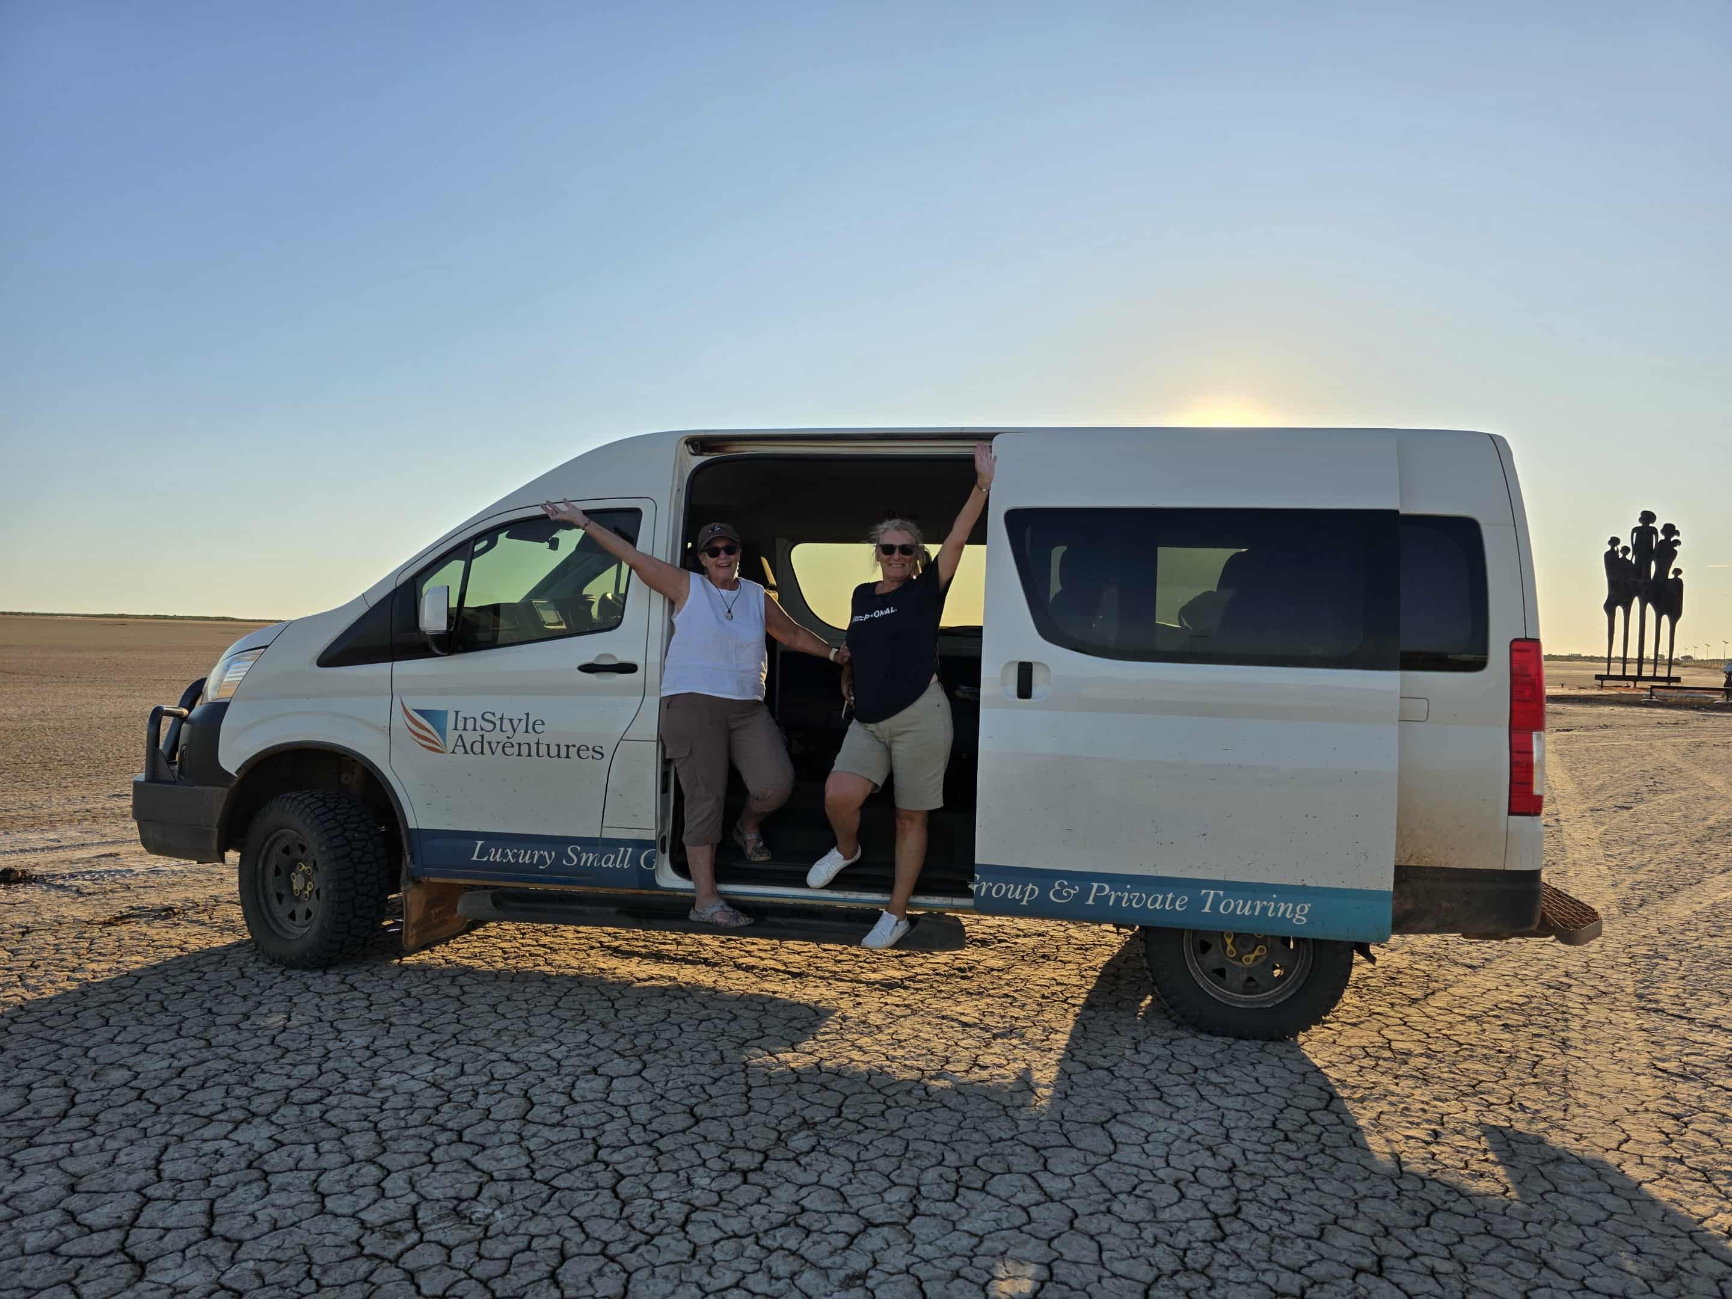
Messenger_creation_6E611B44-00BF-4D88-87BD-F19CF711546B
- In addition, the following further information can assist guests:
Cygnet Bay Pearl Farm
Spinifix Hotel, Derby
Fitzroy River Lodge
APT lodges
Bungle Bungles Savannah Lodge
Mt Elizabeth Station
Ellenbrae Station
El Questro / Emma Gorge
Kununurra

ACCOMMODATION

Room Amenities
- There is a clear opening at least 850mm wide

Bathrooms
The bathrooms have the following facilities/amenities in place
- The door is at least 850mm wide
- There is a minimum of 850mm beside the toilet
- There is a minimum of 1400mm of clear space in front of the toilet
- The toilet seat is 460mm above the floor

ATTRACTIONS

COMMON AREAS

FOOD AND DRINK

Dining Spaces
The dining spaces have the following facilities/amenities in place
- The doorway is at least 850mm wide
- There is level access through the dining area
- Chairs are moveable to allow for wheelchairs to be seated at the tables
- There is an accessible toilet

Our business caters for the following dietary requirements
- Sugar free (diabetic)
- Gluten free (celiac)
- Lactose free (dairy free)
- Low fat and fibre with no gastric content
- Low potassium
- Low sodium
- Nut free
- Additive free
- Organic
- Vegetarian
- Vegan
- Kosher
- Halal
- In addition, the following further information can assist guests:
Our guides have Safe Food and Handling certification

ADVENTURE ACTIVITIES

Report Disclaimer
Please note that this business report, provided as a result of the use of the diagnostic assessment, is for information purposes only.
Australian Tourism Industry Council (ATIC) cannot guarantee the accuracy of respondent’s answers, or that they are fully representative of your business. Therefore, ATIC does not warrant or guarantee any particular outcome in respect of your businesses self-assessment.
This report is intended as guidance only for your business and should not be relied on for future marketing considerations. ATIC recommends that you seek your own independent advice as well as the results from the diagnostic.
Links to external web sites are inserted for convenience and do not constitute endorsement of material at those sites, or any associated organisation, product or service.
ATIC does not:
- Assume any legal liability for the accuracy, completeness, or usefulness of any information from this report or any links provided; or
- Accept responsibility for any loss associated directly or indirectly from the use of this report.

