ATIC Accessibility
To support the accessible community in making informed travel decisions for their individual needs

This report prepared for:
Business name: | Silent Tours
Address: | PO Box 2004
Town: | Kununurra
Contact for enquiries: | Stephen Stevets
Contact Number: | 0455330155
Contact Email: | relax@silenttours.com.au
Website: | silenttours.com.au
Date: | 2026-09-21 00:07

ATIC Accessibility
The following pages provides travellers with information on the businesses facilities and amenities which aims to support the traveller to make an informed decision on whether the business is suitable for their individual needs.
OVERVIEW 4
Business Overview 4
Bookings 4
Emergency Management 4
Guide Dog and Service Animals 5
GENERAL 6
Pre-arrival, arrival and reception 6
Cognitive Impairment Support 6
Car Park and Access amenities 6
Displays, exhibits, commentary and live performances 6
External Paths 7
TOUR OPERATORS 8
Tour/Transport Services 8
Route Planning 8
Guides 8
Report Disclaimer 13

OVERVIEW

Business Overview

Our business caters for the following disability types:
- Deaf or low hearing
- Limited mobility
- Food allergies or intolerances
- Cognitive or people on the Autism Spectrum


Bookings

The business offers the following methods for bookings and enquiries:
- Phone
- Email
- Webportal
- Our forms have high contract boxes and submit boxes
- Staff have undergone disability awareness and training

Emergency Management

I operate a small boat and 4WD vehicle. In case of an emergency on the boat or vehicle I will help passengers disembark.
- Exit access is free and clear at all times
We ensure exit access is free and clear at all times by:
Passengers either sit next to a door or on an open-air boat
- Exit doors are able to be opened by all occupants
- In addition, the following further information can assist guests:
Guests are prompted to detail any mobility limiting issues at time of booking
- In addition, the following further information can assist guests:
Guest mobility is assessed when meeting. Priority is given to those who need assistance

Guide Dog and Service Animals
- The business provides a secure area with shade and water for service animals
- The business provides a toilet area for service animals
- Bowls, bedding, etc. are provided for service animals
The business provides the following services for services animals:
I will allow eaither a seat or boat floor space for a service animal. I have vehicle car seat harness for service dogs.

GENERAL

Pre-arrival, arrival and reception
The business has the following in place to support guests during pre-arrival, arrival and reception
- Information and maps are available in written form
- A familiarisation tour
- In addition, the following further information can assist guests:
Guests will be provided options to sit if waiting for extended periods
- In addition, the following further information can assist guests:
Silent Tours offers relaxing, slow paced tours. While there are options to walk we also offer the option to just sit and relax.

Cognitive Impairment Support
- A "social script" guide to your premises or attraction describing the sights, sounds and smells to aid parents/carers prepare visitors in advance
- Quiet periods or early opening times for people on the Autism Spectrum

Car Park and Access amenities
The business has the following Car Park and Access amenities
- Designated disabled parking bays
- In addition, the following further information can assist guests:
Silent Tours operates in a vairety of natural environments and will pick up guests directly outside there accommodation. These areas are not under the control of Silent Tours

Displays, exhibits, commentary and live performances
For displays, exhibits, commentary and live performances the following amenities are in place
- Seating
- In addition, the following further information can assist guests:
Silent Tours operates small and quiet tour groups no more than 4 people. Hard of hearing guests are welcomed to sit close to the tour guide where the guide will increase volume and face directly to the guest

External Paths
External paths of travel
- Paths or slopes longer than 15 metres have resting places or seats
The width of the smallest pathway is:
Pathways vary greatly

We are outdoors in nature
- In addition, the following further information can assist guests:
Silent Tours guide used to work in aged care and is experienced in helping guests if required
- In addition, the following further information can assist guests:
There are sidesteps into the 4WD vehicle and ladder at the back of the boat only

TOUR OPERATORS

Tour/Transport Services
The tour/transport services have the following facilities/amenities in place
- Buses/Coaches
- Nil vehicles have wheelchair lifts or ramps
- Nil vehicles have low floors with ramped entry
The maximum wheelchair capacity available in the fleet is:
Nil

Route Planning
- Route Planning
- The tour route includes stops with accessible toilet facilities
- In addition, the following further information can assist guests:
Silent Tours offers small tours allowing the lead guide to tailor the tour to your specific needs. All tours are slow paced allowing guests to be comfortable with surroundings and move safely.
- Lunch stop venues are accessible
- Sightseeing and photo opportunity stops are step free
- Walking Tours
- Multi-paced to account for slower walkers

Guides

Guides have been trained in the following
- Use of clear/simple English
- Correct pronunciation for lip readers
- There is a audio description of surroundings
- Marine
  - Image(s)
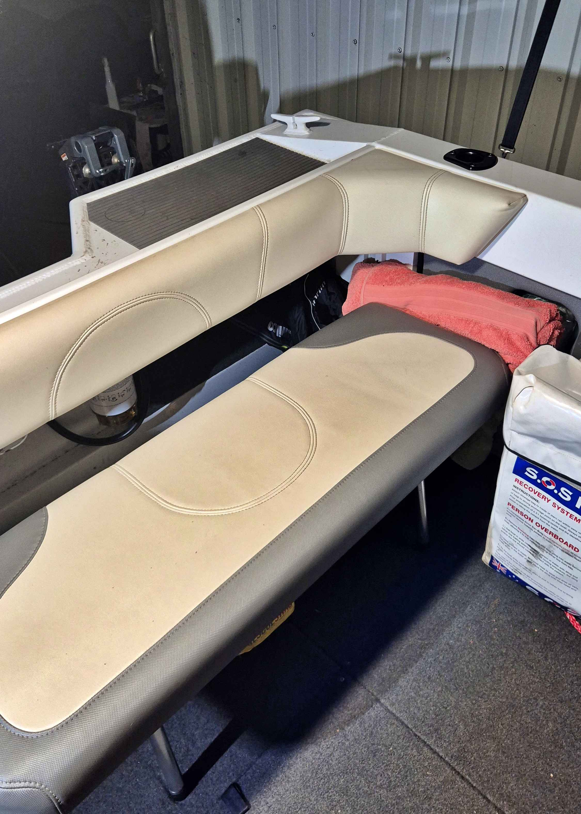
Boat back seat and Step up to rear disembark-embarkment walkway
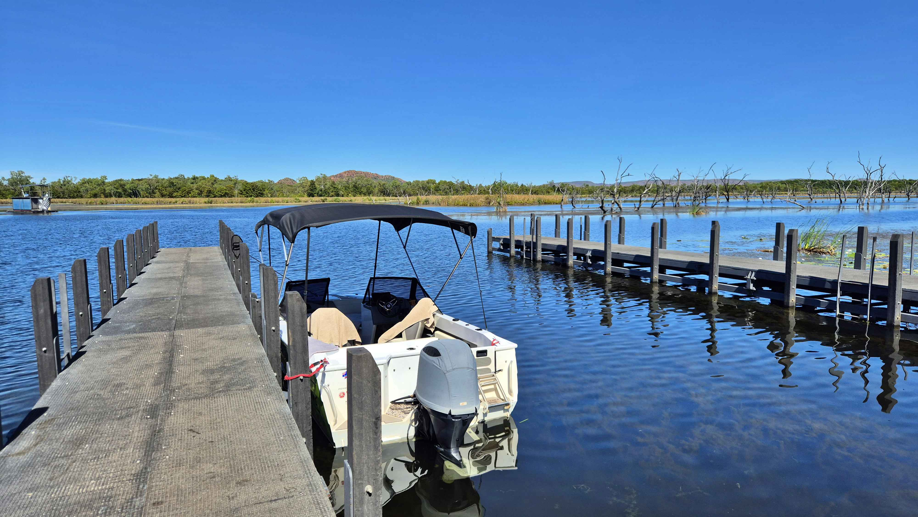
Celebrity Tree Park Boat Ramp Jetty
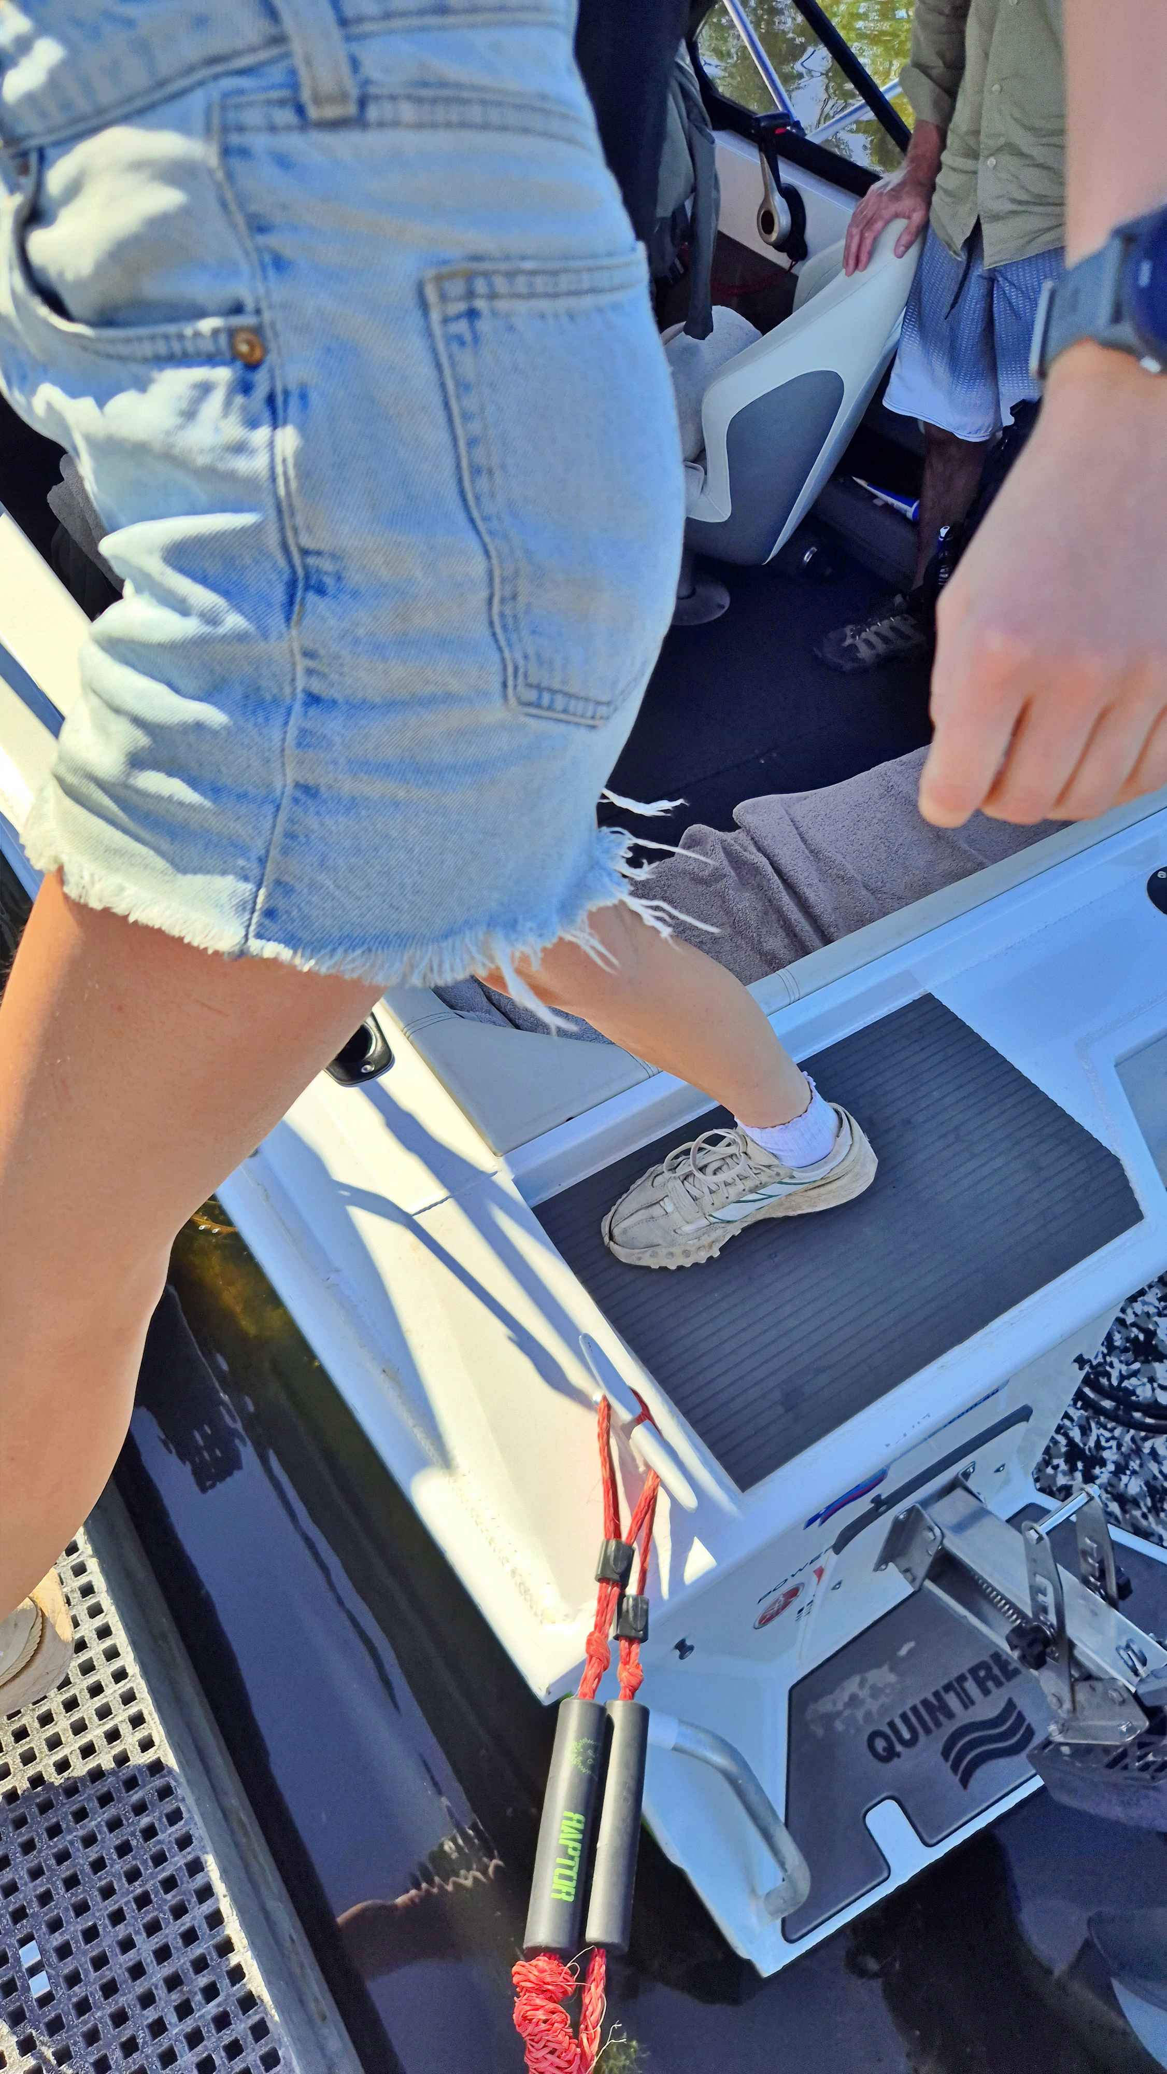
Rear Step from boat to Jetty Gangway
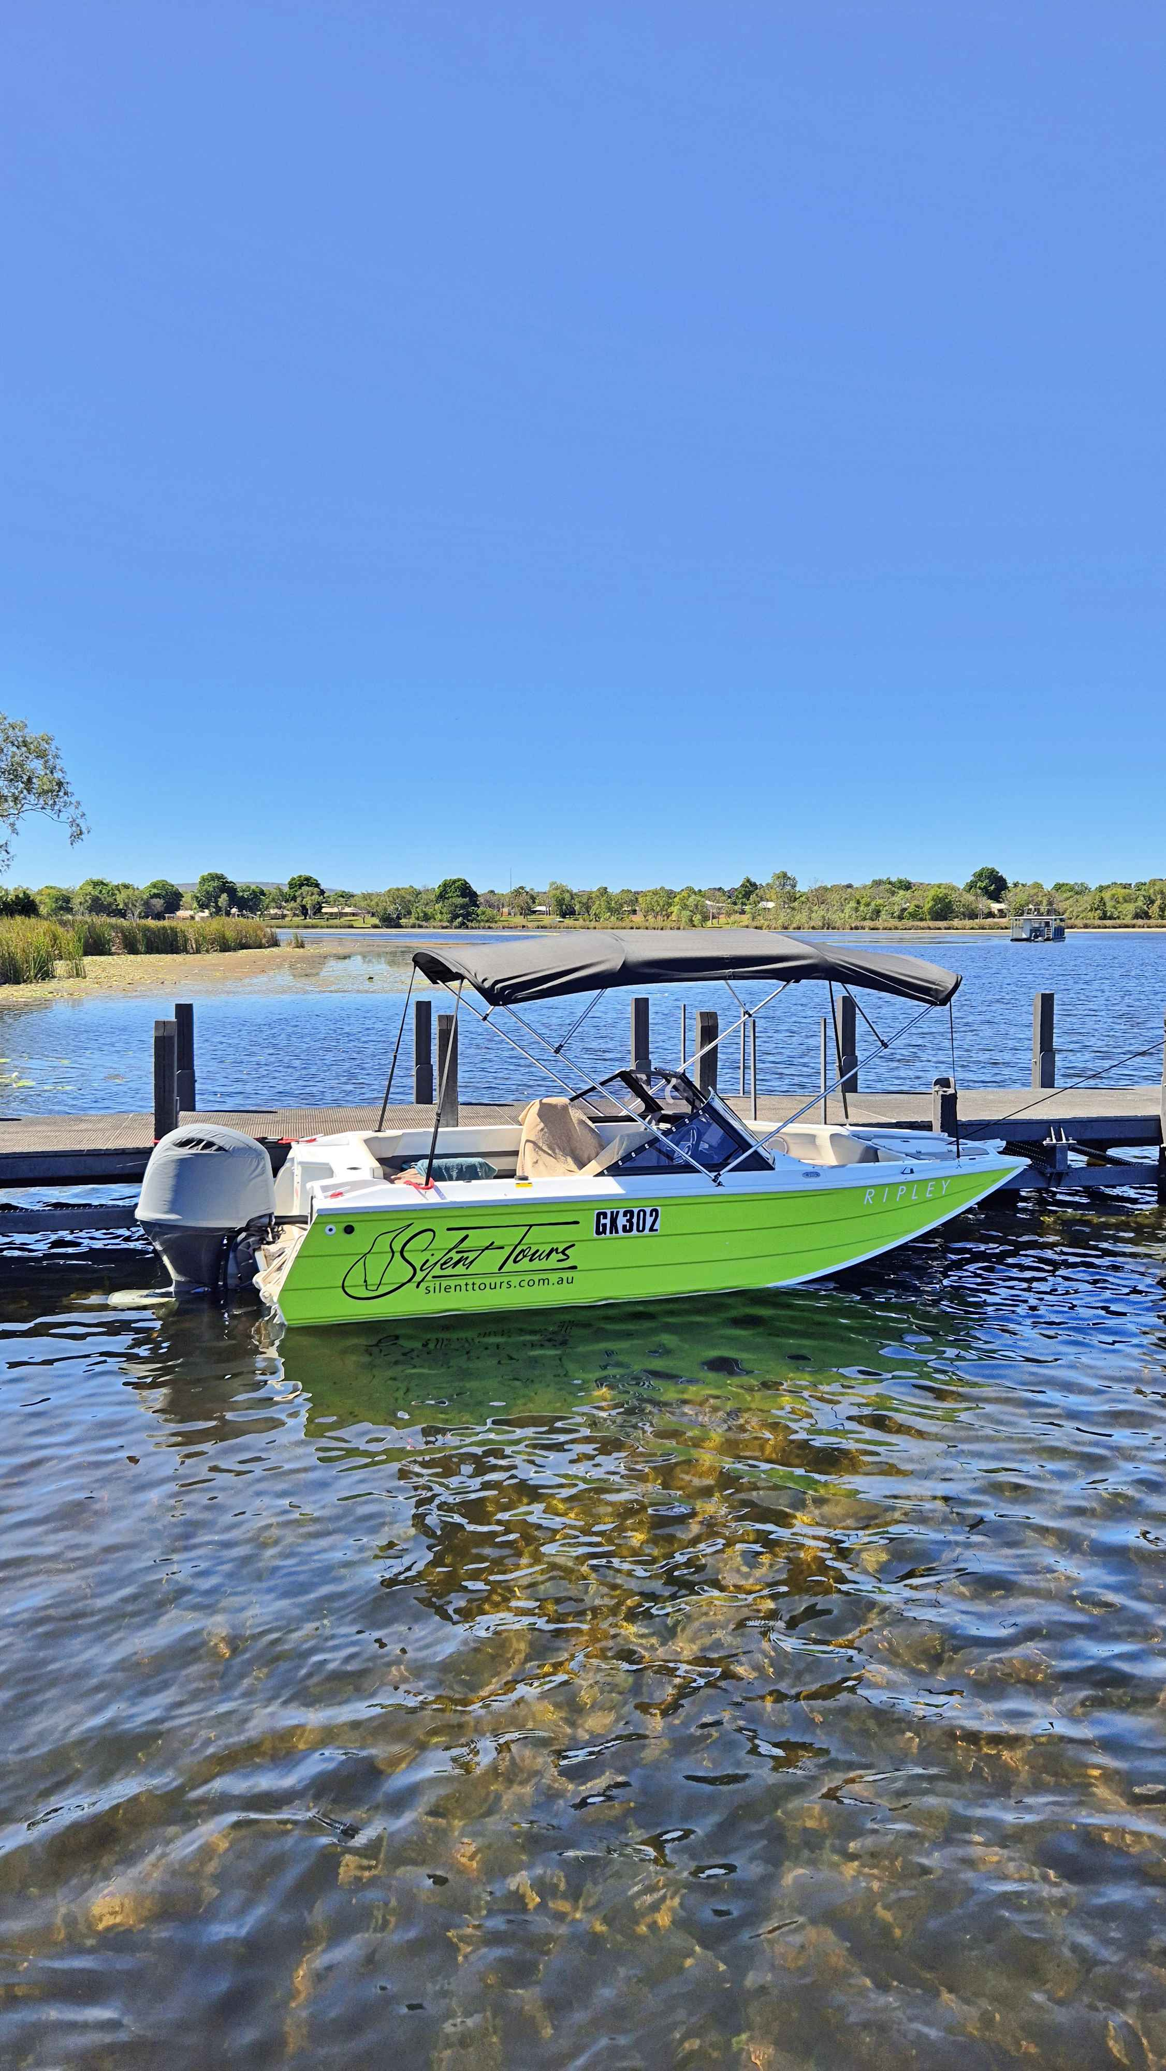
SIlent Tours seating
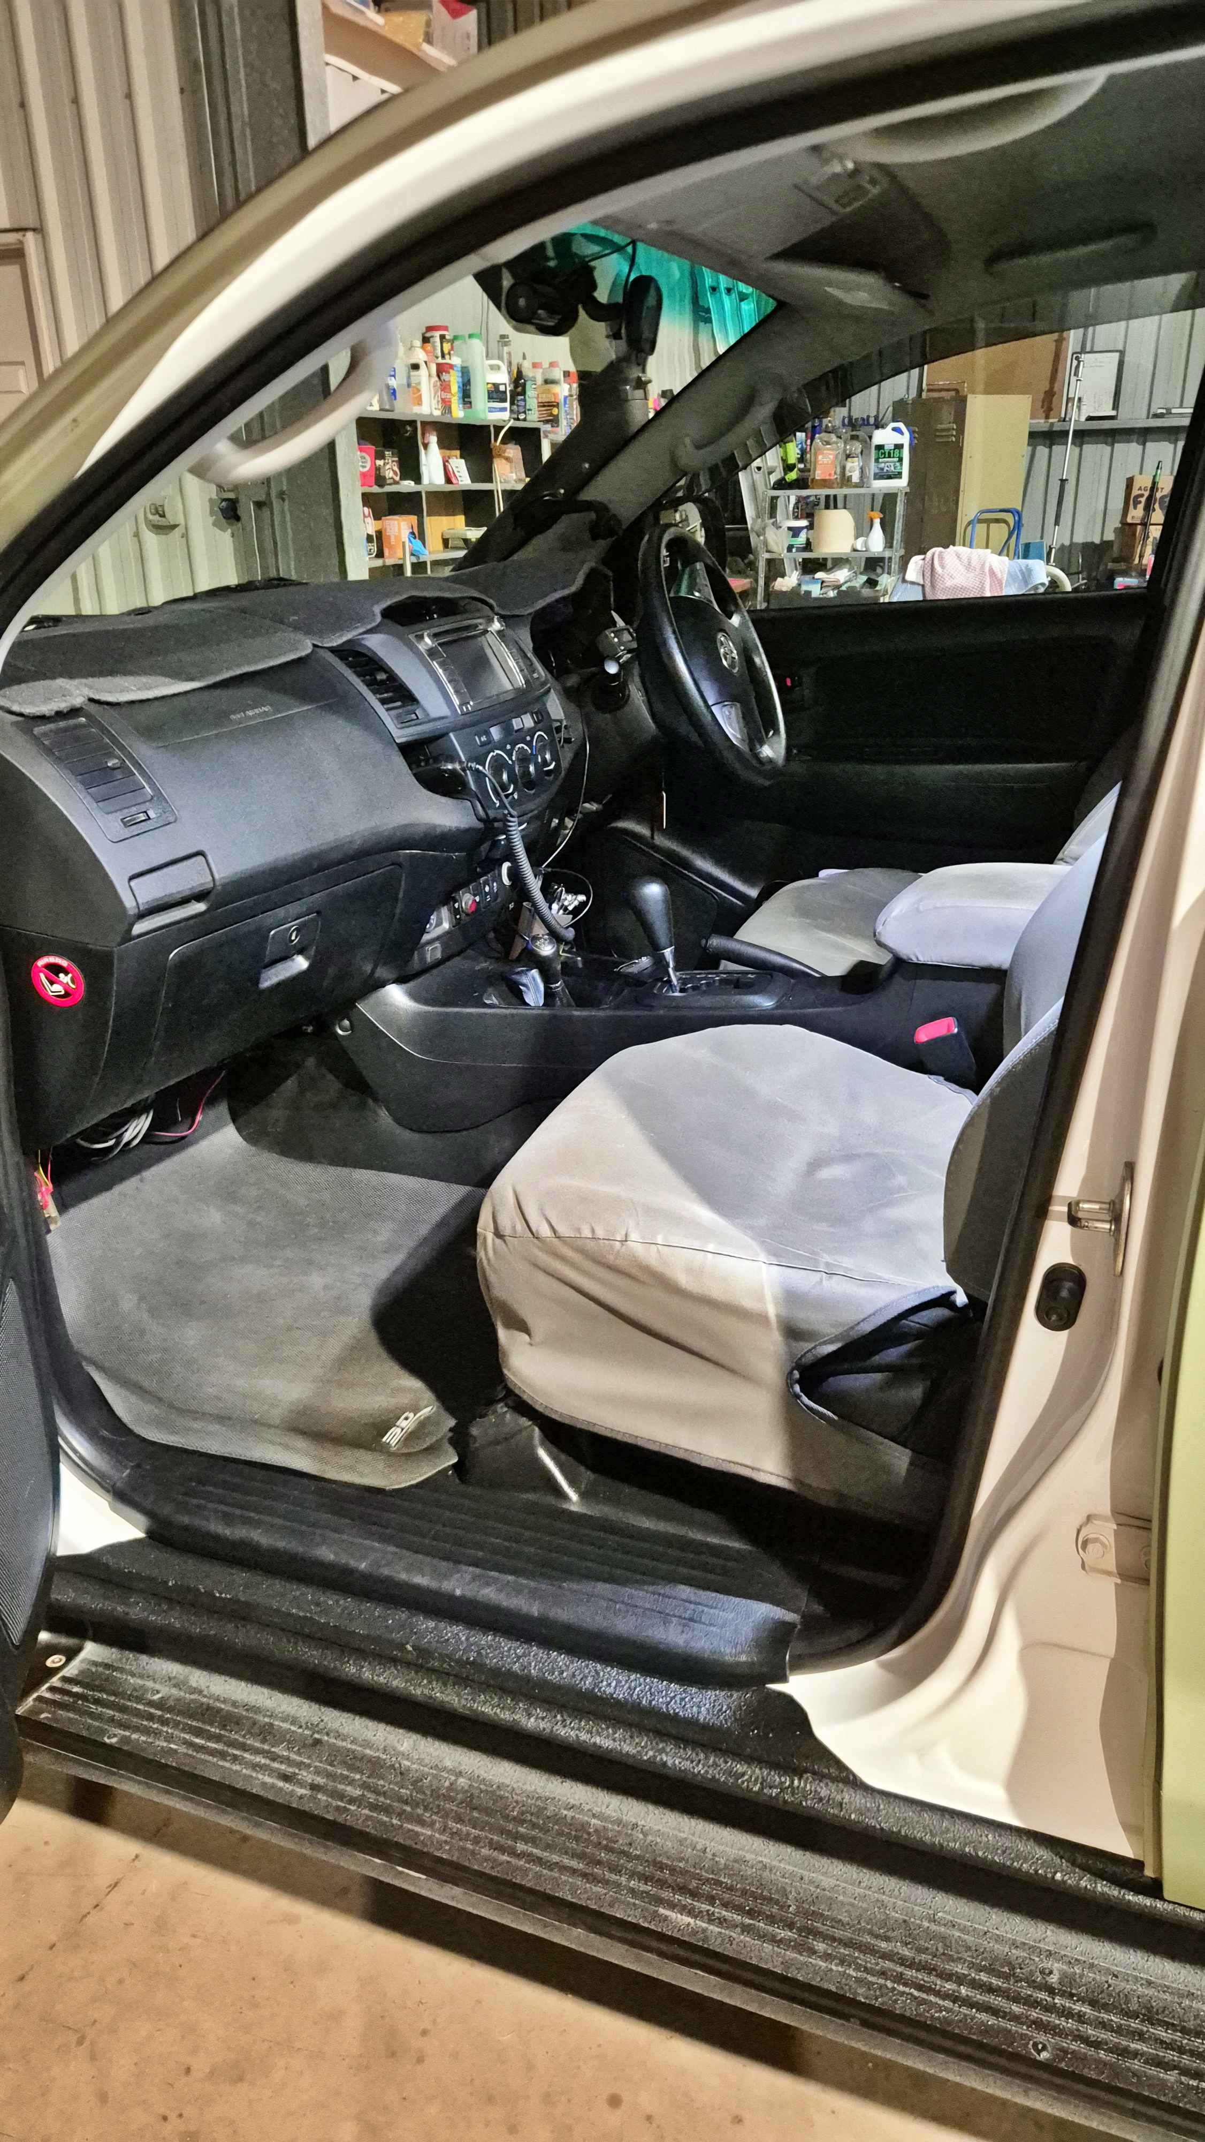
4WD side step to seating
- In addition, the following further information can assist guests:
The Hoochery https://www.hoochery.com.au/
Blak Tappas https://blaktapas.com.au/
Ivanhoe Cafe https://www.ivanhoecafe.com.au/
Spilled the Beans cafe https://www.facebook.com/spilledthebeanskimberleyland
Kimberley Ornamental Stonecraft https://www.kimberleyornamentalstonecraft.com.au/
Emma Gorge/El Questro Station https://elquestro.com.au/

- In addition, the following further information can assist guests:
The lead tour guide used to work in medical health, spinal rehabilitation and aged care providing a strong grounding in care needs for those with limited mobility &amp; sensory impairment.

Report Disclaimer
Please note that this business report, provided as a result of the use of the diagnostic assessment, is for information purposes only.
Australian Tourism Industry Council (ATIC) cannot guarantee the accuracy of respondent’s answers, or that they are fully representative of your business. Therefore, ATIC does not warrant or guarantee any particular outcome in respect of your businesses self-assessment.
This report is intended as guidance only for your business and should not be relied on for future marketing considerations. ATIC recommends that you seek your own independent advice as well as the results from the diagnostic.
Links to external web sites are inserted for convenience and do not constitute endorsement of material at those sites, or any associated organisation, product or service.
ATIC does not:
- Assume any legal liability for the accuracy, completeness, or usefulness of any information from this report or any links provided; or
- Accept responsibility for any loss associated directly or indirectly from the use of this report.

