ATIC Accessibility
To support the accessible community in making informed travel decisions for their individual needs

This report prepared for:
Business name: | Bubbles by Shelly
Address: | 4 Waxberry Gardens
Town: | Canning Vale
Contact for enquiries: | Xudong Wang
Contact Number: | 0436959465
Contact Email: | sheldonwang008@gmail.com
Website: | NA.
Date: | 2026-10-29 04:11

ATIC Accessibility
The following pages provides travellers with information on the businesses facilities and amenities which aims to support the traveller to make an informed decision on whether the business is suitable for their individual needs.
OVERVIEW 3
Business Overview 3
Bookings 3
Emergency Management 3
Other Information 4
Guide Dog and Service Animals 4
GENERAL 5
Pre-arrival, arrival and reception 5
Car Park and Access amenities 5
External Paths 5
TOUR OPERATORS 7
Route Planning 7
Guides 7
Report Disclaimer 10

OVERVIEW

Business Overview

The business has the following products/services available
- Tour/Transport

Our business caters for the following disability types:
- Deaf or low hearing
- Limited mobility
- Food allergies or intolerances


Bookings

The business offers the following methods for bookings and enquiries:
- Phone
- Email

Emergency Management
- Emergency and evacuation procedures are explained on arrival
- Exit signs are clear and easy to see
- Exit signs have raised lettering or braille
- Exit access is free and clear at all times
We ensure exit access is free and clear at all times by:
In car stickers
- Exit doors are able to be opened by all occupants
- Exits to the emergency evacuation point does not include stairways
- The evacuation point is clearly marked by a sign
- The evacuation point is clearly marked by a sign with raised letters or braille
- In addition, the following further information can assist guests:
Guests are asked during the booking process to advise us of any disability, medical condition, mobility limitation or other support needs. This information is recorded confidentially in the booking notes and communicated to the driver before departure. At the start of each tour, the driver confirms any assistance requirements with guests. In an emergency, the driver uses the passenger list and this information to identify and assist guests who may require additional support.
- In addition, the following further information can assist guests:
In an emergency, the driver will stop the vehicle in the safest available location, contact emergency services by calling 000 and follow their instructions. Guests who require assistance will be supported according to their individual needs and moved to a safe location only when it is safe to do so. The driver will provide clear instructions, assist with mobility where practicable, and ensure that mobility aids and essential medication remain with the guest where possible. Guests will not be moved if this may cause further injury unless there is an immediate danger. A passenger headcount will be completed, and the driver will remain with the group until emergency services arrive.
- Guests with disabilities are noted in the guest log book for emergency and evacuation purposes

Other Information
- The business accepts the companion card

Guide Dog and Service Animals
- The business provides a secure area with shade and water for service animals
- The business provides a toilet area for service animals
- Bowls, bedding, etc. are provided for service animals
The business provides the following services for services animals:
Recognised assistance animals are welcome in our vehicles at no additional charge. Guests are asked to advise us when booking so that suitable space can be arranged. Water and rest stops can be provided during the journey, and the assistance animal may remain with its handler wherever practicable. Guests should bring any food, medication, harnesses or other equipment required by the animal.

GENERAL

Pre-arrival, arrival and reception
The business has the following in place to support guests during pre-arrival, arrival and reception
- Information and maps are available in written form
- In addition, the following further information can assist guests:
As a private charter service, we arrange scheduled pick-up times and communicate directly with guests to minimise waiting. Guests who experience disability-related fatigue can board first, remain seated in the vehicle where safe, and request additional rest stops. Pick-up times, the itinerary and the pace of the tour can be adjusted to suit individual needs where practicable.
- In addition, the following further information can assist guests:
Please advise us of any accessibility, mobility, sensory or fatigue-related requirements when booking. We will discuss your needs and make reasonable adjustments wherever practicable. As vehicle access and destination facilities may vary, advance notice helps us plan a safe and comfortable journey.

Car Park and Access amenities
The business has the following Car Park and Access amenities
- A drop off zone
- Designated disabled parking bays
- Level or ramped access from the car park to the entrance
- The accessible entrance is clearly signed from the parking bay
- In addition, the following further information can assist guests:
We are a mobile private charter service and do not operate from a fixed public premises or customer car park. Pick-up and drop-off locations are arranged individually and may vary depending on the itinerary. Guests are encouraged to advise us of any mobility or accessibility requirements when booking so that we can select a safe and convenient location where practicable. Accessibility at third-party attractions and destinations may vary.

External Paths
External paths of travel
- Surfaces are concrete, asphalt, smooth paving or hard packed fine gravel (max aggregate size 13mm)
- Paths or slopes longer than 15 metres have resting places or seats
- Pathways are wider than 900mm
- There 3 successive steps or less on any path or at any doorway
- Any paths having steps are clearly identified as non-wheelchair accessible
- Step free routes clearly signed
- In addition, the following further information can assist guests:
We are a mobile private charter service and do not own or control the external paths, steps or signage at the attractions and destinations visited. Accessibility conditions vary between locations. Guests are encouraged to advise us of their mobility requirements in advance so that suitable destinations and step-free routes can be identified where information is available.
- In addition, the following further information can assist guests:
Our private charter vehicle requires passengers to step up when boarding and does not have a wheelchair ramp or lift. Guests who have difficulty with steps are encouraged to contact us before booking to discuss their needs. We can provide additional boarding time and reasonable assistance where safe and practicable. Accessibility at third-party destinations may vary.
- In addition, the following further information can assist guests:
Our private charter vehicle does not have an onboard toilet, wheelchair ramp or lift. We do not operate public toilet or Changing Places facilities. Where practicable, comfort stops can be planned at locations with accessible public toilets; however, these facilities are operated by third parties and availability may vary. Guests are encouraged to advise us of their requirements before booking so that suitable stops can be included in the itinerary.

TOUR OPERATORS

Route Planning
- Route Planning
- The tour route includes stops with accessible toilet facilities
- In addition, the following further information can assist guests:
We operate a private charter vehicle rather than a bus, coach or boat. Our itineraries include stops where guests may leave the vehicle to visit attractions, cafés and other destinations. Where practicable, routes can include comfort stops with accessible toilet facilities. These facilities are operated by third parties, so availability and accessibility may vary. Our vehicle does not have an onboard toilet. Guests are encouraged to advise us of their requirements before booking so that suitable stops can be planned.
- Lunch stop venues are accessible
- Sightseeing and photo opportunity stops are step free
- Overnight Stops
- For overnight stays, wheelchair accessible rooms are available
- The accommodation provider used for overnight stops has been independently verified as accessible, please contact us for further information
The total number of wheelchair passengers that can be catered for at overnight stops are:
1

Guides
- AUSLAN
- Use of clear/simple English
- Correct pronunciation for lip readers
- There is a audio description of surroundings
  - Image(s)
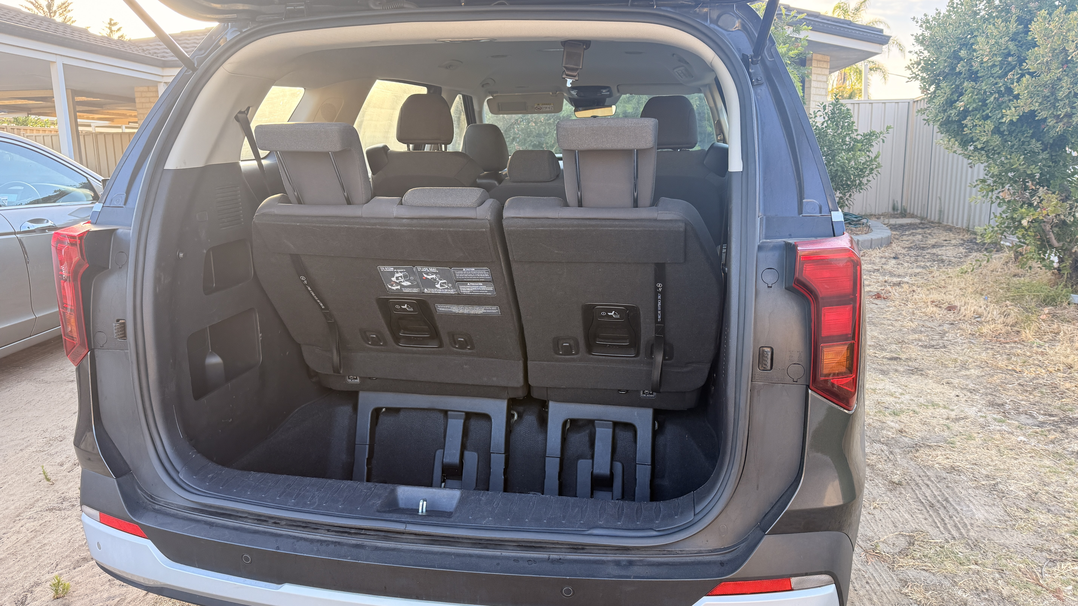
IMG_6674.JPG
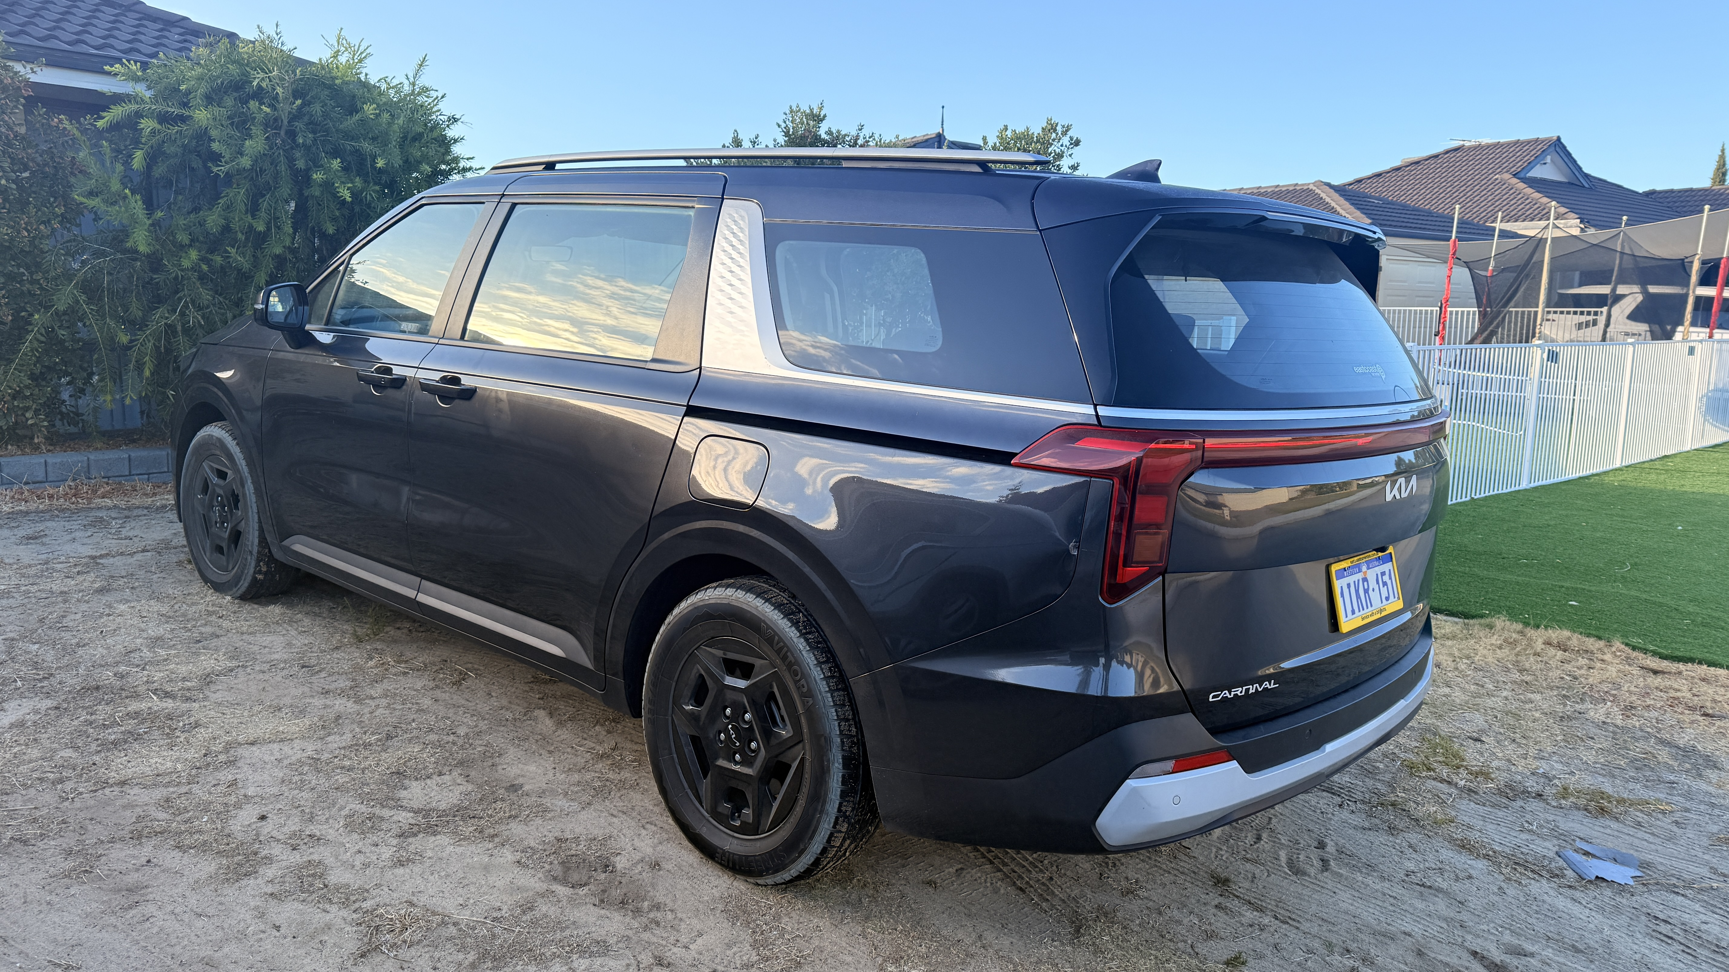
IMG_6675.JPG
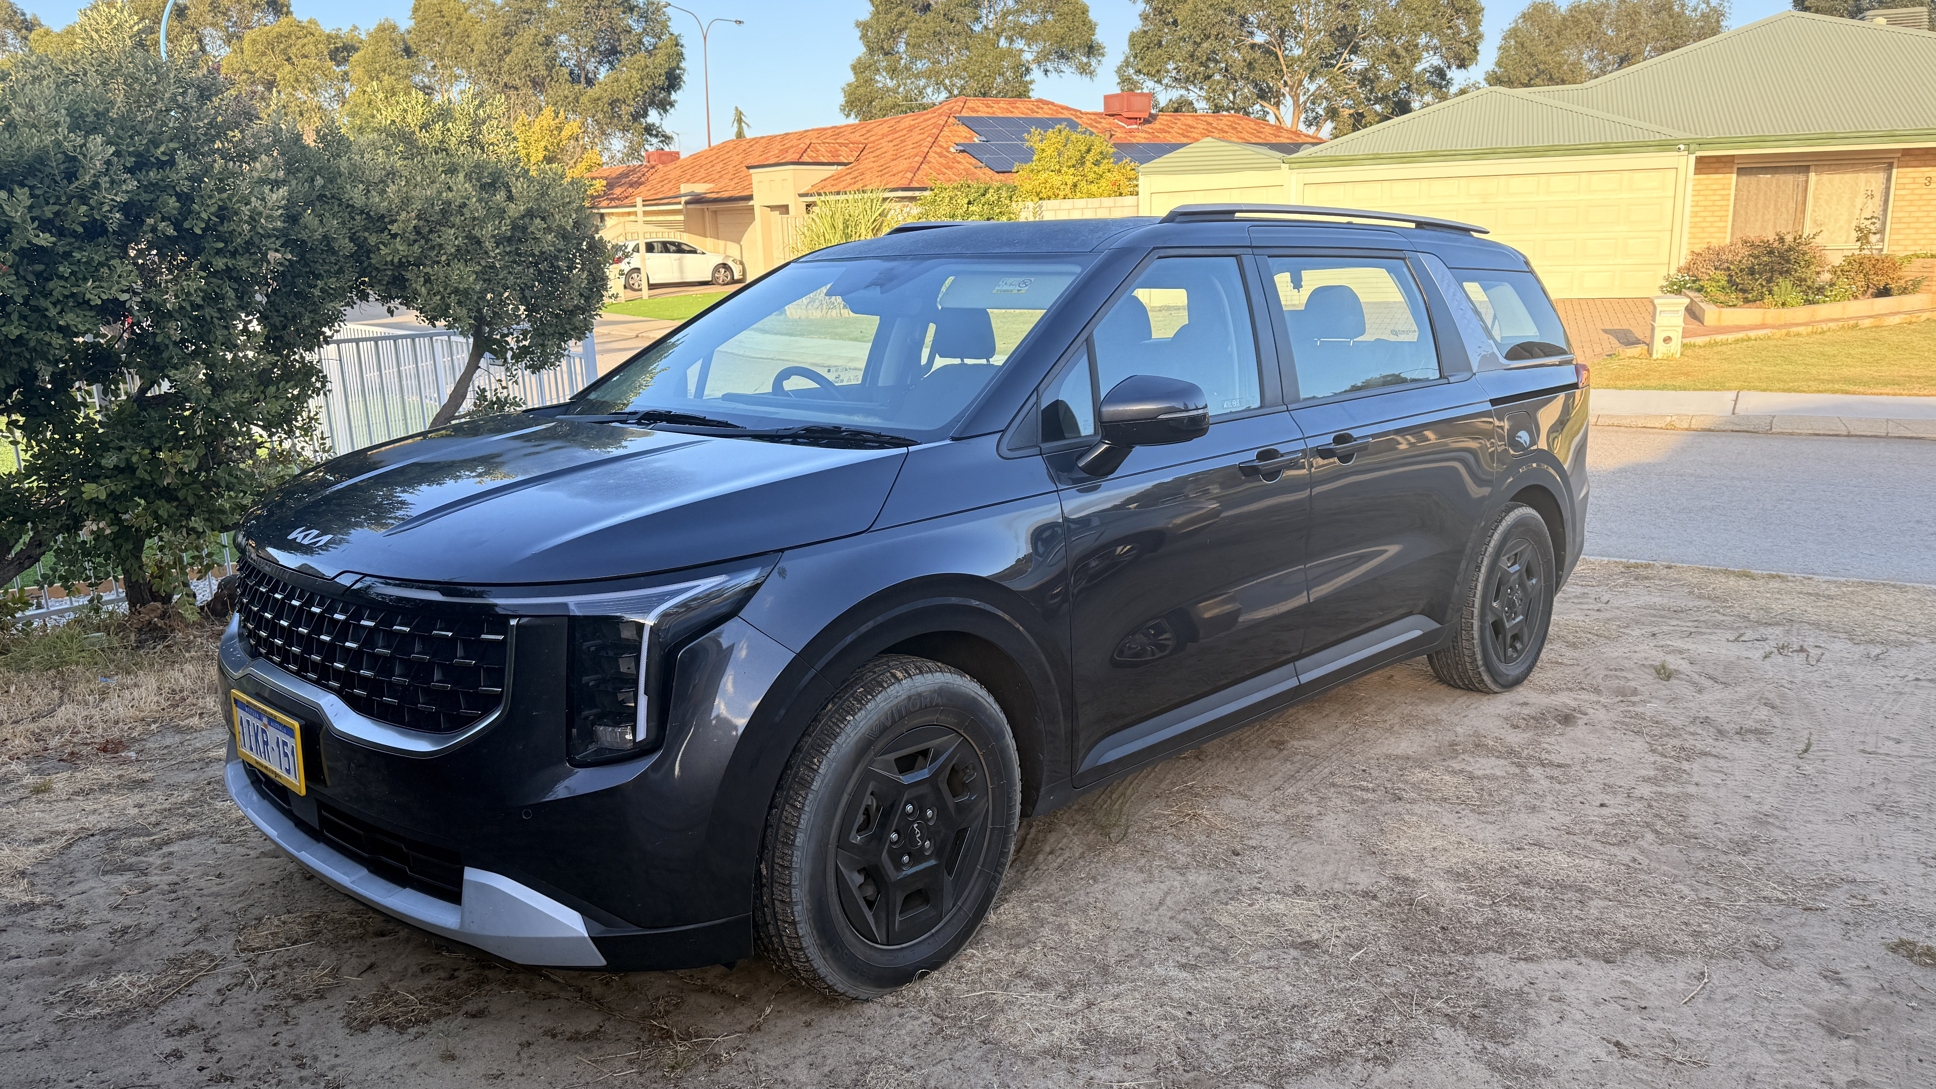
IMG_6676.JPG
- In addition, the following further information can assist guests:
Our private charter itineraries are customised to each booking. Stops may include independently operated attractions, accommodation providers, restaurants, cafés and retail businesses throughout Western Australia. As these businesses vary according to the guest’s chosen itinerary, their names and website details will be confirmed with guests during the booking process.
- In addition, the following further information can assist guests:
Accessibility facilities at third-party attractions, accommodation, restaurants, cafés and retail businesses vary and are outside our control. Guests are encouraged to advise us of any accessibility requirements before booking. Where practicable, we can help identify suitable destinations, confirm available accessibility information and adjust the itinerary to meet individual needs. Guests may also wish to contact each venue directly for the most current information.

Report Disclaimer
Please note that this business report, provided as a result of the use of the diagnostic assessment, is for information purposes only.
Australian Tourism Industry Council (ATIC) cannot guarantee the accuracy of respondent’s answers, or that they are fully representative of your business. Therefore, ATIC does not warrant or guarantee any particular outcome in respect of your businesses self-assessment.
This report is intended as guidance only for your business and should not be relied on for future marketing considerations. ATIC recommends that you seek your own independent advice as well as the results from the diagnostic.
Links to external web sites are inserted for convenience and do not constitute endorsement of material at those sites, or any associated organisation, product or service.
ATIC does not:
- Assume any legal liability for the accuracy, completeness, or usefulness of any information from this report or any links provided; or
- Accept responsibility for any loss associated directly or indirectly from the use of this report.

