ATIC Accessibility
To support the accessible community in making informed travel decisions for their individual needs

This report prepared for:
Business name: | Exmouth Bus Charters
Address: | 40 Pelias Street
Town: | Exmouth
Contact for enquiries: | Stella Klopper
Contact Number: | 0480798615
Contact Email: | book@exmouthbuscharters.com.au
Website: | https://exmouthbuscharters.com.au/
Date: | 2026-09-15 19:10

ATIC Accessibility
The following pages provides travellers with information on the businesses facilities and amenities which aims to support the traveller to make an informed decision on whether the business is suitable for their individual needs.
OVERVIEW 4
Business Overview 4
Bookings 4
Emergency Management 4
Communications 5
Other Information 5
Guide Dog and Service Animals 5
GENERAL 6
Pre-arrival, arrival and reception 6
Cognitive Impairment Support 6
Car Park and Access amenities 6
Entry 7
Internal Spaces 7
Public areas 8
External Paths 8
Public Toilets/Adult change facilities 9
TOUR OPERATORS 10
Tour/Transport Services 10
Route Planning 10
Guides 10
Report Disclaimer 14

OVERVIEW

Business Overview

The business has the following products/services available
- Tour/Transport

Our business caters for the following disability types:
- Limited mobility
- Wheelchairs or mobility scooters
- Food allergies or intolerances


Bookings

The business offers the following methods for bookings and enquiries:
- Phone
- Email
- Webportal
- Our forms have high contract boxes and submit boxes
- Staff have undergone disability awareness and training

Emergency Management
- Emergency and evacuation procedures are explained on arrival
- Exit signs are clear and easy to see
- Exit access is free and clear at all times
We ensure exit access is free and clear at all times by:
By having internal processes that the team are trained up on. Actioned before and during journey.
- The evacuation point is clearly marked by a sign
- In addition, the following further information can assist guests:
n/a
- In addition, the following further information can assist guests:
n/a
- Guests with disabilities are noted in the guest log book for emergency and evacuation purposes

Communications
- An accessibility guide is available on the website

https://accreditation.qualitytourismaustralia.com/report/AccessReportPublicHtml2/68c731c7-9d29-4304-becf-976105f6afc3

Other Information
- For bookings made onsite, the ticket booth/counter/box office is accessible for people using a wheelchair
- The business accepts the companion card

Guide Dog and Service Animals
- The business provides a secure area with shade and water for service animals
- The business provides a toilet area for service animals
- Bowls, bedding, etc. are provided for service animals
The business provides the following services for services animals:
Transport services

GENERAL

Pre-arrival, arrival and reception
The business has the following in place to support guests during pre-arrival, arrival and reception
- There is a reception/public entryway.
- Seating available at reception
- A clipboard to allow check-in/ticket purchase whilst seated
- A tablet with text to voice or pen and paper at reception to aid in communication
- Lighting in the reception area is even and glare free
- Large print information sheets and registration forms
- Information and maps are available in written form
- In addition, the following further information can assist guests:
We give priority check-in to people with disability
- In addition, the following further information can assist guests:
We are basing our answers on ariport arrival

Cognitive Impairment Support
- Documents are available in plain English for people with cognitive impairment (This may include instructions, guides, menus and general information)

Car Park and Access amenities
The business has the following Car Park and Access amenities
- A drop off zone
- Designated disabled parking bays
- Level or ramped access from the car park to the entrance
- Kerb ramps are in place where a pavement or walkway needs to be crossed
- In addition, the following further information can assist guests:
We've based our answers on customers arriving at LEA and coming to our ticket booth to book transfers

Entry
The business has the following amenities/systems in place for entry
- A drop off point close to the entrance
- A path of access to the building is slip resistance and even
- A path of access to the building is clear of obstruction
- Self opening entry doors or fitted with a self closer
- Glass doors are fitted with a visual sighting strip
- Door jams/doors are of a contrasting colour to surrounding walls
- Door handles are of a contrasting colour to the door
- Signage is written in a contrasting colour
- Signage is written in a Sans Serif font and use upper and lower case letters
- The entry door is a minimum of 850mm wide
- The entrance sill is less than 13mm
- There a clear space of at least 1500mm x 1500mm in front of all doors.
- The entrance door mats have a thickness less than 13mm and a width of 7500mm or greater
- In addition, the following further information can assist guests:
We've based our answers on customers arriving at LEA and coming to our ticket booth to book transfers

Internal Spaces
- Clear and unobstructed routes through and between buildings
- Interior walls are matte or low sheen
- Floors, walls, counters and furniture are of contrasting colours
- Any protruding or overhanging obstructions are at least 2meters above the floor or are protected
- Floor surfaces are hard or short pile carpet
- Seating is available for guests unable to stand for long periods
- Accessible facilities are clearly signed and visible from all areas
- All corridors greater than 900mm
- In addition, the following further information can assist guests:
We've based our answers on customers arriving at LEA and coming to our ticket booth to book transfers

Public areas
The public areas have the following amenities in place
- Seating
- In addition, the following further information can assist guests:
We've based our answers on customers arriving at LEA and coming to our ticket booth to book transfers

External Paths
External paths of travel
- Surfaces are concrete, asphalt, smooth paving or hard packed fine gravel (max aggregate size 13mm)
- Pathways are wider than 900mm
- There 3 successive steps or less on any path or at any doorway
- Any paths having steps are clearly identified as non-wheelchair accessible
- In addition, the following further information can assist guests:
We've based our answers on customers arriving at LEA and coming to our ticket booth to book transfers

- In addition, the following further information can assist guests:
We've based our answers on customers arriving at LEA and coming to our ticket booth to book transfers

Public Toilets/Adult change facilities
Public Toilets/Adult change facilities have the following amenities are in place
- There is an accessible toilet for public use
- The door is at least 850mm wide
- There is a minimum of 850mm beside the toilet
- Handrails are fitted
- The toilet seat is 460mm above the floor
- The toilet seat of a contrasting colour to the floor
- The toilet seat is460mm above the floor
- In addition, the following further information can assist guests:
We've based our answers at customers arriving at LEA and coming to our ticket booth to book transfers

TOUR OPERATORS

Tour/Transport Services
The tour/transport services have the following facilities/amenities in place
- Buses/Coaches
- One vehicles have wheelchair lifts or ramps
- None vehicles have low floors with ramped entry
The maximum wheelchair capacity available in the fleet is:
One

Route Planning
- Route Planning
- Lunch stop venues are accessible

Guides
- Use of clear/simple English
- Correct pronunciation for lip readers
- There is a audio description of surroundings
  - Image(s)
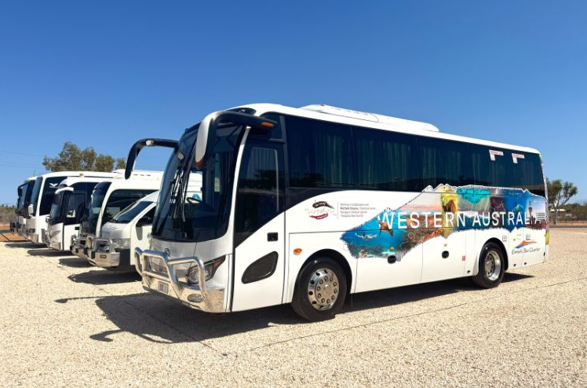
Screenshot 2025-06-13 155049
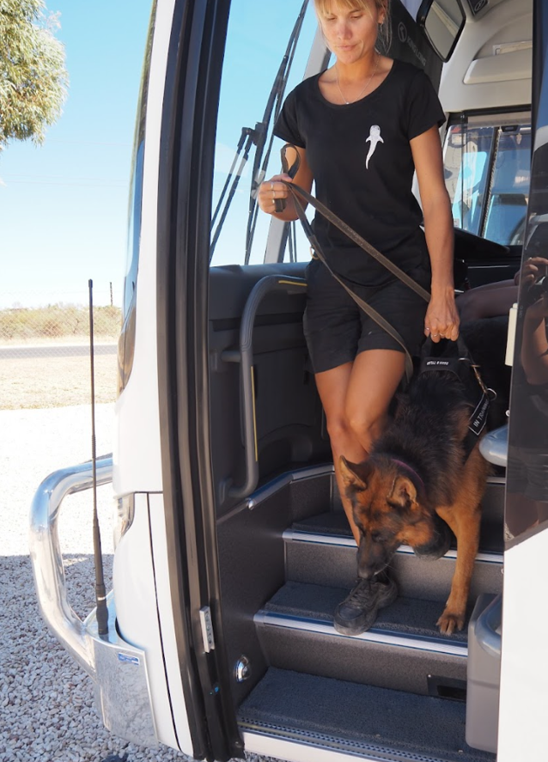
Screenshot 2025-06-13 154952
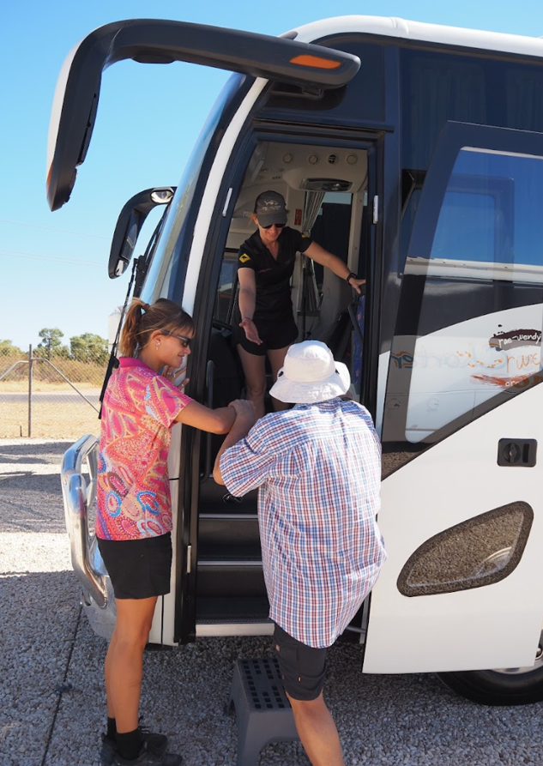
Screenshot 2025-06-13 154933
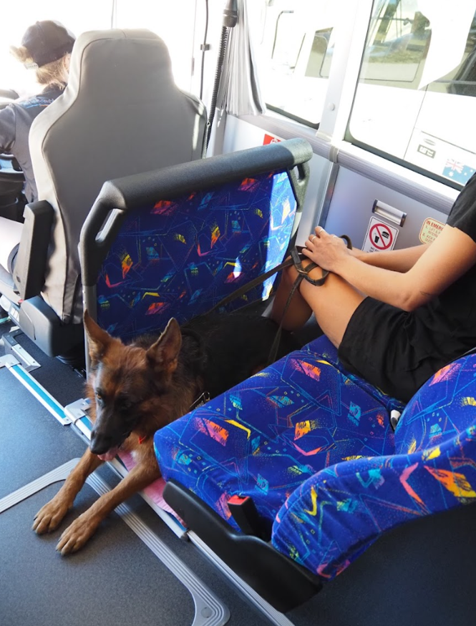
Screenshot 2025-06-13 154914
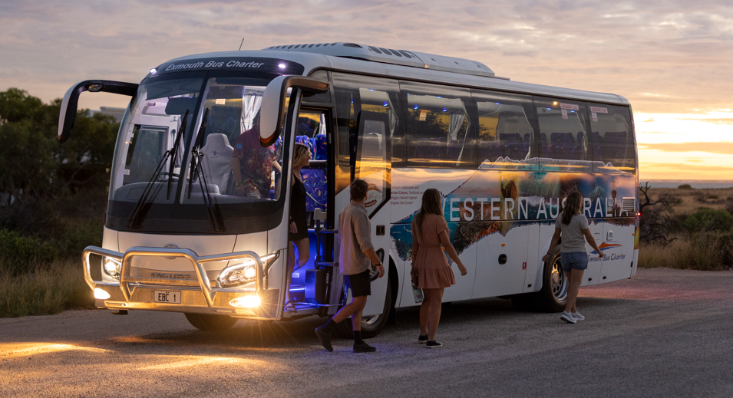
Screenshot 2025-06-13 154845
- In addition, the following further information can assist guests:
Our new Cape Range Discovery Tour stop locations: Charles Knife Canyon Lookout, Bundegi or Hunters Beach, Vlamingh Head Lighthouse and Mildura Wreck.
Other stops include or may include:
LEA Airport:
Milyering Centre: https://exploreparks.dbca.wa.gov.au/site/milyering-discovery-centre
Ningaloo Visitor Centre: https://www.ningaloocentre.com.au/
Adrift Cafe: https://www.adriftcafe.com.au/
Whalers Restaurant: https://www.whalersrestaurant.com.au/
Local accommodations or resorts such as Mantarays Beach Resort: https://www.mantaraysningalooresort.com.au/
Blue Lips cafe: https://www.bluelips.com.au/

Report Disclaimer
Please note that this business report, provided as a result of the use of the diagnostic assessment, is for information purposes only.
Australian Tourism Industry Council (ATIC) cannot guarantee the accuracy of respondent’s answers, or that they are fully representative of your business. Therefore, ATIC does not warrant or guarantee any particular outcome in respect of your businesses self-assessment.
This report is intended as guidance only for your business and should not be relied on for future marketing considerations. ATIC recommends that you seek your own independent advice as well as the results from the diagnostic.
Links to external web sites are inserted for convenience and do not constitute endorsement of material at those sites, or any associated organisation, product or service.
ATIC does not:
- Assume any legal liability for the accuracy, completeness, or usefulness of any information from this report or any links provided; or
- Accept responsibility for any loss associated directly or indirectly from the use of this report.

