ATIC Accessibility
To support the accessible community in making informed travel decisions for their individual needs

This report prepared for:
Business name: | paranaple convention centre Devonport
Address: | 137 Rooke Street
Town: | Devonport
Contact for enquiries: | Linda Petersen
Contact Number: | 0364202950
Contact Email: | functions@devonport.tas.gov.au
Website: | https://www.paranapleconventioncentre.com.au/
Date: | 2026-07-28 16:22

ATIC Accessibility
The following pages provides travellers with information on the businesses facilities and amenities which aims to support the traveller to make an informed decision on whether the business is suitable for their individual needs.
OVERVIEW 4
Business Overview 4
Bookings 4
Emergency Management 4
Communications 5
Other Information 5
Guide Dog and Service Animals 5
GENERAL 6
Pre-arrival, arrival and reception 6
Cognitive Impairment Support 6
Car Park and Access amenities 6
Entry 7
Lifts 7
Internal Spaces 7
Public areas 8
External Paths 8
Public Toilets/Adult change facilities 9
FOOD AND DRINK 10
Dining Spaces 10
EVENTS 13
Events 13
Report Disclaimer 15

OVERVIEW

Business Overview

The business has the following products/services available
- Food and Drink
- Event

Our business caters for the following disability types:
- Blind or low vision
- Deaf or low hearing
- Limited mobility
- Wheelchairs or mobility scooters
- Food allergies or intolerances
- Cognitive or people on the Autism Spectrum


Bookings

The business offers the following methods for bookings and enquiries:
- Phone
- Email
- Webportal
- Our website supports Screen Readers
- Our forms have high contract boxes and submit boxes
- Staff have undergone disability awareness and training

Emergency Management
- The business has an emergency management and evacuation plan for guests with a disability
- Emergency and evacuation procedures are explained on arrival
- Guests with disabilities are noted in the guest log book for emergency and evacuation purposes

Communications
- An accessibility guide is available on the website

https://www.paranapleconventioncentre.com.au/wp-content/uploads/2025/05/ATICAccessibilityPublic-2025-05-05-13_30.pdf
- Our website meets WCAG 2.0 accessibility standards

Other Information
- For bookings made onsite, the ticket booth/counter/box office is accessible for people using a wheelchair
- The business accepts the companion card

Guide Dog and Service Animals
- The business provides a secure area with shade and water for service animals
The business provides the following services for services animals:
Welcome into all spaces

GENERAL

Pre-arrival, arrival and reception
The business has the following in place to support guests during pre-arrival, arrival and reception
- There is a reception/public entryway.
- Seating available at reception
- A lower counter at reception/ticket office
- A clipboard to allow check-in/ticket purchase whilst seated
- A tablet with text to voice or pen and paper at reception to aid in communication
- Lighting in the reception area is even and glare free
- Information and maps are available in written form
- A familiarisation tour
- In addition, the following further information can assist guests:
Seating provided in foyer and landing areas on all levels and outside.
- In addition, the following further information can assist guests:
There are accessible toilets, ramps and lifts throughout our venue, including wheelchair friendly access from the car park.&nbsp;

Cognitive Impairment Support
- Documents are available in plain English for people with cognitive impairment (This may include instructions, guides, menus and general information)
- A "social script" guide to your premises or attraction describing the sights, sounds and smells to aid parents/carers prepare visitors in advance
- The 'social script' is available in word and other editable formats
- A space for parents and children on the Autism Spectrum

Car Park and Access amenities
The business has the following Car Park and Access amenities
- A drop off zone
- Designated disabled parking bays
- Level or ramped access from the car park to the entrance
- The accessible entrance is clearly signed from the parking bay
- The public transport services available are:

Bus shelter accessed 50 metres from entrance via level surfaces
- Kerb ramps are in place where a pavement or walkway needs to be crossed
- In addition, the following further information can assist guests:
Should you need assistance from the car park, please contact&nbsp;6420 2950&nbsp;

Entry
The business has the following amenities/systems in place for entry
- A drop off point close to the entrance
- A path of access to the building is slip resistance and even
- A path of access to the building is clear of obstruction
- Self opening entry doors or fitted with a self closer
- Glass doors are fitted with a visual sighting strip
- Door jams/doors are of a contrasting colour to surrounding walls
- Door handles are of a contrasting colour to the door
- Signage is written in a contrasting colour
- Signage is written in a Sans Serif font and use upper and lower case letters
- The entry door is a minimum of 850mm wide
- The entry door has self opening or a light opening pressure (for manual operations)
- The entrance sill is less than 13mm
- There a clear space of at least 1500mm x 1500mm in front of all doors.
- The entrance door mats have a thickness less than 13mm and a width of 7500mm or greater
- In addition, the following further information can assist guests:
paranaple Centre complies with Disability (Access to Premises – Buildings) Standards 2010.

Lifts
- Premises has lifts
- Lift location: Located on landing next to escalator, all levels. Has visual floor indicator
- In addition, the following further information can assist guests:
Selecting Upper Ground (UG) in the lift allows direct access to the outside of the building.

Internal Spaces
- Clear and unobstructed routes through and between buildings
- Interior walls are matte or low sheen
- Floors, walls, counters and furniture are of contrasting colours
- Any protruding or overhanging obstructions are at least 2meters above the floor or are protected
- Menus are available in large print or Braille
- Tableware/glassware contrast with the table surface or table cloth
- Floor surfaces are hard or short pile carpet
- Seating is available for guests unable to stand for long periods
- Accessible facilities are clearly signed and visible from all areas
- All corridors greater than 900mm
- There is a quiet space for parents and children on the Autism Spectrum
- In addition, the following further information can assist guests:
Private meeting rooms and green room available on request.

Public areas
The public areas have the following amenities in place
- Display units, Televisions, Video displays etc. are open captioned
- Hearing loops
- Hearing loop symbols are displayed
- Even lighting
- Seating
- In addition, the following further information can assist guests:
Please see technician or Front of House Manager for hearing loop.

External Paths
External paths of travel
- Surfaces are concrete, asphalt, smooth paving or hard packed fine gravel (max aggregate size 13mm)
- Paths or slopes longer than 15 metres have resting places or seats
- Pathways are wider than 900mm
- There 3 successive steps or less on any path or at any doorway

All areas are accessible

Public Toilets/Adult change facilities
Public Toilets/Adult change facilities have the following amenities are in place
- There is an accessible toilet for public use
- The door is at least 850mm wide
- There is a minimum of 850mm beside the toilet
- Handrails are fitted
- The toilet seat is 460mm above the floor
- There is 2m mm of clear space in front of the toilet
- The toilet seat of a contrasting colour to the floor
- The toilet seat is460mm above the floor

FOOD AND DRINK

Dining Spaces
The dining spaces have the following facilities/amenities in place
- The entrance has level access
- The doorway is at least 850mm wide
- There is level access through the dining area
- Chairs are moveable to allow for wheelchairs to be seated at the tables
- Hearing loops are available
- All glass doors and full height windows have contrast markings
- There are areas of full lighting
- There are large print menus
- There are Plain English menus
- There is an accessible toilet

Our business caters for the following dietary requirements
- Sugar free (diabetic)
- Gluten free (celiac)
- Lactose free (dairy free)
- Low fat and fibre with no gastric content
- Low potassium
- Low sodium
- Nut free
- Additive free
- Organic
- Vegetarian
- Vegan
- Kosher
- Halal
- In addition, the following further information can assist guests:
Raw ingredients and allergens are stored in separate areas, ensuring that they are clearly labelled and easily identifiable to prevent accidental mixing. &nbsp;Staff undergo food handling and hygiene training.
- There is a sample menu available online
Sample menu is available here -
https://www.paranapleconventioncentre.com.au/plan/
  - Food and Beverage Image(s)
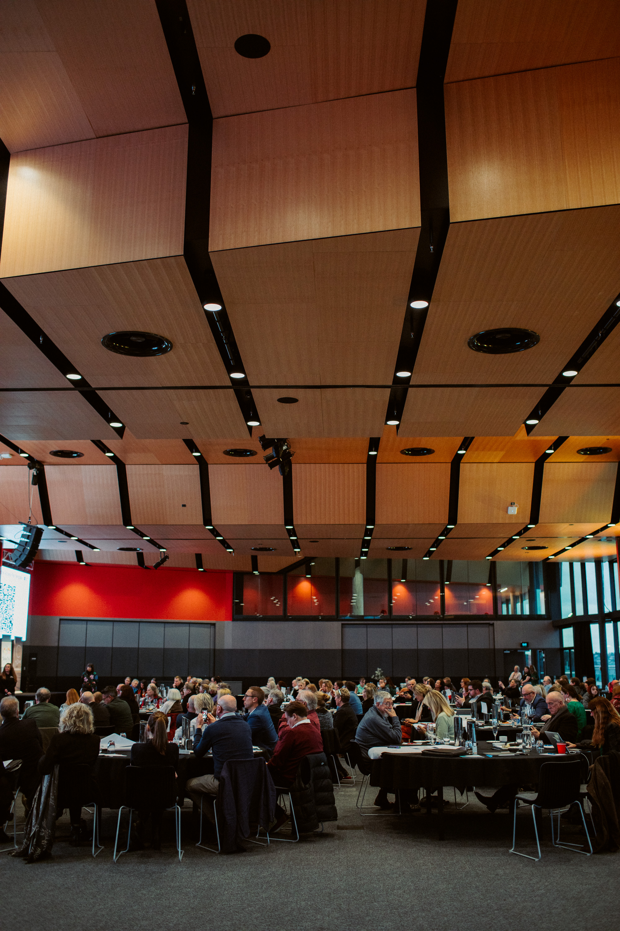
Find-2
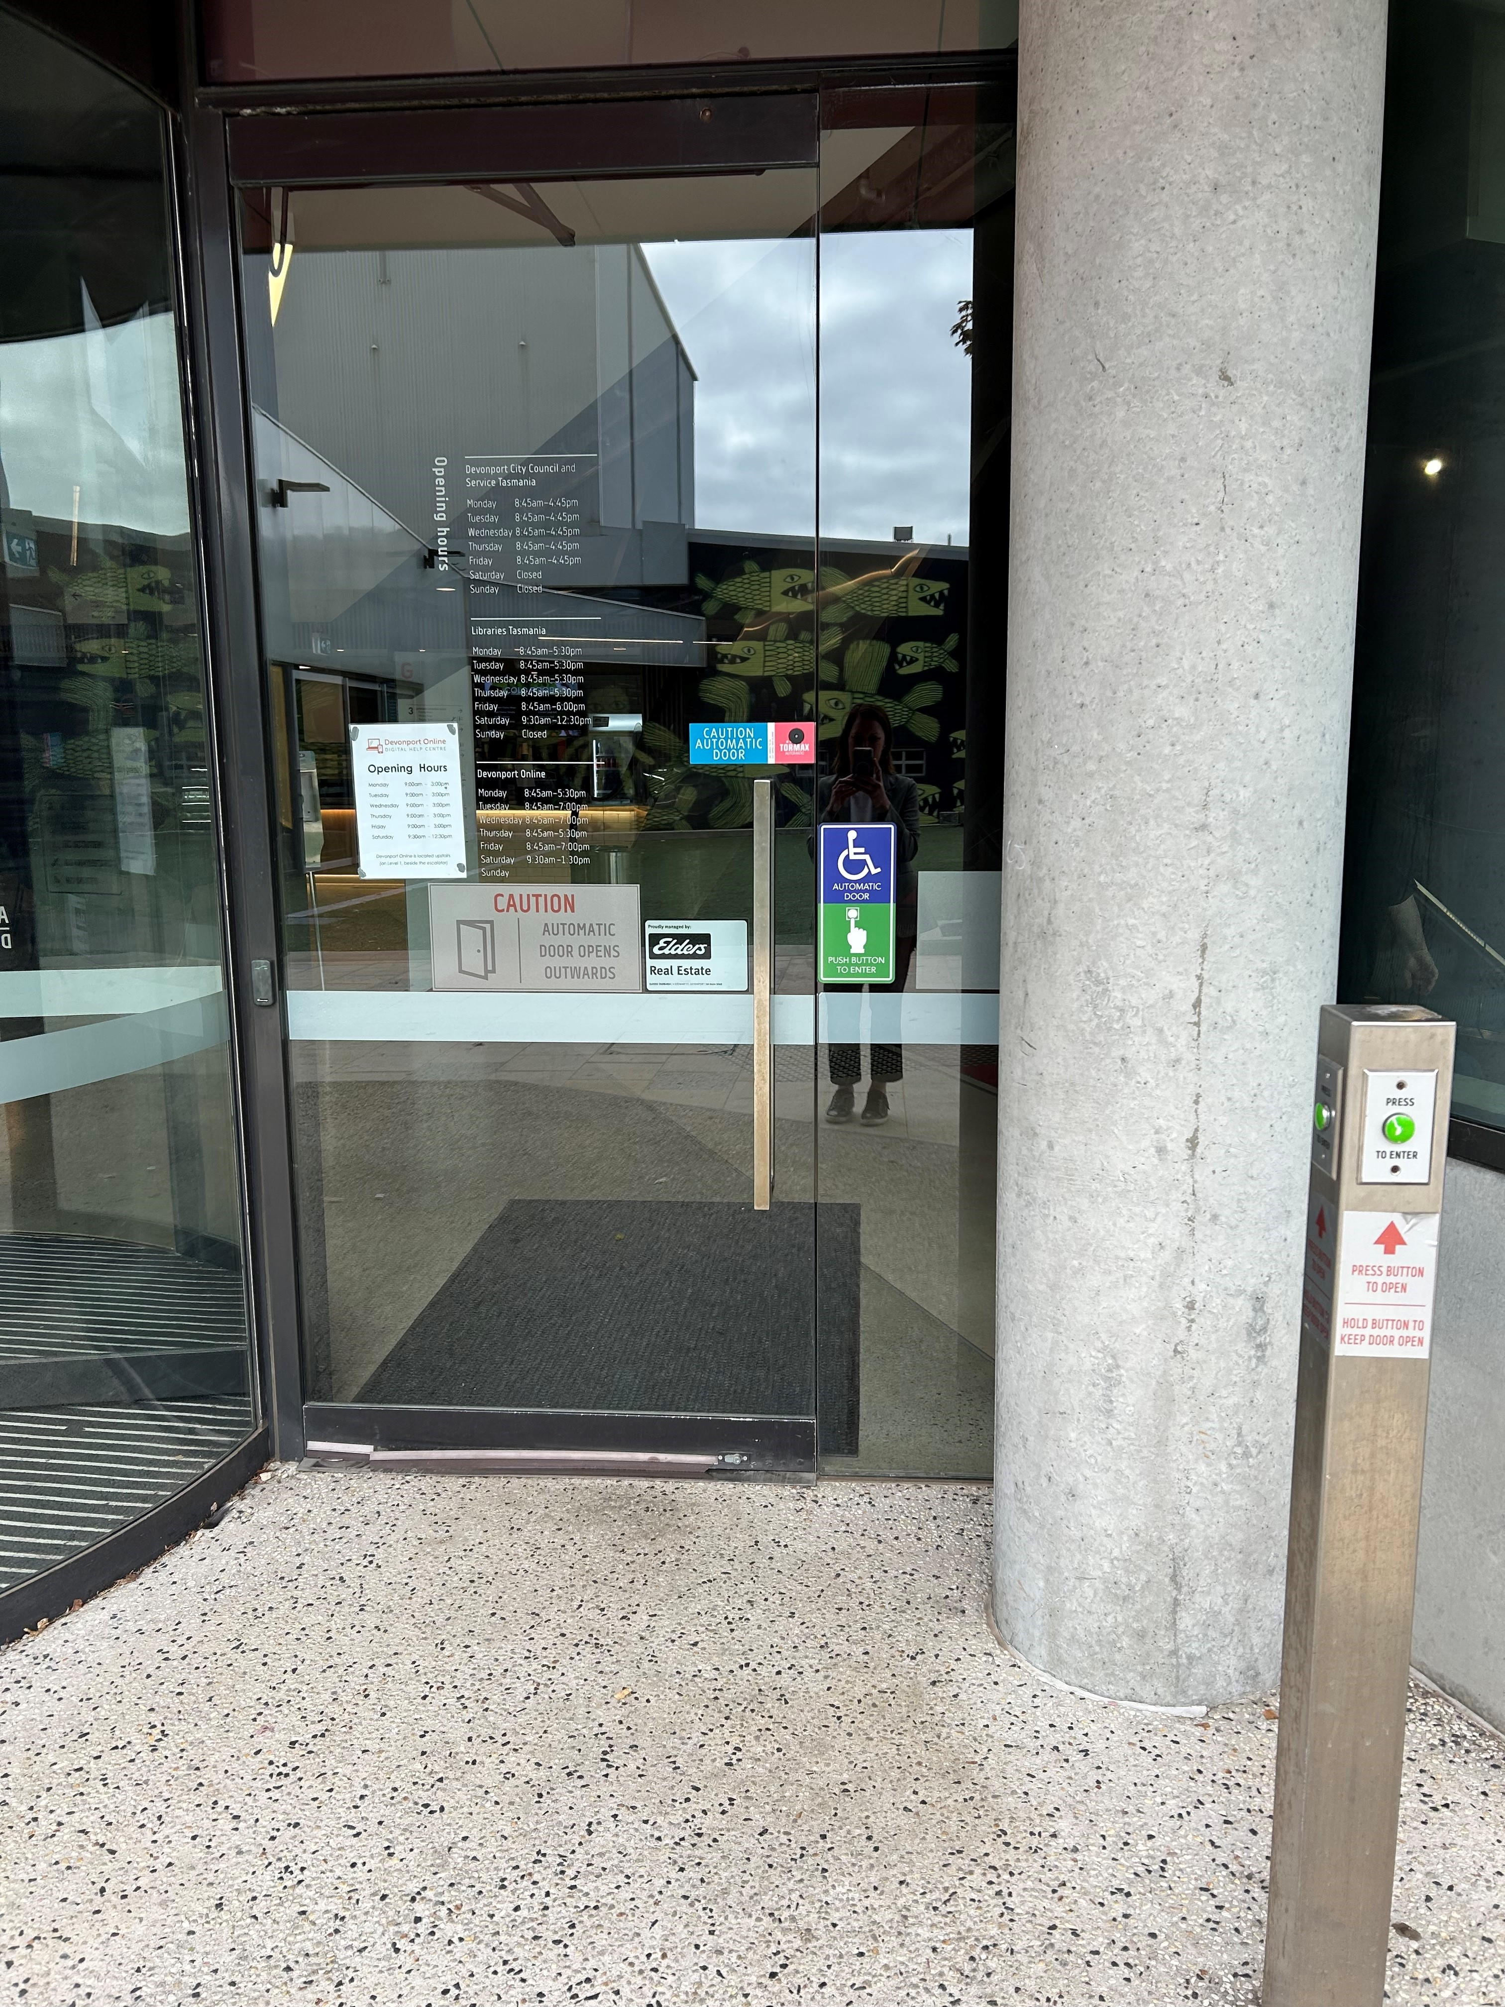
ground floor auto door
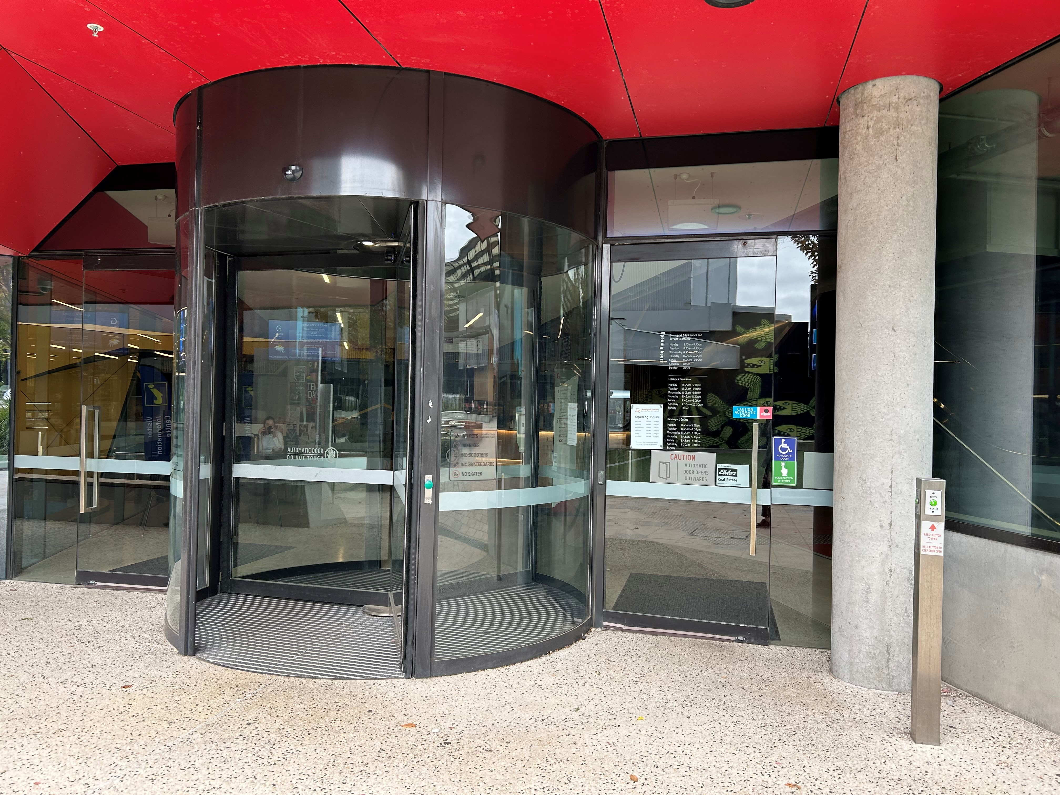
ground floor entrance
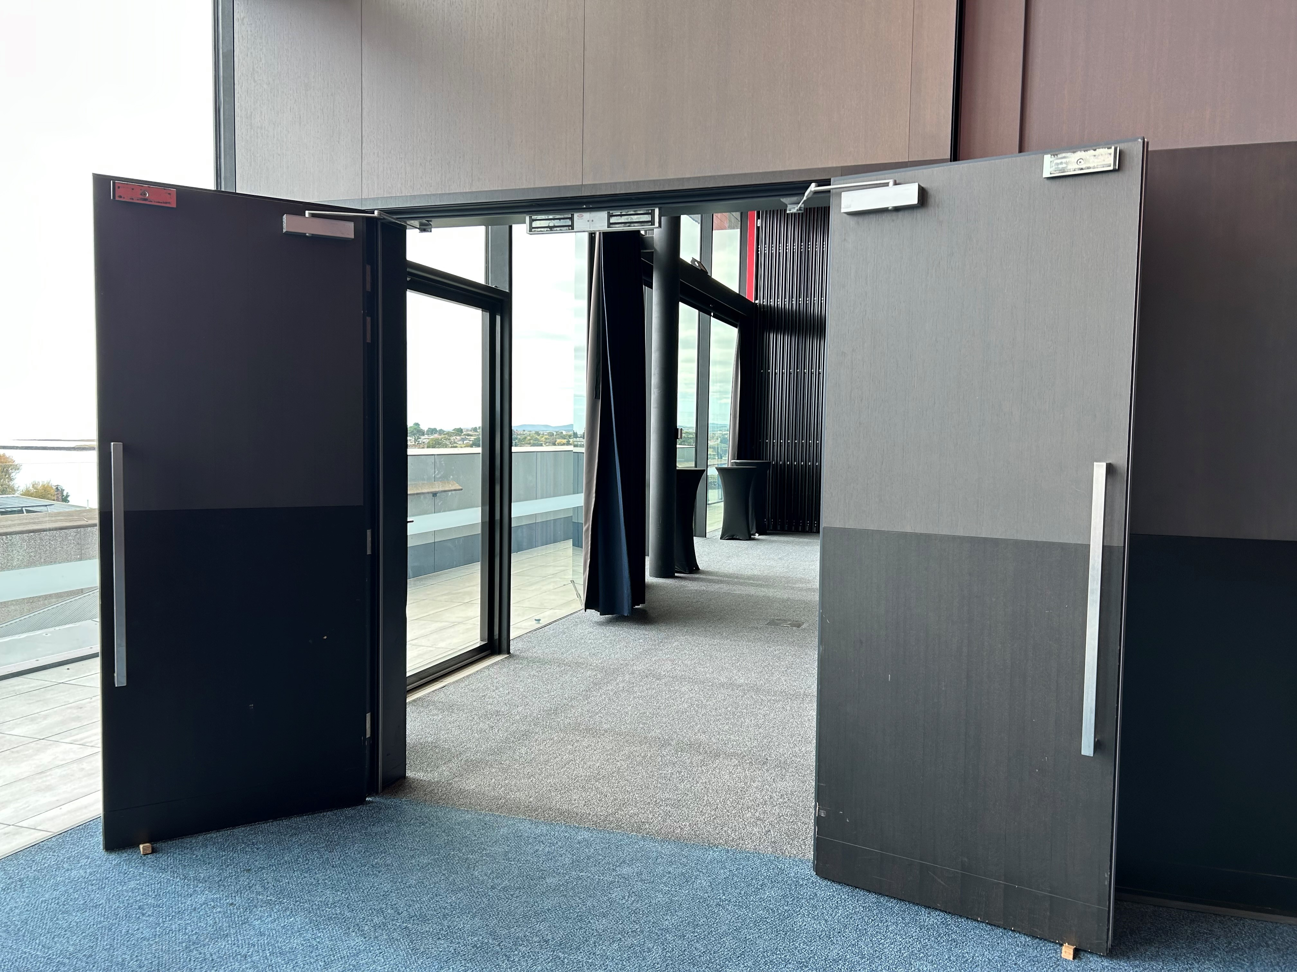
level 3 main door
- In addition, the following further information can assist guests:
&nbsp;As an event space, the type of menu served is dependent on client requirements. &nbsp; Please contact your event organiser in advance if you have any specific dietary needs or allergies.

EVENTS

Events
Events have the following facilities/amenities in place
- There is step free access throughout the venue
- Reception, registration desks or ticket offices have a lower counter section
- A hearing loop is available at reception, registration desks or ticket offices
- All ancillary areas are step free e.g. breakout rooms, dining areas, outside areas and exhibition spaces
- All stage areas including speaker platforms are accessible
- Accessible toilets are available at the venue
- There is clear signage throughout the venue including accessible routes and accessible facilities
- Wheelchair designated seating is provided
- We cater for a range of seating and viewing options
- We cater for varying group sizes
- Our event can be booked from the main web site
- A hearing loop is provided
- There is reserved seating in the loop area
- Speakers/performers are instructed to use the microphones
- Audio description is available
- There is good circulation space with the number of people expected to allow people with a disability to move around freely
- Food and water is available for guide and service animals
- Accessible car parking is available
- There are designated drop-off points
- There is accessible public transport to the venue
- Accessible public transport is detailed in the event information
- There is an event map available
- The event map shows accessible facilities
- A step free route is shown
- Quiet rooms, marquees or spaces are available

Report Disclaimer
Please note that this business report, provided as a result of the use of the diagnostic assessment, is for information purposes only.
Australian Tourism Industry Council (ATIC) cannot guarantee the accuracy of respondent’s answers, or that they are fully representative of your business. Therefore, ATIC does not warrant or guarantee any particular outcome in respect of your businesses self-assessment.
This report is intended as guidance only for your business and should not be relied on for future marketing considerations. ATIC recommends that you seek your own independent advice as well as the results from the diagnostic.
Links to external web sites are inserted for convenience and do not constitute endorsement of material at those sites, or any associated organisation, product or service.
ATIC does not:
- Assume any legal liability for the accuracy, completeness, or usefulness of any information from this report or any links provided; or
- Accept responsibility for any loss associated directly or indirectly from the use of this report.

