ATIC Accessibility
To support the accessible community in making informed travel decisions for their individual needs

This report prepared for:
Business name: | Toffeemont Alpacas
Address: | 53 Orielton Rd
Town: | Orielton
Contact for enquiries: | Janelle Jago
Contact Number: | 0428939979
Contact Email: | toffeemontalpacas@gmail.com
Website: | https://www.toffeemontalpacas.com/
Date: | 2026-10-22 11:47

ATIC Accessibility
The following pages provides travellers with information on the businesses facilities and amenities which aims to support the traveller to make an informed decision on whether the business is suitable for their individual needs.
OVERVIEW 4
Business Overview 4
Bookings 4
Emergency Management 5
Communications 5
Other Information 5
Guide Dog and Service Animals 5
GENERAL 7
Pre-arrival, arrival and reception 7
Cognitive Impairment Support 7
Car Park and Access amenities 7
Entry 7
Internal Spaces 8
Public areas 8
External Paths 8
Ramps 9
Public Toilets/Adult change facilities 9
ATTRACTIONS 10
COMMON AREAS 11
Report Disclaimer 13

OVERVIEW

Business Overview

The business has the following products/services available
- Attraction

Our business caters for the following disability types:
- Blind or low vision
- Deaf or low hearing
- Limited mobility
- Wheelchairs or mobility scooters
- Food allergies or intolerances
- Cognitive or people on the Autism Spectrum
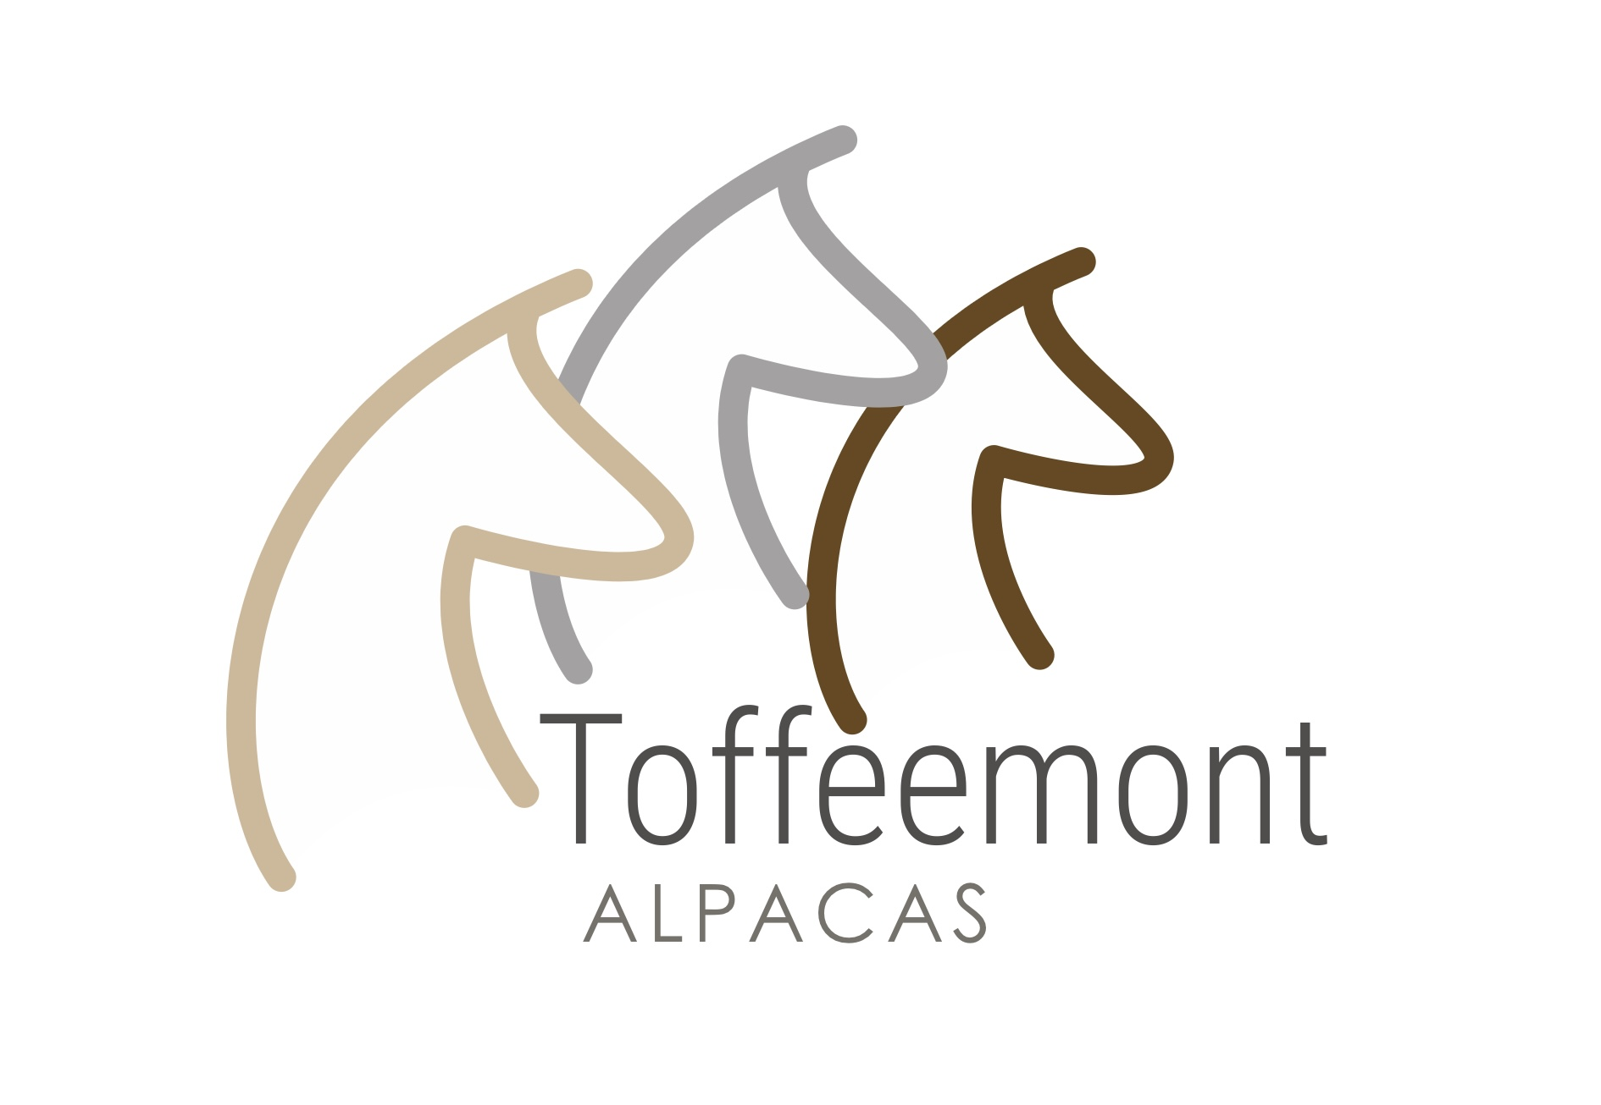

Bookings

The business offers the following methods for bookings and enquiries:
- Phone
- Email
- Webportal
- Our forms have high contract boxes and submit boxes
- Staff have undergone disability awareness and training

Emergency Management
- The business has an emergency management and evacuation plan for guests with a disability
- Emergency and evacuation procedures are explained on arrival
- Guests with disabilities are noted in the guest log book for emergency and evacuation purposes

Communications
- Our website meets WCAG 2.0 accessibility standards
- Our business offers the following alternative communication methods
- Plain English
- Braille Displays

Not specified
- There is easy to read signage and information (e.g. menus and emergency information)

Other Information
- For bookings made onsite, the ticket booth/counter/box office is accessible for people using a wheelchair
- The business accepts the companion card

Guide Dog and Service Animals
- The business provides a secure area with shade and water for service animals
- The business provides a toilet area for service animals
- Bowls, bedding, etc. are provided for service animals
The business provides the following services for services animals:
Service Dogs at Toffeemont Alpacas Farm Tours Commitment to Assistance Animals Toffeemont Alpacas welcomes accredited assistance animals, including guide dogs, hearing dogs, and other service dogs, in accordance with Australian disability discrimination legislation. Assistance animals are permitted to accompany their handler throughout farm tour experiences unless there is a genuine safety risk that cannot be reasonably managed. ⸻ Services and Support Offered Prior to Arrival Guests travelling with a service dog are encouraged to advise us when booking so we can: * Provide information about terrain and accessibility. * Discuss any potential interactions with alpacas or other livestock. * Arrange suitable parking close to the tour starting point. * Identify rest areas and water points for the dog. * Discuss any specific support requirements. ⸻ During the Tour Toffeemont Alpacas will provide: Water Access * Fresh drinking water available for service dogs. * Additional water provided during hot weather. Rest Areas * Access to shaded rest areas where available. * Opportunity for handlers and dogs to take breaks as required. Accessible Routes * Guidance on the most suitable pathways and surfaces. * Alternative routes where terrain may be challenging. Staff Assistance * Staff briefed to interact appropriately with service dogs. * Staff will not distract, feed, pat or engage with a service dog without the handler’s permission. ⸻ Managing Livestock Interactions As a working alpaca farm: * Service dogs must remain under effective control at all times. * Dogs should remain on lead unless required for a specific disability-related task. * Staff will advise handlers of areas where alpacas may be particularly curious or reactive. * Alternative viewing locations may be offered if livestock behaviour presents a safety concern. ⸻ Emergency Evacuation Support In an emergency: * The handler and service dog will remain together wherever possible. * Staff will ensure evacuation routes accommodate both the guest and their assistance animal. * Emergency assembly areas are accessible to service dogs. * Water will be made available if evacuation is prolonged. * Staff will communicate directly with the handler regarding any evacuation assistance required. ⸻ Visitor Facilities Where available, service dog handlers will have access to: * Accessible parking. * Accessible toilet facilities. * Seating areas throughout the visitor experience. * Covered shelter during adverse weather conditions. ⸻ Responsibilities of Service Dog Handlers Handlers are responsible for: * Maintaining effective control of their service dog at all times. * Ensuring the dog is healthy and fit to attend a farm environment. * Cleaning up after their dog. * Informing staff of any assistance requirements during an emergency. ⸻ Staff Training Toffeemont Alpacas staff receive guidance on: * Appropriate interaction with assistance animals. * Disability awareness and inclusion. * Emergency evacuation involving service dogs. * Managing safe interactions between assistance animals and livestock. ⸻ Our Commitment At Toffeemont Alpacas, we strive to ensure that visitors accompanied by service dogs can enjoy a safe, welcoming and inclusive farm experience while maintaining the welfare of both assistance animals and our alpacas.

GENERAL

Pre-arrival, arrival and reception
The business has the following in place to support guests during pre-arrival, arrival and reception
- There is a reception/public entryway.
- Seating available at reception
- A lower counter at reception/ticket office
- A tablet with text to voice or pen and paper at reception to aid in communication
- Lighting in the reception area is even and glare free

NA
- Information and maps are available in written form
- A familiarisation tour
- In addition, the following further information can assist guests:
pre booked no waiting required

Cognitive Impairment Support
- Quiet periods or early opening times for people on the Autism Spectrum
- A space for parents and children on the Autism Spectrum

Car Park and Access amenities
The business has the following Car Park and Access amenities
- A drop off zone
- Designated disabled parking bays
- Level or ramped access from the car park to the entrance
- The accessible entrance is clearly signed from the parking bay

Entry
The business has the following amenities/systems in place for entry
- A drop off point close to the entrance
- A path of access to the building is slip resistance and even
- A path of access to the building is clear of obstruction
- Self opening entry doors or fitted with a self closer
- Glass doors are fitted with a visual sighting strip
- Door jams/doors are of a contrasting colour to surrounding walls
- Door handles are of a contrasting colour to the door
- Signage is written in a contrasting colour
- Signage is written in a Sans Serif font and use upper and lower case letters
- The entry door is a minimum of 850mm wide
- The entry door has self opening or a light opening pressure (for manual operations)
- The entrance sill is less than 13mm
- There a clear space of at least 1500mm x 1500mm in front of all doors.
- The entrance door mats have a thickness less than 13mm and a width of 7500mm or greater

Internal Spaces
- Clear and unobstructed routes through and between buildings
- Interior walls are matte or low sheen
- Floors, walls, counters and furniture are of contrasting colours
- Any protruding or overhanging obstructions are at least 2meters above the floor or are protected
- Floor surfaces are hard or short pile carpet
- Seating is available for guests unable to stand for long periods
- Accessible facilities are clearly signed and visible from all areas
- All corridors greater than 900mm
- There is a quiet space for parents and children on the Autism Spectrum

Public areas
The public areas have the following amenities in place
- Even lighting
- Seating

External Paths
External paths of travel
- Surfaces are concrete, asphalt, smooth paving or hard packed fine gravel (max aggregate size 13mm)
- Paths or slopes longer than 15 metres have resting places or seats
- Pathways are wider than 900mm
- There 3 successive steps or less on any path or at any doorway

do not have any steps
- Step free routes clearly signed

Ramps
Ramps have the following amenities are in place
- There are ramps.
- All fixed ramps are 1:14 or less
- Hand rails are fitted
- Long ramps (more than 10m) are 1:20 or less
- Ramps have a raised edge of at least 100mm

Public Toilets/Adult change facilities
Public Toilets/Adult change facilities have the following amenities are in place
- There is an accessible toilet for public use
- The door is at least 850mm wide
- There is a minimum of 850mm beside the toilet
- Handrails are fitted
- The toilet seat is 460mm above the floor
- There is 2100 mm of clear space in front of the toilet
- The toilet seat of a contrasting colour to the floor
- The toilet seat is460mm above the floor
- A facility with an adult change table

ATTRACTIONS
  - Image(s)

COMMON AREAS

Report Disclaimer
Please note that this business report, provided as a result of the use of the diagnostic assessment, is for information purposes only.
Australian Tourism Industry Council (ATIC) cannot guarantee the accuracy of respondent’s answers, or that they are fully representative of your business. Therefore, ATIC does not warrant or guarantee any particular outcome in respect of your businesses self-assessment.
This report is intended as guidance only for your business and should not be relied on for future marketing considerations. ATIC recommends that you seek your own independent advice as well as the results from the diagnostic.
Links to external web sites are inserted for convenience and do not constitute endorsement of material at those sites, or any associated organisation, product or service.
ATIC does not:
- Assume any legal liability for the accuracy, completeness, or usefulness of any information from this report or any links provided; or
- Accept responsibility for any loss associated directly or indirectly from the use of this report.

