ATIC Accessibility
To support the accessible community in making informed travel decisions for their individual needs

This report prepared for:
Business name: | Lumina Suites
Address: | 105 Batman St, West Melbourne Vic 3003, Australia
Town: | West Melbourne
Contact for enquiries: | Tolga Topcuoglu
Contact Number: | 0388423009
Contact Email: | reservations@luminasuites.com.au
Website: | luminasuites.com.au
Date: | 2026-10-21 16:03

ATIC Accessibility
The following pages provides travellers with information on the businesses facilities and amenities which aims to support the traveller to make an informed decision on whether the business is suitable for their individual needs.
OVERVIEW 4
Business Overview 4
Bookings 4
Emergency Management 4
Communications 5
Other Information 5
Guide Dog and Service Animals 5
GENERAL 6
Pre-arrival, arrival and reception 6
Cognitive Impairment Support 6
Car Park and Access amenities 6
Entry 6
Lifts 7
Internal Spaces 7
Public areas 7
External Paths 7
Public Toilets/Adult change facilities 8
ACCOMMODATION 9
Room Amenities 9
Bathrooms 9
COMMON AREAS 11
Swimming pools, spas and waterparks 11
Report Disclaimer 13

OVERVIEW

Business Overview

The business has the following products/services available
- Accommodation

Our business caters for the following disability types:
- Blind or low vision
- Deaf or low hearing
- Limited mobility
- Food allergies or intolerances
- Cognitive or people on the Autism Spectrum
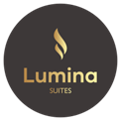

Bookings

The business offers the following methods for bookings and enquiries:
- Phone
- Email
- Webportal
- Our forms have high contract boxes and submit boxes

Emergency Management
- There are Audible device/s to alert occupants to evacuate with instructions on how to evacuate.
- Exit signs are clear and easy to see
- Exit access is free and clear at all times
We ensure exit access is free and clear at all times by:
Continous floor checks by the building concierge, cleaners and building management. Any obstruction to paths of egress are removed immediately.
- Exits and access to exists are greater than 900mm
- Exit doors are able to be opened by all occupants
- Exits including stairwells, have bright edges used on the steps.
- The evacuation point is clearly marked by a sign
- In addition, the following further information can assist guests:
By leveraging the system requirements and data sharing between the building team and reception staff.
- In addition, the following further information can assist guests:
Records kept of all apartments requiring assistance. These are then provided to the emergeny services attending. The guest is contacted prior to the arrival of emergency services to ensure they know assistance is on the way.
- Guests with disabilities are noted in the guest log book for emergency and evacuation purposes

Communications
- Our business offers the following alternative communication methods
- Plain English

Not specified
- There is easy to read signage and information (e.g. menus and emergency information)

Other Information
- For bookings made onsite, the ticket booth/counter/box office is accessible for people using a wheelchair

Guide Dog and Service Animals
The business provides the following services for services animals:
Not specified

GENERAL

Pre-arrival, arrival and reception
The business has the following in place to support guests during pre-arrival, arrival and reception
- Booking information and websites are compatible with screen readers
- There is a reception/public entryway.
- Seating available at reception
- A clipboard to allow check-in/ticket purchase whilst seated
- A tablet with text to voice or pen and paper at reception to aid in communication
- Lighting in the reception area is even and glare free
- Information and maps are available in written form
- A familiarisation tour
- Keys are available for each guest
- Luggage assistance
- In addition, the following further information can assist guests:
Pre check-in options and plenty of relaxed seating areas for waiting.

Cognitive Impairment Support
- Documents are available in plain English for people with cognitive impairment (This may include instructions, guides, menus and general information)

Car Park and Access amenities
The business has the following Car Park and Access amenities
- A drop off zone
- Designated disabled parking bays
- Level or ramped access from the car park to the entrance
- An intercom system is available at the entrance of car park

Entry
The business has the following amenities/systems in place for entry
- A drop off point close to the entrance
- A path of access to the building is slip resistance and even
- A path of access to the building is clear of obstruction
- Self opening entry doors or fitted with a self closer
- Glass doors are fitted with a visual sighting strip
- Door jams/doors are of a contrasting colour to surrounding walls
- Signage is written in a contrasting colour
- Signage is written in a Sans Serif font and use upper and lower case letters
- The entry door is a minimum of 850mm wide
- The entry door has self opening or a light opening pressure (for manual operations)
- The entrance sill is less than 13mm
- There a clear space of at least 1500mm x 1500mm in front of all doors.
- The entrance door mats have a thickness less than 13mm and a width of 7500mm or greater

Lifts
- Premises has lifts

Internal Spaces
- Clear and unobstructed routes through and between buildings
- Interior walls are matte or low sheen
- Floors, walls, counters and furniture are of contrasting colours
- Any protruding or overhanging obstructions are at least 2meters above the floor or are protected
- Floor surfaces are hard or short pile carpet
- Seating is available for guests unable to stand for long periods
- All corridors greater than 900mm

Public areas
The public areas have the following amenities in place
- Even lighting
- Seating

External Paths
External paths of travel
- Surfaces are concrete, asphalt, smooth paving or hard packed fine gravel (max aggregate size 13mm)
- Paths or slopes longer than 15 metres have resting places or seats
- Pathways are wider than 900mm

Public Toilets/Adult change facilities
Public Toilets/Adult change facilities have the following amenities are in place
- There is an accessible toilet for public use
- The door is at least 850mm wide
- There is a minimum of 850mm beside the toilet
- Handrails are fitted
- The toilet seat is 460mm above the floor
- The toilet seat of a contrasting colour to the floor
- The toilet seat is460mm above the floor

ACCOMMODATION

Room Amenities
- In addition, the following further information can assist guests:
N/A
- Televisions are equipped with closed captioning capability
- There is contrast between the walls, skirtings, floor and furniture
- There is a clear path through the room
- Doors open fully against the adjoining wall
- There is a clear opening at least 850mm wide
- Wardrobe and drawer handles are easy to grip
- The bedside lamp switch is easy to reach from the bed
- The business offers a range of non-allergenic bedding
- Non-allergenic cleaning products are used
- In addition, the following further information can assist guests:
N/A

Bathrooms
The bathrooms have the following facilities/amenities in place
- All heating appliances and hot water pipes are protected or insulated
- All shower, bath and basin taps are clearly differentiated between hot and cold
- The hot water is thermostatically controlled to 41 degrees
- The door is at least 850mm wide
- The width beside the toilet is Varies by layout, anywhere from 5cm to 20cm..
- There is 700mm mm of clear space in front of the toilet
- The toilet seat is a contrasting colour to the floor
- The toilet seat is 460mm above the floor
- A door is fitted to the shower
- A door is fitted to the showers with an outward swing at minimum width of 900 mm
  - Bathroom Image(s)
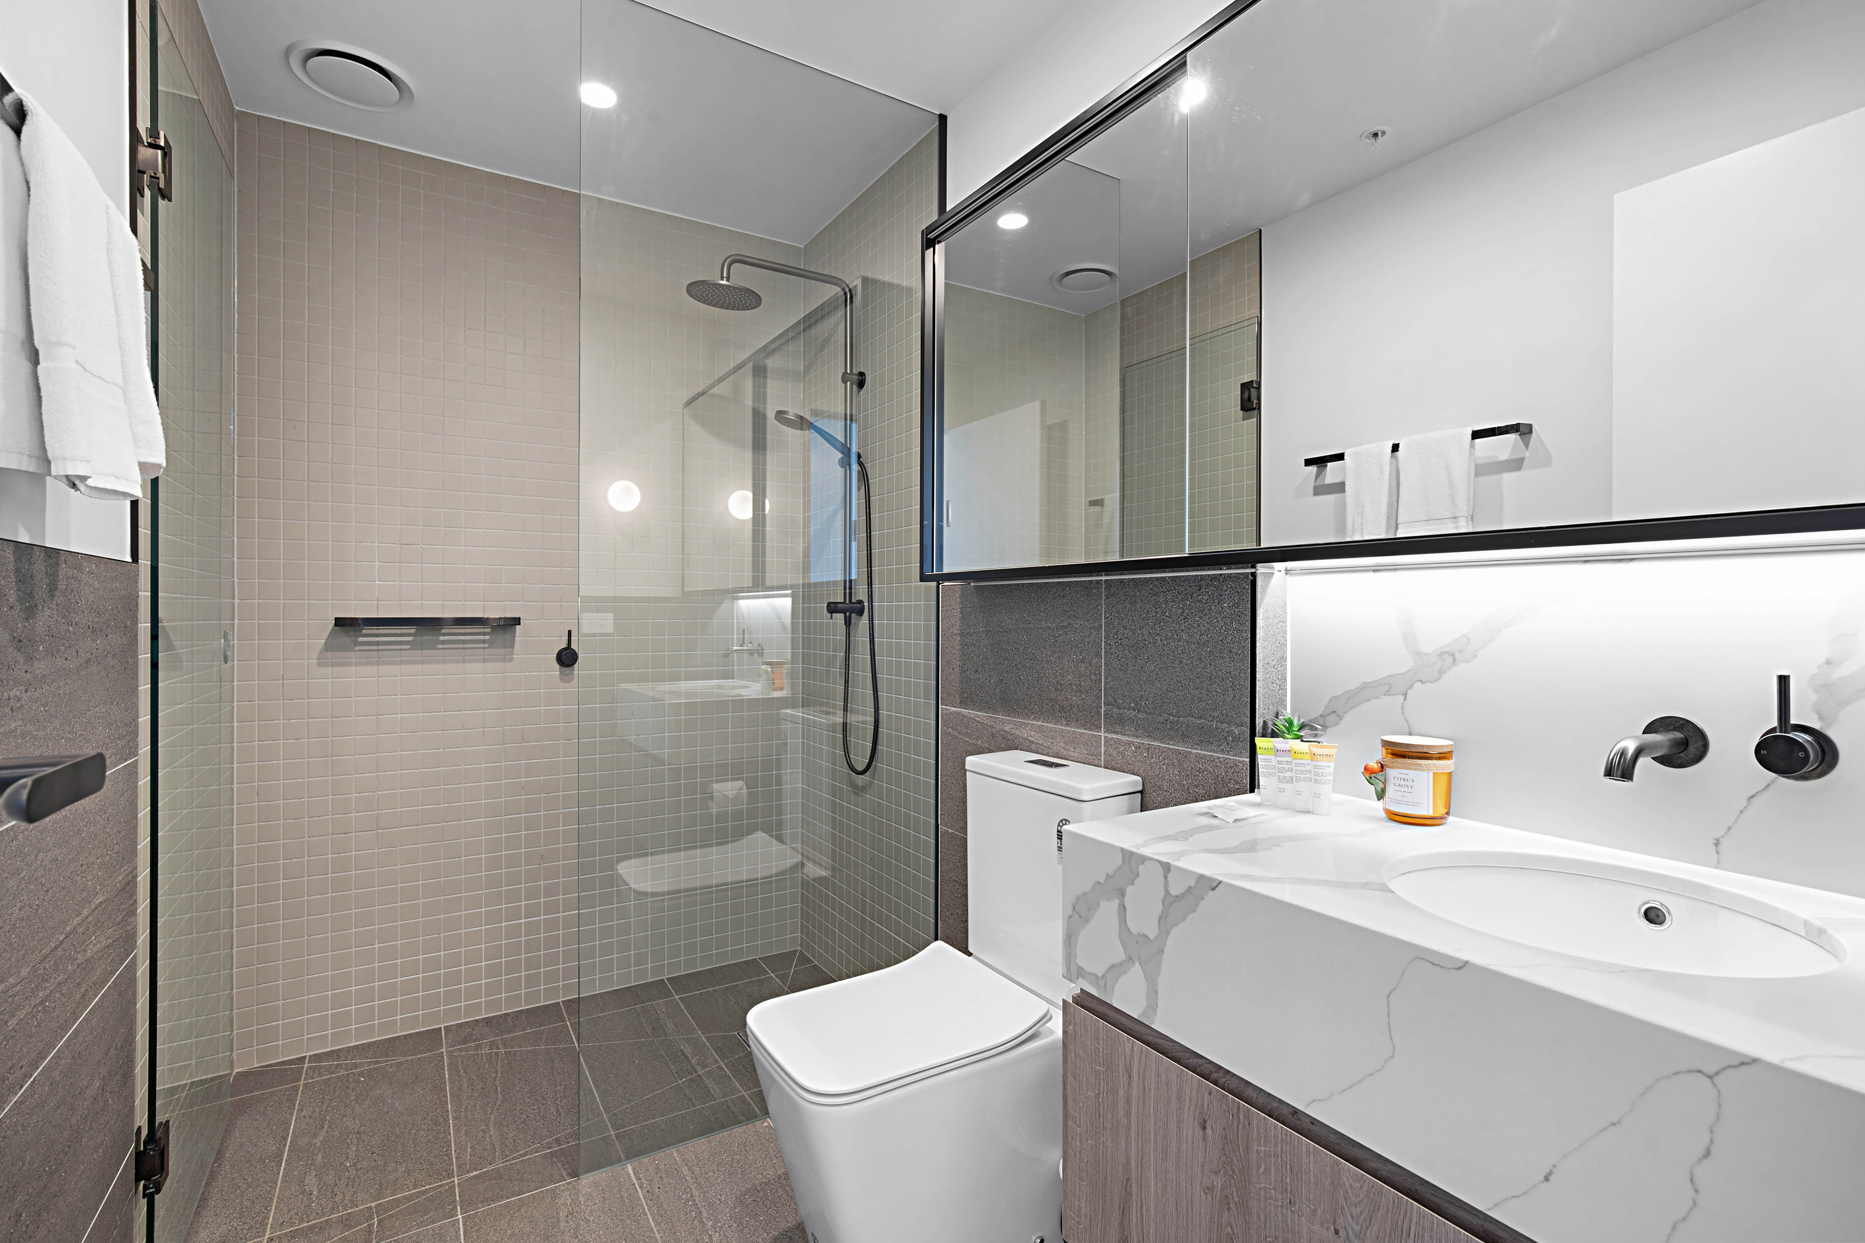
10 copy

COMMON AREAS

Swimming pools, spas and waterparks
- The following swimming pools, spas and waterparks amenities are available
- Unisex change facilities with an accessible toilet

Report Disclaimer
Please note that this business report, provided as a result of the use of the diagnostic assessment, is for information purposes only.
Australian Tourism Industry Council (ATIC) cannot guarantee the accuracy of respondent’s answers, or that they are fully representative of your business. Therefore, ATIC does not warrant or guarantee any particular outcome in respect of your businesses self-assessment.
This report is intended as guidance only for your business and should not be relied on for future marketing considerations. ATIC recommends that you seek your own independent advice as well as the results from the diagnostic.
Links to external web sites are inserted for convenience and do not constitute endorsement of material at those sites, or any associated organisation, product or service.
ATIC does not:
- Assume any legal liability for the accuracy, completeness, or usefulness of any information from this report or any links provided; or
- Accept responsibility for any loss associated directly or indirectly from the use of this report.

