ATIC Accessibility
To support the accessible community in making informed travel decisions for their individual needs

This report prepared for:
Business name: | Dimboola Imaginarium
Address: | 7-9 Lochiel Street
Town: | Dimboola
Contact for enquiries: | Chan Uoy
Contact Number: | 0425705591
Contact Email: | chan@dimboolaimaginarium.com
Website: | https://dimboolaimaginarium.com/
Date: | 2026-10-17 11:35

ATIC Accessibility
The following pages provides travellers with information on the businesses facilities and amenities which aims to support the traveller to make an informed decision on whether the business is suitable for their individual needs.
OVERVIEW 4
Business Overview 4
Bookings 4
Emergency Management 5
Communications 5
Guide Dog and Service Animals 5
GENERAL 6
Pre-arrival, arrival and reception 6
Cognitive Impairment Support 6
Car Park and Access amenities 6
Entry 6
Internal Spaces 7
Public areas 7
External Paths 7
Steps 7
Public Toilets/Adult change facilities 8
ACCOMMODATION 9
Room Amenities 9
Bathrooms 9
ATTRACTIONS 10
COMMON AREAS 11
FOOD AND DRINK 12
Dining Spaces 12
Report Disclaimer 14

OVERVIEW

Business Overview

The business has the following products/services available
- Accommodation
- Attraction
- Food and Drink

Our business caters for the following disability types:
- Food allergies or intolerances


Bookings

The business offers the following methods for bookings and enquiries:
- Phone
- Email
- Webportal

Emergency Management
- Emergency and evacuation procedures are explained on arrival
- Exit signs are clear and easy to see
- Exit access is free and clear at all times
We ensure exit access is free and clear at all times by:
It is a checked everyday the the exit access is clear at all times.
- Exit doors are able to be opened by all occupants
- The evacuation point is clearly marked by a sign
- In addition, the following further information can assist guests:
We take note of them when they arrive.
- In addition, the following further information can assist guests:
We attend to them first.

Communications
- Our business offers the following alternative communication methods
- Plain English

Not specified
- There is easy to read signage and information (e.g. menus and emergency information)

Guide Dog and Service Animals
- The business provides a secure area with shade and water for service animals
The business provides the following services for services animals:
If we have a special request, we will offer bowls, bedding and a toilet area for the service animal.

GENERAL

Pre-arrival, arrival and reception
The business has the following in place to support guests during pre-arrival, arrival and reception
- A familiarisation tour
- Keys are available for each guest
- Luggage assistance
- In addition, the following further information can assist guests:
There are no long wait times, as we only take one exclusive booking at a time. The service is personalised and private.
- In addition, the following further information can assist guests:
We only take one accommodation booking at a time, so we do not mix strangers. You pay for the rooms you require.

Cognitive Impairment Support
- Documents are available in plain English for people with cognitive impairment (This may include instructions, guides, menus and general information)
- Quiet periods or early opening times for people on the Autism Spectrum

Car Park and Access amenities
The business has the following Car Park and Access amenities
- A drop off zone
- Kerb ramps are in place where a pavement or walkway needs to be crossed
- In addition, the following further information can assist guests:
We can assist with special requirements upon arrival.

Entry
The business has the following amenities/systems in place for entry
- A drop off point close to the entrance
- A path of access to the building is slip resistance and even
- A path of access to the building is clear of obstruction
- Glass doors are fitted with a visual sighting strip
- Door jams/doors are of a contrasting colour to surrounding walls
- Door handles are of a contrasting colour to the door
- Signage is written in a contrasting colour
- The entry door is a minimum of 850mm wide
- The entrance door mats have a thickness less than 13mm and a width of 7500mm or greater

Internal Spaces
- Interior walls are matte or low sheen
- Floors, walls, counters and furniture are of contrasting colours
- Any protruding or overhanging obstructions are at least 2meters above the floor or are protected
- Tableware/glassware contrast with the table surface or table cloth
- Floor surfaces are hard or short pile carpet
- Seating is available for guests unable to stand for long periods
- All corridors greater than 900mm
- There is a quiet space for parents and children on the Autism Spectrum

Public areas
The public areas have the following amenities in place
- Even lighting
- Seating

External Paths
External paths of travel
- Surfaces are concrete, asphalt, smooth paving or hard packed fine gravel (max aggregate size 13mm)
- Pathways are wider than 900mm
- There 3 successive steps or less on any path or at any doorway

Steps
Steps
- There are steps.
- The underside of all staircases are enclosed or protected to a height of at least 2 metres
- Handrails fitted to all open sets of steps
- Where steps are present are there three steps or less

Public Toilets/Adult change facilities
Public Toilets/Adult change facilities have the following amenities are in place
- There is an accessible toilet for public use
- The door is at least 850mm wide
- There is a minimum of 850mm beside the toilet
- The toilet seat is 460mm above the floor
- The toilet seat of a contrasting colour to the floor
- The toilet seat is460mm above the floor

ACCOMMODATION

Room Amenities
- Televisions are equipped with closed captioning capability
- There is contrast between the walls, skirtings, floor and furniture
- There is a clear path through the room
- Wardrobe handles are a contrasting colour to the doors and draws
- Housekeeping procedures instruct staff not to reposition furniture that has been moved
- Doors open fully against the adjoining wall
- There is a clear opening at least 850mm wide
- There at least one chair with rigid arms
- Wardrobe and drawer handles are easy to grip
- The bedside lamp switch is easy to reach from the bed
- There is at least 850mm clear space beside the bed
- The bed height is no higher than 680mm from the floor
- There is at least 130mm clearance under the bed
- The business offers a range of non-allergenic bedding
- Non-allergenic cleaning products are used

Bathrooms
The bathrooms have the following facilities/amenities in place
- All heating appliances and hot water pipes are protected or insulated
- All shower, bath and basin taps are clearly differentiated between hot and cold
- Fixtures and fittings have rounded edges
- The hot water is thermostatically controlled to 41 degrees
- The door is at least 850mm wide
- There is a minimum of 850mm beside the toilet
- There is a minimum of 1400mm of clear space in front of the toilet
- The toilet seat is a contrasting colour to the floor
- The toilet seat is 460mm above the floor
- A range of non-allergenic toiletries are available
- There is a roll-in shower with fold down fixed seat or a shower chair
- There is a portable shower head on flexible hose
- A door is fitted to the shower
- A door is fitted to the showers with an outward swing at minimum width of 900 mm

ATTRACTIONS
  - Image(s)
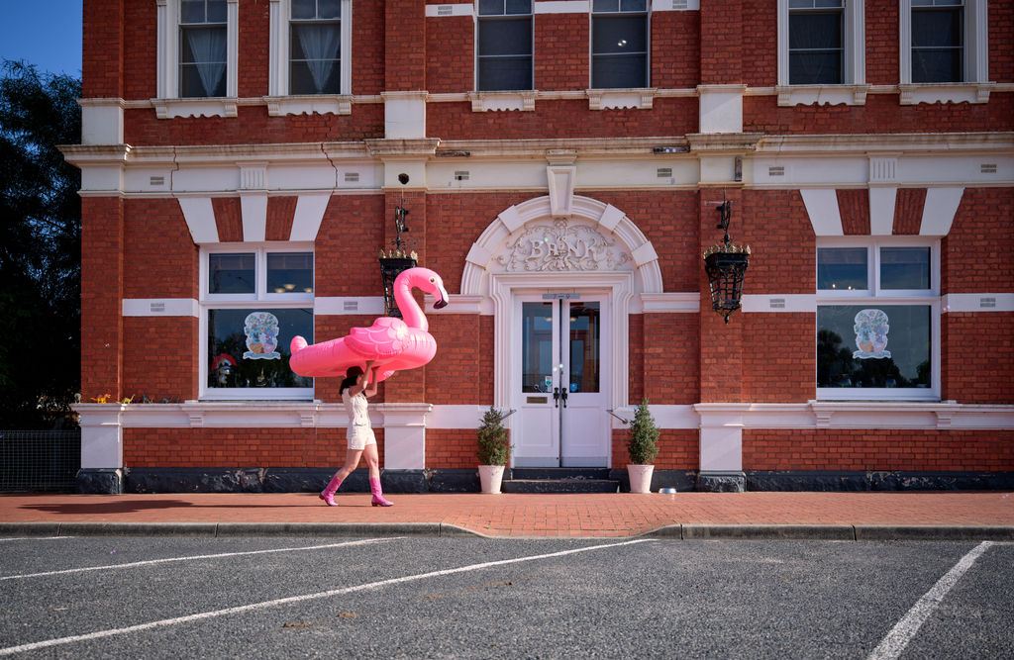
Imaginarium
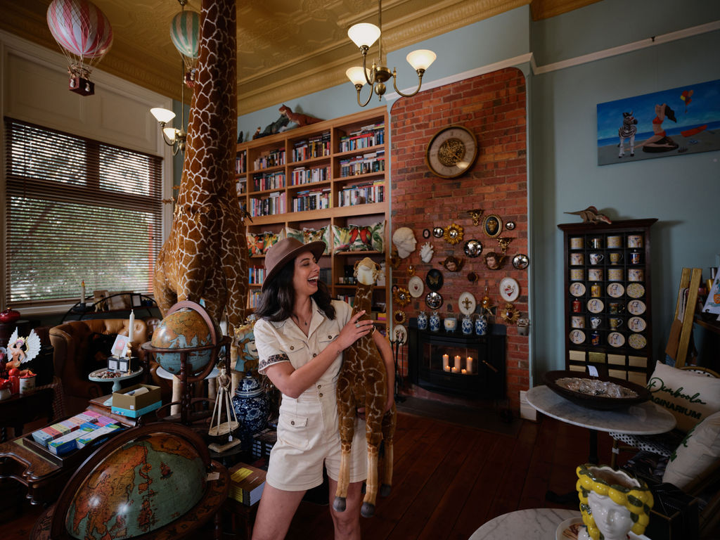
Imaginarium35

COMMON AREAS

FOOD AND DRINK

Dining Spaces
The dining spaces have the following facilities/amenities in place
- The doorway is at least 850mm wide
- There are areas of full lighting
- There is an accessible toilet close by that is open during our business hours
- In addition, the following further information can assist guests:
Not applicable
  - Food and Beverage Image(s)
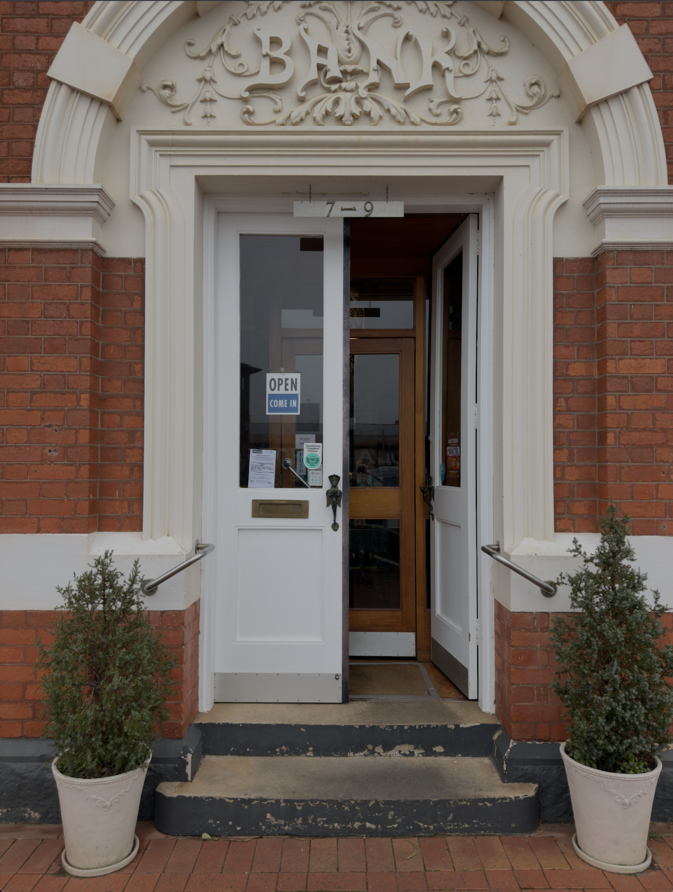
Screenshot 2026-07-18 at 10.54.59 am

Report Disclaimer
Please note that this business report, provided as a result of the use of the diagnostic assessment, is for information purposes only.
Australian Tourism Industry Council (ATIC) cannot guarantee the accuracy of respondent’s answers, or that they are fully representative of your business. Therefore, ATIC does not warrant or guarantee any particular outcome in respect of your businesses self-assessment.
This report is intended as guidance only for your business and should not be relied on for future marketing considerations. ATIC recommends that you seek your own independent advice as well as the results from the diagnostic.
Links to external web sites are inserted for convenience and do not constitute endorsement of material at those sites, or any associated organisation, product or service.
ATIC does not:
- Assume any legal liability for the accuracy, completeness, or usefulness of any information from this report or any links provided; or
- Accept responsibility for any loss associated directly or indirectly from the use of this report.

