ATIC Accessibility
To support the accessible community in making informed travel decisions for their individual needs

This report prepared for:
Business name: | Bungle Bungle Caravan Park And Tour Company
Address: | Mabel Downs Station
Town: | Ord river
Contact for enquiries: | Rebecca Trinick
Contact Number: | 08916960001
Contact Email: | bookings@bunglebunglecaravanpark.com
Website: | https://www.bunglebunglecaravanpark.com.au/
Date: | 2026-10-23 01:15

ATIC Accessibility
The following pages provides travellers with information on the businesses facilities and amenities which aims to support the traveller to make an informed decision on whether the business is suitable for their individual needs.
OVERVIEW 4
Business Overview 4
Bookings 4
Emergency Management 4
Communications 5
Guide Dog and Service Animals 5
GENERAL 6
Pre-arrival, arrival and reception 6
Cognitive Impairment Support 6
Car Park and Access amenities 6
Entry 7
Internal Spaces 7
Public areas 7
Displays, exhibits, commentary and live performances 7
External Paths 8
TOUR OPERATORS 9
Tour/Transport Services 9
Route Planning 9
Guides 9
ACCOMMODATION 13
Room Amenities 13
Bathrooms 13
COMMON AREAS 14
FOOD AND DRINK 15
Dining Spaces 15
Report Disclaimer 18

OVERVIEW

Business Overview

The business has the following products/services available
- Tour/Transport
- Accommodation
- Food and Drink

Our business caters for the following disability types:
- Food allergies or intolerances
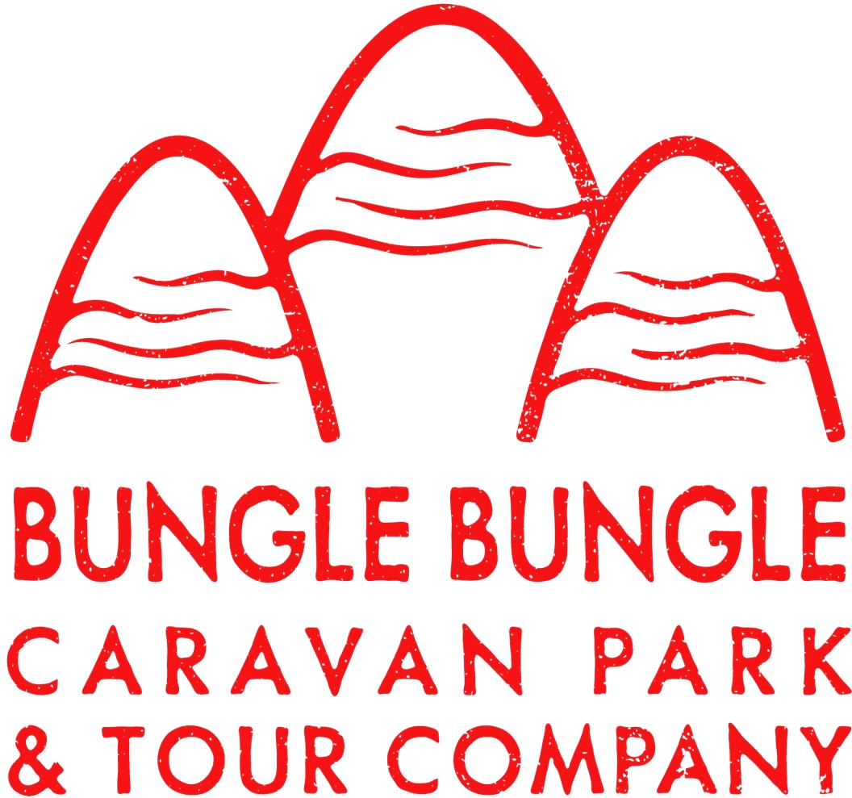

Bookings

The business offers the following methods for bookings and enquiries:
- Phone
- Email
- Webportal

Emergency Management
- Emergency and evacuation procedures are explained on arrival
- Guests with disabilities are noted in the guest log book for emergency and evacuation purposes

Communications
- Our website meets WCAG 2.0 accessibility standards
- Our business offers the following alternative communication methods
- Plain English

Not specified
- There is easy to read signage and information (e.g. menus and emergency information)

UHF Sets and phones

Guide Dog and Service Animals
- The business provides a secure area with shade and water for service animals
- The business provides a toilet area for service animals
- Bowls, bedding, etc. are provided for service animals
The business provides the following services for services animals:
Guests take care of their own

GENERAL

Pre-arrival, arrival and reception
The business has the following in place to support guests during pre-arrival, arrival and reception
- Booking information and websites are compatible with screen readers
- There is a reception/public entryway.
- A lower counter at reception/ticket office
- A clipboard to allow check-in/ticket purchase whilst seated
- Lighting in the reception area is even and glare free
- Large print information sheets and registration forms

We have copies of site maps for our guests, also highlighting emergency evacuation area
- Information and maps are available in written form
- In addition, the following further information can assist guests:
our 5 cabins are vacated and cleaned prior to arrival. our main accomodation is what people bring with them - caravans etc
- In addition, the following further information can assist guests:
Please let us know if you are arriving earlier than 12pm

Cognitive Impairment Support
- Documents are available in plain English for people with cognitive impairment (This may include instructions, guides, menus and general information)
- Quiet periods or early opening times for people on the Autism Spectrum
- A space for parents and children on the Autism Spectrum

Car Park and Access amenities
The business has the following Car Park and Access amenities
- A drop off zone
- In addition, the following further information can assist guests:
Please contact reception via ph 08 9168 6001 or via email bookings@bunglebunglecaravanpark.com.au if we can assit

Entry
The business has the following amenities/systems in place for entry
- A drop off point close to the entrance
- A path of access to the building is clear of obstruction
- Self opening entry doors or fitted with a self closer
- Glass doors are fitted with a visual sighting strip
- Door jams/doors are of a contrasting colour to surrounding walls
- Door handles are of a contrasting colour to the door
- Signage is written in a contrasting colour
- The entry door is a minimum of 850mm wide
- The entrance door mats have a thickness less than 13mm and a width of 7500mm or greater

Internal Spaces
- Clear and unobstructed routes through and between buildings
- Interior walls are matte or low sheen
- Floors, walls, counters and furniture are of contrasting colours
- Floor surfaces are hard or short pile carpet
- Seating is available for guests unable to stand for long periods
The width of the smallest corridor is:
no corridors
- There is a quiet space for parents and children on the Autism Spectrum

Public areas
The public areas have the following amenities in place
- Even lighting
- Seating

Displays, exhibits, commentary and live performances
For displays, exhibits, commentary and live performances the following amenities are in place
- Seating
- A written transcript where audio description is provided i.e. display commentary, tour commentary
- In addition, the following further information can assist guests:
We do not advise those with mobility issue to book our tour as the steps onto the bus are tall, and the day will involve 6 km of walking on uneven ground with some climbing.

External Paths
External paths of travel
- Surfaces are concrete, asphalt, smooth paving or hard packed fine gravel (max aggregate size 13mm)
- Pathways are wider than 900mm
- There 3 successive steps or less on any path or at any doorway
- In addition, the following further information can assist guests:
We have 2 wide steps into our reception office and shop. The ablutions are one step.
Sunset hill is a rocky path where climbing over rocks is required.

TOUR OPERATORS

Tour/Transport Services
The tour/transport services have the following facilities/amenities in place
- Buses/Coaches
- nil vehicles have wheelchair lifts or ramps
- nil vehicles have low floors with ramped entry
The maximum wheelchair capacity available in the fleet is:
nil

Route Planning
- Route Planning
- The tour route includes stops with accessible toilet facilities
- In addition, the following further information can assist guests:
We strongly advise to contact reception if you have mobility difficulty prior to booking one of our tours.
- Lunch stop venues are accessible
- Walking Tours
- Multi-paced to account for slower walkers

Guides

Guides have been trained in the following
- Use of clear/simple English
- Correct pronunciation for lip readers
- There is a audio description of surroundings
  - Image(s)
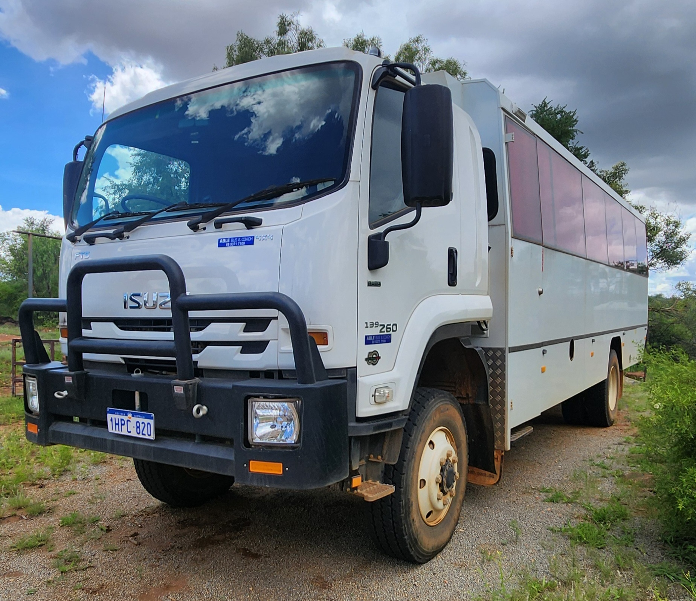
4x4 tour bus
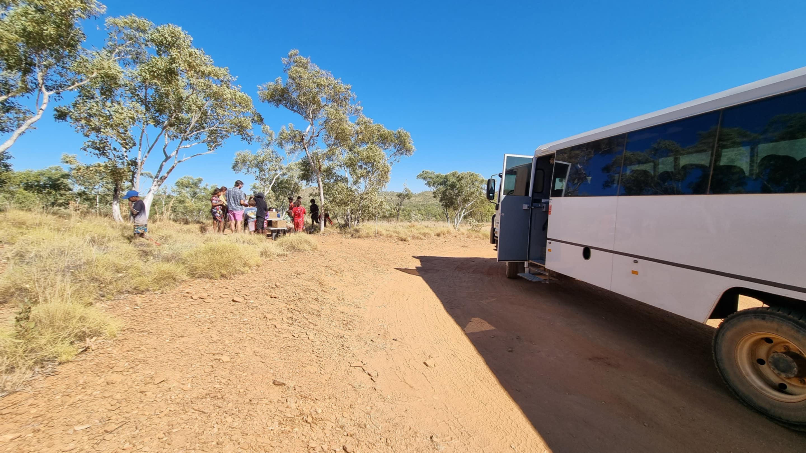
Osmond Range first stop
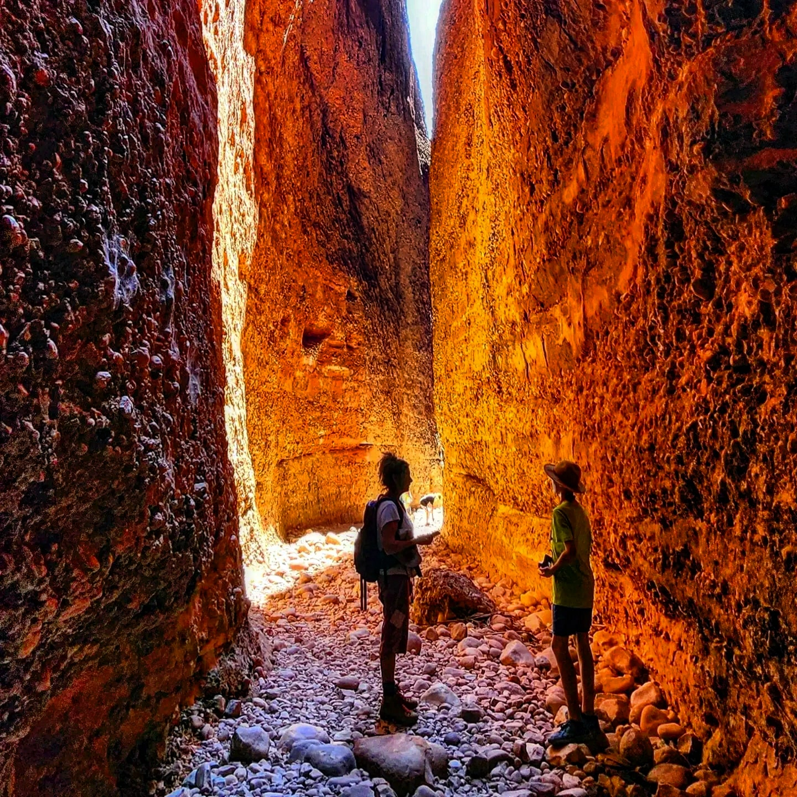
Echidna Chasm Walk
- In addition, the following further information can assist guests:
Purnululu Visitor Center https://exploreparks.dbca.wa.gov.au/site/purnululu-visitor-centre

ACCOMMODATION

Room Amenities

There are no wardrobes in any of our 5 cabins
- There is contrast between the walls, skirtings, floor and furniture
- There is a clear path through the room
- Housekeeping procedures instruct staff not to reposition furniture that has been moved
- Doors open fully against the adjoining wall
- There is a clear opening at least 850mm wide
- Wardrobe and drawer handles are easy to grip
- The bedside lamp switch is easy to reach from the bed
- There is at least 850mm clear space beside the bed
- The bed height is no higher than 680mm from the floor

Bathrooms
The bathrooms have the following facilities/amenities in place
- All heating appliances and hot water pipes are protected or insulated
- All shower, bath and basin taps are clearly differentiated between hot and cold
- The hot water is thermostatically controlled to 41 degrees
- The door is at least 850mm wide
- There is a minimum of 850mm beside the toilet
- There is 1300mm mm of clear space in front of the toilet
- The toilet seat is a contrasting colour to the floor
- The toilet seat is 460mm above the floor
- A range of non-allergenic toiletries are available
- There is a portable shower head on flexible hose

COMMON AREAS

FOOD AND DRINK

Dining Spaces
The dining spaces have the following facilities/amenities in place
- The entrance has level access
- The doorway is at least 850mm wide
- Chairs are moveable to allow for wheelchairs to be seated at the tables
- All glass doors and full height windows have contrast markings

Our business caters for the following dietary requirements
- Sugar free (diabetic)
- Gluten free (celiac)
- Lactose free (dairy free)
- Low fat and fibre with no gastric content
- Low potassium
- Low sodium
- Nut free
- Additive free
- Organic
- Vegetarian
- Vegan
- In addition, the following further information can assist guests:
We cover a lot of dietary requirements.
Our dinners are a BBQ buffet incorperating local produce of beef Barra and snags, with three seasonal salads that change daily.
Our tours offer sandwiches, packed drink, chips, variety of snacks packed individually. Dietary requirements are covered through guests' communication apon booking and added to notes on all activities which is handed to management to discuss suitable options.
  - Food and Beverage Image(s)
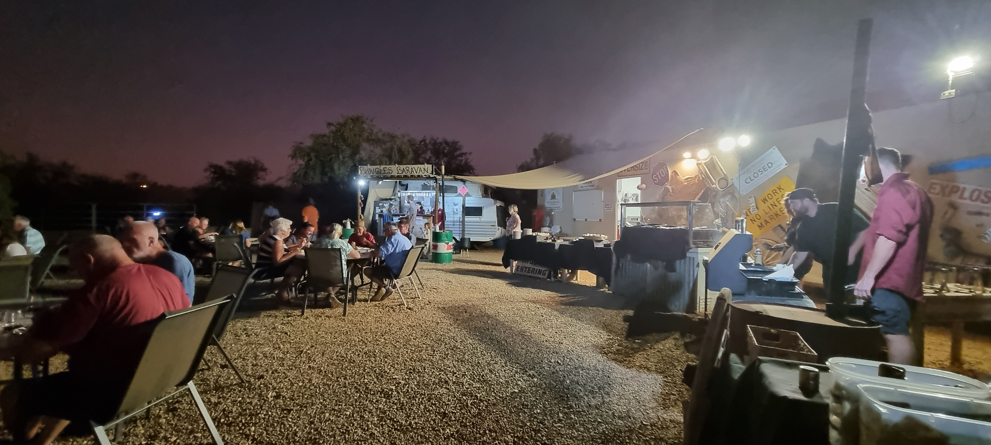
restraunt by night
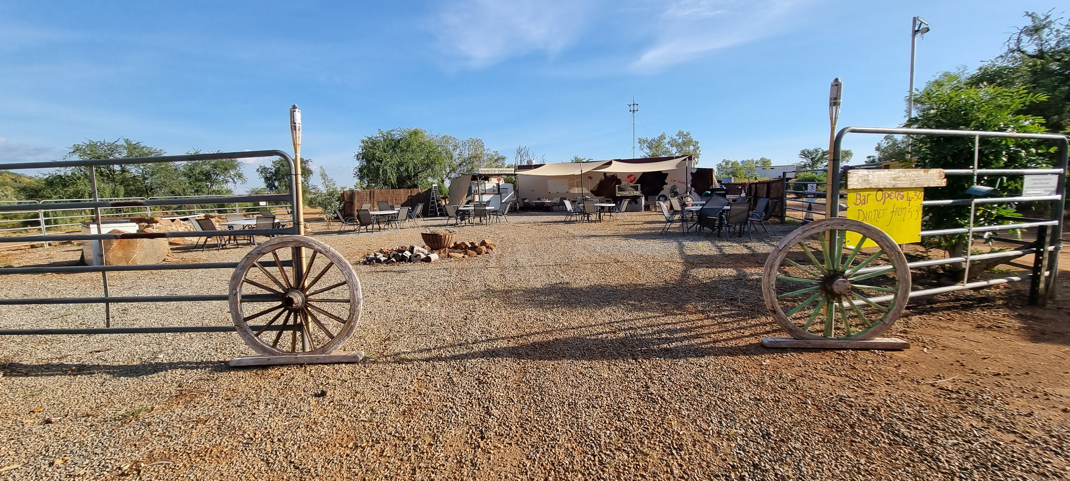
end of season restraunt
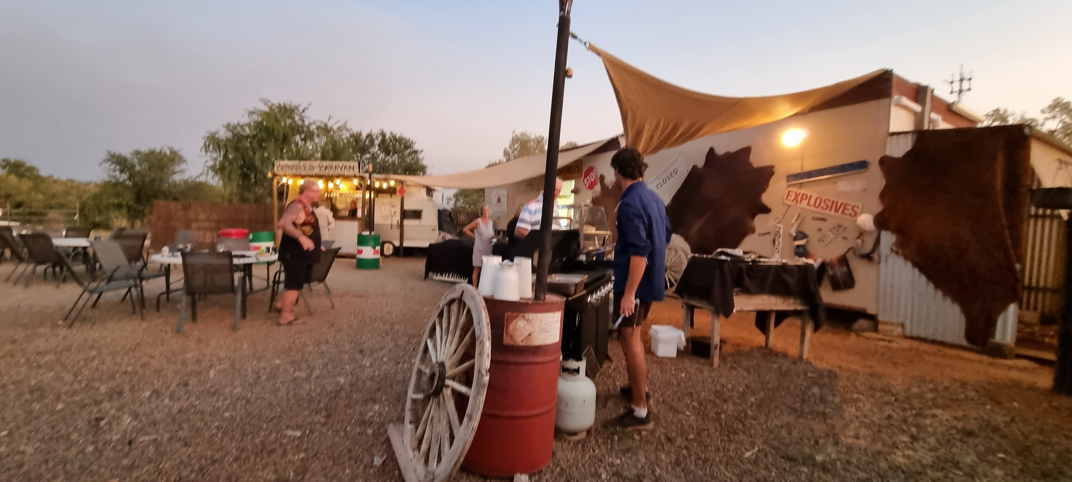
Bufffet service
- In addition, the following further information can assist guests:
Our BBQ Buffet happens in the Bull ring, and open air setting with view of the Chef's cooking on the BBQ.
Dinner is booked through reception or online only.

Report Disclaimer
Please note that this business report, provided as a result of the use of the diagnostic assessment, is for information purposes only.
Australian Tourism Industry Council (ATIC) cannot guarantee the accuracy of respondent’s answers, or that they are fully representative of your business. Therefore, ATIC does not warrant or guarantee any particular outcome in respect of your businesses self-assessment.
This report is intended as guidance only for your business and should not be relied on for future marketing considerations. ATIC recommends that you seek your own independent advice as well as the results from the diagnostic.
Links to external web sites are inserted for convenience and do not constitute endorsement of material at those sites, or any associated organisation, product or service.
ATIC does not:
- Assume any legal liability for the accuracy, completeness, or usefulness of any information from this report or any links provided; or
- Accept responsibility for any loss associated directly or indirectly from the use of this report.

