ATIC Accessibility
To support the accessible community in making informed travel decisions for their individual needs

This report prepared for:
Business name: | Margaret River Surfing Academy
Address: | 2 Percy Street
Town: | Gracetown
Contact for enquiries: | Simon Tien
Contact Number: | 0418958264
Contact Email: | info@mrsurf.com.au
Website: | www.mrsurf.com.au
Date: | 2026-09-06 17:33

ATIC Accessibility
The following pages provides travellers with information on the businesses facilities and amenities which aims to support the traveller to make an informed decision on whether the business is suitable for their individual needs.
OVERVIEW 4
Business Overview 4
Bookings 5
Emergency Management 5
Communications 6
Guide Dog and Service Animals 6
GENERAL 7
Pre-arrival, arrival and reception 7
Cognitive Impairment Support 7
Car Park and Access amenities 7
External Paths 7
Steps 8
Ramps 8
Public Toilets/Adult change facilities 8
TOUR OPERATORS 9
ADVENTURE ACTIVITIES 10
Adventure activities 10
Report Disclaimer 12

OVERVIEW

Business Overview

The business has the following products/services available
- Tour/Transport
- Adventure

Our business caters for the following disability types:
- Blind or low vision
- Deaf or low hearing
- Limited mobility
- Wheelchairs or mobility scooters
- Food allergies or intolerances
- Cognitive or people on the Autism Spectrum
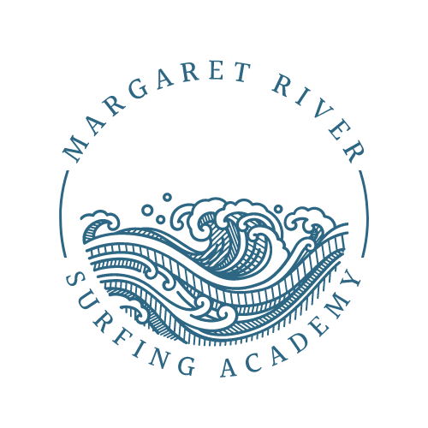

Bookings

The business offers the following methods for bookings and enquiries:
- Phone
- Email
- Webportal
- Our website supports Screen Readers
- Staff have undergone disability awareness and training

Emergency Management
- The business has an emergency management and evacuation plan for guests with a disability
- Emergency and evacuation procedures are explained on arrival
- Guests with disabilities are noted in the guest log book for emergency and evacuation purposes

Communications
- An accessibility guide is available on the website

https://www.mrsurf.com.au/accessibility
- Our website meets WCAG 2.0 accessibility standards
- Our business offers the following alternative communication methods
- Plain English

We can demonstrate skills on the beach and then have participants try themselves through non-verbal communication

Guide Dog and Service Animals
- The business provides a secure area with shade and water for service animals
- The business provides a toilet area for service animals
The business provides the following services for services animals:
Dogs are allowed at the beaches we operate. There is shade and water at each beach.

GENERAL

Pre-arrival, arrival and reception
The business has the following in place to support guests during pre-arrival, arrival and reception
- Booking information and websites are compatible with screen readers
- There is a reception/public entryway.
- Large print information sheets and registration forms

There is large print of H4 on our website booking page
- A step free map/guide
- A familiarisation tour
- In addition, the following further information can assist guests:
We can shorten the duration of time in the water for people suffering fatigue issues. There are no wait times when attending lessons. Private lessons are structured for the individual

Cognitive Impairment Support
- Documents are available in plain English for people with cognitive impairment (This may include instructions, guides, menus and general information)
- Quiet periods or early opening times for people on the Autism Spectrum

Car Park and Access amenities
The business has the following Car Park and Access amenities
- A drop off zone
- Designated disabled parking bays
- Level or ramped access from the car park to the entrance
- The accessible entrance is clearly signed from the parking bay
- Kerb ramps are in place where a pavement or walkway needs to be crossed

External Paths
External paths of travel
- Surfaces are concrete, asphalt, smooth paving or hard packed fine gravel (max aggregate size 13mm)
- Pathways are wider than 900mm
- There 3 successive steps or less on any path or at any doorway
- Any paths having steps are clearly identified as non-wheelchair accessible

Steps
Steps
- There are steps.
- Top and bottom steps are easily distinguished through colour contrast or the use of TGSIs (Tactile Ground Surface Indicators)
- All steps or staircases have enclosed risers
- The underside of all staircases are enclosed or protected to a height of at least 2 metres
- Handrails fitted to all open sets of steps
- Handrails extend 300mm beyond the top and bottom step
- Where steps are present are there three steps or less

Ramps
Ramps have the following amenities are in place
- There are ramps.
- All fixed ramps are 1:14 or less
- Hand rails are fitted
- Long ramps (more than 10m) are 1:20 or less
- Ramps have a raised edge of at least 100mm

Public Toilets/Adult change facilities
Public Toilets/Adult change facilities have the following amenities are in place
- There is an accessible toilet for public use
- The door is at least 850mm wide
- There is a minimum of 850mm beside the toilet
- Handrails are fitted
- The toilet seat is 460mm above the floor
- The toilet seat of a contrasting colour to the floor
- The toilet seat is460mm above the floor
- There is a registered changing places facility

TOUR OPERATORS
  - Changing Place Image(s)
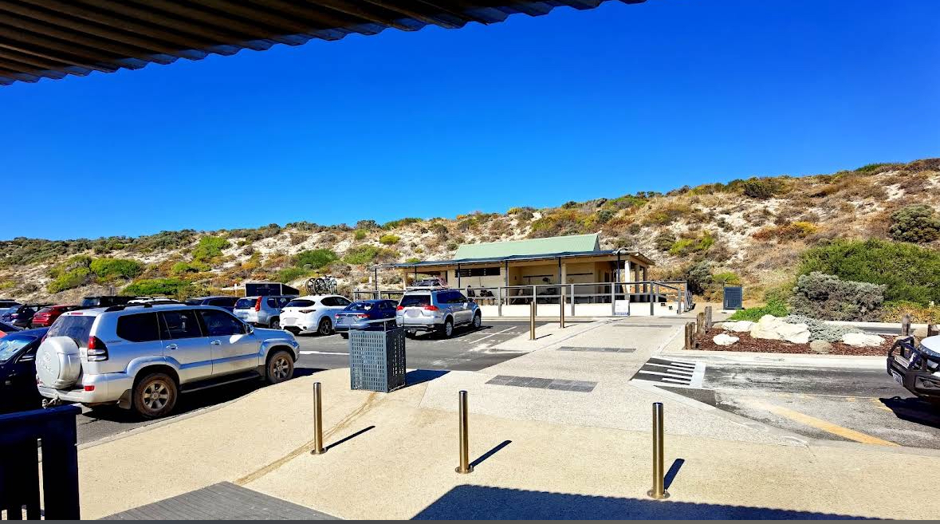
IMG_2041

ADVENTURE ACTIVITIES

Adventure activities
The adventure activities have the following facilities/amenities in place
- Our adventure activities cater for people with a disability
- In addition, the following further information can assist guests:
learning to surf or being on a surfboard. We can operate in the ocean or the river when the river mouth is closed, which is 10 months of the year
- In addition, the following further information can assist guests:
We use large soft surfboards for our lessons, which are more buoyant
- In addition, the following further information can assist guests:
Group lessons. For people with disabilities to attend our lessons, they need individual or private lessons for a safer and more enjoyable experience.

Report Disclaimer
Please note that this business report, provided as a result of the use of the diagnostic assessment, is for information purposes only.
Australian Tourism Industry Council (ATIC) cannot guarantee the accuracy of respondent’s answers, or that they are fully representative of your business. Therefore, ATIC does not warrant or guarantee any particular outcome in respect of your businesses self-assessment.
This report is intended as guidance only for your business and should not be relied on for future marketing considerations. ATIC recommends that you seek your own independent advice as well as the results from the diagnostic.
Links to external web sites are inserted for convenience and do not constitute endorsement of material at those sites, or any associated organisation, product or service.
ATIC does not:
- Assume any legal liability for the accuracy, completeness, or usefulness of any information from this report or any links provided; or
- Accept responsibility for any loss associated directly or indirectly from the use of this report.

