ATIC Accessibility
To support the accessible community in making informed travel decisions for their individual needs

This report prepared for:
Business name: | ibis Adelaide
Address: | 122 Grenfell Street
Town: | Adelaide
Contact for enquiries: | Vrinda Trehan
Contact Number: | 08 8159 5500
Contact Email: | https://all.accor.com/hotel/8822/index.en.shtml?utm_campaign=seo+maps&utm_medium=seo+maps&utm_source=google+Maps
Website: | https://www.ibisadelaide.com.au/
Date: | 2026-10-24 19:29

ATIC Accessibility
The following pages provides travellers with information on the businesses facilities and amenities which aims to support the traveller to make an informed decision on whether the business is suitable for their individual needs.
OVERVIEW 4
Business Overview 4
Bookings 4
Emergency Management 5
Communications 5
Other Information 6
Guide Dog and Service Animals 6
GENERAL 7
Pre-arrival, arrival and reception 7
Cognitive Impairment Support 7
Car Park and Access amenities 7
Entry 8
Lifts 8
Internal Spaces 8
Public areas 9
External Paths 9
Steps 9
Public Toilets/Adult change facilities 10
ACCOMMODATION 11
Bedrooms 11
Room Amenities 11
Bathrooms 12
COMMON AREAS 13
FOOD AND DRINK 14
Dining Spaces 14
Report Disclaimer 17

OVERVIEW

Business Overview

The business has the following products/services available
- Accommodation
- Food and Drink

Our business caters for the following disability types:
- Blind or low vision
- Deaf or low hearing
- Limited mobility
- Wheelchairs or mobility scooters
- Food allergies or intolerances
- Cognitive or people on the Autism Spectrum
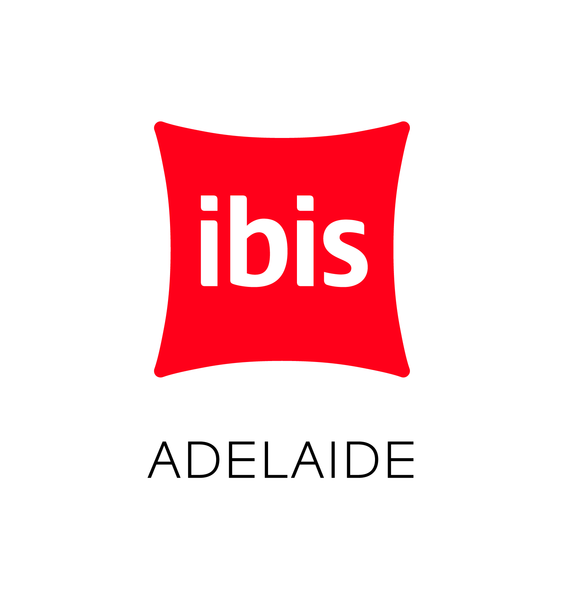

Bookings

The business offers the following methods for bookings and enquiries:
- Phone
- Email
- Webportal
- Our forms have high contract boxes and submit boxes

Emergency Management
- The business has an emergency management and evacuation plan for guests with a disability
- Emergency and evacuation procedures are explained on arrival
- Guests with disabilities are noted in the guest log book for emergency and evacuation purposes

Communications
- An accessibility guide is available on the website

https://www.ibisadelaide.com.au/
- Our website meets WCAG 2.0 accessibility standards
- Our business offers the following alternative communication methods
- Plain English

NA
- There is easy to read signage and information (e.g. menus and emergency information)
- There is a Pictorial menu
  - Pictorial Menu Image(s)
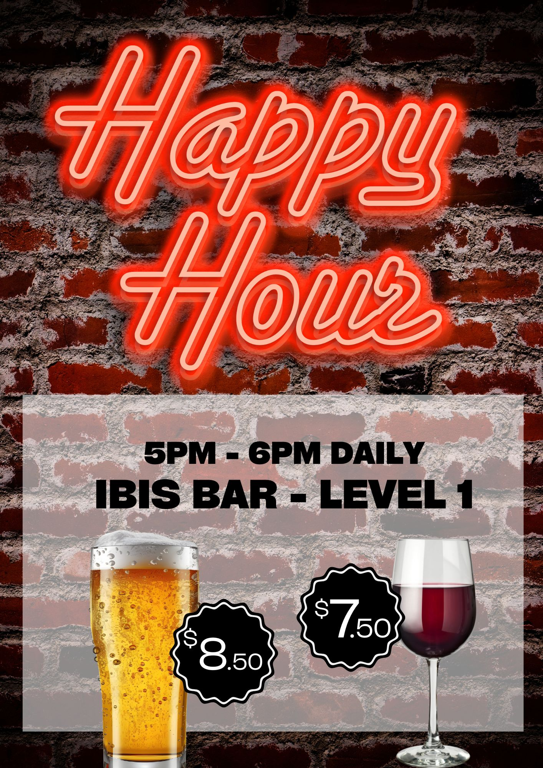
TV SCREEN Cocktail Image Happy Hour Flyer Portrait

Other Information
- For bookings made onsite, the ticket booth/counter/box office is accessible for people using a wheelchair
- The business accepts the companion card

Guide Dog and Service Animals
- The business provides a secure area with shade and water for service animals
The business provides the following services for services animals:
Service animals may accommodate house guests if advices prior to arrival

GENERAL

Pre-arrival, arrival and reception
The business has the following in place to support guests during pre-arrival, arrival and reception
- There is a reception/public entryway.
- Seating available at reception
- A lower counter at reception/ticket office
- A clipboard to allow check-in/ticket purchase whilst seated
- A tablet with text to voice or pen and paper at reception to aid in communication
- Hearing loop fitted to the reception area
- Lighting in the reception area is even and glare free
- Large print information sheets and registration forms
- Information and maps are available in written form
- A familiarisation tour
- Keys are available for each guest
- Luggage assistance
- In addition, the following further information can assist guests:
Express checkin and large seated reception area
- In addition, the following further information can assist guests:
Express check in emails prior prior to checkin

Cognitive Impairment Support
- Documents are available in plain English for people with cognitive impairment (This may include instructions, guides, menus and general information)
- Quiet periods or early opening times for people on the Autism Spectrum
- Access has alternative procedures and clear written instructions with universal access symbols

Car Park and Access amenities
The business has the following Car Park and Access amenities
- A drop off zone
- Designated disabled parking bays
- Level or ramped access from the car park to the entrance
- The accessible entrance is clearly signed from the parking bay
- The public transport services available are:

Verbal communication and employee knowledge
- In addition, the following further information can assist guests:
NA

Entry
The business has the following amenities/systems in place for entry
- A drop off point close to the entrance
- A path of access to the building is slip resistance and even
- A path of access to the building is clear of obstruction
- Self opening entry doors or fitted with a self closer
- Glass doors are fitted with a visual sighting strip
- Door jams/doors are of a contrasting colour to surrounding walls
- Door handles are of a contrasting colour to the door
- Signage is written in a contrasting colour
- The entry door is a minimum of 850mm wide
- The entry door has self opening or a light opening pressure (for manual operations)
- There a clear space of at least 1500mm x 1500mm in front of all doors.
- In addition, the following further information can assist guests:
There are no obstructions at either main entrance to the ibis Adelaide

Lifts
- Premises has lifts

Internal Spaces
- Clear and unobstructed routes through and between buildings
- Interior walls are matte or low sheen
- Floors, walls, counters and furniture are of contrasting colours
- Any protruding or overhanging obstructions are at least 2meters above the floor or are protected
- Menus are available in large print or Braille
- Tableware/glassware contrast with the table surface or table cloth
- Floor surfaces are hard or short pile carpet
- Seating is available for guests unable to stand for long periods
- Accessible facilities are clearly signed and visible from all areas
- All corridors greater than 900mm
- There is a quiet space for parents and children on the Autism Spectrum
- In addition, the following further information can assist guests:
NA

Public areas
The public areas have the following amenities in place
- Display units, Televisions, Video displays etc. are open captioned
- Even lighting
- Seating
- In addition, the following further information can assist guests:
A number of seating areas are provided in the lobby area of the hotel

External Paths
External paths of travel
- Surfaces are concrete, asphalt, smooth paving or hard packed fine gravel (max aggregate size 13mm)
- Pathways are wider than 900mm

Steps do not have to be taken

All are accessible

Steps
Steps
- There are steps.
- All steps or staircases have enclosed risers
- The underside of all staircases are enclosed or protected to a height of at least 2 metres
- Handrails fitted to all open sets of steps
- Handrails extend 300mm beyond the top and bottom step
- Where steps are present are there three steps or less

Public Toilets/Adult change facilities
Public Toilets/Adult change facilities have the following amenities are in place
- There is an accessible toilet for public use
- The door is at least 850mm wide
- There is a minimum of 850mm beside the toilet
- Handrails are fitted
- The toilet seat is 460mm above the floor
- There is NA mm of clear space in front of the toilet
- The toilet seat of a contrasting colour to the floor
- The toilet seat is460mm above the floor
- In addition, the following further information can assist guests:
NA

ACCOMMODATION

Bedrooms
The bedrooms have the following facilities/amenities in place
- There are 13 rooms available to guests who use a wheelchair
- Bedroom furniture can be re-arranged on request
  - Layout of room Image(s)
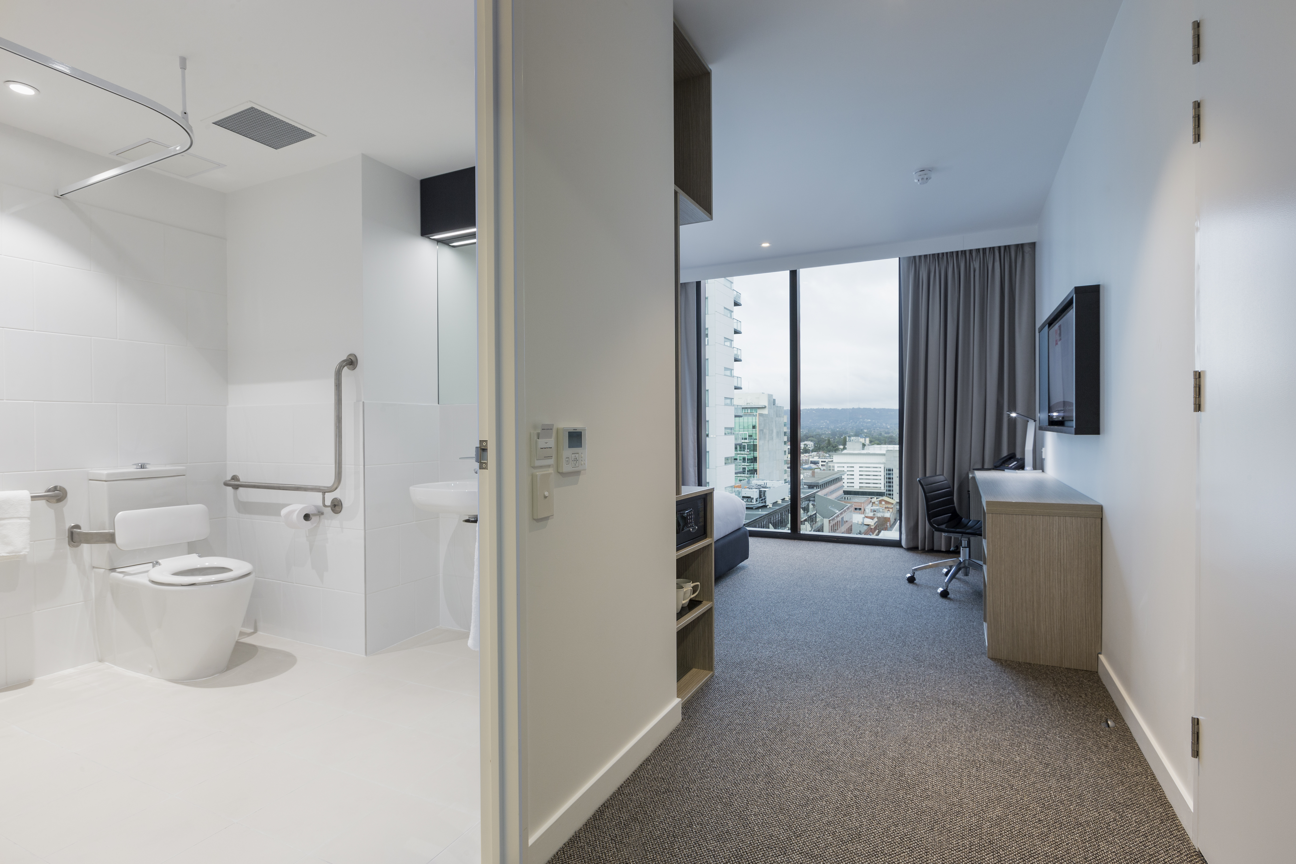
ibis Adelaide Special Access Room

Room Amenities
- Lower hanging rails are in wardrobes
- Visual alarm is fitted to the room
- Televisions are equipped with closed captioning capability
- Vibrating alarm clocks
- Room phones have volume control
- Room phones have a visual ringing indicator
- Room phones are capable of sending and receiving an SMS
- There is contrast between the walls, skirtings, floor and furniture
- There is a clear path through the room
- The edges of all furniture and fixtures are rounded
- Wardrobe handles are a contrasting colour to the doors and draws
- Housekeeping procedures instruct staff not to reposition furniture that has been moved
- Doors open fully against the adjoining wall
- There is a clear opening at least 850mm wide
- There at least one chair with rigid arms
- Wardrobe and drawer handles are easy to grip
- The bedside lamp switch is easy to reach from the bed
- There is at least 850mm clear space beside the bed
- The bed height is no higher than 680mm from the floor
- There is at least 130mm clearance under the bed
- Non-allergenic cleaning products are used
- In addition, the following further information can assist guests:
Accor approved products provided in all accommodation rooms

Bathrooms
The bathrooms have the following facilities/amenities in place
- All heating appliances and hot water pipes are protected or insulated
- All shower, bath and basin taps are clearly differentiated between hot and cold
- Fixtures and fittings have rounded edges
- The door is at least 850mm wide
- There is a minimum of 850mm beside the toilet
- Handrails are fitted
- There is a minimum of 1400mm of clear space in front of the toilet
- The toilet seat is 460mm above the floor
- A range of non-allergenic toiletries are available
- There is a roll-in shower with fold down fixed seat or a shower chair
- There is a portable shower head on flexible hose
  - Bathroom Image(s)
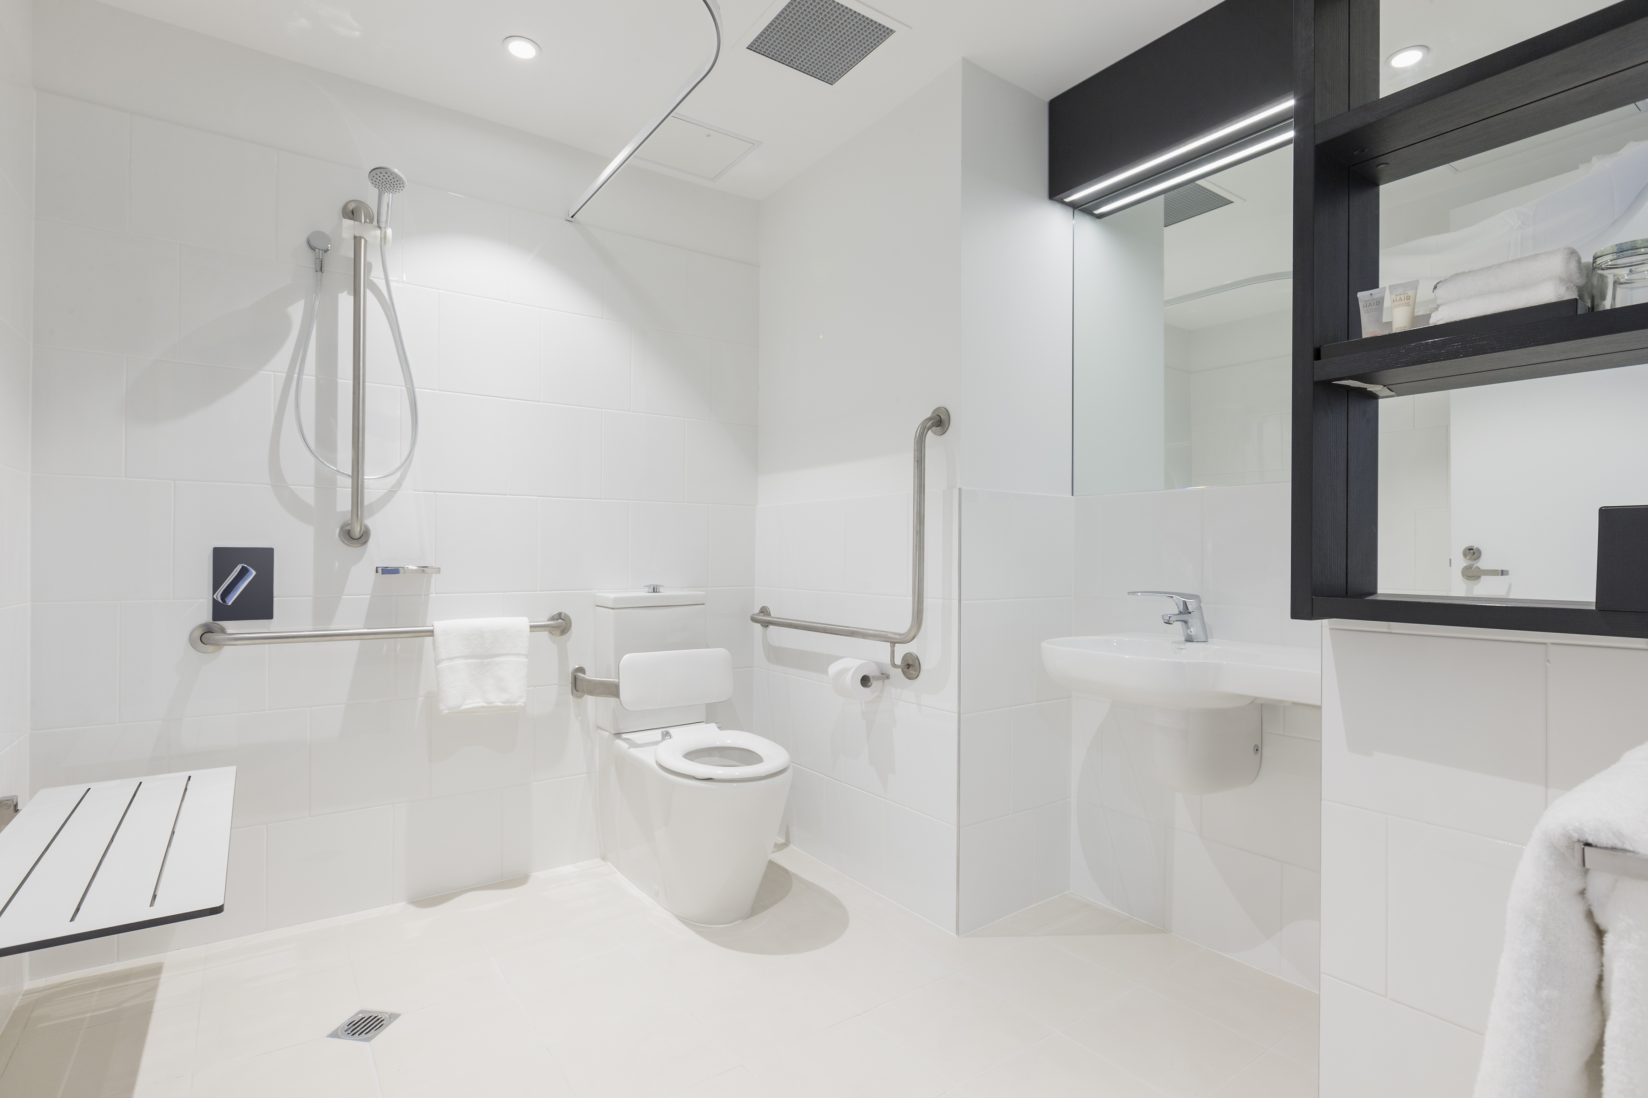
ibis Adelaide Special Access Bathroom
- In addition, the following further information can assist guests:
Hotel has accessible rooms purpose build for wheelchair access

COMMON AREAS

FOOD AND DRINK

Dining Spaces
The dining spaces have the following facilities/amenities in place
- The entrance has level access
- The doorway is at least 850mm wide
- There is level access through the dining area
- Chairs are moveable to allow for wheelchairs to be seated at the tables
- All glass doors and full height windows have contrast markings
- There are areas of full lighting
- There are large print menus
- There are Plain English menus
- There is an accessible toilet

Our business caters for the following dietary requirements
- Sugar free (diabetic)
- Gluten free (celiac)
- Lactose free (dairy free)
- Low fat and fibre with no gastric content
- Low potassium
- Low sodium
- Nut free
- Additive free
- Organic
- Vegetarian
- Vegan
- In addition, the following further information can assist guests:
NA
- There is a sample menu available online
Sample menu is available here -
https://www.ibisadelaide.com.au/dining/ibis-kitchen-restaurant
  - Food and Beverage Image(s)
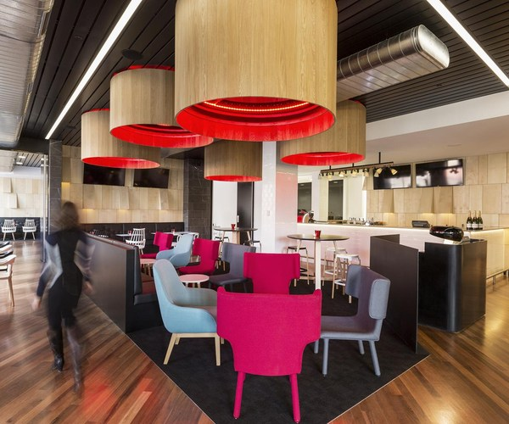
aperitif_Bar_3
- In addition, the following further information can assist guests:
NA

Report Disclaimer
Please note that this business report, provided as a result of the use of the diagnostic assessment, is for information purposes only.
Australian Tourism Industry Council (ATIC) cannot guarantee the accuracy of respondent’s answers, or that they are fully representative of your business. Therefore, ATIC does not warrant or guarantee any particular outcome in respect of your businesses self-assessment.
This report is intended as guidance only for your business and should not be relied on for future marketing considerations. ATIC recommends that you seek your own independent advice as well as the results from the diagnostic.
Links to external web sites are inserted for convenience and do not constitute endorsement of material at those sites, or any associated organisation, product or service.
ATIC does not:
- Assume any legal liability for the accuracy, completeness, or usefulness of any information from this report or any links provided; or
- Accept responsibility for any loss associated directly or indirectly from the use of this report.

