ATIC Accessibility
To support the accessible community in making informed travel decisions for their individual needs

This report prepared for:
Business name: | Alice Springs Desert Park
Address: | Larapinta Drive
Town: | Alice Springs
Contact for enquiries: | Hannah Smyth
Contact Number: | 0889518788
Contact Email: | asdp@nt.gov.au
Website: | www.alicespringsdesertpark.com.au
Date: | 2026-10-17 20:28

ATIC Accessibility
The following pages provides travellers with information on the businesses facilities and amenities which aims to support the traveller to make an informed decision on whether the business is suitable for their individual needs.
OVERVIEW 4
Business Overview 4
Bookings 4
Emergency Management 5
Communications 5
Other Information 6
Guide Dog and Service Animals 6
GENERAL 7
Pre-arrival, arrival and reception 7
Cognitive Impairment Support 7
Car Park and Access amenities 7
Entry 7
Internal Spaces 8
Public areas 8
Displays, exhibits, commentary and live performances 8
External Paths 8
Public Toilets/Adult change facilities 9
TOUR OPERATORS 10
Route Planning 10
Guides 10
ATTRACTIONS 11
Attractions Basics 11
Zoos and Wildlife Parks 11
COMMON AREAS 16
Report Disclaimer 18

OVERVIEW

Business Overview

The business has the following products/services available
- Tour/Transport
- Attraction

Our business caters for the following disability types:
- Limited mobility
- Wheelchairs or mobility scooters
- Food allergies or intolerances
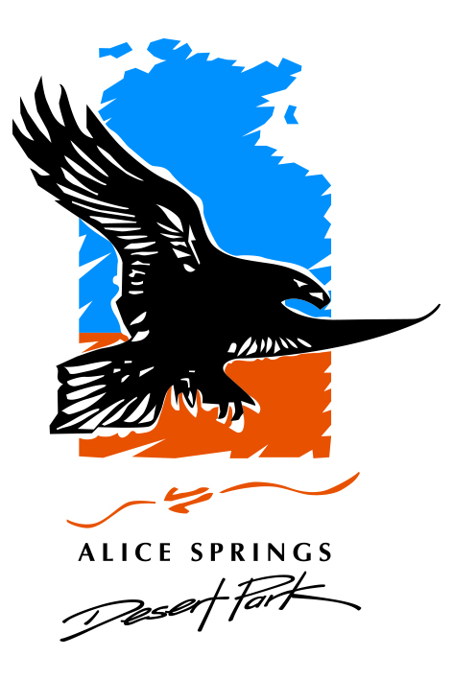

Bookings

The business offers the following methods for bookings and enquiries:
- Phone
- Email
- Webportal
- Our forms have high contract boxes and submit boxes
- Staff have undergone disability awareness and training

Emergency Management
- The business has an emergency management and evacuation plan for guests with a disability
- Emergency and evacuation procedures are explained on arrival
- Guests with disabilities are noted in the guest log book for emergency and evacuation purposes

Communications
- An accessibility guide is available on the website

https://alicespringsdesertpark.com.au/plan-your-visit/accessibility
- Our business offers the following alternative communication methods
- Plain English

Interactive Digital Map with audio tour options
- There is easy to read signage and information (e.g. menus and emergency information)
- There are Picture boards
  - Picture Boards Image(s)
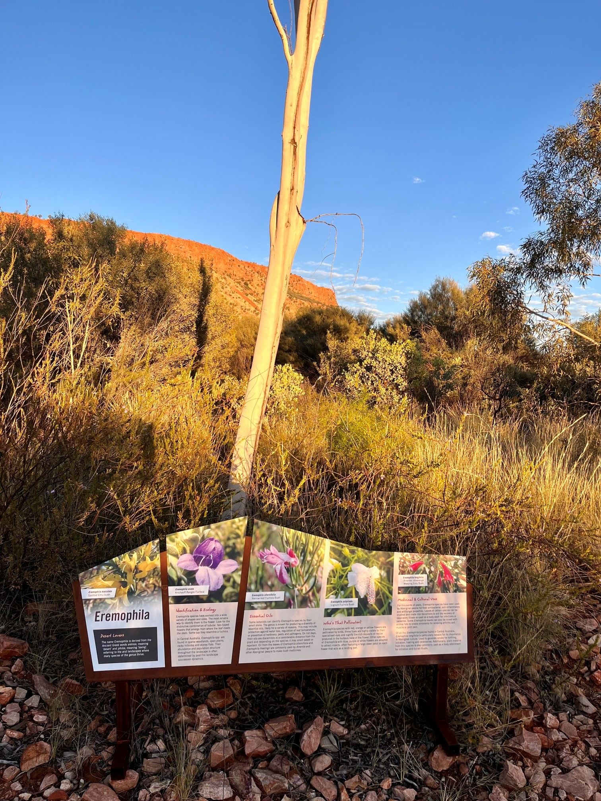
2

Other Information
- For bookings made onsite, the ticket booth/counter/box office is accessible for people using a wheelchair
- The business accepts the companion card

Guide Dog and Service Animals
- The business provides a secure area with shade and water for service animals
- The business provides a toilet area for service animals
The business provides the following services for services animals:
Service animals may enter the park

GENERAL

Pre-arrival, arrival and reception
The business has the following in place to support guests during pre-arrival, arrival and reception
- There is a reception/public entryway.
- Seating available at reception
- A lower counter at reception/ticket office
- A clipboard to allow check-in/ticket purchase whilst seated
- Lighting in the reception area is even and glare free
- Large print information sheets and registration forms
- Information and maps are available in written form
- A step free map/guide
- In addition, the following further information can assist guests:
Alice Springs Desert Park aims to minimise wait times wherever possible to ensure all visitors have a comfortable experience. Tickets can be purchased online in advance, reducing time spent at the entry station, while visitor services staff are available to assist guests promptly on arrival.

Cognitive Impairment Support
- Documents are available in plain English for people with cognitive impairment (This may include instructions, guides, menus and general information)

Car Park and Access amenities
The business has the following Car Park and Access amenities
- A drop off zone
- Designated disabled parking bays
- Level or ramped access from the car park to the entrance
- The accessible entrance is clearly signed from the parking bay
- Kerb ramps are in place where a pavement or walkway needs to be crossed

Entry
The business has the following amenities/systems in place for entry
- A drop off point close to the entrance
- A path of access to the building is slip resistance and even
- A path of access to the building is clear of obstruction
- Self opening entry doors or fitted with a self closer
- Signage is written in a contrasting colour
- The entry door is a minimum of 850mm wide
- The entrance sill is less than 13mm
- There a clear space of at least 1500mm x 1500mm in front of all doors.
- The entrance door mats have a thickness less than 13mm and a width of 7500mm or greater

Internal Spaces
- Clear and unobstructed routes through and between buildings
- Interior walls are matte or low sheen
- Floors, walls, counters and furniture are of contrasting colours
- Any protruding or overhanging obstructions are at least 2meters above the floor or are protected
- Floor surfaces are hard or short pile carpet
- Seating is available for guests unable to stand for long periods
- Accessible facilities are clearly signed and visible from all areas
- All corridors greater than 900mm

Public areas
The public areas have the following amenities in place
- Seating

Displays, exhibits, commentary and live performances
For displays, exhibits, commentary and live performances the following amenities are in place
- Seating
- Wheelchair accessible spaces/seating

External Paths
External paths of travel
- Surfaces are concrete, asphalt, smooth paving or hard packed fine gravel (max aggregate size 13mm)
- Paths or slopes longer than 15 metres have resting places or seats
- Pathways are wider than 900mm
- There 3 successive steps or less on any path or at any doorway
- Any paths having steps are clearly identified as non-wheelchair accessible
- Step free routes clearly signed

Public Toilets/Adult change facilities
Public Toilets/Adult change facilities have the following amenities are in place
- There is an accessible toilet for public use
- The door is at least 850mm wide
- There is a minimum of 850mm beside the toilet
- Handrails are fitted
- The toilet seat is 460mm above the floor
- The toilet seat of a contrasting colour to the floor
- The toilet seat is460mm above the floor

TOUR OPERATORS

Route Planning
- Walking Tours
- Operated on a step free route
- Multi-paced to account for slower walkers

Guides

Guides have been trained in the following
- Use of clear/simple English

ATTRACTIONS

Attractions Basics
- A park map is available here:

https://map.alicespringsdesertpark.com.au/

Zoos and Wildlife Parks
- Guide and service dogs are welcome
- In addition, the following further information can assist guests:
Service animals are permitted on the main pathways of the park, but cannot enter our walk-through aviaries or enter our free-flying bird show.
- A secure area with shade and water for service dogs is available
- Displays have glass or mesh viewing panels for children or people seated in wheelchairs
- Signage is positioned between 800mm and 1200mm above the ground
- Signage is in a font larger than 18 point
- Signage and information provide pictorial information
- In addition, the following further information can assist guests:
Audio tours are available, in addition to printed written information sheets and the interactive digital map via QR code.
- Seating is provided at regular intervals
- Aviaries and other enclosures provide level access
- Airlocks provide sufficient room for a wheelchair
  - Image(s)
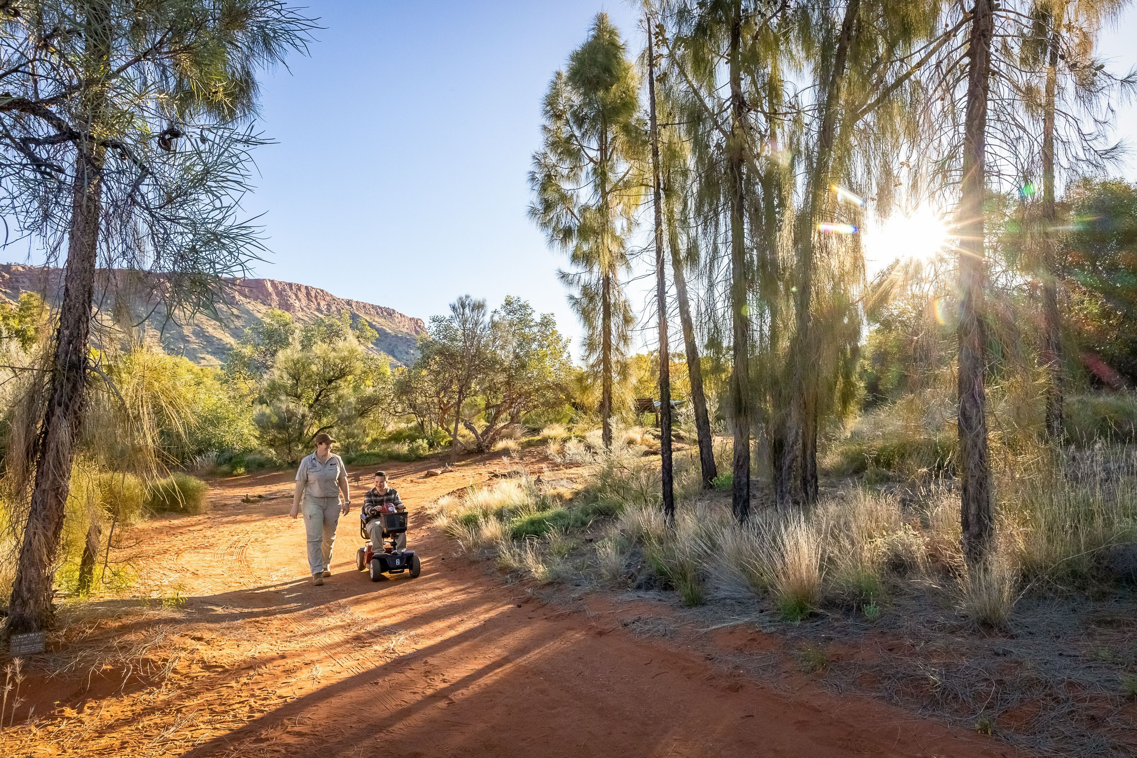
Erin & Scooter must credit TourismNT and Helen Orr
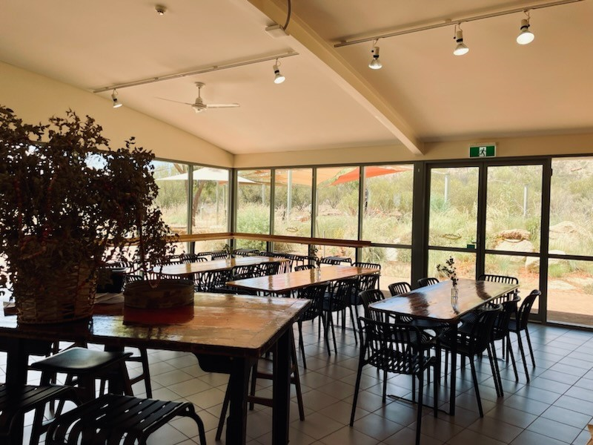
interor tables and chairs
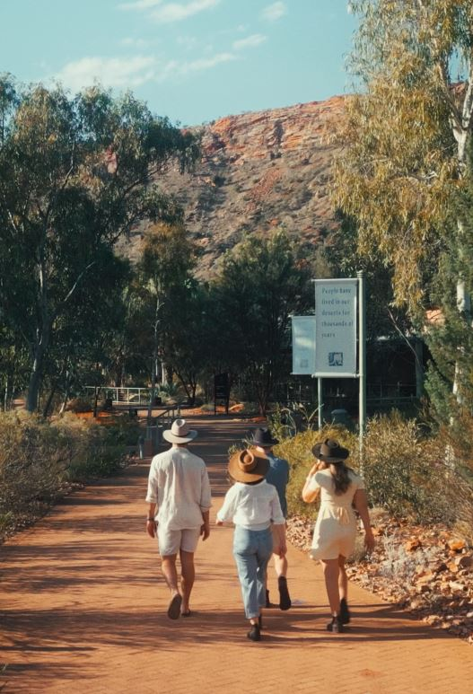
arriving.JPG
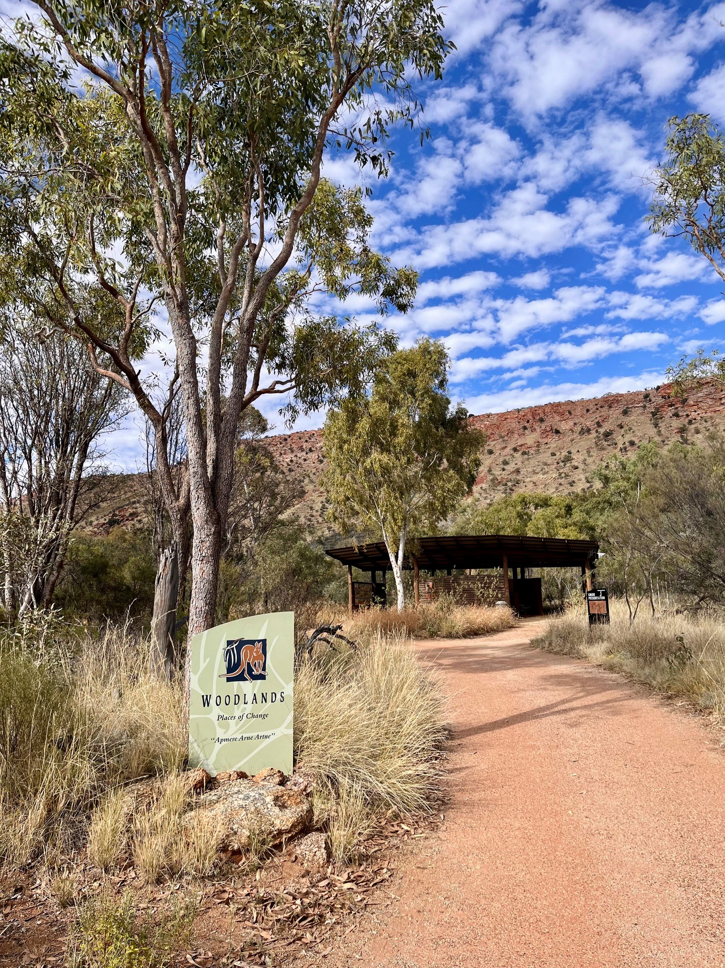
woodlands
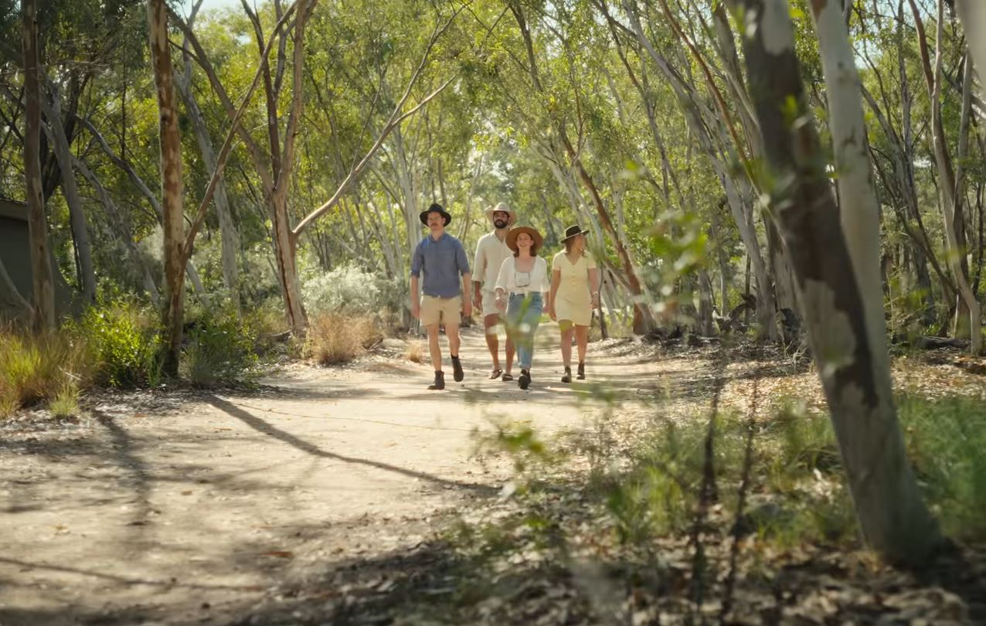
desert rivers arbor still.JPG
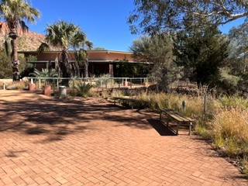
Various park seating
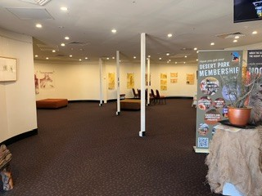
entry station
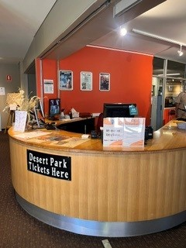
entry
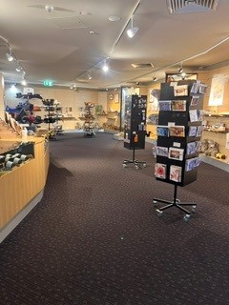
gift shop
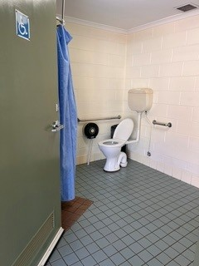
disabled toilet

COMMON AREAS

Report Disclaimer
Please note that this business report, provided as a result of the use of the diagnostic assessment, is for information purposes only.
Australian Tourism Industry Council (ATIC) cannot guarantee the accuracy of respondent’s answers, or that they are fully representative of your business. Therefore, ATIC does not warrant or guarantee any particular outcome in respect of your businesses self-assessment.
This report is intended as guidance only for your business and should not be relied on for future marketing considerations. ATIC recommends that you seek your own independent advice as well as the results from the diagnostic.
Links to external web sites are inserted for convenience and do not constitute endorsement of material at those sites, or any associated organisation, product or service.
ATIC does not:
- Assume any legal liability for the accuracy, completeness, or usefulness of any information from this report or any links provided; or
- Accept responsibility for any loss associated directly or indirectly from the use of this report.

