ATIC Accessibility
To support the accessible community in making informed travel decisions for their individual needs

This report prepared for:
Business name: | Bendigo Heritage
Address: | 76 Violet Street
Town: | Bendigo
Contact for enquiries: | Tynille Thurlow
Contact Number: | (03) 5443 8117
Contact Email: | tours@bendigoheritage.com.au
Website: | www.bendigoheritage.com.au
Date: | 2026-10-23 20:50

ATIC Accessibility
The following pages provides travellers with information on the businesses facilities and amenities which aims to support the traveller to make an informed decision on whether the business is suitable for their individual needs.
OVERVIEW 4
Business Overview 4
Bookings 4
Emergency Management 5
Communications 5
Other Information 6
Guide Dog and Service Animals 6
GENERAL 7
Pre-arrival, arrival and reception 7
Cognitive Impairment Support 7
Car Park and Access amenities 7
Entry 7
Internal Spaces 8
Public areas 8
Displays, exhibits, commentary and live performances 8
External Paths 9
Steps 9
Ramps 9
Public Toilets/Adult change facilities 9
TOUR OPERATORS 11
Route Planning 11
Guides 11
ATTRACTIONS 12
COMMON AREAS 13
FOOD AND DRINK 14
Dining Spaces 14
ADVENTURE ACTIVITIES 15
Report Disclaimer 17

OVERVIEW

Business Overview

The business has the following products/services available
- Tour/Transport
- Attraction
- Food and Drink

Our business caters for the following disability types:
- Blind or low vision
- Deaf or low hearing
- Limited mobility
- Wheelchairs or mobility scooters
- Food allergies or intolerances
- Cognitive or people on the Autism Spectrum
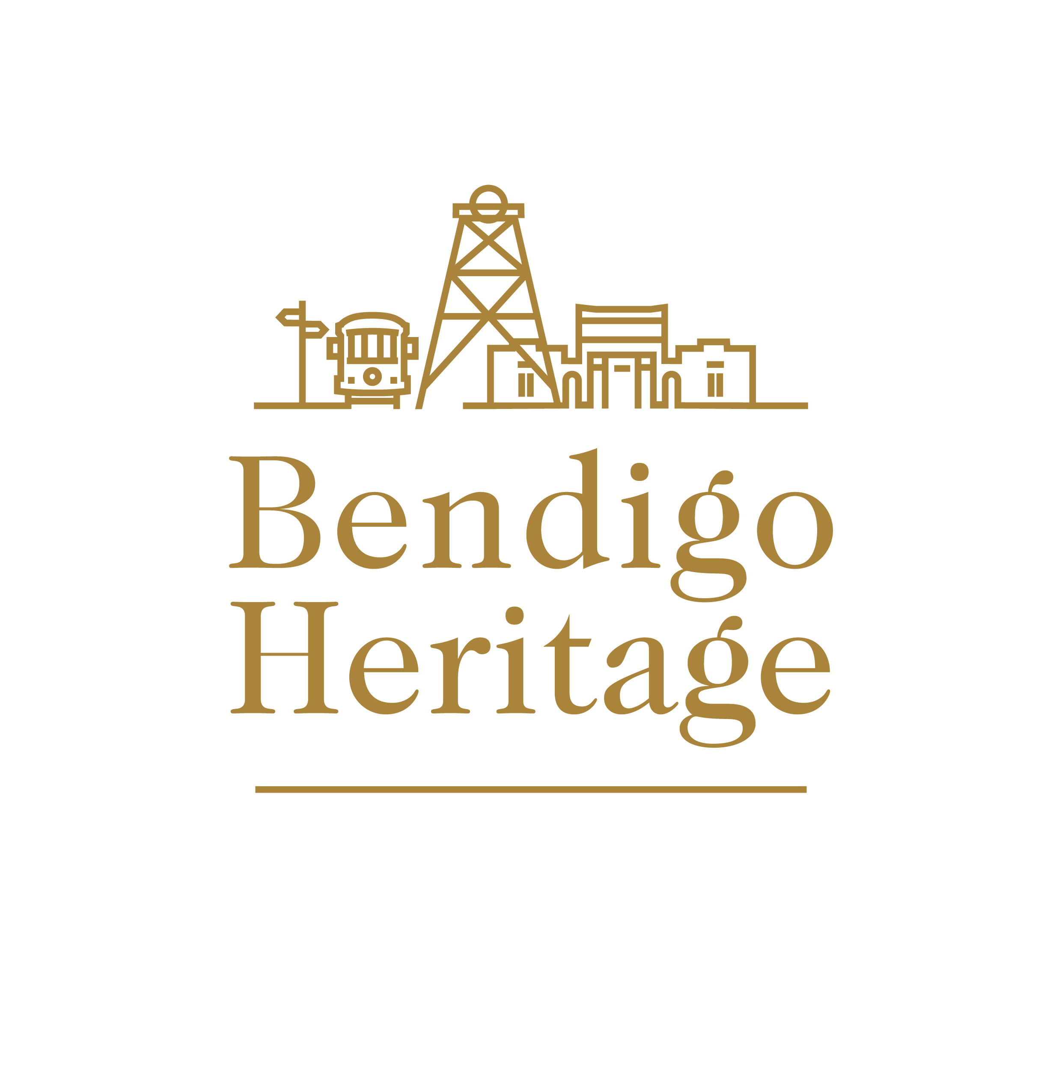

Bookings

The business offers the following methods for bookings and enquiries:
- Phone
- Email
- Webportal
- Our forms have high contract boxes and submit boxes
- Staff have undergone disability awareness and training

Emergency Management
- Emergency and evacuation procedures are explained on arrival
- There are Audible device/s to alert occupants to evacuate with instructions on how to evacuate.
- Exit signs are clear and easy to see
- Exit access is free and clear at all times
We ensure exit access is free and clear at all times by:
Regular routine checks; "Keep Clear" signage; education and instruction
- Exits and access to exists are greater than 900mm
- Exit doors are able to be opened by all occupants
- Exits to the emergency evacuation point does not include stairways
- The evacuation point is clearly marked by a sign
- In addition, the following further information can assist guests:
Identified at check-in. Tours are guided.
- In addition, the following further information can assist guests:
Tour Guides assist guests in an evacuation.
- Guests with disabilities are noted in the guest log book for emergency and evacuation purposes

Communications
- An accessibility guide is available on the website

https://www.central-deborah.com/visit/facilities-and-accessibility & https://www.bendigotramways.com/about/accessibility
- Our business offers the following alternative communication methods
- Plain English

Not specified
- There is easy to read signage and information (e.g. menus and emergency information)

Other Information
- The business accepts the companion card

Guide Dog and Service Animals
- The business provides a toilet area for service animals
The business provides the following services for services animals:
Not specified

GENERAL

Pre-arrival, arrival and reception
The business has the following in place to support guests during pre-arrival, arrival and reception
- There is a reception/public entryway.
- Lighting in the reception area is even and glare free
- Information and maps are available in written form
- In addition, the following further information can assist guests:
We prioritise guests with a disability at check-in and show them areas where they can rest during their stay.

Cognitive Impairment Support
- Documents are available in plain English for people with cognitive impairment (This may include instructions, guides, menus and general information)
- A "social script" guide to your premises or attraction describing the sights, sounds and smells to aid parents/carers prepare visitors in advance
- A space for parents and children on the Autism Spectrum

Car Park and Access amenities
The business has the following Car Park and Access amenities
- A drop off zone
- Designated disabled parking bays
- Level or ramped access from the car park to the entrance
- Kerb ramps are in place where a pavement or walkway needs to be crossed

Entry
The business has the following amenities/systems in place for entry
- A drop off point close to the entrance
- A path of access to the building is clear of obstruction
- Self opening entry doors or fitted with a self closer
- Door jams/doors are of a contrasting colour to surrounding walls
- Door handles are of a contrasting colour to the door
- Signage is written in a contrasting colour
- The entry door is a minimum of 850mm wide
- The entrance sill is less than 13mm
- There a clear space of at least 1500mm x 1500mm in front of all doors.
- In addition, the following further information can assist guests:
Tour Guides take guests underground using a personnel and materials hoist. The hoist cannot be accessed by the general public and can only be operated by one of our qualified Tour Guides with a High-Risk Work license. The hoist is wheelchair accessible, but can be loud for people with sensory overwhelm.

Internal Spaces
- Clear and unobstructed routes through and between buildings
- Interior walls are matte or low sheen
- Floors, walls, counters and furniture are of contrasting colours
- Any protruding or overhanging obstructions are at least 2meters above the floor or are protected
- Menus are available in large print or Braille
- Floor surfaces are hard or short pile carpet
- Seating is available for guests unable to stand for long periods
- All corridors greater than 900mm
- There is a quiet space for parents and children on the Autism Spectrum

Public areas
The public areas have the following amenities in place
- Display units, Televisions, Video displays etc. are open captioned
- Even lighting
- Seating

Displays, exhibits, commentary and live performances
For displays, exhibits, commentary and live performances the following amenities are in place
- Wheelchair accessible spaces/seating
- A written transcript where audio description is provided i.e. display commentary, tour commentary
- In addition, the following further information can assist guests:
There are locations underground where guests can sit, but not all areas have seating.

External Paths
External paths of travel
- Paths or slopes longer than 15 metres have resting places or seats
- Pathways are wider than 900mm
- There 3 successive steps or less on any path or at any doorway

Steps
Steps
- There are steps.
- The underside of all staircases are enclosed or protected to a height of at least 2 metres
- Handrails fitted to all open sets of steps
- Handrails extend 300mm beyond the top and bottom step
- In addition, the following further information can assist guests:
There is a set of four steps as part of one of our heritage buildings.

Ramps
Ramps have the following amenities are in place
- There are ramps.
- All fixed ramps are 1:14 or less
- Hand rails are fitted
- Long ramps (more than 10m) are 1:20 or less
- Temporary ramps are available
- Temporary ramps are in place for the duration of the guests stay
- Ramps have a raised edge of at least 100mm
- In addition, the following further information can assist guests:
Tram are accessible via ramp that can be firmly attached to the tram's entrance.

Public Toilets/Adult change facilities
Public Toilets/Adult change facilities have the following amenities are in place
- There is an accessible toilet for public use
- The door is at least 850mm wide
- There is a minimum of 850mm beside the toilet
- Handrails are fitted
- The toilet seat is 460mm above the floor
- The toilet seat of a contrasting colour to the floor
- The toilet seat is460mm above the floor

TOUR OPERATORS

Route Planning
- Walking Tours
- Operated on a step free route
- Multi-paced to account for slower walkers

Guides

Guides have been trained in the following
- Use of clear/simple English
- Correct pronunciation for lip readers
- There is a audio description of surroundings

ATTRACTIONS

COMMON AREAS

FOOD AND DRINK

Dining Spaces
The dining spaces have the following facilities/amenities in place
- The entrance has level access
- The doorway is at least 850mm wide
- There is level access through the dining area
- Chairs are moveable to allow for wheelchairs to be seated at the tables
- All glass doors and full height windows have contrast markings
- There are areas of full lighting
- There are Plain English menus
- There is an accessible toilet

Our business caters for the following dietary requirements
- Sugar free (diabetic)
- Gluten free (celiac)
- Lactose free (dairy free)
- Nut free
- Vegetarian
- Kosher
- Halal
- In addition, the following further information can assist guests:
Utensils, benches and equipment are cleaned and sanitised thoroughly after each useAllergen-containing foods are stored separatelyStaff are trained to understand and manage food allergen safetyPersonal hygiene and PPEDifferent equipment is used when preparing cooked and raw foodsEverything is clearly labelled to avoid cross-contamination

ADVENTURE ACTIVITIES
- In addition, the following further information can assist guests:
N/A
- In addition, the following further information can assist guests:
N/A
- In addition, the following further information can assist guests:
N/A

Report Disclaimer
Please note that this business report, provided as a result of the use of the diagnostic assessment, is for information purposes only.
Australian Tourism Industry Council (ATIC) cannot guarantee the accuracy of respondent’s answers, or that they are fully representative of your business. Therefore, ATIC does not warrant or guarantee any particular outcome in respect of your businesses self-assessment.
This report is intended as guidance only for your business and should not be relied on for future marketing considerations. ATIC recommends that you seek your own independent advice as well as the results from the diagnostic.
Links to external web sites are inserted for convenience and do not constitute endorsement of material at those sites, or any associated organisation, product or service.
ATIC does not:
- Assume any legal liability for the accuracy, completeness, or usefulness of any information from this report or any links provided; or
- Accept responsibility for any loss associated directly or indirectly from the use of this report.

