ATIC Accessibility
To support the accessible community in making informed travel decisions for their individual needs

This report prepared for:
Business name: | Wimmera Steampunk Festival
Address: | 7-9 Lochiel Street
Town: | Dimboola
Contact for enquiries: | Chan Uoy
Contact Number: | 0425705591
Contact Email: | chan@dimboolaimaginarium.com
Website: | www.wimmerasteampunkfestival.com.au
Date: | 2026-10-17 09:27

ATIC Accessibility
The following pages provides travellers with information on the businesses facilities and amenities which aims to support the traveller to make an informed decision on whether the business is suitable for their individual needs.
OVERVIEW 4
Business Overview 4
Bookings 4
Emergency Management 5
Other Information 5
Guide Dog and Service Animals 5
GENERAL 6
Pre-arrival, arrival and reception 6
Cognitive Impairment Support 6
Car Park and Access amenities 6
Displays, exhibits, commentary and live performances 6
External Paths 7
Public Toilets/Adult change facilities 7
ATTRACTIONS 8
COMMON AREAS 9
FOOD AND DRINK 10
Dining Spaces 10
EVENTS 11
Events 11
Report Disclaimer 13

OVERVIEW

Business Overview

The business has the following products/services available
- Attraction
- Food and Drink
- Event

Our business caters for the following disability types:
- Limited mobility
- Wheelchairs or mobility scooters
- Food allergies or intolerances


Bookings

The business offers the following methods for bookings and enquiries:
- Phone
- Email
- Webportal
- Our forms have high contract boxes and submit boxes

Emergency Management
- Exits and access to exists are greater than 900mm
- In addition, the following further information can assist guests:
The volunteers at the gates will identify guests who will need additional assistance. They will be registered and allocated a volunteer.
- In addition, the following further information can assist guests:
Registered guests with assistance needs will have dedicated volunteers to assist them in the rescue. This information will also be shared with the emergency workers and police.
- Guests with disabilities are noted in the guest log book for emergency and evacuation purposes

Other Information
- The business accepts the companion card

Guide Dog and Service Animals
The business provides the following services for services animals:
At future events we will have a secure area for service animals where shade, water, toilet, bowls and bedding are provided.

GENERAL

Pre-arrival, arrival and reception
The business has the following in place to support guests during pre-arrival, arrival and reception
- Information and maps are available in written form
- In addition, the following further information can assist guests:
As the main event is a street party, there is a high potential for queues during peak times. Volunteers at the gate will note those in need of assistance. If noticeable distress occurs, volunteers can escort them to the front as priority guests. If the queue is extremely long, a volunteer will scan the crowd to identify individuals who require assistance.
- In addition, the following further information can assist guests:
Please notify the committee or volunteers if you require special assistance.

Cognitive Impairment Support
- Documents are available in plain English for people with cognitive impairment (This may include instructions, guides, menus and general information)

Car Park and Access amenities
The business has the following Car Park and Access amenities
- A drop off zone
- In addition, the following further information can assist guests:
Since the main event is a street party in the town centre, there are limited parking options near the road closures. There are two drop-off zones on Lloyd Street. When we can recruit more volunteers, we will be able to create dedicated spaces for people with disabilities.

Displays, exhibits, commentary and live performances
For displays, exhibits, commentary and live performances the following amenities are in place
- Seating
- Wheelchair accessible spaces/seating
- In addition, the following further information can assist guests:
We have open-air entertainment with no formal seating options.

External Paths
External paths of travel
- Surfaces are concrete, asphalt, smooth paving or hard packed fine gravel (max aggregate size 13mm)
- Paths or slopes longer than 15 metres have resting places or seats
- Pathways are wider than 900mm
- There 3 successive steps or less on any path or at any doorway
- In addition, the following further information can assist guests:
The town centre hosts the street party, so the pathways are typical of any main street.
- In addition, the following further information can assist guests:
Since it's a street party, you only need to worry about the curbside.

Public Toilets/Adult change facilities
Public Toilets/Adult change facilities have the following amenities are in place
- There is an accessible toilet for public use
- The door is at least 850mm wide
- There is a minimum of 850mm beside the toilet
- Handrails are fitted
- The toilet seat is 460mm above the floor
- The toilet seat of a contrasting colour to the floor
- The toilet seat is460mm above the floor

ATTRACTIONS
  - Image(s)
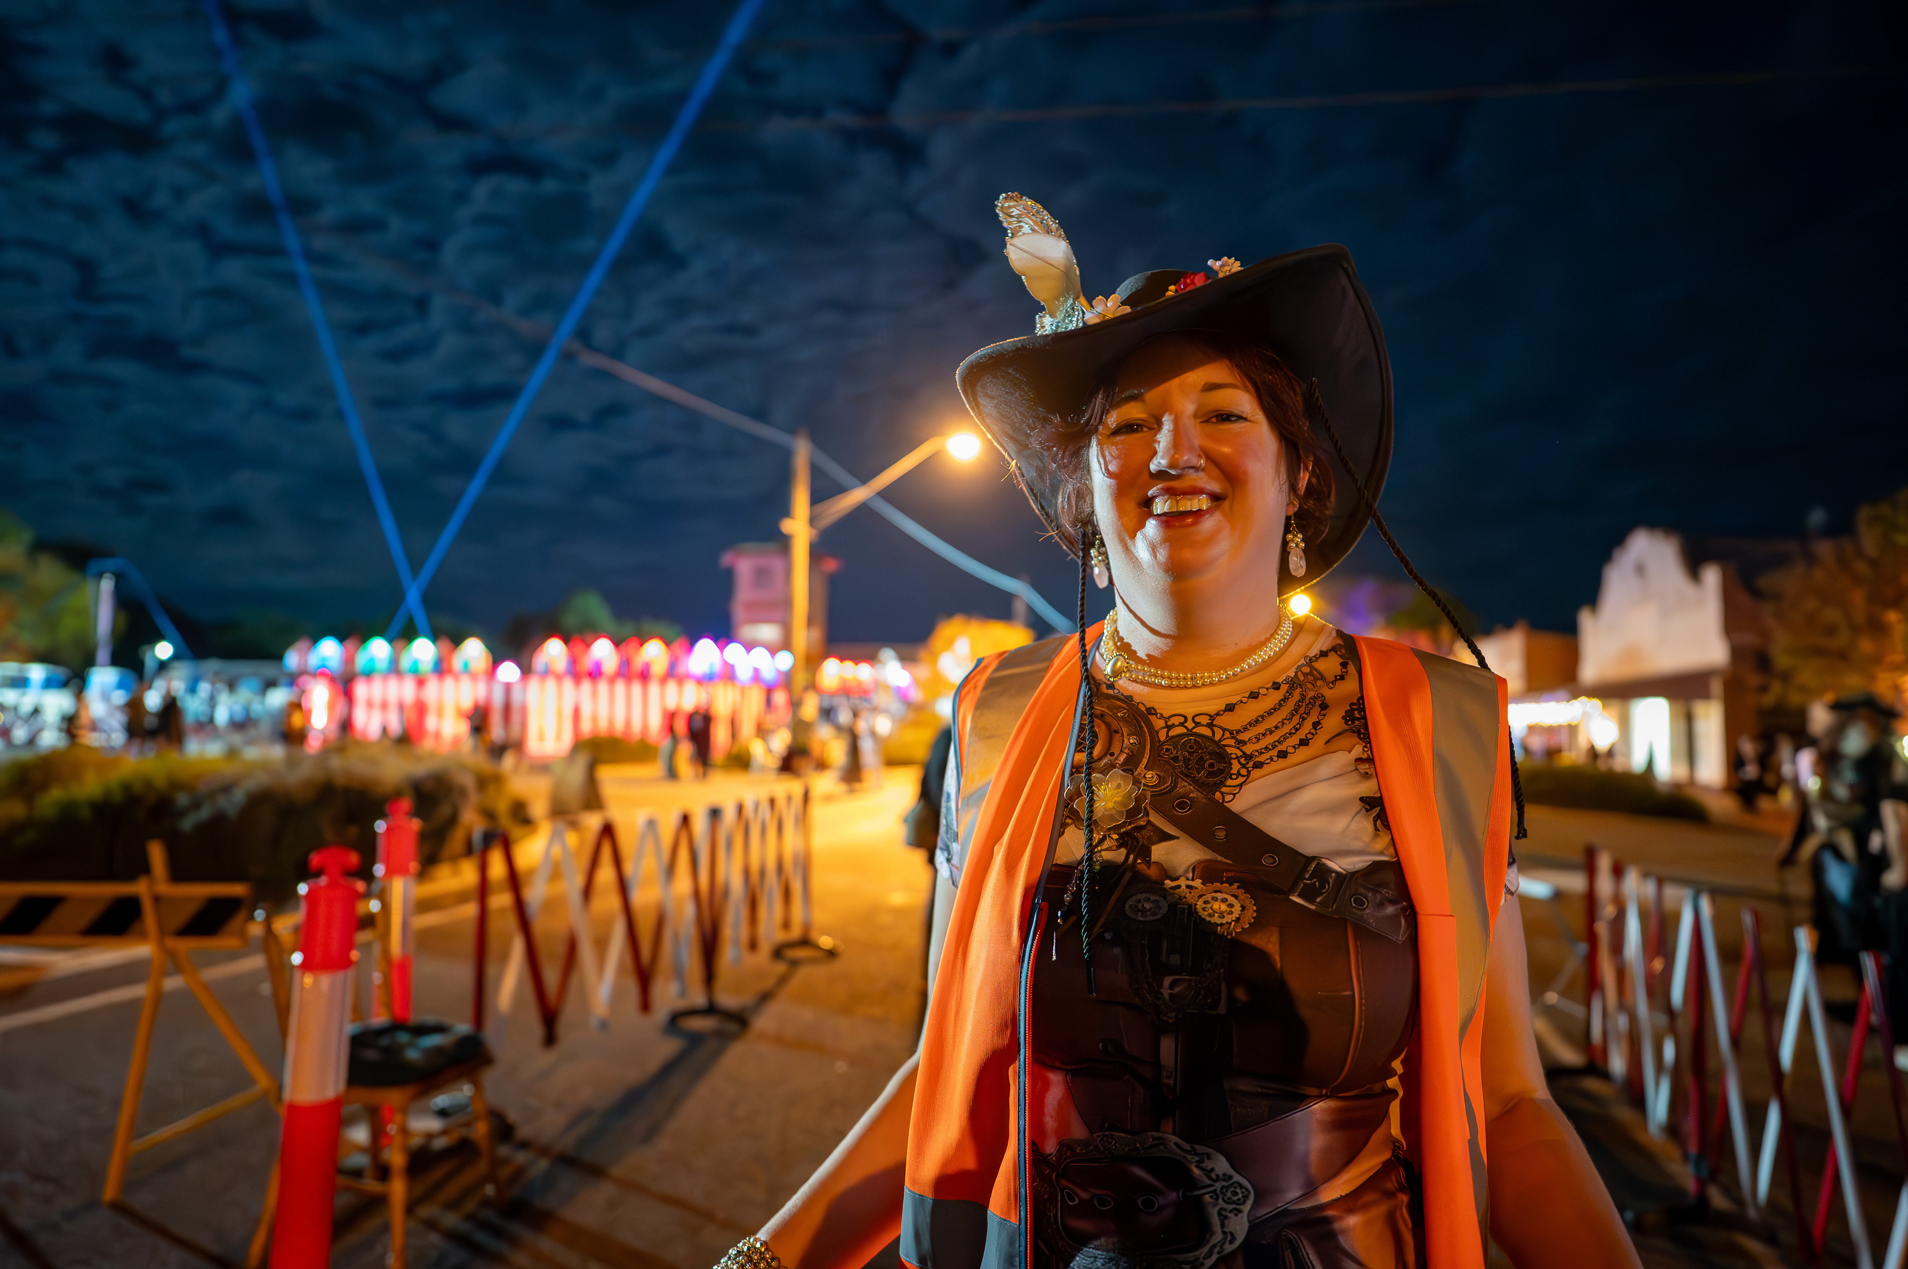
The main entrance
- In addition, the following further information can assist guests:
In addition to the three performance stages, we also feature roving performers and an aerial acrobat.

COMMON AREAS

FOOD AND DRINK

Dining Spaces
The dining spaces have the following facilities/amenities in place
- The entrance has level access
- The doorway is at least 850mm wide
- There is level access through the dining area
- Chairs are moveable to allow for wheelchairs to be seated at the tables
- There are areas of full lighting
- There are large print menus
- There are Plain English menus
- There is an accessible toilet

Our business caters for the following dietary requirements
- Sugar free (diabetic)
- Gluten free (celiac)
- Lactose free (dairy free)
- Low fat and fibre with no gastric content
- Low sodium
- Nut free
- Vegetarian
- Vegan
- In addition, the following further information can assist guests:
Since it's a street party, our food stall holders are responsible for accommodating various dietary requirements. We aim to cater to as many as possible, but this can sometimes be challenging at regional events.
- In addition, the following further information can assist guests:
Since the main event is a street party, there won't be doors, a table layout, servery, bar, etc.

EVENTS

Events
Events have the following facilities/amenities in place
- There is step free access throughout the venue
- All ancillary areas are step free e.g. breakout rooms, dining areas, outside areas and exhibition spaces
- Accessible toilets are available at the venue
- There is clear signage throughout the venue including accessible routes and accessible facilities
- Wheelchair designated seating is provided
- We cater for varying group sizes
- Our event can be booked from the main web site
- There is good circulation space with the number of people expected to allow people with a disability to move around freely
- The event is outdoors
- Portable accessible toilets are available
- Seating is at regular intervals
- Side shows, activities etc. are accessible
- There are designated drop-off points
- There is an event map available
- The event map shows accessible facilities
- The event includes the use of loud noises, fireworks or strobe lighting
- There is a warning included in the event information
- In addition, the following further information can assist guests:
The event is an outdoor street party featuring three stages for live music acts.

Report Disclaimer
Please note that this business report, provided as a result of the use of the diagnostic assessment, is for information purposes only.
Australian Tourism Industry Council (ATIC) cannot guarantee the accuracy of respondent’s answers, or that they are fully representative of your business. Therefore, ATIC does not warrant or guarantee any particular outcome in respect of your businesses self-assessment.
This report is intended as guidance only for your business and should not be relied on for future marketing considerations. ATIC recommends that you seek your own independent advice as well as the results from the diagnostic.
Links to external web sites are inserted for convenience and do not constitute endorsement of material at those sites, or any associated organisation, product or service.
ATIC does not:
- Assume any legal liability for the accuracy, completeness, or usefulness of any information from this report or any links provided; or
- Accept responsibility for any loss associated directly or indirectly from the use of this report.

