ATIC Accessibility
To support the accessible community in making informed travel decisions for their individual needs

This report prepared for:
Business name: | Boho & Prosecco
Address: | Unit 15/9 Dellamarta Road
Town: | Wangara
Contact for enquiries: | Sharon Christou
Contact Number: | 0447279248
Contact Email: | hello@bohoandprosecco.net.au
Website: | https://www.bohoandprosecco.net.au/
Date: | 2026-10-13 14:58

ATIC Accessibility
The following pages provides travellers with information on the businesses facilities and amenities which aims to support the traveller to make an informed decision on whether the business is suitable for their individual needs.
OVERVIEW 3
Business Overview 3
Bookings 3
Communications 3
Other Information 3
Guide Dog and Service Animals 3
GENERAL 5
Pre-arrival, arrival and reception 5
Cognitive Impairment Support 5
Report Disclaimer 7

OVERVIEW

Business Overview
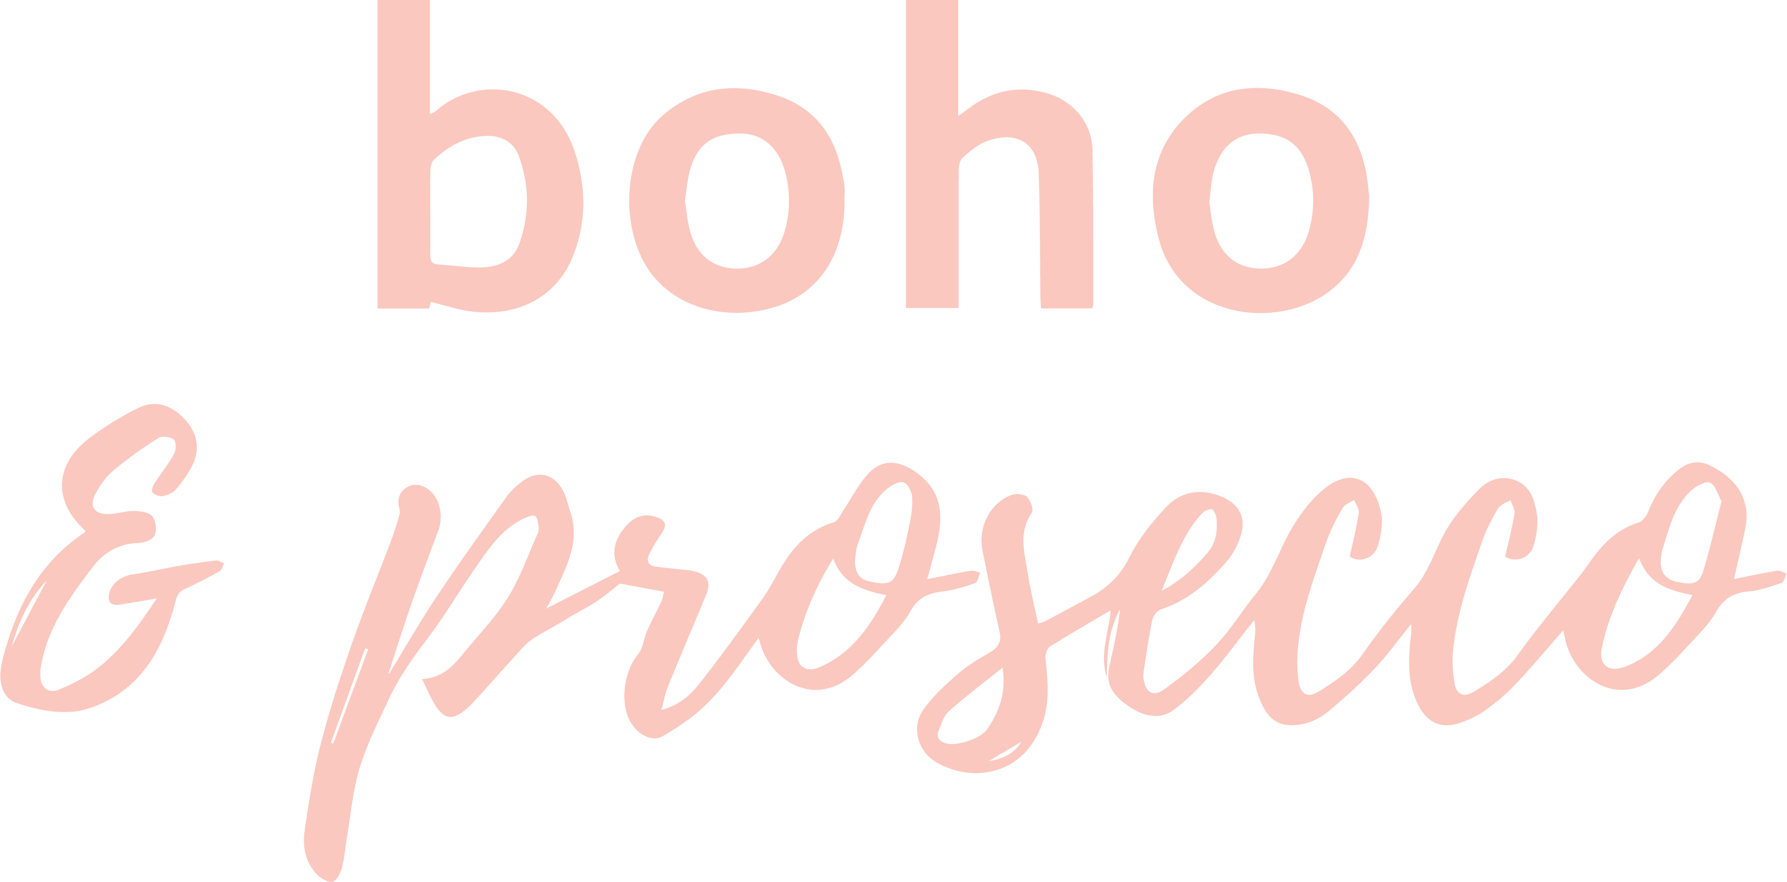

Bookings

The business offers the following methods for bookings and enquiries:
- Phone
- Email

Communications
- Our website meets WCAG 2.0 accessibility standards
- Our business offers the following alternative communication methods
- Plain English
- Magnifiers

Communication through carers, or people who can sign

Other Information
- The business accepts the companion card

Guide Dog and Service Animals
- The business provides a secure area with shade and water for service animals
- The business provides a toilet area for service animals
- Bowls, bedding, etc. are provided for service animals
The business provides the following services for services animals:
All owners with servie dogs are welcomed and we ask what they would like us to provide for the animals comfort and if any rules are to be adhered by staff, eg No patting the animal.

GENERAL

Pre-arrival, arrival and reception
The business has the following in place to support guests during pre-arrival, arrival and reception
- Booking information and websites are compatible with screen readers
- In addition, the following further information can assist guests:
NA
- In addition, the following further information can assist guests:
na

Cognitive Impairment Support
- Documents are available in plain English for people with cognitive impairment (This may include instructions, guides, menus and general information)
- Quiet periods or early opening times for people on the Autism Spectrum
- A space for parents and children on the Autism Spectrum
- In addition, the following further information can assist guests:
na
The width of the smallest pathway is:
na

Outside Park areas ran by councils and the department of parks

Outside Park areas ran by councils and the department of parks
- In addition, the following further information can assist guests:
Outside Park areas ran by councils and the department of parks
- In addition, the following further information can assist guests:
Outside Park areas ran by councils and the department of parks
- In addition, the following further information can assist guests:
Outside Park areas ran by councils and the department of parks

Report Disclaimer
Please note that this business report, provided as a result of the use of the diagnostic assessment, is for information purposes only.
Australian Tourism Industry Council (ATIC) cannot guarantee the accuracy of respondent’s answers, or that they are fully representative of your business. Therefore, ATIC does not warrant or guarantee any particular outcome in respect of your businesses self-assessment.
This report is intended as guidance only for your business and should not be relied on for future marketing considerations. ATIC recommends that you seek your own independent advice as well as the results from the diagnostic.
Links to external web sites are inserted for convenience and do not constitute endorsement of material at those sites, or any associated organisation, product or service.
ATIC does not:
- Assume any legal liability for the accuracy, completeness, or usefulness of any information from this report or any links provided; or
- Accept responsibility for any loss associated directly or indirectly from the use of this report.

