ATIC Accessibility
To support the accessible community in making informed travel decisions for their individual needs

This report prepared for:
Business name: | Cheynes Beach Caravan Park
Address: | 12 Bald Island Rd
Town: | CHEYNES
Contact for enquiries: | Joanne Marsh
Contact Number: | 0898461247
Contact Email: | reception@cheynesbeachcp.au
Website: | www.cheynesbeachcaravanpark.com.au
Date: | 2026-10-26 20:15

ATIC Accessibility
The following pages provides travellers with information on the businesses facilities and amenities which aims to support the traveller to make an informed decision on whether the business is suitable for their individual needs.
OVERVIEW 4
Business Overview 4
Bookings 4
Emergency Management 5
Communications 5
Other Information 5
Guide Dog and Service Animals 6
GENERAL 7
Pre-arrival, arrival and reception 7
Car Park and Access amenities 7
Entry 7
Internal Spaces 8
Public areas 8
External Paths 8
Ramps 8
Public Toilets/Adult change facilities 9
ACCOMMODATION 10
Room Amenities 10
Bathrooms 10
COMMON AREAS 12
Play Spaces 12
FOOD AND DRINK 13
Dining Spaces 13
Report Disclaimer 16

OVERVIEW

Business Overview

The business has the following products/services available
- Accommodation
- Food and Drink

Our business caters for the following disability types:
- Limited mobility
- Wheelchairs or mobility scooters
- Food allergies or intolerances
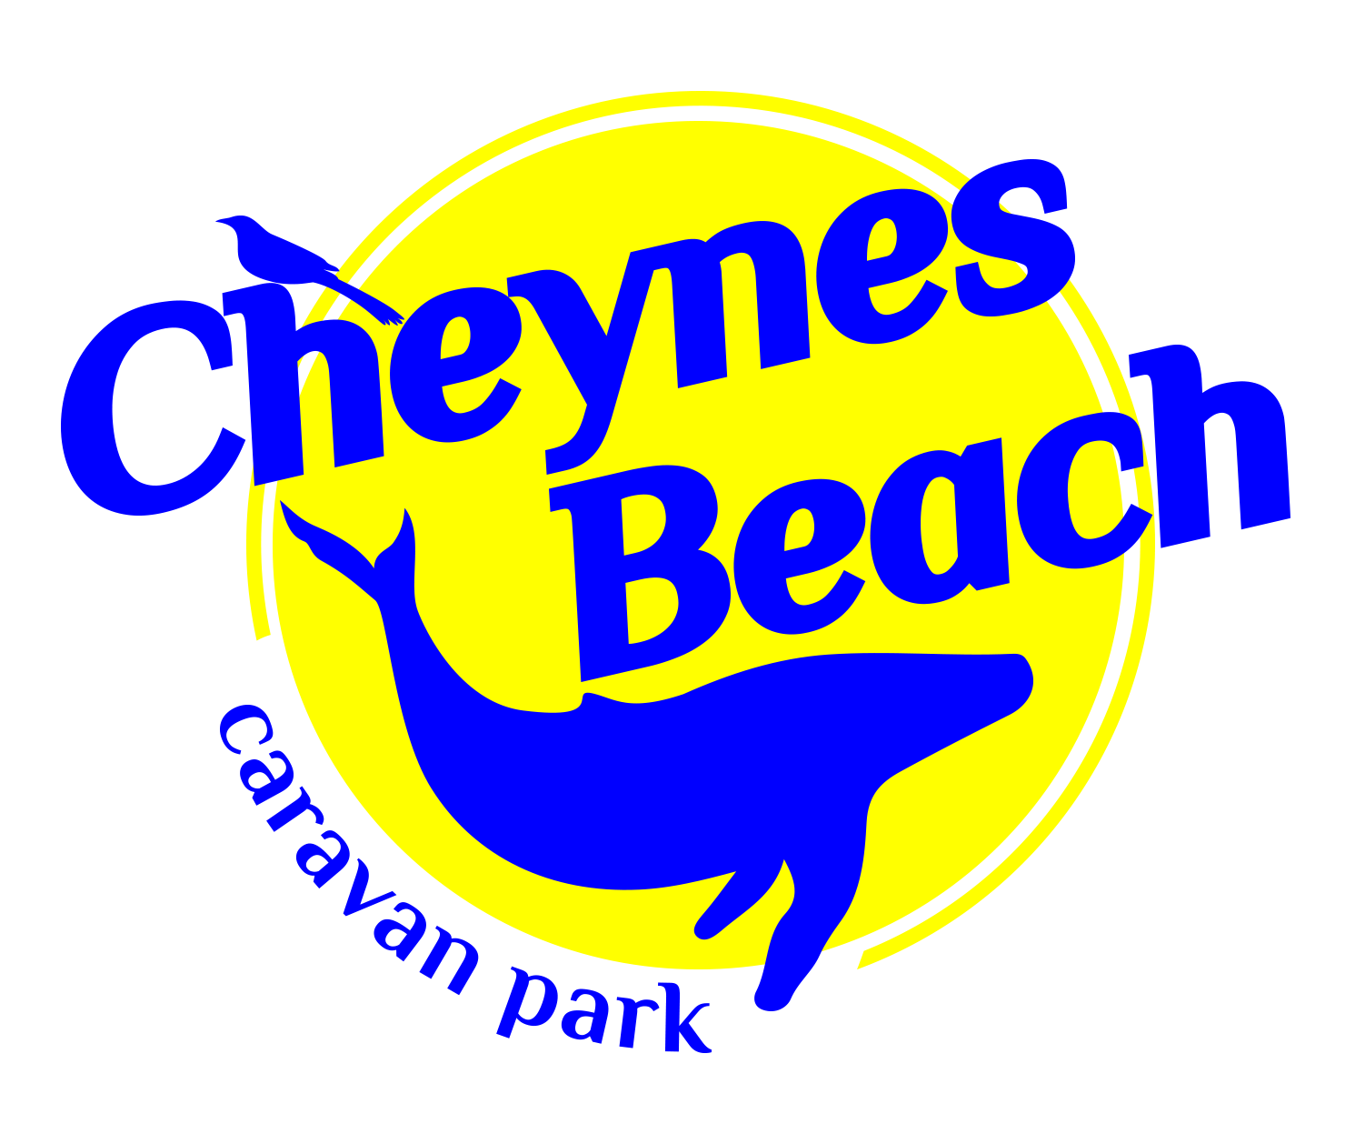

Bookings

The business offers the following methods for bookings and enquiries:
- Phone
- Email
- Webportal
- Our website supports Screen Readers

Emergency Management
- Emergency and evacuation procedures are explained on arrival
- There are visual device/s to alert occupants to evacuate.
- Exit signs are clear and easy to see
- Exit signs have raised lettering or braille
- Exit access is free and clear at all times
We ensure exit access is free and clear at all times by:
Signage and patrol. Our best practice proceedures dictate to keep clear.
- Exits and access to exists are greater than 900mm
- Exit doors are able to be opened by all occupants
- Exits to the emergency evacuation point does not include stairways
- The evacuation point is clearly marked by a sign
- The evacuation point is clearly marked by a sign with raised letters or braille
- In addition, the following further information can assist guests:
On booking we make note of any extra assistance required.
- In addition, the following further information can assist guests:
Identifying any guests who may need extra assistance and offering service. This could be in the form of connecting the caravan to the vehicle ready for departure.
- Guests with disabilities are noted in the guest log book for emergency and evacuation purposes

Communications
- Our business offers the following alternative communication methods
- Plain English

Not specified

Other Information
- For bookings made onsite, the ticket booth/counter/box office is accessible for people using a wheelchair

Guide Dog and Service Animals
- The business provides a secure area with shade and water for service animals
- The business provides a toilet area for service animals
The business provides the following services for services animals:
Water point and shaded at reception and takeaway. Campings sites grassed with water and shade.

GENERAL

Pre-arrival, arrival and reception
The business has the following in place to support guests during pre-arrival, arrival and reception
- Booking information and websites are compatible with screen readers
- There is a reception/public entryway.
- Seating available at reception
- A tablet with text to voice or pen and paper at reception to aid in communication
- Lighting in the reception area is even and glare free

No part of the check in process requires written communication
- Information and maps are available in written form
- In addition, the following further information can assist guests:
We have a speedy check in process with minimal check in times. During the peak season there are more staff on. Maximum wait times are 10 minutes.

Car Park and Access amenities
The business has the following Car Park and Access amenities
- A drop off zone
- Designated disabled parking bays
- Level or ramped access from the car park to the entrance

Entry
The business has the following amenities/systems in place for entry
- A drop off point close to the entrance
- A path of access to the building is slip resistance and even
- A path of access to the building is clear of obstruction
- Glass doors are fitted with a visual sighting strip
- Door jams/doors are of a contrasting colour to surrounding walls
- Signage is written in a contrasting colour
- The entry door is a minimum of 850mm wide
- The entrance sill is less than 13mm
- There a clear space of at least 1500mm x 1500mm in front of all doors.
- The entrance door mats have a thickness less than 13mm and a width of 7500mm or greater
- In addition, the following further information can assist guests:
No lifts

Internal Spaces
- Clear and unobstructed routes through and between buildings
- Interior walls are matte or low sheen
- Floors, walls, counters and furniture are of contrasting colours
- Floor surfaces are hard or short pile carpet
- Seating is available for guests unable to stand for long periods
- Accessible facilities are clearly signed and visible from all areas
- All corridors greater than 900mm

Public areas
The public areas have the following amenities in place
- Even lighting
- Seating

External Paths
External paths of travel
- Surfaces are concrete, asphalt, smooth paving or hard packed fine gravel (max aggregate size 13mm)
- Pathways are wider than 900mm
- Step free routes clearly signed

Ramps
Ramps have the following amenities are in place
- There are ramps.
- All fixed ramps are 1:14 or less
- Hand rails are fitted
- Long ramps (more than 10m) are 1:20 or less
- Ramps have a raised edge of at least 100mm

Public Toilets/Adult change facilities
Public Toilets/Adult change facilities have the following amenities are in place
- There is an accessible toilet for public use
- The door is at least 850mm wide
- There is a minimum of 850mm beside the toilet
- Handrails are fitted
- The toilet seat is 460mm above the floor
- The toilet seat of a contrasting colour to the floor
- The toilet seat is460mm above the floor

ACCOMMODATION

Room Amenities
- Televisions are equipped with closed captioning capability
- There is contrast between the walls, skirtings, floor and furniture
- There is a clear path through the room
- The edges of all furniture and fixtures are rounded
- Housekeeping procedures instruct staff not to reposition furniture that has been moved
- Doors open fully against the adjoining wall
- There is a clear opening at least 850mm wide
- There at least one chair with rigid arms
- Wardrobe and drawer handles are easy to grip
- The bedside lamp switch is easy to reach from the bed
- There is at least 850mm clear space beside the bed
- The bed height is no higher than 680mm from the floor
- Non-allergenic cleaning products are used

Bathrooms
The bathrooms have the following facilities/amenities in place
- All heating appliances and hot water pipes are protected or insulated
- All shower, bath and basin taps are clearly differentiated between hot and cold
- Fixtures and fittings have rounded edges
- The hot water is thermostatically controlled to 41 degrees
- The door is at least 850mm wide
- The width beside the toilet is n/a.
- There is 1200 mm of clear space in front of the toilet
- The toilet seat is a contrasting colour to the floor
- The toilet seat is 460mm above the floor
- A door is fitted to the shower
  - Bathroom Image(s)
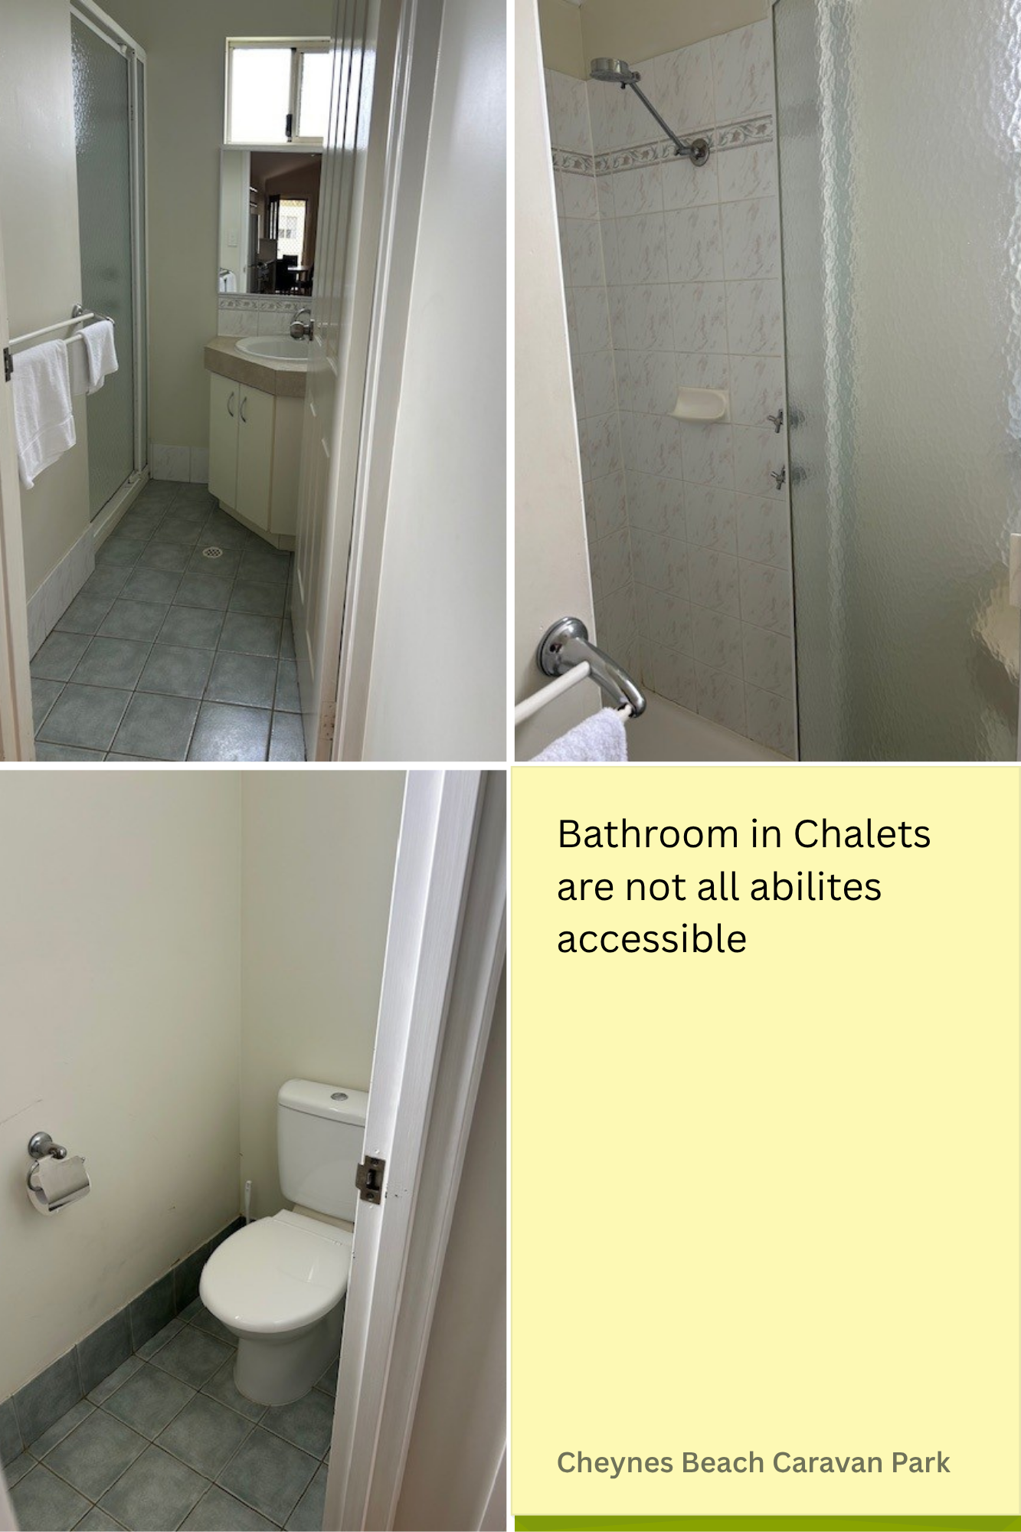
chalet bathroom1
- In addition, the following further information can assist guests:
The amenities in the caravan park have an all abilities bathroom available to use.

COMMON AREAS

Play Spaces
- Level access is provided to play spaces
- The play space contains tactile play panels or activities
- The space contain colour contrasting elements
- Seating is provided in or around the play space
  - Image(s)
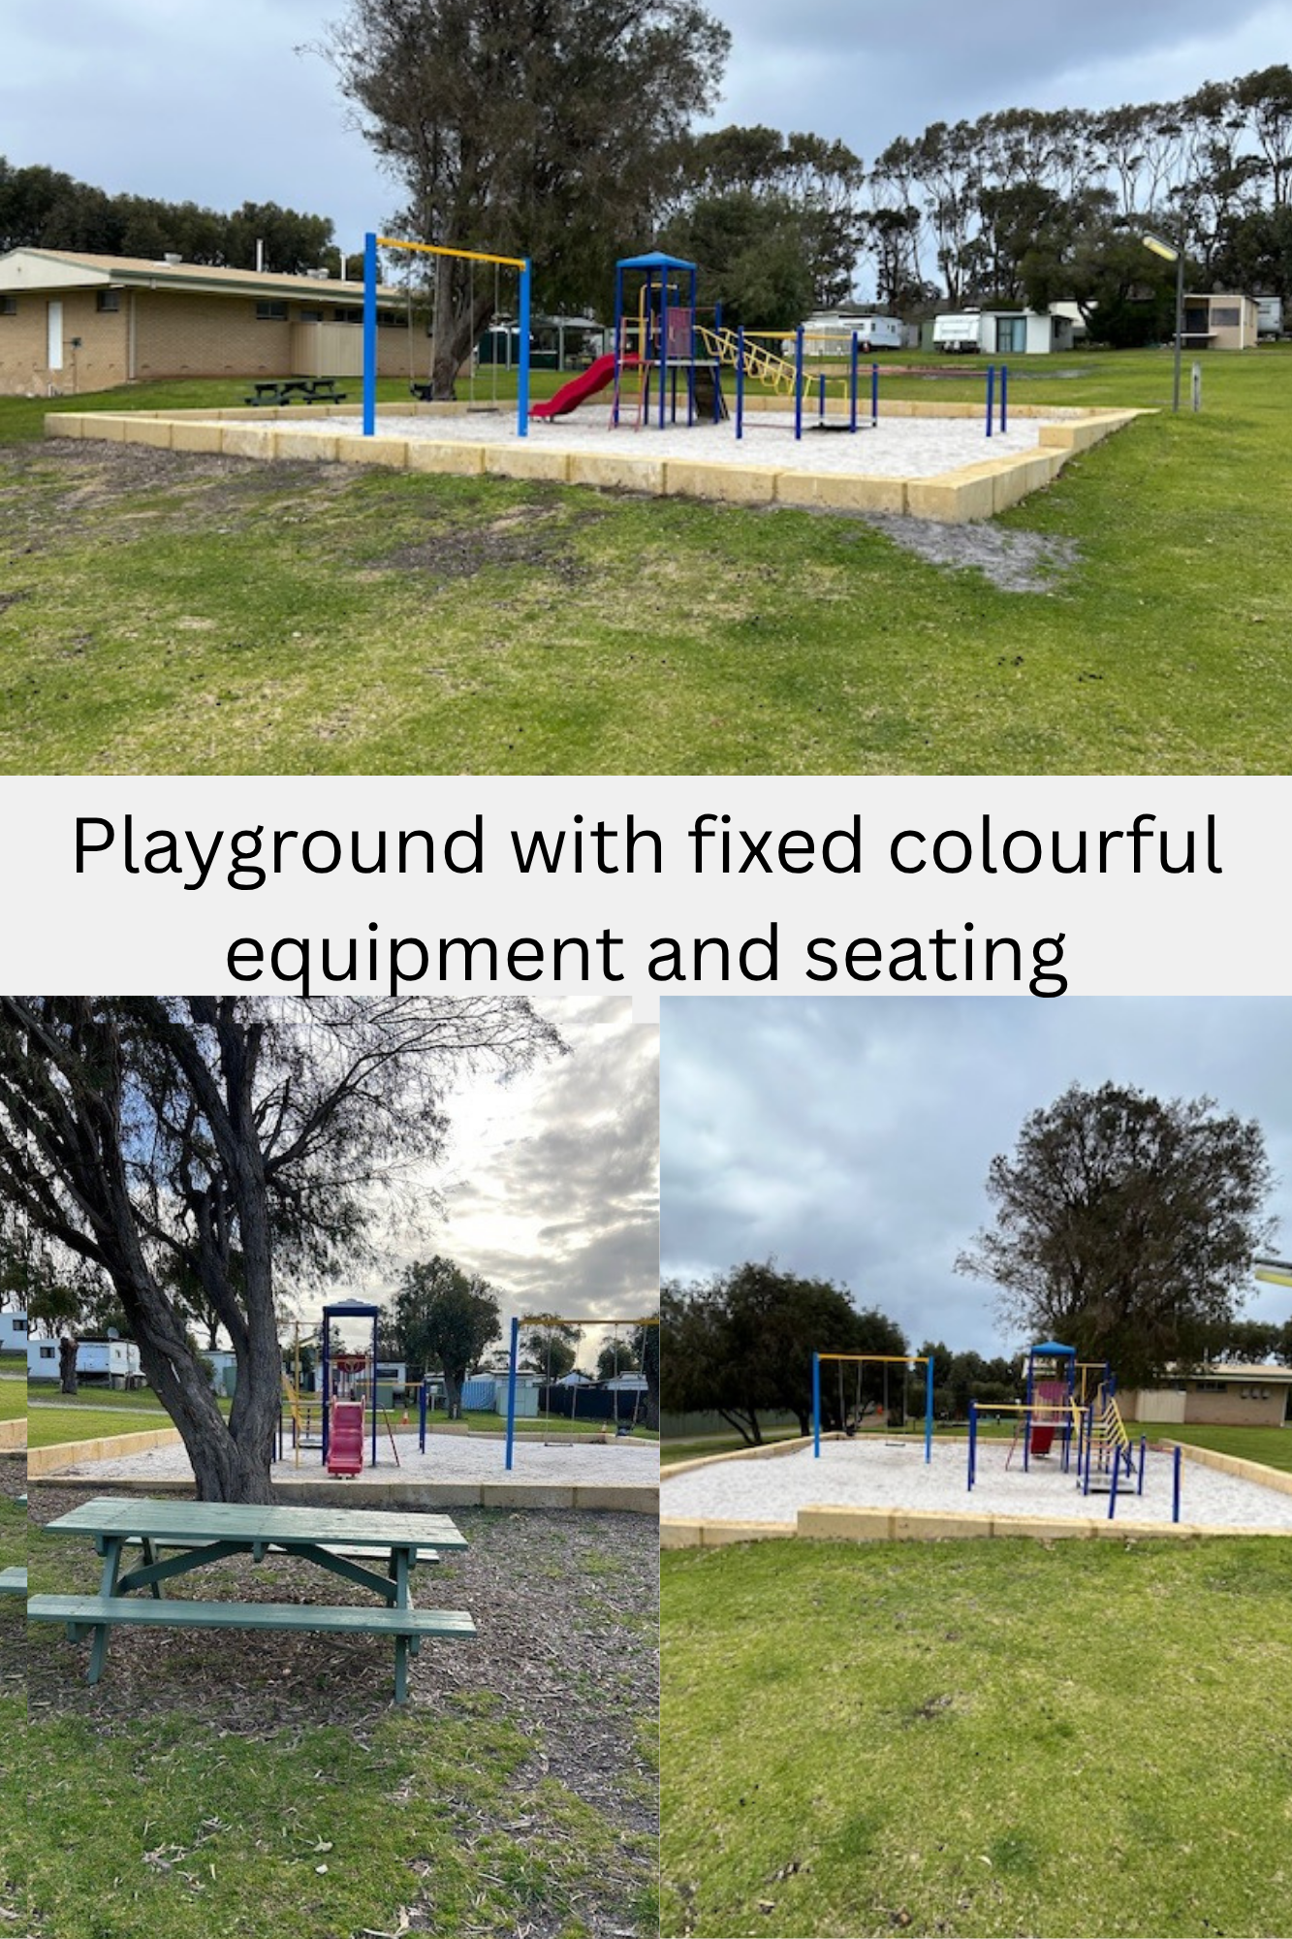
playground..

FOOD AND DRINK

Dining Spaces
The dining spaces have the following facilities/amenities in place
- The entrance has level access
- The doorway is at least 850mm wide
- There is level access through the dining area
- Chairs are moveable to allow for wheelchairs to be seated at the tables
- All glass doors and full height windows have contrast markings
- There are areas of full lighting
- There are Plain English menus
- There is an accessible toilet

Our business caters for the following dietary requirements
- Sugar free (diabetic)
- Gluten free (celiac)
- Lactose free (dairy free)
- Nut free
- Vegetarian
- In addition, the following further information can assist guests:
all food prep is separate. separate deep fryer for glueten free.
- There is a sample menu available online
Sample menu is available here -
https://www.cheynesbeachcaravanpark.com.au/takeaway-cafe
  - Food and Beverage Image(s)
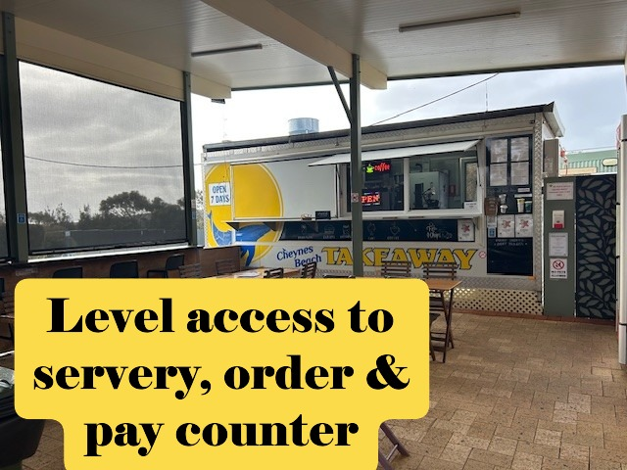
takeaway1a.JPG
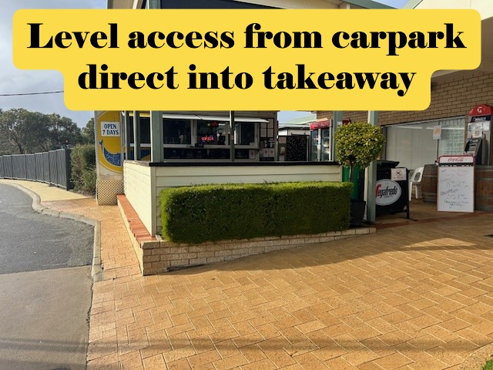
takeaway2a.JPG
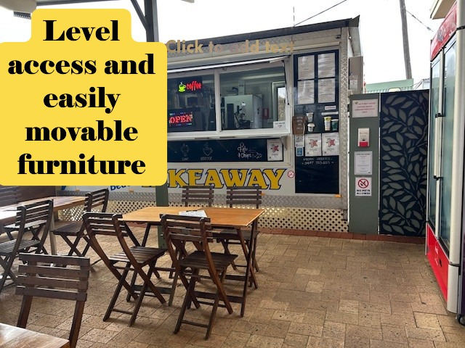
takeway5a.JPG

Report Disclaimer
Please note that this business report, provided as a result of the use of the diagnostic assessment, is for information purposes only.
Australian Tourism Industry Council (ATIC) cannot guarantee the accuracy of respondent’s answers, or that they are fully representative of your business. Therefore, ATIC does not warrant or guarantee any particular outcome in respect of your businesses self-assessment.
This report is intended as guidance only for your business and should not be relied on for future marketing considerations. ATIC recommends that you seek your own independent advice as well as the results from the diagnostic.
Links to external web sites are inserted for convenience and do not constitute endorsement of material at those sites, or any associated organisation, product or service.
ATIC does not:
- Assume any legal liability for the accuracy, completeness, or usefulness of any information from this report or any links provided; or
- Accept responsibility for any loss associated directly or indirectly from the use of this report.

