ATIC Accessibility
To support the accessible community in making informed travel decisions for their individual needs

This report prepared for:
Business name: | Absolute Ocean Charters
Address: | 10 Weld St
Town: | Broome
Contact for enquiries: | Kelly Woodley
Contact Number: | 08 91925095
Contact Email: | info@absoluteoceancharters.com.au
Website: | https://www.absoluteoceancharters.com.au
Date: | 2026-09-20 20:50

ATIC Accessibility
The following pages provides travellers with information on the businesses facilities and amenities which aims to support the traveller to make an informed decision on whether the business is suitable for their individual needs.
OVERVIEW 4
Business Overview 4
Bookings 4
Emergency Management 5
Communications 5
Other Information 5
GENERAL 6
Pre-arrival, arrival and reception 6
Cognitive Impairment Support 6
Car Park and Access amenities 6
Displays, exhibits, commentary and live performances 6
External Paths 7
Public Toilets/Adult change facilities 7
TOUR OPERATORS 8
Tour/Transport Services 8
Route Planning 8
Guides 8
ATTRACTIONS 10
COMMON AREAS 11
ADVENTURE ACTIVITIES 12
Adventure activities 12
Report Disclaimer 14

OVERVIEW

Business Overview

The business has the following products/services available
- Tour/Transport
- Attraction
- Adventure

Our business caters for the following disability types:
- Blind or low vision
- Deaf or low hearing
- Limited mobility
- Wheelchairs or mobility scooters
- Food allergies or intolerances
- Cognitive or people on the Autism Spectrum
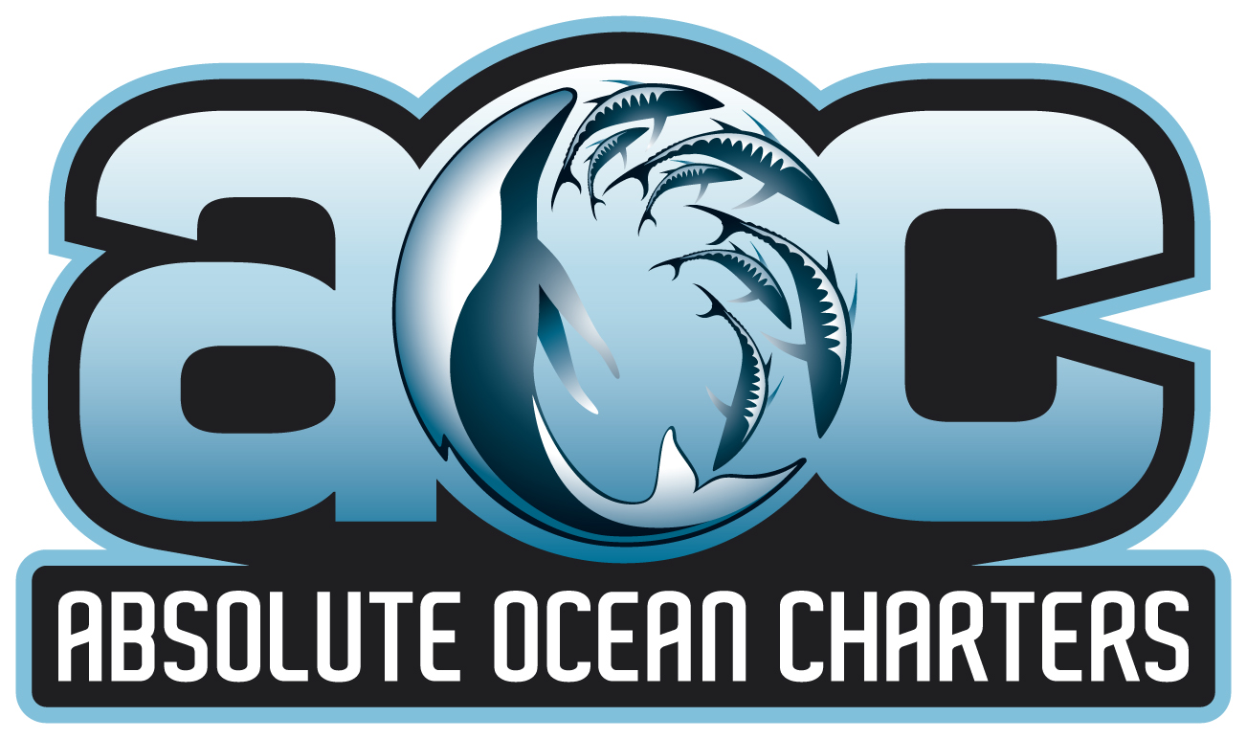

Bookings

The business offers the following methods for bookings and enquiries:
- Phone
- Email
- Webportal
- Our website supports Screen Readers
- Our forms have high contract boxes and submit boxes
- Staff have undergone disability awareness and training

Emergency Management
- Emergency and evacuation procedures are explained on arrival
- There are Audible device/s to alert occupants to evacuate with instructions on how to evacuate.
- Exit signs are clear and easy to see
- Exit access is free and clear at all times
We ensure exit access is free and clear at all times by:
Walkways are always clear on the vessel and isn't an enclosed space.
- Exits and access to exists are greater than 900mm
- Exit doors are able to be opened by all occupants
- Exits to the emergency evacuation point does not include stairways
- The evacuation point is clearly marked by a sign
- In addition, the following further information can assist guests:
It is noted at time of booking and is alerted to all staff prior to boarding.
- In addition, the following further information can assist guests:
crew and skipper assist as required
- Guests with disabilities are noted in the guest log book for emergency and evacuation purposes

Communications
- Our website meets WCAG 2.0 accessibility standards
- Our business offers the following alternative communication methods
- Plain English

Not specified
- There is easy to read signage and information (e.g. menus and emergency information)
- There is a Pictorial menu

Other Information
- The business accepts the companion card
The business provides the following services for services animals:
Not specified

GENERAL

Pre-arrival, arrival and reception
The business has the following in place to support guests during pre-arrival, arrival and reception
- Booking information and websites are compatible with screen readers
- Information and maps are available in written form
- In addition, the following further information can assist guests:
Priority boarding and Set Pick Up Times

Cognitive Impairment Support
- Documents are available in plain English for people with cognitive impairment (This may include instructions, guides, menus and general information)
- Access has alternative procedures and clear written instructions with universal access symbols

Car Park and Access amenities
The business has the following Car Park and Access amenities
- A drop off zone

Displays, exhibits, commentary and live performances
For displays, exhibits, commentary and live performances the following amenities are in place
- Seating
- Wheelchair accessible spaces/seating
- A written transcript where audio description is provided i.e. display commentary, tour commentary
- In addition, the following further information can assist guests:
For our boat charters we have wheelchair spaces / seating available.
For our bus tours we can accommodate a folding wheelchair, bus seating would need to be used.
Please note we do not have ramp access to the boat or bus, so please contact us to discuss prior to booking.

External Paths
External paths of travel
- Pathways are wider than 900mm

Public Toilets/Adult change facilities
Public Toilets/Adult change facilities have the following amenities are in place
- There is a registered changing places facility
- There is a 'Changing Place' within 1.5mtr of our business

TOUR OPERATORS

Tour/Transport Services
The tour/transport services have the following facilities/amenities in place
- Buses/Coaches
- 0 vehicles have wheelchair lifts or ramps
- 0 vehicles have low floors with ramped entry
The maximum wheelchair capacity available in the fleet is:
3
- Commentary is available in written format

Route Planning
- Route Planning
- In addition, the following further information can assist guests:
Boat Toilet - would require the wheelchair to remain outside, hand rail is available.

- Lunch stop venues are accessible
- Sightseeing and photo opportunity stops are step free

Guides
- Use of clear/simple English
- Correct pronunciation for lip readers
- There is a audio description of surroundings
- Marine
  - Image(s)
AOC Logo
- In addition, the following further information can assist guests:
Bus Tour: Top sites include Streeters Jetty, Matso's Broome Brewery, Roebuck Bay, Entrance Point, Gantheaume Point, Cable Beach and More!

ATTRACTIONS
  - Image(s)
AOC Logo

COMMON AREAS

ADVENTURE ACTIVITIES

Adventure activities
The adventure activities have the following facilities/amenities in place
- Our adventure activities cater for people with a disability
- In addition, the following further information can assist guests:
Fishing Charters
Snubfin Dolphin Cruises
Whale Cruises
Broome Town Bus Tour
- In addition, the following further information can assist guests:
Fishing Charters - Involve Fishing Rods, Hooks, Bait, Lures.
Snubfin Dolphin and Whale Cruises - no additional equipment required - Wildlife viewing
Broome Town Bus Tour - no additional equipment required
- In addition, the following further information can assist guests:
Accessibility onto the vessel and bus, will need to be accessed per individual as some movement to and from the bus and boat, does require physical assistant from the crew and some moveability from the individual.
  - Adventure Activity Image(s)
AOC Logo

Report Disclaimer
Please note that this business report, provided as a result of the use of the diagnostic assessment, is for information purposes only.
Australian Tourism Industry Council (ATIC) cannot guarantee the accuracy of respondent’s answers, or that they are fully representative of your business. Therefore, ATIC does not warrant or guarantee any particular outcome in respect of your businesses self-assessment.
This report is intended as guidance only for your business and should not be relied on for future marketing considerations. ATIC recommends that you seek your own independent advice as well as the results from the diagnostic.
Links to external web sites are inserted for convenience and do not constitute endorsement of material at those sites, or any associated organisation, product or service.
ATIC does not:
- Assume any legal liability for the accuracy, completeness, or usefulness of any information from this report or any links provided; or
- Accept responsibility for any loss associated directly or indirectly from the use of this report.

