ATIC Accessibility
To support the accessible community in making informed travel decisions for their individual needs

This report prepared for:
Business name: | FORM building a state of creativity Limited
Address: | Level 4, Saint Georges Tce
Town: | Perth
Contact for enquiries: | Stephanie Xiao
Contact Number: | 0893852200
Contact Email: | mail@form.net.au
Website: | www.form.net.au
Date: | 2026-10-21 14:41

ATIC Accessibility
The following pages provides travellers with information on the businesses facilities and amenities which aims to support the traveller to make an informed decision on whether the business is suitable for their individual needs.
OVERVIEW 4
Business Overview 4
Bookings 4
Emergency Management 4
Communications 5
Other Information 5
Guide Dog and Service Animals 5
GENERAL 7
Pre-arrival, arrival and reception 7
Cognitive Impairment Support 7
Car Park and Access amenities 7
Entry 7
Internal Spaces 8
Public areas 8
Displays, exhibits, commentary and live performances 8
External Paths 8
Public Toilets/Adult change facilities 9
ATTRACTIONS 10
COMMON AREAS 16
EVENTS 17
Events 17
Report Disclaimer 19

OVERVIEW

Business Overview

The business has the following products/services available
- Attraction
- Event

Our business caters for the following disability types:
- Blind or low vision
- Deaf or low hearing
- Limited mobility
- Wheelchairs or mobility scooters
- Cognitive or people on the Autism Spectrum


Bookings

The business offers the following methods for bookings and enquiries:
- Phone
- Email
- Webportal
- Our forms have high contract boxes and submit boxes

Emergency Management
- Emergency and evacuation procedures are explained on arrival
- There are Audible device/s to alert occupants to evacuate with instructions on how to evacuate.
- Exit signs are clear and easy to see
- Exit access is free and clear at all times
We ensure exit access is free and clear at all times by:
No objects blocking the door ways
- Exits and access to exists are greater than 900mm
- Exit doors are able to be opened by all occupants
- Exits to the emergency evacuation point does not include stairways
- In addition, the following further information can assist guests:
All of our artists notify us of extra assistance on application to be an artist under Spinifex Hill Studio
- In addition, the following further information can assist guests:
Most of our artists are not left without a studio coordinator to supervise, or they are supported by a social worker or support worker

Communications
- Our business offers the following alternative communication methods
- Plain English

Not specified
- There is easy to read signage and information (e.g. menus and emergency information)

Other Information
- For bookings made onsite, the ticket booth/counter/box office is accessible for people using a wheelchair
- The business accepts the companion card

Guide Dog and Service Animals
- The business provides a secure area with shade and water for service animals
- The business provides a toilet area for service animals
The business provides the following services for services animals:
Not specified

GENERAL

Pre-arrival, arrival and reception
The business has the following in place to support guests during pre-arrival, arrival and reception
- Booking information and websites are compatible with screen readers
- There is a reception/public entryway.
- A lower counter at reception/ticket office
- Lighting in the reception area is even and glare free
- Large print information sheets and registration forms
- A familiarisation tour
- In addition, the following further information can assist guests:
We are an art centre so there is no wait time, it is simply about people taking their time when viewing in the gallery.

Cognitive Impairment Support
- Documents are available in plain English for people with cognitive impairment (This may include instructions, guides, menus and general information)
- Access has alternative procedures and clear written instructions with universal access symbols

Car Park and Access amenities
The business has the following Car Park and Access amenities
- Designated disabled parking bays
- Level or ramped access from the car park to the entrance
- The accessible entrance is clearly signed from the parking bay

Entry
The business has the following amenities/systems in place for entry
- A path of access to the building is slip resistance and even
- A path of access to the building is clear of obstruction
- Glass doors are fitted with a visual sighting strip
- Door handles are of a contrasting colour to the door
- Signage is written in a contrasting colour
- The entry door is a minimum of 850mm wide
- The entry door has self opening or a light opening pressure (for manual operations)
- There a clear space of at least 1500mm x 1500mm in front of all doors.
- The entrance door mats have a thickness less than 13mm and a width of 7500mm or greater

Internal Spaces
- Clear and unobstructed routes through and between buildings
- Interior walls are matte or low sheen
- Floors, walls, counters and furniture are of contrasting colours
- Any protruding or overhanging obstructions are at least 2meters above the floor or are protected
- Seating is available for guests unable to stand for long periods
- Accessible facilities are clearly signed and visible from all areas
- All corridors greater than 900mm

Public areas
The public areas have the following amenities in place
- Even lighting

Displays, exhibits, commentary and live performances
For displays, exhibits, commentary and live performances the following amenities are in place
- Wheelchair accessible spaces/seating
- A written transcript where audio description is provided i.e. display commentary, tour commentary

External Paths
External paths of travel
- Surfaces are concrete, asphalt, smooth paving or hard packed fine gravel (max aggregate size 13mm)
- Paths or slopes longer than 15 metres have resting places or seats
- Pathways are wider than 900mm
- Step free routes clearly signed

Public Toilets/Adult change facilities
Public Toilets/Adult change facilities have the following amenities are in place
- There is an accessible toilet for public use
- The door is at least 850mm wide
- There is a minimum of 850mm beside the toilet
- Handrails are fitted
- The toilet seat is 460mm above the floor
- The toilet seat of a contrasting colour to the floor
- The toilet seat is460mm above the floor

ATTRACTIONS
  - Image(s)
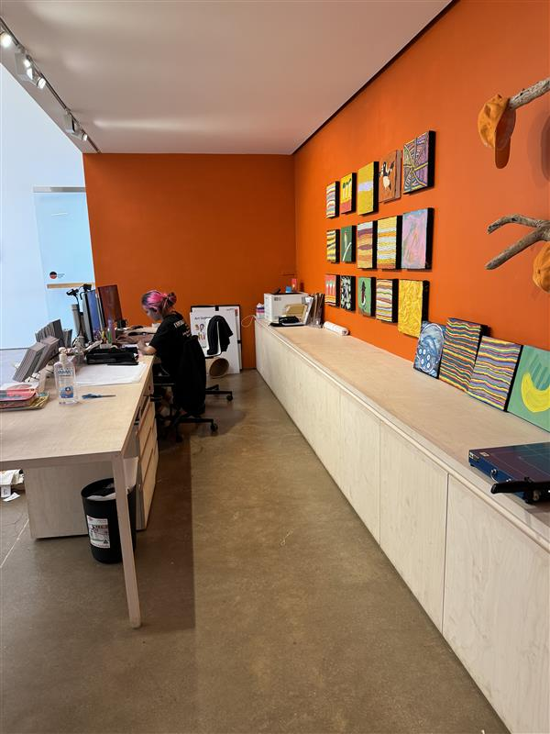
be7e7e85-804d-43d6-9201-a0a363d8c17b
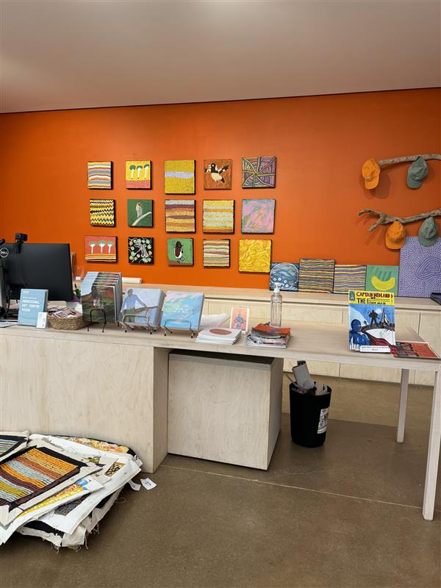
3118238b-2234-4ea9-b7c6-98bf06b878f4
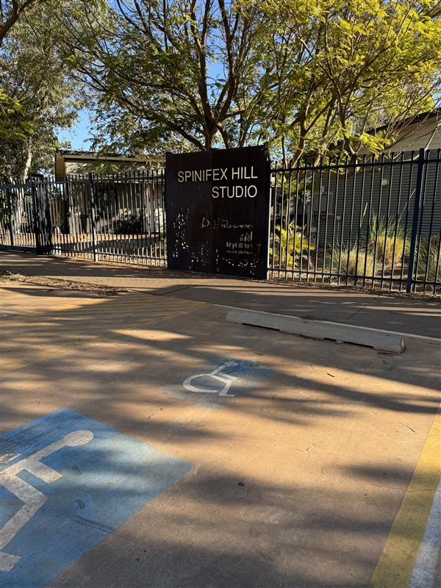
2a547859-4b50-431b-82b8-578cfdc99eda
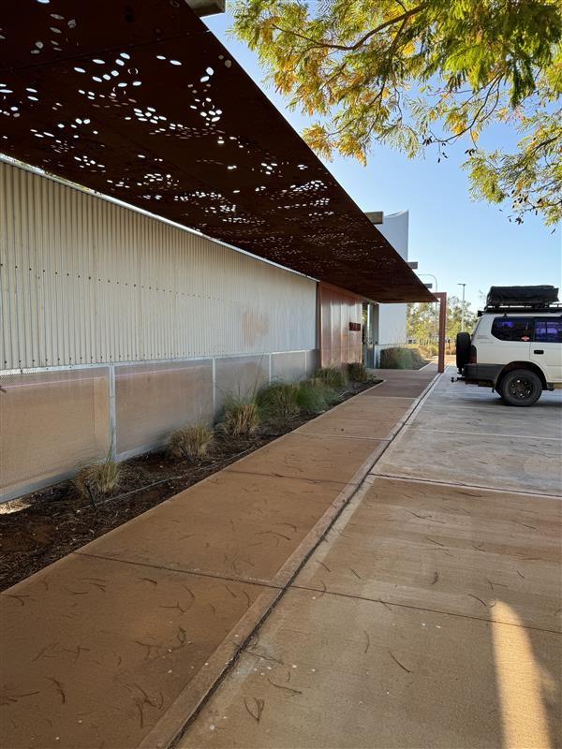
5bc10b7c-a007-4044-a4fc-99c11357415b
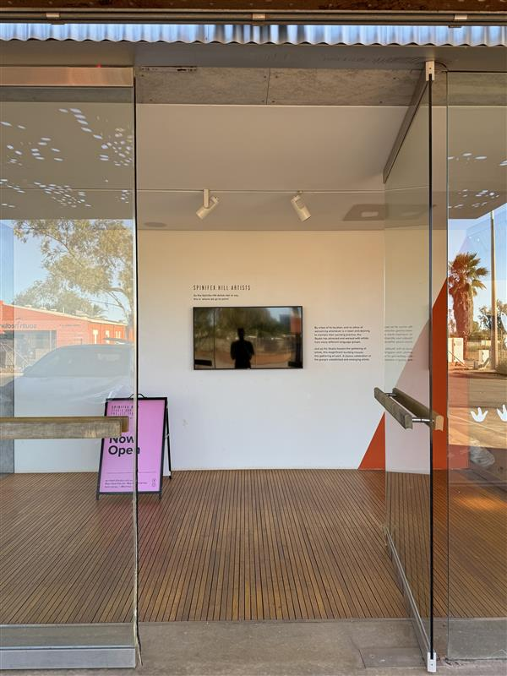
ab4bf0ea-08b3-4a79-84f7-a6d2364e9564
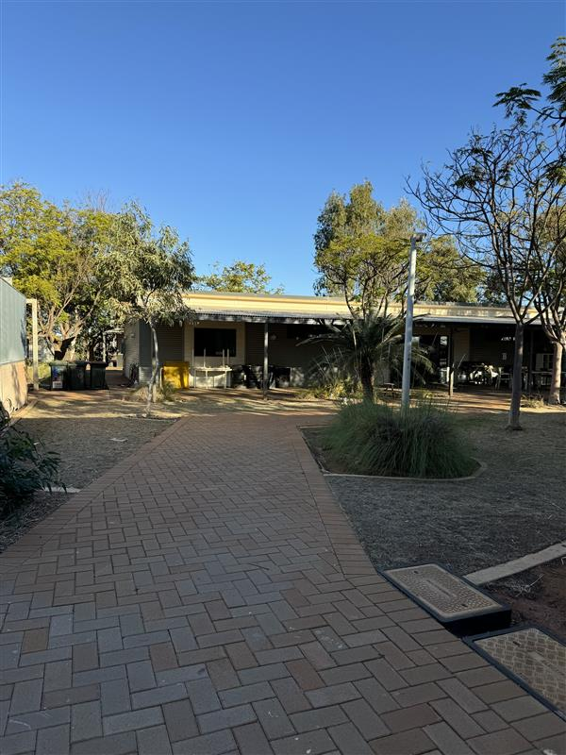
fee116ed-d215-4428-a08d-c90ba7691578
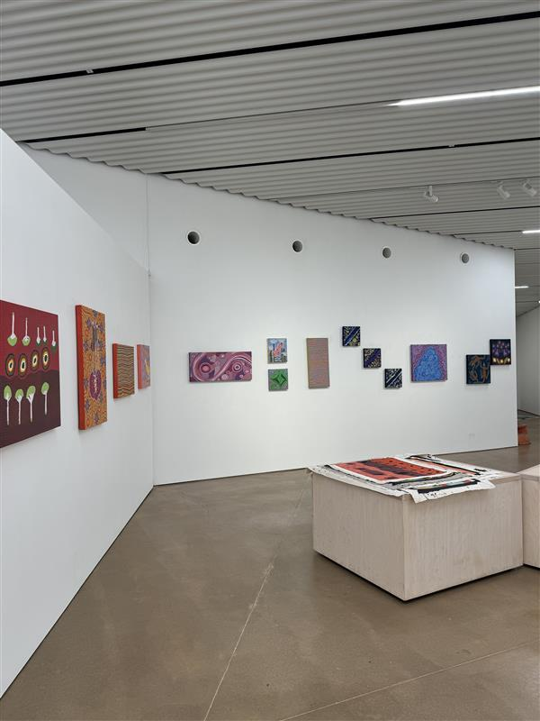
65e04bcc-394c-4604-ba72-e50d199f5288
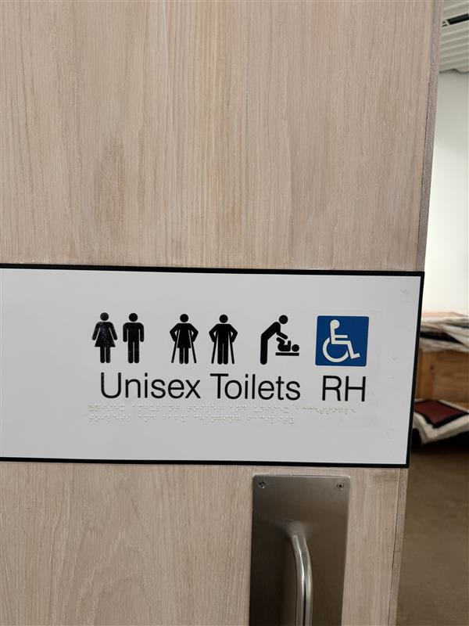
c66d1766-47fe-457e-87d1-943b222b44e8
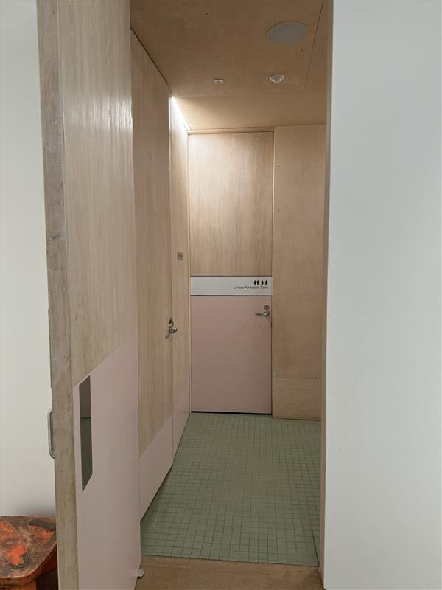
82a5a9f2-2d3c-44a7-b3a3-5c9a36f0fc43
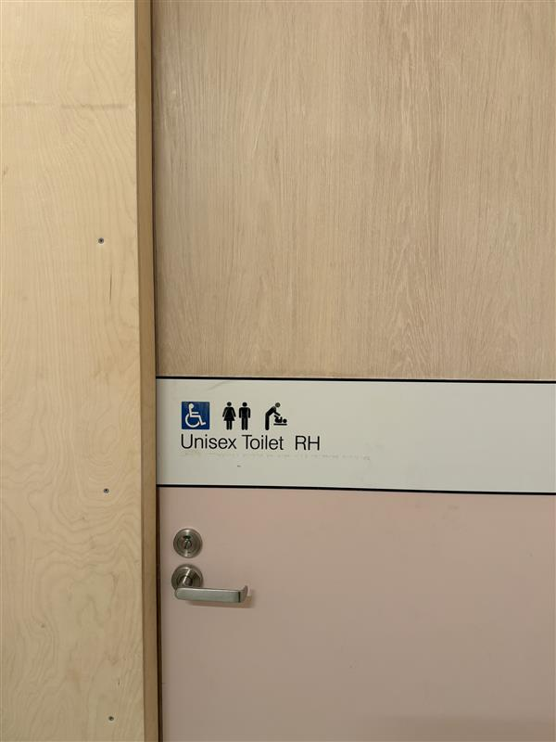
db045b66-9fb6-42c3-a258-8a5213c8baa8
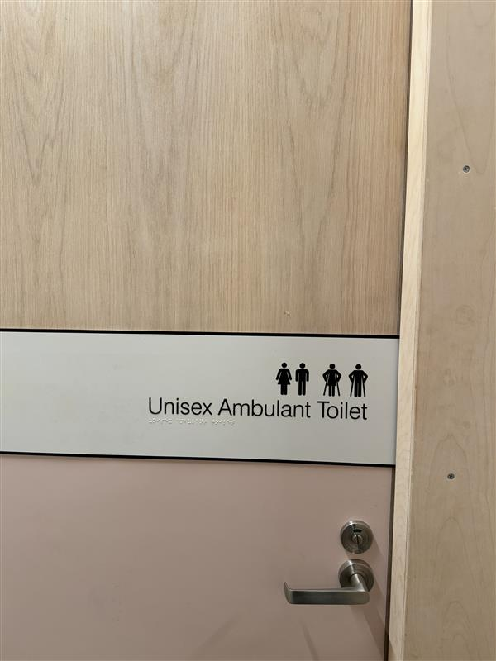
64d6b2ca-0305-4014-8d55-f46825becf67
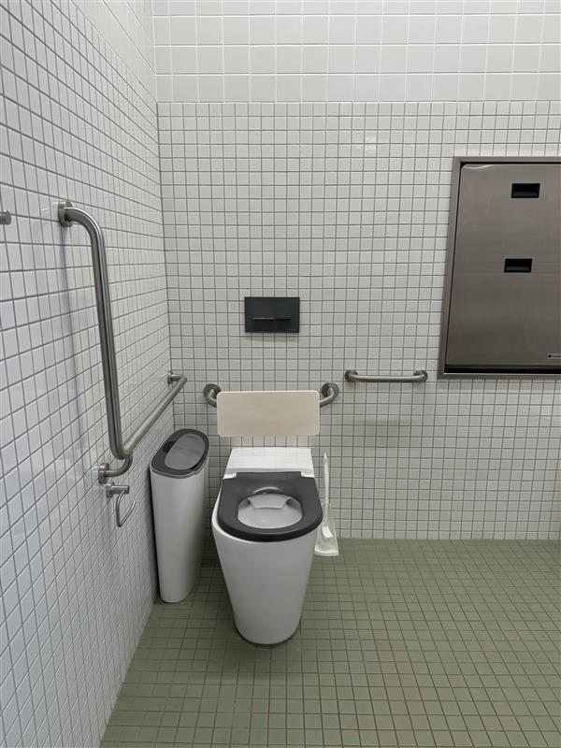
a53932ed-3ce5-4852-a190-6e664286fcbd
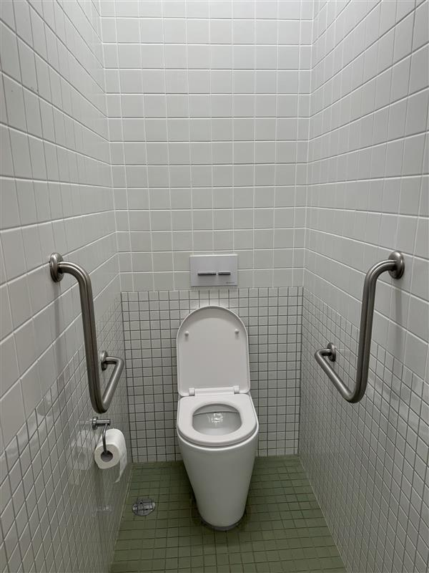
a47fdee3-6af9-4962-a001-d6535959a3ff

COMMON AREAS

EVENTS

Events
Events have the following facilities/amenities in place
- There is step free access throughout the venue
- Reception, registration desks or ticket offices have a lower counter section
- All ancillary areas are step free e.g. breakout rooms, dining areas, outside areas and exhibition spaces
- All stage areas including speaker platforms are accessible
- Accessible toilets are available at the venue
- There is clear signage throughout the venue including accessible routes and accessible facilities
- There is good circulation space with the number of people expected to allow people with a disability to move around freely
- Food and water is available for guide and service animals
- Accessible car parking is available

Report Disclaimer
Please note that this business report, provided as a result of the use of the diagnostic assessment, is for information purposes only.
Australian Tourism Industry Council (ATIC) cannot guarantee the accuracy of respondent’s answers, or that they are fully representative of your business. Therefore, ATIC does not warrant or guarantee any particular outcome in respect of your businesses self-assessment.
This report is intended as guidance only for your business and should not be relied on for future marketing considerations. ATIC recommends that you seek your own independent advice as well as the results from the diagnostic.
Links to external web sites are inserted for convenience and do not constitute endorsement of material at those sites, or any associated organisation, product or service.
ATIC does not:
- Assume any legal liability for the accuracy, completeness, or usefulness of any information from this report or any links provided; or
- Accept responsibility for any loss associated directly or indirectly from the use of this report.

