ATIC Accessibility
To support the accessible community in making informed travel decisions for their individual needs

This report prepared for:
Business name: | The Fenway Hostel
Address: | 20 Lindsay Street
Town: | Invermay
Contact for enquiries: | Sarah Calabro
Contact Number: | 03 6349 1038
Contact Email: | info@thefenway.com.au
Website: | www.thefenway.com.au
Date: | 2026-10-25 16:54

ATIC Accessibility
The following pages provides travellers with information on the businesses facilities and amenities which aims to support the traveller to make an informed decision on whether the business is suitable for their individual needs.
OVERVIEW 4
Business Overview 4
Bookings 4
Emergency Management 4
Communications 5
Guide Dog and Service Animals 5
GENERAL 6
Pre-arrival, arrival and reception 6
Cognitive Impairment Support 6
External Paths 6
Steps 7
ACCOMMODATION 8
Room Amenities 8
Bathrooms 8
COMMON AREAS 11
FOOD AND DRINK 12
Dining Spaces 12
Report Disclaimer 14

OVERVIEW

Business Overview

The business has the following products/services available
- Accommodation
- Food and Drink

Our business caters for the following disability types:
- Food allergies or intolerances


Bookings

The business offers the following methods for bookings and enquiries:
- Email
- Webportal
- Our forms have high contract boxes and submit boxes

Emergency Management
- Exit signs are clear and easy to see
- Exit access is free and clear at all times
We ensure exit access is free and clear at all times by:
Nothing is stored in the hallways to ensure exits are always accessible.
- Exits and access to exists are greater than 900mm
- Exit doors are able to be opened by all occupants
- The evacuation point is clearly marked by a sign
- In addition, the following further information can assist guests:
Our guest are welcome to inform us of any accessibilty concerns and this is noted on the booking.
- In addition, the following further information can assist guests:
This is assessed on an individual case basis when we have been informed of any concerns by our guests.

Communications
- Our business offers the following alternative communication methods
- Plain English

Our primary method for communication is via text or email to reduce communication issues, we use a Touchstay Digital Guidebook enabled with google translate which is screen reader compatible.
- There is easy to read signage and information (e.g. menus and emergency information)

Guide Dog and Service Animals
The business provides the following services for services animals:
The nature and layout of the property limits our capacity to provide suitable accommodation for guests requiring a service dog, we invite individuals to reach out and discuss this directly.

GENERAL

Pre-arrival, arrival and reception
The business has the following in place to support guests during pre-arrival, arrival and reception
- Booking information and websites are compatible with screen readers
- Information and maps are available in written form
- Keys are available for each guest
- In addition, the following further information can assist guests:
Our guests are welcome to make use of the seating facilities located in the Den.
- In addition, the following further information can assist guests:
Check-in is available any time after 3pm and is very straightforward! If guests arrive earlier, they are welcome to reach out to us directly if there are any specific consideration we can work with them to accommodate.

Cognitive Impairment Support
- Documents are available in plain English for people with cognitive impairment (This may include instructions, guides, menus and general information)
- In addition, the following further information can assist guests:
Whilst we do not have a guest carpark, there is plenty of street parking available nearby.

External Paths
External paths of travel
- Pathways are wider than 900mm
- There 3 successive steps or less on any path or at any doorway
- In addition, the following further information can assist guests:
The front of the property is located directly off the street. We do have a back courtyard with loose cobblestones so require quests to be careful when using this space.

Steps
Steps
- There are steps.
- Handrails fitted to all open sets of steps
- In addition, the following further information can assist guests:
The Fenway is set in a grand old historic three storey pub, built in 1888. Due to its heritage-nature there is no lift and our guests must be able to navigate stairs to access most rooms.

ACCOMMODATION

Room Amenities
- There is a clear path through the room
- There is a clear opening at least 850mm wide
- Non-allergenic cleaning products are used

Bathrooms
The bathrooms have the following facilities/amenities in place
- All shower, bath and basin taps are clearly differentiated between hot and cold
- The door is at least 850mm wide
- The width beside the toilet is Varying, some no more than 300mm.
- There is Varying mm of clear space in front of the toilet
- The toilet seat is 460mm above the floor
- A door is fitted to the shower
  - Bathroom Image(s)
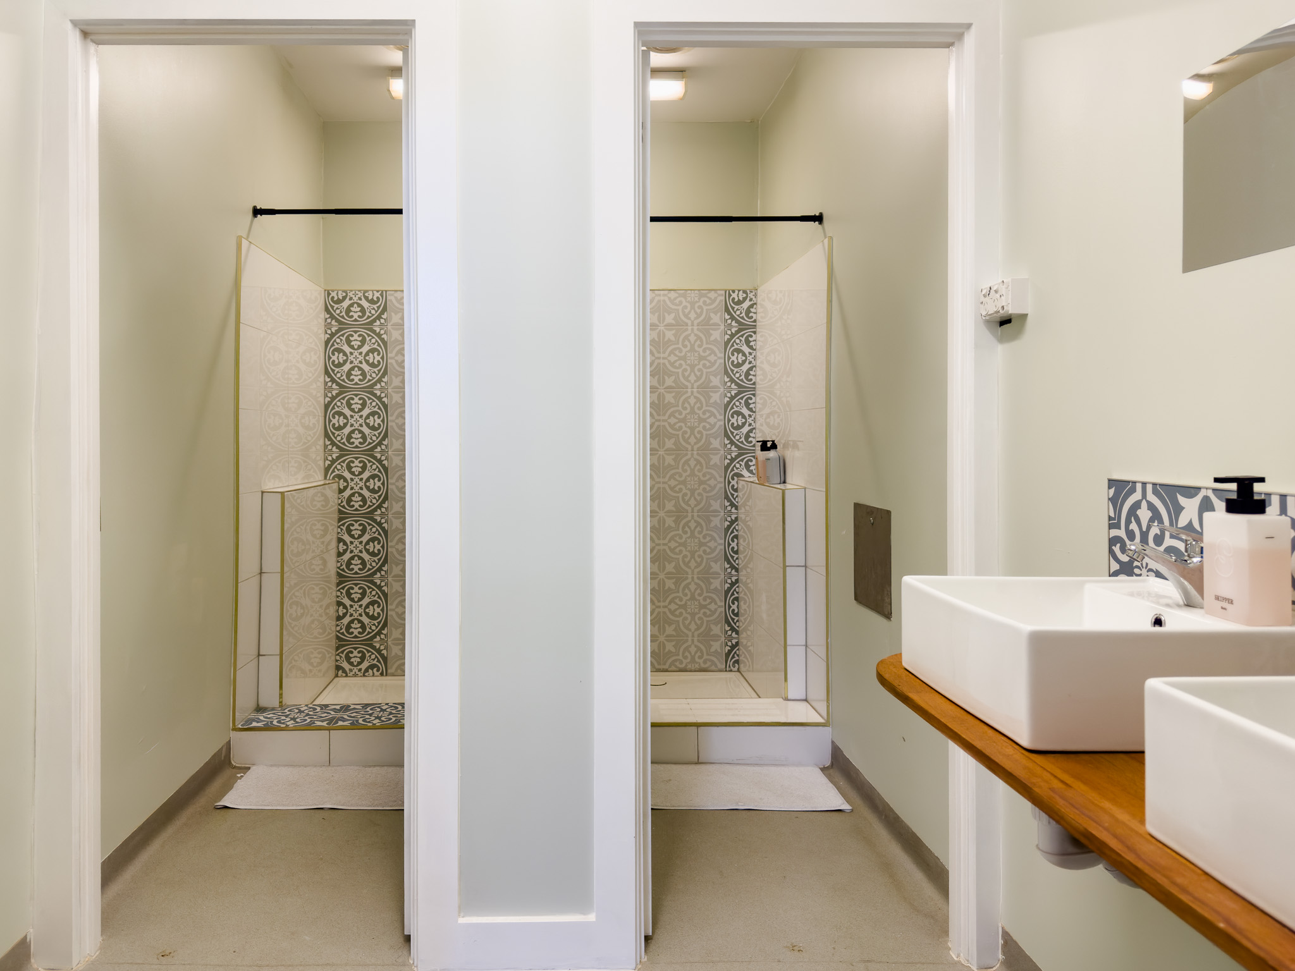
Ground floor bathroom
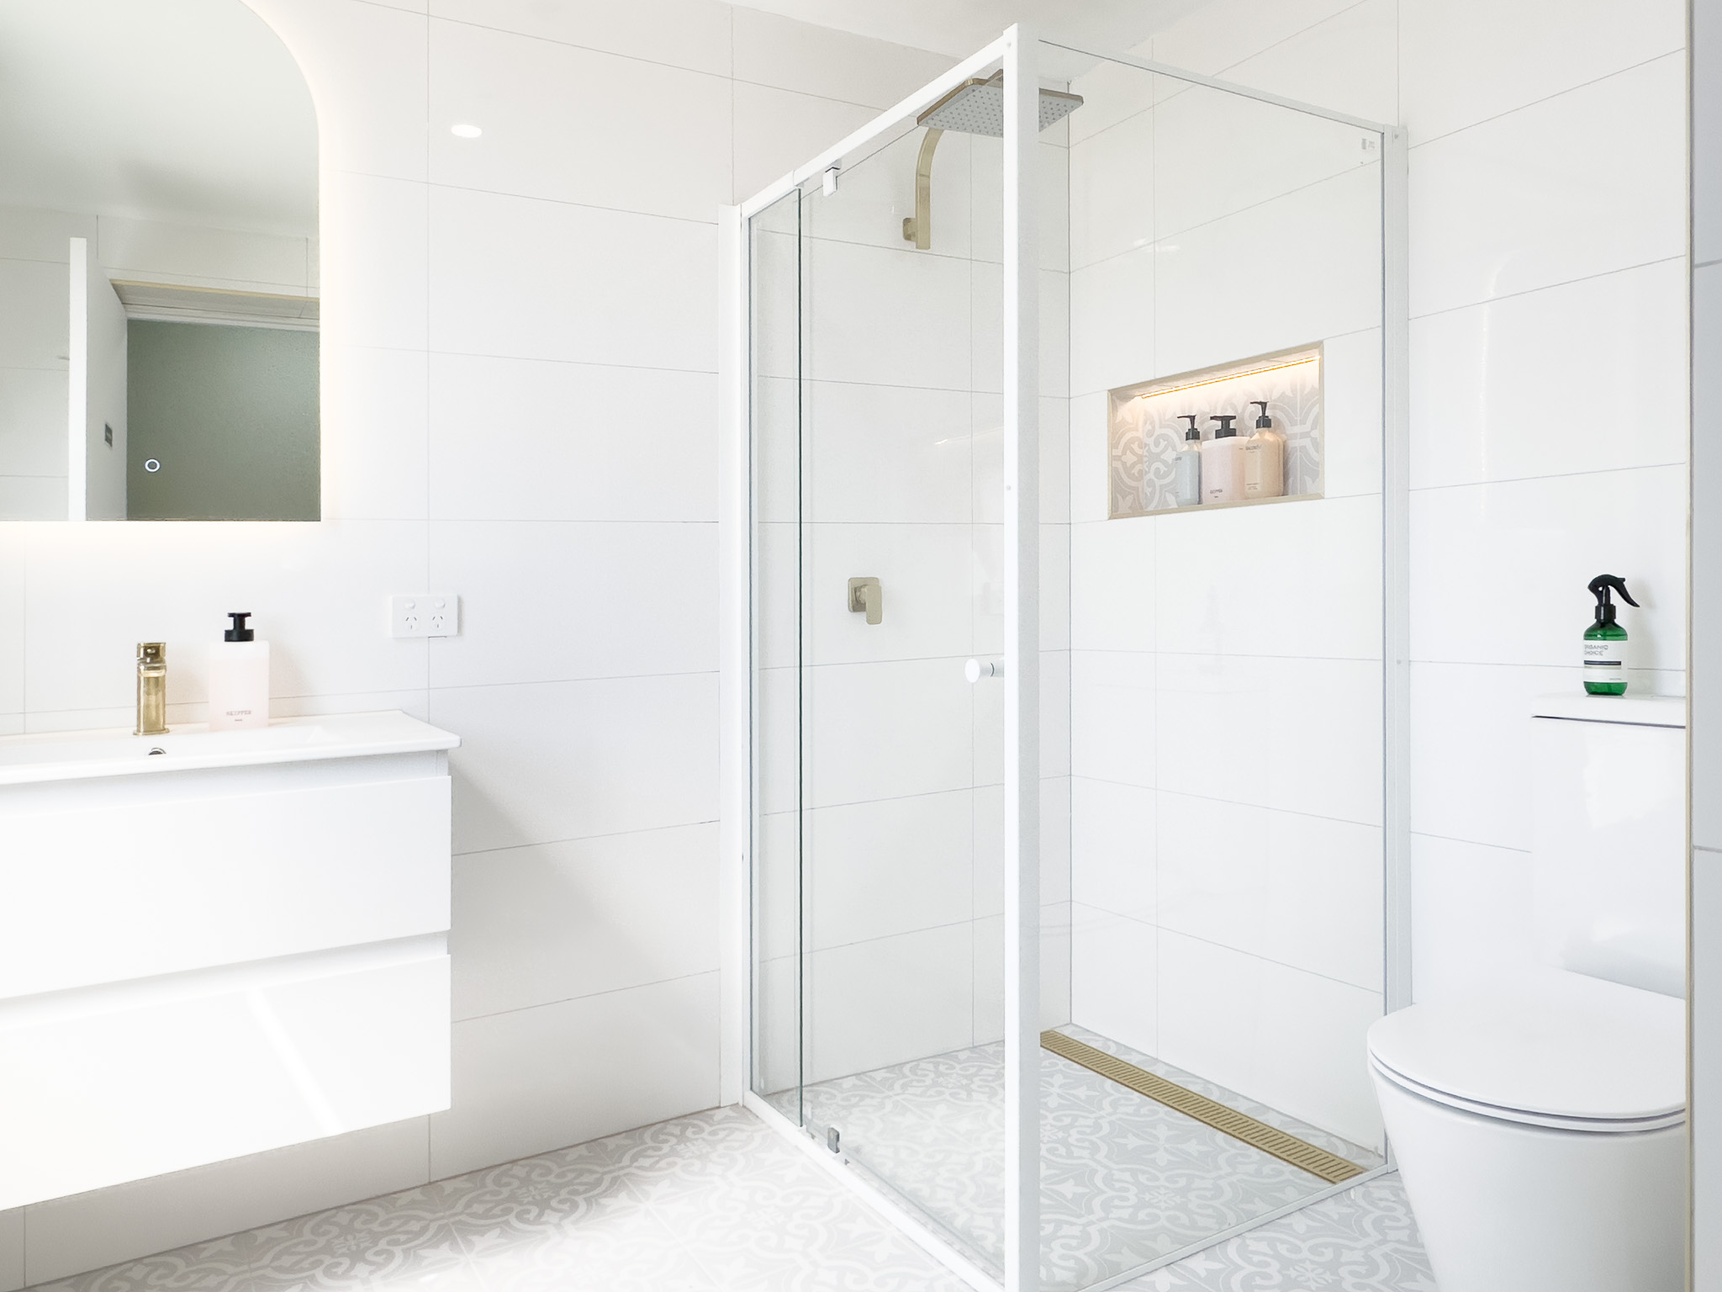
Level 3 bathroom - stair access only - 1
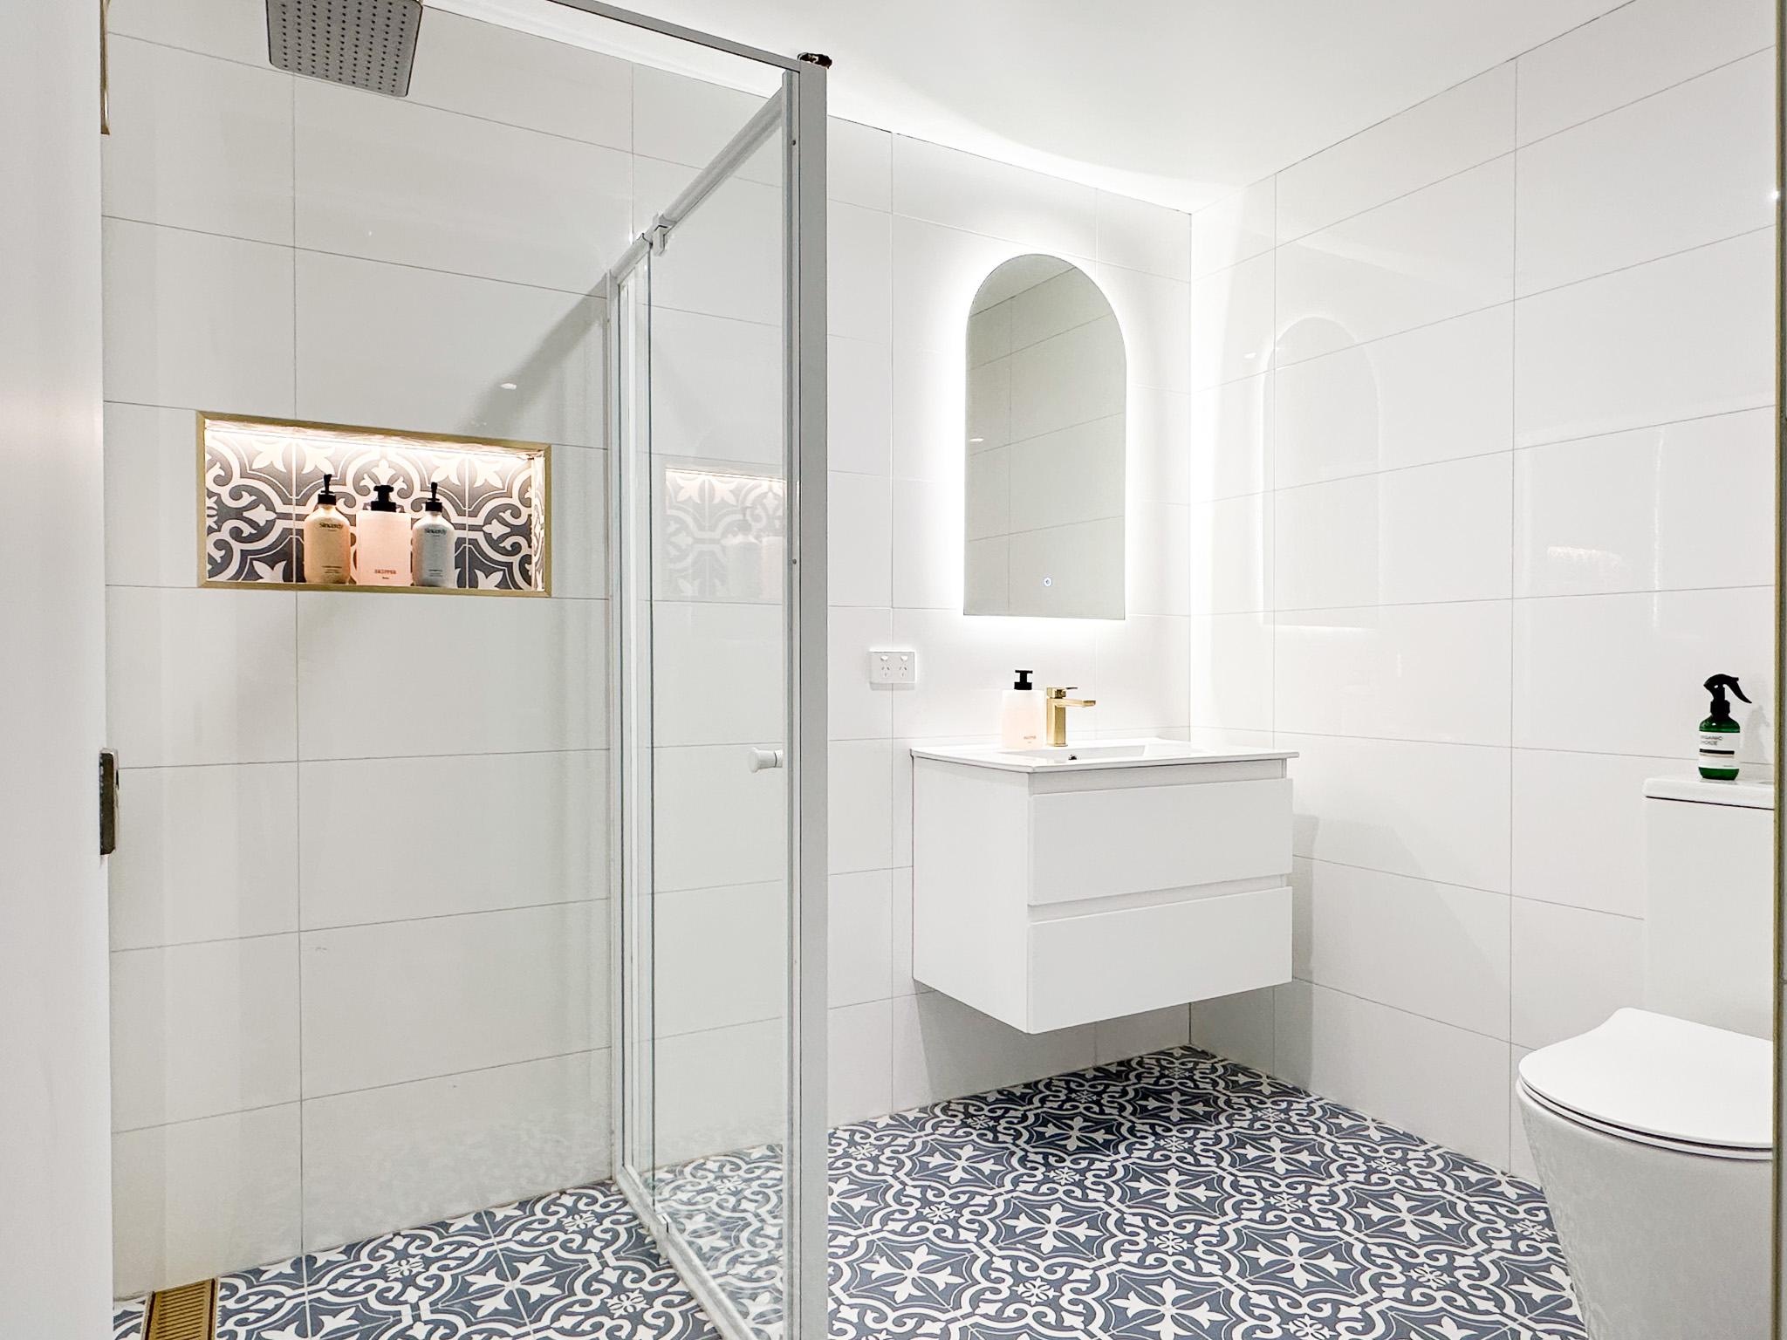
Level 3 bathroom - stair access only - 2
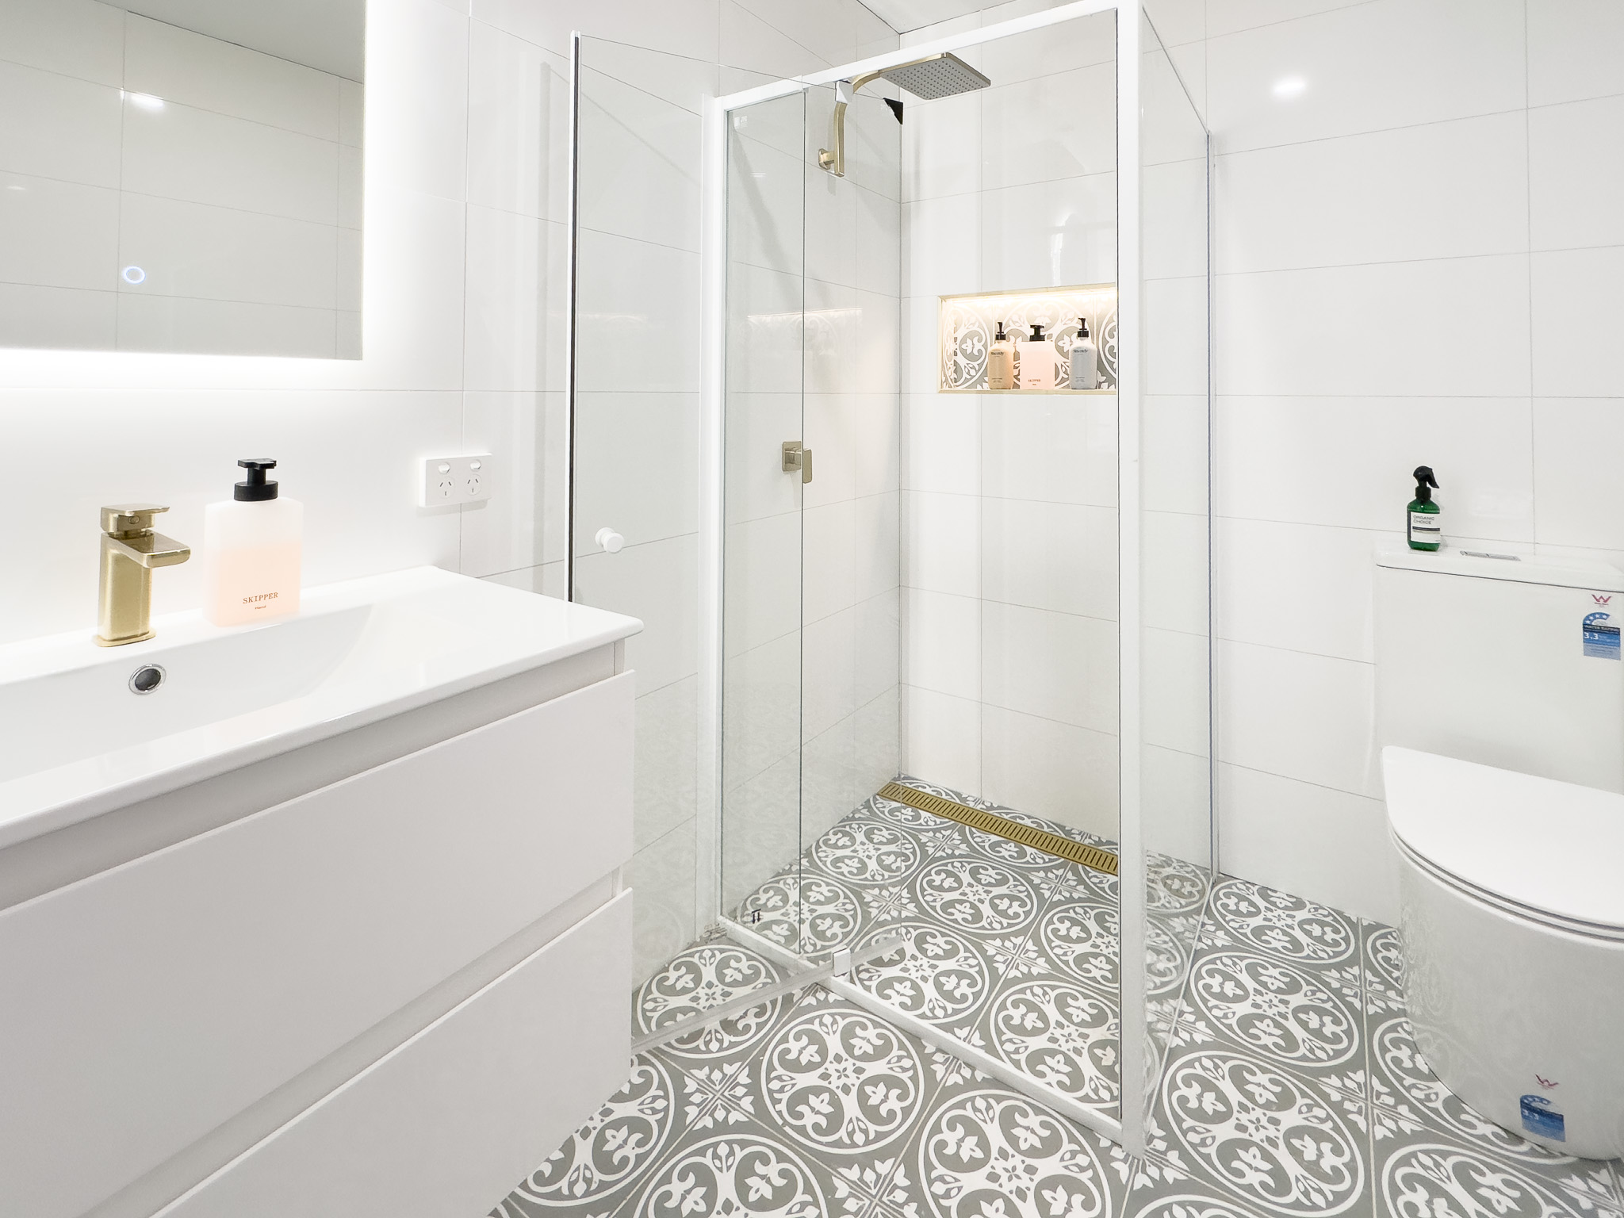
Level 3 bathroom - stair access only - 3
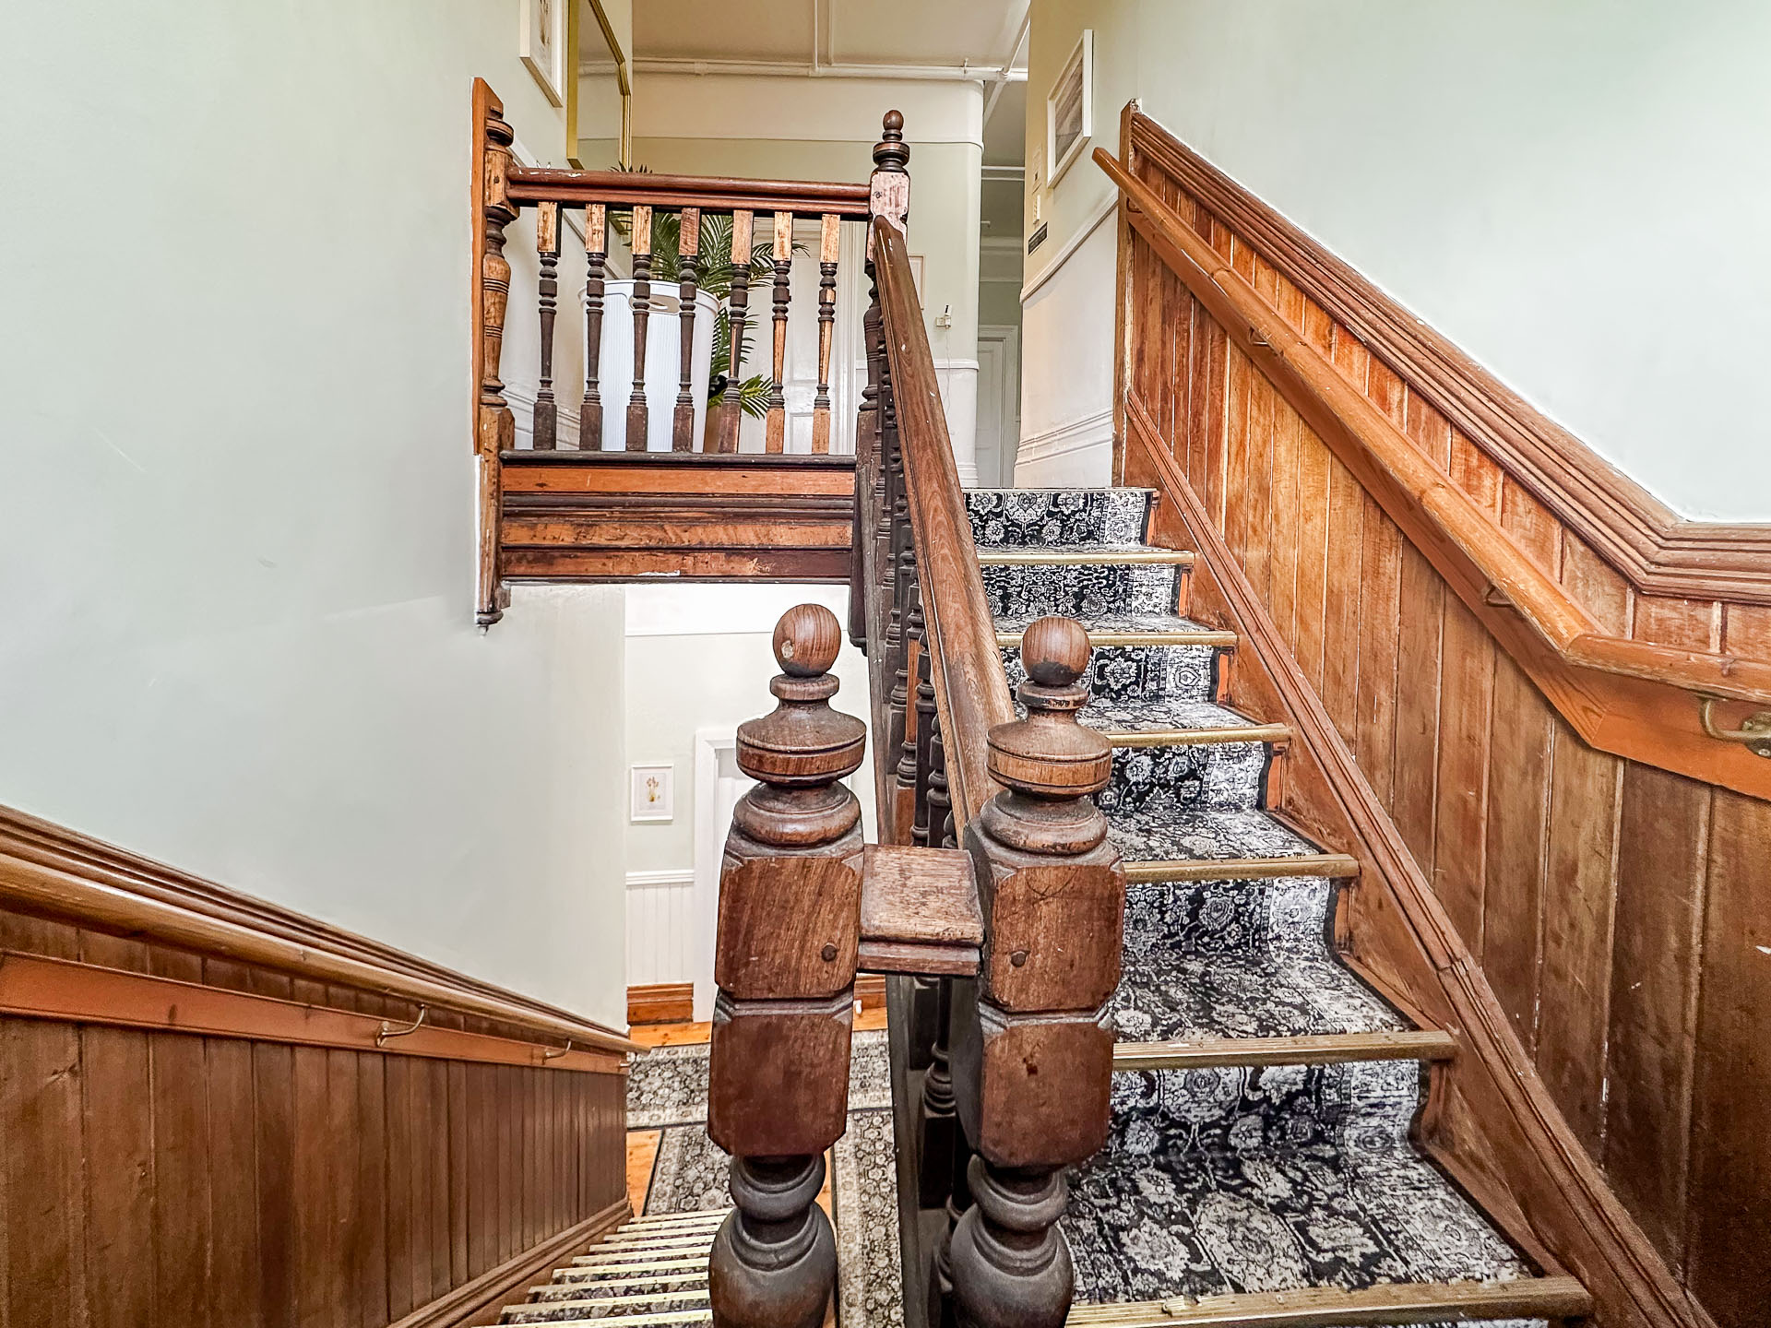
Stairs to access level 2 and 3 rooms
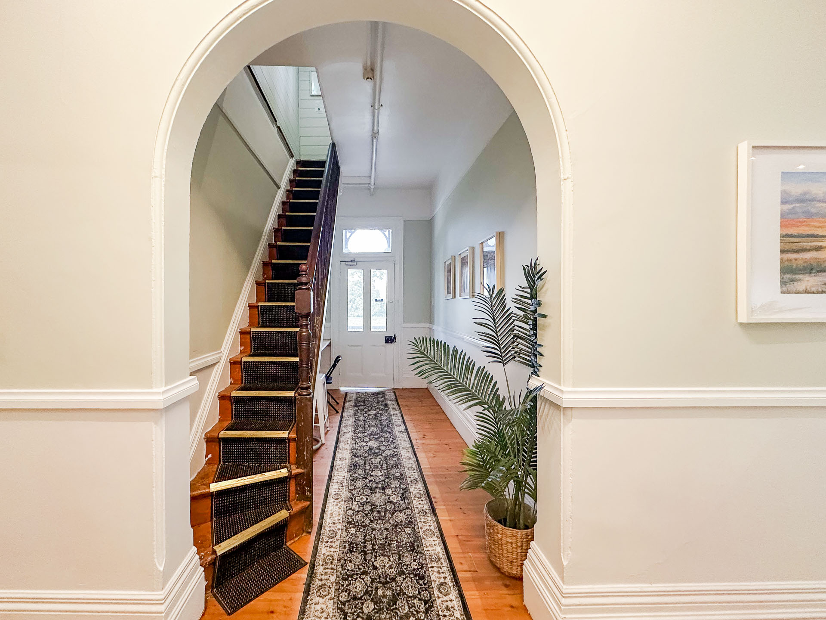
Stairs to level 3 rooms and bathrooms
- In addition, the following further information can assist guests:
We have bathrooms located on each floor which are available for guest use. The ground floor bathrooms require no stair access, however do require a small step into the shower.

COMMON AREAS

FOOD AND DRINK

Dining Spaces
The dining spaces have the following facilities/amenities in place
- The doorway is at least 850mm wide
- There is level access through the dining area

Our business caters for the following dietary requirements
- Gluten free (celiac)
- Lactose free (dairy free)
- Nut free
- Additive free
- Vegetarian
- Vegan
- Kosher
- Halal
- In addition, the following further information can assist guests:
We provide a simple breakfast cereal option with dairy and non-dairy milk options.

Report Disclaimer
Please note that this business report, provided as a result of the use of the diagnostic assessment, is for information purposes only.
Australian Tourism Industry Council (ATIC) cannot guarantee the accuracy of respondent’s answers, or that they are fully representative of your business. Therefore, ATIC does not warrant or guarantee any particular outcome in respect of your businesses self-assessment.
This report is intended as guidance only for your business and should not be relied on for future marketing considerations. ATIC recommends that you seek your own independent advice as well as the results from the diagnostic.
Links to external web sites are inserted for convenience and do not constitute endorsement of material at those sites, or any associated organisation, product or service.
ATIC does not:
- Assume any legal liability for the accuracy, completeness, or usefulness of any information from this report or any links provided; or
- Accept responsibility for any loss associated directly or indirectly from the use of this report.

