ATIC Accessibility
To support the accessible community in making informed travel decisions for their individual needs

This report prepared for:
Business name: | Losari Retreat
Address: | 498 Osmington Road
Town: | Bramley
Contact for enquiries: | Susan Dawson
Contact Number: | 0417895118
Contact Email: | essence@losariretreat.com.au
Website: | https://www.losariretreat.com.au/
Date: | 2026-10-25 08:54

ATIC Accessibility
The following pages provides travellers with information on the businesses facilities and amenities which aims to support the traveller to make an informed decision on whether the business is suitable for their individual needs.
OVERVIEW 4
Business Overview 4
Bookings 6
Emergency Management 6
Guide Dog and Service Animals 6
GENERAL 7
Pre-arrival, arrival and reception 7
Cognitive Impairment Support 7
Car Park and Access amenities 7
External Paths 8
ACCOMMODATION 9
Bedrooms 9
Room Amenities 9
Bathrooms 10
COMMON AREAS 12
Report Disclaimer 14

OVERVIEW

Business Overview

The business has the following products/services available
- Accommodation

Our business caters for the following disability types:
- Deaf or low hearing
- Limited mobility
- Wheelchairs or mobility scooters
- Food allergies or intolerances
- Cognitive or people on the Autism Spectrum
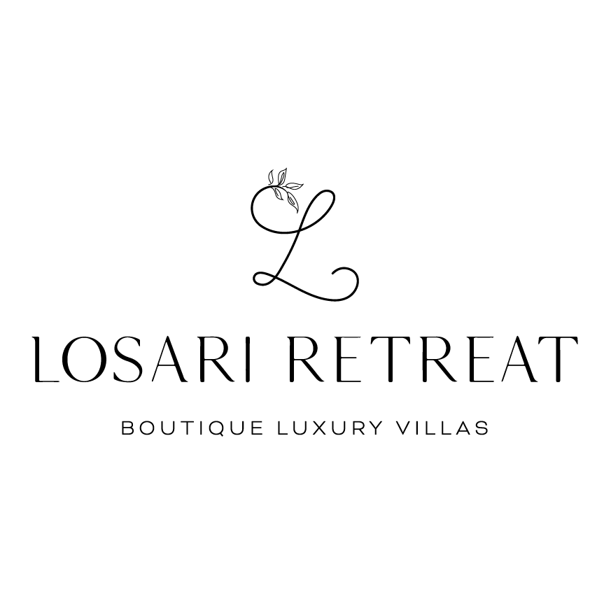

Bookings

The business offers the following methods for bookings and enquiries:
- Phone
- Email
- Webportal
- Our website supports Screen Readers

Emergency Management
- Exits to the emergency evacuation point does not include stairways
- In addition, the following further information can assist guests:
Using our PMS system we have knowledge of each guest who is staying at one time. We have 6 villas on the property with all guests contact details.
- In addition, the following further information can assist guests:
tbc
- Guests with disabilities are noted in the guest log book for emergency and evacuation purposes

Guide Dog and Service Animals
- The business provides a secure area with shade and water for service animals
- The business provides a toilet area for service animals
- Bowls, bedding, etc. are provided for service animals
The business provides the following services for services animals:
We allow service animals if requested in advance.

GENERAL

Pre-arrival, arrival and reception
The business has the following in place to support guests during pre-arrival, arrival and reception
- Booking information and websites are compatible with screen readers
- There is a reception/public entryway.
- Seating available at reception
- A lower counter at reception/ticket office
- A clipboard to allow check-in/ticket purchase whilst seated
- Lighting in the reception area is even and glare free
- Large print information sheets and registration forms
- Information and maps are available in written form
- A familiarisation tour
- Keys are available for each guest
- Luggage assistance
- In addition, the following further information can assist guests:
Not applicable to us.
- In addition, the following further information can assist guests:
Large entrance way to our reception with no steps. Guests are given a map of the property but welcomed by reception staff and taken up to their villa.

Cognitive Impairment Support
- Documents are available in plain English for people with cognitive impairment (This may include instructions, guides, menus and general information)

Car Park and Access amenities
The business has the following Car Park and Access amenities
- A drop off zone
- Level or ramped access from the car park to the entrance
- In addition, the following further information can assist guests:
No designated parking bays required. Parking is available at each accessable villa.

External Paths
External paths of travel
- Surfaces are concrete, asphalt, smooth paving or hard packed fine gravel (max aggregate size 13mm)
- Pathways are wider than 900mm
- In addition, the following further information can assist guests:
The property has a ring road and parking right at the front of the accessible villas with no steps.
- In addition, the following further information can assist guests:
No steps in our Reception area or Garden Spa Villas. Our Lakehouse Spa Villas and Botanica Spa Villas do have steps and are not suitable.
- In addition, the following further information can assist guests:
No public toilets available.

ACCOMMODATION

Bedrooms
The bedrooms have the following facilities/amenities in place
- There are 2 rooms available to guests who use a wheelchair
- Bedroom furniture can be re-arranged on request
  - Layout of room Image(s)
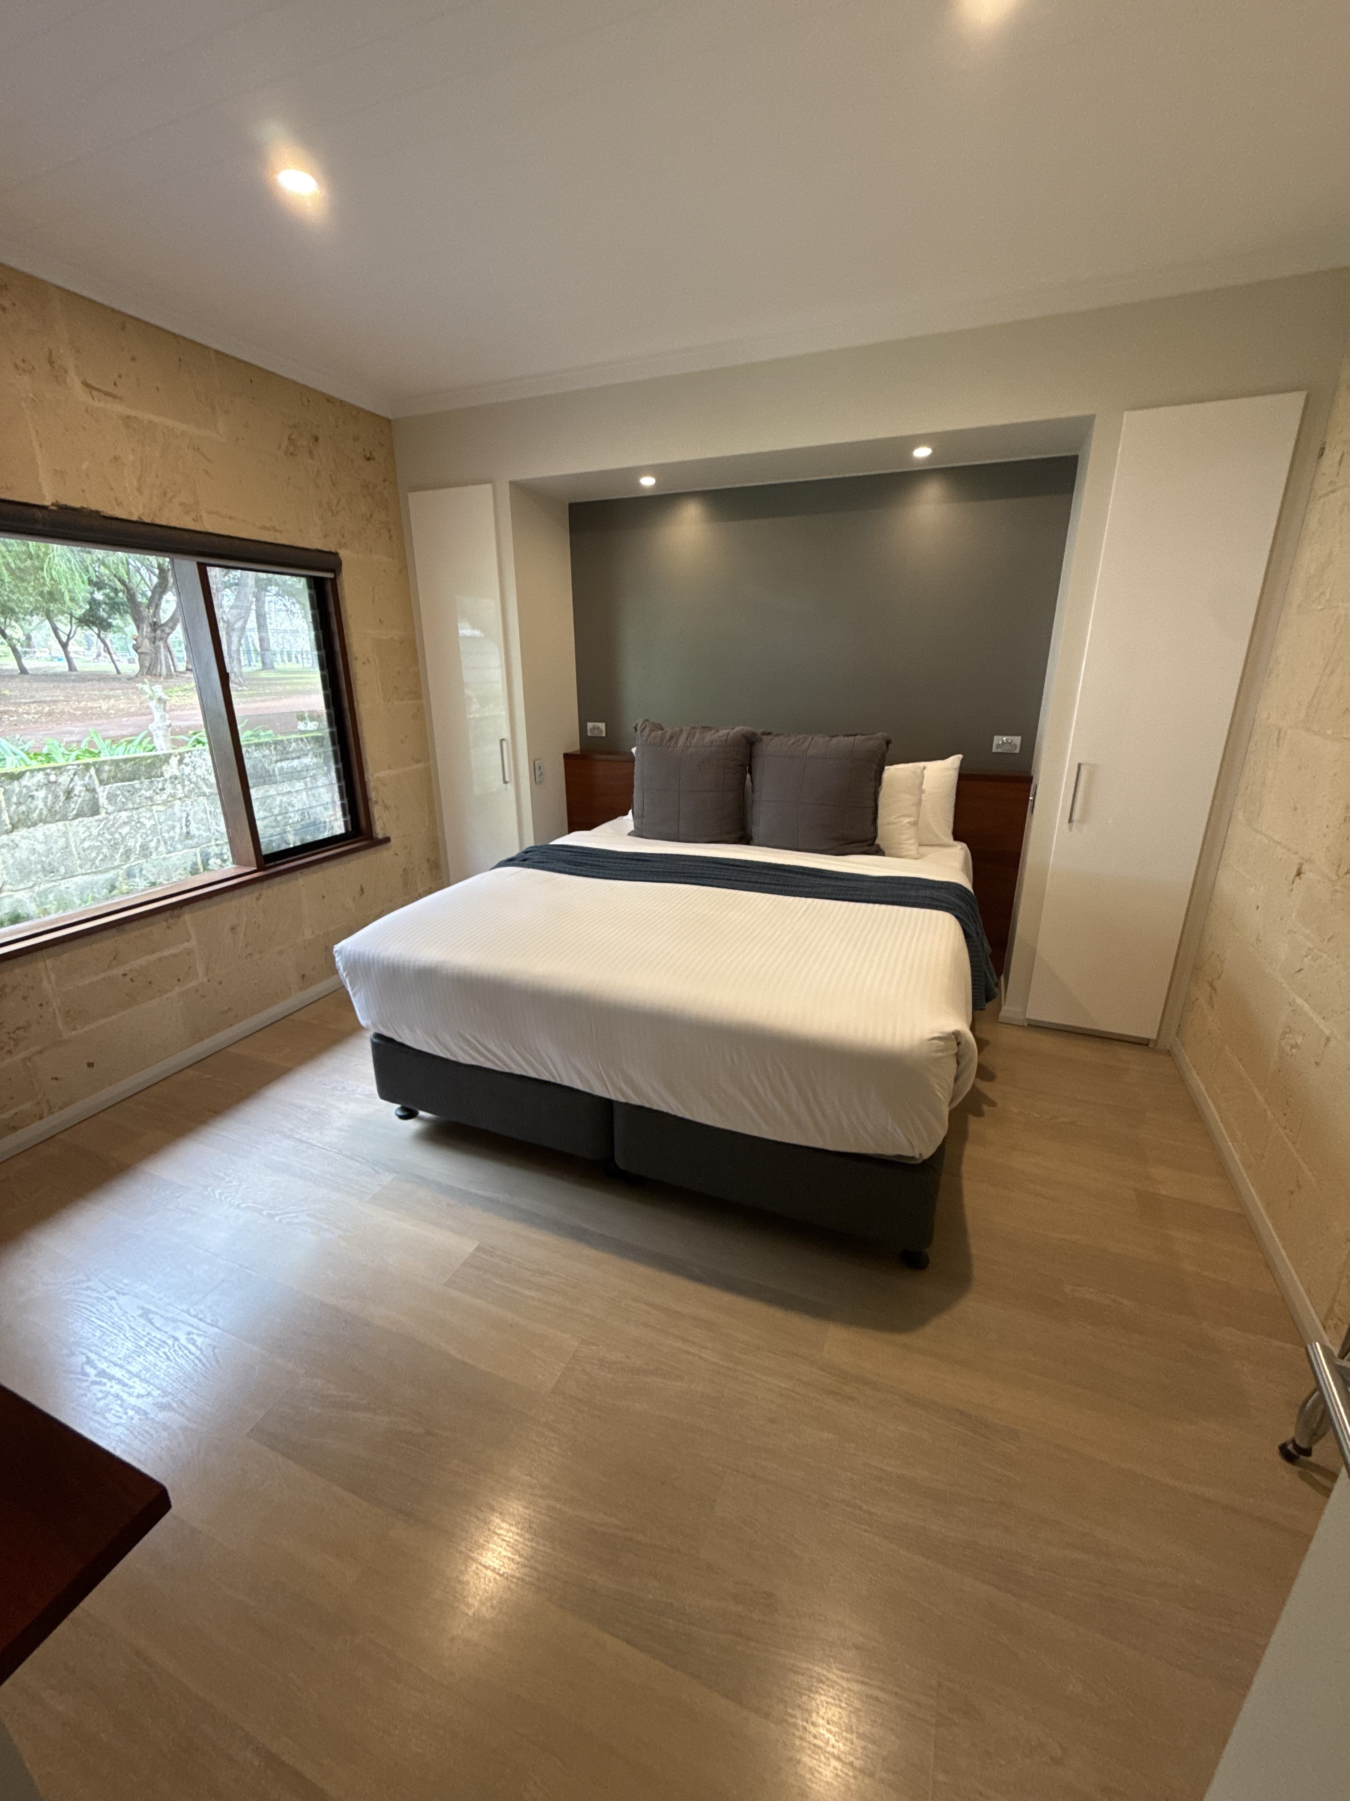
Garden Spa Villa Bedroom

Room Amenities
- In addition, the following further information can assist guests:
We have onsite staff who live onsite and are available 24/7. In the case of an emergency, the onsite team would personally ensure the evacuation of each guest.
- Televisions are equipped with closed captioning capability
- There is contrast between the walls, skirtings, floor and furniture
- There is a clear path through the room
- The edges of all furniture and fixtures are rounded
- Wardrobe handles are a contrasting colour to the doors and draws
- Housekeeping procedures instruct staff not to reposition furniture that has been moved
- Doors open fully against the adjoining wall
- There is a clear opening at least 850mm wide
- Wardrobe and drawer handles are easy to grip
- The bedside lamp switch is easy to reach from the bed
- There is at least 850mm clear space beside the bed
- The bed height is no higher than 680mm from the floor
- There is at least 130mm clearance under the bed
- The business offers a range of non-allergenic bedding
- Non-allergenic cleaning products are used
- In addition, the following further information can assist guests:
In the main bedroom of our Garden Spa Villa there is 980mm one side and 890mm the other side for space. There are light switches on the wall next to the bed for the room.

Bathrooms
The bathrooms have the following facilities/amenities in place
- All heating appliances and hot water pipes are protected or insulated
- All shower, bath and basin taps are clearly differentiated between hot and cold
- Fixtures and fittings have rounded edges
- The hot water is thermostatically controlled to 41 degrees
- The door is at least 850mm wide
- The width beside the toilet is 900mm between the two vanities and the toilet is placed in the middle.
- There is a minimum of 1400mm of clear space in front of the toilet
- The toilet seat is a contrasting colour to the floor
- The actual height of the toilet seat is 430mm from the floor.
- A range of non-allergenic toiletries are available
- There is a portable shower head on flexible hose
  - Bathroom Image(s)
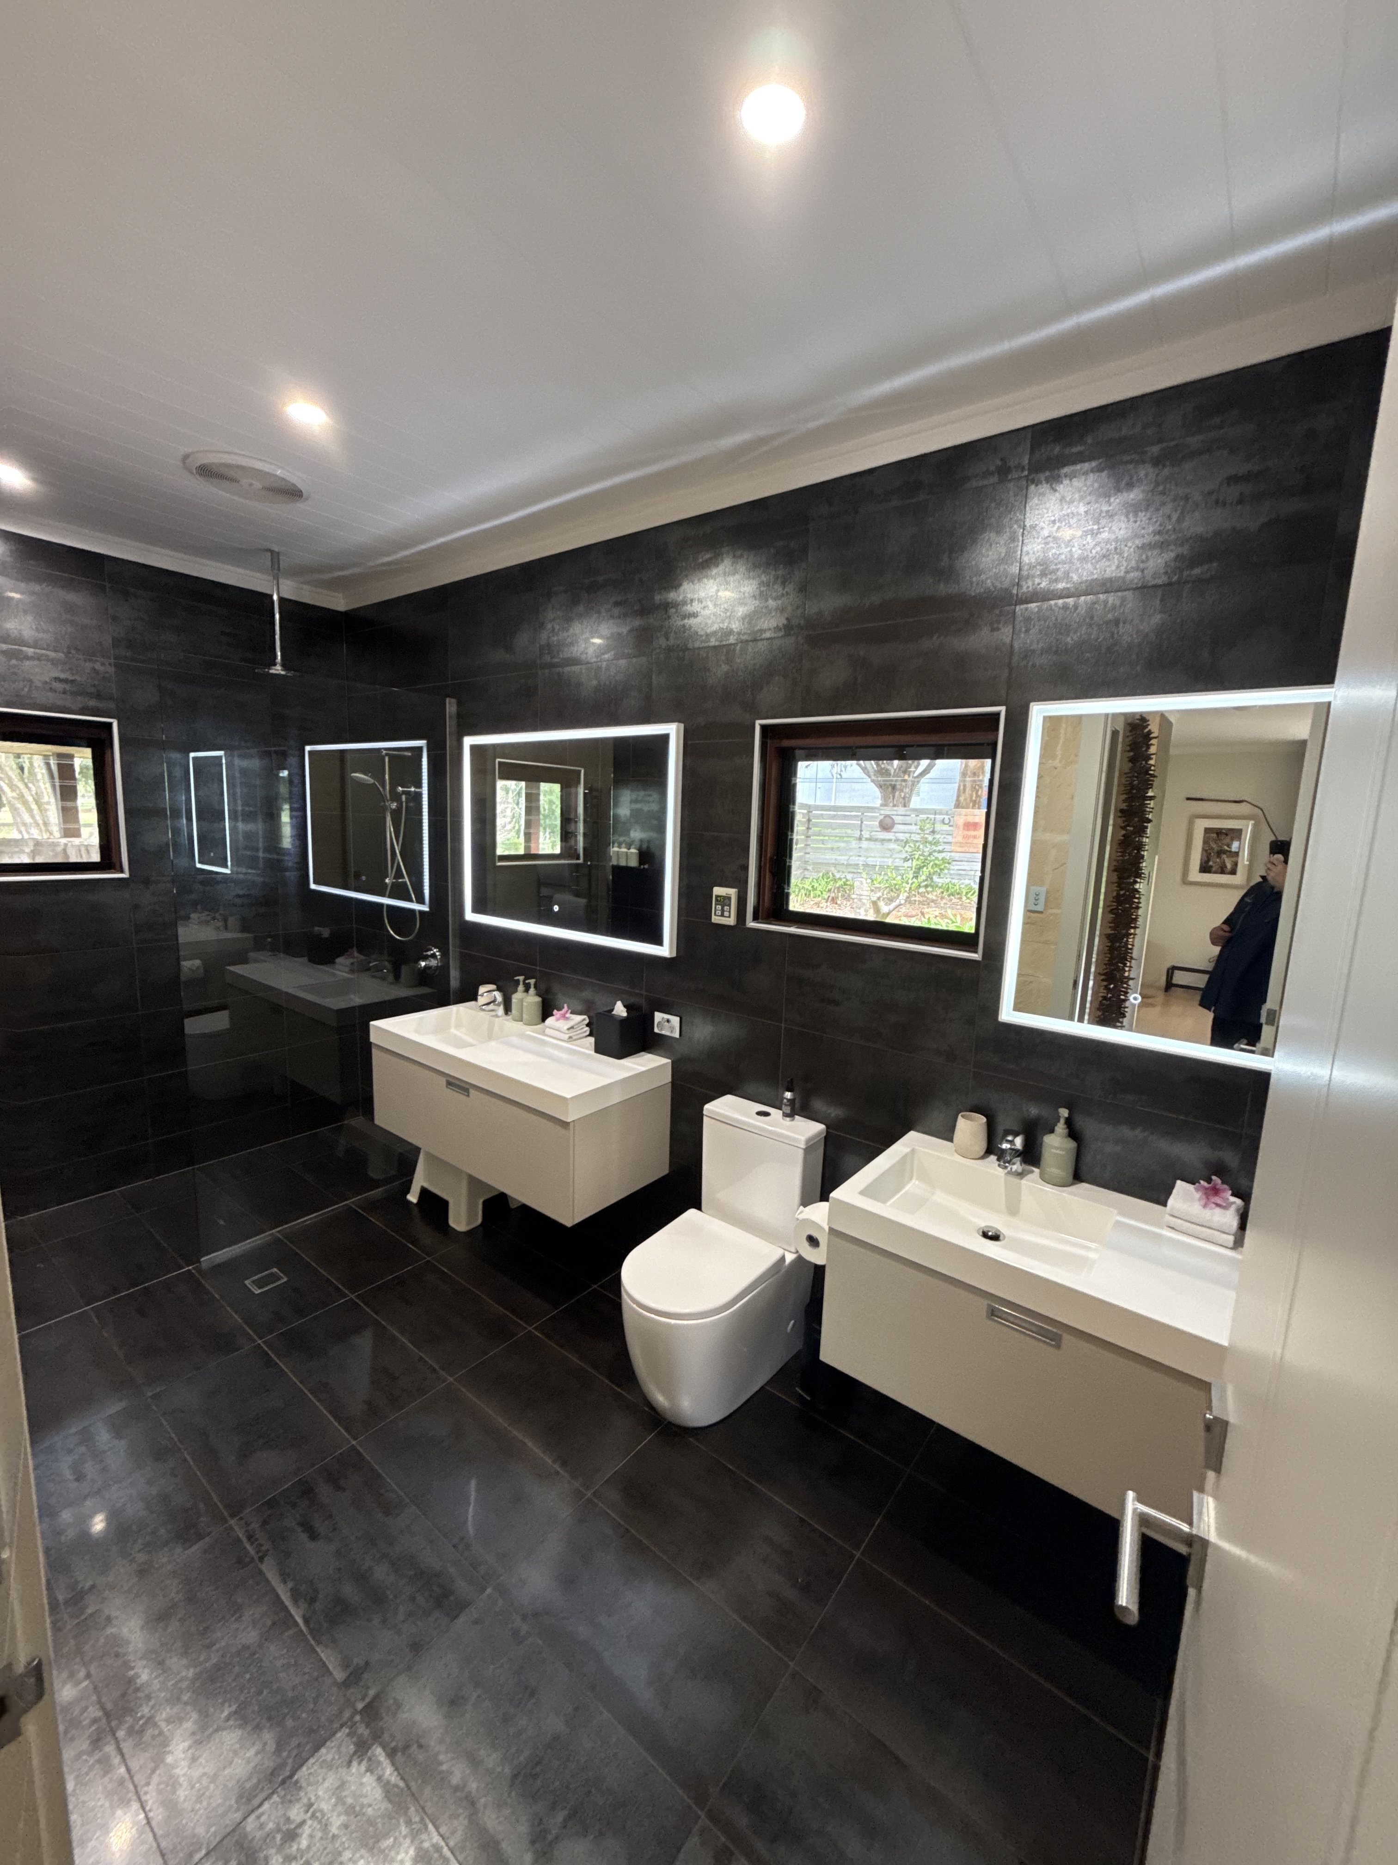
Garden Spa Villa Bathroom
- In addition, the following further information can assist guests:
- A shower seat is available for guests to use on request.
- No hand rail on shower or toilet, the toilet is located between two vanity untirs

COMMON AREAS

Report Disclaimer
Please note that this business report, provided as a result of the use of the diagnostic assessment, is for information purposes only.
Australian Tourism Industry Council (ATIC) cannot guarantee the accuracy of respondent’s answers, or that they are fully representative of your business. Therefore, ATIC does not warrant or guarantee any particular outcome in respect of your businesses self-assessment.
This report is intended as guidance only for your business and should not be relied on for future marketing considerations. ATIC recommends that you seek your own independent advice as well as the results from the diagnostic.
Links to external web sites are inserted for convenience and do not constitute endorsement of material at those sites, or any associated organisation, product or service.
ATIC does not:
- Assume any legal liability for the accuracy, completeness, or usefulness of any information from this report or any links provided; or
- Accept responsibility for any loss associated directly or indirectly from the use of this report.

