ATIC Accessibility
To support the accessible community in making informed travel decisions for their individual needs

This report prepared for:
Business name: | Park Trek Walking Holidays Australia
Address: | 52 Charles Street
Town: | Fitzroy
Contact for enquiries: | Charles Thompson
Contact Number: | 0399970500
Contact Email: | info@parktrek.com.au
Website: | www.parktrek.com.au
Date: | 2026-10-10 11:14

ATIC Accessibility
The following pages provides travellers with information on the businesses facilities and amenities which aims to support the traveller to make an informed decision on whether the business is suitable for their individual needs.
OVERVIEW 4
Business Overview 4
Bookings 4
Emergency Management 5
Communications 5
Guide Dog and Service Animals 5
GENERAL 6
Pre-arrival, arrival and reception 6
Cognitive Impairment Support 6
Car Park and Access amenities 7
Entry 7
Internal Spaces 7
Public areas 8
Displays, exhibits, commentary and live performances 8
Public Toilets/Adult change facilities 9
TOUR OPERATORS 10
Tour/Transport Services 10
Route Planning 10
Guides 10
ACCOMMODATION 12
Room Amenities 12
Bathrooms 12
ATTRACTIONS 13
Attractions Basics 13
COMMON AREAS 14
Swimming pools, spas and waterparks 14
FOOD AND DRINK 15
Dining Spaces 15
ADVENTURE ACTIVITIES 16
Adventure activities 16
EVENTS 17
Report Disclaimer 19

OVERVIEW

Business Overview

The business has the following products/services available
- Tour/Transport
- Accommodation
- Attraction
- Food and Drink
- Adventure
- Event

Our business caters for the following disability types:
- Blind or low vision
- Deaf or low hearing
- Food allergies or intolerances
- Cognitive or people on the Autism Spectrum
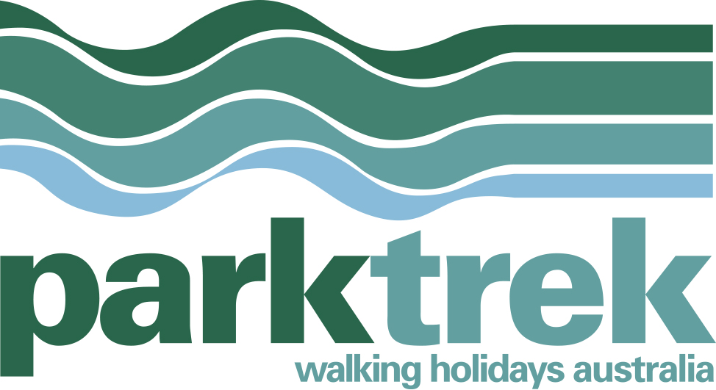

Bookings

The business offers the following methods for bookings and enquiries:
- Phone
- Email
- Webportal
- Our website supports Screen Readers
- Our forms have high contract boxes and submit boxes

Emergency Management
- The business has an emergency management and evacuation plan for guests with a disability
- Emergency and evacuation procedures are explained on arrival
- Guests with disabilities are noted in the guest log book for emergency and evacuation purposes

Communications
- Our business offers the following alternative communication methods
- Plain English

Not specified
- There is easy to read signage and information (e.g. menus and emergency information)

Guide Dog and Service Animals
- The business provides a secure area with shade and water for service animals
- The business provides a toilet area for service animals
- Bowls, bedding, etc. are provided for service animals
The business provides the following services for services animals:
As a former director of Guide Dogs Victoria and Guide Dogs Australia I am aware of our obligations and we have conduced tours for blind and low vision guests with assistance dogs.

GENERAL

Pre-arrival, arrival and reception
The business has the following in place to support guests during pre-arrival, arrival and reception
- There is a reception/public entryway.
- Seating available at reception
- A tablet with text to voice or pen and paper at reception to aid in communication
- Lighting in the reception area is even and glare free

Our tours are arranged and booked by customers 60 days prior to departure, not on a walk-up basis given they are multi-day.
- Information and maps are available in written form
- A familiarisation tour
- Keys are available for each guest
- Luggage assistance
- In addition, the following further information can assist guests:
As part of our booking and manifesting process we always seek out details of a guest's capabilities and potential ailments / dietaries to ensure the product they have chosen is fit for purpose.
- In addition, the following further information can assist guests:
We often conduct walking tours on behalf of charities and fundraising groups. In many instances those charities and fundraising groups include participants affected by certain ailments, so we endeavour to refine or redesign our tours (so far as practicable) to ensure safe participation. The nature of our experiences, physical and outdoors, demands certain minimum capabilities. However, our Owner &amp; Director (a former Chair of Guide Dogs Victoria) is committed to ensuring our experiences are open and accessible to most Victorians.

Cognitive Impairment Support
- Documents are available in plain English for people with cognitive impairment (This may include instructions, guides, menus and general information)
- A "social script" guide to your premises or attraction describing the sights, sounds and smells to aid parents/carers prepare visitors in advance

Car Park and Access amenities
The business has the following Car Park and Access amenities
- A drop off zone
- The public transport services available are:

All of our tours leave from convenient publicly accessible locations.
- In addition, the following further information can assist guests:
NA

Entry
The business has the following amenities/systems in place for entry
- A drop off point close to the entrance
- A path of access to the building is clear of obstruction
- Self opening entry doors or fitted with a self closer
- Glass doors are fitted with a visual sighting strip
- In addition, the following further information can assist guests:
We work with third party accommodation providers and some scenic and local attraction providers. All providers we work with ordinarily have accessible designs.
- In addition, the following further information can assist guests:
Not applicable.

Internal Spaces
- Clear and unobstructed routes through and between buildings
- Seating is available for guests unable to stand for long periods
- Accessible facilities are clearly signed and visible from all areas
The width of the smallest corridor is:
Some places in nature or third-party accommodation facilities have limited access, however ordinarily we can circumvent such limitations.
- In addition, the following further information can assist guests:
Most of our itineraries can be tailored to accommodate specific guest requirements, bearing in mind however that we are in nature and engaging in the outside world.

Public areas
The public areas have the following amenities in place
- Even lighting
- Seating
- In addition, the following further information can assist guests:
Our itineraries are designed to be accessible for most walkers and can be tailored as required to certain limitations (within reason). If tailoring the experience would require too much of a compromise or entail an unacceptable risk to participants, then we would caution about participating and discuss with them a more appropriate alternative. The nature of our experiences, physical and outdoors, demands certain minimum capabilities. However, our Owner &amp; Director (a former Chair of Guide Dogs Victoria) is committed to ensuring our experiences are open and accessible to most Victorians.

Displays, exhibits, commentary and live performances
For displays, exhibits, commentary and live performances the following amenities are in place
- Seating
- Wheelchair accessible spaces/seating
- A written transcript where audio description is provided i.e. display commentary, tour commentary
- In addition, the following further information can assist guests:
Hearing loops may be required.
The width of the smallest pathway is:
We use nature trails which vary.

Nature trails.

Nature trails.
- In addition, the following further information can assist guests:
We will advise guests accordingly in advance of their suitability to complete all or parts of our walking itinerary. The nature of our experiences, physical and outdoors, demands certain minimum capabilities. However, our Owner &amp; Director (a former Chair of Guide Dogs Victoria) is committed to ensuring our experiences are open and accessible to most Victorians.

Public Toilets/Adult change facilities
Public Toilets/Adult change facilities have the following amenities are in place
- There is an accessible toilet for public use
- The door is at least 850mm wide
- There is Not applicable mm beside the toilet
- The height of the toilet seat is: Not applicable.
- In addition, the following further information can assist guests:
Our third party providers generally provide for this.

TOUR OPERATORS

Tour/Transport Services
The tour/transport services have the following facilities/amenities in place
- Buses/Coaches
- None vehicles have wheelchair lifts or ramps
- None vehicles have low floors with ramped entry
The maximum wheelchair capacity available in the fleet is:
None

Route Planning
- Route Planning
- The tour route includes stops with accessible toilet facilities
- In addition, the following further information can assist guests:
The nature of our experiences, physical and outdoors, demands certain minimum capabilities. However, our Owner &amp; Director (a former Chair of Guide Dogs Victoria) is committed to ensuring our experiences are open and accessible to most Victorians.
- Lunch stop venues are accessible
- Overnight Stops
The total number of wheelchair passengers that can be catered for at overnight stops are:
Our minibuses unfortunately do not cater for wheelchairs.
- Walking Tours
- Multi-paced to account for slower walkers
- Hearing aid compatible

Guides

Guides have been trained in the following
- Use of clear/simple English
- Marine
  - Image(s)
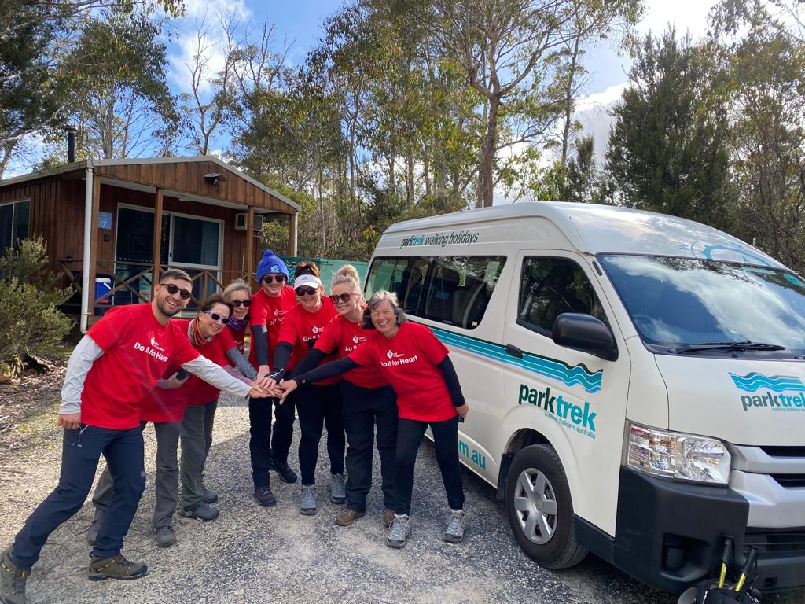
IMG-20231115-WA0002
- In addition, the following further information can assist guests:
Full details of all venues visited can be found in our detailed Product Trip Notes.
- In addition, the following further information can assist guests:
The nature of our experiences, physical and outdoors, demands certain minimum capabilities. However, our Owner &amp; Director (a former Chair of Guide Dogs Victoria) is committed to ensuring our experiences are open and accessible to most Victorians.

ACCOMMODATION

Room Amenities
- Lower hanging rails are in wardrobes
- In addition, the following further information can assist guests:
Guests are briefed concerning the amenities and emergency procedures of all our lodgings.
- There is a clear path through the room
- Openings are a minimum of NA wide
- There at least one chair with rigid arms
- Wardrobe and drawer handles are easy to grip
- The bedside lamp switch is easy to reach from the bed
- The business offers a range of non-allergenic bedding
- Non-allergenic cleaning products are used
- In addition, the following further information can assist guests:
The nature of our experiences, physical and outdoors, demands certain minimum capabilities. However, our Owner &amp; Director (a former Chair of Guide Dogs Victoria) is committed to ensuring our experiences are open and accessible to most Victorians.

Bathrooms
The bathrooms have the following facilities/amenities in place
- All heating appliances and hot water pipes are protected or insulated
- All shower, bath and basin taps are clearly differentiated between hot and cold
- The width of the door is NA.
- The width beside the toilet is NA.
- There is NA mm of clear space in front of the toilet
- The toilet seat is 460mm above the floor
- A range of non-allergenic toiletries are available
- In addition, the following further information can assist guests:
The nature of our experiences, physical and outdoors, demands certain minimum capabilities. However, our Owner &amp; Director (a former Chair of Guide Dogs Victoria) is committed to ensuring our experiences are open and accessible to most Victorians.

ATTRACTIONS

Attractions Basics
- A park map is available here:

Refer to our detailed Product Trip Notes.
- In addition, the following further information can assist guests:
The nature of our experiences, physical and outdoors, demands certain minimum capabilities. However, our Owner &amp; Director (a former Chair of Guide Dogs Victoria) is committed to ensuring our experiences are open and accessible to most Victorians.

COMMON AREAS

Swimming pools, spas and waterparks
- The following swimming pools, spas and waterparks amenities are available
- In addition, the following further information can assist guests:
The nature of our experiences, physical and outdoors, demands certain minimum capabilities. However, our Owner &amp; Director (a former Chair of Guide Dogs Victoria) is committed to ensuring our experiences are open and accessible to most Victorians.

FOOD AND DRINK

Dining Spaces
The dining spaces have the following facilities/amenities in place
- The smallest doorway is It depends on the Lodge Provider. wide
- Chairs are moveable to allow for wheelchairs to be seated at the tables
- There are areas of full lighting
- There are Plain English menus
- There is an accessible toilet

Our business caters for the following dietary requirements
- Sugar free (diabetic)
- Gluten free (celiac)
- Lactose free (dairy free)
- Low fat and fibre with no gastric content
- Low potassium
- Low sodium
- Nut free
- Additive free
- Organic
- Vegetarian
- Vegan
- Kosher
- Halal
- In addition, the following further information can assist guests:
All our guides and accredited in safe food handling procedures.
- In addition, the following further information can assist guests:
The nature of our experiences, physical and outdoors, demands certain minimum capabilities. However, our Owner &amp; Director (a former Chair of Guide Dogs Victoria) is committed to ensuring our experiences are open and accessible to most Victorians.

ADVENTURE ACTIVITIES

Adventure activities
The adventure activities have the following facilities/amenities in place
- Our adventure activities cater for people with a disability
- In addition, the following further information can assist guests:
We have conducted tours for people who are affected by blindness or low vision, Parkinson's Disease, and other disabilities. The nature of our experiences, physical and outdoors, demands certain minimum capabilities. However, our Owner &amp; Director (a former Chair of Guide Dogs Victoria) is committed to ensuring our experiences are open and accessible to most Victorians.
- In addition, the following further information can assist guests:
Great guides, and where applicable, NDIS funding for further support.
- In addition, the following further information can assist guests:
Where the risk associated with the disability and undertaking our service is assessed to be too high or incapable of mitigation, we have no option but to limit participation.
- In addition, the following further information can assist guests:
The nature of our experiences, physical and outdoors, demands certain minimum capabilities. However, our Owner &amp; Director (a former Chair of Guide Dogs Victoria) is committed to ensuring our experiences are open and accessible to most Victorians.

EVENTS
- In addition, the following further information can assist guests:
The nature of our experiences, physical and outdoors, demands certain minimum capabilities. However, our Owner &amp; Director (a former Chair of Guide Dogs Victoria) is committed to ensuring our experiences are open and accessible to most Victorians.

Report Disclaimer
Please note that this business report, provided as a result of the use of the diagnostic assessment, is for information purposes only.
Australian Tourism Industry Council (ATIC) cannot guarantee the accuracy of respondent’s answers, or that they are fully representative of your business. Therefore, ATIC does not warrant or guarantee any particular outcome in respect of your businesses self-assessment.
This report is intended as guidance only for your business and should not be relied on for future marketing considerations. ATIC recommends that you seek your own independent advice as well as the results from the diagnostic.
Links to external web sites are inserted for convenience and do not constitute endorsement of material at those sites, or any associated organisation, product or service.
ATIC does not:
- Assume any legal liability for the accuracy, completeness, or usefulness of any information from this report or any links provided; or
- Accept responsibility for any loss associated directly or indirectly from the use of this report.

