ATIC Accessibility
To support the accessible community in making informed travel decisions for their individual needs

This report prepared for:
Business name: | Yardie Creek Boat Tours
Address: | Yardie Creek, Yardie Creek Road
Town: | Exmouth
Contact for enquiries: | Amelia Kaleyias
Contact Number: | 0473 668 065
Contact Email: | info@yardiecreektours.com.au
Website: | www.yardiecreekboattours.com.au
Date: | 2026-10-19 02:48

ATIC Accessibility
The following pages provides travellers with information on the businesses facilities and amenities which aims to support the traveller to make an informed decision on whether the business is suitable for their individual needs.
OVERVIEW 4
Business Overview 4
Bookings 6
Emergency Management 6
Guide Dog and Service Animals 7
GENERAL 8
Pre-arrival, arrival and reception 8
Cognitive Impairment Support 8
Car Park and Access amenities 8
External Paths 8
Steps 9
TOUR OPERATORS 10
Tour/Transport Services 10
Route Planning 10
Guides 10
Report Disclaimer 13

OVERVIEW

Business Overview

The business has the following products/services available
- Tour/Transport

Our business caters for the following disability types:
- Deaf or low hearing
- Limited mobility
- Cognitive or people on the Autism Spectrum

Bookings

The business offers the following methods for bookings and enquiries:
- Phone
- Email
- Webportal
- Our forms have high contract boxes and submit boxes

Emergency Management
- Emergency and evacuation procedures are explained on arrival
- Exit signs are clear and easy to see
- Exit access is free and clear at all times
We ensure exit access is free and clear at all times by:
Ensuring customers remain seated in designated seats at all times.
- In addition, the following further information can assist guests:
Firstly, guests have the option to include any special requirements that are needed at the time of booking. These are then added to the daily manifest so that the skipper is aware. The skipper then has a chat with the guest on arrival about the nature of the help that is needed should there be an emergency. The skipper then seats those needing assistance to the closest exit point. The skipper makes a mental note of the guests requiring assistance and is able to help them should an emergency occur.
- In addition, the following further information can assist guests:
Yardie Creek Boat Tours identifies guests who may need assistance during the pre-tour phase through observation, interaction, or disclosure by the guest. Guests requiring assistance are seated in easily accessible areas of the vessel. In the event of an emergency, the skipper announces the situation to all passengers, providing calm and clear instructions. Guests requiring assistance are directed to remain seated until specific help is provided. The skipper oversees the rescue procedure and, if feasible, assigns able-bodied passengers to assist by keeping the area clear or providing support as directed.
- Guests with disabilities are noted in the guest log book for emergency and evacuation purposes

Guide Dog and Service Animals
The business provides the following services for services animals:
Service dogs may only be permitted with specific approval and at the discretion of DBCA's Parks and Wildlife Service.

GENERAL

Pre-arrival, arrival and reception
The business has the following in place to support guests during pre-arrival, arrival and reception
- Information and maps are available in written form
- In addition, the following further information can assist guests:
Tours stick to a strict time schedule therefore limiting the chance of long wait times, priority boarding is also given to guests requiring it.

Cognitive Impairment Support
- Documents are available in plain English for people with cognitive impairment (This may include instructions, guides, menus and general information)

Car Park and Access amenities
The business has the following Car Park and Access amenities
- Level or ramped access from the car park to the entrance

External Paths
External paths of travel
- Surfaces are concrete, asphalt, smooth paving or hard packed fine gravel (max aggregate size 13mm)
- Pathways are wider than 900mm

No steps along path to boat pontoon

No steps along path to boat pontoon
- In addition, the following further information can assist guests:
Whilst it is a hard packed fine gravel pathway from the carpark to the boat, it sometimes may have sand due to the wind over sections of the pathway, we recommend contacting us to find out current pathway conditions.

Steps
Steps
- There are steps.
- All steps or staircases have enclosed risers
- The underside of all staircases are enclosed or protected to a height of at least 2 metres
- Handrails fitted to all open sets of steps
- Where steps are present are there three steps or less
- In addition, the following further information can assist guests:
There is x1 200mm step from the pontoon to the boat.
There are then x2 steps on the boat and each step is approximately 205mm in height.
940mm is the length of the top step, 400mm is the second step length.
380mm is the width of all steps.
The handrail is located on the right hand side as you enter the boat while the flooring has checker plating installed.
- In addition, the following further information can assist guests:
Whilst there are no toilet facilities on board, The carpark has x1 Accessible Unisex Drop Toilet without running water, change table or hoist facilities.

TOUR OPERATORS

Tour/Transport Services
The tour/transport services have the following facilities/amenities in place
- Buses/Coaches
- None vehicles have wheelchair lifts or ramps
- None vehicles have low floors with ramped entry
The maximum wheelchair capacity available in the fleet is:
None

Route Planning
- Route Planning
- The tour route includes stops with accessible toilet facilities
- Lunch stop venues are accessible
- Sightseeing and photo opportunity stops are step free

Guides
- Use of clear/simple English
- Correct pronunciation for lip readers
- There is a audio description of surroundings
- Marine
  - Image(s)
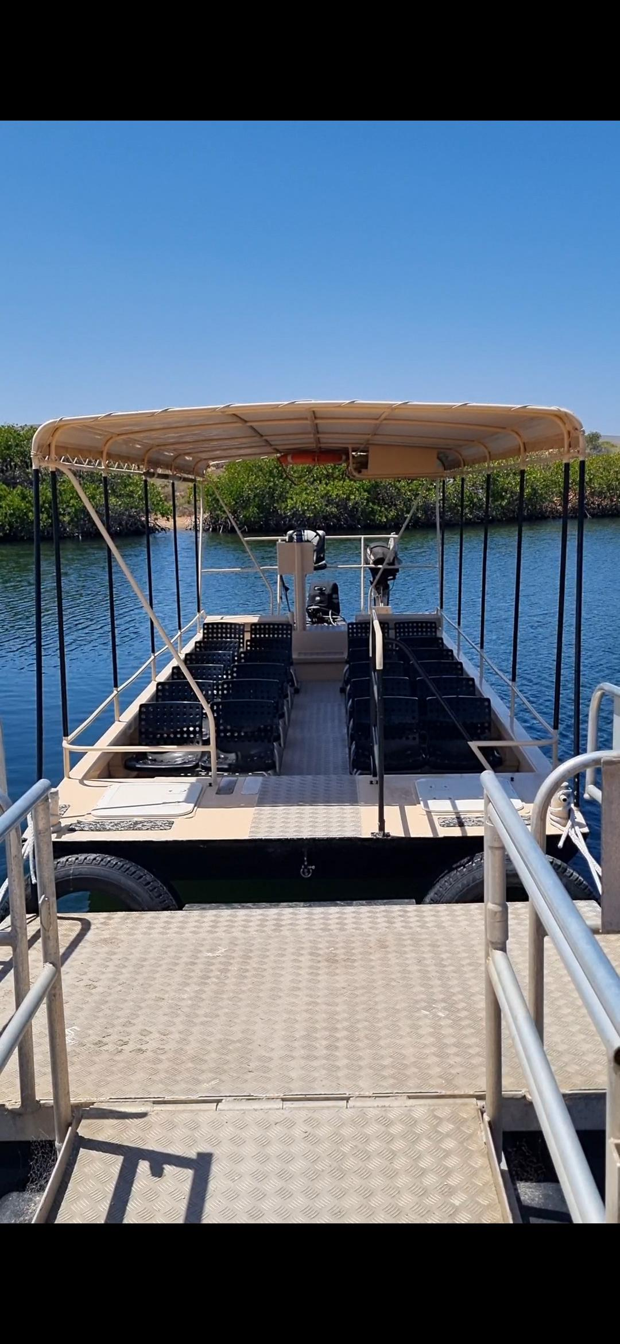
Step from pontoon onto boat
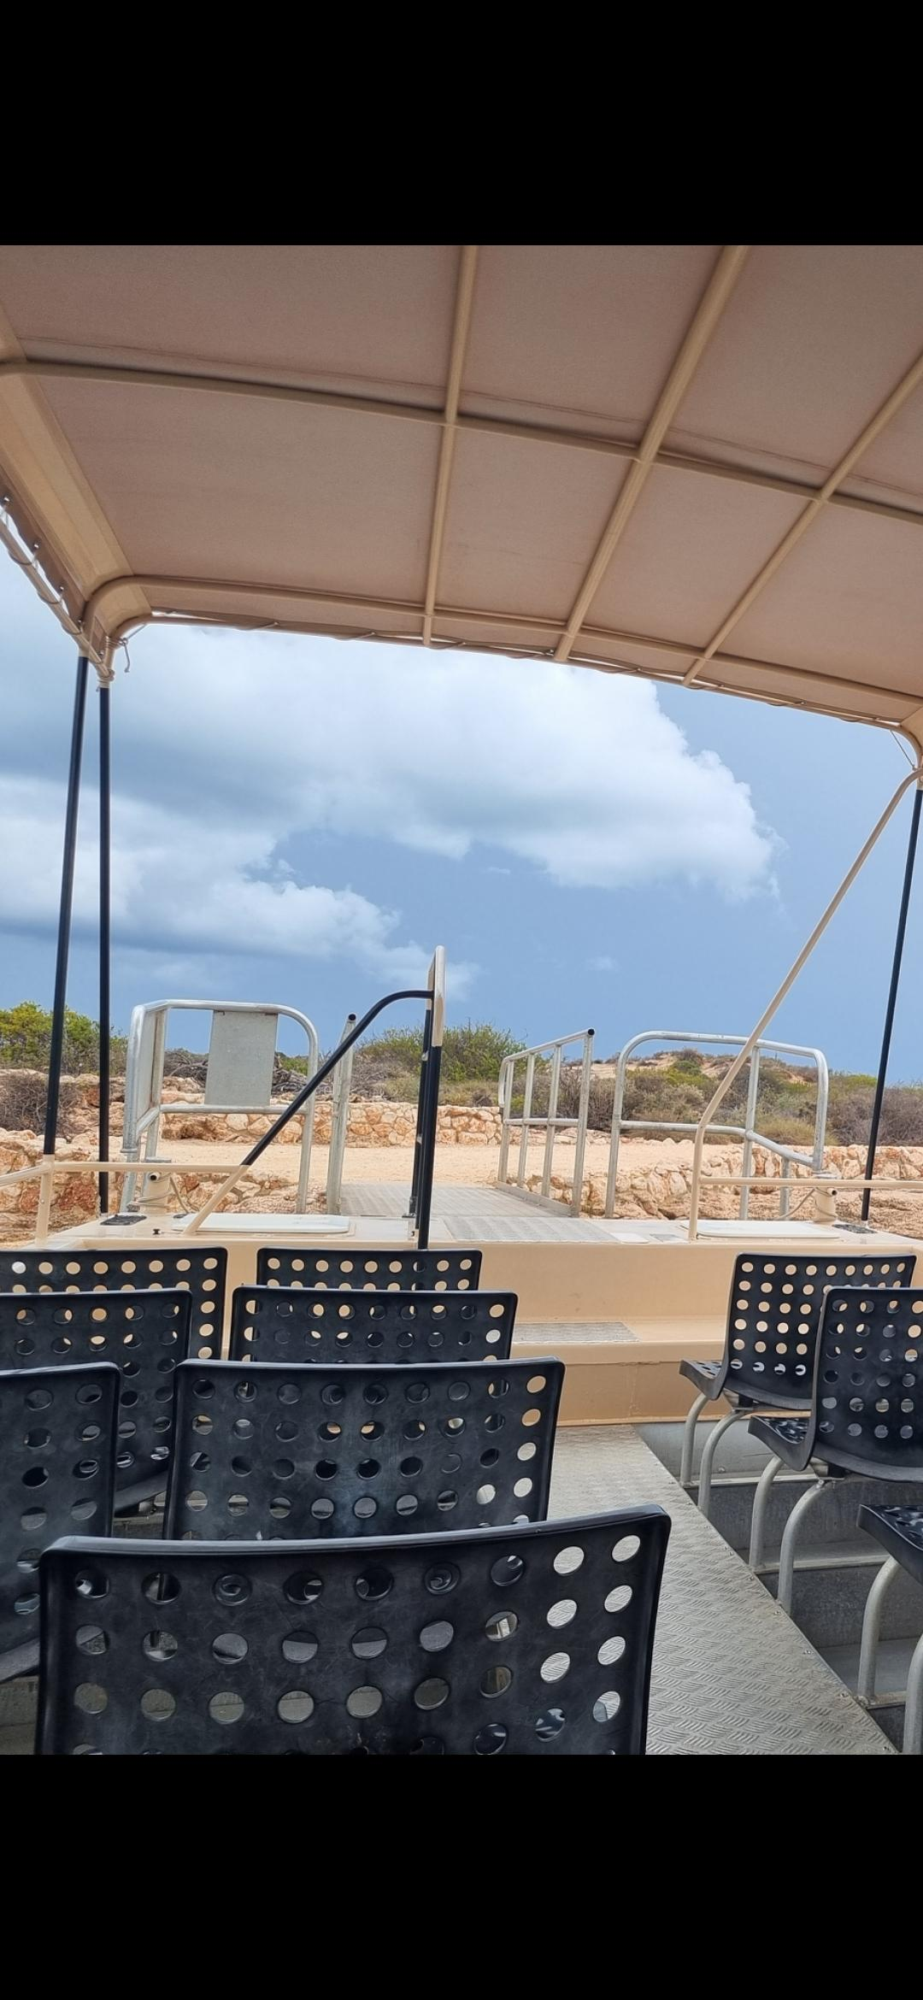
Steps inside the boat

Report Disclaimer
Please note that this business report, provided as a result of the use of the diagnostic assessment, is for information purposes only.
Australian Tourism Industry Council (ATIC) cannot guarantee the accuracy of respondent’s answers, or that they are fully representative of your business. Therefore, ATIC does not warrant or guarantee any particular outcome in respect of your businesses self-assessment.
This report is intended as guidance only for your business and should not be relied on for future marketing considerations. ATIC recommends that you seek your own independent advice as well as the results from the diagnostic.
Links to external web sites are inserted for convenience and do not constitute endorsement of material at those sites, or any associated organisation, product or service.
ATIC does not:
- Assume any legal liability for the accuracy, completeness, or usefulness of any information from this report or any links provided; or
- Accept responsibility for any loss associated directly or indirectly from the use of this report.

