ATIC Accessibility
To support the accessible community in making informed travel decisions for their individual needs

This report prepared for:
Business name: | Sail Ningaloo Pty Ltd
Address: | 1 Robinson Street
Town: | Coral Bay
Contact for enquiries: | Lannie Riley
Contact Number: | 0458822895
Contact Email: | res@sailningaloo.com.au
Website: | www.sailningaloo.com.au
Date: | 2026-10-04 20:28

ATIC Accessibility
The following pages provides travellers with information on the businesses facilities and amenities which aims to support the traveller to make an informed decision on whether the business is suitable for their individual needs.
OVERVIEW 4
Business Overview 4
Bookings 4
Emergency Management 5
Guide Dog and Service Animals 5
GENERAL 6
Pre-arrival, arrival and reception 6
Cognitive Impairment Support 6
Car Park and Access amenities 6
Internal Spaces 7
Displays, exhibits, commentary and live performances 7
Steps 8
TOUR OPERATORS 9
Tour/Transport Services 9
Route Planning 9
Guides 9
ACCOMMODATION 14
Room Amenities 14
Bathrooms 15
COMMON AREAS 19
FOOD AND DRINK 20
Dining Spaces 20
ADVENTURE ACTIVITIES 23
Adventure activities 23
Report Disclaimer 27

OVERVIEW

Business Overview

The business has the following products/services available
- Tour/Transport
- Accommodation
- Food and Drink
- Adventure

Our business caters for the following disability types:
- Blind or low vision
- Deaf or low hearing
- Limited mobility
- Food allergies or intolerances
- Cognitive or people on the Autism Spectrum
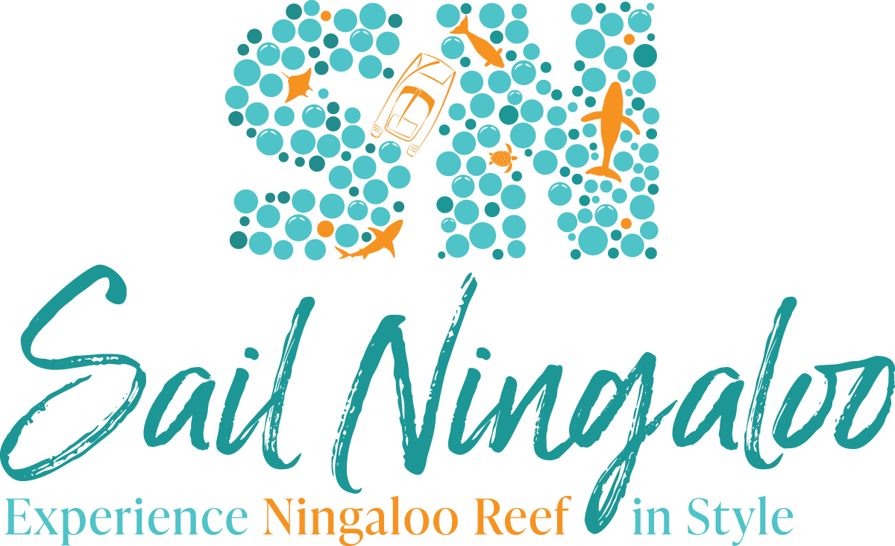

Bookings

The business offers the following methods for bookings and enquiries:
- Phone
- Email
- Webportal
- Staff have undergone disability awareness and training

Emergency Management
- Emergency and evacuation procedures are explained on arrival
- There are Audible device/s to alert occupants to evacuate with instructions on how to evacuate.
- Exit signs are clear and easy to see
- Exit access is free and clear at all times
We ensure exit access is free and clear at all times by:
Large back deck door access which is always open during charters. Large roof cabin hatches for those able.
- Exit doors are able to be opened by all occupants
- In addition, the following further information can assist guests:
Sail Ningaloo has a comprehensive booking procedure in place in order to understand guests requirements, requests and abilities. This information is communicated with our vessel crew prior to departure and then once on board can discuss further with participants.
- In addition, the following further information can assist guests:
All crew are trained in emergency procedures and we have a range of safety equipment on board to assist, such as alarms and ships bell, a tender vessel, life rings, life raft, pool noodles, life jackets, defibrillator and emergency oxygen. Guests personal/specific needs are discussed at booking enquiry stage so we can be prepared with a specific action plan if required.
- Guests with disabilities are noted in the guest log book for emergency and evacuation purposes

Guide Dog and Service Animals
The business provides the following services for services animals:
Sail Ningaloo is a sailing tour operator and our vessel is a 51ft sailing catamaran. Please be aware that we cruise along the reef for the duration of the tour and so access to the beach/shore is very limited (some days it is impossible due to the coastline), so please consider if this is appropriate for your service animal. As bookings are generally made in advance, we can assist with providing required items for service animals, please discuss your requrements when you enquire.

GENERAL

Pre-arrival, arrival and reception
The business has the following in place to support guests during pre-arrival, arrival and reception
- Booking information and websites are compatible with screen readers
- Information and maps are available in written form
- Luggage assistance
- In addition, the following further information can assist guests:
Sail Ningaloo accommodates only 8 - 10 guests.
On departure, complimentary mini-bus transfers are available from your accommodation in Coral Bay directly to the jetty facility to board our vessel, Shore Thing. At this time access to Shore Thing is immediate and no wait time is required. Guests are invited to sit down whilst the Captain provides a safety briefing.
Whilst underway and during the tour, there are multiple locations on board to sit and enjoy the view or quiet spaces, the upper deck, the front and back decks, the inside saloon, or your private cabin.
In-water activities are accompanied by a guide and flotation aids are available if required.
Once the tour returns, on disembarkation our minibus is once again waiting for our arrival, so no waiting around time is necessary and we will drop you back to your Coral Bay accommodation
- In addition, the following further information can assist guests:
At booking enquiry stage our reservations team will be happy to answer any questions you have about our tour, our vessel and activities offered on board. We will work with you to provide any and all information you need to make an informed decision about booking with Sail Ningaloo.

Cognitive Impairment Support
- Quiet periods or early opening times for people on the Autism Spectrum
- A space for parents and children on the Autism Spectrum

Car Park and Access amenities
The business has the following Car Park and Access amenities
- A drop off zone
- Level or ramped access from the car park to the entrance
- Kerb ramps are in place where a pavement or walkway needs to be crossed
- In addition, the following further information can assist guests:
Departure/arrival location is the Coral Bay jetty facility which is a public access jetty, there are no private pens and we bring the vessel alongside at departure/return times only.
Whilst there is a public drop-off car parking zone at the start of the jetty, long-term public parking is up on top of the hill. Our minibus can collect drivers from the carpark to save them walking down, however usually guests find it easier to park in Coral Bay township at their accommodation, or town car park, and utilise our complimentary pick up/drop off service.

Internal Spaces
- Tableware/glassware contrast with the table surface or table cloth

Displays, exhibits, commentary and live performances
For displays, exhibits, commentary and live performances the following amenities are in place
- Seating
- A written transcript where audio description is provided i.e. display commentary, tour commentary
- In addition, the following further information can assist guests:
Sail Ningaloo caters for small groups, 8 - 10 guests so crew are available for any guests requiring additional support and information on board.
Written safety, vessel and cabin inductions are available if required.
Written safety briefings for activities (sailing, snorkelling, scuba diving, manta ray interactions) are available if required, and activity briefings are accompanied by site maps.
Vessel has a library on board, including a folder put together by Sail Ningaloo which provides information about the local area, sites visited and marine life seen.
The width of the smallest pathway is:
Being a sailing vessel, there are no pathways.

Being a sailing vessel, there are no pathways.

Being a sailing vessel, there are no pathways.
- In addition, the following further information can assist guests:
Sail Ningaloo operates tours on board a sailing catamaran.

Steps
Steps
- There are steps.
- Top and bottom steps are easily distinguished through colour contrast or the use of TGSIs (Tactile Ground Surface Indicators)
- All steps or staircases have enclosed risers
- The underside of all staircases are enclosed or protected to a height of at least 2 metres
- In addition, the following further information can assist guests:
Shore thing is our vessel, a 51ft sailing catamaran.
On boarding, there are 2 large steps from the deck down to the back deck. Whilst there are no handrails here, crew can assist guests if required.
From the back deck into the saloon area, there is a step-over. This is to provide water tight integrity to the vessel. Crew can assist with access here if required.
From the saloon down to the guest cabins, there are 4 smaller steps to get access, with handrails. Cabins require a small step-over on entry, as do the bathroom facilities. Bathrooms for rear Deluxe cabins are located adjacent to the cabins. Bathrooms for forward Stateroom cabins are located in the cabin, with a small step-over to access the toilet and basin and another into the shower.
For activities, there are 2 large steps from the back deck down to water level, with handrails and crew can also assist if required. There is a (removable) ladder at water level to get back on board from the water, or crew can assist if required. Some activities may be facilitated from our tender vessel, in which case crew can assist boarding from the main vessel. Access back into the tender from the water is via a small ladder at the back of the boat and crew can assist if required.
If guests would like a private guide/crew person to accompany them on board to assist with moving around the vessel and activities, please enquire at booking enquiry stage.
- In addition, the following further information can assist guests:
Sail Ningaloo operates tours on board a sailing catamaran.
No public toilets or change facilities are available, however guests have their own private cabins and facilities.

TOUR OPERATORS

Tour/Transport Services
The tour/transport services have the following facilities/amenities in place
- Buses/Coaches
- 0 vehicles have wheelchair lifts or ramps
- 0 vehicles have low floors with ramped entry
The maximum wheelchair capacity available in the fleet is:
0
- Commentary is available in written format

Route Planning
- Route Planning
- In addition, the following further information can assist guests:
Sail Ningaloo is a sailing tour operator and our vessel is a 51ft sailing catamaran. Please be aware that we cruise along the reef for the duration of the tour and so access to the beach/shore is very limited (some days it is impossible due to the coastline), so expect to remain on board for most of the duration of the tour (except for snorkelling/scuba diving activities). When we do go ashore, we are on a remote coastline ad no facilities are available.
Sail Ningaloo caters for small groups, 8 - 10 guests so crew are available for any guests requiring additional support and information on board.
If guests would like a private guide/crew person to accompany them on board to assist with moving around the vessel and activities, please enquire at booking enquiry stage.
- Overnight Stops
The total number of wheelchair passengers that can be catered for at overnight stops are:
0

Guides
- Use of clear/simple English
- Correct pronunciation for lip readers
- Marine
  - Image(s)
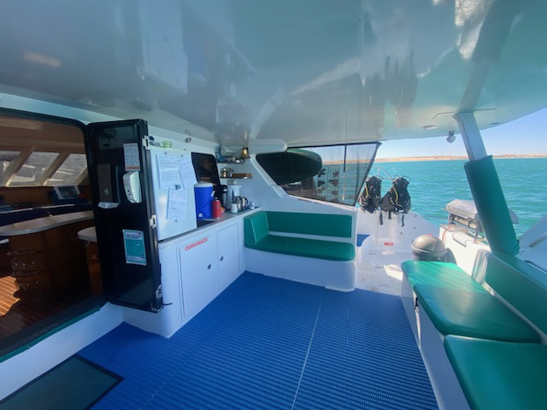
Shore Thing back deck seating area
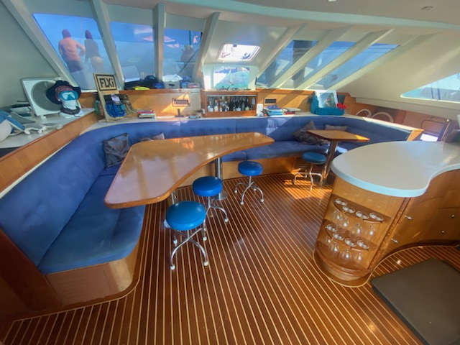
Shore thing inside saloon and galley
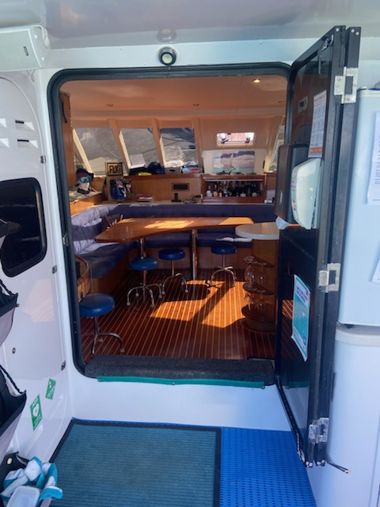
Shore Thing stepping into saloon from back deck
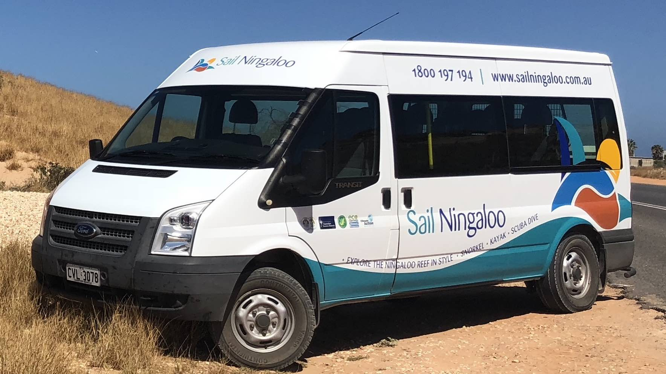
Sail Ningaloo transfer bus
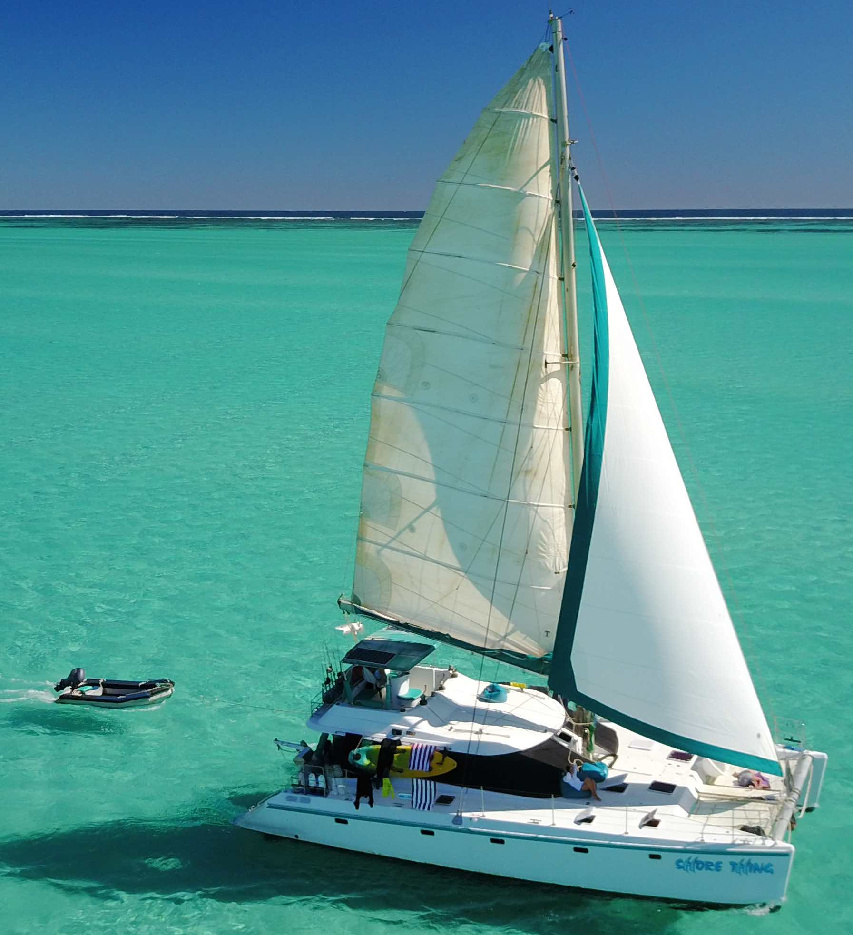
Shore Thing underway
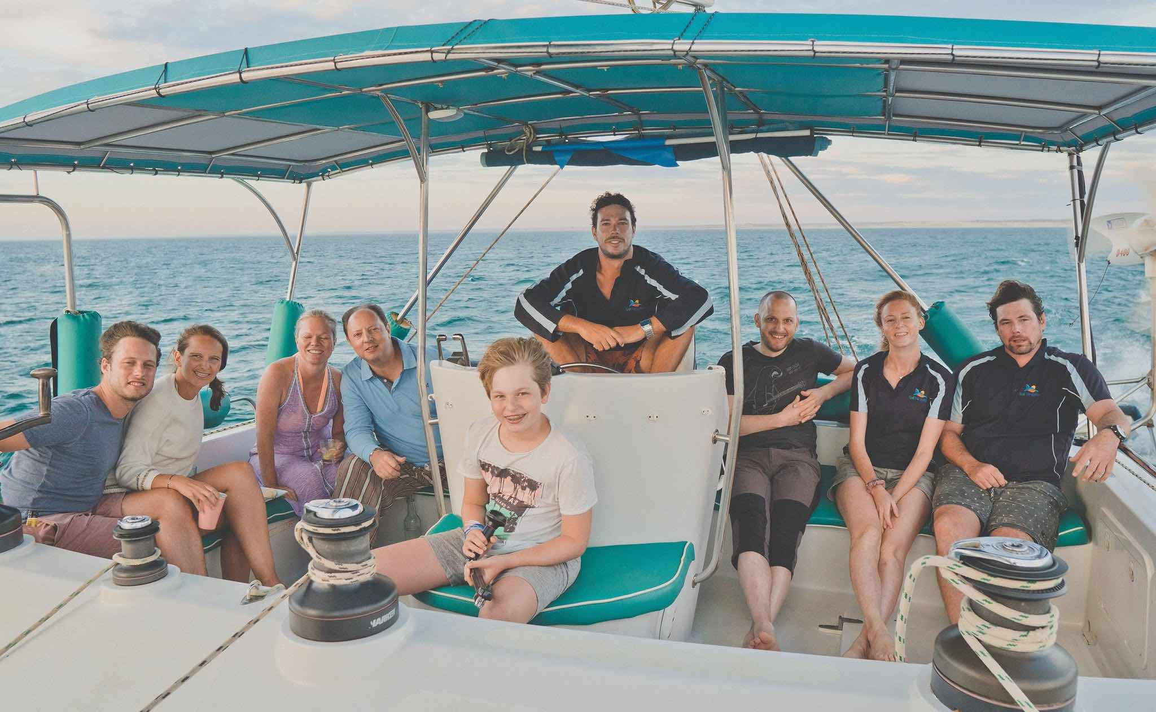
Shore Thing upper helm area
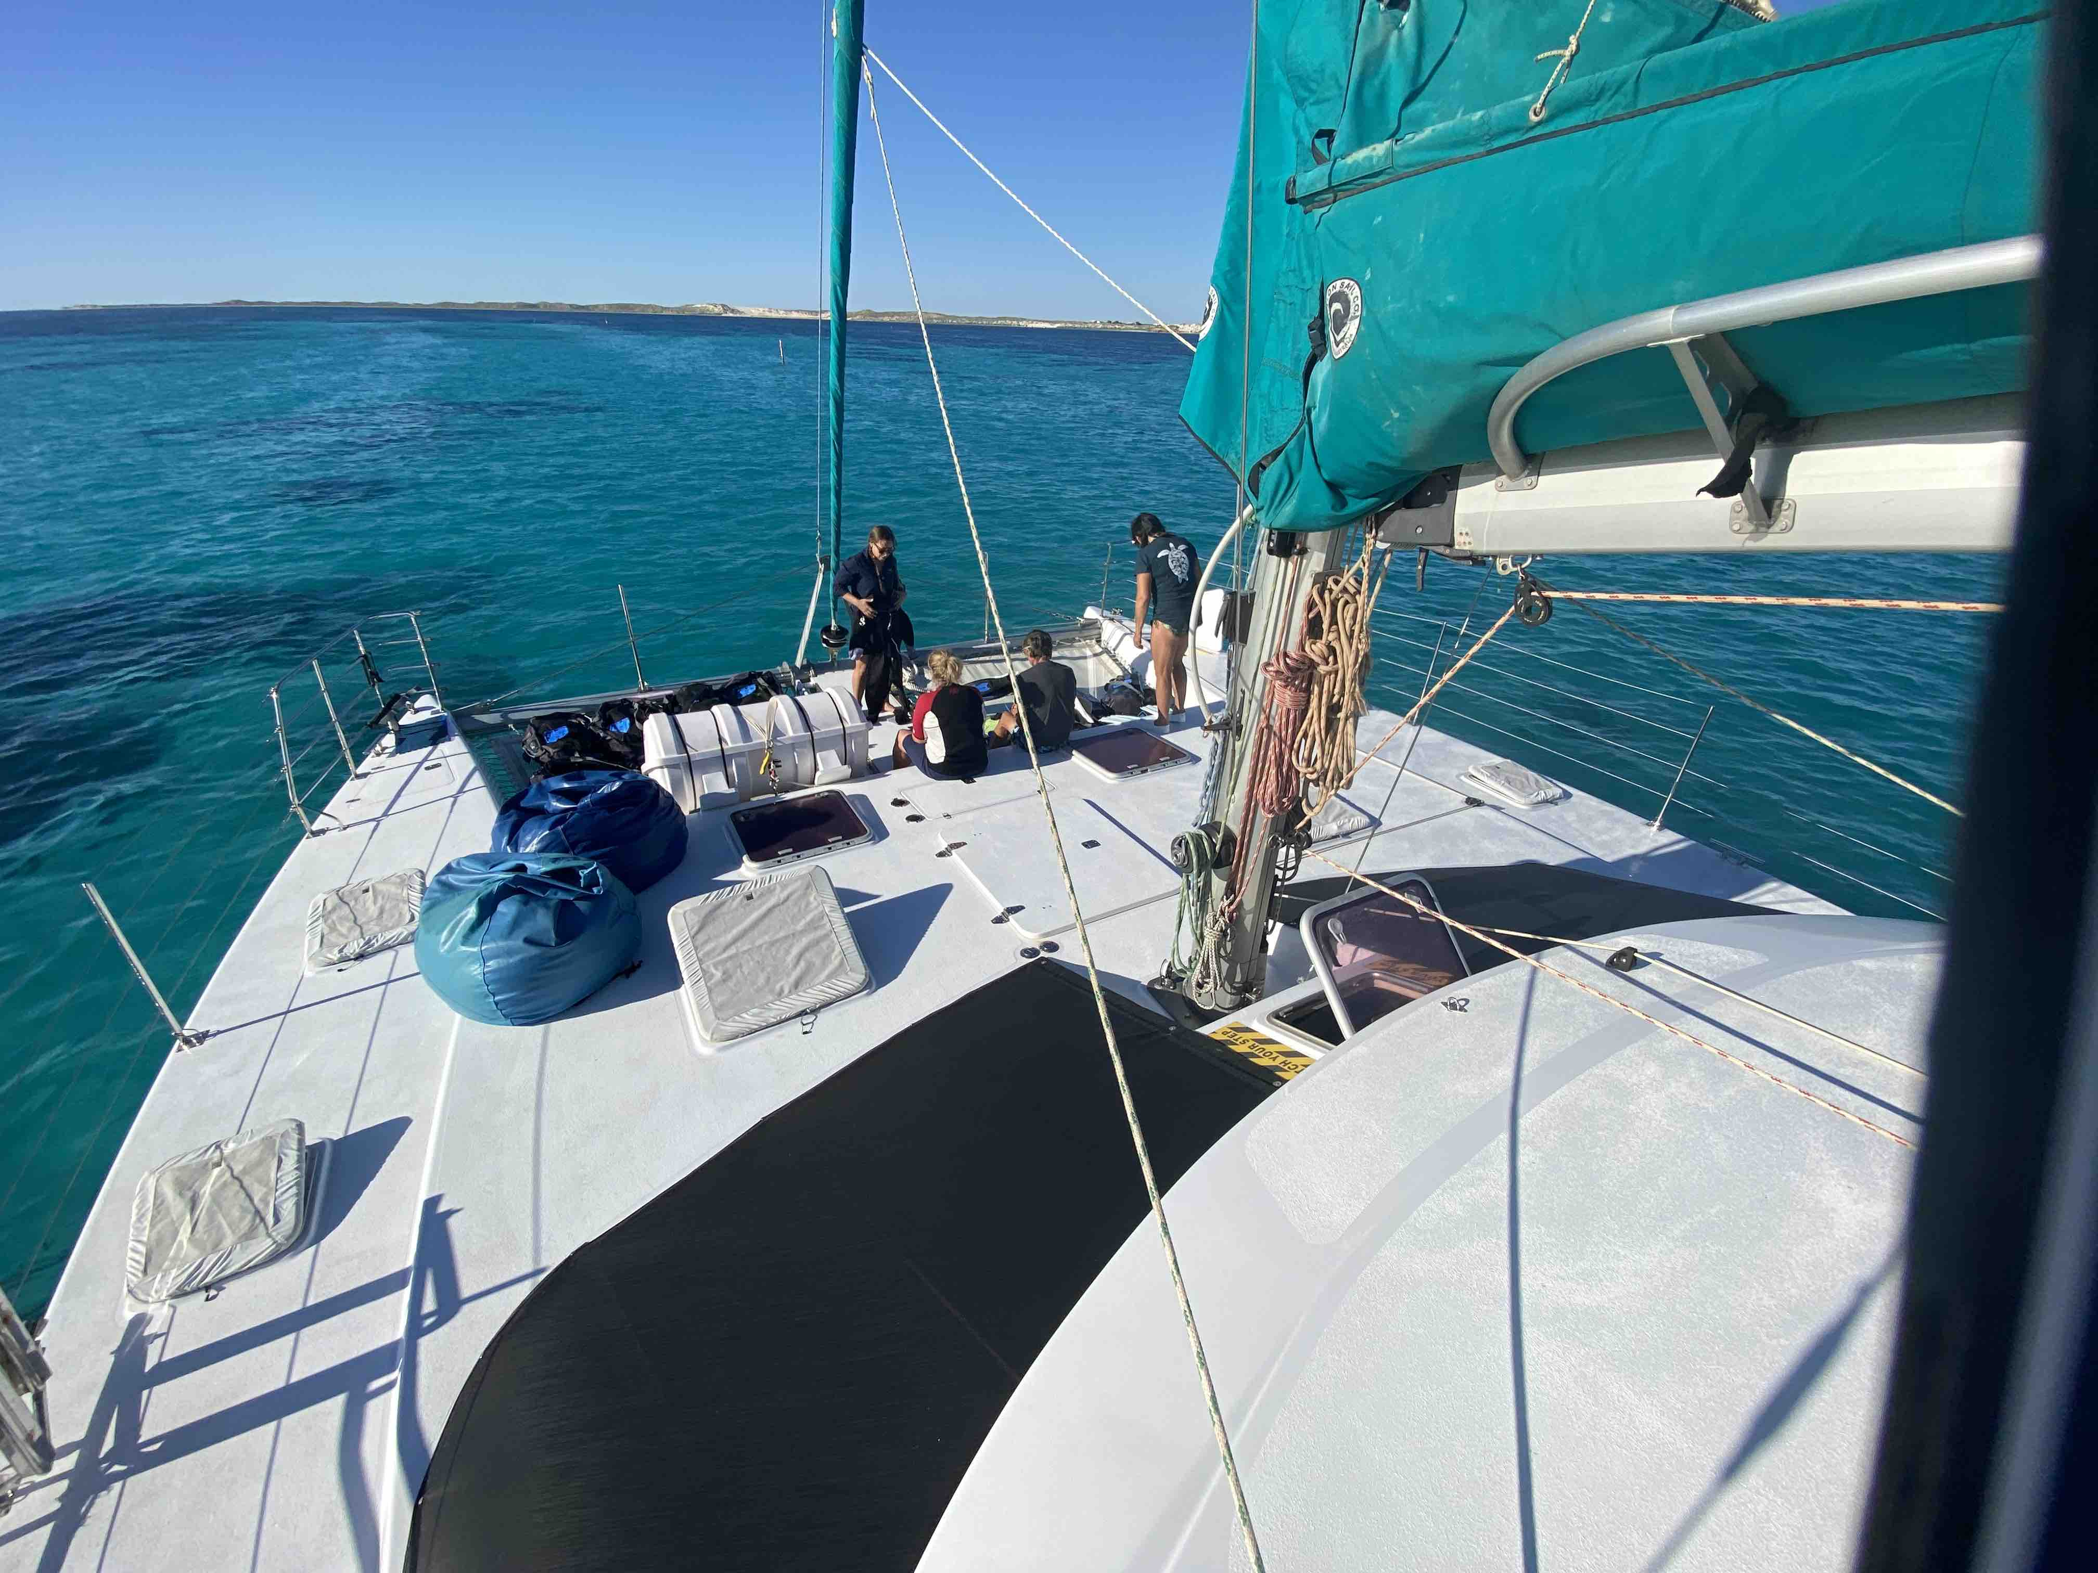
Shore Thing front deck
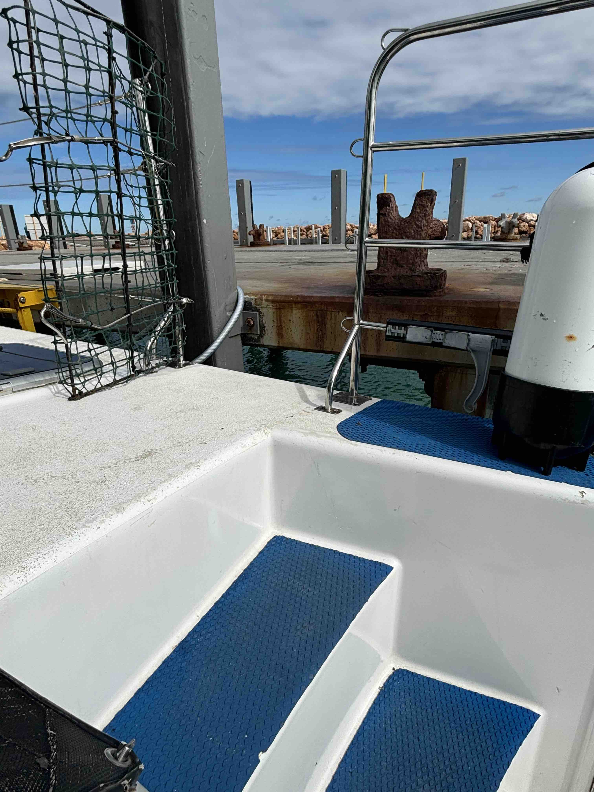
Shore Thing step from jetty
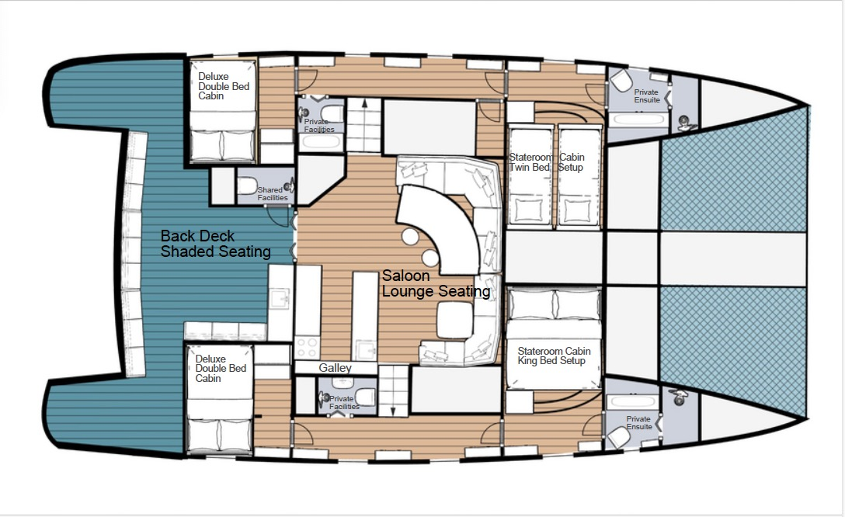
Shore Thing Layout
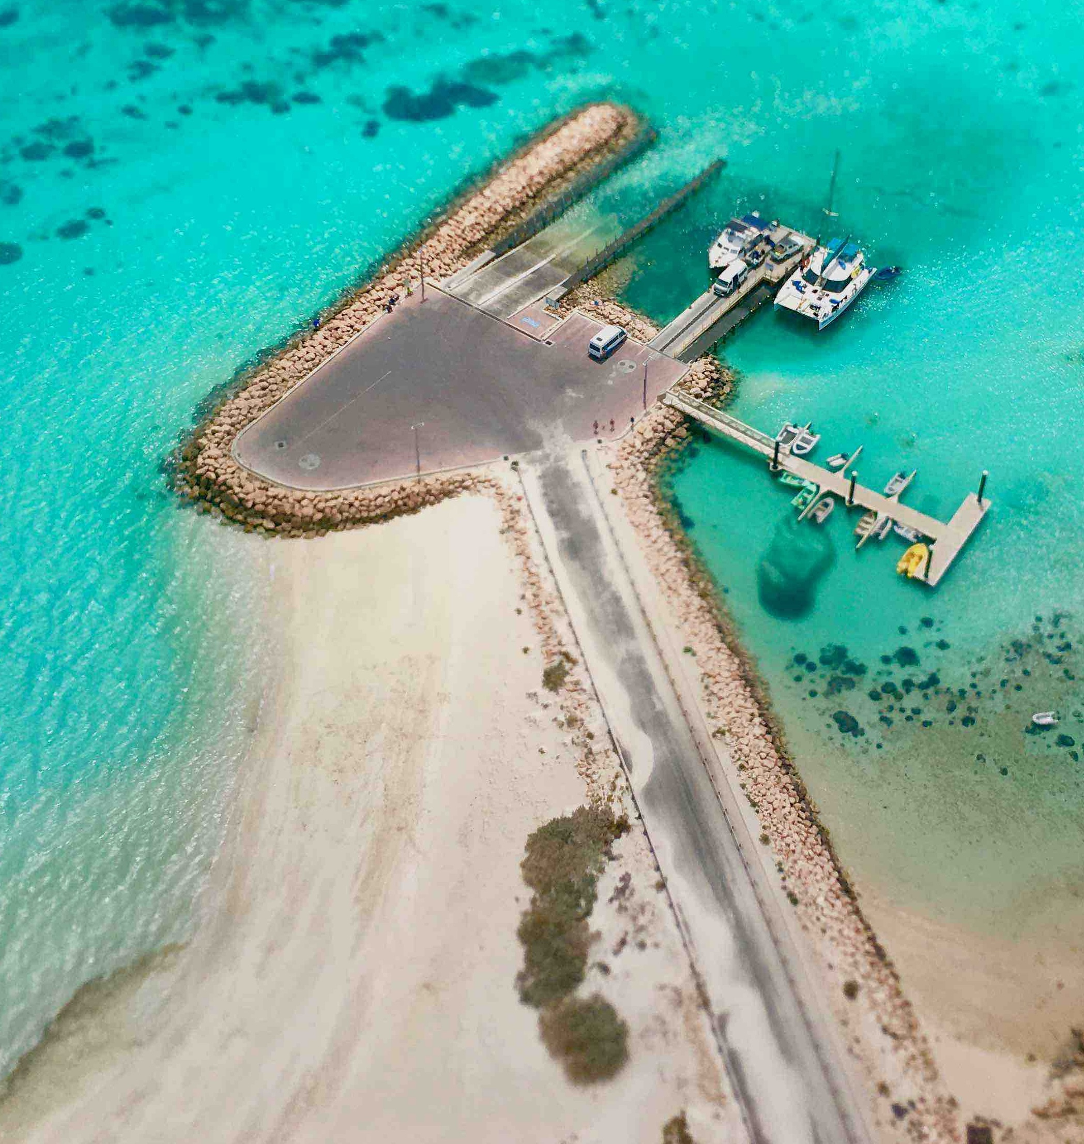
Coral Bay jetty facility
- In addition, the following further information can assist guests:
Sail Ningaloo caters for small groups, 8 - 10 guests so crew are available for any guests requiring additional support and information on board.
Written safety, vessel and cabin inductions are available if required.
Written safety briefings for activities (sailing, snorkelling, scuba diving, manta ray interactions) are available if required, and activity briefings are accompanied by site maps.
Vessel has a library on board, including a folder put together by Sail Ningaloo which provides information about the local area, sites visited and marine life seen.
If guests would like a private guide/crew person to accompany them on board to assist with moving around the vessel and activities, please enquire at booking enquiry stage.

ACCOMMODATION

Room Amenities
- In addition, the following further information can assist guests:
The vessel has a loud alarm system as well as a manual bell.
As we cater for a small number of guests, crew are able to personally assist guests if required, please discuss your requirements at booking enquiry stage.
- There is contrast between the walls, skirtings, floor and furniture
- There is a clear path through the room
- The edges of all furniture and fixtures are rounded
- Wardrobe handles are a contrasting colour to the doors and draws
- Openings are a minimum of 400mm wide
- The bedside lamp switch is easy to reach from the bed
- The business offers a range of non-allergenic bedding
- Non-allergenic cleaning products are used
- In addition, the following further information can assist guests:
Sail Ningaloo is a sailing tour company and you are accommodated on board Shore Thing, a 51ft sailing catamaran.
Please note we are not a cruise ship and cabins are smaller than hotel style rooms, with limited amenities. There are no telephones.

There are 2 x Stateroom king bed cabins on board featuring a king bed, with access to the bed via 2 large steps at the foot of the bed (walls either side of the bed). There is a ceiling hatch above the bed to provide fresh air and reading lights are on the ceiling above you, usually reached by sitting up. To enter the cabin and the adjoining ensuite, a small step-over is required to clear bulk head doors.

There are 2 x Deluxe cabins on board featuring a double bed, with access to the bed on one side (wall on the other side of the bed). There is a ceiling hatch above the bed to provide fresh air and reading lights are on the side of the wardrobe next to you. To enter the cabin and the bathroom just outside of the cabin, a small step-over is required to clear bulk head doors.

Bathrooms
The bathrooms have the following facilities/amenities in place
- All heating appliances and hot water pipes are protected or insulated
- All shower, bath and basin taps are clearly differentiated between hot and cold
- Fixtures and fittings have rounded edges
- The width of the door is 450mm into bathroom, 500mm into shower..
- The width beside the toilet is 130 - 300mm depending on cabin type..
- There is 330 - 550mm depending on cabin type. Stateroom cabin bathrooms are fitted with a handrail. mm of clear space in front of the toilet
- The toilet seat is 460mm above the floor
- A range of non-allergenic toiletries are available
- There is a portable shower head on flexible hose
- A door is fitted to the shower
  - Bathroom Image(s)
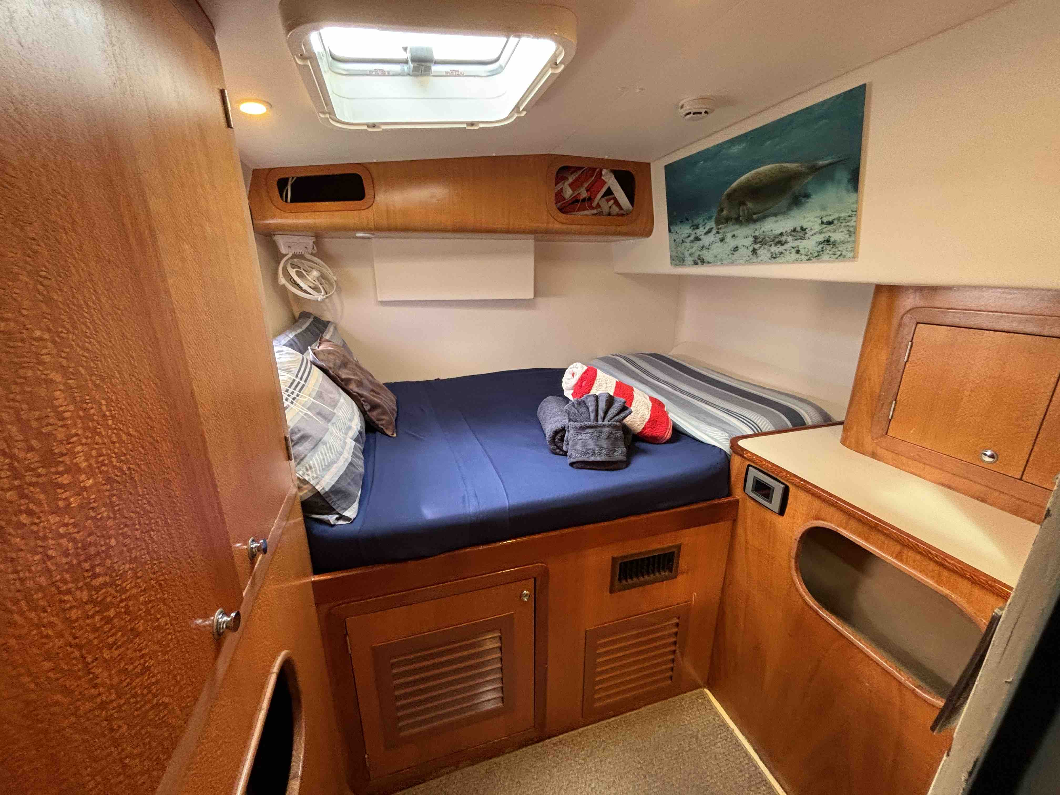
Deluxe double bed cabin
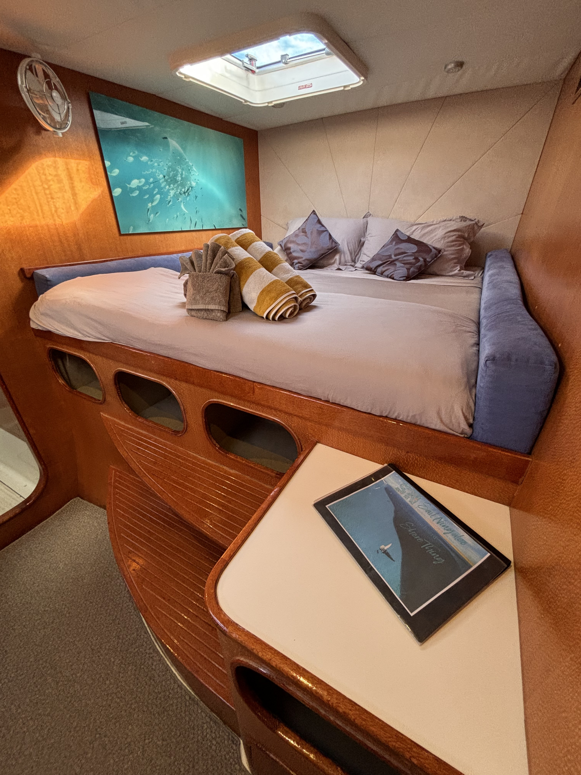
Stateroom king bed cabin
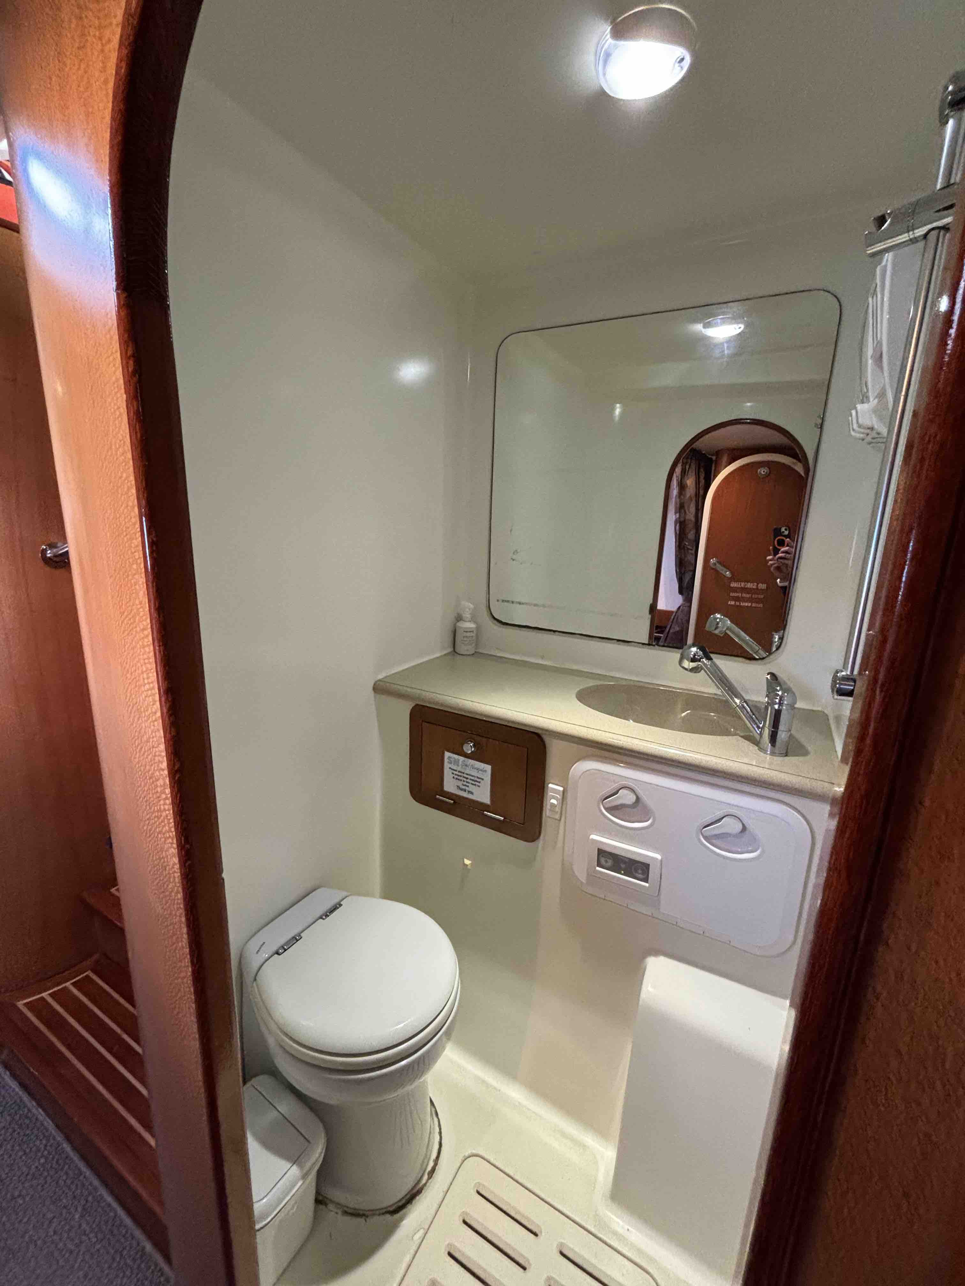
Port Deluxe cabin facilities 2
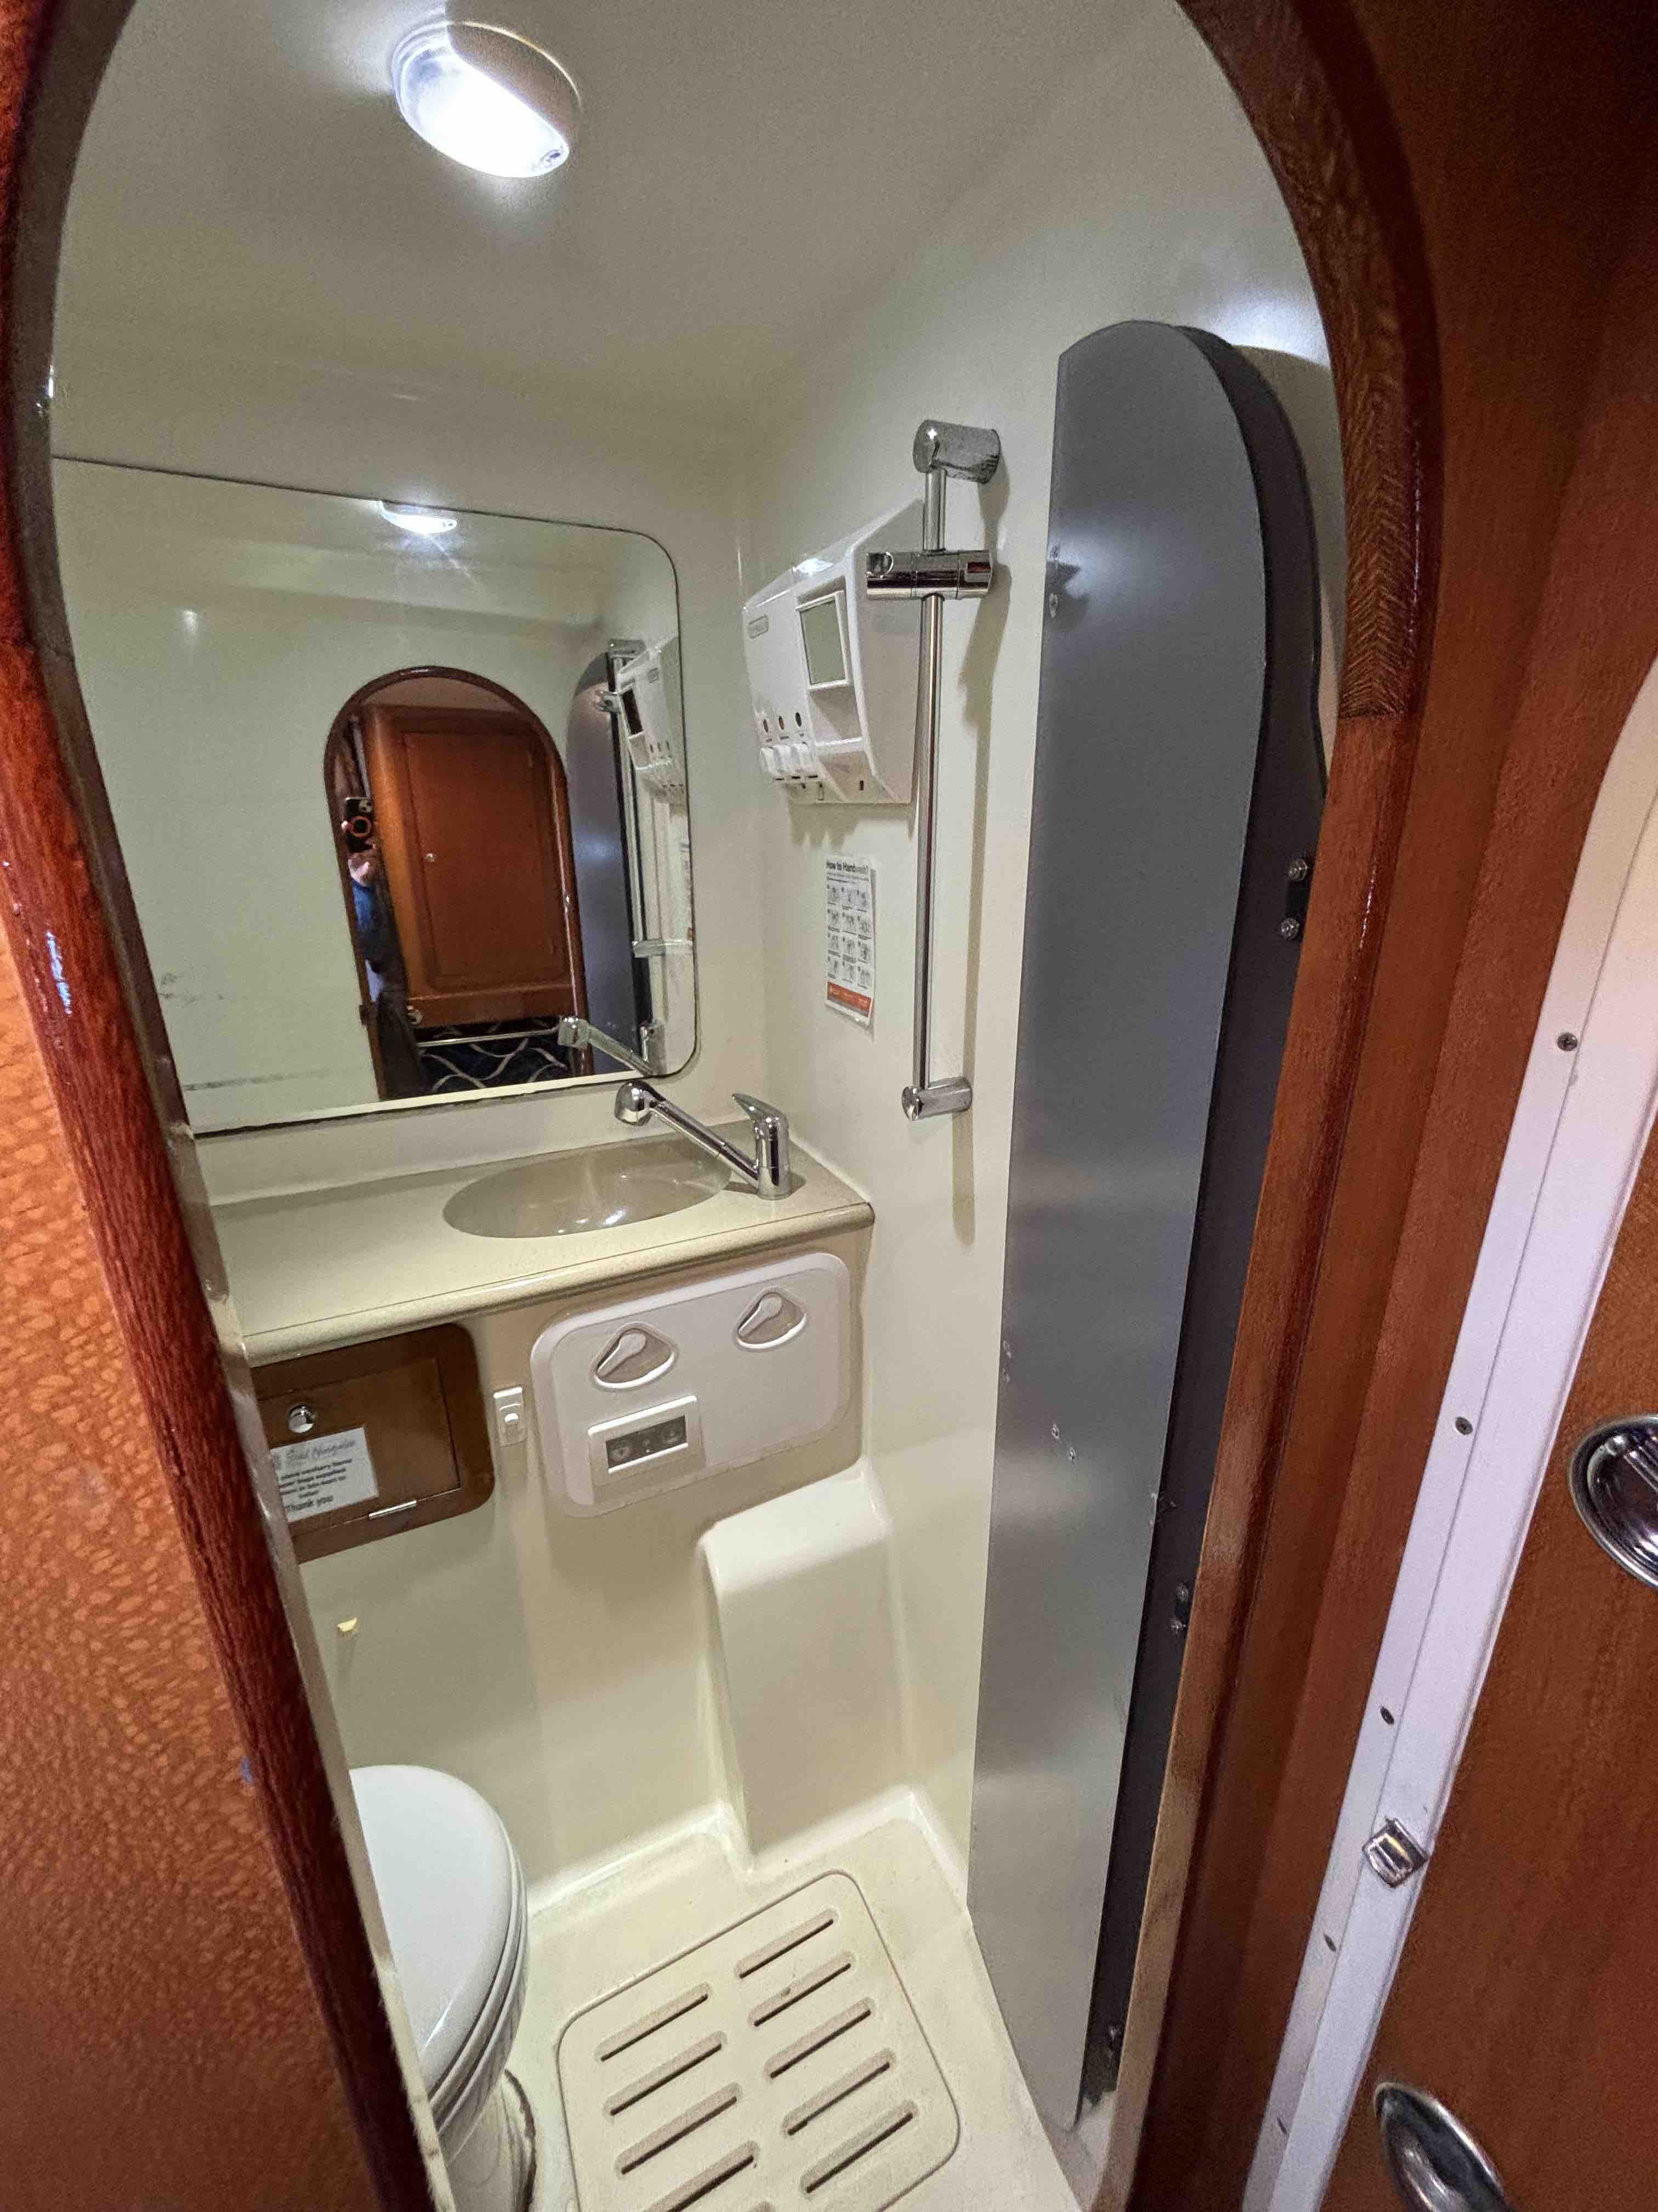
Port Deluxe cabin facilities 1
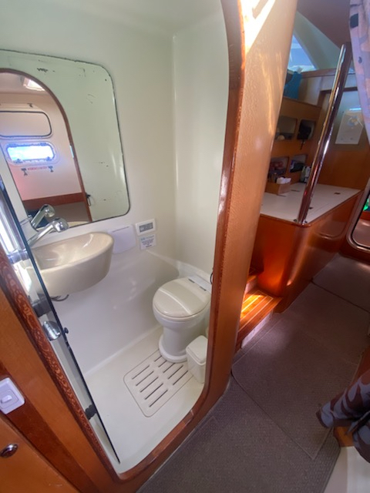
Starboard Deluxe cabin facilities
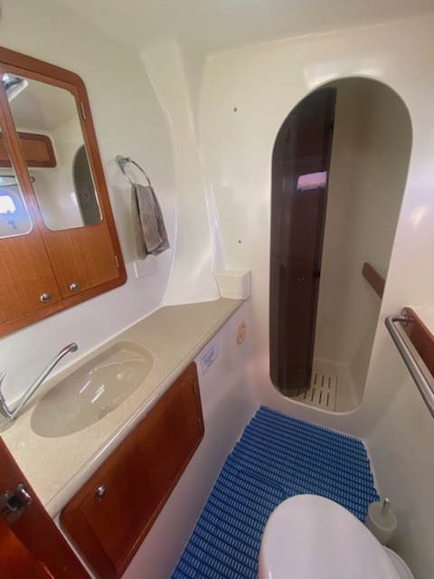
Starboard Stateroom cabin facilities - basin handrail toilet
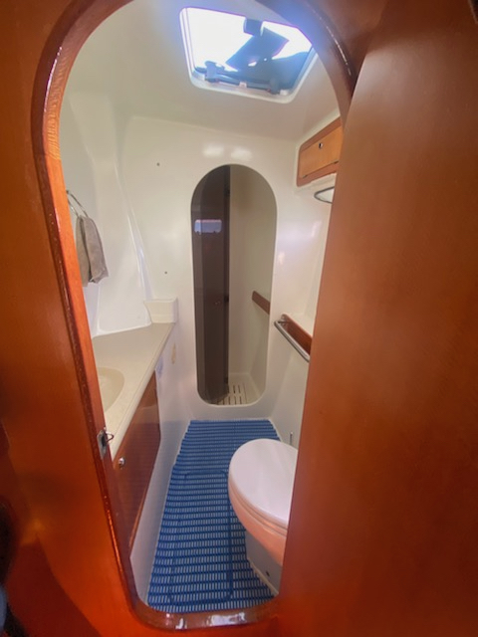
Starboard Stateroom cabin facilities - looking in
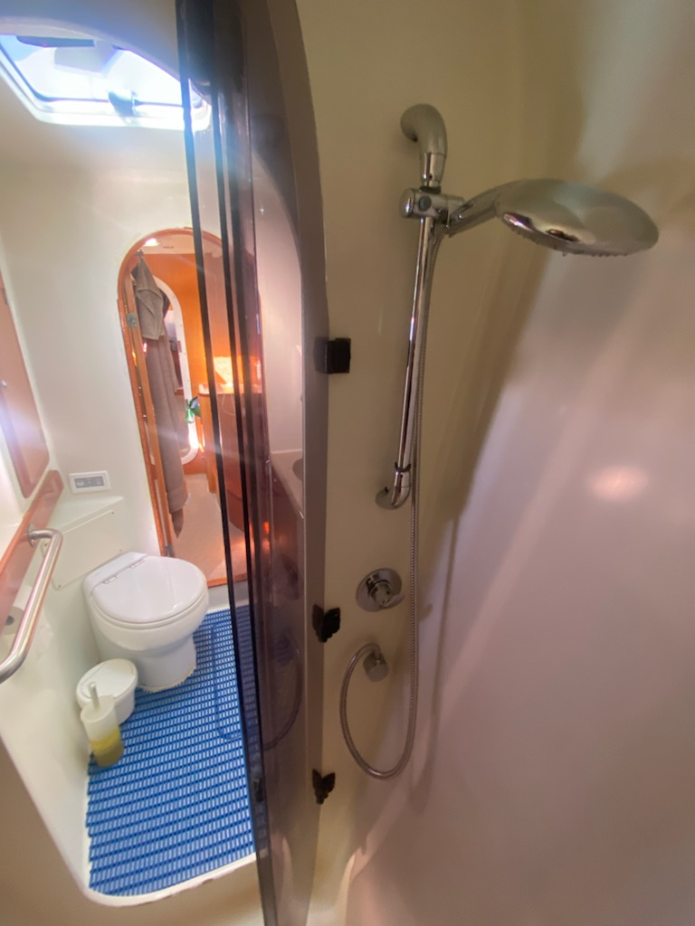
Starboard Stateroom cabin facilities - looking out - shower
- In addition, the following further information can assist guests:
Being a sailing catamaran, bathroom facilities are much smaller &amp; more compact than regular bathrooms.
There is a small step-over to access all bathroom facilities.
In Stateroom cabins, the toilet and basin area is larger, with a separate shower recess. These cabins would be recommended for guests with some restricted mobility needs.
In Deluxe cabins, toilets and showers are all-in-one.
At booking enquiry stage our reservations team will be happy to answer any questions you have about our vessel and cabins/bathroom facilities on board.

COMMON AREAS

FOOD AND DRINK

Dining Spaces
The dining spaces have the following facilities/amenities in place
- The doorway is at least 850mm wide
- Chairs are moveable to allow for wheelchairs to be seated at the tables
- All glass doors and full height windows have contrast markings
- There are areas of full lighting

Our business caters for the following dietary requirements
- Sugar free (diabetic)
- Gluten free (celiac)
- Lactose free (dairy free)
- Low fat and fibre with no gastric content
- Low potassium
- Low sodium
- Nut free
- Additive free
- Vegetarian
- Vegan
- In addition, the following further information can assist guests:
All crew complete food safety and allergen awareness training when starting employment and receive full on the job training. Proper food handling procedures are in place around handling, preparing, cooking and storage.
Food items are separated to be stored on board and when required, some food items are not taken on board, for example when serious allergies are disclosed.
- There is a sample menu available online
Sample menu is available here -
https://sailningaloo.com.au/wp-content/uploads/2024/03/Sail-Ningaloo-Sample-3-Night-Tour-Menu-3.pdf
  - Food and Beverage Image(s)
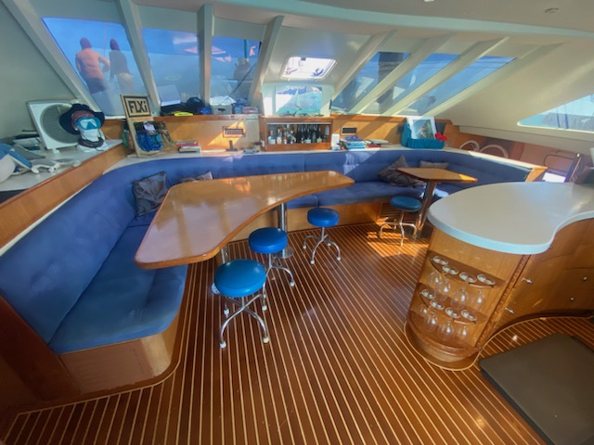
Shore Thing Saloon - inside dining seating area
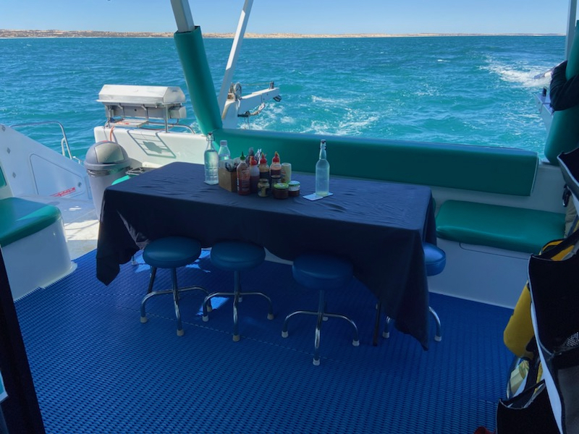
Shore Thing back deck dining area
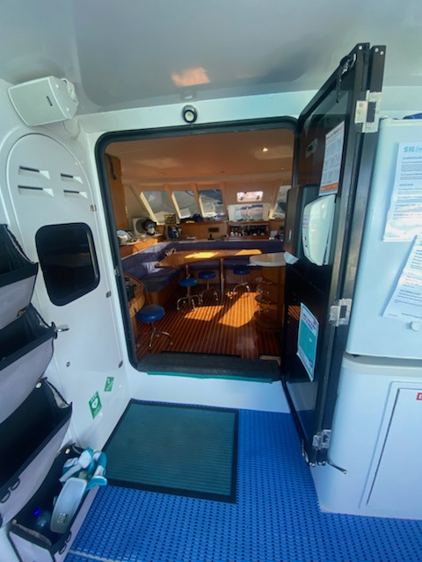
Shore Thing stepping into saloon from back deck 2
- In addition, the following further information can assist guests:
At booking enquiry stage our reservations team will be happy to answer any questions you have about our tour and the meals and drinks offered on board.
Please disclose all dietary requests and requirements, we happily cater for most dietary requirements, and those that we don't cater for (organic/kosher/halal) are due to our remote location and having limited access to produce/ingredients/items required.
Set menus are created for each tour taking into account guests requests so please ensure requirements are advised as early as possible.
Breakfasts are continental including fruit salad, alternating with a cooked breakfast.
Morning teas are baked goods, alternating with a fruit platter.
Lunches are generally a cooked protein, a couple of salad options, freshly made bread or rolls/scrolls.
Afternoon tea can be a cheese platter or similar.
Dinners are plated and 2 courses, alternating between entrees &amp; dessert each night.
Non-alcoholic drinks (water/soda water/soft drinks/juices) are complimentary.
Alcoholic drinks (beer/wine/spirits) are available for purchase on board. Special drink requests can be catered for with enough notice.

ADVENTURE ACTIVITIES

Adventure activities
The adventure activities have the following facilities/amenities in place
- Our adventure activities cater for people with a disability
- In addition, the following further information can assist guests:
Tours are operated on board our sailing catamaran Shore Thing. The vessel is wide and stable on the ocean, however may not be suitable for all people. Please discuss in detail with our reservations when you make your booking enquiry.
Shore Thing is 15m long and 8m wide, with 4 guest cabins (2 in each hull). There is a large back deck area &amp; inside saloon with couches. There are steps to navigate down to the cabins and up to the front deck and upper helm area. Being a multi-day tour, all accommodation, meals and activities are on board. We step ashore on remote beaches once or twice during a 5 night tour but there is no infrastructure/facilities there.
Activities available on board include sailing, snorkelling, scuba diving (certified divers), relaxing, star-gazing, beach walks on longer tours and kayaking. We have a range of flotation devices to assist guests, such as life jackets and pool noodles. We have some prescription masks for certain prescriptions. Some activities are taken from Shore Thing and some are taken from our smaller tender.
- In addition, the following further information can assist guests:
3mm or 5mm wetsuits, snorkelling equipment (mask, snorkel, fins), life jackets, pool noodles &amp; rescue floats on a rope. Some prescription masks are available - please advise your prescription at booking enquiry stage.
For scuba diving, tanks, weights, BCD &amp; regulator (available for certified scuba divers only).
- In addition, the following further information can assist guests:
Scuba diving, guests must be certified divers.
Snorkelling, may not be available for all disabilities but it is really dependent on individuals. Please discuss with us during your booking enquiry and we can discuss personal requirements.
  - Adventure Activity Image(s)
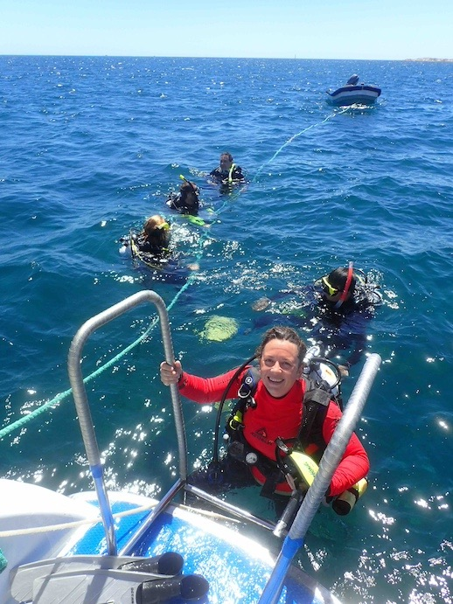
Ladder on back transom
Shore Thing underway
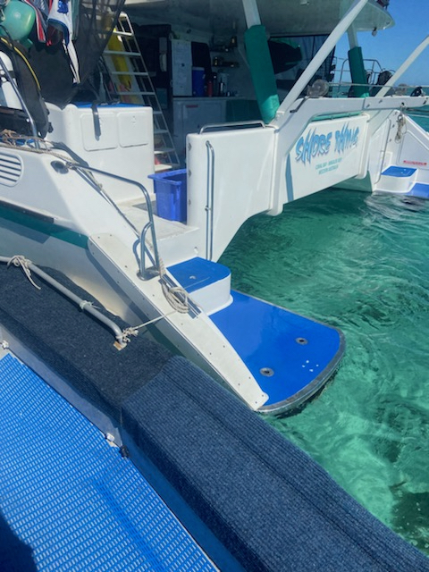
Shore Thing steps to water and tender
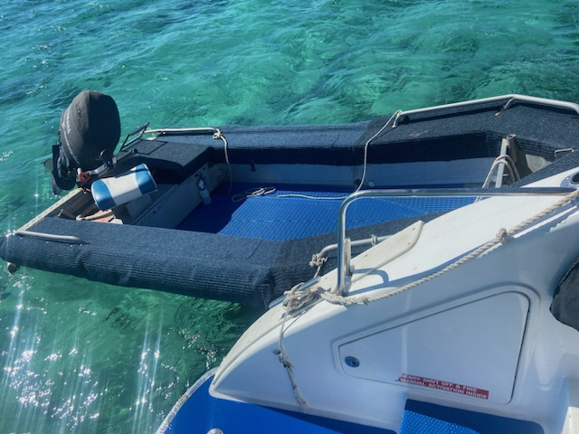
Shore Thing tender
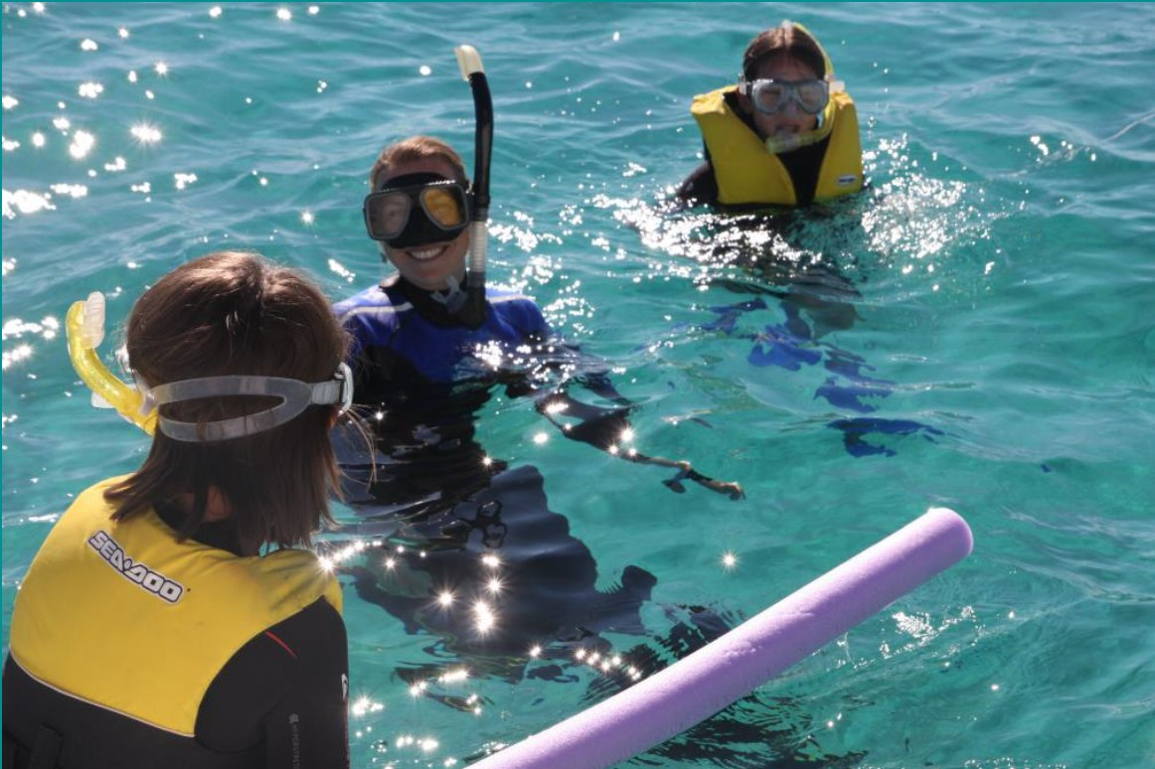
Shore Thing snorkelling with a lifejacket and guide
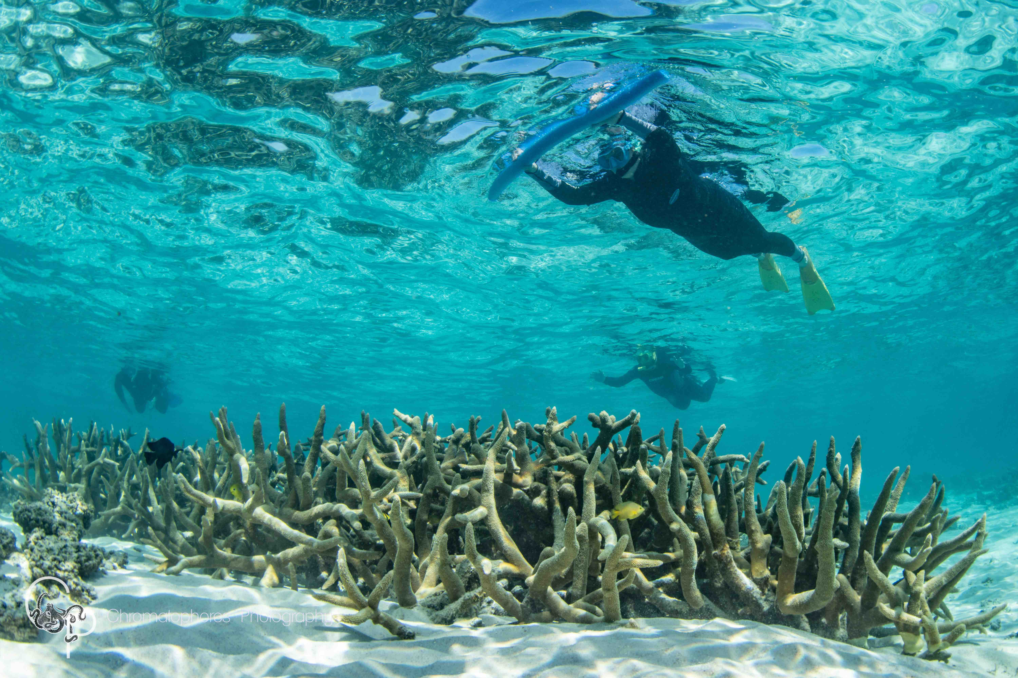
Shore Thing snorkelling with pool noodle
- In addition, the following further information can assist guests:
Please discuss with us your personal requirements during your booking enquiry.
There is always a crew member in the water with the guest group guiding snorkelling and diving activities, however if you would like a private guide/crew person to accompany you on board to assist with moving around the vessel and in-water activities, please enquire at booking enquiry stage.

Report Disclaimer
Please note that this business report, provided as a result of the use of the diagnostic assessment, is for information purposes only.
Australian Tourism Industry Council (ATIC) cannot guarantee the accuracy of respondent’s answers, or that they are fully representative of your business. Therefore, ATIC does not warrant or guarantee any particular outcome in respect of your businesses self-assessment.
This report is intended as guidance only for your business and should not be relied on for future marketing considerations. ATIC recommends that you seek your own independent advice as well as the results from the diagnostic.
Links to external web sites are inserted for convenience and do not constitute endorsement of material at those sites, or any associated organisation, product or service.
ATIC does not:
- Assume any legal liability for the accuracy, completeness, or usefulness of any information from this report or any links provided; or
- Accept responsibility for any loss associated directly or indirectly from the use of this report.

