ATIC Accessibility
To support the accessible community in making informed travel decisions for their individual needs

This report prepared for:
Business name: | Tassie Tours Tasmania
Address: | 30 Woodhurst Road
Town: | Seven Mile Beach
Contact for enquiries: | Patrick Bass
Contact Number: | 0409404337
Contact Email: | info@tassietours.com
Website: | www.tassietours.com
Date: | 2026-09-17 06:15

ATIC Accessibility
The following pages provides travellers with information on the businesses facilities and amenities which aims to support the traveller to make an informed decision on whether the business is suitable for their individual needs.
OVERVIEW 4
Business Overview 4
Bookings 5
Emergency Management 5
Communications 6
Other Information 6
Guide Dog and Service Animals 6
GENERAL 8
Pre-arrival, arrival and reception 8
Cognitive Impairment Support 9
Car Park and Access amenities 9
Public Toilets/Adult change facilities 10
TOUR OPERATORS 11
Tour/Transport Services 11
Route Planning 11
Guides 11
ACCOMMODATION 12
Report Disclaimer 14

OVERVIEW

Business Overview

The business has the following products/services available
- Tour/Transport

Our business caters for the following disability types:
- Blind or low vision
- Limited mobility
- Wheelchairs or mobility scooters
- Food allergies or intolerances
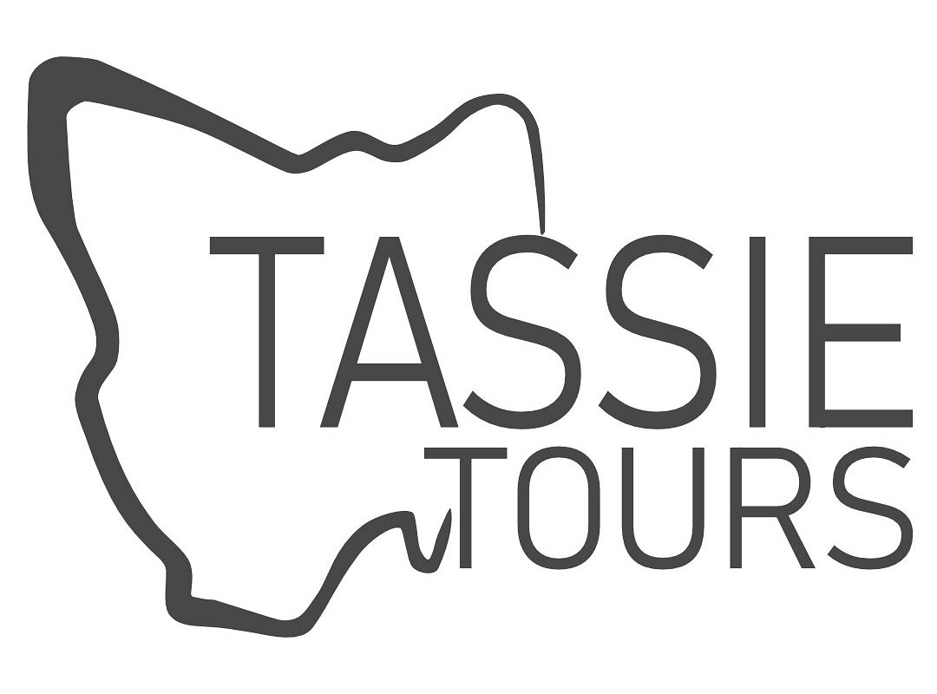
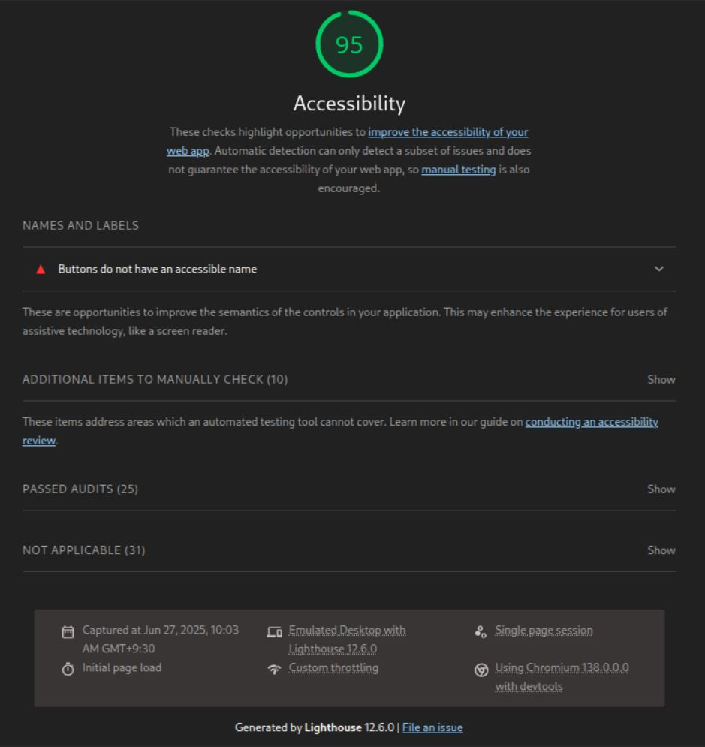

Bookings

The business offers the following methods for bookings and enquiries:
- Phone
- Email
- Webportal
- Our website supports Screen Readers
- Our forms have high contract boxes and submit boxes

Emergency Management
- Emergency and evacuation procedures are explained on arrival
- Exit signs are clear and easy to see
- Exit access is free and clear at all times
We ensure exit access is free and clear at all times by:
When on the buses yes, but we can't guarantee for external locations on tours. Regular Vehicle Inspections: Tour vehicles are routinely checked to ensure that all emergency exits (including doors, windows, and aisles) are unobstructed and fully operational before each tour departs. Clear Signage & Instructions: Emergency exits are clearly marked with visible signage, and staff provide safety briefings to passengers, reminding them not to block or place items near exits. Passenger Monitoring: Staff monitor the vehicle during stops and while on board to promptly address any safety concerns, including blocked exits.
- Exits and access to exists are greater than 900mm
- Exit doors are able to be opened by all occupants
- In addition, the following further information can assist guests:
Pre-Booking or Booking Stage Questions: Guests are encouraged (often via booking forms or direct inquiries) to disclose any mobility, sensory, medical, or cognitive needs. This allows the business to prepare appropriately in advance. On-Arrival Interaction: Staff are trained to observe and engage politely with guests upon arrival or boarding. If a guest appears to need assistance or self-identifies, staff can take note discreetly and offer support as needed. Driver & Staff Training: All drivers and guides are trained in safety protocols, including maintaining clear exit paths throughout the journey and ensuring passengers do not leave luggage or personal items in aisles or exit areas.
- In addition, the following further information can assist guests:
The staff calmly communicate with the guest needing help, explaining what is happening and what support will be provided. If possible, the guest is helped to exit using standard means (e.g. walking with assistance, using a ramp or lift). If mobility is limited or evacuation is difficult, staff may: Use manual handling techniques (only if trained and safe to do so). Use available equipment (e.g. evacuation chair, slide board) if present. Call emergency responders immediately for assistance if the situation is beyond the staff’s capacity. Post-Emergency Follow-Up Once safe, staff check in with the guest to provide comfort and further support. An incident report is completed, and any learnings are integrated into future safety training.
- Guests with disabilities are noted in the guest log book for emergency and evacuation purposes

Communications
- Our website meets WCAG 2.0 accessibility standards
- Our business offers the following alternative communication methods
- Plain English

Podcasts available for low vision - please see attached website accessibility page above
- There is easy to read signage and information (e.g. menus and emergency information)

Other Information
- For bookings made onsite, the ticket booth/counter/box office is accessible for people using a wheelchair

Guide Dog and Service Animals
- The business provides a secure area with shade and water for service animals
- The business provides a toilet area for service animals
- Bowls, bedding, etc. are provided for service animals
The business provides the following services for services animals:
Welcoming Policy Certified service animals are welcomed on all tours, in line with Tasmanian and Australian legislation. Staff are trained to understand the rights of guests accompanied by service animals and will ensure they are treated respectfully and professionally. Transport Accommodations Service animals can travel inside tour vehicles with their handler. Seating can be adjusted where possible to ensure a comfortable and safe space for both the guest and their service animal. If needed, water-resistant mats or blankets may be provided to help protect seating and ensure hygiene. Comfort & Welfare Tour stops will include access to water for the animal, and guides can assist in identifying pet-friendly rest areas along the way. If additional breaks are required for the animal’s wellbeing, guides can accommodate within reason and within tour timing constraints. Booking Support Guests are encouraged to notify the team during the booking process if they are travelling with a service animal, so appropriate arrangements can be made in advance. This ensures smooth boarding, suitable vehicle setup, and staff awareness. Compliance and Respect Only legally recognised and accredited assistance animals are permitted (in accordance with Disability Discrimination Act 1992). Staff will never request personal medical information, but may ask for service animal identification or certification, if not visibly clear.

GENERAL

Pre-arrival, arrival and reception
The business has the following in place to support guests during pre-arrival, arrival and reception
- Booking information and websites are compatible with screen readers
- There is a reception/public entryway.
- Seating available at reception
- A lower counter at reception/ticket office
- A clipboard to allow check-in/ticket purchase whilst seated
- A tablet with text to voice or pen and paper at reception to aid in communication
- Picture Board at reception to aid in communication
- Lighting in the reception area is even and glare free
- Large print information sheets and registration forms
- Information and maps are available in written form
- A step free map/guide
- In addition, the following further information can assist guests:
Minimised Wait Times &amp; Prioritised AssistanceGuests who disclose fatigue-related conditions are offered priority boarding and seating, reducing time spent waiting in queues or standing.

Where possible, early boarding is arranged to allow guests to settle in comfortably without the stress of crowds or time pressure.

Seating Availability at Meeting PointsStaff ensure that accessible seating is available at key tour meeting points or pickup locations, especially for guests who may have difficulty standing for extended periods.

If public seating is limited, portable seating solutions may be provided upon request.

Pre-Tour CommunicationGuests are encouraged to share access needs during the booking process. This allows staff to plan ahead and minimise physical exertion or waiting periods for individuals with fatigue or chronic conditions.

Efficient Boarding ProceduresBoarding processes are kept quick and streamlined for all guests, with additional patience and support offered to those who may need more time or rest before or after boarding.

Trained Staff SupportStaff are trained to recognise signs of fatigue and provide appropriate assistance, such as:

Offering a place to sit while waiting

Checking in regularly throughout the tour

Adjusting pace and communication as needed

Cognitive Impairment Support
- Documents are available in plain English for people with cognitive impairment (This may include instructions, guides, menus and general information)

Car Park and Access amenities
The business has the following Car Park and Access amenities
- A drop off zone
- Designated disabled parking bays
- Level or ramped access from the car park to the entrance
- The accessible entrance is clearly signed from the parking bay
- The public transport services available are:

Tour pickup locations vary, details are given mostly verbally but can also be sent via various forms of technology
- Kerb ramps are in place where a pavement or walkway needs to be crossed
The width of the smallest pathway is:
We run tours, often places visited have very small pathways and we have no way of knowing so felt it best to be on the safe side and say no

We run tours, places visited varies

We run tours, places visited varies
- In addition, the following further information can assist guests:
We run tours, places visited varies
- In addition, the following further information can assist guests:
We run tours, places visited varies

Public Toilets/Adult change facilities
Public Toilets/Adult change facilities have the following amenities are in place
- There is an accessible toilet for public use
- The door is at least 850mm wide
- There is a minimum of 850mm beside the toilet
- Handrails are fitted
- The toilet seat is 460mm above the floor
- The toilet seat of a contrasting colour to the floor
- The toilet seat is460mm above the floor
- There is a registered changing places facility
- There is a 'Changing Place' within We run tours, places visited varies, we visit places that have public toilet facilities that adhere to these standards of our business

TOUR OPERATORS

Tour/Transport Services
The tour/transport services have the following facilities/amenities in place
- Buses/Coaches
- 2 vehicles have wheelchair lifts or ramps
- 0 vehicles have low floors with ramped entry
The maximum wheelchair capacity available in the fleet is:
2
- Commentary is available in written format

Route Planning
- Route Planning
- The tour route includes stops with accessible toilet facilities
- Lunch stop venues are accessible
- Sightseeing and photo opportunity stops are step free

Guides
- Use of clear/simple English
- Correct pronunciation for lip readers
- There is a audio description of surroundings
- In addition, the following further information can assist guests:
Port Arthur, Bruny Island Cheese Co. &amp; Beer Co. ,Get Shucked Oyster Bar, Bruny Island Honey ,Cape Bruny Lighthouse, Bonorong Park, Richmond Bridge , St. John’s Catholic Church , Wicked Cheese Company, Littlewood Berry Farm, Richmond Lolly Shop etc.

ACCOMMODATION
- In addition, the following further information can assist guests:
We don't use accomodation
- The width of the door is We don't use accomodation.
- The width beside the toilet is We don't use accommodation.
- There is We don't use accommodation mm of clear space in front of the toilet
- The actual height of the toilet seat is We don't use accommodation.
- In addition, the following further information can assist guests:
We don't use accommodation

Report Disclaimer
Please note that this business report, provided as a result of the use of the diagnostic assessment, is for information purposes only.
Australian Tourism Industry Council (ATIC) cannot guarantee the accuracy of respondent’s answers, or that they are fully representative of your business. Therefore, ATIC does not warrant or guarantee any particular outcome in respect of your businesses self-assessment.
This report is intended as guidance only for your business and should not be relied on for future marketing considerations. ATIC recommends that you seek your own independent advice as well as the results from the diagnostic.
Links to external web sites are inserted for convenience and do not constitute endorsement of material at those sites, or any associated organisation, product or service.
ATIC does not:
- Assume any legal liability for the accuracy, completeness, or usefulness of any information from this report or any links provided; or
- Accept responsibility for any loss associated directly or indirectly from the use of this report.

