ATIC Accessibility
To support the accessible community in making informed travel decisions for their individual needs

This report prepared for:
Business name: | Holiday Inn Perth
Address: | 788 Hay St
Town: | Perth
Contact for enquiries: | Bee Aurmanarom
Contact Number: | 0892617210
Contact Email: | bookinghiccp@ihg.com
Website:
Date: | 2026-10-18 17:04

ATIC Accessibility
The following pages provides travellers with information on the businesses facilities and amenities which aims to support the traveller to make an informed decision on whether the business is suitable for their individual needs.
OVERVIEW 4
Business Overview 4
Bookings 4
Emergency Management 5
Communications 5
Other Information 5
Guide Dog and Service Animals 6
GENERAL 7
Pre-arrival, arrival and reception 7
Car Park and Access amenities 7
Entry 7
Lifts 8
Internal Spaces 8
Public areas 8
External Paths 8
Steps 9
Public Toilets/Adult change facilities 9
ACCOMMODATION 10
Bedrooms 10
Room Amenities 10
Bathrooms 11
COMMON AREAS 12
FOOD AND DRINK 13
Dining Spaces 13
Report Disclaimer 15

OVERVIEW

Business Overview

The business has the following products/services available
- Accommodation
- Food and Drink

Our business caters for the following disability types:
- Blind or low vision
- Deaf or low hearing
- Limited mobility
- Wheelchairs or mobility scooters
- Food allergies or intolerances
- Cognitive or people on the Autism Spectrum
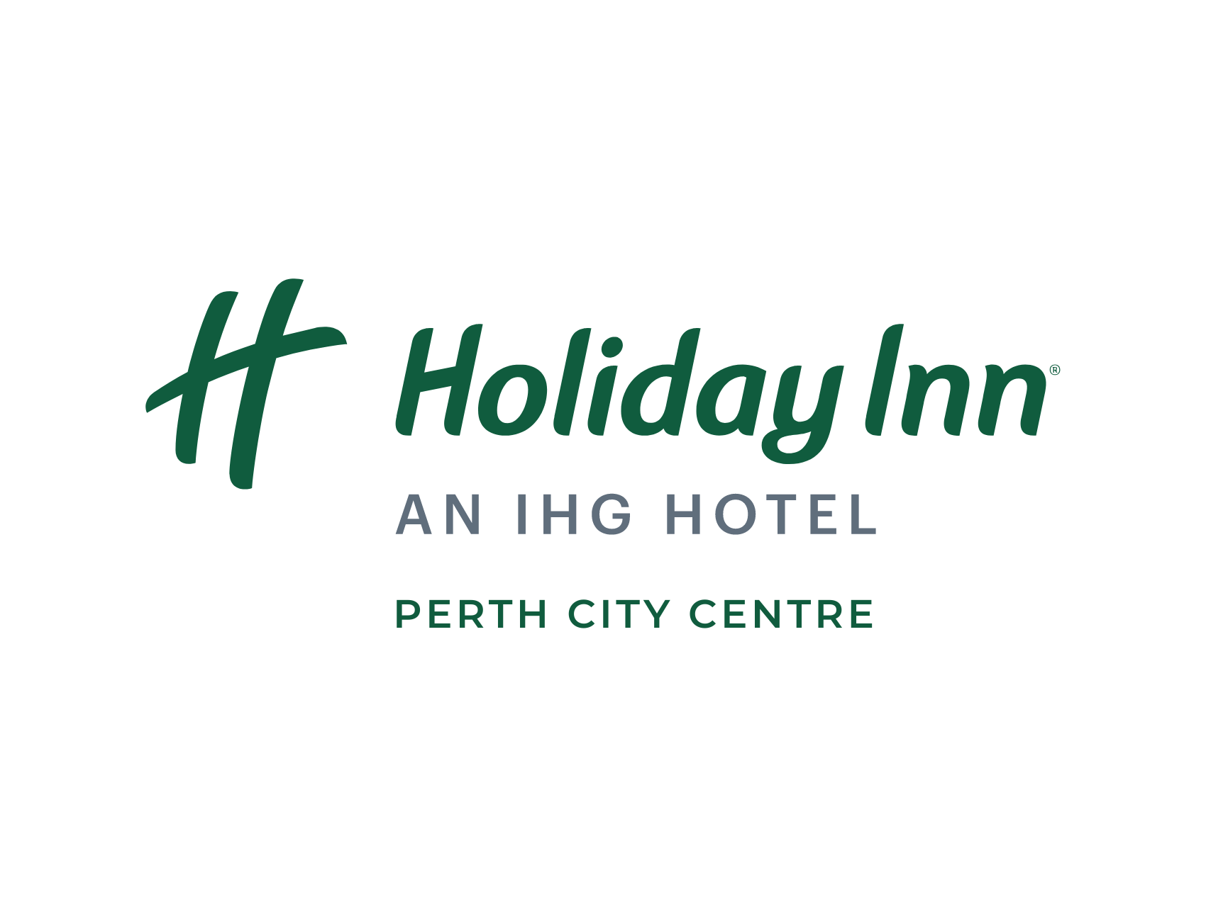

Bookings

The business offers the following methods for bookings and enquiries:
- Phone
- Email
- Webportal
- Our website supports Screen Readers
- Our forms have high contract boxes and submit boxes

Emergency Management
- Emergency and evacuation procedures are explained on arrival
- There are Audible device/s to alert occupants to evacuate with instructions on how to evacuate.
- There are visual device/s to alert occupants to evacuate.
- Exit signs are clear and easy to see
- Exit signs have raised lettering or braille
- Exit access is free and clear at all times
We ensure exit access is free and clear at all times by:
Staff run floor checks regularly to check fire exits
- Exit doors are able to be opened by all occupants
- Exits including stairwells, have bright edges used on the steps.
- In addition, the following further information can assist guests:
A notice board is kept in the front office which is updated daily as guests who require additional assistance check-in/out of the hotel.
- In addition, the following further information can assist guests:
If you have guests who are obviously unable to evacuate safely it will be necessary to do the following: 1) Advise the Chief Warden of the situation using WIP phone for further instruction 2) After the remaining guests have evacuated the floor, assist the person close to the fire stairs as directed by the Chief Warden 3) Should there be a need to enter the fire stairs with a disabled person, advise the Chief Warden and position the person in the corner of the small landing so that others can safely pass.
- Guests with disabilities are noted in the guest log book for emergency and evacuation purposes

Communications
- Our website meets WCAG 2.0 accessibility standards

Other Information
- For bookings made onsite, the ticket booth/counter/box office is accessible for people using a wheelchair

Guide Dog and Service Animals
- The business provides a secure area with shade and water for service animals
- The business provides a toilet area for service animals
The business provides the following services for services animals:
Not specified

GENERAL

Pre-arrival, arrival and reception
The business has the following in place to support guests during pre-arrival, arrival and reception
- Booking information and websites are compatible with screen readers
- There is a reception/public entryway.
- Seating available at reception
- A clipboard to allow check-in/ticket purchase whilst seated
- A tablet with text to voice or pen and paper at reception to aid in communication
- Lighting in the reception area is even and glare free
- Information and maps are available in written form
- A familiarisation tour
- Keys are available for each guest
- Luggage assistance
- In addition, the following further information can assist guests:
We have multiple chairs and couches in our lobby for guests to sit comfortably when waiting for check-in.

Car Park and Access amenities
The business has the following Car Park and Access amenities
- A drop off zone
- Level or ramped access from the car park to the entrance

Entry
The business has the following amenities/systems in place for entry
- A drop off point close to the entrance
- A path of access to the building is slip resistance and even
- A path of access to the building is clear of obstruction
- Self opening entry doors or fitted with a self closer
- Glass doors are fitted with a visual sighting strip
- Door jams/doors are of a contrasting colour to surrounding walls
- Door handles are of a contrasting colour to the door
- Signage is written in a contrasting colour
- Signage is written in a Sans Serif font and use upper and lower case letters
- The entry door is a minimum of 850mm wide
- The entry door has self opening or a light opening pressure (for manual operations)
- The entrance sill is less than 13mm
- There a clear space of at least 1500mm x 1500mm in front of all doors.
- The entrance door mats have a thickness less than 13mm and a width of 7500mm or greater

Lifts
- Premises has lifts

Internal Spaces
- Clear and unobstructed routes through and between buildings
- Interior walls are matte or low sheen
- Floors, walls, counters and furniture are of contrasting colours
- Tableware/glassware contrast with the table surface or table cloth
- Floor surfaces are hard or short pile carpet
- Seating is available for guests unable to stand for long periods
- Accessible facilities are clearly signed and visible from all areas
- All corridors greater than 900mm

Public areas
The public areas have the following amenities in place
- Display units, Televisions, Video displays etc. are open captioned
- Even lighting
- Seating

External Paths
External paths of travel
- Pathways are wider than 900mm

No paths with steps

Steps
Steps
- There are steps.
- Top and bottom steps are easily distinguished through colour contrast or the use of TGSIs (Tactile Ground Surface Indicators)
- All steps or staircases have enclosed risers
- Handrails fitted to all open sets of steps
- Handrails extend 300mm beyond the top and bottom step

Public Toilets/Adult change facilities
Public Toilets/Adult change facilities have the following amenities are in place
- There is an accessible toilet for public use
- The door is at least 850mm wide
- There is a minimum of 850mm beside the toilet
- Handrails are fitted
- The toilet seat of a contrasting colour to the floor
- The toilet seat is460mm above the floor

ACCOMMODATION

Bedrooms
The bedrooms have the following facilities/amenities in place
- There are 3 rooms available to guests who use a wheelchair
- Bedroom furniture can be re-arranged on request
  - Layout of room Image(s)
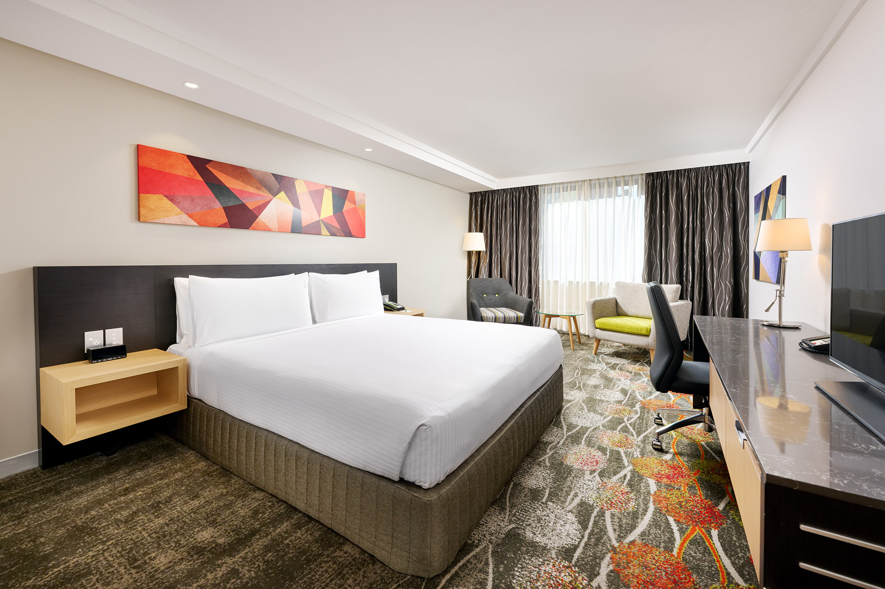
1 King Standard Accessible Room
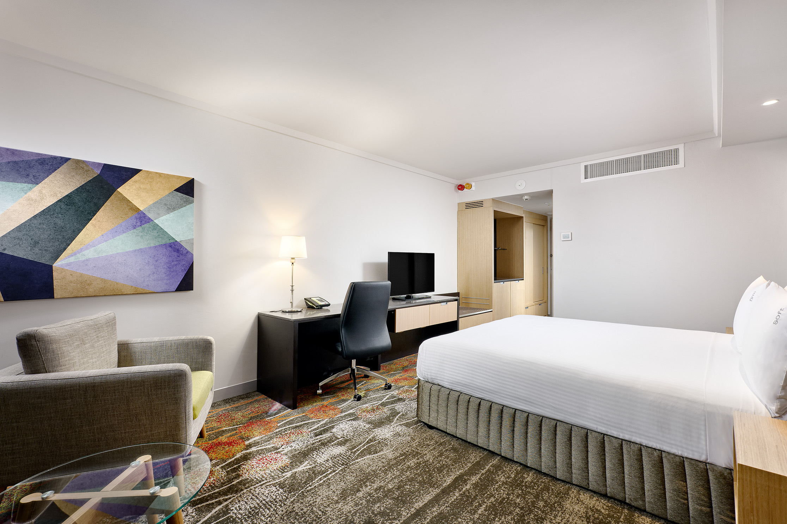
1 King Bed Standard Accessible - alarms

Room Amenities
- Lower hanging rails are in wardrobes
- Visual alarm is fitted to the room
- Televisions are equipped with closed captioning capability
- Vibrating alarm clocks
- Room phones have volume control
- Room phones have a visual ringing indicator
- There is contrast between the walls, skirtings, floor and furniture
- There is a clear path through the room
- Wardrobe handles are a contrasting colour to the doors and draws
- Housekeeping procedures instruct staff not to reposition furniture that has been moved
- Doors open fully against the adjoining wall
- There is a clear opening at least 850mm wide
- There at least one chair with rigid arms
- Wardrobe and drawer handles are easy to grip
- The bedside lamp switch is easy to reach from the bed
- There is at least 850mm clear space beside the bed
- The bed height is no higher than 680mm from the floor
- The business offers a range of non-allergenic bedding
- Non-allergenic cleaning products are used

Bathrooms
The bathrooms have the following facilities/amenities in place
- All heating appliances and hot water pipes are protected or insulated
- All shower, bath and basin taps are clearly differentiated between hot and cold
- Fixtures and fittings have rounded edges
- The width of the door is 800mm.
- There is a minimum of 850mm beside the toilet
- Handrails are fitted
- There is a minimum of 1400mm of clear space in front of the toilet
- The toilet seat is a contrasting colour to the floor
- The toilet seat is 460mm above the floor
- There is a roll-in shower with fold down fixed seat or a shower chair
- There is a portable shower head on flexible hose
  - Bathroom Image(s)
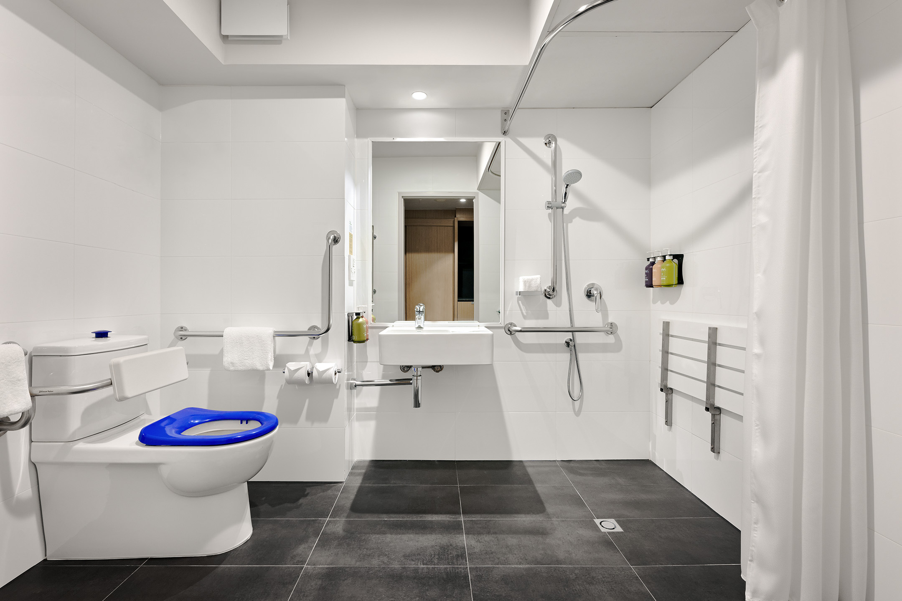
Accessible bathroom

COMMON AREAS

FOOD AND DRINK

Dining Spaces
The dining spaces have the following facilities/amenities in place
- The entrance has level access
- The doorway is at least 850mm wide
- There is level access through the dining area
- Chairs are moveable to allow for wheelchairs to be seated at the tables
- All glass doors and full height windows have contrast markings
- There are areas of full lighting
- There is an accessible toilet

Our business caters for the following dietary requirements
- Sugar free (diabetic)
- Gluten free (celiac)
- Lactose free (dairy free)
- Low sodium
- Nut free
- Additive free
- Vegetarian
- Vegan
- In addition, the following further information can assist guests:
To avoid cross contamination of food products, we follow strict food safety procedures including:Using seperate cutting boards and utensils for raw and cooked foodsStoring raw meats below ready-to-eat items in refrigerationsEnsuring all staff wash hands thoroughly and regularly, especially between handing different food typesCleaning and sanitising all surfaces and equipment after each useLabelling and dating all food items to maintain proper rotation and storage practices
- There is a sample menu available online
Sample menu is available here -
https://perth.holidayinn.com/dine/in-room-dining/

Report Disclaimer
Please note that this business report, provided as a result of the use of the diagnostic assessment, is for information purposes only.
Australian Tourism Industry Council (ATIC) cannot guarantee the accuracy of respondent’s answers, or that they are fully representative of your business. Therefore, ATIC does not warrant or guarantee any particular outcome in respect of your businesses self-assessment.
This report is intended as guidance only for your business and should not be relied on for future marketing considerations. ATIC recommends that you seek your own independent advice as well as the results from the diagnostic.
Links to external web sites are inserted for convenience and do not constitute endorsement of material at those sites, or any associated organisation, product or service.
ATIC does not:
- Assume any legal liability for the accuracy, completeness, or usefulness of any information from this report or any links provided; or
- Accept responsibility for any loss associated directly or indirectly from the use of this report.

