ATIC Accessibility
To support the accessible community in making informed travel decisions for their individual needs

This report prepared for:
Business name: | Air Kimberley
Address: | 7 Gus Winckel Road
Town: | Broome
Contact for enquiries: | Ash Munn
Contact Number: | +61437598669
Contact Email: | fly@airkimberley.com.au
Website: | www.airkimberley.com.au
Date: | 2026-07-28 11:38

ATIC Accessibility
The following pages provides travellers with information on the businesses facilities and amenities which aims to support the traveller to make an informed decision on whether the business is suitable for their individual needs.
OVERVIEW 4
Business Overview 4
Bookings 4
Emergency Management 4
Other Information 5
Guide Dog and Service Animals 5
GENERAL 6
Pre-arrival, arrival and reception 6
Cognitive Impairment Support 6
Car Park and Access amenities 6
Entry 7
Internal Spaces 7
Public areas 8
Displays, exhibits, commentary and live performances 8
External Paths 8
Steps 8
Ramps 9
Public Toilets/Adult change facilities 9
TOUR OPERATORS 10
Route Planning 10
Guides 10
ADVENTURE ACTIVITIES 11
Report Disclaimer 13

OVERVIEW

Business Overview

Our business caters for the following disability types:
- Blind or low vision
- Deaf or low hearing
- Limited mobility
- Wheelchairs or mobility scooters
- Food allergies or intolerances
- Cognitive or people on the Autism Spectrum
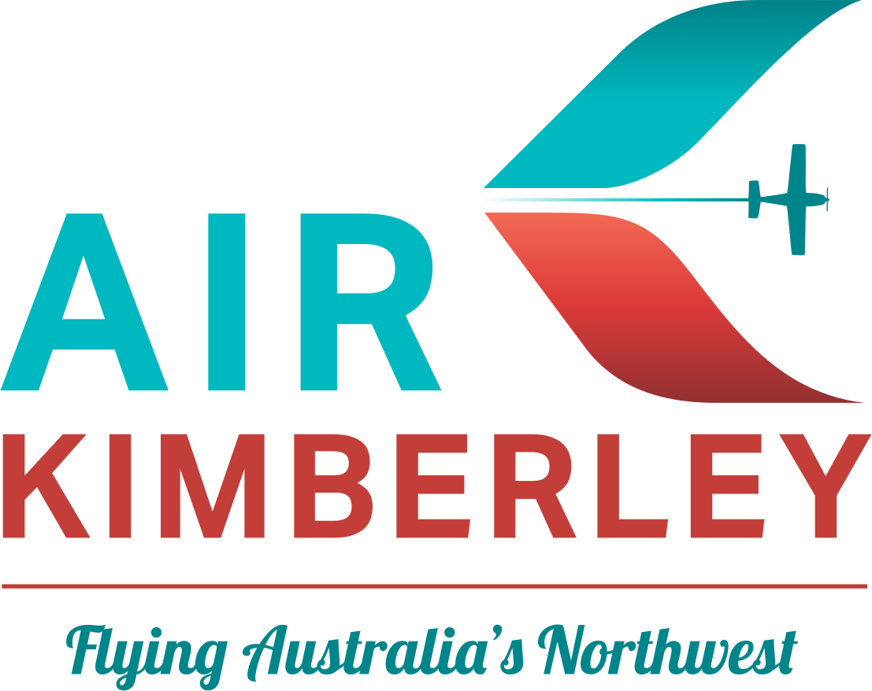

Bookings

The business offers the following methods for bookings and enquiries:
- Phone
- Email
- Webportal
- Staff have undergone disability awareness and training

Emergency Management
- Emergency and evacuation procedures are explained on arrival
- Exit signs are clear and easy to see
- Exit access is free and clear at all times
We ensure exit access is free and clear at all times by:
Exits and emergency exits are clear of obstructions at all times and checked regularly.
- Exits and access to exists are greater than 900mm
- Exit doors are able to be opened by all occupants
- Exits to the emergency evacuation point does not include stairways
- The evacuation point is clearly marked by a sign
The business identifies guests who need additional assistance should an emergency occur by:
During the booking process, we identify any particular needs of our guests to ensure adequate planning and assistance is in place during their visit or tour experience.
The procedure for assisting guests who need assisted rescue is:
Evacuation of people with disabilities will be given high priority in all emergencies and will be evacuated if possible. It is important to ask someone with a disability how you can help before attempting any rescue technique or giving assistance. Ask how he or she can best be assisted or moved, and whether there are any special considerations or items that need to come with the person.
- Guests with disabilities are noted in the guest log book for emergency and evacuation purposes

Other Information
- For bookings made onsite, the ticket booth/counter/box office is accessible for people using a wheelchair
- The business accepts the companion card

Guide Dog and Service Animals
- The business provides a secure area with shade and water for service animals
- The business provides a toilet area for service animals
- Bowls, bedding, etc. are provided for service animals
The business provides the following services for services animals:
Service animals are welcome at Air Kimberley, there is adequate shade and water available at the terminal and at destinations including areas where service animals can go to the toilet. We provide bowls, and bedding is available on request at time of booking. Service animals can be carried onboard our aircraft by placing the service animal on an absorbent mat beside the passenger.

GENERAL

Pre-arrival, arrival and reception
The business has the following in place to support guests during pre-arrival, arrival and reception
- There is a reception/public entryway.
- Seating available at reception
- A clipboard to allow check-in/ticket purchase whilst seated
- A tablet with text to voice or pen and paper at reception to aid in communication
- Lighting in the reception area is even and glare free
- Information and maps are available in written form
- A familiarisation tour
- Advertising material, web sites and social media contain information relating to phone numbers available for non-voice communication e: Text, SMS, email and fax
- A key to any accessible facilities that are locked
- In addition, the following further information can assist guests:
There are no 'long' wait times at Air Kimberley. Being a small to medium operation we are adequately staffed and able to assist in a very timely manner at all times.
- In addition, the following further information can assist guests:
The Air Kimberley terminal is accessible with ramps and rails to assist guests. The accessible unisex toilet whilst locked, is fitted with a coded door lock with code provided to guests as required. Any step areas of the terminal have tactile pads installed for safety.&nbsp;

Cognitive Impairment Support
- Documents are available in plain English for people with cognitive impairment (This may include instructions, guides, menus and general information)
- A space for parents and children on the Autism Spectrum

Car Park and Access amenities
The business has the following Car Park and Access amenities
- A drop off zone
- Designated disabled parking bays
- Level or ramped access from the car park to the entrance
- Kerb ramps are in place where a pavement or walkway needs to be crossed
- In addition, the following further information can assist guests:
Disabled parking bays are located in front of the Air Kimberley Terminal and reception area with a ramp leading to reception.

Entry
The business has the following amenities/systems in place for entry
- A drop off point close to the entrance
- A path of access to the building is slip resistance and even
- A path of access to the building is clear of obstruction
- Glass doors are fitted with a visual sighting strip
- Door jams/doors are of a contrasting colour to surrounding walls
- Door handles are of a contrasting colour to the door
- Signage is written in a contrasting colour
- The entry door is a minimum of 850mm wide
- The entrance sill is less than 13mm
- There a clear space of at least 1500mm x 1500mm in front of all doors.
- In addition, the following further information can assist guests:
The Air Kimberley terminal meets the BCA Australian Standard that relates to the provision of Disability Access (Australian Standard AS1428).
- In addition, the following further information can assist guests:
N/A

Internal Spaces
- Clear and unobstructed routes through and between buildings
- Floors, walls, counters and furniture are of contrasting colours
- Floor surfaces are hard or short pile carpet
- Seating is available for guests unable to stand for long periods
- All corridors greater than 900mm
- There is a quiet space for parents and children on the Autism Spectrum
- In addition, the following further information can assist guests:
The Air Kimberley terminal meets the BCA Australian Standard that relates to the provision of Disability Access (Australian Standard AS1428).

Public areas
The public areas have the following amenities in place
- Even lighting
- Seating

Displays, exhibits, commentary and live performances
For displays, exhibits, commentary and live performances the following amenities are in place
- Seating
- Wheelchair accessible spaces/seating
- A written transcript where audio description is provided i.e. display commentary, tour commentary

External Paths
External paths of travel
- Surfaces are concrete, asphalt, smooth paving or hard packed fine gravel (max aggregate size 13mm)
- Pathways are wider than 900mm
- There 3 successive steps or less on any path or at any doorway
- Any paths having steps are clearly identified as non-wheelchair accessible

Steps
Steps
- There are steps.
- Top and bottom steps are easily distinguished through colour contrast or the use of TGSIs (Tactile Ground Surface Indicators)
- All steps or staircases have enclosed risers
- The underside of all staircases are enclosed or protected to a height of at least 2 metres
- Handrails fitted to all open sets of steps
- Handrails extend 300mm beyond the top and bottom step
- Where steps are present are there three steps or less
- In addition, the following further information can assist guests:
Minimal steps located at Air Kimberley and are either 1 or 2 steps only (fitted with tactile pads) however all terminal areas can be accessed by a ramp.

Ramps
Ramps have the following amenities are in place
- There are ramps.
- All fixed ramps are 1:14 or less
- Hand rails are fitted
- Long ramps (more than 10m) are 1:20 or less
- Ramps have a raised edge of at least 100mm
- In addition, the following further information can assist guests:
The Air Kimberley terminal meets the BCA Australian Standard that relates to the provision of Disability Access (Australian Standard AS1428).

Public Toilets/Adult change facilities
Public Toilets/Adult change facilities have the following amenities are in place
- There is an accessible toilet for public use
- The door is at least 850mm wide
- There is a minimum of 850mm beside the toilet
- Handrails are fitted
- The toilet seat is 460mm above the floor
- There is 2000mm mm of clear space in front of the toilet
- The toilet seat of a contrasting colour to the floor
- The toilet seat is460mm above the floor

TOUR OPERATORS

Route Planning
- Route Planning
- In addition, the following further information can assist guests:
Air Kimberley operate aircraft with no toilets onboard.
- Overnight Stops
- For overnight stays, wheelchair accessible rooms are available
The total number of wheelchair passengers that can be catered for at overnight stops are:
1 wheelchair passenger per aircraft
- Walking Tours
- Multi-paced to account for slower walkers

Guides

Guides have been trained in the following
- Use of clear/simple English
- Correct pronunciation for lip readers
- Marine
- In addition, the following further information can assist guests:
One Arm Point Hatchery - https://www.ardyaloonhatchery.com.au/Cygnet Bay Pearl Farm - https://www.cygnetbaypearlfarm.com.au/Mitchell Falls - No websiteBungle Bungles - No websiteMount Hart Wilderness Lodge - https://www.mounthart.com.au/
- In addition, the following further information can assist guests:
Air Kimberley operate aircraft to conduct scenic flights which include air, land and sea tours depending on the tour itinerary. Air Kimberley can accommodate 1 wheel chair accessible person per aircraft however, the wheelchair needs to be foldable and compact to fit in the aircraft. Marine craft are operated on our Cygnet Bay Explorer Tour via our tour partner however this particular tour is not suitable for wheelchair access. We do encourage guests who require accessibility needs to contact us before booking so we can advise which of our tour itineraries are suitable.

ADVENTURE ACTIVITIES
- In addition, the following further information can assist guests:
Our tour itineraries which include adventure activities (hiking/swimming/manoeuvring caves, tunnels and rocks/helicopter rides) are only suitable for people who are deaf, or have low hearing and people with cognitive disabilities or people on the Autism Spectrum.

Report Disclaimer
Please note that this business report, provided as a result of the use of the diagnostic assessment, is for information purposes only.
Australian Tourism Industry Council (ATIC) cannot guarantee the accuracy of respondent’s answers, or that they are fully representative of your business. Therefore, ATIC does not warrant or guarantee any particular outcome in respect of your businesses self-assessment.
This report is intended as guidance only for your business and should not be relied on for future marketing considerations. ATIC recommends that you seek your own independent advice as well as the results from the diagnostic.
Links to external web sites are inserted for convenience and do not constitute endorsement of material at those sites, or any associated organisation, product or service.
ATIC does not:
- Assume any legal liability for the accuracy, completeness, or usefulness of any information from this report or any links provided; or
- Accept responsibility for any loss associated directly or indirectly from the use of this report.

