ATIC Accessibility
To support the accessible community in making informed travel decisions for their individual needs

This report prepared for:
Business name: | Berkeley River Lodge
Address: | Kimberley Coast
Town: | Oombulgurri
Contact for enquiries: | Rachel Bromage
Contact Number: | 0438 562 750
Contact Email: | info@berkeleyriverlodge.com.au
Website: | http://www.berkeleyriverlodge.com.au/
Date: | 2026-09-12 14:28

ATIC Accessibility
The following pages provides travellers with information on the businesses facilities and amenities which aims to support the traveller to make an informed decision on whether the business is suitable for their individual needs.
OVERVIEW 4
Business Overview 4
Bookings 4
Emergency Management 4
Communications 5
Guide Dog and Service Animals 5
GENERAL 6
Pre-arrival, arrival and reception 6
Displays, exhibits, commentary and live performances 6
External Paths 7
Steps 7
TOUR OPERATORS 8
Tour/Transport Services 8
Route Planning 8
Guides 8
ACCOMMODATION 11
Room Amenities 11
Bathrooms 11
ATTRACTIONS 13
COMMON AREAS 14
Swimming pools, spas and waterparks 14
FOOD AND DRINK 15
Dining Spaces 15
ADVENTURE ACTIVITIES 17
Report Disclaimer 19

OVERVIEW

Business Overview

The business has the following products/services available
- Tour/Transport
- Accommodation
- Attraction
- Food and Drink
- Adventure

Our business caters for the following disability types:
- Blind or low vision
- Deaf or low hearing
- Limited mobility
- Food allergies or intolerances
- Cognitive or people on the Autism Spectrum


Bookings

The business offers the following methods for bookings and enquiries:
- Phone
- Email
- Webportal

Emergency Management
- Emergency and evacuation procedures are explained on arrival
- Exits and access to exists are greater than 900mm
- Exit doors are able to be opened by all occupants
- Exits to the emergency evacuation point does not include stairways
- The evacuation point is clearly marked by a sign
- In addition, the following further information can assist guests:
With a maximum of 30 guests on site and a high staff-to-guest ratio, we maintain a highly personalised approach to guest care. Our team takes the time to get to know each guest, discussing their needs, abilities, and expectations for activities. This allows us to discreetly identify anyone who may require additional assistance in the event of an emergency and ensure appropriate support is in place.
- In addition, the following further information can assist guests:
All guides carry radios and satellite phones at all times, whether at the lodge or out on tour, ensuring constant communication. In the event a guest requires assisted rescue, the guide provides immediate support using the on-hand first aid kit and contacts the lodge for further assistance. Each situation is assessed individually to determine whether evacuation via the Royal Flying Doctor Service is required, or if the guest can be safely returned to the lodge and flown out the following day. All staff are thoroughly trained to manage these situations with care and professionalism.
- Guests with disabilities are noted in the guest log book for emergency and evacuation purposes

Communications
- An accessibility guide is available on the website

https://berkeleyriverlodge.com.au/about/accessibility

Guide Dog and Service Animals
- The business provides a secure area with shade and water for service animals
- The business provides a toilet area for service animals
- Bowls, bedding, etc. are provided for service animals
The business provides the following services for services animals:
While we have not yet received a request for a service animal in our 12 years of operation due to our remote, fly-in-only location, we fully understand our legal obligation to accommodate service animals. Should a guest require this, we would make every effort to support their needs and ensure the animal is appropriately cared for during their stay, adapting our services as necessary.

GENERAL

Pre-arrival, arrival and reception
The business has the following in place to support guests during pre-arrival, arrival and reception
- Keys are available for each guest
- Luggage assistance
- In addition, the following further information can assist guests:
Due to the small scale of our operations and the personalised nature of our service, guests are never subject to long wait times. All tours and activities run to clearly communicated schedules, with departure and return times provided in advance. As a result, guests—including those who experience fatigue—are able to plan accordingly and are not disadvantaged.
- In addition, the following further information can assist guests:
At Berkeley River Lodge, our remote and intimate setting allows us to offer highly personalised service. We encourage guests to share any specific needs or accessibility requirements prior to arrival so we can ensure the most comfortable and enjoyable experience possible. Our team is always happy to adapt activities, schedules, or accommodations where appropriate—your comfort and wellbeing are our top priority.
- In addition, the following further information can assist guests:
As Berkeley River Lodge is a fly-in-only property with no guest vehicles on site, there is no designated parking or vehicle access. All guest transfers are conducted by our team using lodge vehicles from the private airstrip to the lodge and for guided tours. As such, features such as accessible parking bays, curb ramps, or intercom systems at entrances are not applicable to our setting. However, we are committed to assisting all guests upon arrival and throughout their stay to ensure smooth and comfortable access.

Displays, exhibits, commentary and live performances
For displays, exhibits, commentary and live performances the following amenities are in place
- Seating

External Paths
External paths of travel
- Pathways are wider than 900mm
- In addition, the following further information can assist guests:
As a remote outback property, the external paths at Berkeley River Lodge are natural, uneven, and may become muddy or slippery during the wet season. Surfaces are not paved or hard-packed, and terrain can vary throughout the property and surrounding wilderness. We strongly encourage guests to consider the adventurous nature of the experience before booking, as part of the uniqueness of Berkeley River Lodge lies in its raw, untamed environment. Our team is always available to assist guests as needed and will provide guidance and support to ensure comfort and safety wherever possible.

Steps
Steps
- There are steps.
- In addition, the following further information can assist guests:
Yes, there are steps throughout Berkeley River Lodge. Due to the remote and rugged nature of the property, guests will encounter steps when disembarking the small aircraft, boarding and exiting lodge vehicles, and accessing various areas of the lodge. While our guides are always available to assist, a reasonable level of mobility and agility is required to move safely and comfortably around the property and participate in activities. Berkeley River Lodge is a unique, experiential destination and not a conventional resort environment.

TOUR OPERATORS

Tour/Transport Services
The tour/transport services have the following facilities/amenities in place
- Buses/Coaches
- None of our vehicles are fitted with wheelchair lifts or ramps. Due to the rugged terrain and the nature of our remote outback setting, our vehicles are specifically selected for their off-road capability and are not compatible with wheelchair lift systems. As such, guests must have a reasonable level of mobility to board and disembark from lodge vehicles. vehicles have wheelchair lifts or ramps
- None vehicles have low floors with ramped entry
The maximum wheelchair capacity available in the fleet is:
None

Route Planning
- Route Planning
- In addition, the following further information can assist guests:
All tours include stops where guests disembark to explore the surrounding natural environment. However, due to the remote and undeveloped nature of the areas we visit, accessible toilet facilities are not available at tour stops or on board. Guests should be aware that a moderate level of mobility is required, and we recommend discussing any specific needs with our team prior to travel so we can provide guidance and ensure the most suitable experience.
- Walking Tours

Guides

Guides have been trained in the following
- Use of clear/simple English
- Correct pronunciation for lip readers
- Marine
  - Image(s)
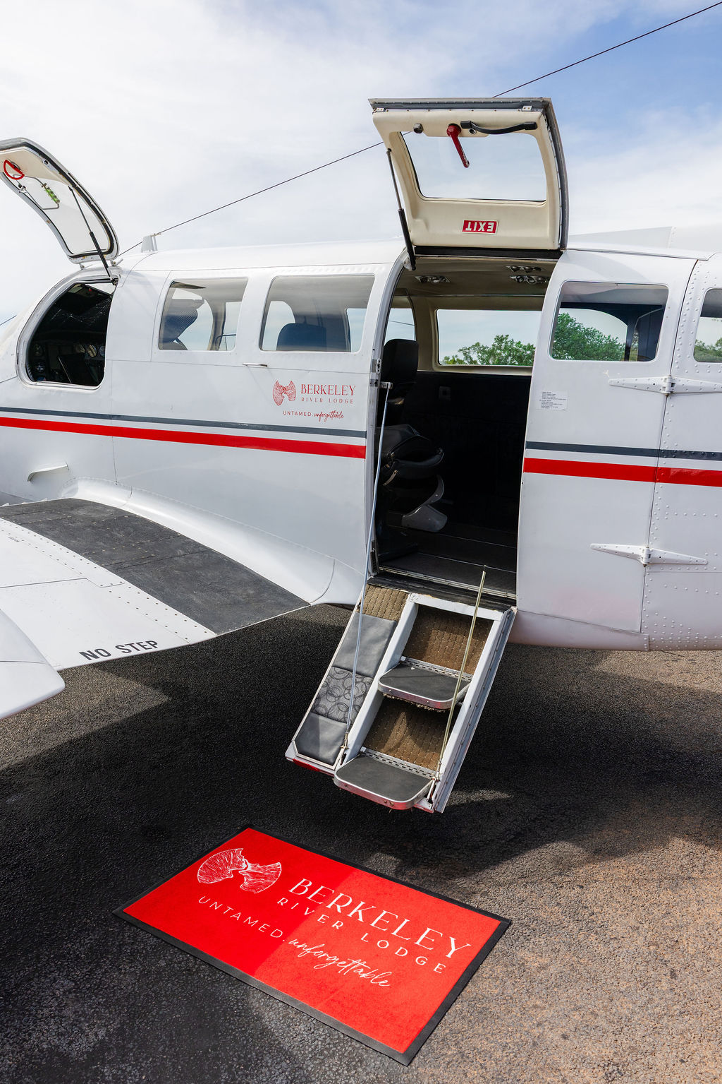
TAR-BRL-CharterDWNBRL-1 (1)
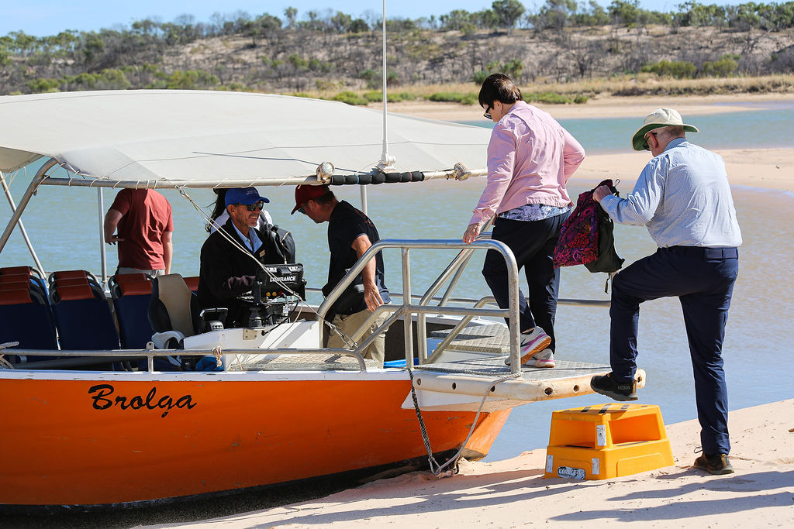
Stepping on boat
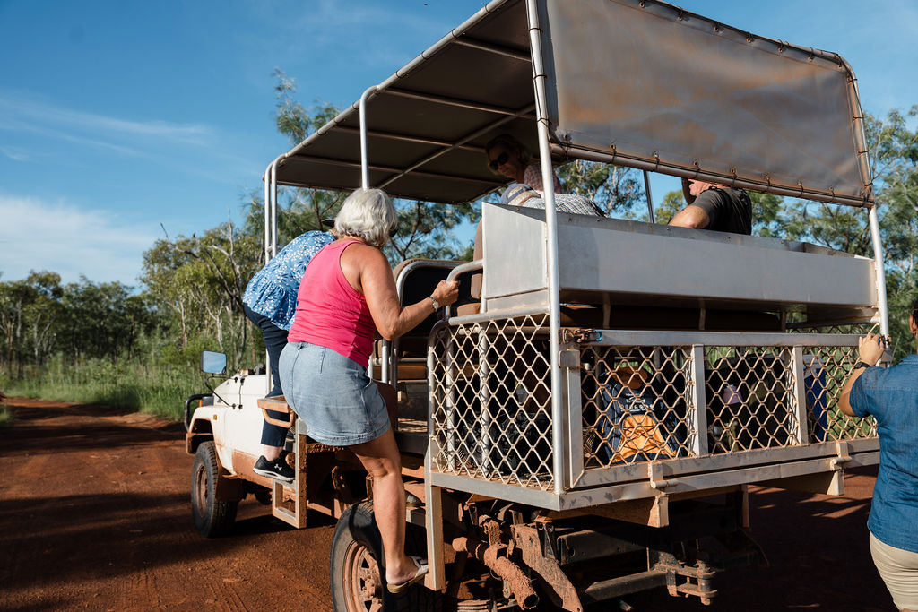
Stepping onto vehicle
- In addition, the following further information can assist guests:
The guided experiences at Berkeley River Lodge are a highlight of our five-night itineraries, offering guests the chance to explore the stunning and remote Kimberley landscape by 4WD, boat, and light aircraft. Due to the nature of the terrain and the design of our transport vehicles—including steep steps, uneven ground, and water access points—a reasonable level of mobility, fitness, and agility is required to participate safely and comfortably. We encourage guests to contact our team in advance to discuss any concerns or to assess suitability prior to booking.

ACCOMMODATION

Room Amenities
- In addition, the following further information can assist guests:
While our villas are not fitted with visual alarm systems, our emergency procedures are designed to ensure the safety of all guests, including those with hearing impairments. It is important that guests advise us of any hearing impairment prior to arrival so appropriate arrangements can be made. In the event of an emergency, the on-duty manager—typically the General Manager or Assistant Manager—will be informed of any guests requiring additional assistance. During an evacuation, they will personally attend the villa to ensure the guest is alerted and safely escorted from the premises, including during overnight hours if necessary.
- There is a clear path through the room
- There is a clear opening at least 850mm wide
- There at least one chair with rigid arms
- Wardrobe and drawer handles are easy to grip
- The bedside lamp switch is easy to reach from the bed
- There is at least 850mm clear space beside the bed
- The bed height is no higher than 680mm from the floor
- There is at least 130mm clearance under the bed
- The business offers a range of non-allergenic bedding
- Non-allergenic cleaning products are used
- In addition, the following further information can assist guests:
Our villas are spacious and uncluttered, offering a simple, open-plan layout designed for comfort and ease of movement. Each villa includes a private balcony with sliding doors and a generous outlook over the remote landscape. While we aim to provide a relaxing and comfortable environment, guests should be aware that due to our remote location, services such as on-site laundry or custom requests for hypoallergenic bedding and cleaning products may not be available. We recommend guests with specific sensitivities or requirements contact us prior to booking to discuss suitability.

Bathrooms
The bathrooms have the following facilities/amenities in place
- All shower, bath and basin taps are clearly differentiated between hot and cold
- The door is at least 850mm wide
- There is a minimum of 850mm beside the toilet
- There is a minimum of 1400mm of clear space in front of the toilet
- The toilet seat is a contrasting colour to the floor
- The toilet seat is 460mm above the floor
  - Bathroom Image(s)
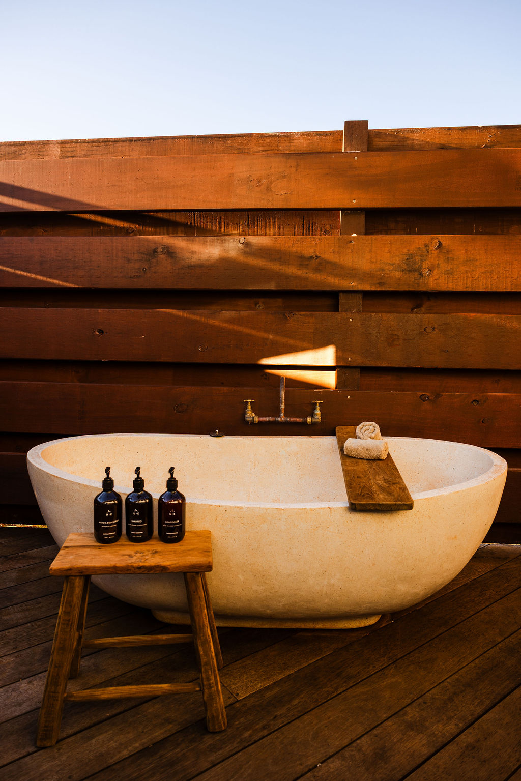
TAR-BRL-Villabathroom-2 (1)
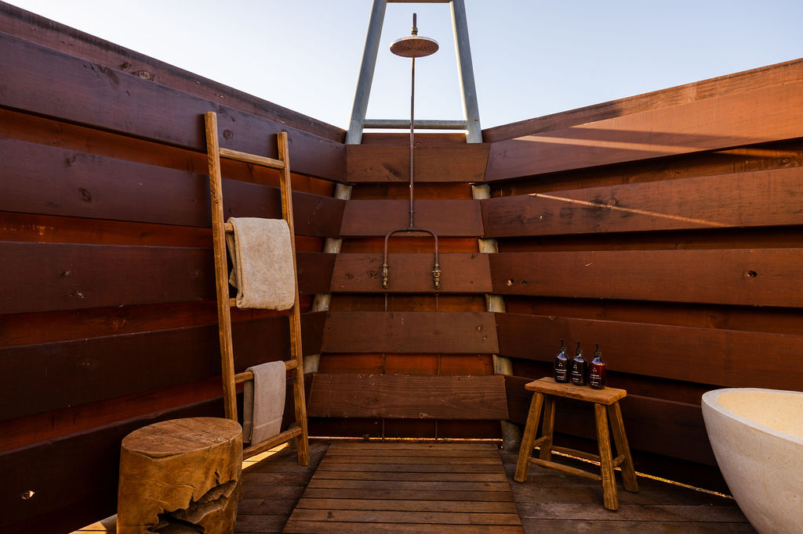
TAR-BRL-Villabathroom-3
- In addition, the following further information can assist guests:
Our villa bathrooms are a standout feature of the Berkeley River Lodge experience—open-air, beautifully designed, and completely immersed in nature. Guests can enjoy a luxurious freestanding bath under the stars, a spacious rain-head shower with custom copper fixtures, and an overall design that reflects the raw beauty of our outback setting. However, it's important to note that these bathrooms are not traditional in layout or operation. The showers feature unique handcrafted controls, and the eco-friendly composting toilets require guests to press a foot pedal for waste disposal. While the space is visually stunning and offers a truly memorable experience, it may present challenges for guests with limited mobility.

ATTRACTIONS

COMMON AREAS

Swimming pools, spas and waterparks
- The following swimming pools, spas and waterparks amenities are available

FOOD AND DRINK

Dining Spaces
The dining spaces have the following facilities/amenities in place
- The entrance has level access
- The doorway is at least 850mm wide
- There is level access through the dining area
- Chairs are moveable to allow for wheelchairs to be seated at the tables
- There are areas of full lighting
- There are Plain English menus

Our business caters for the following dietary requirements
- Sugar free (diabetic)
- Gluten free (celiac)
- Lactose free (dairy free)
- Low fat and fibre with no gastric content
- Low potassium
- Low sodium
- Nut free
- Additive free
- Organic
- Vegetarian
- Vegan
- Kosher
- Halal
- In addition, the following further information can assist guests:
Our chef is highly experienced in catering for a wide range of dietary needs, and dietary restrictions or preferences are never an issue—we encourage guests to notify us in advance so we can plan accordingly. While we operate a single kitchen due to the remote nature of the property, every effort is made to avoid cross-contamination of allergens and dietary-specific ingredients. However, we cannot guarantee an allergen-free environment, such as for gluten or nuts. We take all dietary requirements seriously and will work closely with guests to ensure meals are prepared with the utmost care and consideration.
- In addition, the following further information can assist guests:
Dining at Berkeley River Lodge is a highlight of the guest experience, with meals thoughtfully crafted by our on-site chef using seasonal and locally inspired ingredients. Dinner is served as a set-menu, multi-course experience each evening, often with themed influences such as Asian, French, or seafood nights. All guests receive the same menu unless a dietary restriction has been advised in advance. Please note, we do not offer à la carte dining for dinner.

Breakfast includes a continental buffet with a selection of fresh items, and a daily cooked breakfast special. Lunch is typically offered as an à la carte menu; however, when guests are out on tours, they may be provided with a gourmet picnic, bento box, or shared-style lunch spread depending on the day’s itinerary.

ADVENTURE ACTIVITIES
- In addition, the following further information can assist guests:
Our adventure activities are small-group and nature-based, designed to explore the unique landscapes of the Kimberley rather than high-adrenaline pursuits like skydiving or horse riding. We aim to accommodate guests with disabilities wherever possible, though suitability depends on the specific nature of the disability and the terrain involved. We strongly encourage guests to contact us prior to booking to discuss their individual needs so we can help them make an informed decision and ensure the best possible experience during their stay.

Report Disclaimer
Please note that this business report, provided as a result of the use of the diagnostic assessment, is for information purposes only.
Australian Tourism Industry Council (ATIC) cannot guarantee the accuracy of respondent’s answers, or that they are fully representative of your business. Therefore, ATIC does not warrant or guarantee any particular outcome in respect of your businesses self-assessment.
This report is intended as guidance only for your business and should not be relied on for future marketing considerations. ATIC recommends that you seek your own independent advice as well as the results from the diagnostic.
Links to external web sites are inserted for convenience and do not constitute endorsement of material at those sites, or any associated organisation, product or service.
ATIC does not:
- Assume any legal liability for the accuracy, completeness, or usefulness of any information from this report or any links provided; or
- Accept responsibility for any loss associated directly or indirectly from the use of this report.

