ATIC Accessibility
To support the accessible community in making informed travel decisions for their individual needs

This report prepared for:
Business name: | Blue Derby Pods Ride
Address: | 114 Quills Road
Town: | Lalla, Tasmania
Contact for enquiries: | Steve Howell
Contact Number: | 0407090904
Contact Email: | tara@bluederbypodsride.com.au
Website: | www.bluederbypodsride.com.au
Date: | 2026-10-26 20:37

ATIC Accessibility
The following pages provides travellers with information on the businesses facilities and amenities which aims to support the traveller to make an informed decision on whether the business is suitable for their individual needs.
OVERVIEW 4
Business Overview 4
Bookings 4
Emergency Management 5
Communications 5
Other Information 5
GENERAL 6
Pre-arrival, arrival and reception 6
Cognitive Impairment Support 6
Car Park and Access amenities 6
Internal Spaces 7
External Paths 7
Public Toilets/Adult change facilities 7
TOUR OPERATORS 8
Tour/Transport Services 8
Route Planning 8
Guides 8
ACCOMMODATION 9
Bedrooms 9
Room Amenities 9
Bathrooms 10
COMMON AREAS 11
FOOD AND DRINK 12
Dining Spaces 12
ADVENTURE ACTIVITIES 14
Adventure activities 14
Report Disclaimer 16

OVERVIEW

Business Overview

The business has the following products/services available
- Tour/Transport
- Accommodation
- Food and Drink
- Adventure

Our business caters for the following disability types:
- Blind or low vision
- Deaf or low hearing
- Wheelchairs or mobility scooters
- Food allergies or intolerances


Bookings

The business offers the following methods for bookings and enquiries:
- Phone
- Email
- Webportal
- Our forms have high contract boxes and submit boxes

Emergency Management
- Emergency and evacuation procedures are explained on arrival
- Exit signs are clear and easy to see
- Exit signs have raised lettering or braille
- Exit access is free and clear at all times
We ensure exit access is free and clear at all times by:
Company policy and monitoring from staff.
- Exits and access to exists are greater than 900mm
- Exit doors are able to be opened by all occupants
- Exits to the emergency evacuation point does not include stairways
- The evacuation point is clearly marked by a sign
- The evacuation point is clearly marked by a sign with raised letters or braille
- In addition, the following further information can assist guests:
Yes.
- In addition, the following further information can assist guests:
Staff to assist, where needed.

Communications
- Our website meets WCAG 2.0 accessibility standards
- Our business offers the following alternative communication methods
- Plain English
- Braille Displays

Not specified
- There is easy to read signage and information (e.g. menus and emergency information)

Other Information
- The business accepts the companion card
The business provides the following services for services animals:
We aren't allowed dogs on site, due to being in a Parks and Wildlife managed area, so no guide dogs allowed.

GENERAL

Pre-arrival, arrival and reception
The business has the following in place to support guests during pre-arrival, arrival and reception
- Booking information and websites are compatible with screen readers
- Information and maps are available in written form
- A step free map/guide
- A familiarisation tour
- Keys are available for each guest
- Luggage assistance
- In addition, the following further information can assist guests:
- Personalised, small tour, where staff are there to help all guest needs.
- Additional staff member to be used if guests need extra care.

Cognitive Impairment Support
- Documents are available in plain English for people with cognitive impairment (This may include instructions, guides, menus and general information)
- Quiet periods or early opening times for people on the Autism Spectrum
- A space for parents and children on the Autism Spectrum

Car Park and Access amenities
The business has the following Car Park and Access amenities
- A drop off zone
- Level or ramped access from the car park to the entrance
- The accessible entrance is clearly signed from the parking bay
- Kerb ramps are in place where a pavement or walkway needs to be crossed
- In addition, the following further information can assist guests:
Escorted by car to site, ramp access is then provided to main hub. Boardwalks/doors have been designed to fit a wheelchair, with Pod 1 being our accessible wheelchair Pod.

Internal Spaces
- Tableware/glassware contrast with the table surface or table cloth

External Paths
External paths of travel
- Surfaces are concrete, asphalt, smooth paving or hard packed fine gravel (max aggregate size 13mm)
- Paths or slopes longer than 15 metres have resting places or seats
- Pathways are wider than 900mm
- Step free routes clearly signed
- In addition, the following further information can assist guests:
Walkways to our accessible Pod 1 are free from steps.
- In addition, the following further information can assist guests:
Walkways to our accessible Pod 1 are free from steps.

Public Toilets/Adult change facilities
Public Toilets/Adult change facilities have the following amenities are in place
- There is an accessible toilet for public use
- The door is at least 850mm wide
- There is a minimum of 850mm beside the toilet
- Handrails are fitted
- The toilet seat is 460mm above the floor
- The toilet seat of a contrasting colour to the floor
- The toilet seat is460mm above the floor
- In addition, the following further information can assist guests:
We have an accessible toilet and shower.

TOUR OPERATORS

Tour/Transport Services
The tour/transport services have the following facilities/amenities in place
- Buses/Coaches
- 0 vehicles have wheelchair lifts or ramps
- 0 vehicles have low floors with ramped entry
The maximum wheelchair capacity available in the fleet is:
0

Route Planning
- Route Planning
- The tour route includes stops with accessible toilet facilities
- In addition, the following further information can assist guests:
Toilet break has an accessible toilet.
- Sightseeing and photo opportunity stops are step free
- Overnight Stops
- For overnight stays, wheelchair accessible rooms are available
The total number of wheelchair passengers that can be catered for at overnight stops are:
1
- Walking Tours
- Operated on a step free route
- Multi-paced to account for slower walkers
- Hearing aid compatible

Guides

Guides have been trained in the following
- Use of clear/simple English
- Correct pronunciation for lip readers

ACCOMMODATION

Bedrooms
The bedrooms have the following facilities/amenities in place
- There are 1 rooms available to guests who use a wheelchair
- Bedroom furniture can be re-arranged on request
  - Layout of room Image(s)
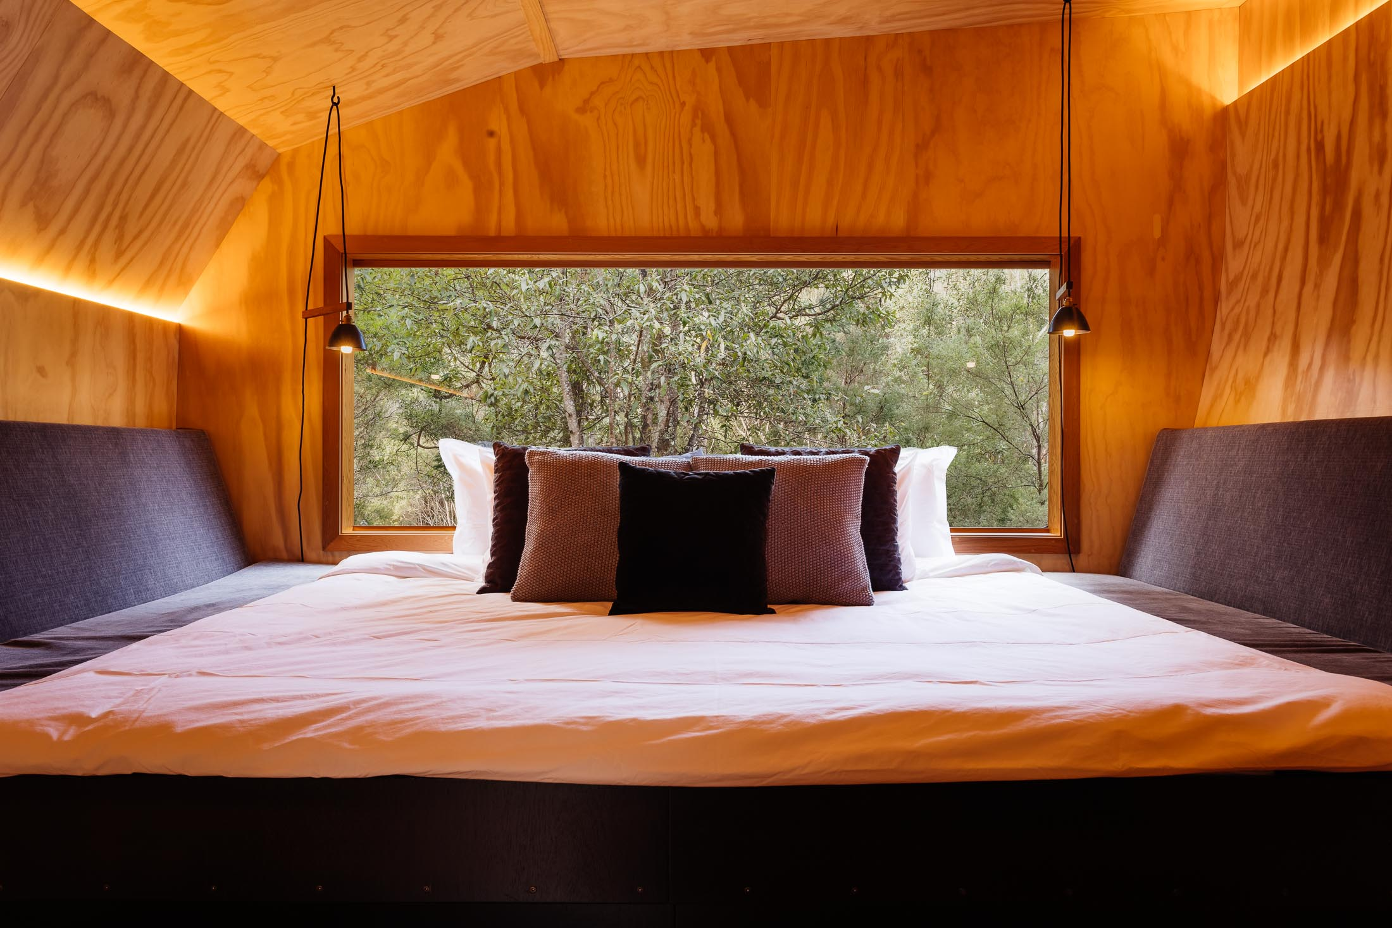
Pods_Inside_Adam_Gibson

Room Amenities
- In addition, the following further information can assist guests:
Guest to have mobile phone of staff member, to call for help if needed.
- There is a clear path through the room
- The edges of all furniture and fixtures are rounded
- Wardrobe handles are a contrasting colour to the doors and draws
- Housekeeping procedures instruct staff not to reposition furniture that has been moved
- Doors open fully against the adjoining wall
- There is a clear opening at least 850mm wide
- Wardrobe and drawer handles are easy to grip
- The bedside lamp switch is easy to reach from the bed
- There is at least 850mm clear space beside the bed
- There is at least 130mm clearance under the bed
- Non-allergenic cleaning products are used
- In addition, the following further information can assist guests:
Pods are a very simple design, all wheel chair friendly.

Bathrooms
The bathrooms have the following facilities/amenities in place
- All heating appliances and hot water pipes are protected or insulated
- All shower, bath and basin taps are clearly differentiated between hot and cold
- Fixtures and fittings have rounded edges
- The hot water is thermostatically controlled to 41 degrees
- The door is at least 850mm wide
- There is a minimum of 850mm beside the toilet
- Handrails are fitted
- There is a minimum of 1400mm of clear space in front of the toilet
- The toilet seat is a contrasting colour to the floor
- The toilet seat is 460mm above the floor
- There is a roll-in shower with fold down fixed seat or a shower chair
- There is a portable shower head on flexible hose
- A door is fitted to the shower
- A door is fitted to the showers with an outward swing at minimum width of 900 mm

COMMON AREAS

FOOD AND DRINK

Dining Spaces
The dining spaces have the following facilities/amenities in place
- The entrance has level access
- The doorway is at least 850mm wide
- There is level access through the dining area
- Chairs are moveable to allow for wheelchairs to be seated at the tables
- All glass doors and full height windows have contrast markings
- There are areas of full lighting
- There is an accessible toilet

Our business caters for the following dietary requirements
- Sugar free (diabetic)
- Gluten free (celiac)
- Lactose free (dairy free)
- Low fat and fibre with no gastric content
- Low potassium
- Low sodium
- Nut free
- Additive free
- Organic
- Vegetarian
- Vegan
- Kosher
- Halal
- In addition, the following further information can assist guests:
We follow all food, health and safety procedures to allow no cross contamination.
  - Food and Beverage Image(s)
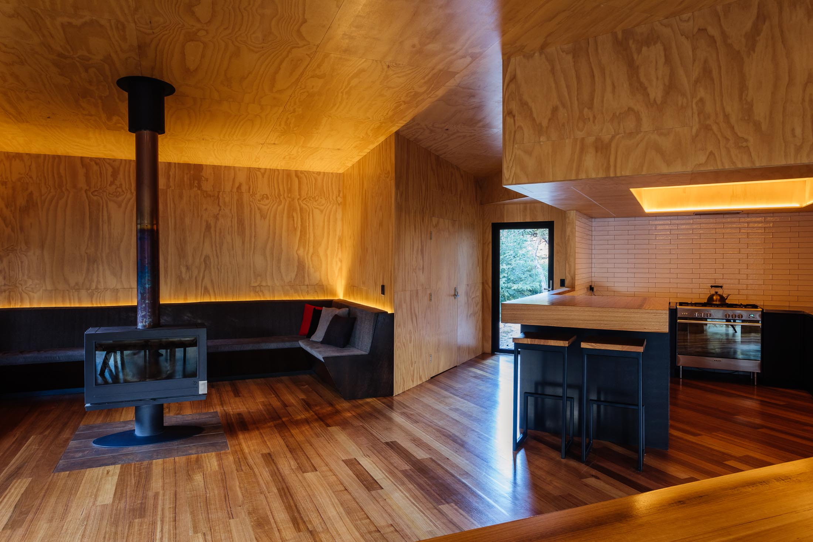
Hub_Inside_Adam_Gibson
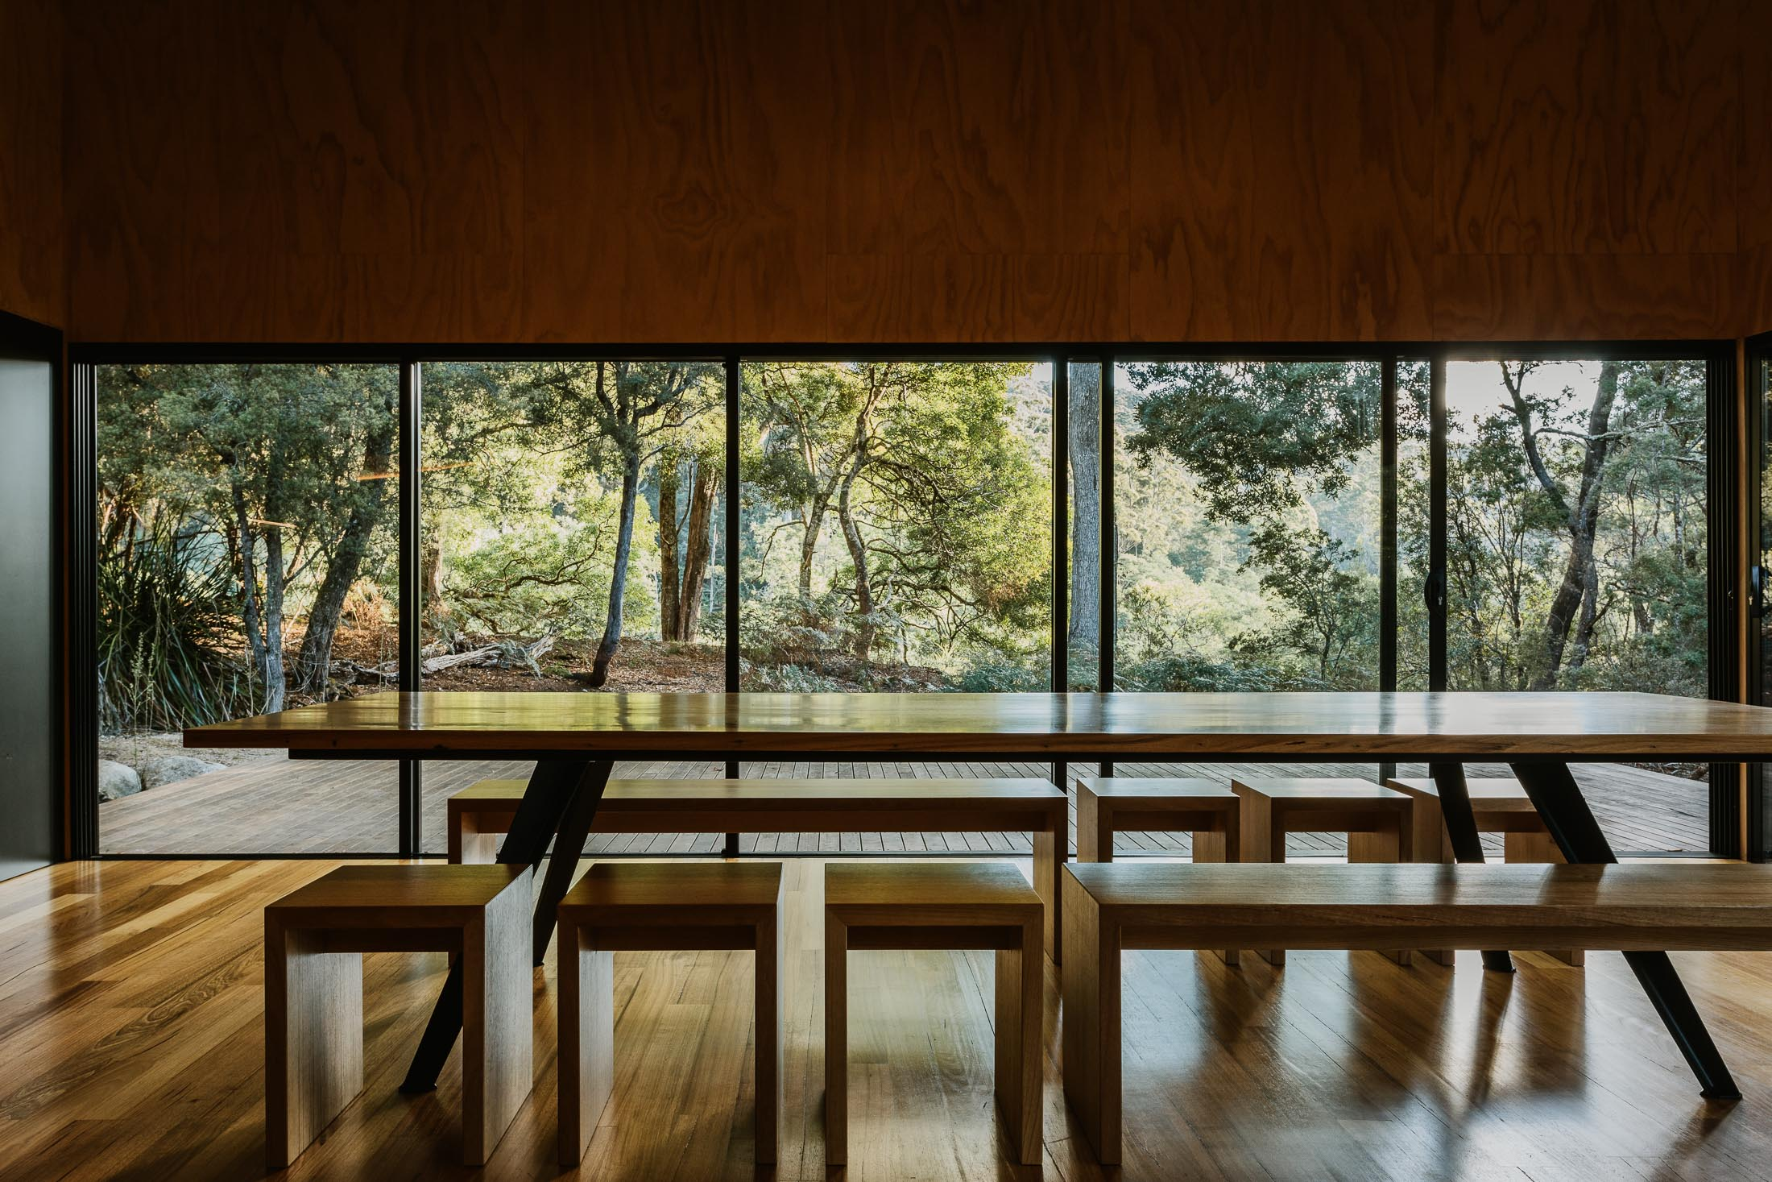
Hub_Dining_Table_Adam_Gibson
- In addition, the following further information can assist guests:
Main Hub/dining area is a big space. Wheel chair access is through whole building, down to Pod 1.

ADVENTURE ACTIVITIES

Adventure activities
The adventure activities have the following facilities/amenities in place
- Our adventure activities cater for people with a disability
- In addition, the following further information can assist guests:
Accessible mountain biking.
- In addition, the following further information can assist guests:
Guest will need to provide own equipment, for example: tandem bike, accessible bike, special bike contraptions.
Additional guide can be organised if guest needs this.
- In addition, the following further information can assist guests:
No specific limitation, only if guest's equipment limits trail accessibility. For example, modified bike may not be able to ride all single track trails.
- In addition, the following further information can assist guests:
We are open to work to suit your needs.

Report Disclaimer
Please note that this business report, provided as a result of the use of the diagnostic assessment, is for information purposes only.
Australian Tourism Industry Council (ATIC) cannot guarantee the accuracy of respondent’s answers, or that they are fully representative of your business. Therefore, ATIC does not warrant or guarantee any particular outcome in respect of your businesses self-assessment.
This report is intended as guidance only for your business and should not be relied on for future marketing considerations. ATIC recommends that you seek your own independent advice as well as the results from the diagnostic.
Links to external web sites are inserted for convenience and do not constitute endorsement of material at those sites, or any associated organisation, product or service.
ATIC does not:
- Assume any legal liability for the accuracy, completeness, or usefulness of any information from this report or any links provided; or
- Accept responsibility for any loss associated directly or indirectly from the use of this report.

