ATIC Accessibility
To support the accessible community in making informed travel decisions for their individual needs

This report prepared for:
Business name: | Seabreeze Kitesurf School
Address: | 36 Fenton Way
Town: | Hamilton Hill
Contact for enquiries: | Andrea Rassega
Contact Number: | 0426 987 655
Contact Email: | seabreezekitesurfschool@gmail.com
Website: | www.seabreezekitesurfschool.com
Date: | 2026-11-04 07:48

ATIC Accessibility
The following pages provides travellers with information on the businesses facilities and amenities which aims to support the traveller to make an informed decision on whether the business is suitable for their individual needs.
OVERVIEW 4
Business Overview 4
Bookings 4
Emergency Management 4
Communications 5
Other Information 5
Guide Dog and Service Animals 5
GENERAL 6
Pre-arrival, arrival and reception 6
Cognitive Impairment Support 6
External Paths 6
ATTRACTIONS 7
COMMON AREAS 8
Parks and gardens 8
ADVENTURE ACTIVITIES 9
Adventure activities 9
Report Disclaimer 12

OVERVIEW

Business Overview

The business has the following products/services available
- Attraction
- Adventure

Our business caters for the following disability types:
- Blind or low vision
- Deaf or low hearing
- Limited mobility
- Wheelchairs or mobility scooters
- Cognitive or people on the Autism Spectrum


Bookings

The business offers the following methods for bookings and enquiries:
- Phone
- Email
- Webportal

Emergency Management
- Emergency and evacuation procedures are explained on arrival
- Exit access is free and clear at all times
We ensure exit access is free and clear at all times by:
It is an open beach
- Exits to the emergency evacuation point does not include stairways
- In addition, the following further information can assist guests:
Before and upon arrival
- In addition, the following further information can assist guests:
Boat rescue

Communications
- Our business offers the following alternative communication methods
- Plain English

Not specified
- There is easy to read signage and information (e.g. menus and emergency information)

Where required

Other Information
- For bookings made onsite, the ticket booth/counter/box office is accessible for people using a wheelchair

Guide Dog and Service Animals
- The business provides a secure area with shade and water for service animals
- The business provides a toilet area for service animals
- Bowls, bedding, etc. are provided for service animals
The business provides the following services for services animals:
We are an outdoors facility with shade

GENERAL

Pre-arrival, arrival and reception
The business has the following in place to support guests during pre-arrival, arrival and reception
- There is a reception/public entryway.
- Seating available at reception

No requirement for guests to complete forms
- Information and maps are available in written form
- A familiarisation tour
- In addition, the following further information can assist guests:
We do not have wait times. Everything is appointment only.

Cognitive Impairment Support
- Documents are available in plain English for people with cognitive impairment (This may include instructions, guides, menus and general information)
- Quiet periods or early opening times for people on the Autism Spectrum
- A space for parents and children on the Autism Spectrum

External Paths
External paths of travel
- Pathways are wider than 900mm
- There 3 successive steps or less on any path or at any doorway
- In addition, the following further information can assist guests:
We are unable to provide a walkway to the water due to council requirements

ATTRACTIONS
- In addition, the following further information can assist guests:
We are unable to provide appropriate access for our participants down to the water due to council limitations. We are working with the council trying to address this.

COMMON AREAS

Parks and gardens
- The following parks and gardens amenities are available
  - Parks and Gardens Stair entry and exit Image(s)
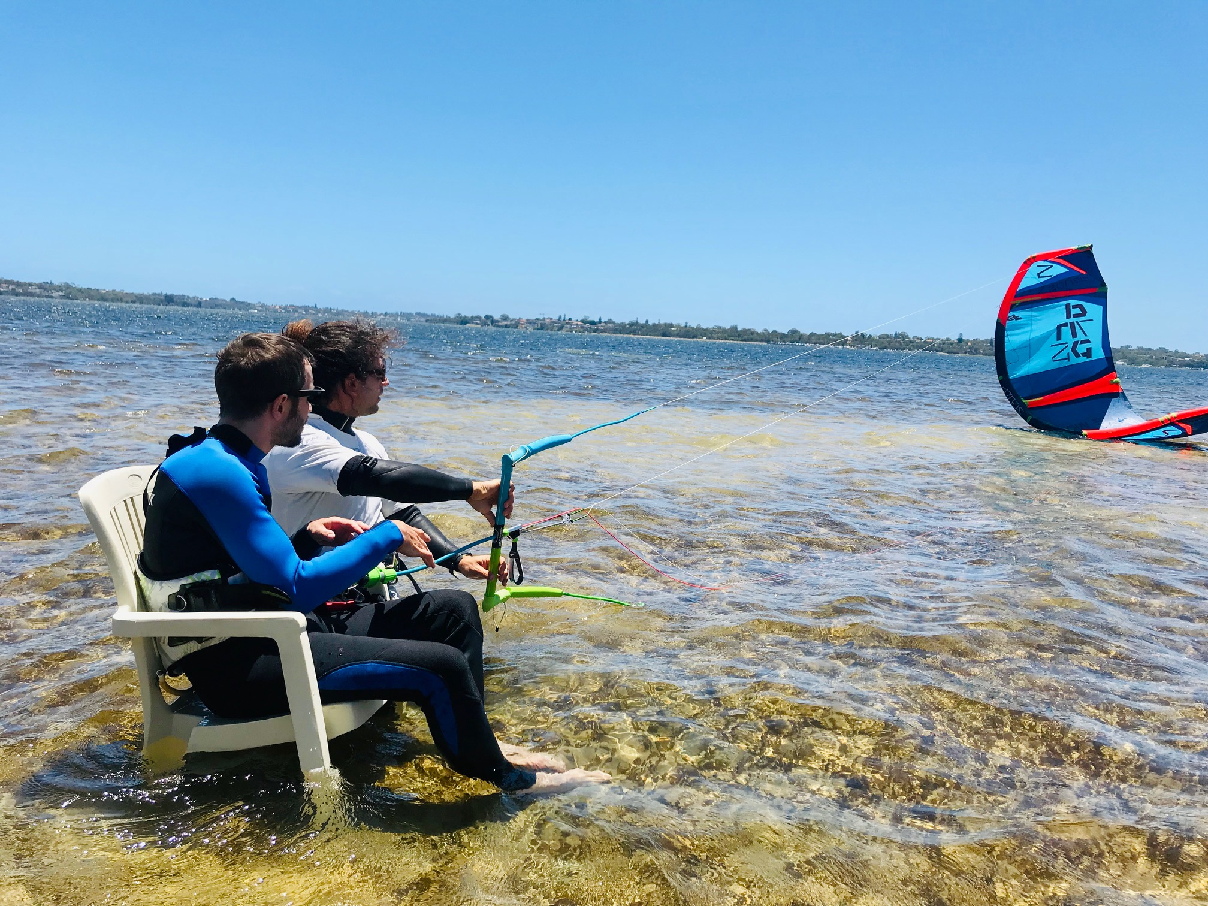
JOHANNES 2

ADVENTURE ACTIVITIES

Adventure activities
The adventure activities have the following facilities/amenities in place
- Our adventure activities cater for people with a disability
- In addition, the following further information can assist guests:
Adapted Kitesurfing is the first of its kind in Australia, specifically designed to teach kitesurfing to individuals with paraplegia. This pioneering initiative provides specialised equipment and personalised instruction, ensuring a safe and comfortable environment for participants to experience the thrill of kitesurfing.

The SUPportive Program offers an accessible and enjoyable experience of Stand Up Paddleboarding tailored for individuals with mental disabilities. We focus on creating a supportive space where participants can explore paddleboarding at their own pace, discover the joy of being on the water and connecting with nature.

Adapted SUP offers a unique and accessible paddleboarding experience for individuals with physical disabilities. With comfortable seating options and expert instructors, we support the creation of safe environment for exploring the water, building skills and having fun. Specialised equipment ensures that you can enjoy the thrill of Stand Up Paddling from a seated position, making the water experience available to everyone.

- In addition, the following further information can assist guests:
Sit kiteboard, rescue boat
- In addition, the following further information can assist guests:
Unfortunately we cannot teach kiteboarding to people with no arm mobility
  - Adventure Activity Image(s)
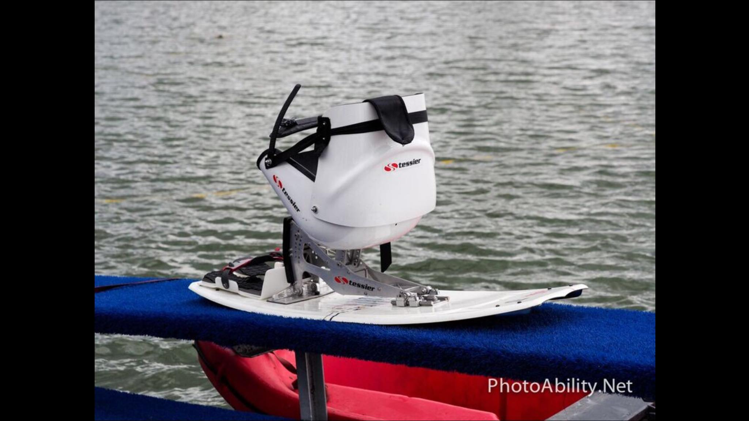
18077134_10211171071726093_7870040883596089489_o
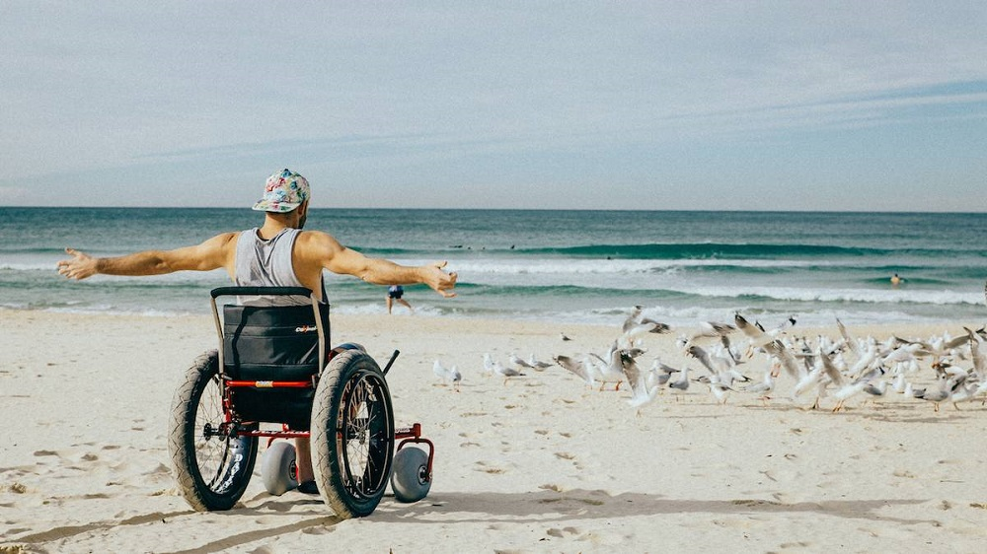
accessible-beaches
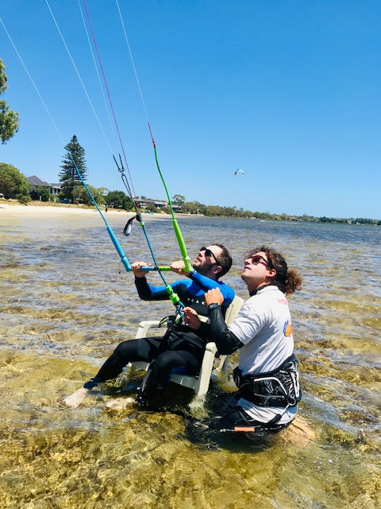
johannes

Report Disclaimer
Please note that this business report, provided as a result of the use of the diagnostic assessment, is for information purposes only.
Australian Tourism Industry Council (ATIC) cannot guarantee the accuracy of respondent’s answers, or that they are fully representative of your business. Therefore, ATIC does not warrant or guarantee any particular outcome in respect of your businesses self-assessment.
This report is intended as guidance only for your business and should not be relied on for future marketing considerations. ATIC recommends that you seek your own independent advice as well as the results from the diagnostic.
Links to external web sites are inserted for convenience and do not constitute endorsement of material at those sites, or any associated organisation, product or service.
ATIC does not:
- Assume any legal liability for the accuracy, completeness, or usefulness of any information from this report or any links provided; or
- Accept responsibility for any loss associated directly or indirectly from the use of this report.

