ATIC Accessibility
To support the accessible community in making informed travel decisions for their individual needs

This report prepared for:
Business name: | Segway Tours WA
Address: | Shop 1,
Town: | Perth
Contact for enquiries: | Belinda Hill
Contact Number: | 0418383951
Contact Email: | info@segwaytourswa.com.au
Website: | www.segwaytourswa.com.au
Date: | 2026-09-15 19:54

ATIC Accessibility
The following pages provides travellers with information on the businesses facilities and amenities which aims to support the traveller to make an informed decision on whether the business is suitable for their individual needs.
OVERVIEW 4
Business Overview 4
Bookings 4
Emergency Management 4
Other Information 5
Guide Dog and Service Animals 5
GENERAL 6
Pre-arrival, arrival and reception 6
Cognitive Impairment Support 6
Car Park and Access amenities 6
Entry 7
Internal Spaces 7
Public areas 7
Displays, exhibits, commentary and live performances 7
External Paths 8
Ramps 8
TOUR OPERATORS 9
Route Planning 9
Guides 9
Report Disclaimer 11

OVERVIEW

Business Overview

The business has the following products/services available
- Tour/Transport

Our business caters for the following disability types:
- Deaf or low hearing
- Limited mobility
- Cognitive or people on the Autism Spectrum
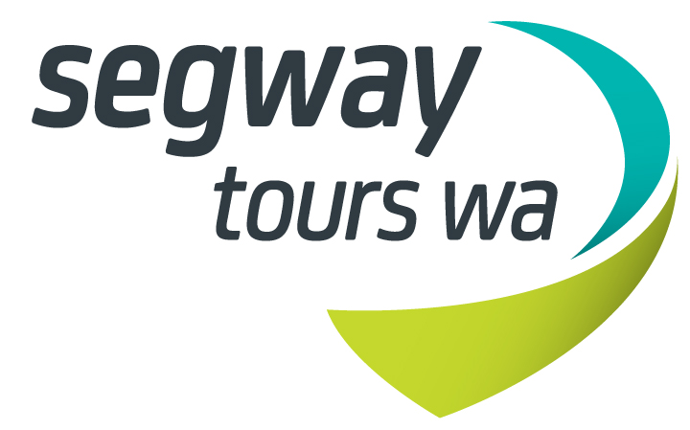

Bookings

The business offers the following methods for bookings and enquiries:
- Phone
- Email
- Webportal
- Our forms have high contract boxes and submit boxes
- Staff have undergone disability awareness and training

Emergency Management

Exit door is clear and visible at all times. It is a small office with direct access to the outdoor space
- Exit signs are clear and easy to see
- Exit signs have raised lettering or braille
- Exit access is free and clear at all times
We ensure exit access is free and clear at all times by:
Door and reception area are clear and open at all times
- Exits and access to exists are greater than 900mm
- Exit doors are able to be opened by all occupants
- Exits to the emergency evacuation point does not include stairways
- The evacuation point is clearly marked by a sign
- The evacuation point is clearly marked by a sign with raised letters or braille
- In addition, the following further information can assist guests:
Immediate assessment of all persons in office area
- In addition, the following further information can assist guests:
All office staff to assist immediately and guide to evacuation area immediately. Stay with all guests.
- Guests with disabilities are noted in the guest log book for emergency and evacuation purposes

Other Information
- For bookings made onsite, the ticket booth/counter/box office is accessible for people using a wheelchair
- The business accepts the companion card

Guide Dog and Service Animals
- The business provides a secure area with shade and water for service animals
- The business provides a toilet area for service animals
The business provides the following services for services animals:
Service animals cannot come out on tour however are looked after in the office if necessary

GENERAL

Pre-arrival, arrival and reception
The business has the following in place to support guests during pre-arrival, arrival and reception
- Booking information and websites are compatible with screen readers
- There is a reception/public entryway.
- Seating available at reception
- A lower counter at reception/ticket office
- A clipboard to allow check-in/ticket purchase whilst seated
- A tablet with text to voice or pen and paper at reception to aid in communication
- Picture Board at reception to aid in communication
- Lighting in the reception area is even and glare free
- Large print information sheets and registration forms
- Information and maps are available in written form
- In addition, the following further information can assist guests:
Numerous staff to handle check-in and training plus chairs and water available to rest prior to and after tour
- In addition, the following further information can assist guests:
Large ramps are available for access if the small permanent ramps are not suitable for the one step entry

Cognitive Impairment Support
- Quiet periods or early opening times for people on the Autism Spectrum

Car Park and Access amenities
The business has the following Car Park and Access amenities
- A drop off zone
- Level or ramped access from the car park to the entrance
- The accessible entrance is clearly signed from the parking bay

Entry
The business has the following amenities/systems in place for entry
- A drop off point close to the entrance
- A path of access to the building is slip resistance and even
- A path of access to the building is clear of obstruction
- Glass doors are fitted with a visual sighting strip
- Door jams/doors are of a contrasting colour to surrounding walls
- Door handles are of a contrasting colour to the door
- Signage is written in a contrasting colour
- The entry door is a minimum of 850mm wide
- The entrance sill is less than 13mm
- There a clear space of at least 1500mm x 1500mm in front of all doors.
- The entrance door mats have a thickness less than 13mm and a width of 7500mm or greater
- In addition, the following further information can assist guests:
Ground level

Internal Spaces
- Clear and unobstructed routes through and between buildings
- Interior walls are matte or low sheen
- Floors, walls, counters and furniture are of contrasting colours
- Floor surfaces are hard or short pile carpet
- Seating is available for guests unable to stand for long periods
- Accessible facilities are clearly signed and visible from all areas
- All corridors greater than 900mm
- There is a quiet space for parents and children on the Autism Spectrum

Public areas
The public areas have the following amenities in place
- Even lighting
- Seating

Displays, exhibits, commentary and live performances
For displays, exhibits, commentary and live performances the following amenities are in place
- Seating
- Wheelchair accessible spaces/seating
- A written transcript where audio description is provided i.e. display commentary, tour commentary
- In addition, the following further information can assist guests:
One on one training to ride the Segway is provided by the tour guide and additional assistance is given when a disability is noted.

External Paths
External paths of travel
- Surfaces are concrete, asphalt, smooth paving or hard packed fine gravel (max aggregate size 13mm)
- Paths or slopes longer than 15 metres have resting places or seats
- Pathways are wider than 900mm
- Step free routes clearly signed

Ramps
Ramps have the following amenities are in place
- There are ramps.
- All fixed ramps are 1:14 or less
- Long ramps (more than 10m) are 1:20 or less
- Temporary ramps are available
- Temporary ramps are in place for the duration of the guests stay
- Ramps have a raised edge of at least 100mm
- There is n/a mm of clear space in front of the toilet

TOUR OPERATORS

Route Planning
- Route Planning
- In addition, the following further information can assist guests:
Accessible toilets are available at the departure point and on most tours along the way. The tour guide will point out stops if required but we dont always stop at these points unless required

Guides
- Use of clear/simple English
- Correct pronunciation for lip readers
- There is a audio description of surroundings

Report Disclaimer
Please note that this business report, provided as a result of the use of the diagnostic assessment, is for information purposes only.
Australian Tourism Industry Council (ATIC) cannot guarantee the accuracy of respondent’s answers, or that they are fully representative of your business. Therefore, ATIC does not warrant or guarantee any particular outcome in respect of your businesses self-assessment.
This report is intended as guidance only for your business and should not be relied on for future marketing considerations. ATIC recommends that you seek your own independent advice as well as the results from the diagnostic.
Links to external web sites are inserted for convenience and do not constitute endorsement of material at those sites, or any associated organisation, product or service.
ATIC does not:
- Assume any legal liability for the accuracy, completeness, or usefulness of any information from this report or any links provided; or
- Accept responsibility for any loss associated directly or indirectly from the use of this report.

