ATIC Accessibility
To support the accessible community in making informed travel decisions for their individual needs

This report prepared for:
Business name: | Kimberley Outback Tours
Address: | 727 Hatch Road
Town: | Bowes
Contact for enquiries: | David Teakle
Contact Number: | 1300286453
Contact Email: | david@kimberleyoutbacktours.com.au
Website: | www.kimberleyoutbacktours.com
Date: | 2026-11-03 22:13

ATIC Accessibility
The following pages provides travellers with information on the businesses facilities and amenities which aims to support the traveller to make an informed decision on whether the business is suitable for their individual needs.
OVERVIEW 3
Business Overview 3
Bookings 3
Emergency Management 3
GENERAL 4
External Paths 4
TOUR OPERATORS 5
Tour/Transport Services 5
Route Planning 5
Guides 5
ADVENTURE ACTIVITIES 10
Report Disclaimer 13

OVERVIEW

Business Overview

The business has the following products/services available
- Tour/Transport
- Adventure

Our business caters for the following disability types:
- Food allergies or intolerances

Bookings

The business offers the following methods for bookings and enquiries:
- Phone
- Email
- Webportal

Emergency Management
- Emergency and evacuation procedures are explained on arrival
The business provides the following services for services animals:
Not specified

GENERAL
- In addition, the following further information can assist guests:
Not applicable as we do not cater to people with disabilities.

External Paths
External paths of travel
- Pathways are wider than 900mm

TOUR OPERATORS

Tour/Transport Services
The tour/transport services have the following facilities/amenities in place
- Buses/Coaches
- none vehicles have wheelchair lifts or ramps
- none vehicles have low floors with ramped entry
The maximum wheelchair capacity available in the fleet is:
zero

Route Planning
- Route Planning
- Walking Tours

Guides

Guides have been trained in the following
- Use of clear/simple English
- Correct pronunciation for lip readers
- Marine
  - Image(s)
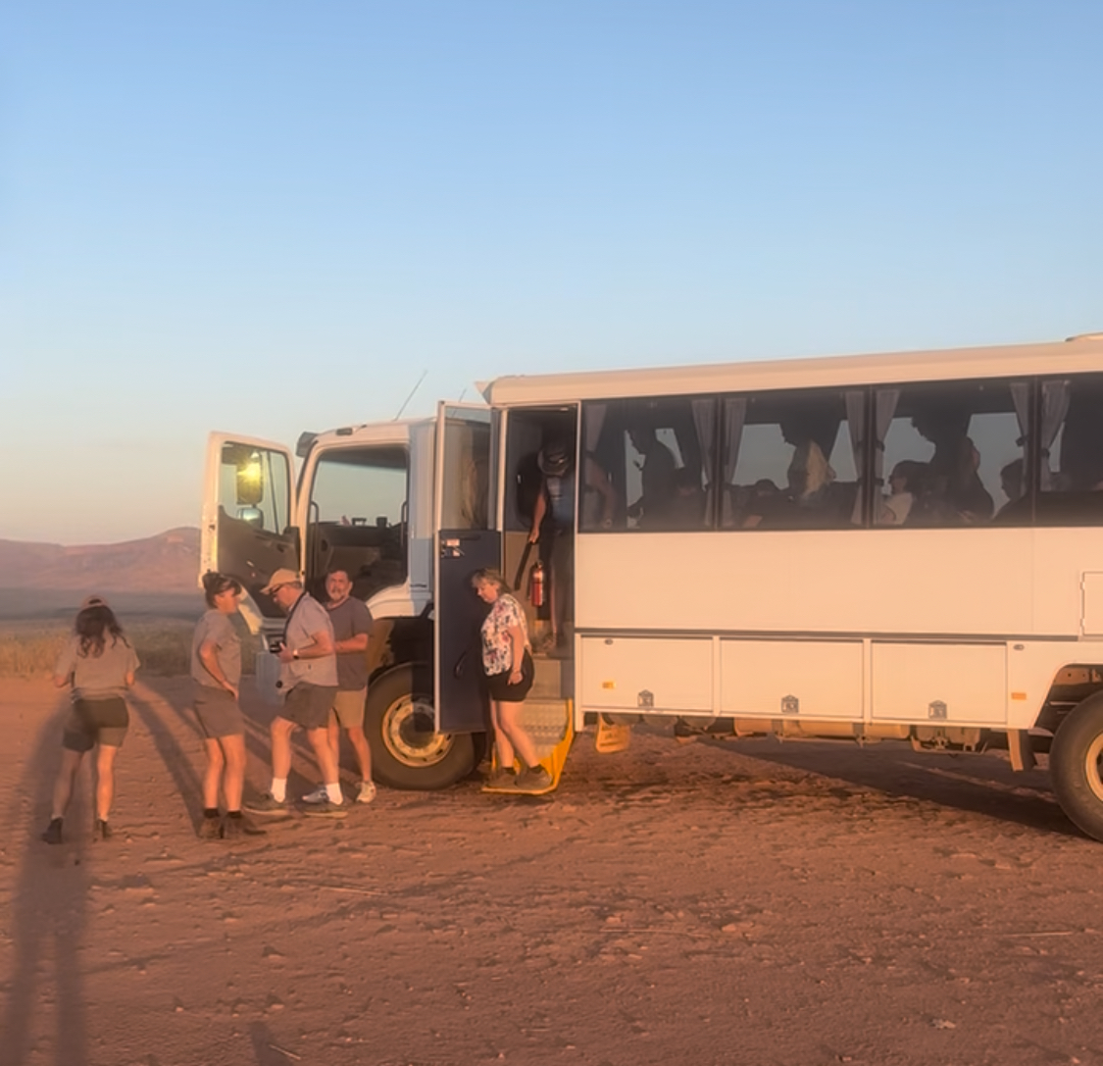
IMG_0660.JPEG
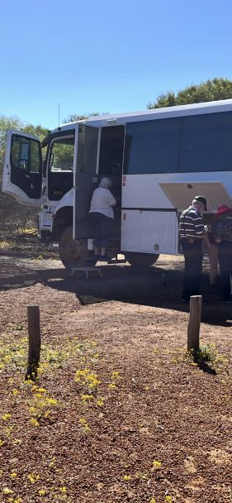
IMG_0661
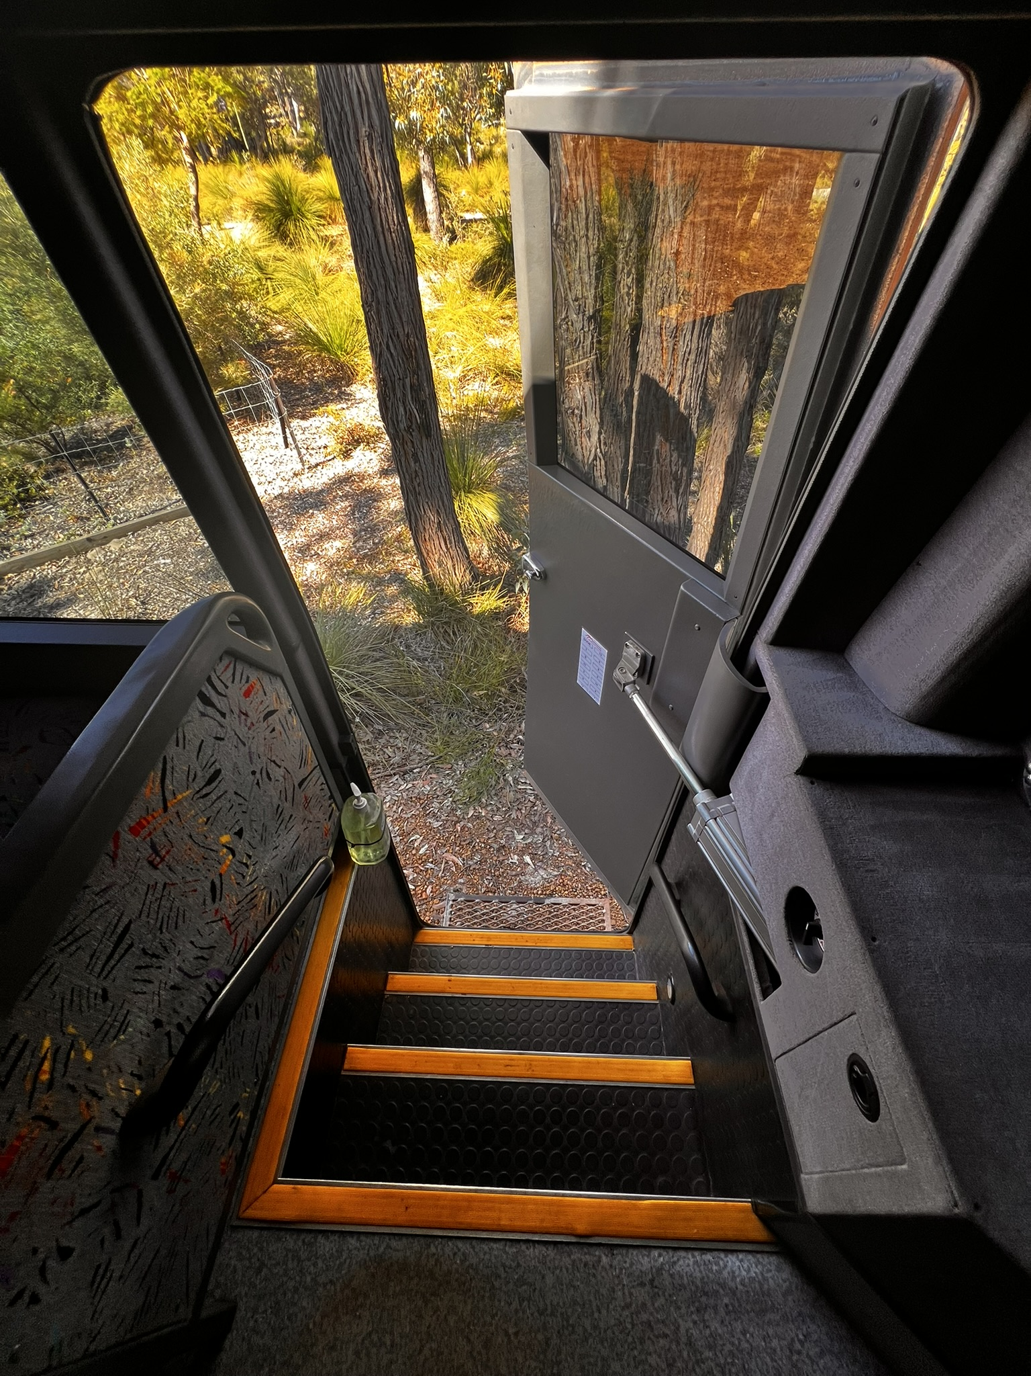
IMG_3887.JPEG
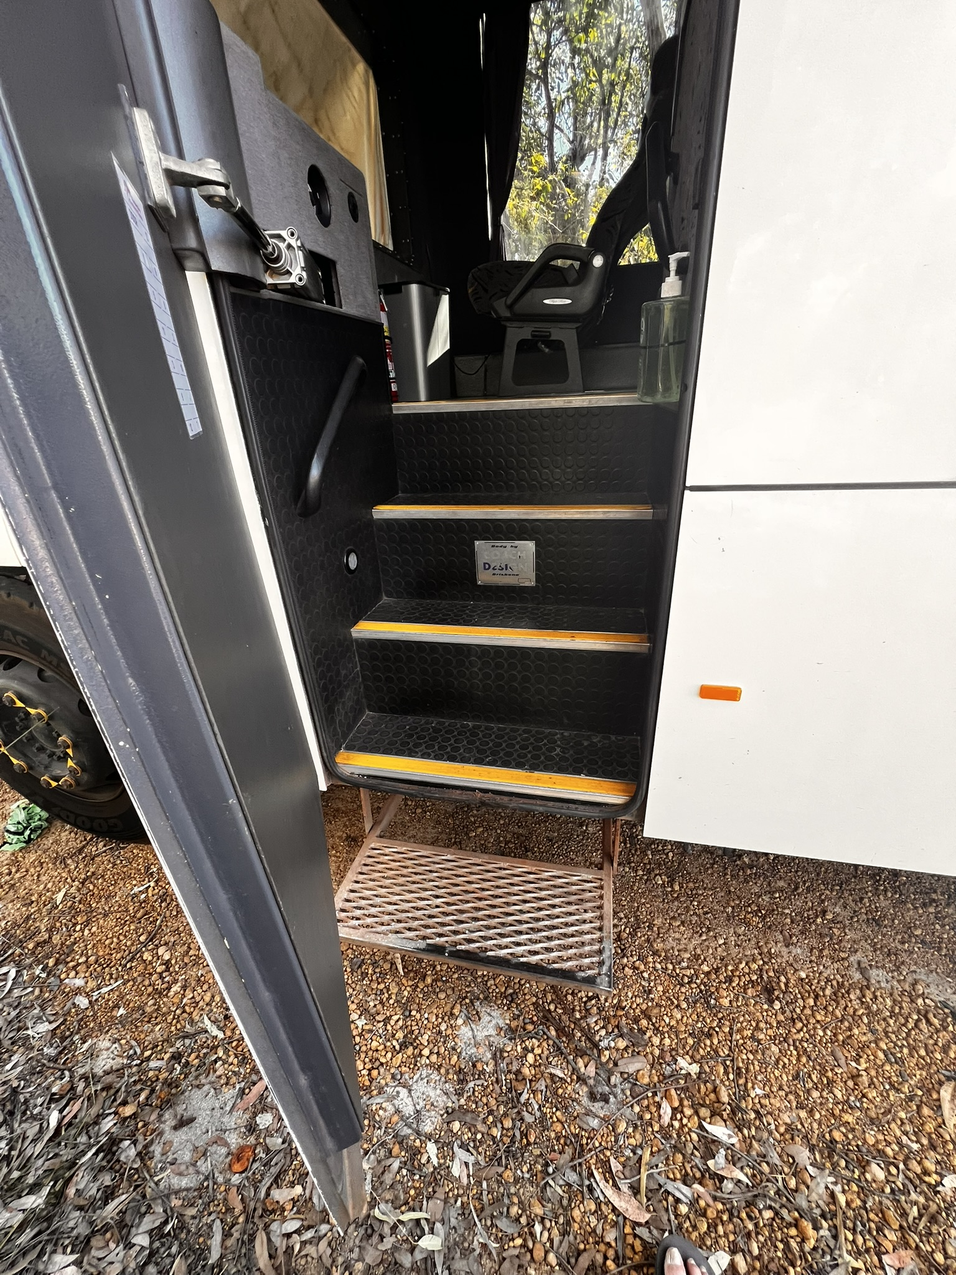
IMG_3885.JPEG
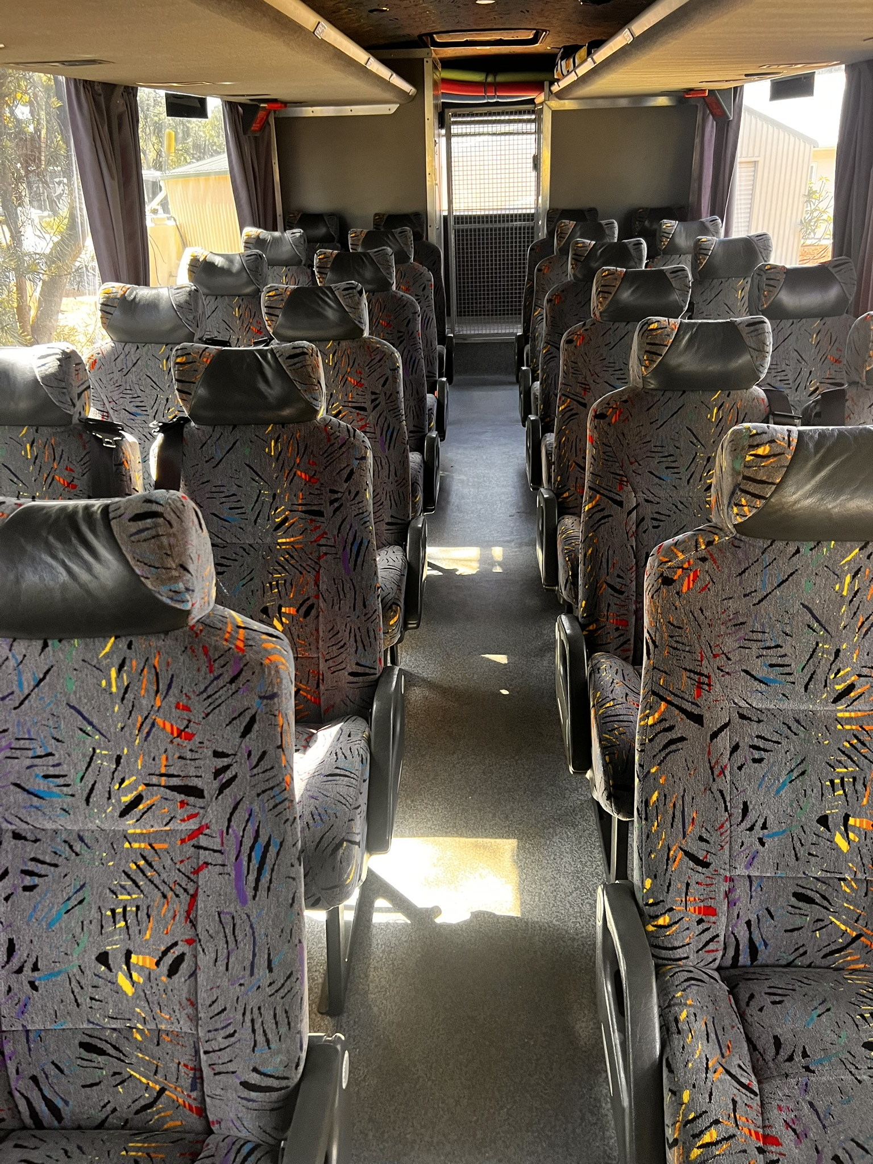
IMG_3889.JPEG
- In addition, the following further information can assist guests:
The Continental Hotel in Broome
Cygnet Bay Pearl Farm
Horizontal Falls Sea Plane Adventures
Mt Hart Wilderness Lodge
APT Bungle Bungles
Savannah Lodge
Kununurra Country Club
Halls Creek Motel
Fitzroy River Lodge
Eco Beach Wilderness Retreat
Port Hedland Hospitality Inn
Hilton Garden Inn Darwin
Cooinda Lodge
Yellow Water Cruise
Triple J Kununurra
Mimbi Caves
Pilbara Tours
Karijini Eco Retreat
Samson Chalets
Yardie Creek Cruises
Pot Shot Resort
RAC Monkey Mia
RAC Pemberton
Emma Gorge El Questro
Kalbarri Edge Resort
Ocean Centre Hotel Geraldton
Skeetas Restaurant
Mt Augustus Tourist Park
InterContinental Perth
Hyden Motel
Railway Inn Kalgoorlie
Comfort Inn Esperance
Hilton Garden Inn Albany
Albany Whaling Station
ANZAC Centre Albany
Cape Leeuwin Lighthouse
Jewel Cave
Rustico by Hayshed Hill
Hilton Garden Inn Busselton
Esplanade Fremantle

ADVENTURE ACTIVITIES
  - Adventure Activity Image(s)
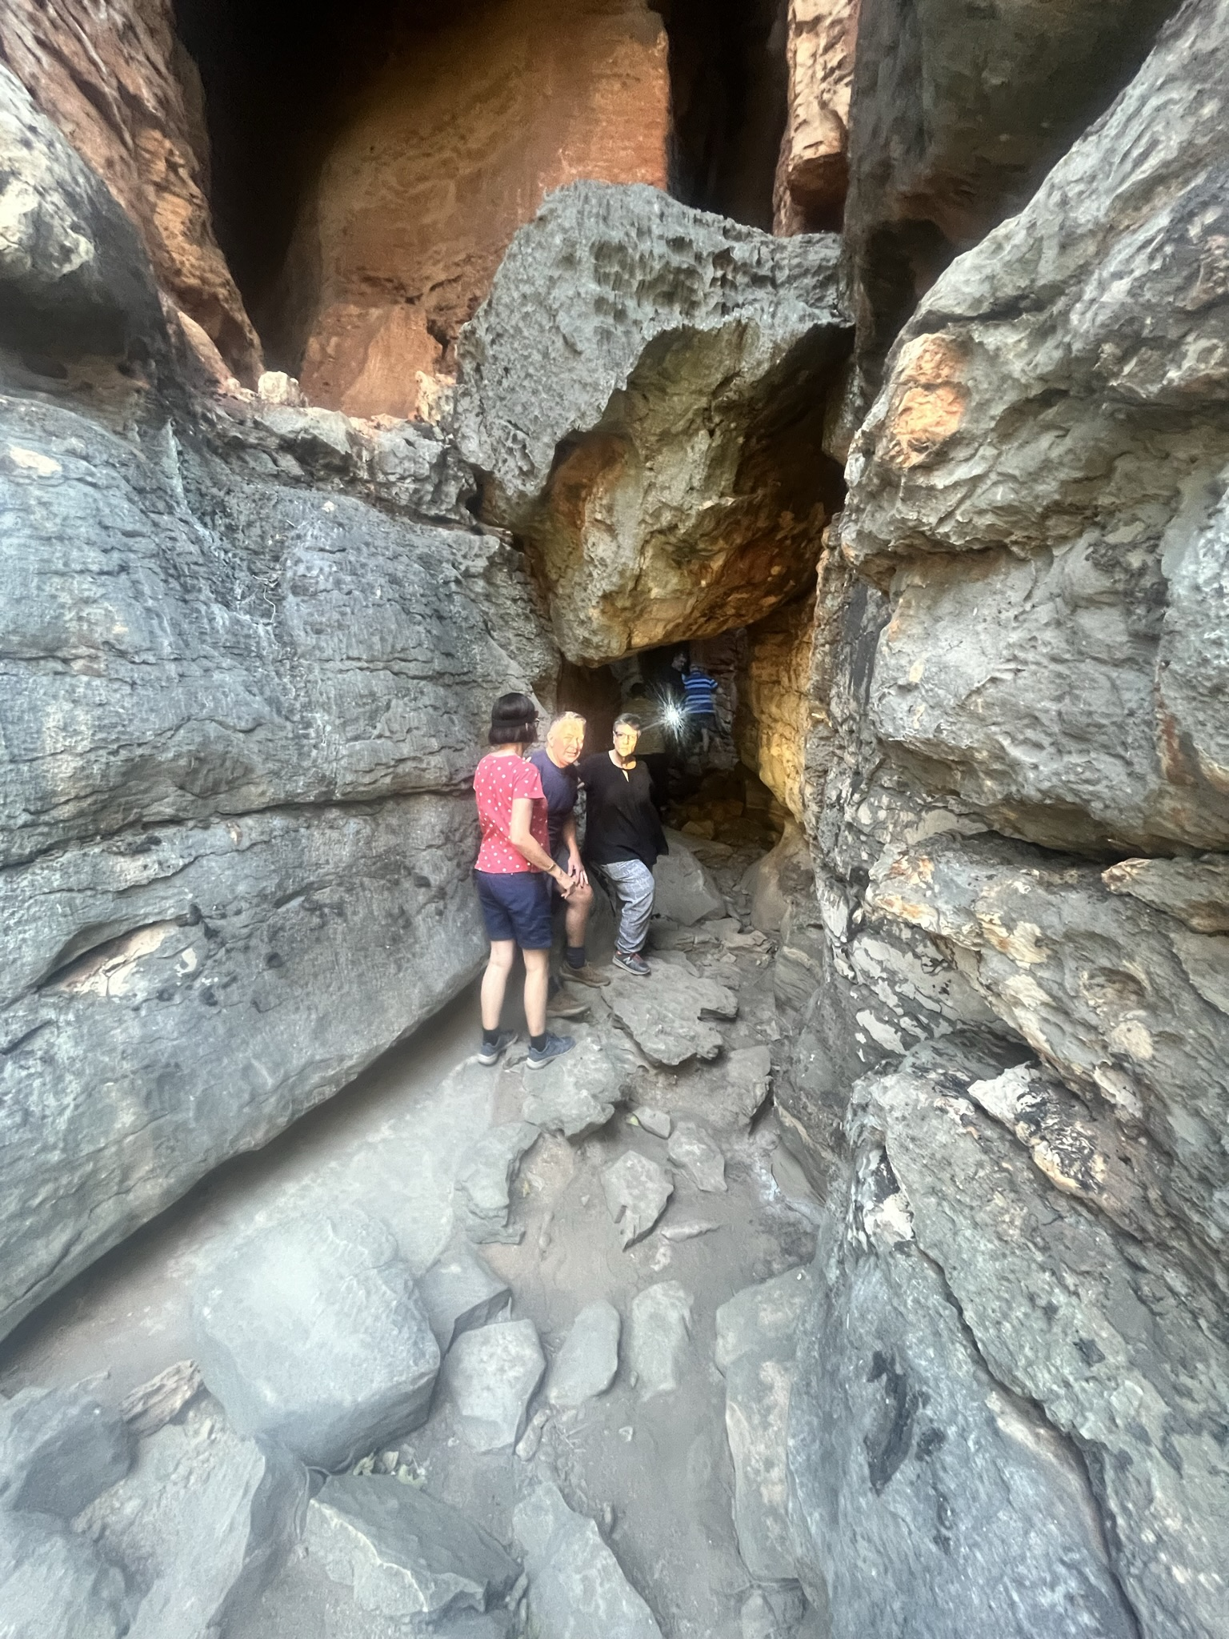
IMG_7129.JPEG
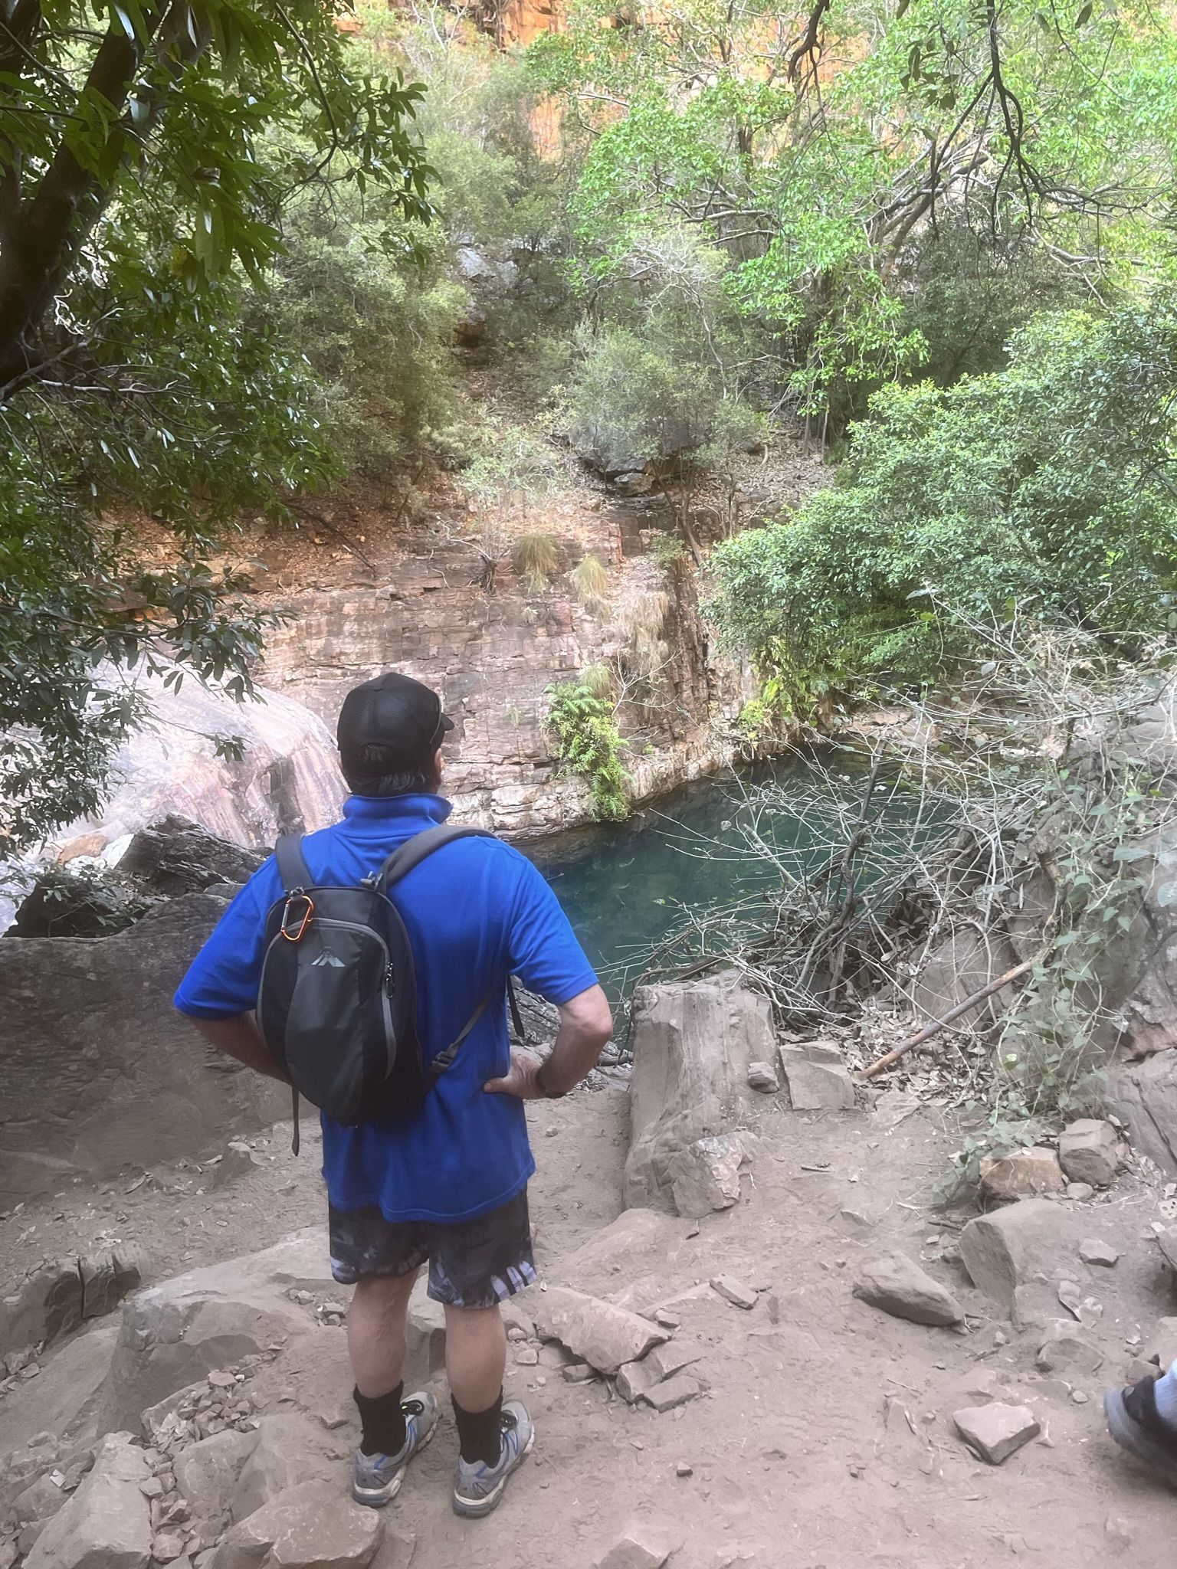
IMG_6938.JPEG
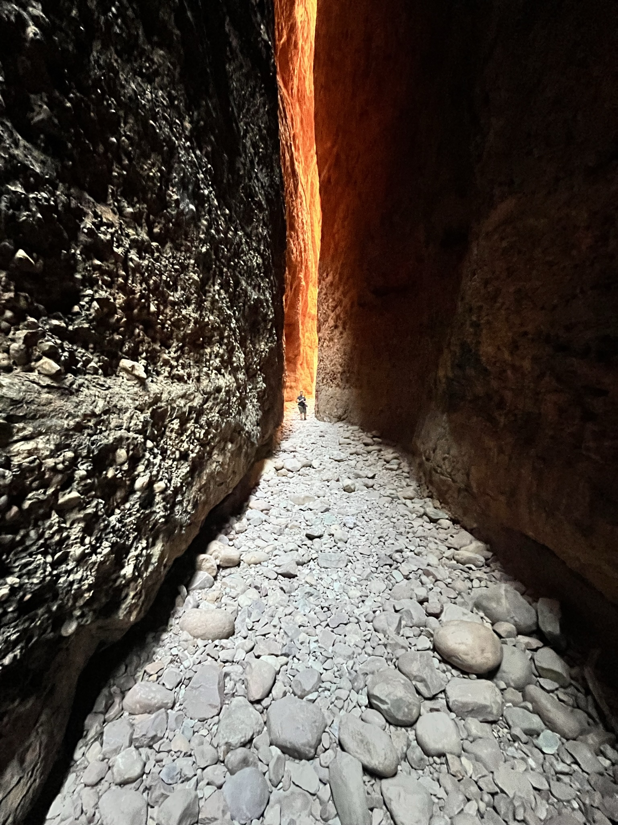
IMG_7100.JPEG
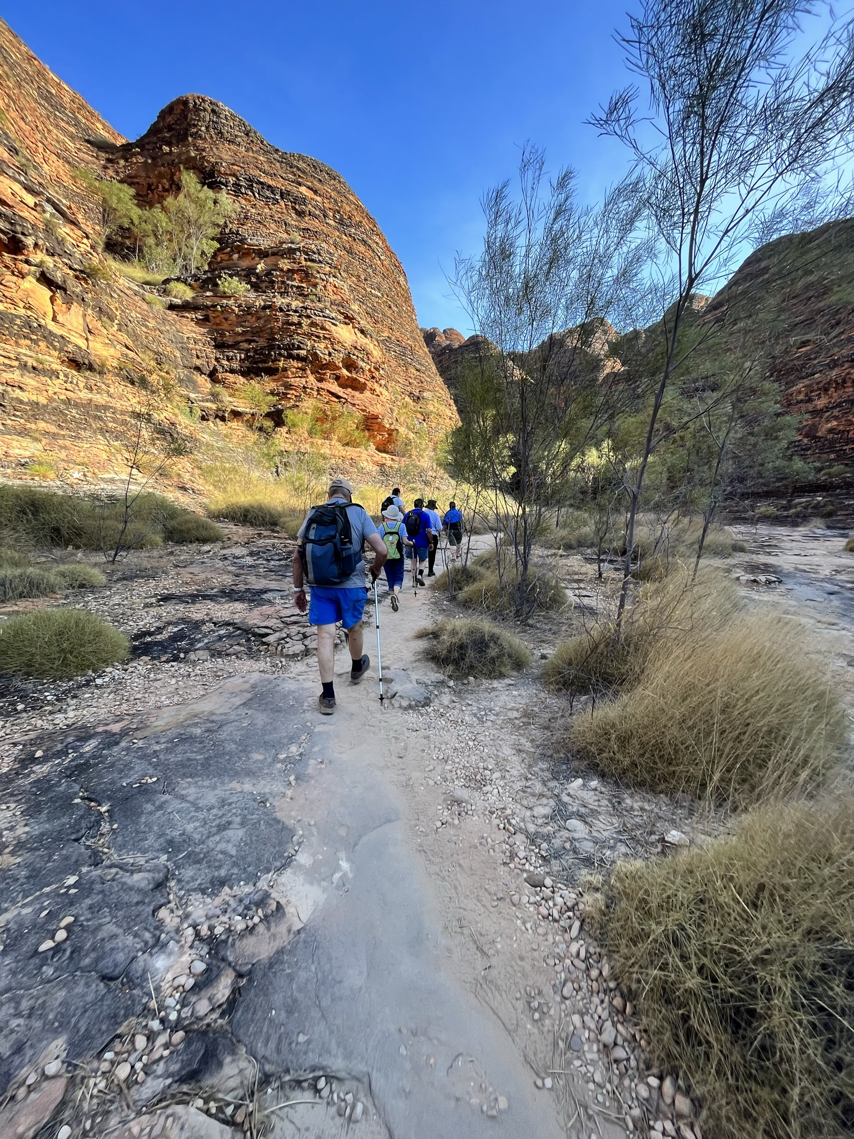
IMG_7062.JPEG
- In addition, the following further information can assist guests:
Many of our walks and swims are in remote locations with unformed paths. There are rocks, boulders and water crossings on many of our walks

Report Disclaimer
Please note that this business report, provided as a result of the use of the diagnostic assessment, is for information purposes only.
Australian Tourism Industry Council (ATIC) cannot guarantee the accuracy of respondent’s answers, or that they are fully representative of your business. Therefore, ATIC does not warrant or guarantee any particular outcome in respect of your businesses self-assessment.
This report is intended as guidance only for your business and should not be relied on for future marketing considerations. ATIC recommends that you seek your own independent advice as well as the results from the diagnostic.
Links to external web sites are inserted for convenience and do not constitute endorsement of material at those sites, or any associated organisation, product or service.
ATIC does not:
- Assume any legal liability for the accuracy, completeness, or usefulness of any information from this report or any links provided; or
- Accept responsibility for any loss associated directly or indirectly from the use of this report.

