ATIC Accessibility
To support the accessible community in making informed travel decisions for their individual needs

This report prepared for:
Business name: | Mount Little Station
Address: | 347 Mt Little Road
Town: | Hawker
Contact for enquiries: | Kellie Zadow
Contact Number: | 0886484206
Contact Email: | bindmurra1@gmail.com
Website: | https://mtlittlestation.com.au/
Date: | 2026-10-24 17:02

ATIC Accessibility
The following pages provides travellers with information on the businesses facilities and amenities which aims to support the traveller to make an informed decision on whether the business is suitable for their individual needs.
OVERVIEW 4
Business Overview 4
Bookings 5
Emergency Management 6
Communications 6
Other Information 7
Guide Dog and Service Animals 7
GENERAL 8
Pre-arrival, arrival and reception 8
Cognitive Impairment Support 8
Car Park and Access amenities 8
Entry 9
Internal Spaces 9
Public areas 9
External Paths 9
Steps 10
Ramps 10
Public Toilets/Adult change facilities 10
ACCOMMODATION 11
Bedrooms 11
Room Amenities 11
Bathrooms 12
COMMON AREAS 13
FOOD AND DRINK 14
Dining Spaces 14
Report Disclaimer 17

OVERVIEW

Business Overview

The business has the following products/services available
- Accommodation
- Food and Drink

Our business caters for the following disability types:
- Limited mobility
- Wheelchairs or mobility scooters
- Food allergies or intolerances
- Cognitive or people on the Autism Spectrum


Bookings

The business offers the following methods for bookings and enquiries:
- Phone
- Email
- Webportal
- Our forms have high contract boxes and submit boxes

Emergency Management
- Emergency and evacuation procedures are explained on arrival
- Exit signs are clear and easy to see
- Exit access is free and clear at all times
We ensure exit access is free and clear at all times by:
wide open spaces, roadways 24,000 acres, limited traffic
- Exits and access to exists are greater than 900mm
- Exit doors are able to be opened by all occupants
- Exits to the emergency evacuation point does not include stairways
- The evacuation point is clearly marked by a sign
- In addition, the following further information can assist guests:
Discussed when booking or checking in
- In addition, the following further information can assist guests:
Staff to assist guests or call emergency services for support

Communications
- An accessibility guide is available on the website

https://www.mtlittlestation.com.au/
- Our website meets WCAG 2.0 accessibility standards
- Our business offers the following alternative communication methods
- Plain English

Not specified
- There is easy to read signage and information (e.g. menus and emergency information)

Other Information
- The business accepts the companion card

Guide Dog and Service Animals
- The business provides a secure area with shade and water for service animals
- The business provides a toilet area for service animals
- Bowls, bedding, etc. are provided for service animals
The business provides the following services for services animals:
Service animals are allowed in accommodation and all areas on the property

GENERAL

Pre-arrival, arrival and reception
The business has the following in place to support guests during pre-arrival, arrival and reception
- There is a reception/public entryway.
- Seating available at reception
- A lower counter at reception/ticket office
- A clipboard to allow check-in/ticket purchase whilst seated
- A tablet with text to voice or pen and paper at reception to aid in communication
- Picture Board at reception to aid in communication
- Large print information sheets and registration forms

On request
- Information and maps are available in written form
- A step free map/guide
- A familiarisation tour
- Luggage assistance
- In addition, the following further information can assist guests:
Guests are given immediate attention, our property and offerings are small so guests do not need to wait long. Special needs and requirements would be addressed through the booking and check in process.

Cognitive Impairment Support
- Documents are available in plain English for people with cognitive impairment (This may include instructions, guides, menus and general information)
- A "social script" guide to your premises or attraction describing the sights, sounds and smells to aid parents/carers prepare visitors in advance
- The 'social script' is available in word and other editable formats
- Quiet periods or early opening times for people on the Autism Spectrum
- A space for parents and children on the Autism Spectrum

Car Park and Access amenities
The business has the following Car Park and Access amenities
- A drop off zone
- Level or ramped access from the car park to the entrance

Entry
The business has the following amenities/systems in place for entry
- A drop off point close to the entrance
- A path of access to the building is slip resistance and even
- A path of access to the building is clear of obstruction
- Self opening entry doors or fitted with a self closer
- Signage is written in a contrasting colour
- The entry door has self opening or a light opening pressure (for manual operations)
- The entrance sill is less than 13mm
- In addition, the following further information can assist guests:
When checking in you arrive at our residence and we will do everything to support your needs with prior notice of your arrival.

Internal Spaces
- Tableware/glassware contrast with the table surface or table cloth
- Seating is available for guests unable to stand for long periods
- All corridors greater than 900mm
- There is a quiet space for parents and children on the Autism Spectrum
- In addition, the following further information can assist guests:
Our property is 24,000 acres so there is plenty of quiet areas.

Public areas
The public areas have the following amenities in place
- Even lighting
- Seating

External Paths
External paths of travel
- Surfaces are concrete, asphalt, smooth paving or hard packed fine gravel (max aggregate size 13mm)
- Pathways are wider than 900mm
- There 3 successive steps or less on any path or at any doorway
- Any paths having steps are clearly identified as non-wheelchair accessible
- In addition, the following further information can assist guests:
Guests are entering our home so needs will be addressed through the booking and check in process.

Steps
Steps
- There are steps.
- Where steps are present are there three steps or less

Ramps
Ramps have the following amenities are in place
- There are ramps.
- All fixed ramps are 1:14 or less
- Hand rails are fitted
- Long ramps (more than 10m) are 1:20 or less

Public Toilets/Adult change facilities
Public Toilets/Adult change facilities have the following amenities are in place
- There is an accessible toilet for public use
- The door is at least 850mm wide
- There is a minimum of 850mm beside the toilet
- Handrails are fitted
- The toilet seat is 460mm above the floor
- The toilet seat of a contrasting colour to the floor
- The toilet seat is460mm above the floor

ACCOMMODATION

Bedrooms
The bedrooms have the following facilities/amenities in place
- There are 2 rooms available to guests who use a wheelchair
- Bedroom furniture can be re-arranged on request
  - Layout of room Image(s)
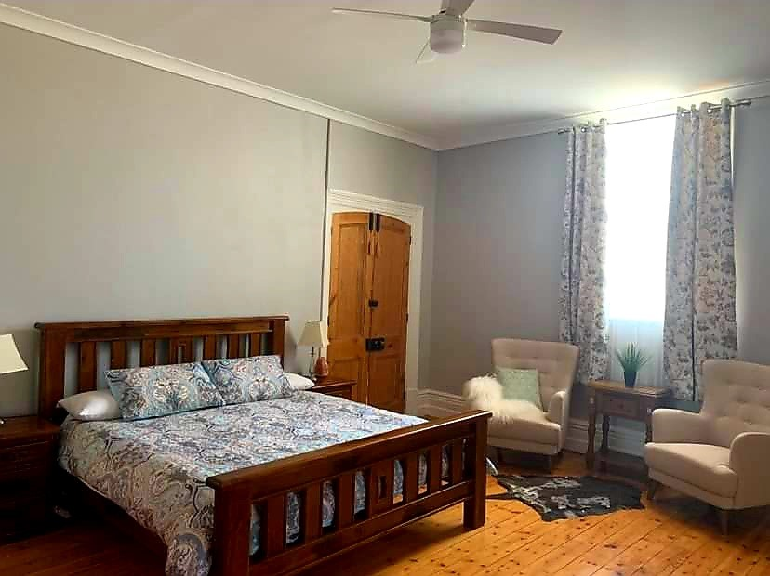
4

Room Amenities
- Lower hanging rails are in wardrobes
- Televisions are equipped with closed captioning capability
- There is contrast between the walls, skirtings, floor and furniture
- There is a clear path through the room
- The edges of all furniture and fixtures are rounded
- Wardrobe handles are a contrasting colour to the doors and draws
- Housekeeping procedures instruct staff not to reposition furniture that has been moved
- Doors open fully against the adjoining wall
- There is a clear opening at least 850mm wide
- There luggage racks for at least two suitcases
- There at least one chair with rigid arms
- Wardrobe and drawer handles are easy to grip
- The bedside lamp switch is easy to reach from the bed
- There is at least 850mm clear space beside the bed
- The bed height is no higher than 680mm from the floor
- The business offers a range of non-allergenic bedding

Bathrooms
The bathrooms have the following facilities/amenities in place
- All heating appliances and hot water pipes are protected or insulated
- All shower, bath and basin taps are clearly differentiated between hot and cold
- The door is at least 850mm wide
- The width beside the toilet is 650mm.
- Handrails are fitted
- There is a minimum of 1400mm of clear space in front of the toilet
- The toilet seat is a contrasting colour to the floor
- The toilet seat is 460mm above the floor
- There is a roll-in shower with fold down fixed seat or a shower chair
  - Bathroom Image(s)
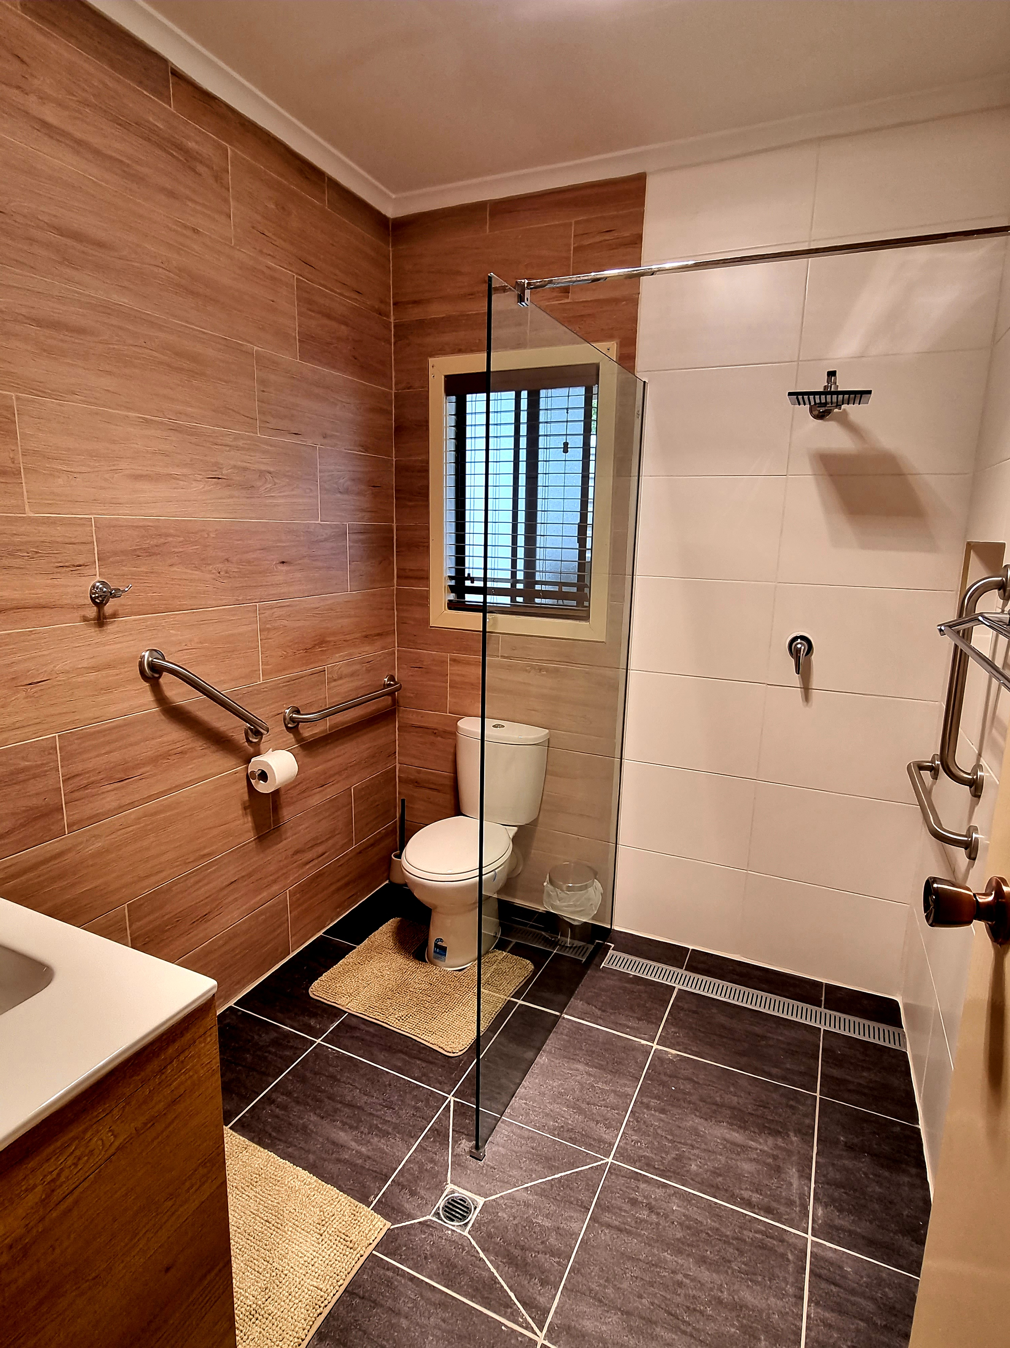
20220323_160008
- In addition, the following further information can assist guests:
We recommend you call to discuss the best accommodation option to best meet your specific needs and we can provide assistance and aids to assist you during your stay. Not applicable to all accommodation options.

COMMON AREAS

FOOD AND DRINK

Dining Spaces
The dining spaces have the following facilities/amenities in place
- The entrance has level access
- The doorway is at least 850mm wide
- Chairs are moveable to allow for wheelchairs to be seated at the tables
- All glass doors and full height windows have contrast markings
- There are areas of full lighting
- There are large print menus
- There are Plain English menus
- There is an accessible toilet

Our business caters for the following dietary requirements
- Sugar free (diabetic)
- Gluten free (celiac)
- Lactose free (dairy free)
- Low fat and fibre with no gastric content
- Low potassium
- Low sodium
- Nut free
- Additive free
- Organic
- Vegetarian
- Vegan
- In addition, the following further information can assist guests:
We have a chef on property and staff have undertaken training with food and safety.
- There is a sample menu available online
Sample menu is available here -
www.mtlittlestation.com.au
  - Food and Beverage Image(s)
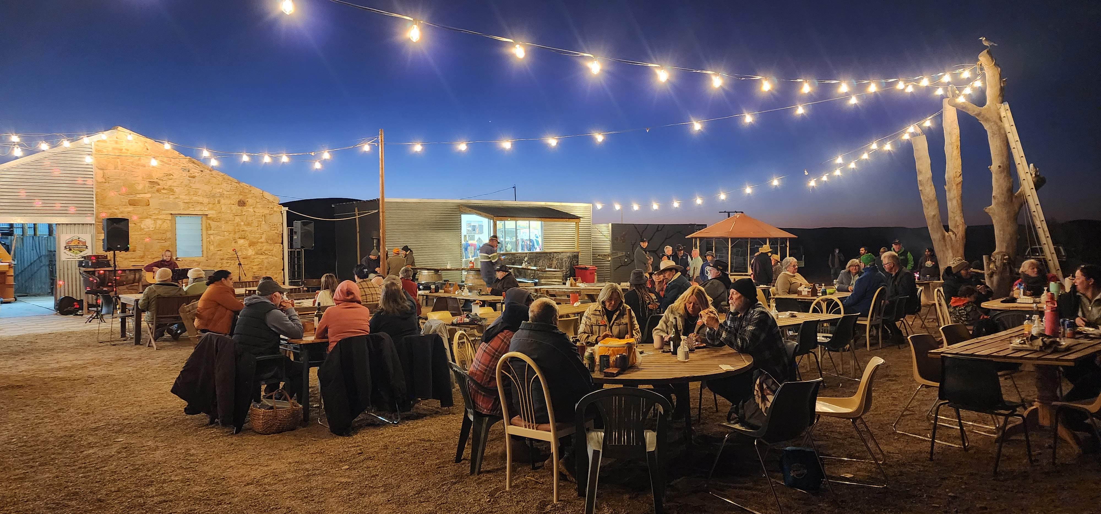
20250521_180830
- In addition, the following further information can assist guests:
The Tavern and Pizza Bar is outdoors with a variety of table and chairs, order station and staff are able to assist guests through the dining experience.

Report Disclaimer
Please note that this business report, provided as a result of the use of the diagnostic assessment, is for information purposes only.
Australian Tourism Industry Council (ATIC) cannot guarantee the accuracy of respondent’s answers, or that they are fully representative of your business. Therefore, ATIC does not warrant or guarantee any particular outcome in respect of your businesses self-assessment.
This report is intended as guidance only for your business and should not be relied on for future marketing considerations. ATIC recommends that you seek your own independent advice as well as the results from the diagnostic.
Links to external web sites are inserted for convenience and do not constitute endorsement of material at those sites, or any associated organisation, product or service.
ATIC does not:
- Assume any legal liability for the accuracy, completeness, or usefulness of any information from this report or any links provided; or
- Accept responsibility for any loss associated directly or indirectly from the use of this report.

