ATIC Accessibility
To support the accessible community in making informed travel decisions for their individual needs

This report prepared for:
Business name: | Spinifex Brewery Cable Beach
Address: | 7 Sanctuary Road
Town: | Broome
Contact for enquiries: | Leanne Andrews
Contact Number: | 61540866
Contact Email: | admin@spinifexbrewery.com.au
Website: | https://www.spinifexbrewery.com.au/cable-beach
Date: | 2026-10-06 05:39

ATIC Accessibility
The following pages provides travellers with information on the businesses facilities and amenities which aims to support the traveller to make an informed decision on whether the business is suitable for their individual needs.
OVERVIEW 4
Business Overview 4
Bookings 4
Emergency Management 5
Communications 5
Other Information 6
Guide Dog and Service Animals 7
GENERAL 8
Pre-arrival, arrival and reception 8
Cognitive Impairment Support 8
Car Park and Access amenities 8
Entry 8
Internal Spaces 9
Public areas 9
Displays, exhibits, commentary and live performances 9
External Paths 10
Steps 10
Ramps 10
Public Toilets/Adult change facilities 10
ATTRACTIONS 12
Zoos and Wildlife Parks 12
COMMON AREAS 13
Play Spaces 13
FOOD AND DRINK 16
Dining Spaces 16
EVENTS 18
Events 18
Report Disclaimer 20

OVERVIEW

Business Overview

The business has the following products/services available
- Attraction
- Food and Drink
- Event

Our business caters for the following disability types:
- Blind or low vision
- Deaf or low hearing
- Limited mobility
- Wheelchairs or mobility scooters
- Food allergies or intolerances
- Cognitive or people on the Autism Spectrum
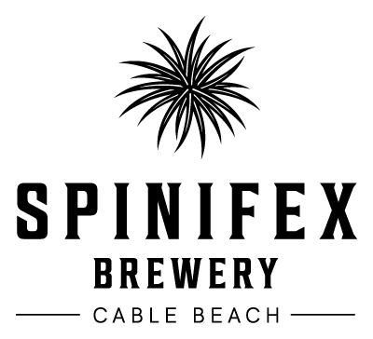

Bookings

The business offers the following methods for bookings and enquiries:
- Phone
- Email
- Webportal
- Our website supports Screen Readers
- Our forms have high contract boxes and submit boxes
- Staff have undergone disability awareness and training

Emergency Management

Emergency and evacuation procedures a prominently displayed around the venue. Staff can assist with queries but as there is no host or table service at the venue there is no method of individually briefing every patron at the venue.
- There are Audible device/s to alert occupants to evacuate with instructions on how to evacuate.
- There are visual device/s to alert occupants to evacuate.
- Exit signs are clear and easy to see
- Exit access is free and clear at all times
We ensure exit access is free and clear at all times by:
There are three emergency access points which remain free, unlocked and clear at all times. There is no furniture obstructing the gates and there is no car parking or loading bays in front or behind these bays.
- Exits and access to exists are greater than 900mm
- Exit doors are able to be opened by all occupants
- Exits to the emergency evacuation point does not include stairways
- The evacuation point is clearly marked by a sign
- In addition, the following further information can assist guests:
Staff are made aware of any patron requiring assistance upon entrance to the venue. During an evacuation, these customers will be prioritised first to ensure they can evacuate safely.
- In addition, the following further information can assist guests:
Assess the situation, engage trained staff, provide immediete assistance, contact emergency services (if required), keep the patron comfortable, incident reporting
- Guests with disabilities are noted in the guest log book for emergency and evacuation purposes

Communications
- Our business offers the following alternative communication methods
- Plain English

Spinifex Brewery is currently undertaking a review of the website and has received a report on suggested improvements to meet WCAG 2 guidelines. This process is underway.
- There is easy to read signage and information (e.g. menus and emergency information)
- There is a Pictorial menu
  - Pictorial Menu Image(s)
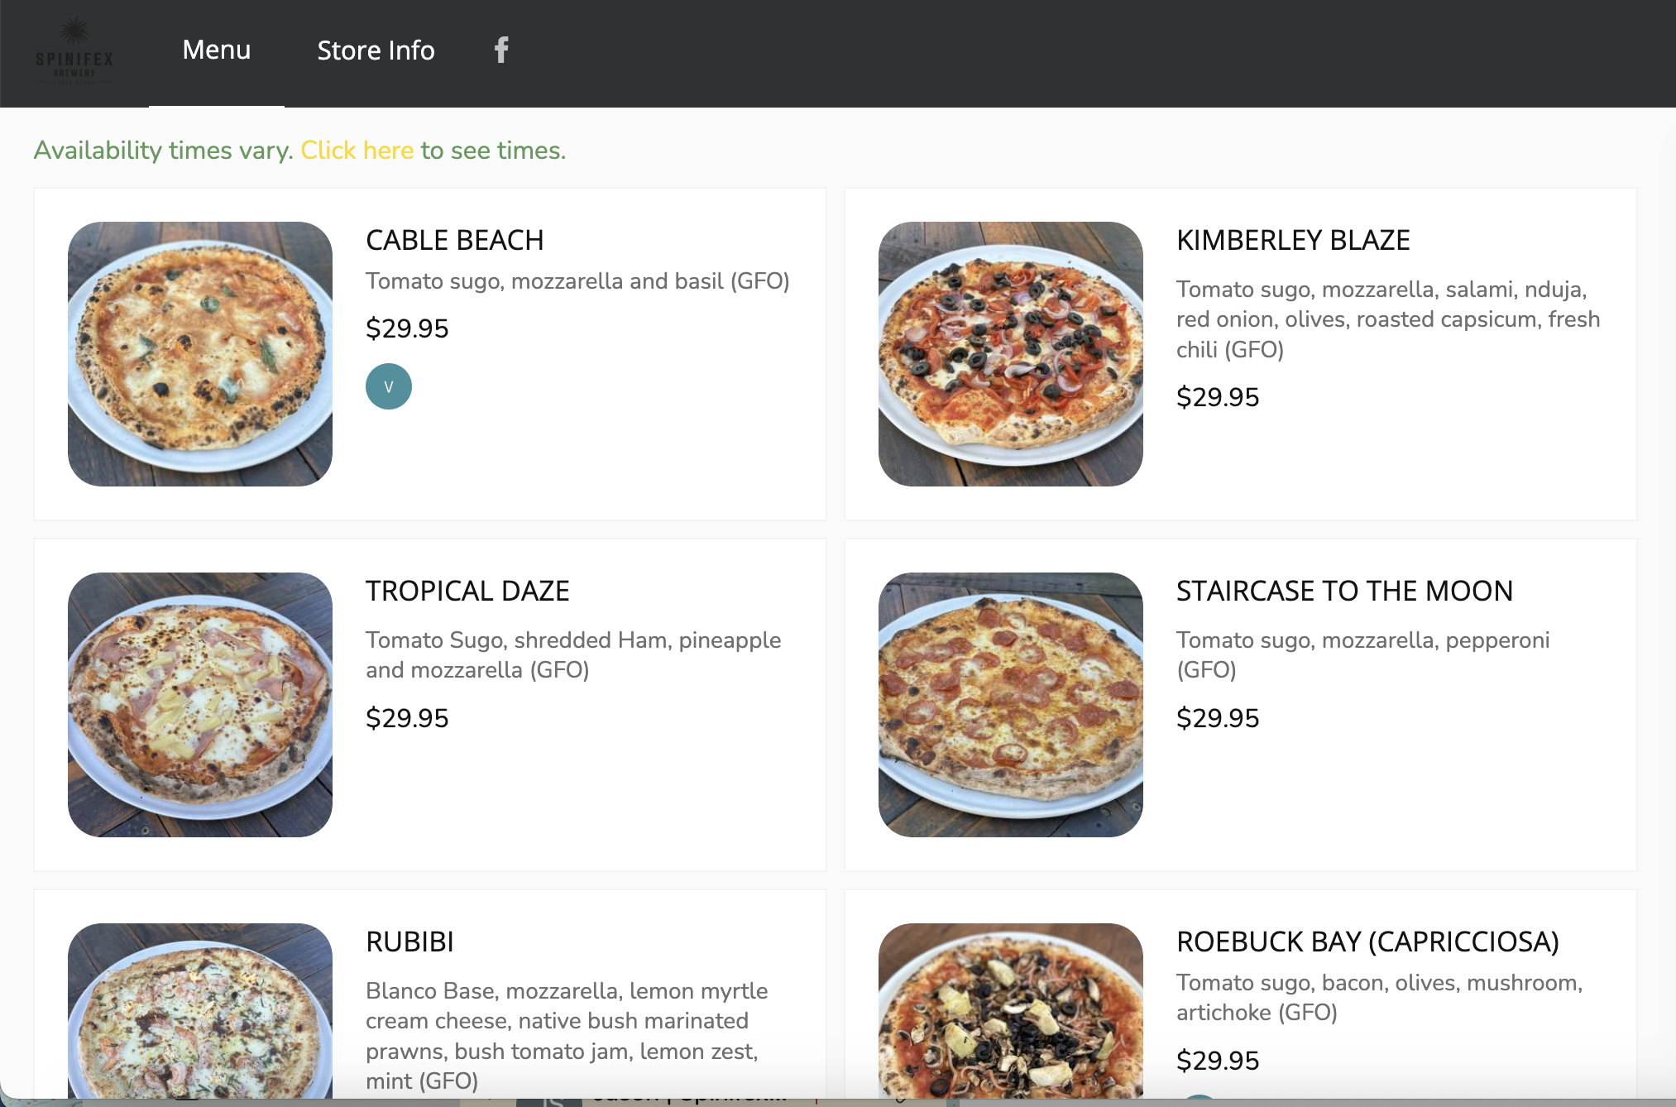
Spinifex Cable Beach_Pictorial Menu Screengrab
- There are Picture boards
  - Picture Boards Image(s)
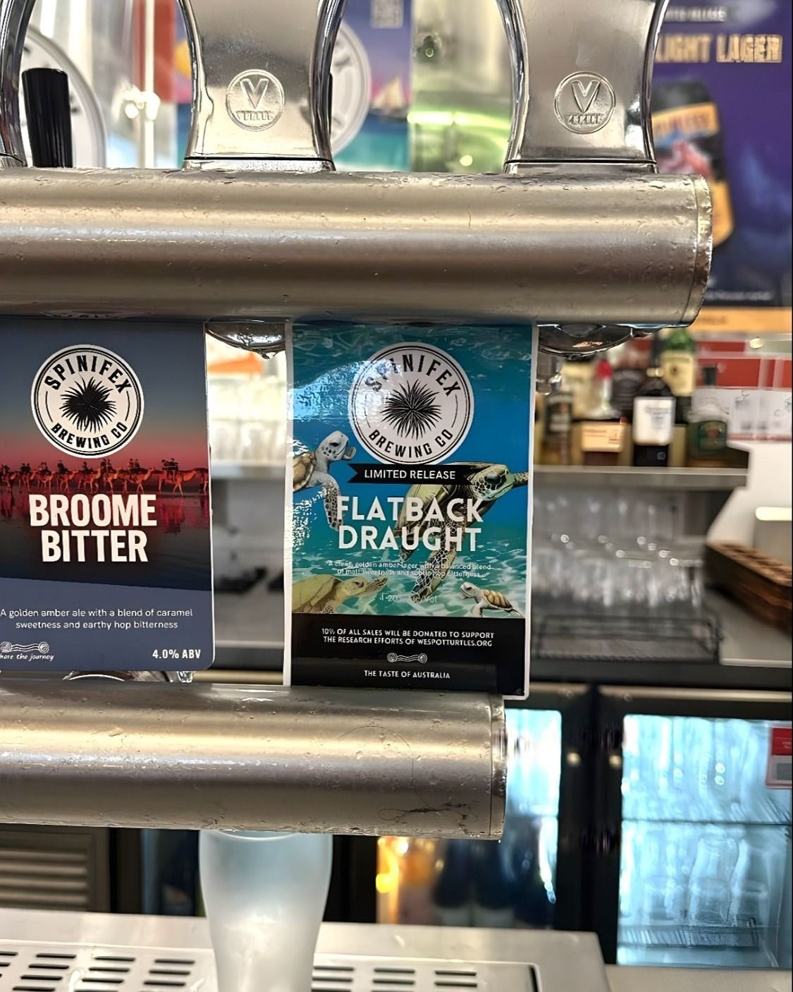
Tap Decals

Other Information
- For bookings made onsite, the ticket booth/counter/box office is accessible for people using a wheelchair

Guide Dog and Service Animals
- The business provides a secure area with shade and water for service animals
- The business provides a toilet area for service animals
- Bowls, bedding, etc. are provided for service animals
The business provides the following services for services animals:
The venue is dog-friendly and has a dedicated shaded area with water. This section is also accessible for those requiring mobility aids

GENERAL

Pre-arrival, arrival and reception
The business has the following in place to support guests during pre-arrival, arrival and reception
- Booking information and websites are compatible with screen readers
- Information and maps are available in written form
- A step free map/guide
- In addition, the following further information can assist guests:
Spinifex is able to offer priority seating for individuals with disabilities, including those with fatigue-related conditions. The main brewery space is climate-controlled (temperature-regulated) to prevent exhaustion. Spinifex also trains employees to recognise fatigue-related disabilities and are able to accommodate requests without requiring extensive explanations.

Cognitive Impairment Support
- Documents are available in plain English for people with cognitive impairment (This may include instructions, guides, menus and general information)
- Quiet periods or early opening times for people on the Autism Spectrum

Car Park and Access amenities
The business has the following Car Park and Access amenities
- A drop off zone
- Designated disabled parking bays
- Level or ramped access from the car park to the entrance
- The accessible entrance is clearly signed from the parking bay
- Kerb ramps are in place where a pavement or walkway needs to be crossed

Entry
The business has the following amenities/systems in place for entry
- A drop off point close to the entrance
- A path of access to the building is slip resistance and even
- A path of access to the building is clear of obstruction
- Self opening entry doors or fitted with a self closer
- Glass doors are fitted with a visual sighting strip
- Door jams/doors are of a contrasting colour to surrounding walls
- Door handles are of a contrasting colour to the door
- Signage is written in a contrasting colour
- Signage is written in a Sans Serif font and use upper and lower case letters
- The entry door is a minimum of 850mm wide
- The entry door has self opening or a light opening pressure (for manual operations)
- The entrance sill is less than 13mm
- There a clear space of at least 1500mm x 1500mm in front of all doors.
- In addition, the following further information can assist guests:
Spinifex Brewery is single-storey, no lifts are required as the venue is completely wheelchair accessible.

Internal Spaces
- Clear and unobstructed routes through and between buildings
- Interior walls are matte or low sheen
- Floors, walls, counters and furniture are of contrasting colours
- Menus are available in large print or Braille
- Tableware/glassware contrast with the table surface or table cloth
- Floor surfaces are hard or short pile carpet
- Seating is available for guests unable to stand for long periods
- Accessible facilities are clearly signed and visible from all areas
- All corridors greater than 900mm

Public areas
The public areas have the following amenities in place
- Display units, Televisions, Video displays etc. are open captioned
- Even lighting
- Seating

Displays, exhibits, commentary and live performances
For displays, exhibits, commentary and live performances the following amenities are in place
- Seating
- Wheelchair accessible spaces/seating
- A written transcript where audio description is provided i.e. display commentary, tour commentary

External Paths
External paths of travel
- Surfaces are concrete, asphalt, smooth paving or hard packed fine gravel (max aggregate size 13mm)
- Pathways are wider than 900mm
- Any paths having steps are clearly identified as non-wheelchair accessible
- Step free routes clearly signed

Steps
Steps
- There are steps.
- Top and bottom steps are easily distinguished through colour contrast or the use of TGSIs (Tactile Ground Surface Indicators)
- All steps or staircases have enclosed risers
- The underside of all staircases are enclosed or protected to a height of at least 2 metres
- Handrails fitted to all open sets of steps
- Handrails extend 300mm beyond the top and bottom step
- Where steps are present are there three steps or less

Ramps
Ramps have the following amenities are in place
- There are ramps.
- All fixed ramps are 1:14 or less
- Hand rails are fitted
- Long ramps (more than 10m) are 1:20 or less
- Ramps have a raised edge of at least 100mm

Public Toilets/Adult change facilities
Public Toilets/Adult change facilities have the following amenities are in place
- There is an accessible toilet for public use
- The door is at least 850mm wide
- There is a minimum of 850mm beside the toilet
- Handrails are fitted
- The toilet seat is 460mm above the floor
- There is 3300mm mm of clear space in front of the toilet
- The toilet seat of a contrasting colour to the floor
- The toilet seat is460mm above the floor
- A facility with an adult change table

ATTRACTIONS

Zoos and Wildlife Parks
- In addition, the following further information can assist guests:
The venue is dog-friendly and has a dedicated shaded area with water. This section is also accessible for those requiring mobility aids.
- A secure area with shade and water for service dogs is available
  - Image(s)
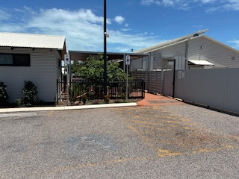
IMG_2314
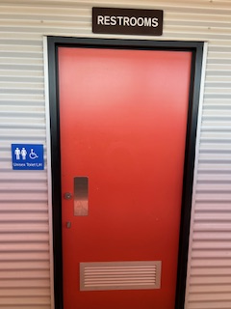
IMG_2316
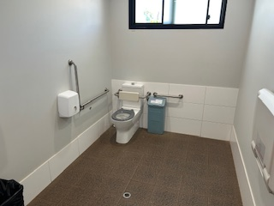
IMG_2317
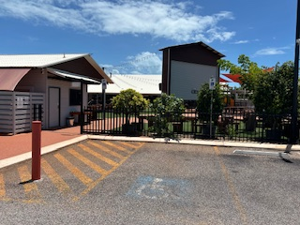
IMG_2321

COMMON AREAS

Play Spaces
- Level access is provided to play spaces
- Ramps provided are at least 25% of elevated sections of the play space
- There wheelchair accessible activities
- The play space contains cognitive play panels
- The play space contains tactile play panels or activities
- The space contain colour contrasting elements
- Seating is provided in or around the play space
  - Image(s)
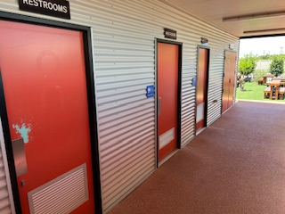
IMG_2315
IMG_2316
IMG_2317
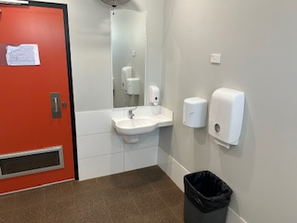
IMG_2318
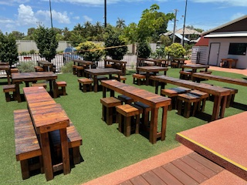
IMG_2319
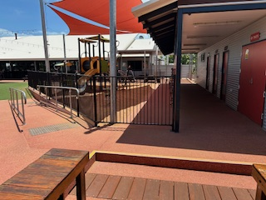
IMG_2320
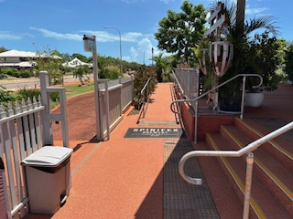
IMG_2322
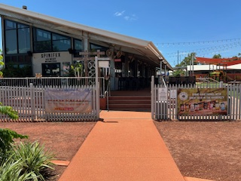
IMG_2323
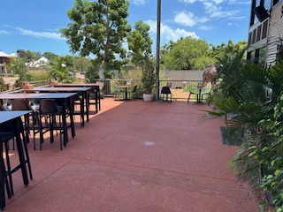
IMG_2324
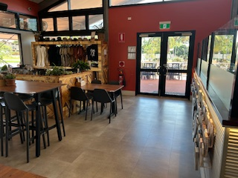
IMG_2327
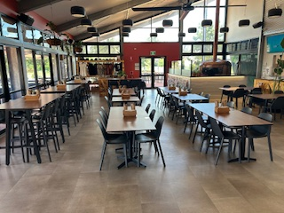
IMG_2328
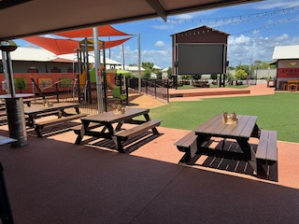
IMG_2332
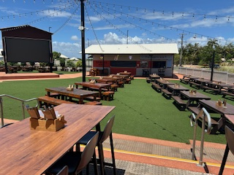
IMG_2333

FOOD AND DRINK

Dining Spaces
The dining spaces have the following facilities/amenities in place
- The entrance has level access
- The doorway is at least 850mm wide
- There is level access through the dining area
- Chairs are moveable to allow for wheelchairs to be seated at the tables
- All glass doors and full height windows have contrast markings
- There are areas of full lighting
- There are large print menus
- There are Plain English menus
- There is an accessible toilet

Our business caters for the following dietary requirements
- Sugar free (diabetic)
- Gluten free (celiac)
- Lactose free (dairy free)
- Low fat and fibre with no gastric content
- Low potassium
- Low sodium
- Nut free
- Additive free
- Vegetarian
- Vegan
- Kosher
- Halal
- In addition, the following further information can assist guests:
1. Promoting personal hygiene including:HandwashingUniform &amp; Hair restraintsNo jewellery or nail polish (in the kitchen)2. Enforcing the separation of food types, including:Use Color-Coded Cutting Boards &amp; UtensilsSeparate Storage3. Regular cleaning and sanitation of surfaces

- There is a sample menu available online
Sample menu is available here -
https://spinifexbrewery.com.au/cable-beach/
  - Food and Beverage Image(s)
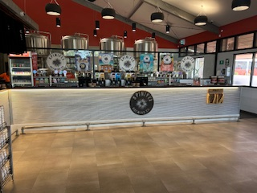
IMG_2310
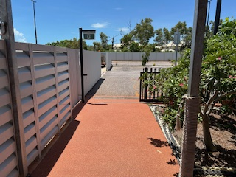
IMG_2313
IMG_2322
IMG_2323
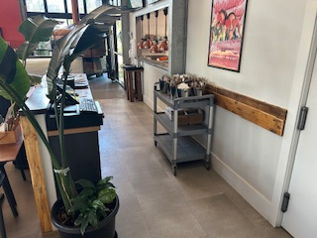
IMG_2330
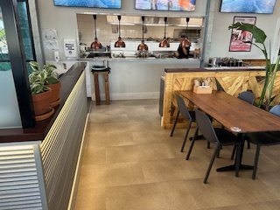
IMG_2331

EVENTS

Events
Events have the following facilities/amenities in place
- There is step free access throughout the venue
- Reception, registration desks or ticket offices have a lower counter section
- All ancillary areas are step free e.g. breakout rooms, dining areas, outside areas and exhibition spaces
- All stage areas including speaker platforms are accessible
- Accessible toilets are available at the venue
- There is clear signage throughout the venue including accessible routes and accessible facilities
- Wheelchair designated seating is provided
- We cater for a range of seating and viewing options
- We cater for varying group sizes
- Our event can be booked from the main web site
- All presentations are captioned
- Live captioning is provided
- Audio description is available
- There is good circulation space with the number of people expected to allow people with a disability to move around freely
- Food and water is available for guide and service animals
- The event is outdoors
- Portable accessible toilets are available
- Seating is at regular intervals
- Grassed areas are covered with a hard surface
- Side shows, activities etc. are accessible
- Accessible car parking is available
- There are designated drop-off points

Report Disclaimer
Please note that this business report, provided as a result of the use of the diagnostic assessment, is for information purposes only.
Australian Tourism Industry Council (ATIC) cannot guarantee the accuracy of respondent’s answers, or that they are fully representative of your business. Therefore, ATIC does not warrant or guarantee any particular outcome in respect of your businesses self-assessment.
This report is intended as guidance only for your business and should not be relied on for future marketing considerations. ATIC recommends that you seek your own independent advice as well as the results from the diagnostic.
Links to external web sites are inserted for convenience and do not constitute endorsement of material at those sites, or any associated organisation, product or service.
ATIC does not:
- Assume any legal liability for the accuracy, completeness, or usefulness of any information from this report or any links provided; or
- Accept responsibility for any loss associated directly or indirectly from the use of this report.

