ATIC Accessibility
To support the accessible community in making informed travel decisions for their individual needs

This report prepared for:
Business name: | Ocean Dream Charters
Address: | Unit 8
Town: | O'Connor
Contact for enquiries: | Hannah Halsey
Contact Number: | 08 6111 1456
Contact Email: | info@oceandreamcharters.com.au
Website: | www.oceandreamcharters.com.au
Date: | 2026-10-12 05:47

ATIC Accessibility
The following pages provides travellers with information on the businesses facilities and amenities which aims to support the traveller to make an informed decision on whether the business is suitable for their individual needs.
OVERVIEW 4
Business Overview 4
Bookings 4
Emergency Management 4
Guide Dog and Service Animals 5
GENERAL 6
Pre-arrival, arrival and reception 6
Displays, exhibits, commentary and live performances 6
External Paths 6
Steps 6
TOUR OPERATORS 8
Tour/Transport Services 8
Route Planning 8
Guides 8
ACCOMMODATION 9
Room Amenities 9
Bathrooms 9
COMMON AREAS 11
Swimming pools, spas and waterparks 11
FOOD AND DRINK 12
Dining Spaces 12
ADVENTURE ACTIVITIES 14
Report Disclaimer 16

OVERVIEW

Business Overview

The business has the following products/services available
- Tour/Transport
- Accommodation
- Food and Drink
- Adventure

Our business caters for the following disability types:
- Food allergies or intolerances

Bookings

The business offers the following methods for bookings and enquiries:
- Phone
- Email
- Staff have undergone disability awareness and training

Emergency Management
- Emergency and evacuation procedures are explained on arrival
- Exit doors are able to be opened by all occupants
- In addition, the following further information can assist guests:
Via our onboard manifest and documentation and guest name badges.
- In addition, the following further information can assist guests:
Multiple evacuation procedures are outlined in our SMS (onboard safety management system)
- Guests with disabilities are noted in the guest log book for emergency and evacuation purposes

Guide Dog and Service Animals
The business provides the following services for services animals:
Not specified

GENERAL

Pre-arrival, arrival and reception
The business has the following in place to support guests during pre-arrival, arrival and reception
- Information and maps are available in written form
- A familiarisation tour
- Luggage assistance
- In addition, the following further information can assist guests:
Shade, water and meals are provided in circumstances where long wait times and fatigue may occur. Ocean Dream considers all transfer times carefully to reduce wait times.

Displays, exhibits, commentary and live performances
For displays, exhibits, commentary and live performances the following amenities are in place
- Seating

External Paths
External paths of travel
- Paths or slopes longer than 15 metres have resting places or seats
The width of the smallest pathway is:
880mm
- In addition, the following further information can assist guests:
Vessel has stairs to the upper and lower decks, including boarding to tenders for excursions.

Steps
Steps
- There are steps.
- All steps or staircases have enclosed risers
- The underside of all staircases are enclosed or protected to a height of at least 2 metres
- Handrails fitted to all open sets of steps
- In addition, the following further information can assist guests:
Handrails extend 300mm beyond at the top but not the bottom stairs.
- The door is 560mm wide

TOUR OPERATORS

Tour/Transport Services
The tour/transport services have the following facilities/amenities in place
- Buses/Coaches
- 0 vehicles have wheelchair lifts or ramps
- 0 vehicles have low floors with ramped entry
The maximum wheelchair capacity available in the fleet is:
0

Route Planning
- Route Planning
- Overnight Stops
The total number of wheelchair passengers that can be catered for at overnight stops are:
0
- Walking Tours
- Multi-paced to account for slower walkers

Guides

Guides have been trained in the following
- Use of clear/simple English
- Marine
- Accessibility is tide dependent
- In addition, the following further information can assist guests:
Horizontal Waterfalls
Mitchell Plateau Scenic Helicopter Flights - Heli Spirit

ACCOMMODATION

Room Amenities
- Televisions are equipped with closed captioning capability
- There is a clear path through the room
- The edges of all furniture and fixtures are rounded
- Wardrobe handles are a contrasting colour to the doors and draws
- Housekeeping procedures instruct staff not to reposition furniture that has been moved
- Openings are a minimum of 560mm wide
- The bedside lamp switch is easy to reach from the bed

Bathrooms
The bathrooms have the following facilities/amenities in place
- All heating appliances and hot water pipes are protected or insulated
- All shower, bath and basin taps are clearly differentiated between hot and cold
- The width of the door is 560mm.
- The width beside the toilet is Various.
- There is Various mm of clear space in front of the toilet
- The toilet seat is 460mm above the floor
- There is a portable shower head on flexible hose
- A door is fitted to the shower
  - Bathroom Image(s)
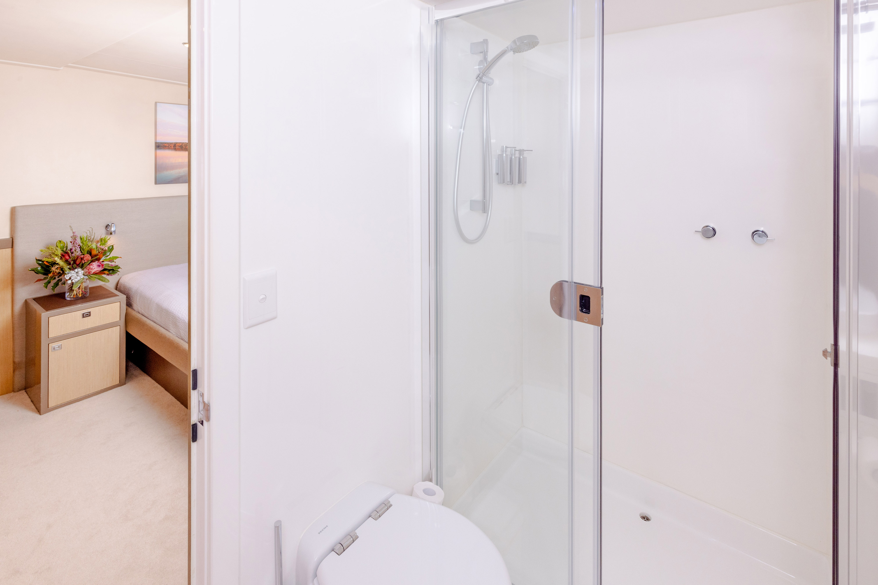
Ocean Dream - Shower & toilet example
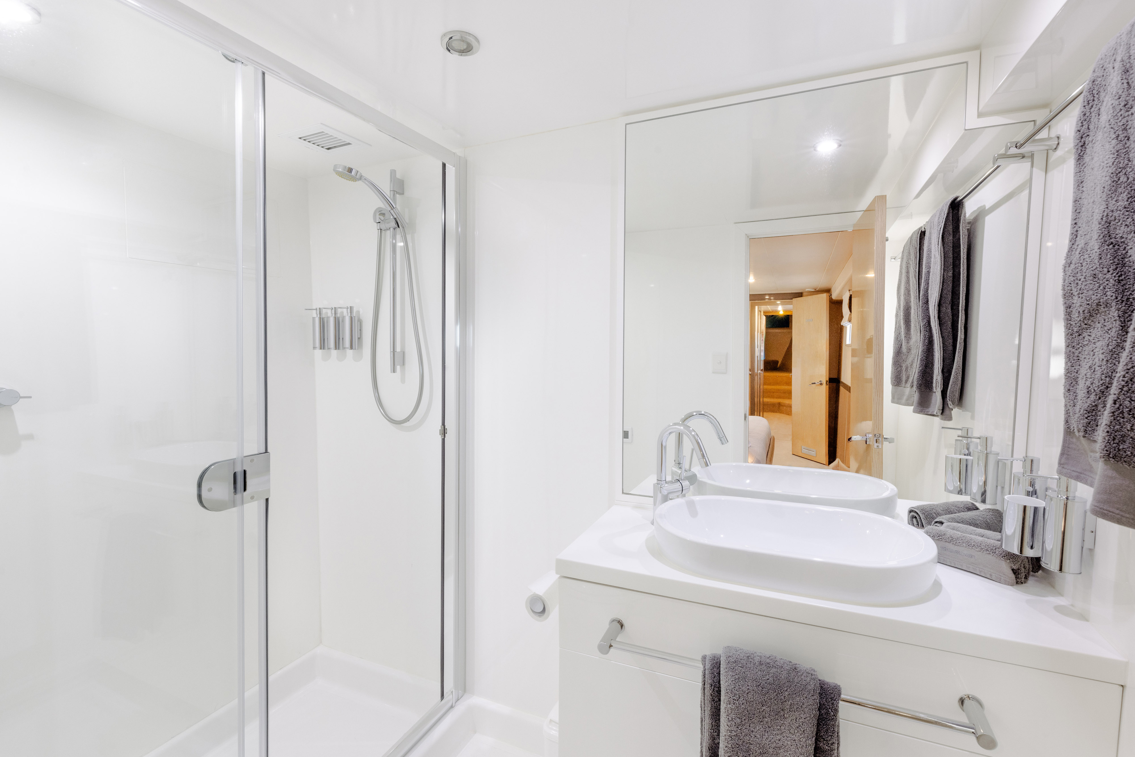
Ocean Dream - Shower example
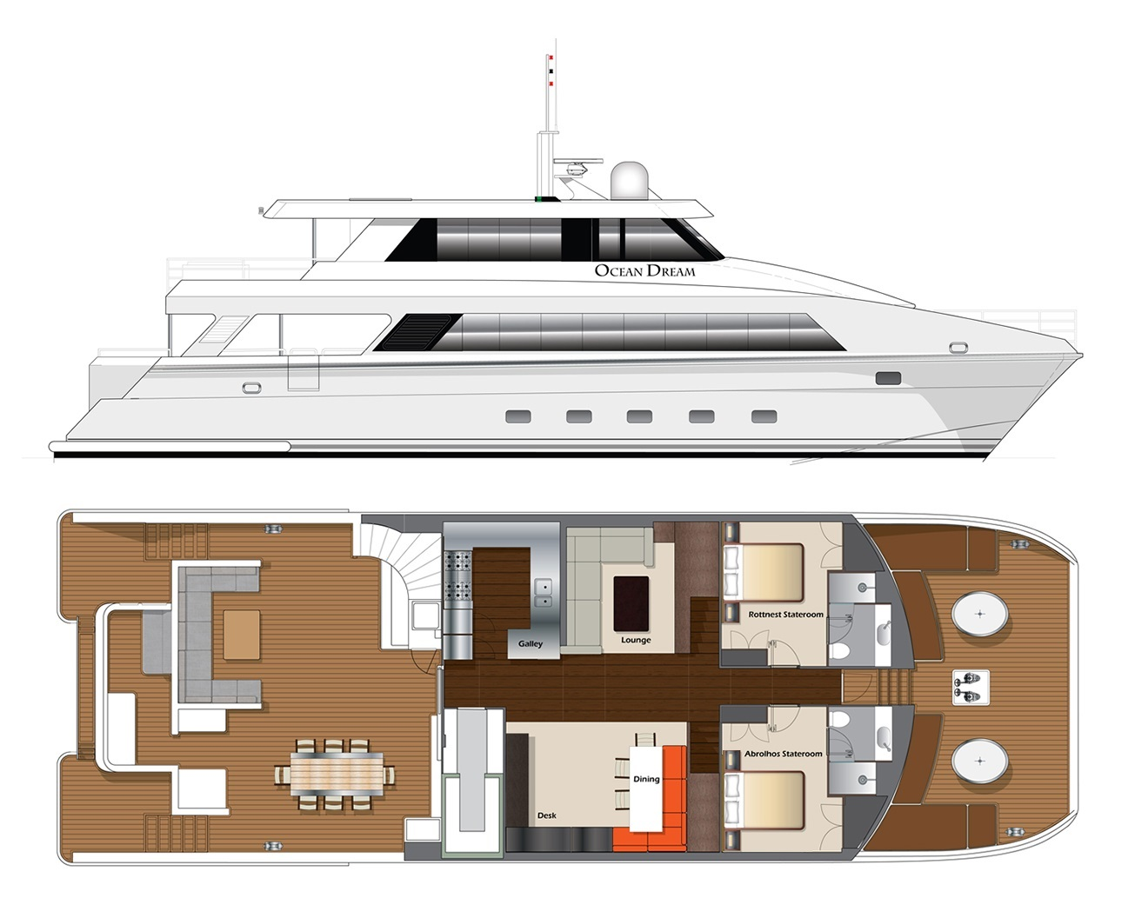
Main_Deck - Revised Abrohlos Queen
- In addition, the following further information can assist guests:
Accessibility is not available in our ensuites. Images attached to show this.

COMMON AREAS

Swimming pools, spas and waterparks
- The following swimming pools, spas and waterparks amenities are available
- Unisex change facilities with an accessible toilet

FOOD AND DRINK

Dining Spaces
The dining spaces have the following facilities/amenities in place
- The entrance has level access
- The doorway is at least 850mm wide
- There is level access through the dining area
- Chairs are moveable to allow for wheelchairs to be seated at the tables
- There are areas of full lighting

Our business caters for the following dietary requirements
- Sugar free (diabetic)
- Gluten free (celiac)
- Lactose free (dairy free)
- Low fat and fibre with no gastric content
- Low potassium
- Low sodium
- Nut free
- Additive free
- Vegetarian
- Vegan
- Kosher
- Halal
- In addition, the following further information can assist guests:
1. Dietary Requirements: Ensure all guests' dietary restrictions and allergies are clearly and visibly posted in the galley at all times.2. Cross-Contamination Prevention: Maintain strict separation between raw and cooked foods.3. Dedicated Equipment: Use separate cutting boards and utensils for different food types (e.g., meat, fish, vegetables).4. General Hygiene: Implement continuous and thorough food hygiene measures, including frequent and thorough washing of hands and all surfaces with hot, soapy water.

- There is a sample menu available online
Sample menu is available here -
https://oceandreamcharters.com.au/gourmet-meals/
  - Food and Beverage Image(s)
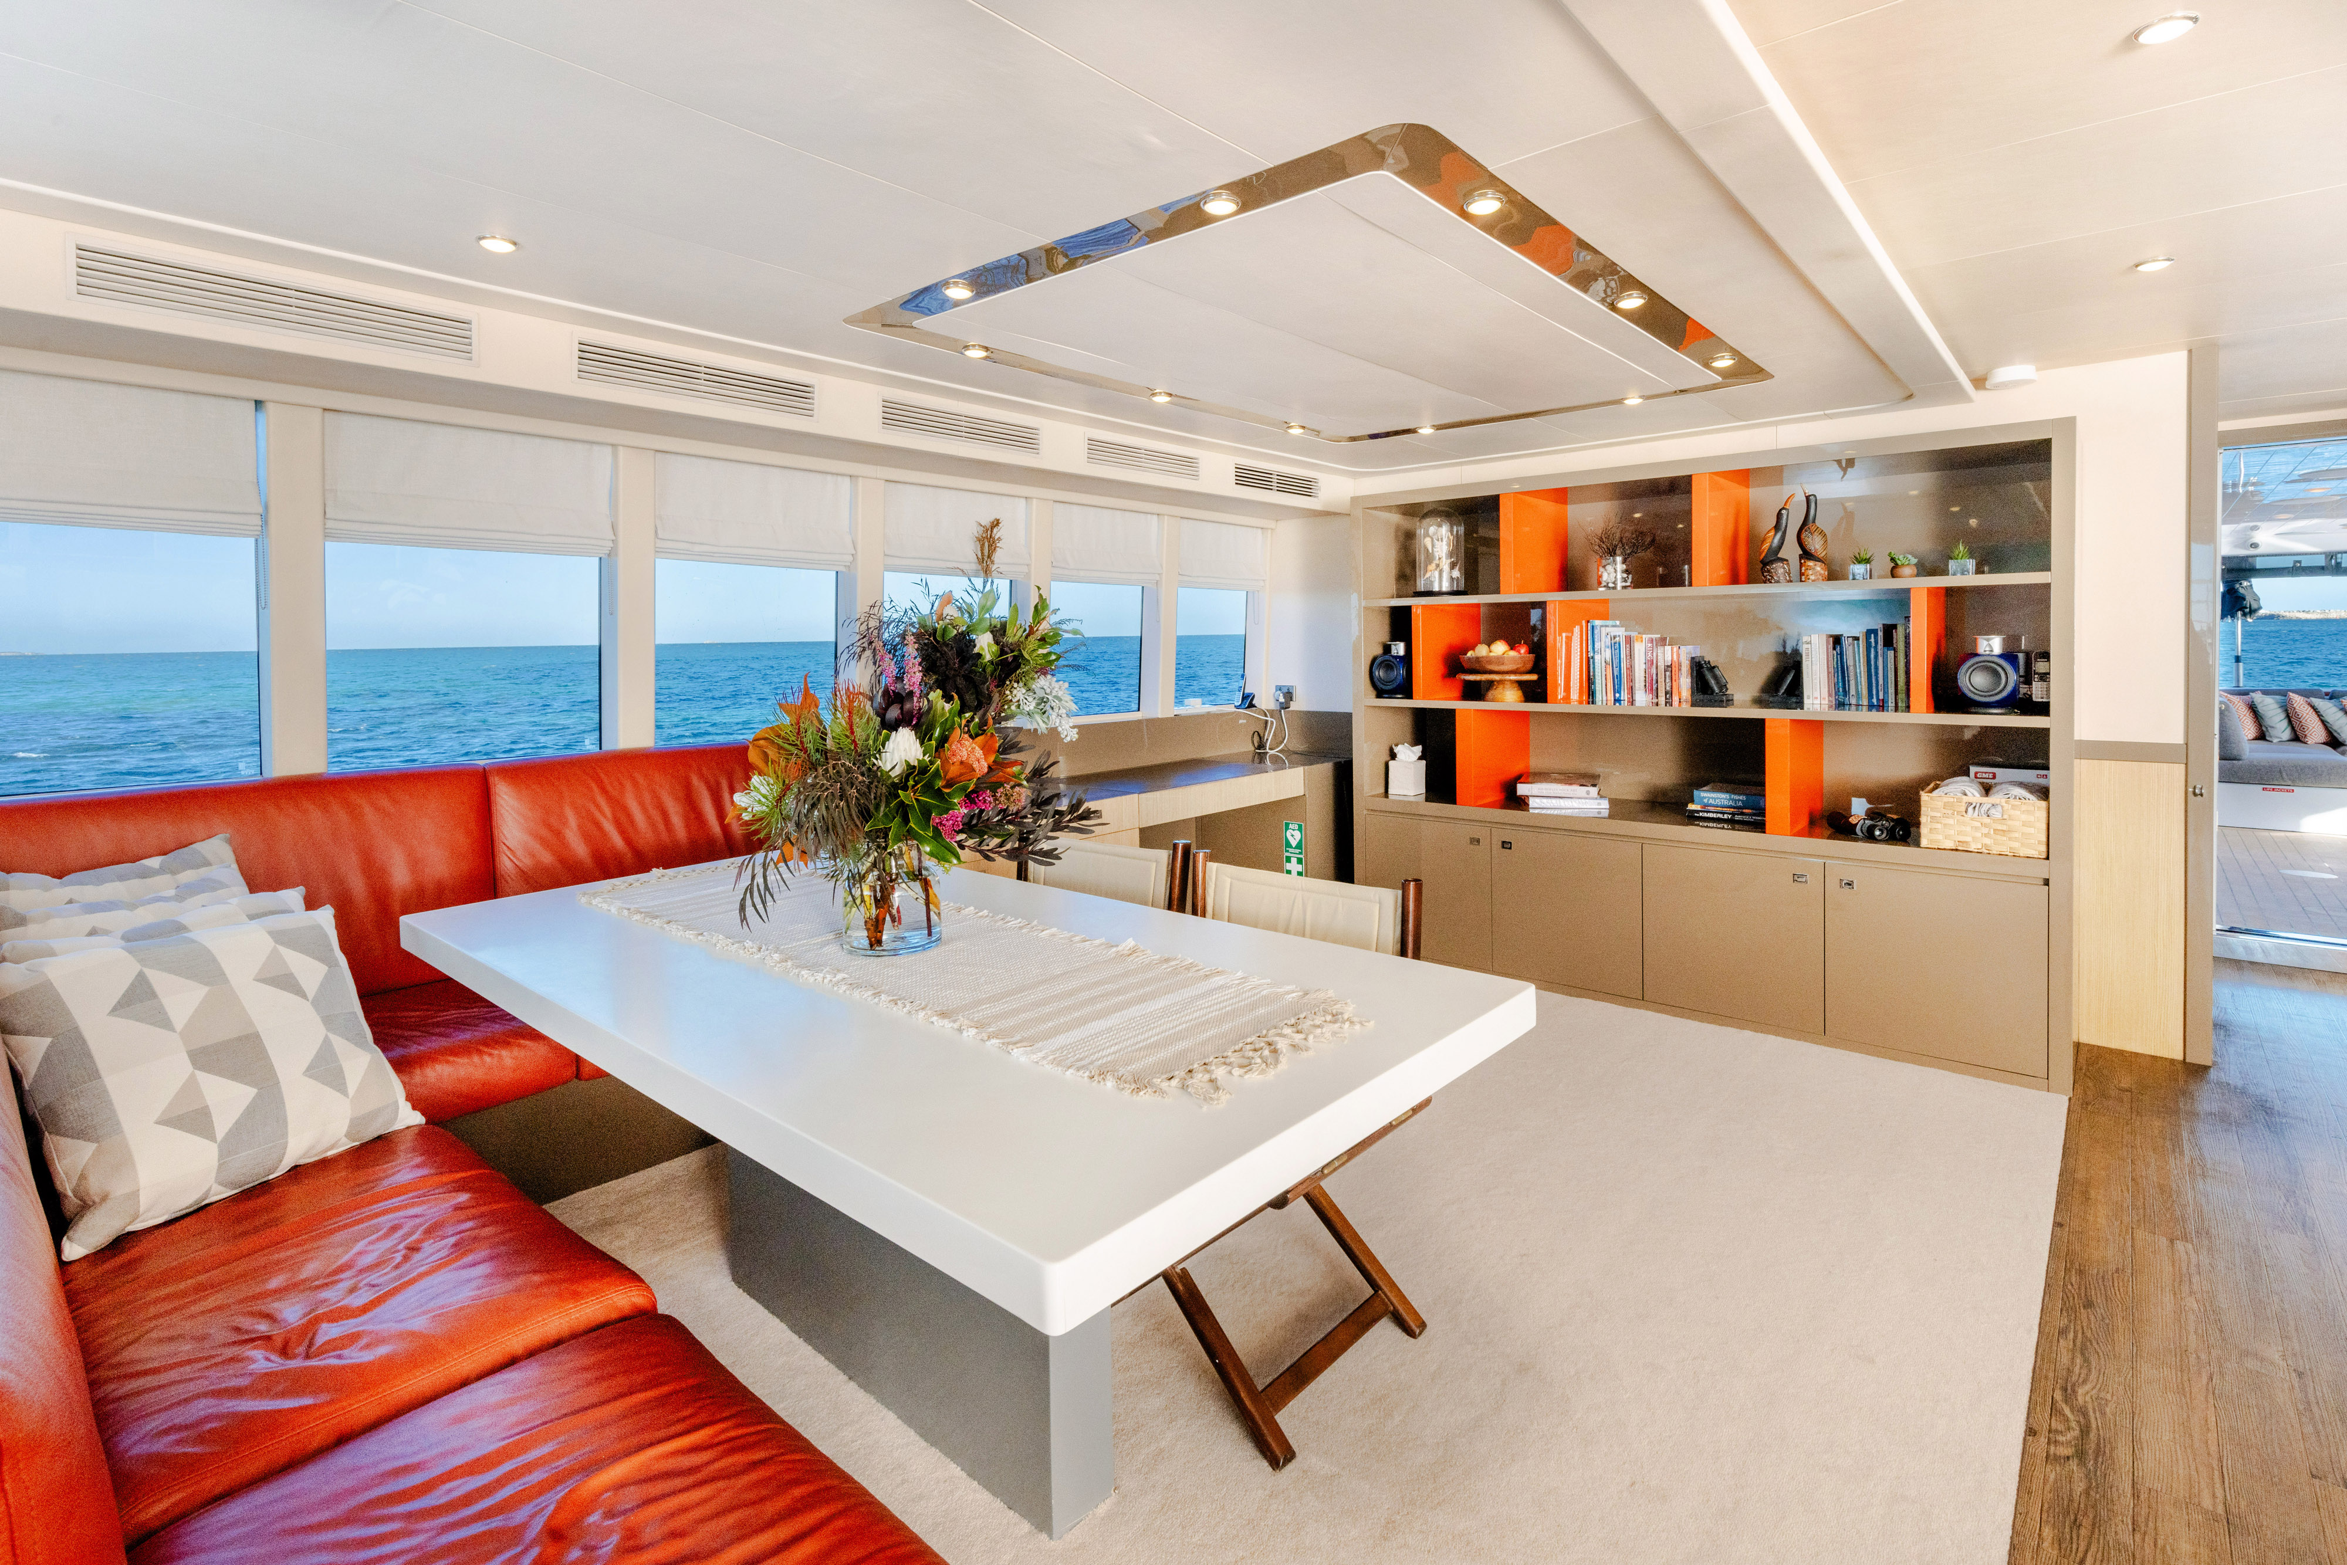
3. Ocean Dream Inside Dining
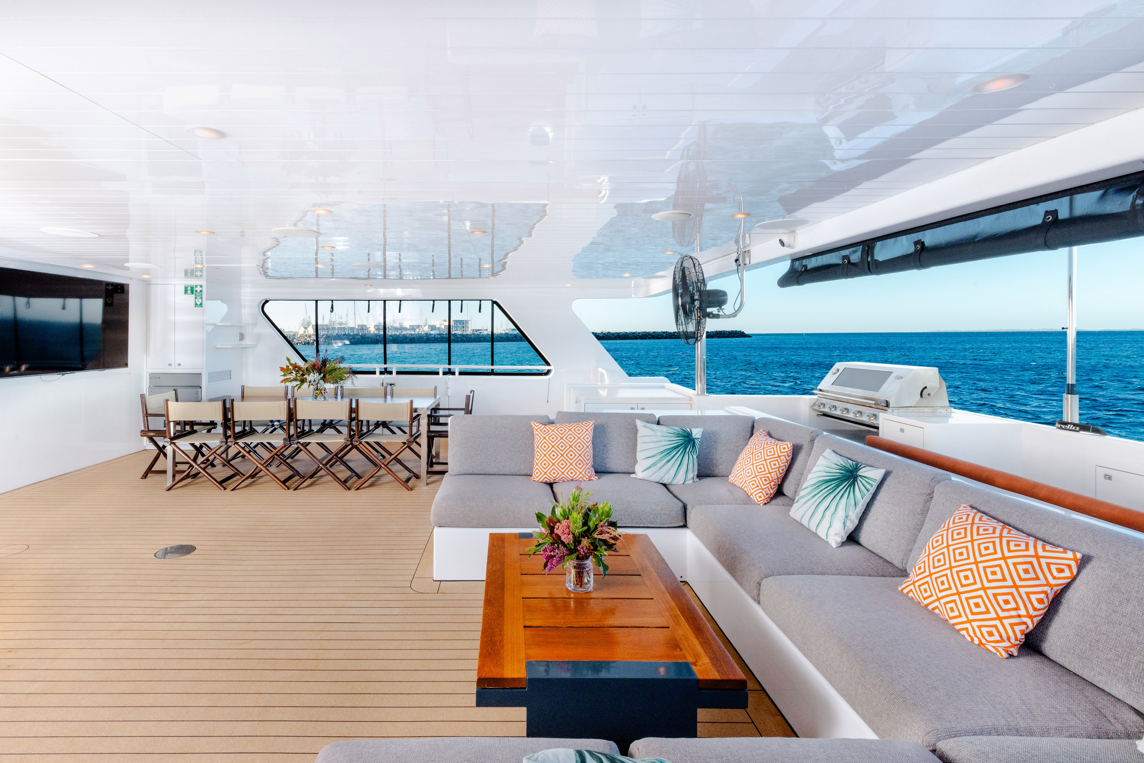
5. Ocean Dream Rear Entertaining Deck
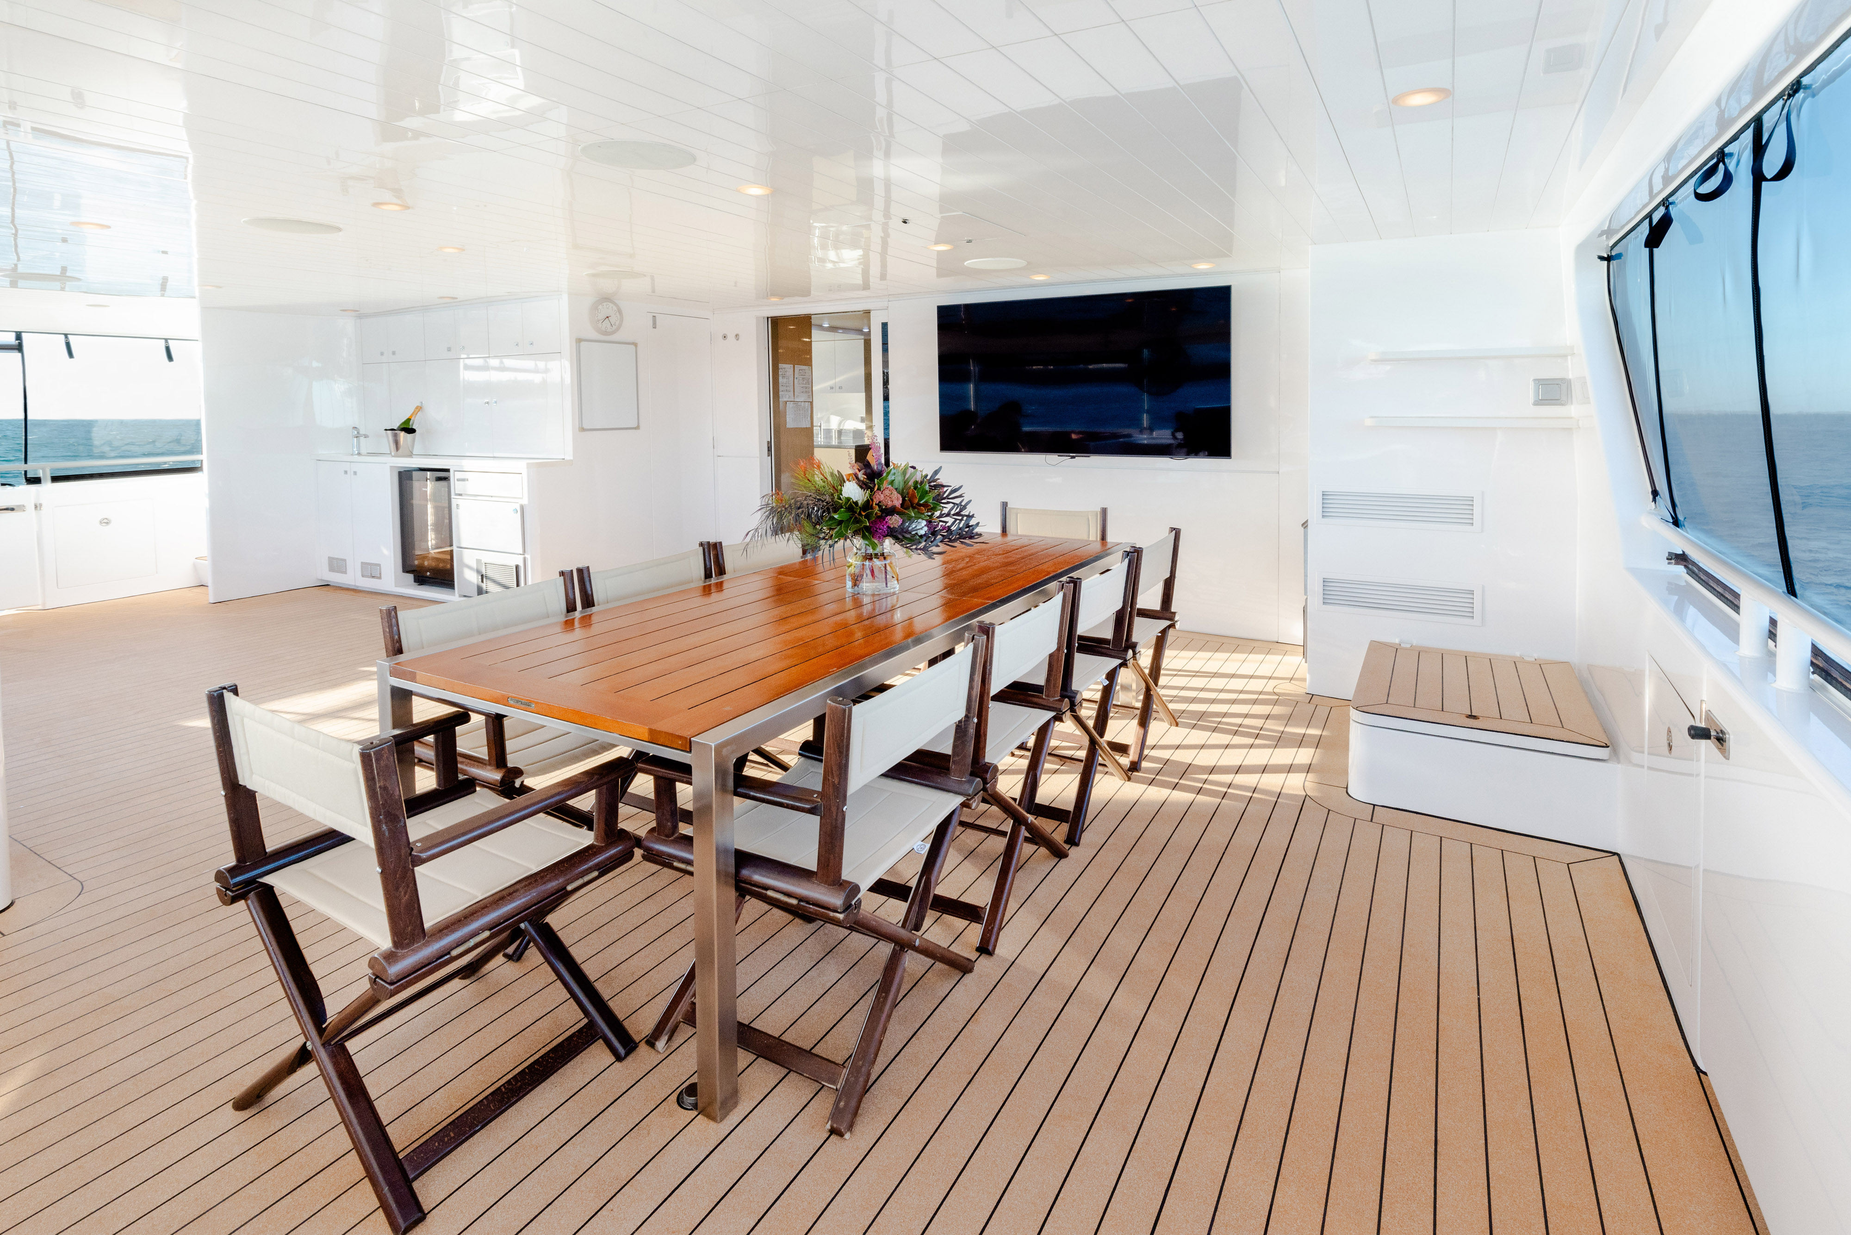
6. Ocean Dream Rear Entertaining Alfresco
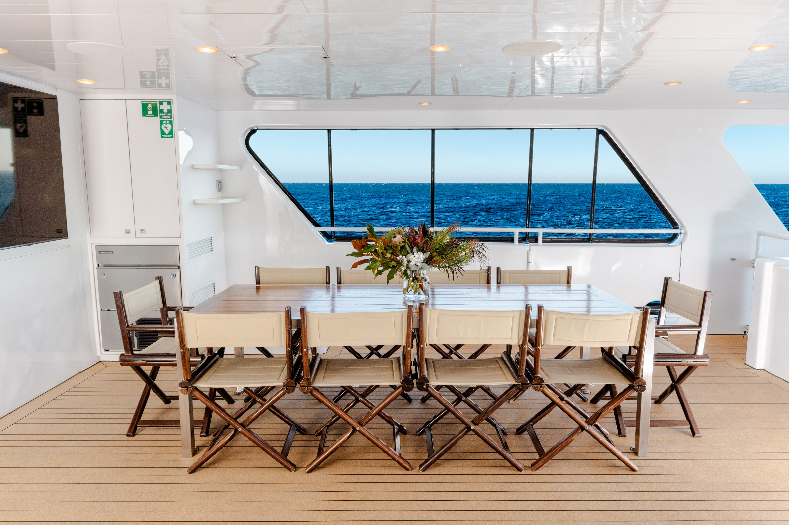
4. Ocean Dream Alfresco Dining Table

ADVENTURE ACTIVITIES

Report Disclaimer
Please note that this business report, provided as a result of the use of the diagnostic assessment, is for information purposes only.
Australian Tourism Industry Council (ATIC) cannot guarantee the accuracy of respondent’s answers, or that they are fully representative of your business. Therefore, ATIC does not warrant or guarantee any particular outcome in respect of your businesses self-assessment.
This report is intended as guidance only for your business and should not be relied on for future marketing considerations. ATIC recommends that you seek your own independent advice as well as the results from the diagnostic.
Links to external web sites are inserted for convenience and do not constitute endorsement of material at those sites, or any associated organisation, product or service.
ATIC does not:
- Assume any legal liability for the accuracy, completeness, or usefulness of any information from this report or any links provided; or
- Accept responsibility for any loss associated directly or indirectly from the use of this report.

