ATIC Accessibility
To support the accessible community in making informed travel decisions for their individual needs

This report prepared for:
Business name: | Nook On The Hill
Address: | 32 Pioneer Lane
Town: | Halls Gap
Contact for enquiries: | Benjamin Bailey-Webb
Contact Number: | 0402240939
Contact Email: | benj@nookonthehill.com.au
Website: | https://nookonthehill.com.au/
Date: | 2026-09-23 01:05

ATIC Accessibility
The following pages provides travellers with information on the businesses facilities and amenities which aims to support the traveller to make an informed decision on whether the business is suitable for their individual needs.
OVERVIEW 4
Business Overview 4
Bookings 5
Emergency Management 5
Communications 5
Guide Dog and Service Animals 6
GENERAL 7
Pre-arrival, arrival and reception 7
Cognitive Impairment Support 7
Car Park and Access amenities 7
Entry 7
Internal Spaces 7
Public areas 8
External Paths 8
Steps 8
ACCOMMODATION 9
Room Amenities 9
Bathrooms 9
COMMON AREAS 11
Report Disclaimer 13

OVERVIEW

Business Overview

The business has the following products/services available
- Accommodation

Our business caters for the following disability types:
- Deaf or low hearing
- Food allergies or intolerances
- Cognitive or people on the Autism Spectrum



Bookings

The business offers the following methods for bookings and enquiries:
- Phone
- Email
- Webportal
- Our website supports Screen Readers
- Our forms have high contract boxes and submit boxes
- Staff have undergone disability awareness and training

Emergency Management
- Emergency and evacuation procedures are explained on arrival
- Exit access is free and clear at all times
We ensure exit access is free and clear at all times by:
Doors have clear paths around them.
- Exits and access to exists are greater than 900mm
- Exit doors are able to be opened by all occupants
- Exits to the emergency evacuation point does not include stairways
- In addition, the following further information can assist guests:
We have an accessibility guide on our website that provides information for discerning guests, we also encourage guests to ask us questions and enquire if they need further clarification on the property and its suitability for their needs.
- In addition, the following further information can assist guests:
Any type of rescue situation is to be handled by professional and qualified service people. 000 will be contacted if required. This number is in our House Notes infromation booklet in the house.

Communications
- An accessibility guide is available on the website

https://nookonthehill.com.au/accessibility-guide
- Our website meets WCAG 2.0 accessibility standards

Guide Dog and Service Animals
The business provides the following services for services animals:
Not specified

GENERAL

Pre-arrival, arrival and reception
The business has the following in place to support guests during pre-arrival, arrival and reception
- Booking information and websites are compatible with screen readers
- Information and maps are available in written form
- In addition, the following further information can assist guests:
Our business is self check in, keys are located on site.

Cognitive Impairment Support
- Documents are available in plain English for people with cognitive impairment (This may include instructions, guides, menus and general information)
- Quiet periods or early opening times for people on the Autism Spectrum
- A space for parents and children on the Autism Spectrum

Car Park and Access amenities
The business has the following Car Park and Access amenities
- A drop off zone
- Level or ramped access from the car park to the entrance

Entry
The business has the following amenities/systems in place for entry
- A drop off point close to the entrance
- A path of access to the building is clear of obstruction
- Door jams/doors are of a contrasting colour to surrounding walls
- Door handles are of a contrasting colour to the door
- The entry door is a minimum of 850mm wide

Internal Spaces
- Clear and unobstructed routes through and between buildings
- Interior walls are matte or low sheen
- Floors, walls, counters and furniture are of contrasting colours
- Any protruding or overhanging obstructions are at least 2meters above the floor or are protected
- Seating is available for guests unable to stand for long periods
The width of the smallest corridor is:
750mm
- There is a quiet space for parents and children on the Autism Spectrum

Public areas
The public areas have the following amenities in place
- Even lighting
- Seating

External Paths
External paths of travel
- Surfaces are concrete, asphalt, smooth paving or hard packed fine gravel (max aggregate size 13mm)
- Pathways are wider than 900mm

No paths with steps

Steps
Steps
- There are steps.
- All steps or staircases have enclosed risers
- The underside of all staircases are enclosed or protected to a height of at least 2 metres
- Handrails fitted to all open sets of steps

ACCOMMODATION

Room Amenities
- Lower hanging rails are in wardrobes
- Visual alarm is fitted to the room
- Televisions are equipped with closed captioning capability
- There is contrast between the walls, skirtings, floor and furniture
- There is a clear path through the room
- There is a clear opening at least 850mm wide
- The bedside lamp switch is easy to reach from the bed
- The bed height is no higher than 680mm from the floor

Bathrooms
The bathrooms have the following facilities/amenities in place
- All heating appliances and hot water pipes are protected or insulated
- All shower, bath and basin taps are clearly differentiated between hot and cold
- The hot water is thermostatically controlled to 41 degrees
- The width of the door is 800mm.
- The width beside the toilet is 300mm.
- There is 900mm mm of clear space in front of the toilet
- The toilet seat is a contrasting colour to the floor
- The toilet seat is 460mm above the floor
  - Bathroom Image(s)
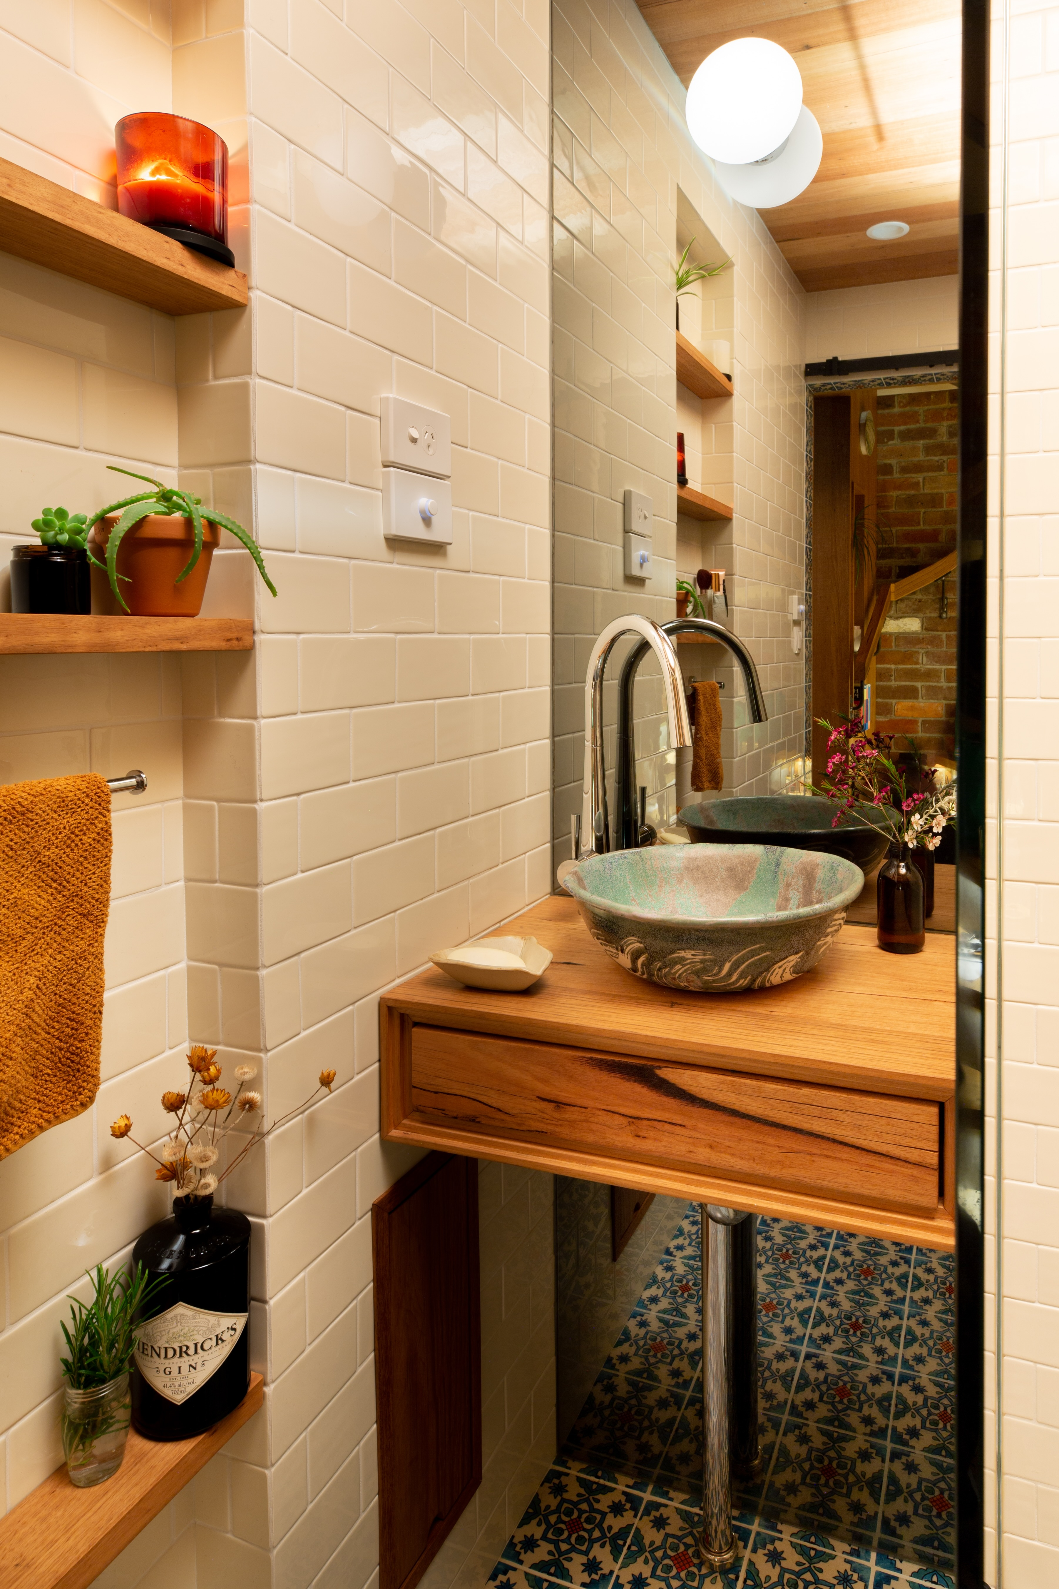
The Nook - 007
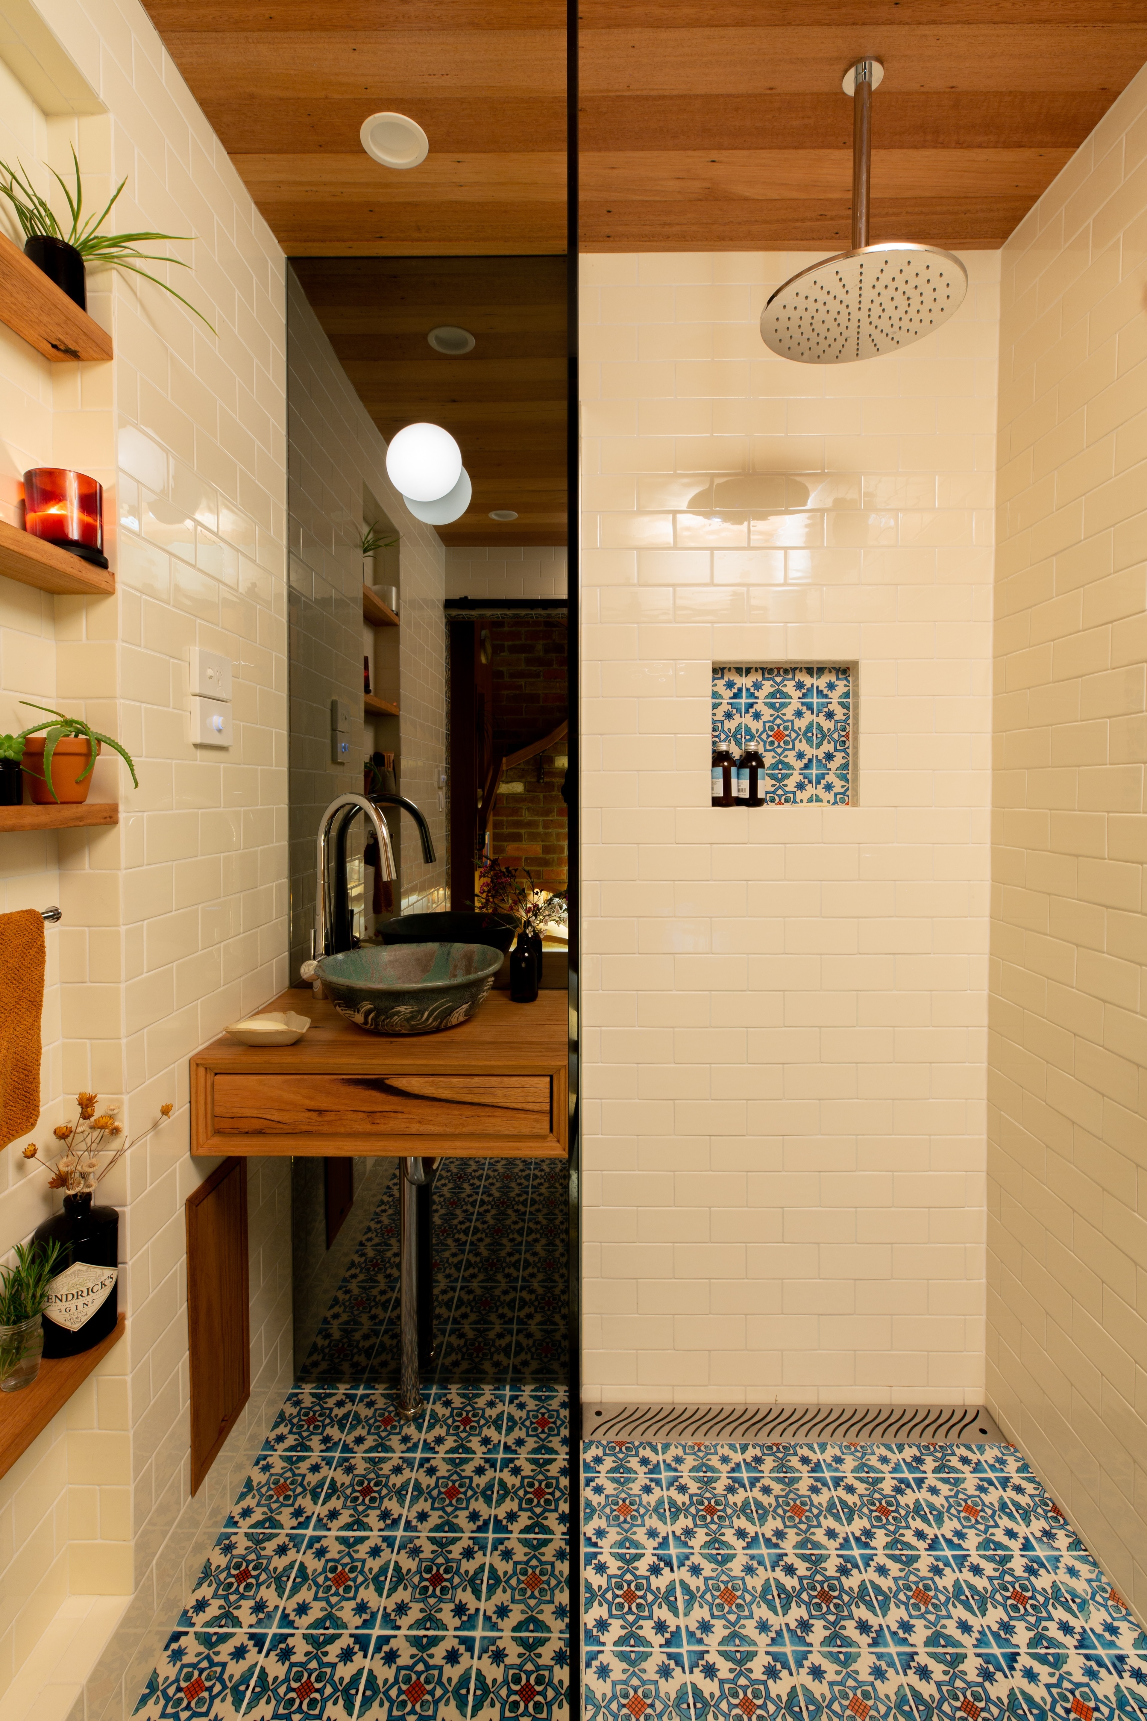
The Nook - 008

COMMON AREAS

Report Disclaimer
Please note that this business report, provided as a result of the use of the diagnostic assessment, is for information purposes only.
Australian Tourism Industry Council (ATIC) cannot guarantee the accuracy of respondent’s answers, or that they are fully representative of your business. Therefore, ATIC does not warrant or guarantee any particular outcome in respect of your businesses self-assessment.
This report is intended as guidance only for your business and should not be relied on for future marketing considerations. ATIC recommends that you seek your own independent advice as well as the results from the diagnostic.
Links to external web sites are inserted for convenience and do not constitute endorsement of material at those sites, or any associated organisation, product or service.
ATIC does not:
- Assume any legal liability for the accuracy, completeness, or usefulness of any information from this report or any links provided; or
- Accept responsibility for any loss associated directly or indirectly from the use of this report.

