ATIC Accessibility
To support the accessible community in making informed travel decisions for their individual needs

This report prepared for:
Business name: | Clairault Streicker Wines
Address: | 3277 Caves Road
Town: | Wilyabrup
Contact for enquiries: | Phil Cowley
Contact Number: | 0429099685
Contact Email: | bookings@clairaultstreicker.com.au
Website: | https://www.clairaultstreickerwines.com.au/
Date: | 2026-10-26 07:17

ATIC Accessibility
The following pages provides travellers with information on the businesses facilities and amenities which aims to support the traveller to make an informed decision on whether the business is suitable for their individual needs.
OVERVIEW 3
Business Overview 3
Bookings 3
Emergency Management 3
Guide Dog and Service Animals 4
GENERAL 5
Car Park and Access amenities 5
External Paths 5
Steps 5
Public Toilets/Adult change facilities 6
FOOD AND DRINK 7
Dining Spaces 7
Report Disclaimer 10

OVERVIEW

Business Overview

The business has the following products/services available
- Food and Drink

Our business caters for the following disability types:
- Limited mobility
- Wheelchairs or mobility scooters
- Food allergies or intolerances
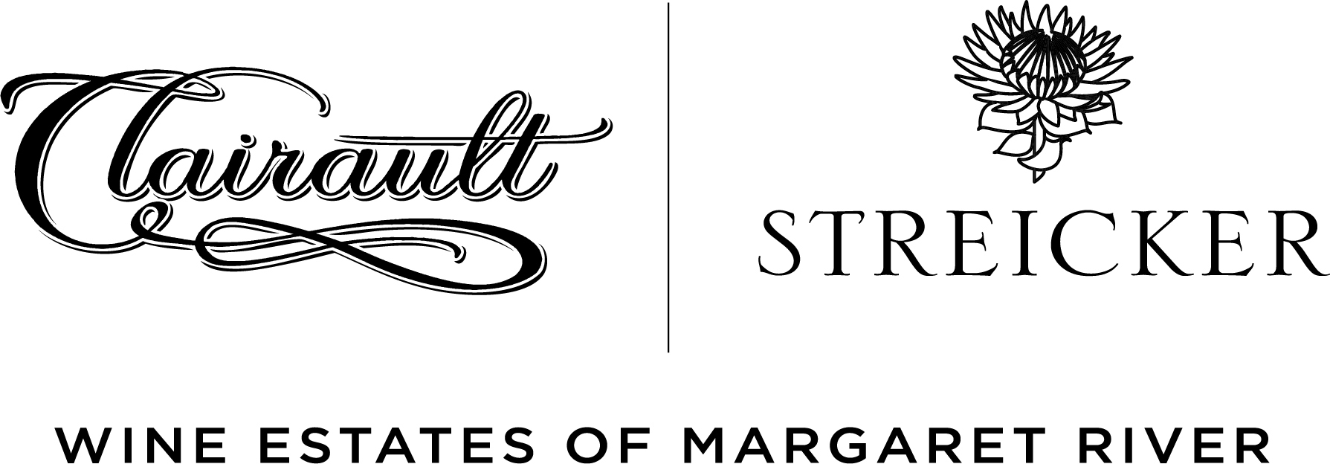

Bookings

The business offers the following methods for bookings and enquiries:
- Phone
- Email
- Webportal
- Our website supports Screen Readers
- Our forms have high contract boxes and submit boxes

Emergency Management
- Exit signs are clear and easy to see
- Exit access is free and clear at all times
We ensure exit access is free and clear at all times by:
We ensure no tables or furniture is placed in front of these exits.
- Exits and access to exists are greater than 900mm
- Exit doors are able to be opened by all occupants
- Exits to the emergency evacuation point does not include stairways
- The evacuation point is clearly marked by a sign
- In addition, the following further information can assist guests:
Staff would use visual cues to determine any guests who require assistance in an emergency
- In addition, the following further information can assist guests:
All senior staff are trained in First Aid and as Fire Wardens - part of these courses is how to respond in an emergency and basic training around how to assist all visitors in an emergency.

Guide Dog and Service Animals
- The business provides a secure area with shade and water for service animals
- The business provides a toilet area for service animals
- Bowls, bedding, etc. are provided for service animals
The business provides the following services for services animals:
We offer treats, water, bowls and blankets for service animals

GENERAL
- In addition, the following further information can assist guests:
We space the times of our reservations to ensure that only a few people arrive at the same time
- In addition, the following further information can assist guests:
There are comfortable lounge chairs for guests to use when they arrive if they would like to sit down if there is a wait for their table to be ready.

Car Park and Access amenities
The business has the following Car Park and Access amenities
- A drop off zone
- Designated disabled parking bays
- Level or ramped access from the car park to the entrance
- In addition, the following further information can assist guests:
Please use the path from the carpark to the venue, then follow the path to the left to access the deck without any steps.

External Paths
External paths of travel
- Surfaces are concrete, asphalt, smooth paving or hard packed fine gravel (max aggregate size 13mm)
- Pathways are wider than 900mm
- There 3 successive steps or less on any path or at any doorway
- In addition, the following further information can assist guests:
Please use the path from the carpark to the venue, then follow the path to the left to access the deck without any steps.

Steps
Steps
- There are steps.
- The underside of all staircases are enclosed or protected to a height of at least 2 metres
- Where steps are present are there three steps or less
- In addition, the following further information can assist guests:
Please let us know at the time of booking if you have specific mobility requirements and we will seat you in the most suitable section. Our upstairs dining room is accessible via 2 steps so if you have a wheelchair or mobility scooter, we will seat you in the downstairs section instead.

Public Toilets/Adult change facilities
Public Toilets/Adult change facilities have the following amenities are in place
- There is an accessible toilet for public use
- The door is at least 850mm wide
- There is 750mm mm beside the toilet
- Handrails are fitted
- There is 700mm mm of clear space in front of the toilet
- The toilet seat of a contrasting colour to the floor
- The toilet seat is460mm above the floor

FOOD AND DRINK

Dining Spaces
The dining spaces have the following facilities/amenities in place
- The entrance has level access
- The doorway is at least 850mm wide
- Chairs are moveable to allow for wheelchairs to be seated at the tables
- All glass doors and full height windows have contrast markings
- There are areas of full lighting
- There is an accessible toilet

Our business caters for the following dietary requirements
- Sugar free (diabetic)
- Gluten free (celiac)
- Lactose free (dairy free)
- Low fat and fibre with no gastric content
- Low potassium
- Low sodium
- Nut free
- Additive free
- Vegetarian
- Vegan
- In addition, the following further information can assist guests:
Our chefs will use separate cutting boards, knives and deep fryers for all allergies that can cross-contaminate.
- There is a sample menu available online
Sample menu is available here -
chrome-extension://efaidnbmnnnibpcajpcglclefindmkaj/https://www.clairaultstreickerwines.com.au/assets/client/File/Menus-VineyardKitchen/Updated%20Summer%20Menu.pdf
  - Food and Beverage Image(s)
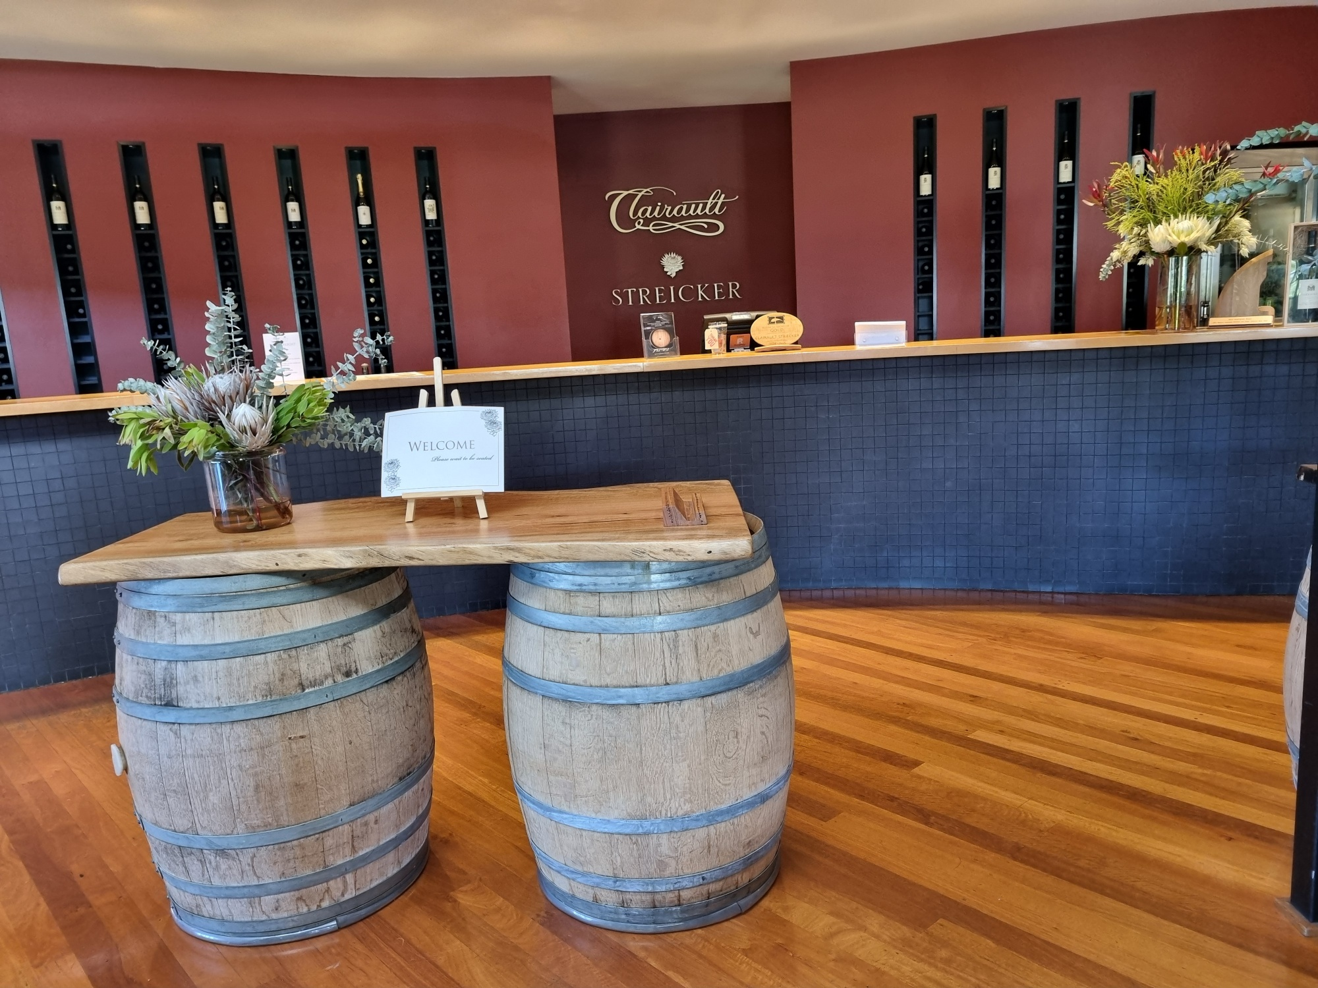
Bar for serving and payment
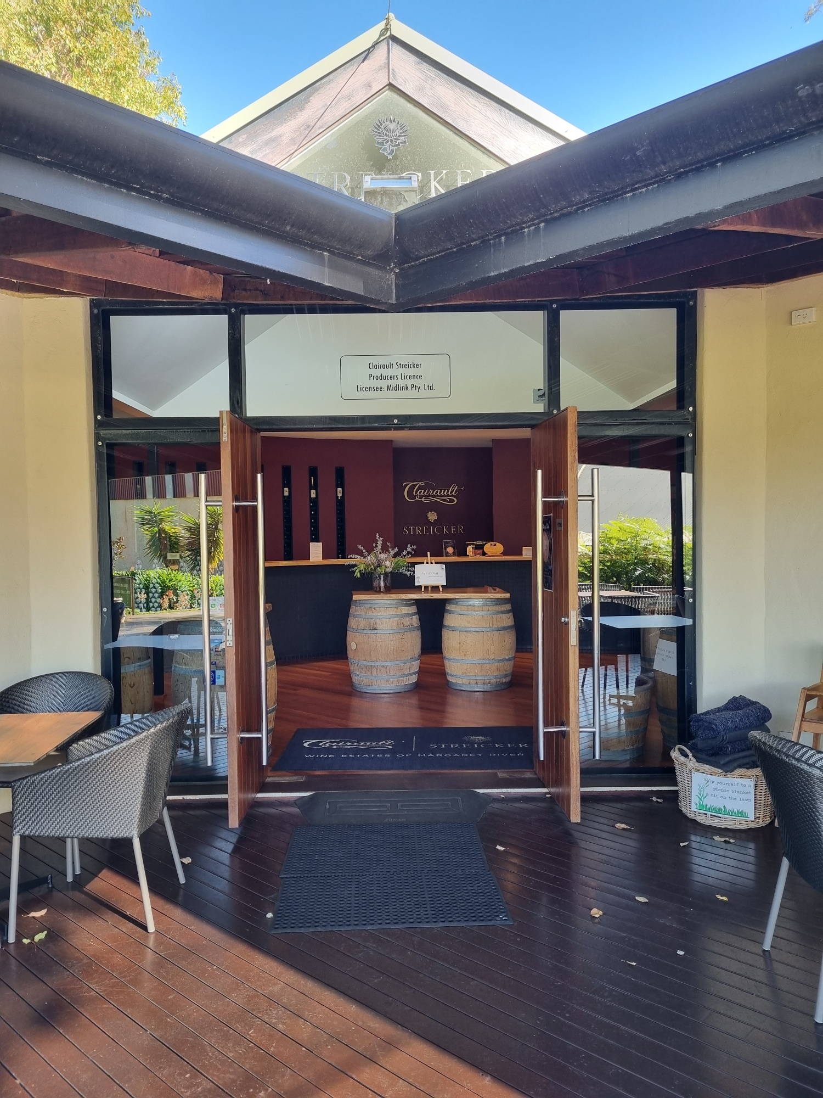
Front entrance
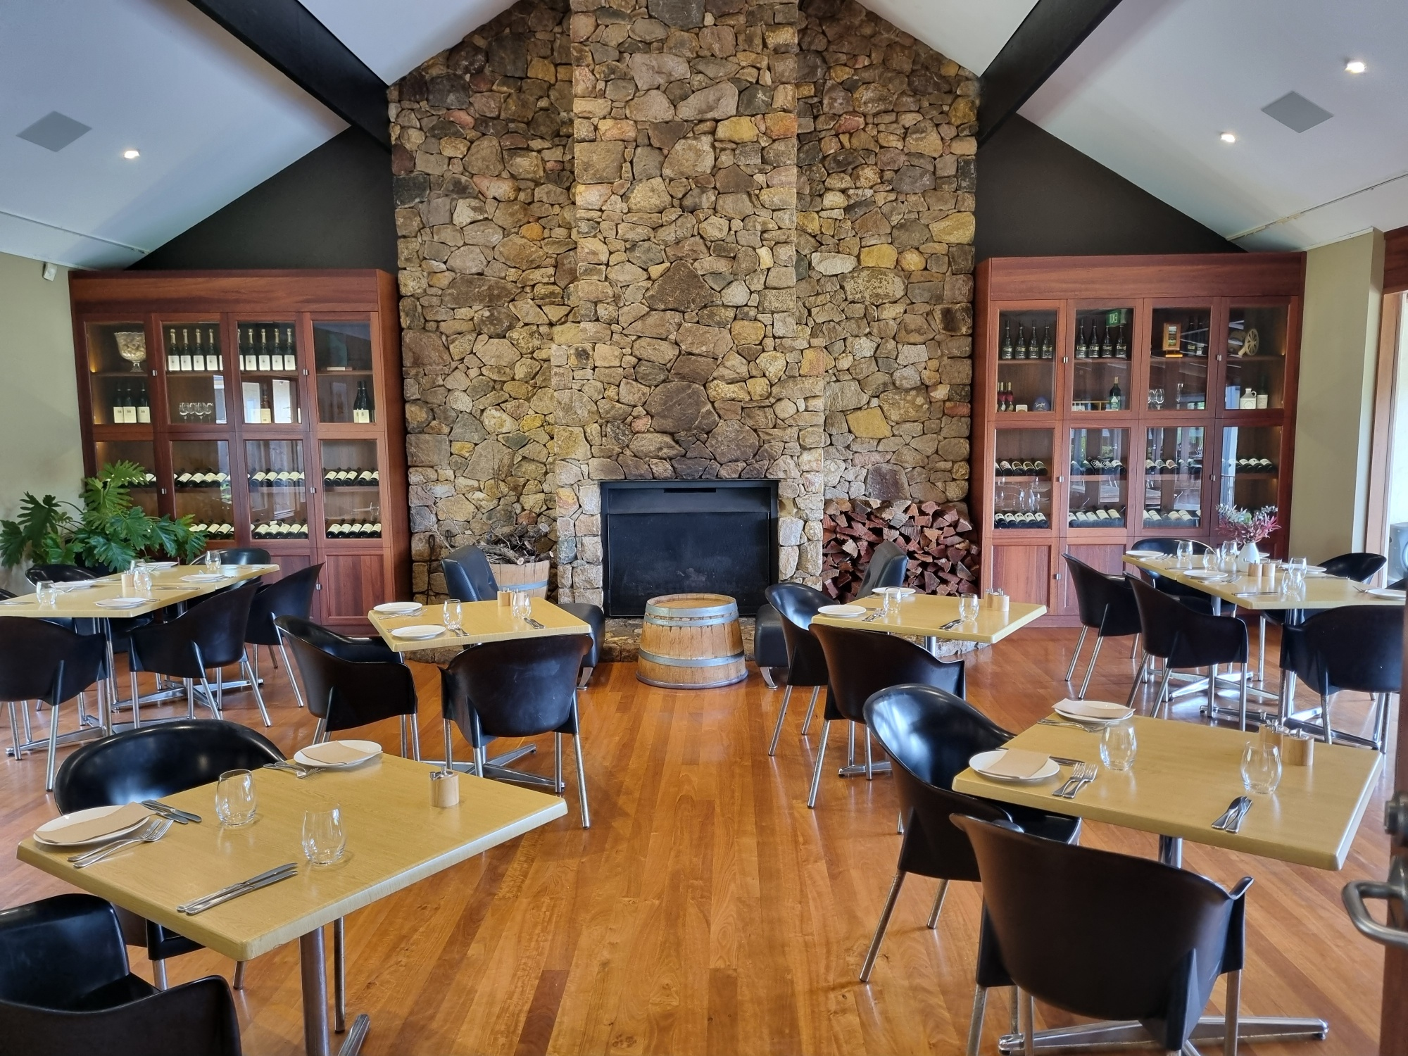
Table setting in Dining Room

Report Disclaimer
Please note that this business report, provided as a result of the use of the diagnostic assessment, is for information purposes only.
Australian Tourism Industry Council (ATIC) cannot guarantee the accuracy of respondent’s answers, or that they are fully representative of your business. Therefore, ATIC does not warrant or guarantee any particular outcome in respect of your businesses self-assessment.
This report is intended as guidance only for your business and should not be relied on for future marketing considerations. ATIC recommends that you seek your own independent advice as well as the results from the diagnostic.
Links to external web sites are inserted for convenience and do not constitute endorsement of material at those sites, or any associated organisation, product or service.
ATIC does not:
- Assume any legal liability for the accuracy, completeness, or usefulness of any information from this report or any links provided; or
- Accept responsibility for any loss associated directly or indirectly from the use of this report.

