ATIC Accessibility
To support the accessible community in making informed travel decisions for their individual needs

This report prepared for:
Business name: | Paradise Links Resort
Address: | 24-70 Nautilus Street
Town: | Craiglie
Contact for enquiries: | Therese Dyer
Contact Number: | 07 4099 1511
Contact Email: | info@paradiselinks.com.au
Website: | www.paradiselinks.com.au
Date: | 2026-10-28 03:41

ATIC Accessibility
The following pages provides travellers with information on the businesses facilities and amenities which aims to support the traveller to make an informed decision on whether the business is suitable for their individual needs.
OVERVIEW 4
Business Overview 4
Bookings 4
Emergency Management 4
Communications 5
Other Information 5
Guide Dog and Service Animals 5
GENERAL 7
Pre-arrival, arrival and reception 7
Cognitive Impairment Support 7
Car Park and Access amenities 7
External Paths 8
Steps 8
Ramps 8
ACCOMMODATION 10
Bedrooms 10
Room Amenities 10
Bathrooms 11
COMMON AREAS 13
Swimming pools, spas and waterparks 13
Parks and gardens 17
Report Disclaimer 20

OVERVIEW

Business Overview

The business has the following products/services available
- Accommodation

Our business caters for the following disability types:
- Blind or low vision
- Deaf or low hearing
- Limited mobility
- Wheelchairs or mobility scooters
- Cognitive or people on the Autism Spectrum

Bookings

The business offers the following methods for bookings and enquiries:
- Phone
- Email
- Webportal
- Our forms have high contract boxes and submit boxes
- Staff have undergone disability awareness and training

Emergency Management
- Emergency and evacuation procedures are explained on arrival
- There are visual device/s to alert occupants to evacuate.
- Exit signs are clear and easy to see
- Exit access is free and clear at all times
We ensure exit access is free and clear at all times by:
We are onsite managers and keep a close eye on the resort to ensure that it is fully operational at all times
- Exits and access to exists are greater than 900mm
- Exit doors are able to be opened by all occupants
- Exits to the emergency evacuation point does not include stairways
- In addition, the following further information can assist guests:
We are a small team and are aware of any guests who have special needs and may require assistance in an emergency situation
- In addition, the following further information can assist guests:
Our team is on hand and available to assist where necessary in an emergency situation.
- Guests with disabilities are noted in the guest log book for emergency and evacuation purposes

Communications
- An accessibility guide is available on the website

https://www.paradiselinks.com.au/resort/accessibility-guide/
- Our website meets WCAG 2.0 accessibility standards
- Our business offers the following alternative communication methods
- Plain English

Not specified
- There is easy to read signage and information (e.g. menus and emergency information)

Other Information
- For bookings made onsite, the ticket booth/counter/box office is accessible for people using a wheelchair

Guide Dog and Service Animals
- The business provides a secure area with shade and water for service animals
- The business provides a toilet area for service animals
- Bowls, bedding, etc. are provided for service animals
The business provides the following services for services animals:
Should service animals accompany a guest, we will make appropriate arrangements for the comfort and safety of the animal based on the accommodation type booked by the guest.

GENERAL

Pre-arrival, arrival and reception
The business has the following in place to support guests during pre-arrival, arrival and reception
- Booking information and websites are compatible with screen readers
- There is a reception/public entryway.
- Seating available at reception
- A clipboard to allow check-in/ticket purchase whilst seated
- Lighting in the reception area is even and glare free
- Large print information sheets and registration forms
- Information and maps are available in written form
- A step free map/guide
- A familiarisation tour
- Keys are available for each guest
- Luggage assistance
- In addition, the following further information can assist guests:
We genuinely listen to our guest's specific needs and will ensure our housekeeping team is notified if a guest requires their accommodation earlier for any reason and we will use our best endeavours to ensure the guest is accommodated as soon as practically possible. We also have comfortable seating in reception.
- In addition, the following further information can assist guests:
We request that guests with special needs contact us prior to booking where possible to discuss their specific circumstances (eg walk in shower, ground floor apartment or assistance with luggage).

Cognitive Impairment Support
- Documents are available in plain English for people with cognitive impairment (This may include instructions, guides, menus and general information)

Car Park and Access amenities
The business has the following Car Park and Access amenities
- A drop off zone
- Level or ramped access from the car park to the entrance
- The public transport services available are:

We do not have public transport in Port Douglas, but can assist guests with booking local shuttle services
- Kerb ramps are in place where a pavement or walkway needs to be crossed
- In addition, the following further information can assist guests:
As above, we recommend that guests contact us prior to booking if they have any special requirements during their stay

External Paths
External paths of travel
- Surfaces are concrete, asphalt, smooth paving or hard packed fine gravel (max aggregate size 13mm)
- Pathways are wider than 900mm
- In addition, the following further information can assist guests:
Guests are requested to please see reception if they require any special assistance during their stay.

Steps
Steps
- There are steps.
- All steps or staircases have enclosed risers
- The underside of all staircases are enclosed or protected to a height of at least 2 metres
- Handrails fitted to all open sets of steps
- Handrails extend 300mm beyond the top and bottom step
- In addition, the following further information can assist guests:
Guests who are unable to use steps are recommended to contact us prior to booking so that a ground floor accommodation is made available for the guest.

Ramps
Ramps have the following amenities are in place
- There are ramps.
- Temporary ramps are available
- Temporary ramps are in place for the duration of the guests stay
- In addition, the following further information can assist guests:
It is recommended that guests contact us prior to booking if they have special needs so that we can make suitable arrangements for them during their stay.
- In addition, the following further information can assist guests:
We have a toilet at reception for guest use. However, it may not be ideal for wheelchair use.

ACCOMMODATION

Bedrooms
The bedrooms have the following facilities/amenities in place
- There are 1 fully accessible hotel room/apartment on the ground floor for wheelchair use. 3 x 4-bed villas and 2 other apartments which may be suitable, having a ground floor bedroom with walk in shower. rooms available to guests who use a wheelchair
- Bedroom furniture can be re-arranged on request
  - Layout of room Image(s)
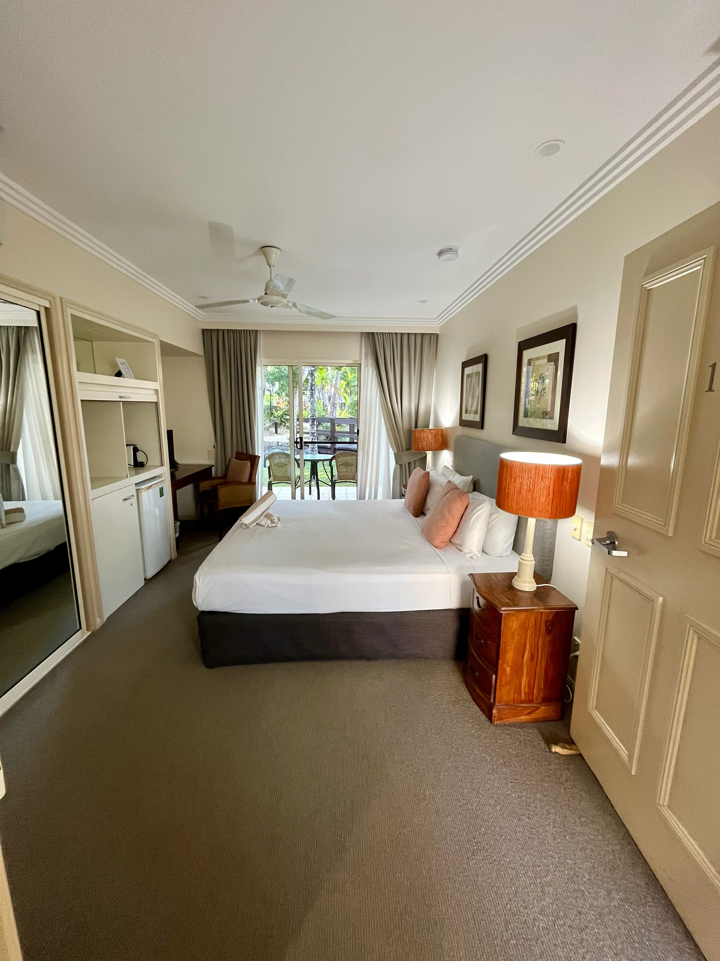
IMG_4304

Room Amenities
- Lower hanging rails are in wardrobes
- In addition, the following further information can assist guests:
In an emergency situation, we can knock loudly and enter the accommodation with the master key if necessary.
- Televisions are equipped with closed captioning capability
- Vibrating alarm clocks
- There is a clear path through the room
- The edges of all furniture and fixtures are rounded
- Housekeeping procedures instruct staff not to reposition furniture that has been moved
- Doors open fully against the adjoining wall
- There is a clear opening at least 850mm wide
- There at least one chair with rigid arms
- Wardrobe and drawer handles are easy to grip
- The bedside lamp switch is easy to reach from the bed
- There is at least 850mm clear space beside the bed
- The bed height is no higher than 680mm from the floor
- There is at least 130mm clearance under the bed
- Non-allergenic cleaning products are used
- In addition, the following further information can assist guests:
As previously mentioned, it is always recommended that guests contact us prior to booking if they have any special requests or require special assistance and we will do our utmost to accommodate their specific requirements.

Bathrooms
The bathrooms have the following facilities/amenities in place
- All heating appliances and hot water pipes are protected or insulated
- All shower, bath and basin taps are clearly differentiated between hot and cold
- Fixtures and fittings have rounded edges
- The hot water is thermostatically controlled to 41 degrees
- The door is at least 850mm wide
- There is a minimum of 850mm beside the toilet
- Handrails are fitted
- There is a minimum of 1400mm of clear space in front of the toilet
- The toilet seat is a contrasting colour to the floor
- The toilet seat is 460mm above the floor
- There is a roll-in shower with fold down fixed seat or a shower chair
- There is a portable shower head on flexible hose
  - Bathroom Image(s)
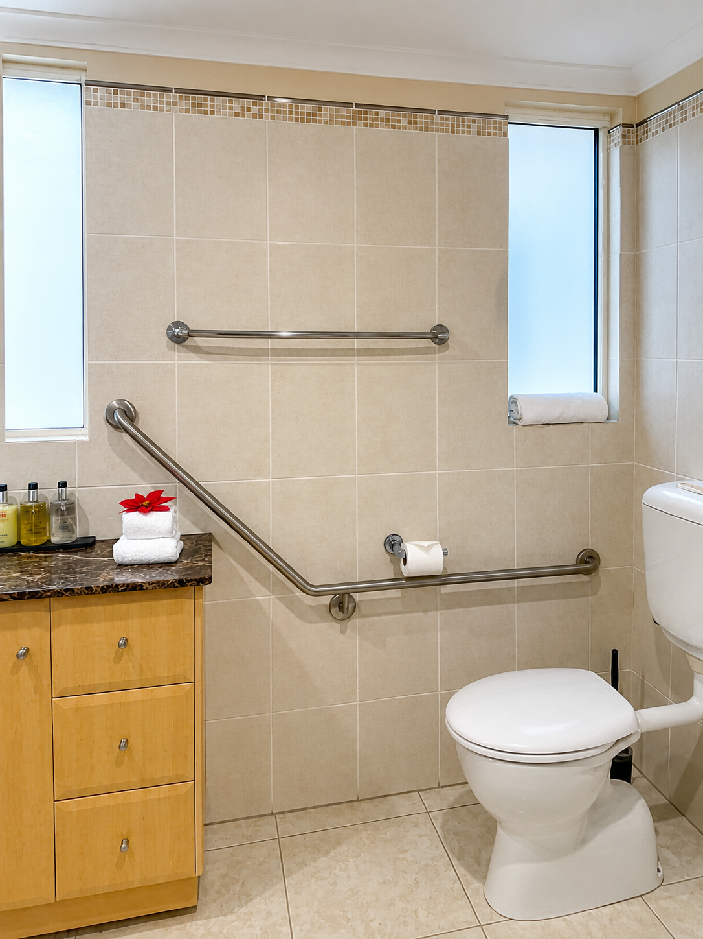
Accessible Links Room 2
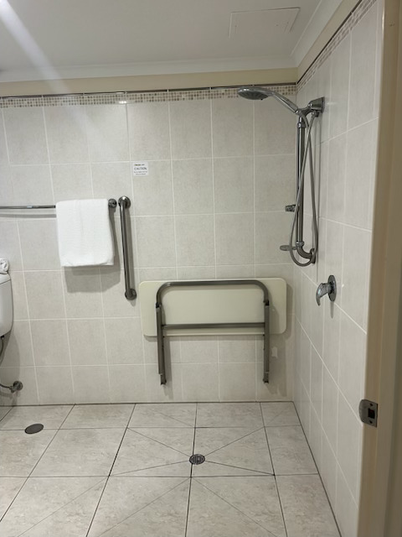
Accessible Links Room 3
- In addition, the following further information can assist guests:
As above, guests should contact us to discuss specific requirements so that we can accommodate their needs, as far as possible.

COMMON AREAS

Swimming pools, spas and waterparks
- The following swimming pools, spas and waterparks amenities are available
- The park map includes a step free route
  - Pool Access Image(s)
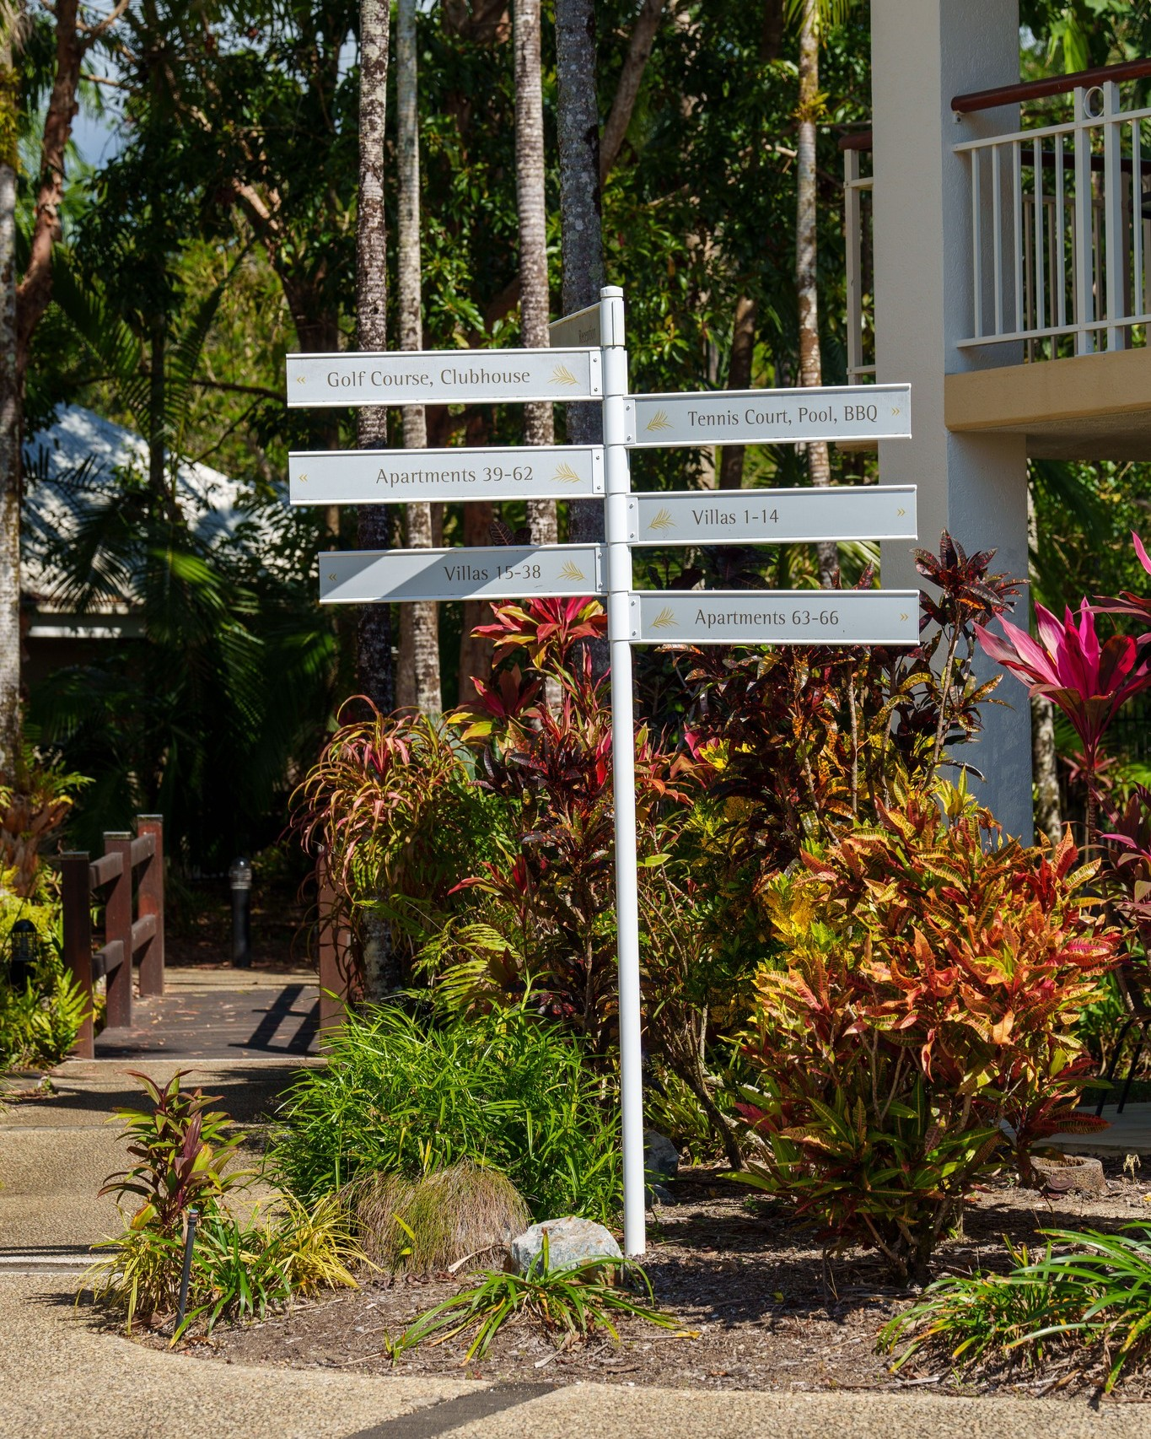
495925153_1255673633227643_4261446783655686333_n
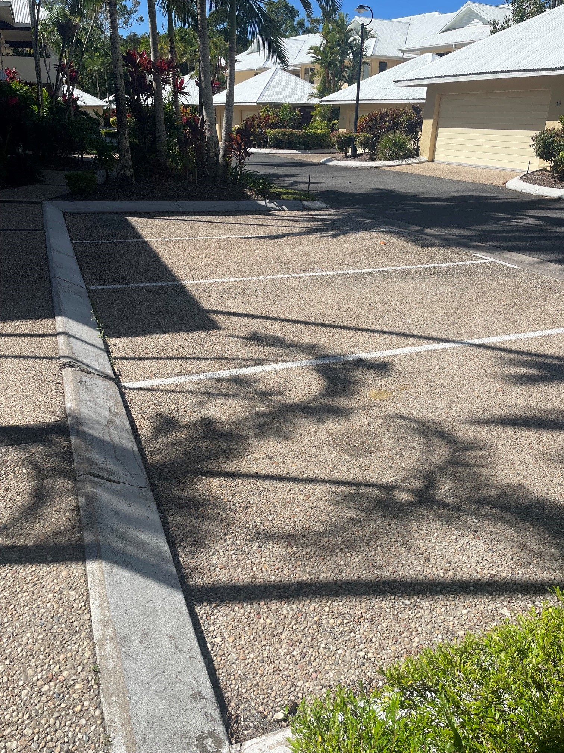
car park
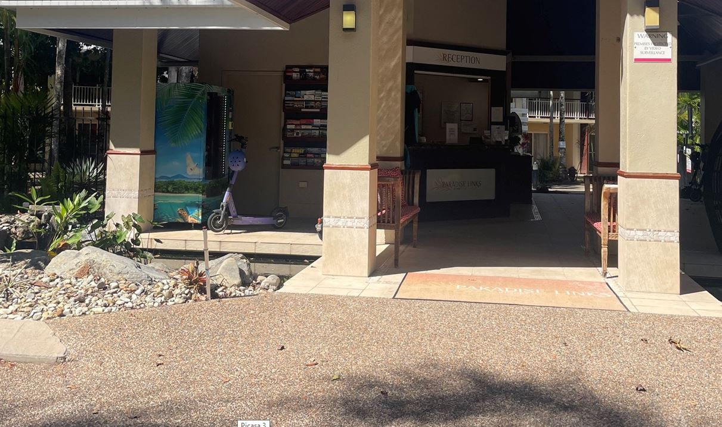
entry.JPG
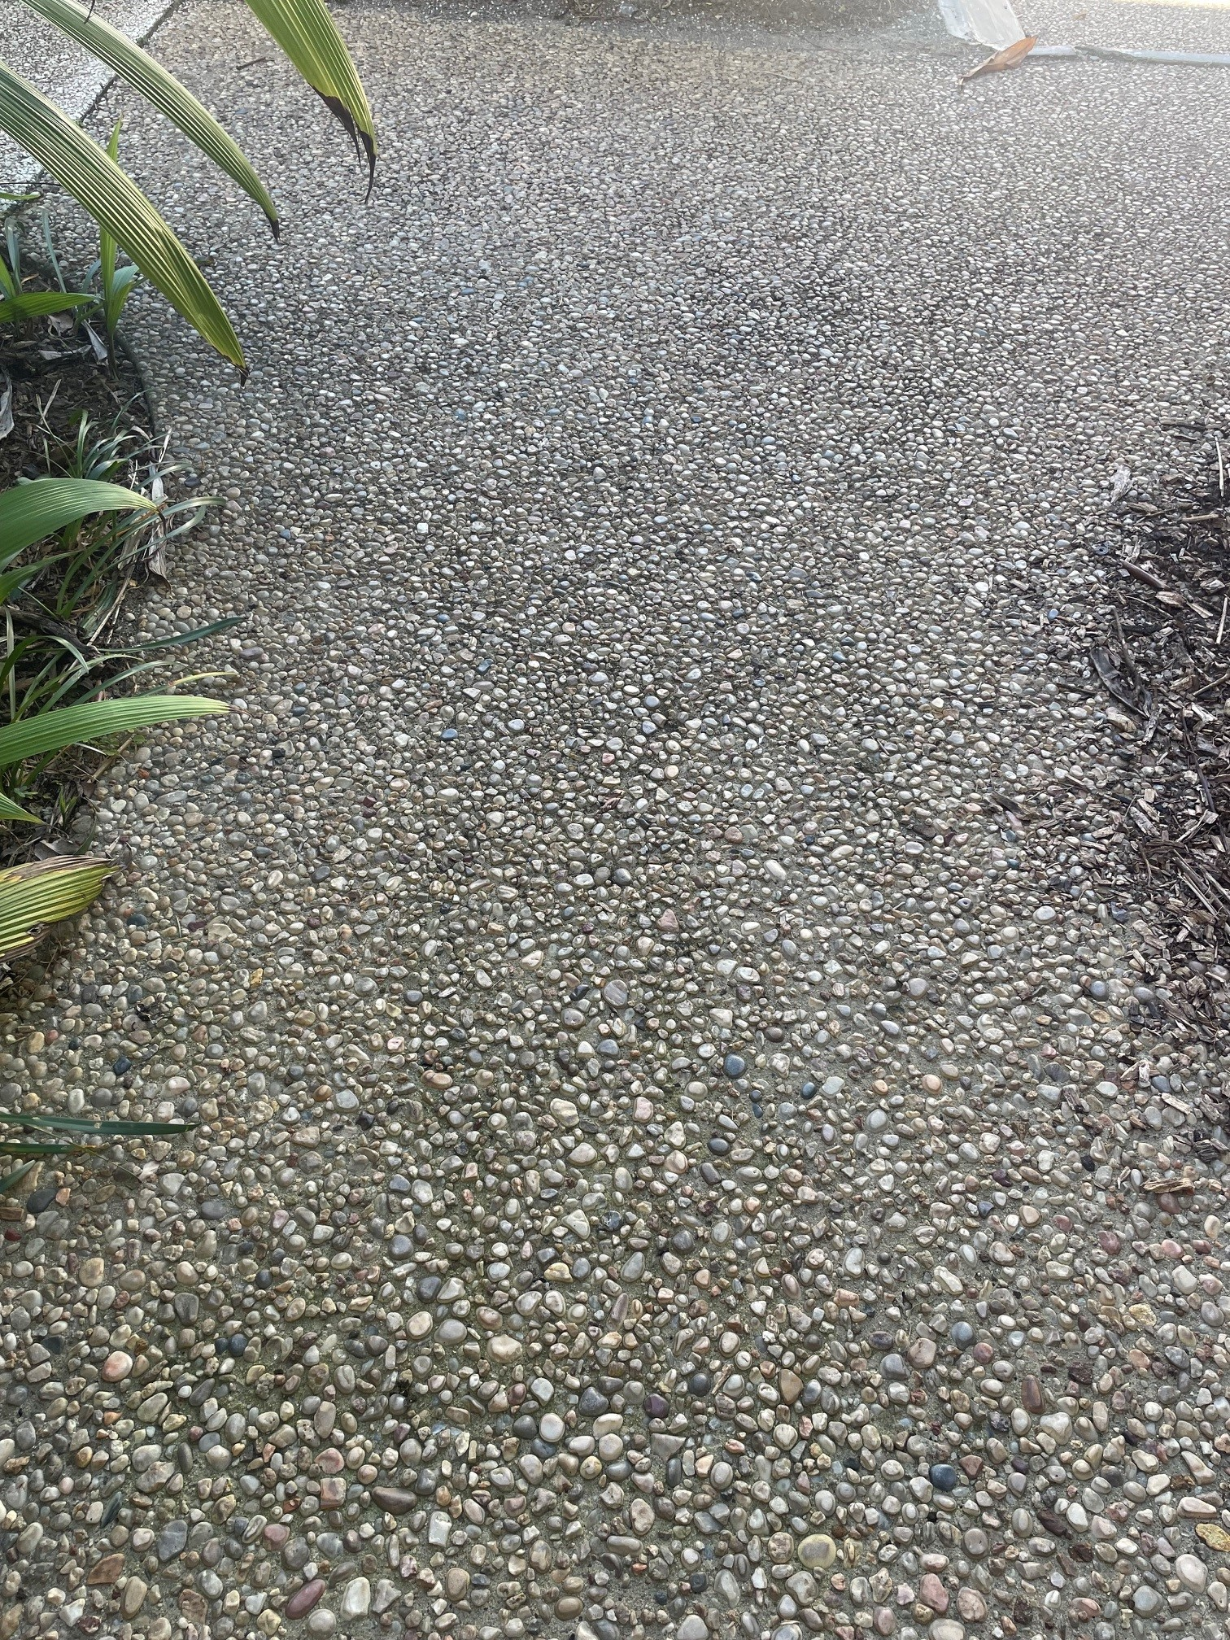
path
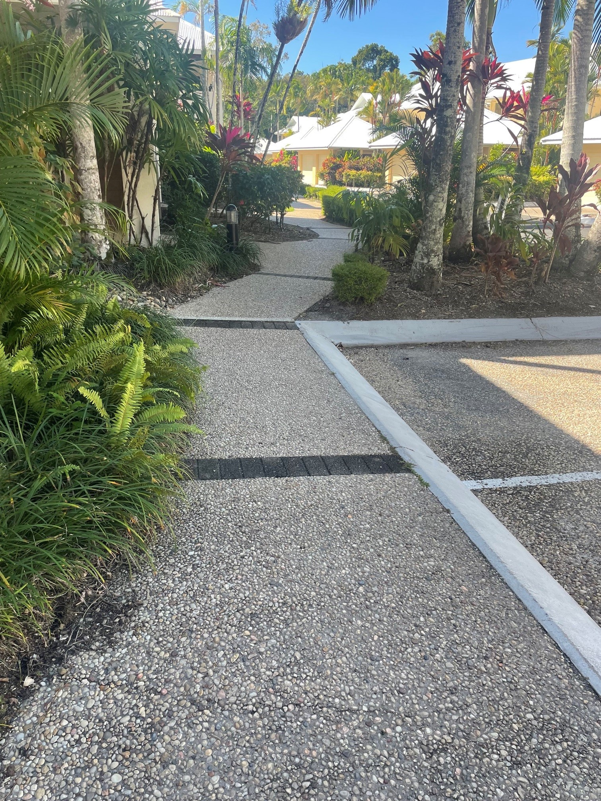
paths 2
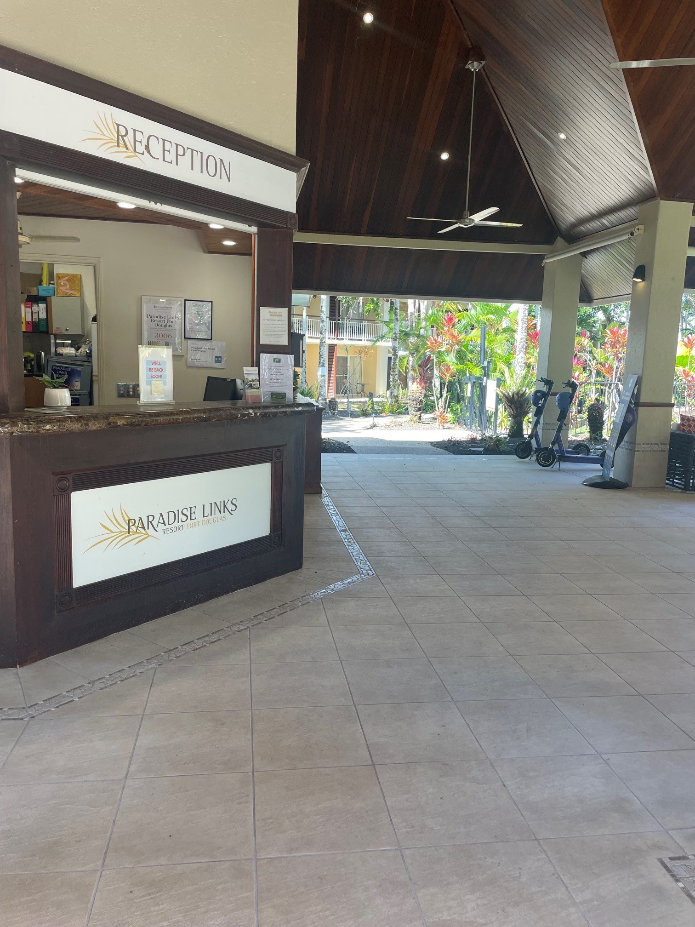
reception area
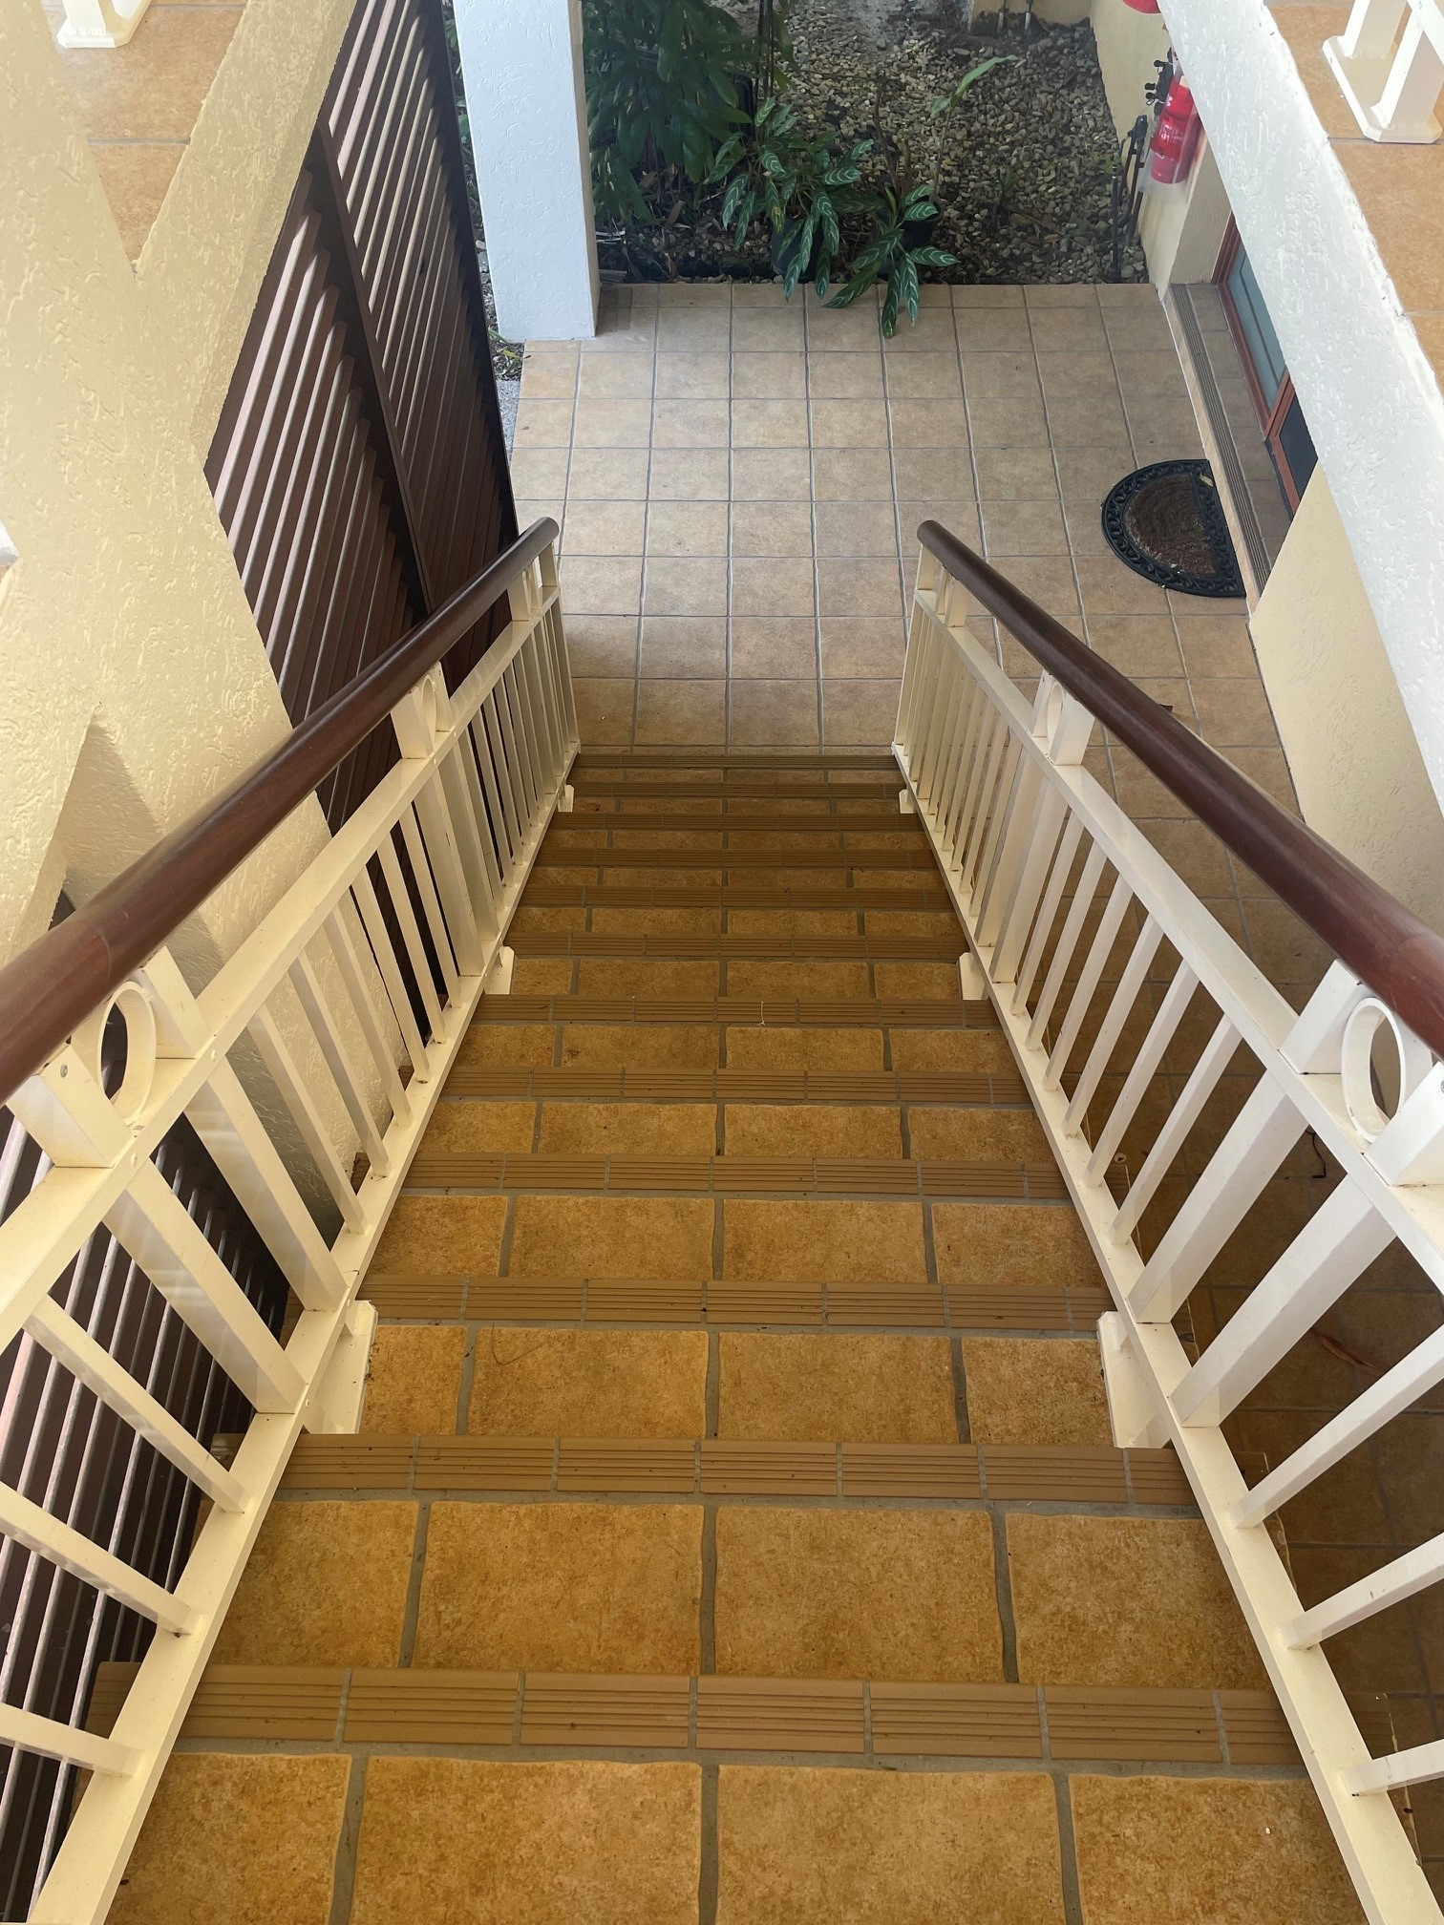
stairs
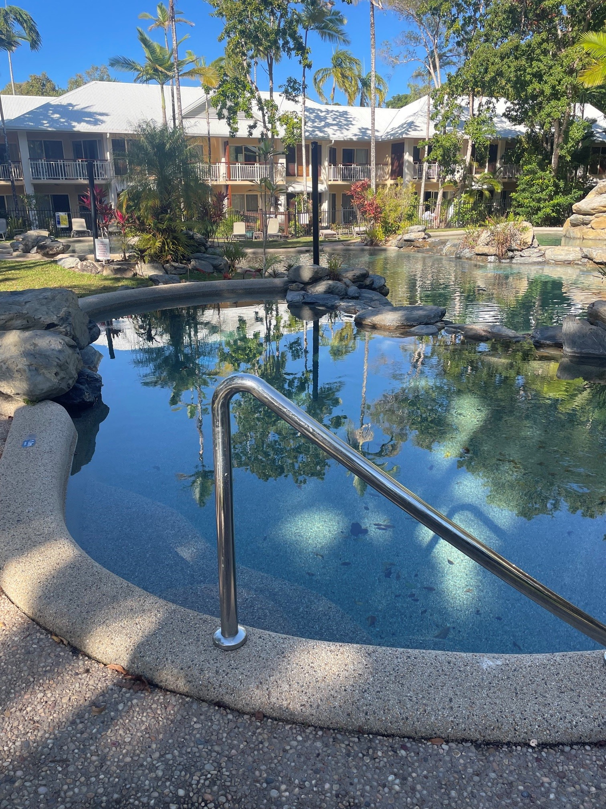
swimming pool 1
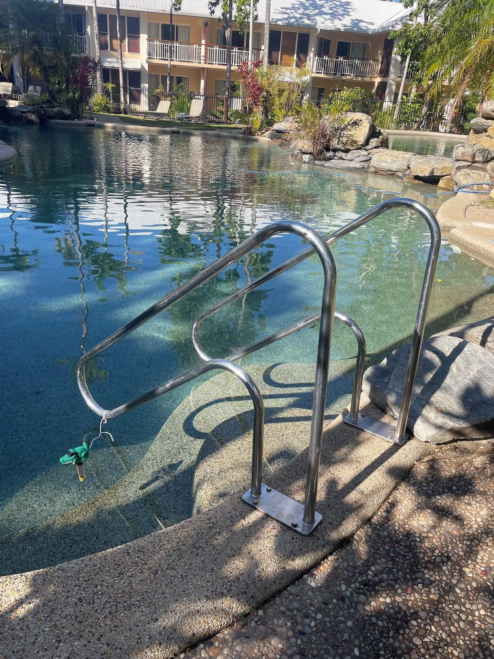
swimming pool 2
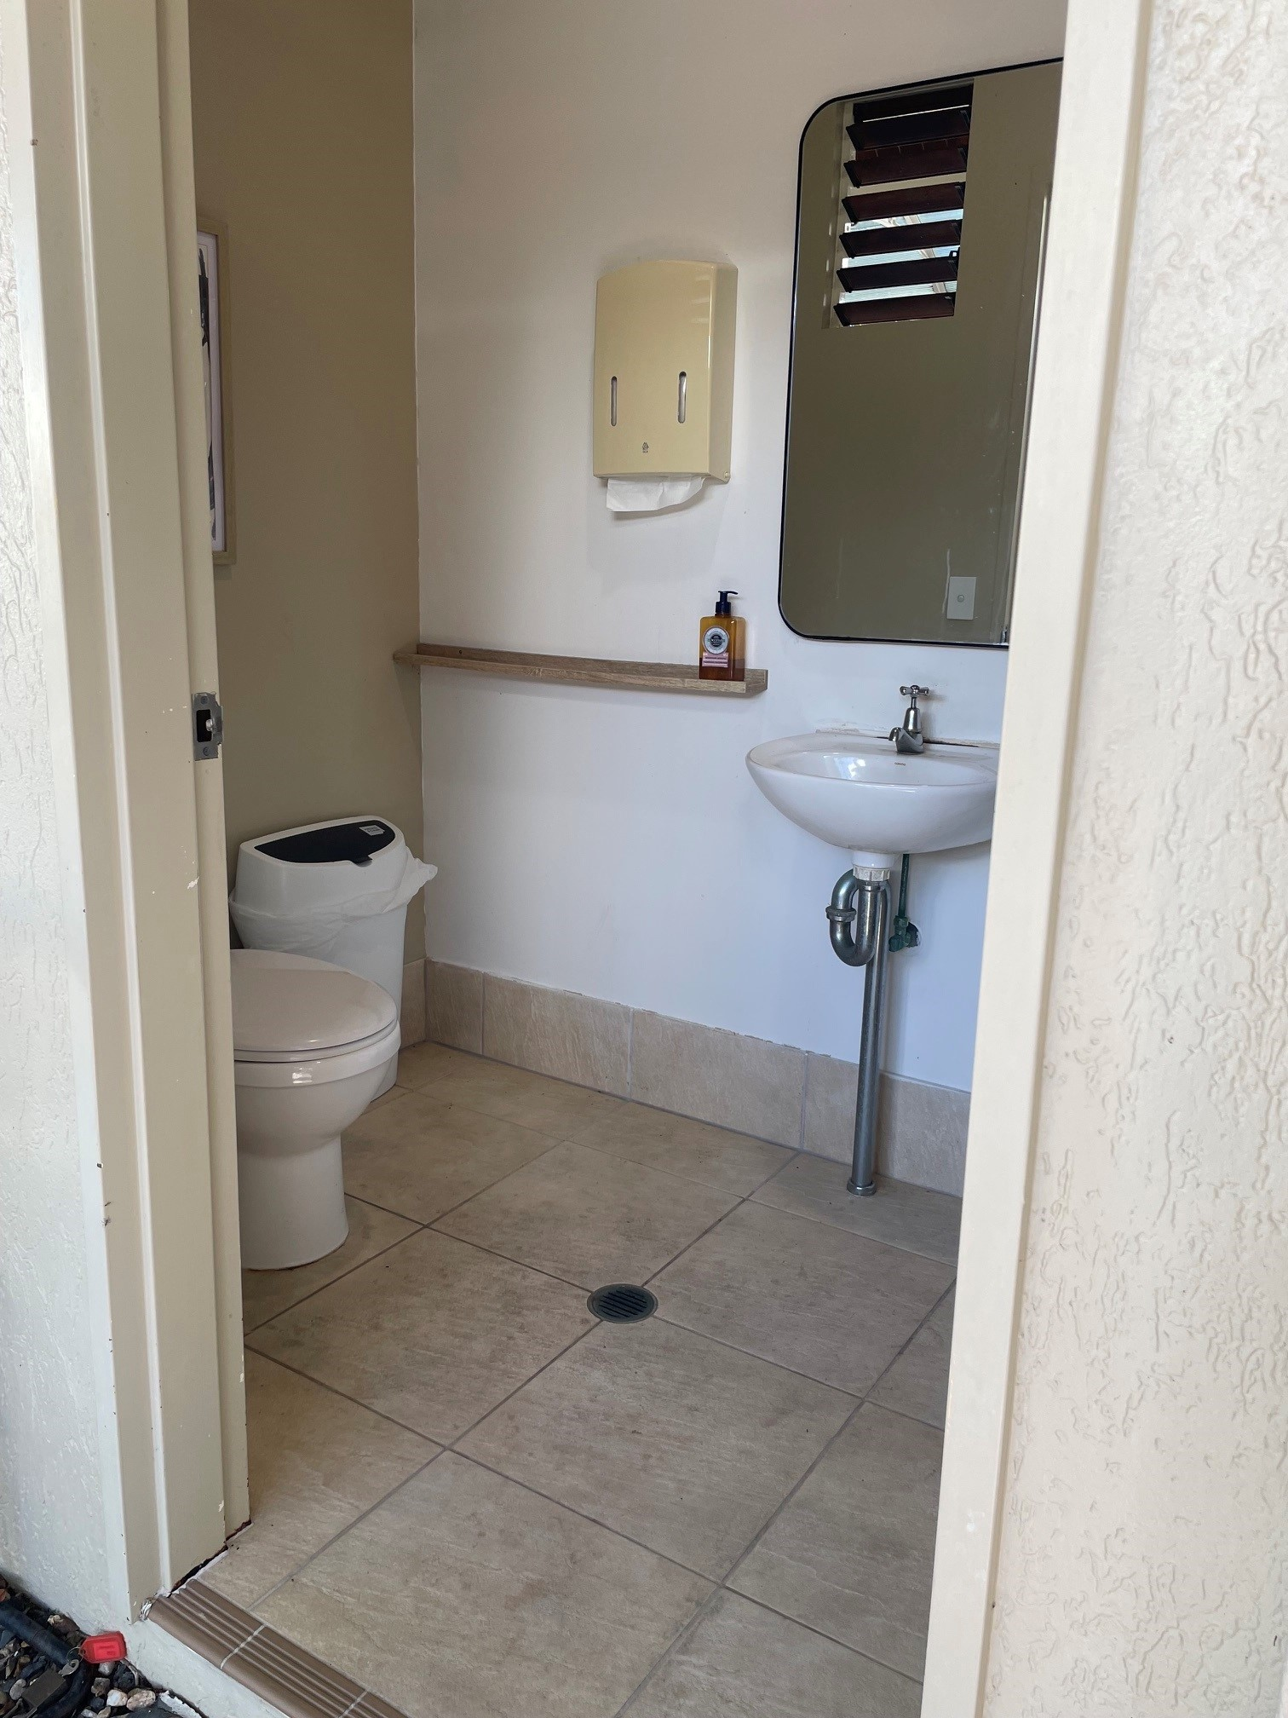
reception toilet
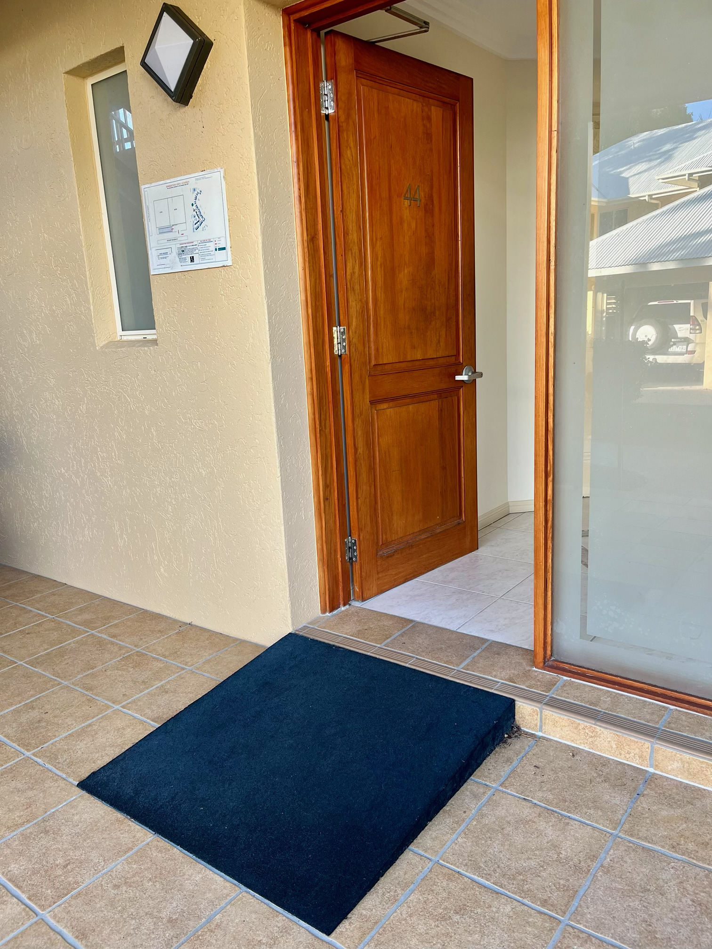
Accessible Links Room Ramp
- In addition, the following further information can assist guests:
As detailed above, we recommend that guests contact us to discuss their specific requirements.

Parks and gardens
- The following parks and gardens amenities are available
- There is a step free map
- This map is available online

https://www.paradiselinks.com.au/resort/
- Accessible picnic tables
- Accessible BBQs
  - Parks and Gardens Access/Entry Image(s)
495925153_1255673633227643_4261446783655686333_n
- In addition, the following further information can assist guests:
As detailed above, we recommend that guests contact us to discuss their specific requirements.
- Handrails and stairs are built as per state/territory building code.
- Slip resistance surfaces are used.
- A handrail is available and at 865-965mm in height.
- The handrail is continuously graspable along entire length at least one side.
  - Parks and Gardens Stair entry and exit Image(s)
stairs

Report Disclaimer
Please note that this business report, provided as a result of the use of the diagnostic assessment, is for information purposes only.
Australian Tourism Industry Council (ATIC) cannot guarantee the accuracy of respondent’s answers, or that they are fully representative of your business. Therefore, ATIC does not warrant or guarantee any particular outcome in respect of your businesses self-assessment.
This report is intended as guidance only for your business and should not be relied on for future marketing considerations. ATIC recommends that you seek your own independent advice as well as the results from the diagnostic.
Links to external web sites are inserted for convenience and do not constitute endorsement of material at those sites, or any associated organisation, product or service.
ATIC does not:
- Assume any legal liability for the accuracy, completeness, or usefulness of any information from this report or any links provided; or
- Accept responsibility for any loss associated directly or indirectly from the use of this report.

