ATIC Accessibility
To support the accessible community in making informed travel decisions for their individual needs

This report prepared for:
Business name: | North East Wine
Address: | 7 Barnard Street
Town: | Bright
Contact for enquiries: | Marion Carrabin
Contact Number: | 0423794418
Contact Email: | info@northeastwine.com.au
Website: | northeastwine.com.au
Date: | 2026-10-22 21:46

ATIC Accessibility
The following pages provides travellers with information on the businesses facilities and amenities which aims to support the traveller to make an informed decision on whether the business is suitable for their individual needs.
OVERVIEW 3
Business Overview 3
Bookings 5
Emergency Management 5
Guide Dog and Service Animals 5
GENERAL 6
Pre-arrival, arrival and reception 6
Cognitive Impairment Support 6
External Paths 6
Steps 6
COMMON AREAS 8
FOOD AND DRINK 9
Dining Spaces 9
Report Disclaimer 12

OVERVIEW

Business Overview

The business has the following products/services available
- Food and Drink

Our business caters for the following disability types:
- Deaf or low hearing
- Limited mobility
- Food allergies or intolerances
- Cognitive or people on the Autism Spectrum
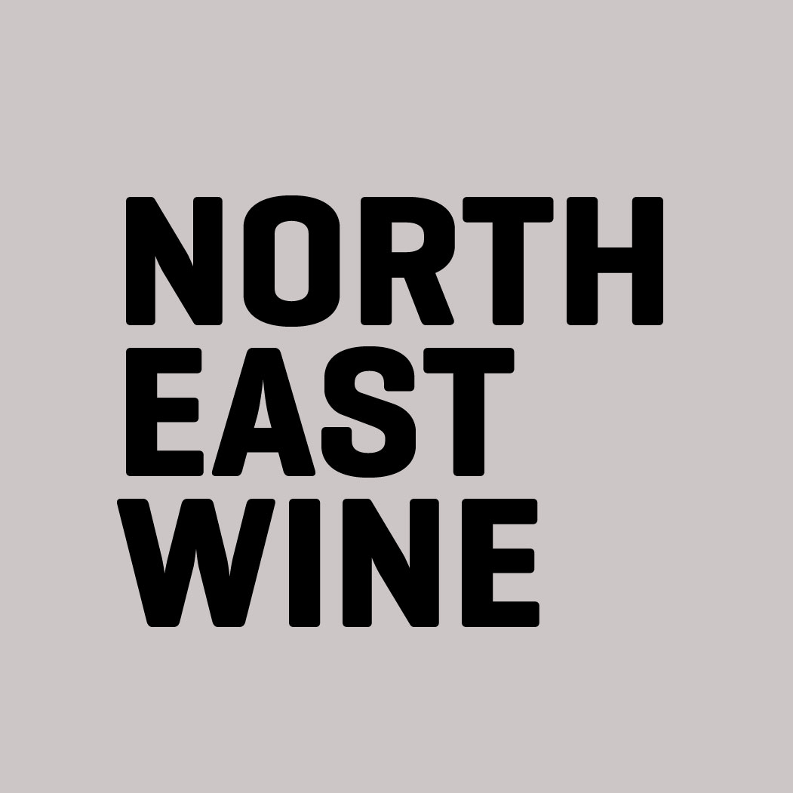

Bookings

The business offers the following methods for bookings and enquiries:
- Webportal
- Our forms have high contract boxes and submit boxes

Emergency Management
- Exit signs are clear and easy to see
- Exit access is free and clear at all times
We ensure exit access is free and clear at all times by:
There is no furniture near the exit access and it s used as a path to go in and out of the shop
- Exits and access to exists are greater than 900mm
- Exits including stairwells, have bright edges used on the steps.
- The evacuation point is clearly marked by a sign
- In addition, the following further information can assist guests:
We have only a patronage of 20 people - we would ensure each customer has left the building
- In addition, the following further information can assist guests:
We will help them down the couple of small steps at the front of the shop that they would have to climb to get into the shop/bar

Guide Dog and Service Animals
- The business provides a secure area with shade and water for service animals
- The business provides a toilet area for service animals
- Bowls, bedding, etc. are provided for service animals
The business provides the following services for services animals:
We have a dog bowl with fresh water. And shade outside and inside the bar/shop. There are bushes at the back of the shop for the "toilet" area and there are general red bins in that area to dispose of animal waste

GENERAL

Pre-arrival, arrival and reception
The business has the following in place to support guests during pre-arrival, arrival and reception
- Booking information and websites are compatible with screen readers
- A familiarisation tour
- Advertising material, web sites and social media contain information relating to phone numbers available for non-voice communication e: Text, SMS, email and fax
- A key to any accessible facilities that are locked
- In addition, the following further information can assist guests:
We only offer people seating and people cannot drink standing up so if there is room in the bar there will always be a seat available. For retail, we offer a quick service and no one waits more than 2 minutes and if they do and need a chair, there are usually plenty of spaces.

Cognitive Impairment Support
- Documents are available in plain English for people with cognitive impairment (This may include instructions, guides, menus and general information)
- In addition, the following further information can assist guests:
We do not provide parking for our customers

External Paths
External paths of travel
- Surfaces are concrete, asphalt, smooth paving or hard packed fine gravel (max aggregate size 13mm)
- Pathways are wider than 900mm
- There 3 successive steps or less on any path or at any doorway
- In addition, the following further information can assist guests:
We have two small steps required to enter the shop.

Steps
Steps
- There are steps.
- Top and bottom steps are easily distinguished through colour contrast or the use of TGSIs (Tactile Ground Surface Indicators)
- The underside of all staircases are enclosed or protected to a height of at least 2 metres
- Where steps are present are there three steps or less
- In addition, the following further information can assist guests:
We have a couple of small steps to enter and exit the shop

COMMON AREAS

FOOD AND DRINK

Dining Spaces
The dining spaces have the following facilities/amenities in place
- The doorway is at least 850mm wide
- There is level access through the dining area
- Chairs are moveable to allow for wheelchairs to be seated at the tables
- All glass doors and full height windows have contrast markings
- There are areas of full lighting
- There are Plain English menus
- There is an accessible toilet close by that is open during our business hours

Our business caters for the following dietary requirements
- Gluten free (celiac)
- Lactose free (dairy free)
- Vegetarian
- Vegan
- Kosher
- Halal
- In addition, the following further information can assist guests:
We serve platters. We have gluten free crackers available and ensure there is no gluten when preparing a gluten free board.
  - Food and Beverage Image(s)
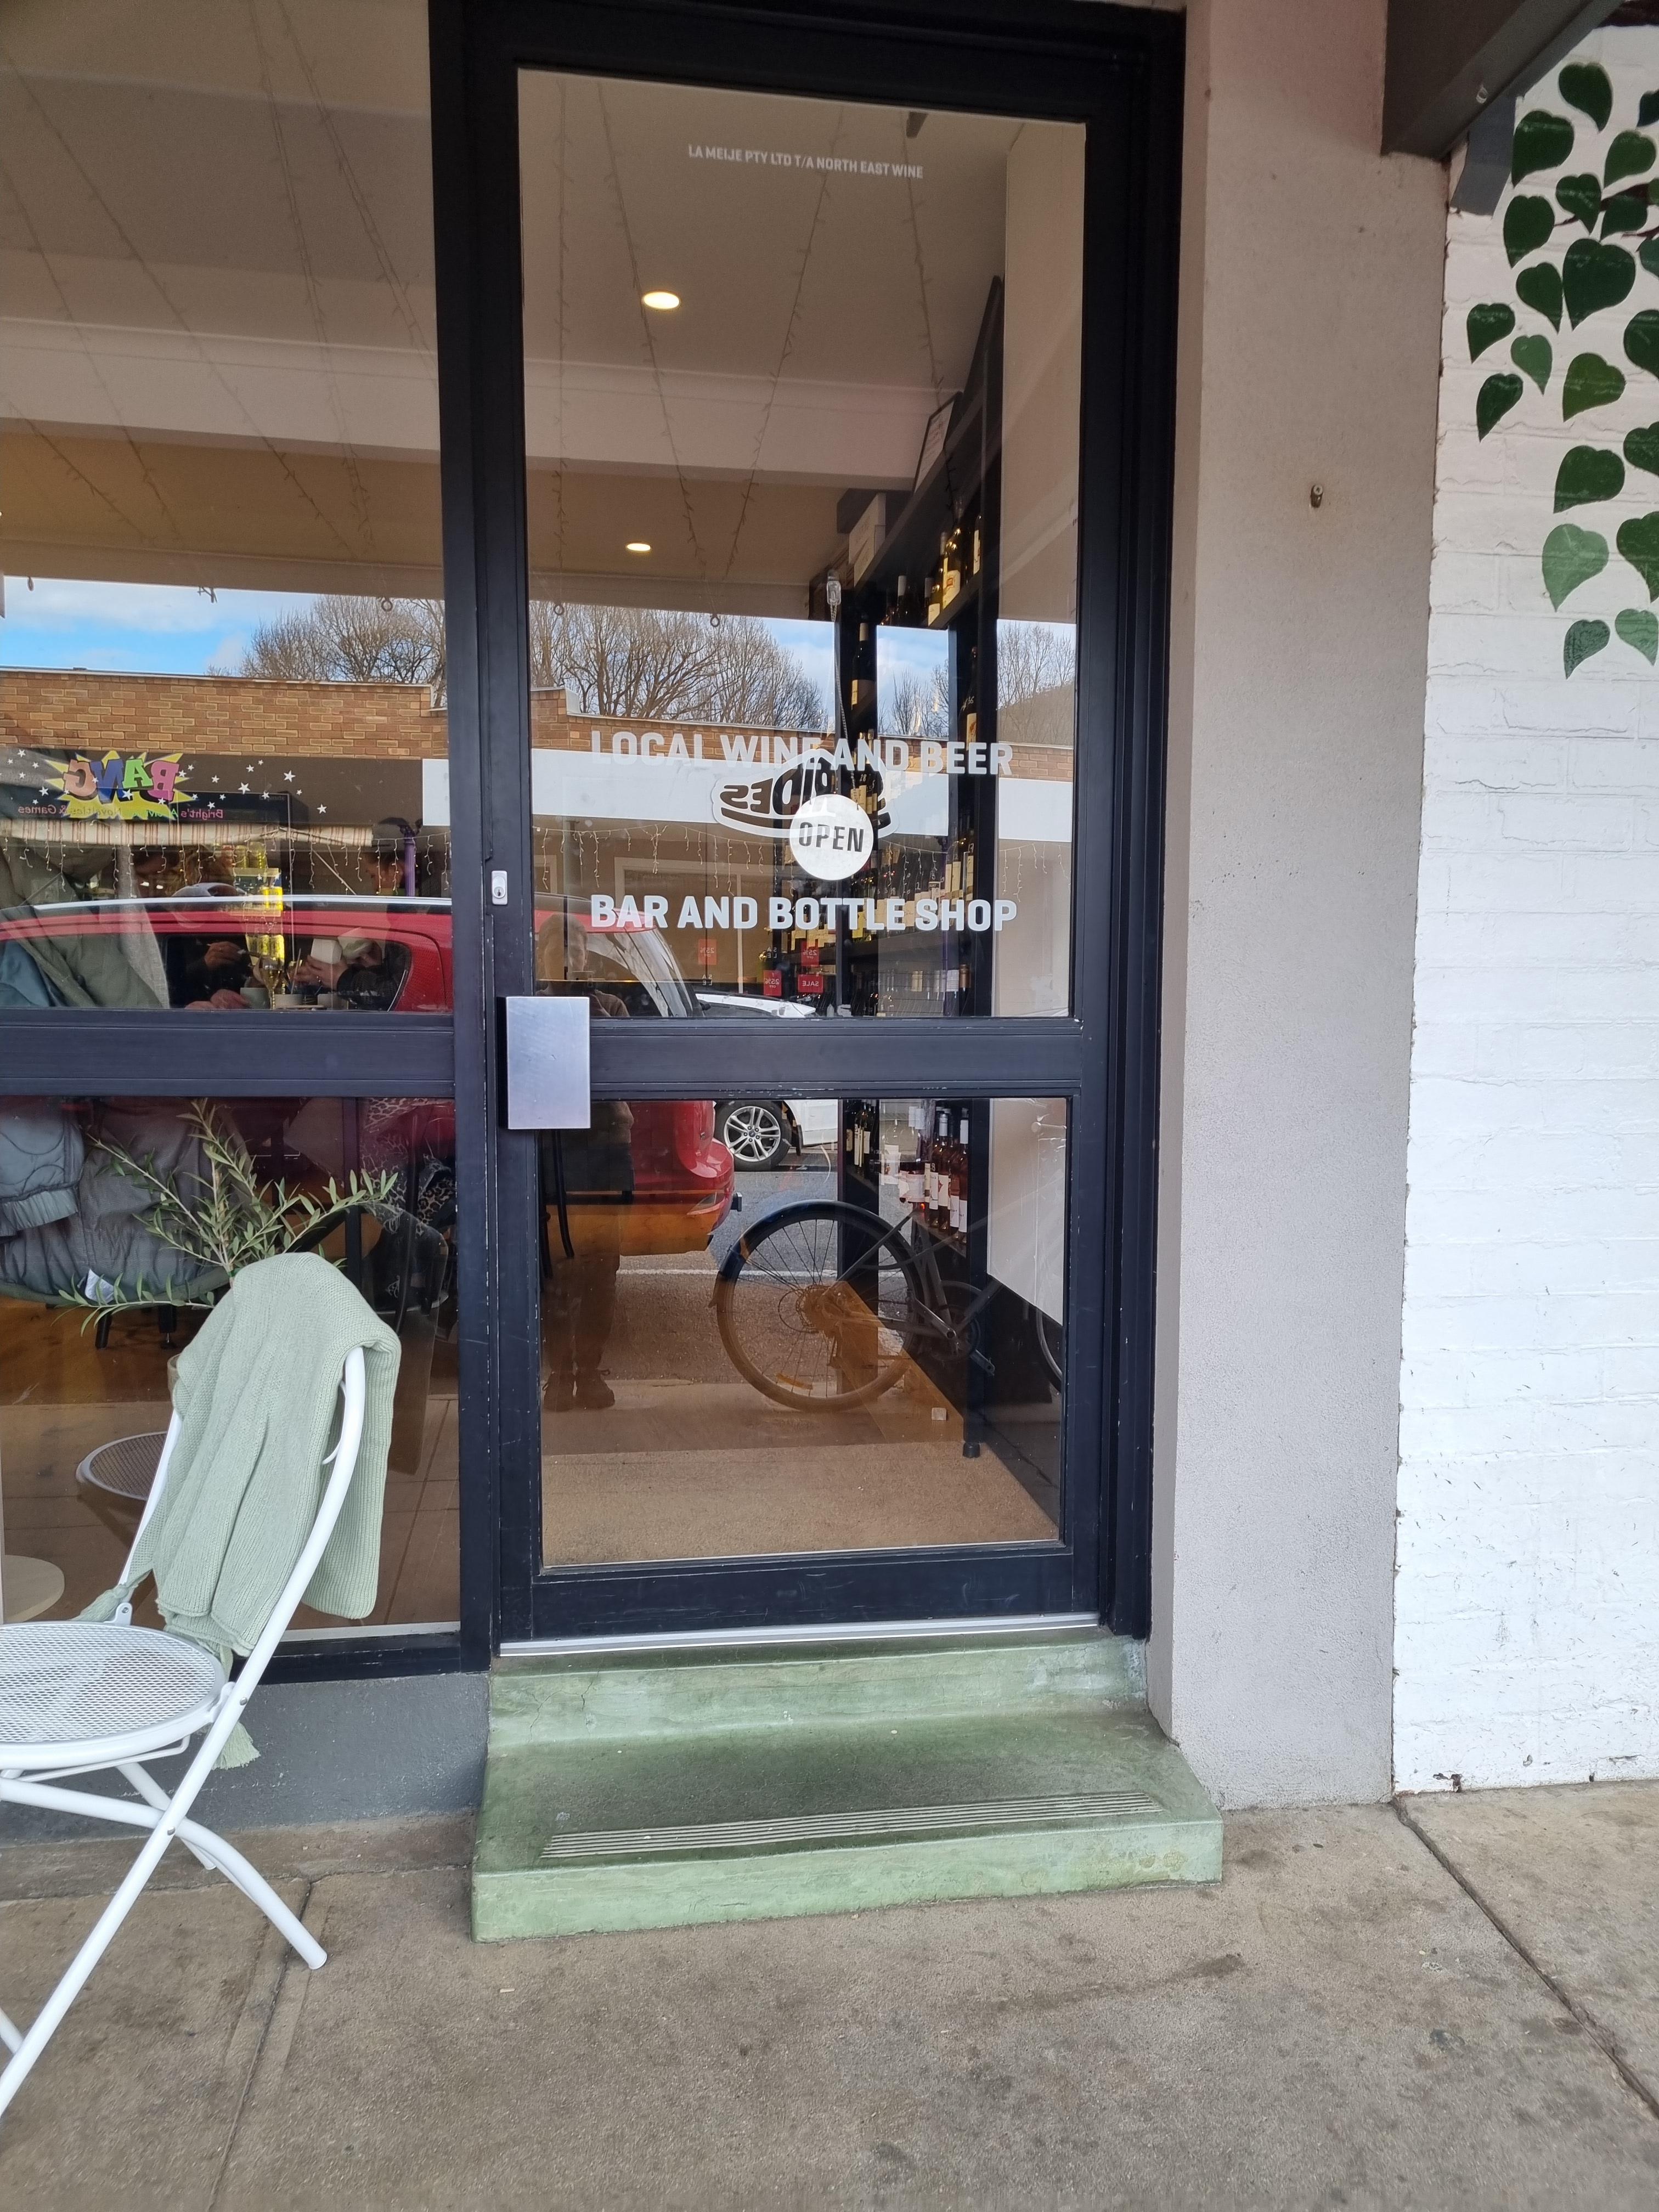
steps
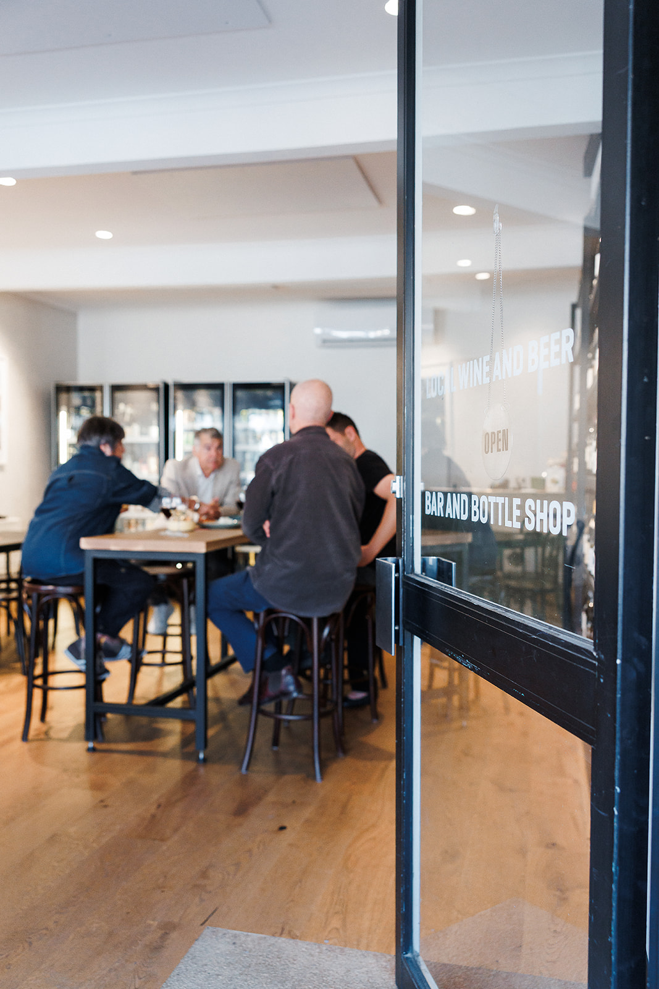
ASC 08.05.2026 (421 of 608)

Report Disclaimer
Please note that this business report, provided as a result of the use of the diagnostic assessment, is for information purposes only.
Australian Tourism Industry Council (ATIC) cannot guarantee the accuracy of respondent’s answers, or that they are fully representative of your business. Therefore, ATIC does not warrant or guarantee any particular outcome in respect of your businesses self-assessment.
This report is intended as guidance only for your business and should not be relied on for future marketing considerations. ATIC recommends that you seek your own independent advice as well as the results from the diagnostic.
Links to external web sites are inserted for convenience and do not constitute endorsement of material at those sites, or any associated organisation, product or service.
ATIC does not:
- Assume any legal liability for the accuracy, completeness, or usefulness of any information from this report or any links provided; or
- Accept responsibility for any loss associated directly or indirectly from the use of this report.

