ATIC Accessibility
To support the accessible community in making informed travel decisions for their individual needs

This report prepared for:
Business name: | My Coffee Cart
Address: | 17 Mundarra Road
Town: | Echuca
Contact for enquiries: | Daniel Mackrell
Contact Number: | 0407775387
Contact Email: | sales@mycoffeecart.com.au
Website: | https://www.mycoffeecart.com.au
Date: | 2026-09-21 04:05

ATIC Accessibility
The following pages provides travellers with information on the businesses facilities and amenities which aims to support the traveller to make an informed decision on whether the business is suitable for their individual needs.
OVERVIEW 3
Business Overview 3
Bookings 5
Communications 5
Guide Dog and Service Animals 5
GENERAL 6
Cognitive Impairment Support 6
Internal Spaces 6
External Paths 6
FOOD AND DRINK 7
Dining Spaces 7
Report Disclaimer 9

OVERVIEW

Business Overview

The business has the following products/services available
- Food and Drink

Our business caters for the following disability types:
- Blind or low vision
- Deaf or low hearing
- Limited mobility
- Wheelchairs or mobility scooters
- Food allergies or intolerances
- Cognitive or people on the Autism Spectrum
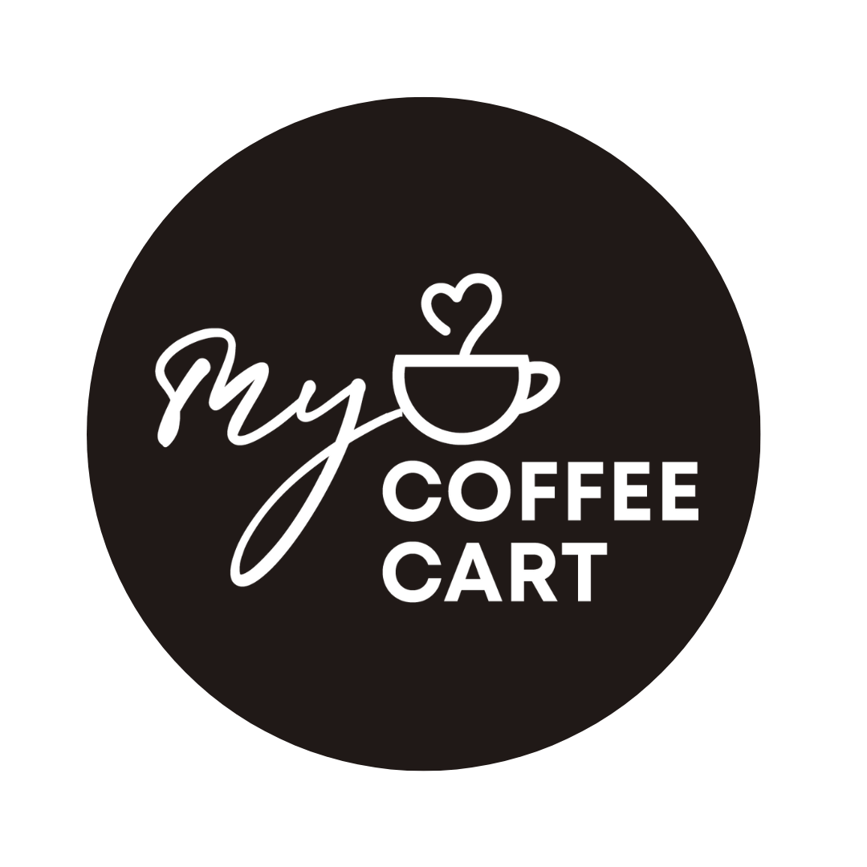

Bookings

The business offers the following methods for bookings and enquiries:
- Phone
- Email
- Webportal
- Our forms have high contract boxes and submit boxes

We attend sites as a value-add service and adhere to the places policies and instructions

Communications
- Our business offers the following alternative communication methods
- Plain English

Not specified
- There is easy to read signage and information (e.g. menus and emergency information)

Guide Dog and Service Animals
The business provides the following services for services animals:
Service animals are treated with respect and we will have available water as required.

GENERAL
- In addition, the following further information can assist guests:
Our service is extremely quick and have staffing at suitable levels. Where required we assist people as needed

Cognitive Impairment Support
- Documents are available in plain English for people with cognitive impairment (This may include instructions, guides, menus and general information)
- In addition, the following further information can assist guests:
We attend sites as a value-add service and adhere to the places policies and instructions

Internal Spaces
- Menus are available in large print or Braille

External Paths
External paths of travel
- Surfaces are concrete, asphalt, smooth paving or hard packed fine gravel (max aggregate size 13mm)
- Pathways are wider than 900mm

We attend sites as a value-add service and adhere to the places policies and instructions

We attend sites as a value-add service and adhere to the places policies and instructions
- In addition, the following further information can assist guests:
We attend sites as a value-add service and adhere to the places policies and instructions
- In addition, the following further information can assist guests:
We attend sites as a value-add service and adhere to the places policies and instructions

FOOD AND DRINK

Dining Spaces
The dining spaces have the following facilities/amenities in place
- The entrance has level access
- The smallest doorway is We attend sites as a value-add service and adhere to the places policies and instructions wide
- Chairs are moveable to allow for wheelchairs to be seated at the tables
- There are areas of full lighting
- There are large print menus
- There are Plain English menus

Our business caters for the following dietary requirements
- Sugar free (diabetic)
- Gluten free (celiac)
- Lactose free (dairy free)
- Low fat and fibre with no gastric content
- Nut free
- Additive free
- Organic
- Vegetarian
- Vegan
- In addition, the following further information can assist guests:
We utilise different jug ware that is labelled and wash hands as per protocol
  - Food and Beverage Image(s)

Report Disclaimer
Please note that this business report, provided as a result of the use of the diagnostic assessment, is for information purposes only.
Australian Tourism Industry Council (ATIC) cannot guarantee the accuracy of respondent’s answers, or that they are fully representative of your business. Therefore, ATIC does not warrant or guarantee any particular outcome in respect of your businesses self-assessment.
This report is intended as guidance only for your business and should not be relied on for future marketing considerations. ATIC recommends that you seek your own independent advice as well as the results from the diagnostic.
Links to external web sites are inserted for convenience and do not constitute endorsement of material at those sites, or any associated organisation, product or service.
ATIC does not:
- Assume any legal liability for the accuracy, completeness, or usefulness of any information from this report or any links provided; or
- Accept responsibility for any loss associated directly or indirectly from the use of this report.

