ATIC Accessibility
To support the accessible community in making informed travel decisions for their individual needs

This report prepared for:
Business name: | Barossa Bespoke Tours
Address: | 2/1 Aveland Avenue
Town: | Trinity Gardens
Contact for enquiries: | Kym Farley
Contact Number: | 0432871636
Contact Email: | kym@barossabespoketours.com.au
Website: | https://www.barossabespoketours.com.au/
Date: | 2026-10-23 22:55

ATIC Accessibility
The following pages provides travellers with information on the businesses facilities and amenities which aims to support the traveller to make an informed decision on whether the business is suitable for their individual needs.
OVERVIEW 4
Business Overview 4
Bookings 4
Emergency Management 5
Communications 5
Other Information 5
Guide Dog and Service Animals 5
GENERAL 6
Pre-arrival, arrival and reception 6
Cognitive Impairment Support 6
Car Park and Access amenities 6
External Paths 6
TOUR OPERATORS 8
Route Planning 8
Guides 8
Report Disclaimer 10

OVERVIEW

Business Overview

The business has the following products/services available
- Tour/Transport

Our business caters for the following disability types:
- Blind or low vision
- Deaf or low hearing
- Limited mobility
- Food allergies or intolerances
- Cognitive or people on the Autism Spectrum
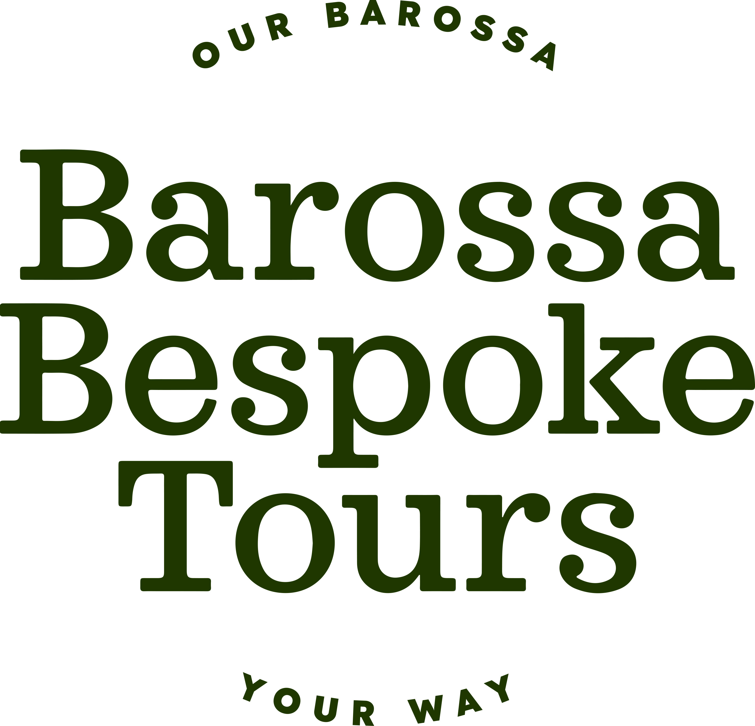

Bookings

The business offers the following methods for bookings and enquiries:
- Phone
- Email
- Webportal
- Our website supports Screen Readers
- Our forms have high contract boxes and submit boxes
- Staff have undergone disability awareness and training

Emergency Management

https://www.barossa.com/
- Guests with disabilities are noted in the guest log book for emergency and evacuation purposes

Communications
- Our website meets WCAG 2.0 accessibility standards

Other Information
- The business accepts the companion card

Guide Dog and Service Animals
- The business provides a secure area with shade and water for service animals
The business provides the following services for services animals:
We will accept service animals on the tour and go to places that they are accepted and where it is appropriate

GENERAL

Pre-arrival, arrival and reception
The business has the following in place to support guests during pre-arrival, arrival and reception
- Booking information and websites are compatible with screen readers
- Information and maps are available in written form
- In addition, the following further information can assist guests:
All destinations on the tour are pre-booked to avoid any wait times

Cognitive Impairment Support
- Documents are available in plain English for people with cognitive impairment (This may include instructions, guides, menus and general information)
- Quiet periods or early opening times for people on the Autism Spectrum
- A space for parents and children on the Autism Spectrum

Car Park and Access amenities
The business has the following Car Park and Access amenities
- A drop off zone
- Designated disabled parking bays
- Level or ramped access from the car park to the entrance
- The accessible entrance is clearly signed from the parking bay
- In addition, the following further information can assist guests:
I pick up guests from their accommodation

External Paths
External paths of travel
- Surfaces are concrete, asphalt, smooth paving or hard packed fine gravel (max aggregate size 13mm)
- Paths or slopes longer than 15 metres have resting places or seats
- Pathways are wider than 900mm
- There 3 successive steps or less on any path or at any doorway
- Any paths having steps are clearly identified as non-wheelchair accessible
- Step free routes clearly signed
- In addition, the following further information can assist guests:
The destinations that I take all guests too will have all of these requirements

TOUR OPERATORS

Route Planning
- Route Planning
- The tour route includes stops with accessible toilet facilities
- Lunch stop venues are accessible
- Sightseeing and photo opportunity stops are step free

Guides
- Use of clear/simple English
- Correct pronunciation for lip readers
- In addition, the following further information can assist guests:
Harvest Kitchen https://www.harvest-kitchen.com.au/
First Drop Wines https://firstdropwines.com/?srsltid=AfmBOoq7dyIiZPWwaNMpEAfMYqe5bQpsjJE3hkm1BHqfLSi-bay3dqRx
Vintners https://www.vintners.com.au/

Report Disclaimer
Please note that this business report, provided as a result of the use of the diagnostic assessment, is for information purposes only.
Australian Tourism Industry Council (ATIC) cannot guarantee the accuracy of respondent’s answers, or that they are fully representative of your business. Therefore, ATIC does not warrant or guarantee any particular outcome in respect of your businesses self-assessment.
This report is intended as guidance only for your business and should not be relied on for future marketing considerations. ATIC recommends that you seek your own independent advice as well as the results from the diagnostic.
Links to external web sites are inserted for convenience and do not constitute endorsement of material at those sites, or any associated organisation, product or service.
ATIC does not:
- Assume any legal liability for the accuracy, completeness, or usefulness of any information from this report or any links provided; or
- Accept responsibility for any loss associated directly or indirectly from the use of this report.

