ATIC Accessibility
To support the accessible community in making informed travel decisions for their individual needs

This report prepared for:
Business name: | Dabungool Cultural Experiences
Address: | 23 Dalyup Drive
Town: | Nulsen
Contact for enquiries: | Julie Dabb
Contact Number: | 0455031797
Contact Email: | dabungool@hotmail.com
Website: | www.dabungool.com.au
Date: | 2026-09-21 02:24

ATIC Accessibility
The following pages provides travellers with information on the businesses facilities and amenities which aims to support the traveller to make an informed decision on whether the business is suitable for their individual needs.
OVERVIEW 4
Business Overview 4
Bookings 5
Emergency Management 5
Communications 6
Other Information 6
Guide Dog and Service Animals 6
GENERAL 7
Pre-arrival, arrival and reception 7
Cognitive Impairment Support 7
Car Park and Access amenities 7
External Paths 7
Steps 8
TOUR OPERATORS 9
Route Planning 9
Guides 9
ATTRACTIONS 10
COMMON AREAS 11
Parks and gardens 11
FOOD AND DRINK 13
Dining Spaces 13
ADVENTURE ACTIVITIES 14
Report Disclaimer 16

OVERVIEW

Business Overview

The business has the following products/services available
- Tour/Transport
- Attraction
- Food and Drink
- Adventure

Our business caters for the following disability types:
- Blind or low vision
- Deaf or low hearing
- Limited mobility
- Wheelchairs or mobility scooters
- Food allergies or intolerances
- Cognitive or people on the Autism Spectrum
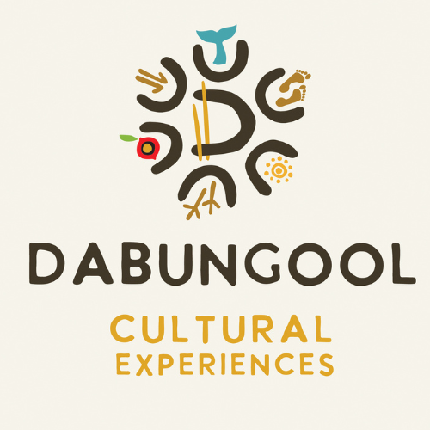

Bookings

The business offers the following methods for bookings and enquiries:
- Phone
- Email
- Webportal
- Our forms have high contract boxes and submit boxes
- Staff have undergone disability awareness and training

Emergency Management
- The business has an emergency management and evacuation plan for guests with a disability
- Emergency and evacuation procedures are explained on arrival

Communications
- Our business offers the following alternative communication methods
- Plain English

Not specified
- There is easy to read signage and information (e.g. menus and emergency information)

Other Information
- For bookings made onsite, the ticket booth/counter/box office is accessible for people using a wheelchair
- The business accepts the companion card

Guide Dog and Service Animals
- The business provides a secure area with shade and water for service animals
- The business provides a toilet area for service animals
The business provides the following services for services animals:
We only offer 1 Tour that accommodates bringing animals other tours are in National Parks. As long as you have reasonable proof that they are an assistance animal, you can bring your trained assistance animal, including guide dogs and hearing dogs, into areas open to the public.

GENERAL

Pre-arrival, arrival and reception
The business has the following in place to support guests during pre-arrival, arrival and reception
- Information and maps are available in written form
- In addition, the following further information can assist guests:
Toilets are Public toilets

Cognitive Impairment Support
- Documents are available in plain English for people with cognitive impairment (This may include instructions, guides, menus and general information)
- A "social script" guide to your premises or attraction describing the sights, sounds and smells to aid parents/carers prepare visitors in advance
- Quiet periods or early opening times for people on the Autism Spectrum

Car Park and Access amenities
The business has the following Car Park and Access amenities
- Designated disabled parking bays
- Level or ramped access from the car park to the entrance
- The accessible entrance is clearly signed from the parking bay

External Paths
External paths of travel
- Surfaces are concrete, asphalt, smooth paving or hard packed fine gravel (max aggregate size 13mm)
- Paths or slopes longer than 15 metres have resting places or seats
- Pathways are wider than 900mm
- There 3 successive steps or less on any path or at any doorway
- Any paths having steps are clearly identified as non-wheelchair accessible
- In addition, the following further information can assist guests:
Steps are in a National Park

Steps
Steps
- There are steps.
- Handrails fitted to all open sets of steps
- Handrails extend 300mm beyond the top and bottom step
- In addition, the following further information can assist guests:
This is a Shire Based Nature Trail
- In addition, the following further information can assist guests:
Walk Trails are in National Park and Shire Based Nature Reserve

TOUR OPERATORS

Route Planning
- In addition, the following further information can assist guests:
No Applicable
- Walking Tours
- Operated on a step free route
- Multi-paced to account for slower walkers

Guides

Guides have been trained in the following
- Use of clear/simple English
- Correct pronunciation for lip readers

ATTRACTIONS

COMMON AREAS

Parks and gardens
- The following parks and gardens amenities are available
- Accessible toilets
- Direction signage contains distances
- The park or garden contains sensory experiences
- Accessible picnic tables
- Accessible BBQs
- The park contains an observation deck or tower
- Handrails and stairs are built as per state/territory building code.
- Slip resistance surfaces are used.
- A handrail is available and at 865-965mm in height.
- The handrail is continuously graspable along entire length at least one side.
  - Parks and Gardens Stair entry and exit Image(s)
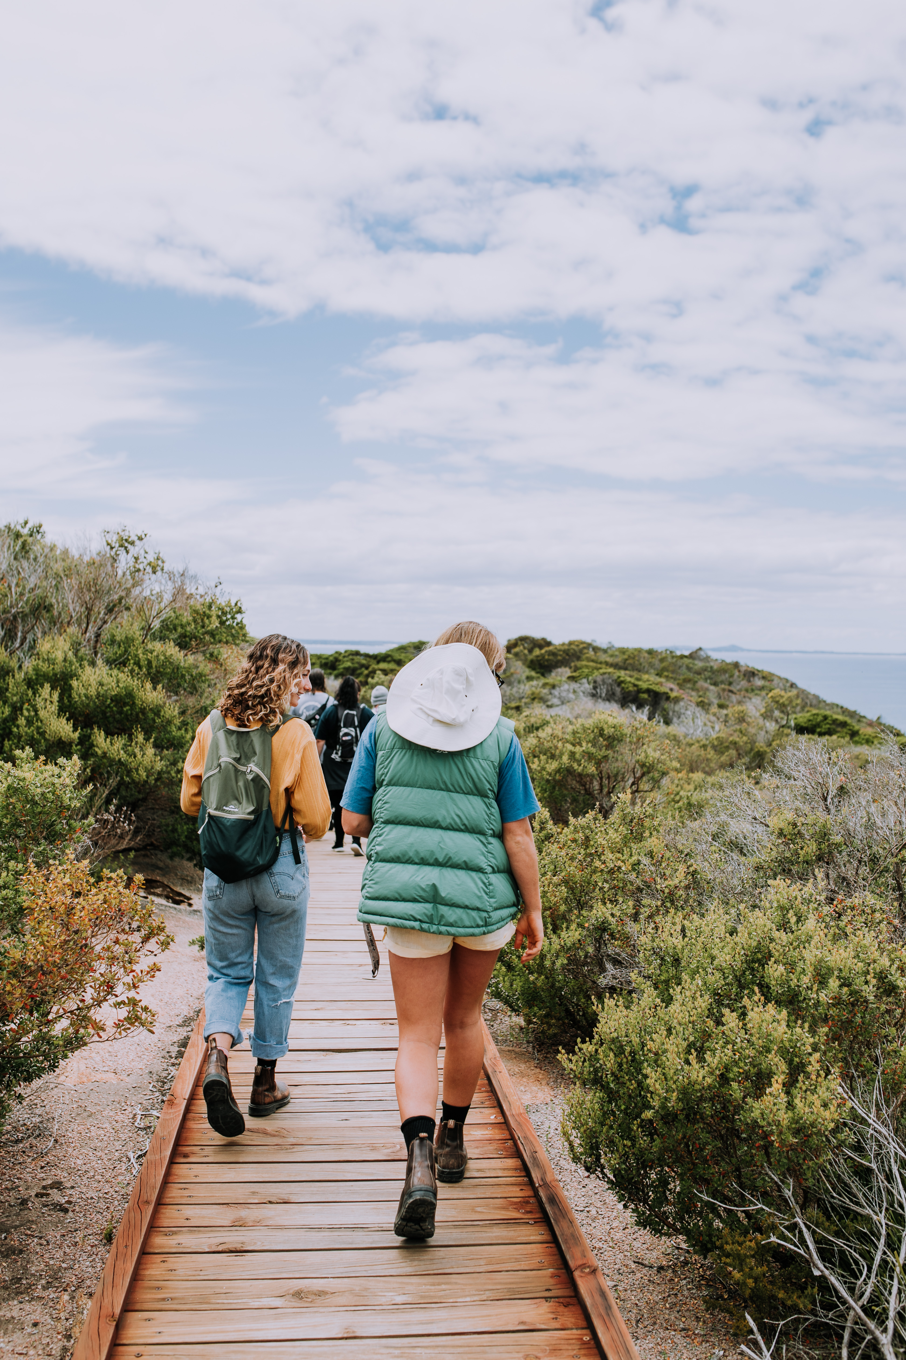
2021 ET Dabungool Tour_byRosieHenderson_MG_9072
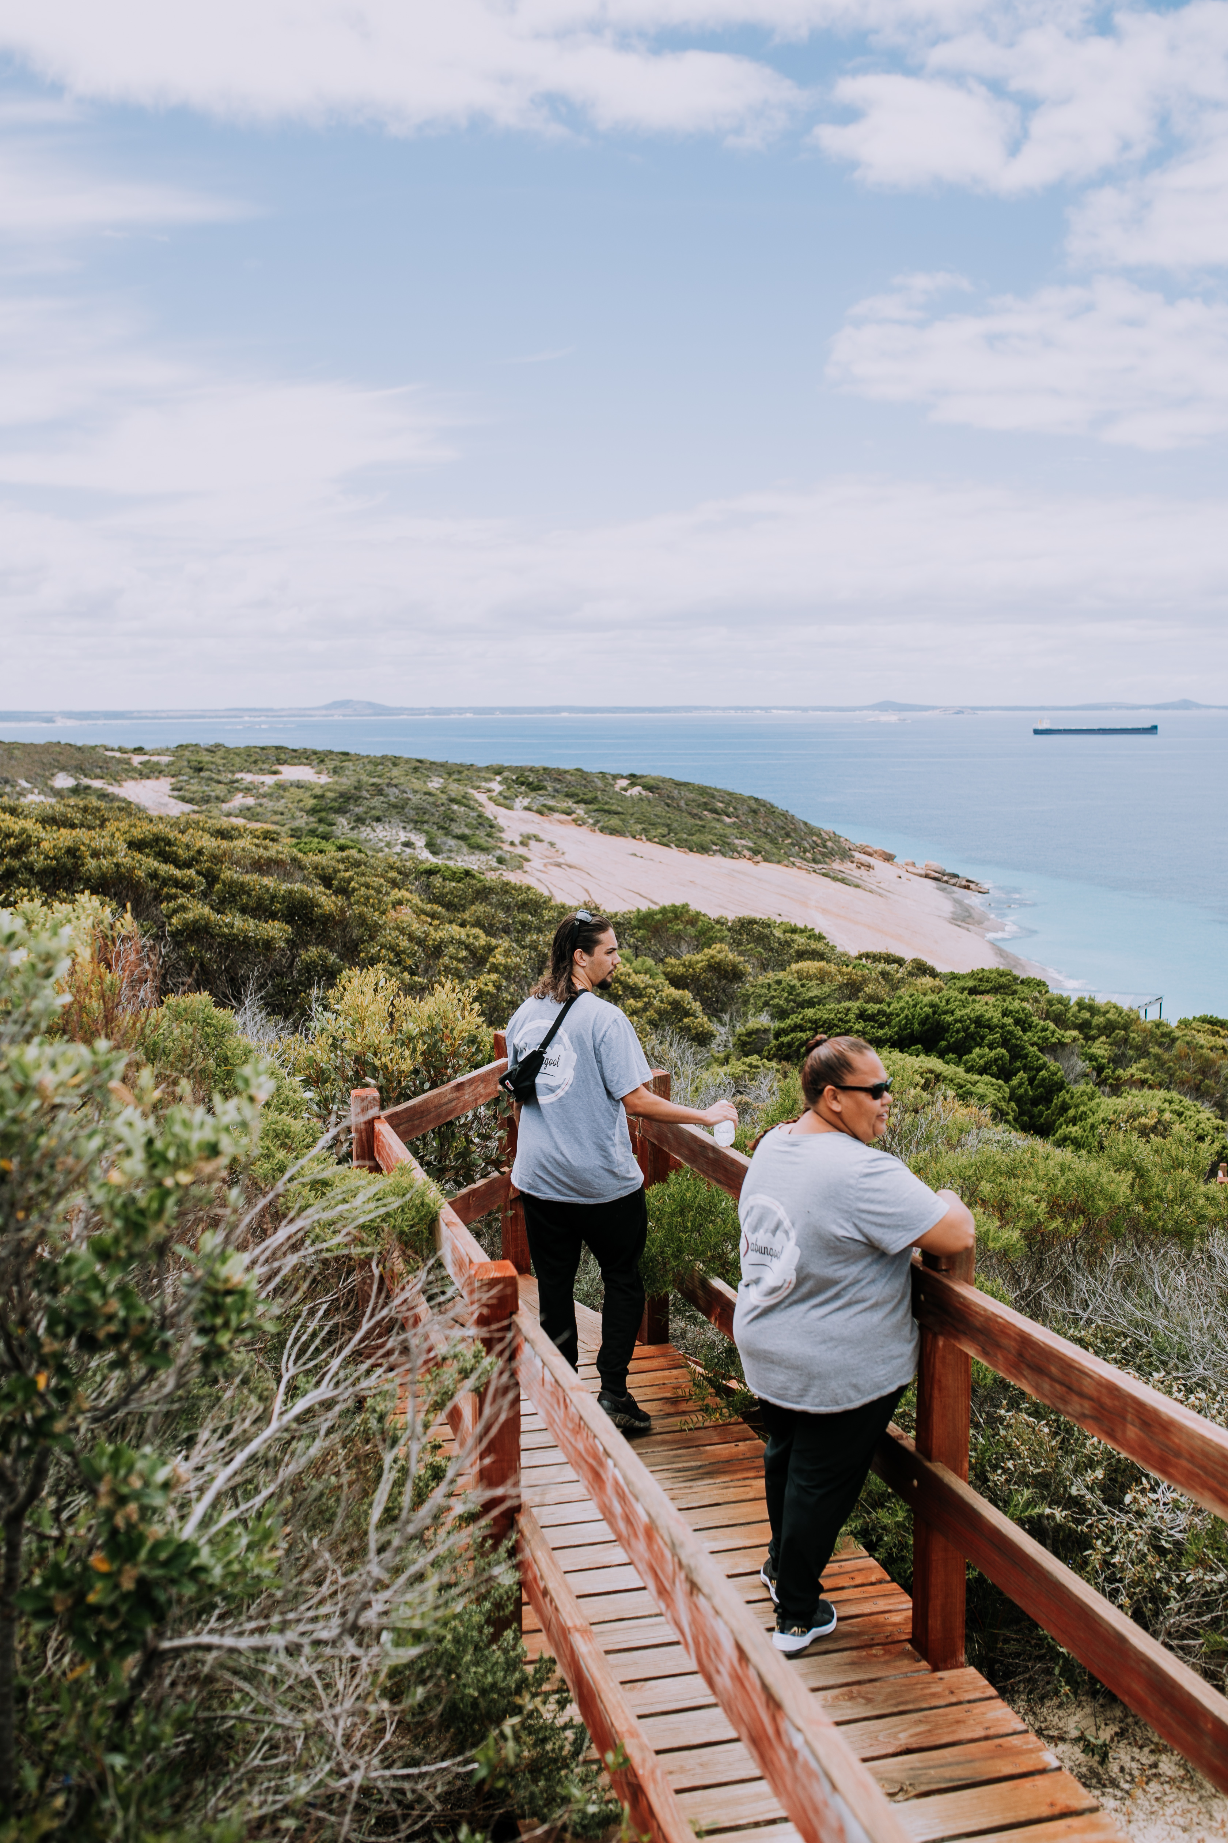
2021 ET Dabungool Tour_byRosieHenderson_MG_9088

FOOD AND DRINK

Dining Spaces
The dining spaces have the following facilities/amenities in place
- The smallest doorway is We don't have a building wide
- There is an accessible toilet

Our business caters for the following dietary requirements
- Sugar free (diabetic)
- Gluten free (celiac)
- Lactose free (dairy free)
- Low fat and fibre with no gastric content
- Low potassium
- Low sodium
- Nut free
- Additive free
- Organic
- Vegetarian
- Vegan
- Kosher
- In addition, the following further information can assist guests:
We offer ready made food.

ADVENTURE ACTIVITIES

Report Disclaimer
Please note that this business report, provided as a result of the use of the diagnostic assessment, is for information purposes only.
Australian Tourism Industry Council (ATIC) cannot guarantee the accuracy of respondent’s answers, or that they are fully representative of your business. Therefore, ATIC does not warrant or guarantee any particular outcome in respect of your businesses self-assessment.
This report is intended as guidance only for your business and should not be relied on for future marketing considerations. ATIC recommends that you seek your own independent advice as well as the results from the diagnostic.
Links to external web sites are inserted for convenience and do not constitute endorsement of material at those sites, or any associated organisation, product or service.
ATIC does not:
- Assume any legal liability for the accuracy, completeness, or usefulness of any information from this report or any links provided; or
- Accept responsibility for any loss associated directly or indirectly from the use of this report.

