ATIC Accessibility
To support the accessible community in making informed travel decisions for their individual needs

This report prepared for:
Business name: | All Seasons Holiday Park
Address: | 818 fifteenth street
Town: | Mildura
Contact for enquiries: | Lucy Bromley
Contact Number: | 1800223375
Contact Email: | info@allseasonscaravanpark.com.au
Website: | https://allseasonsholidaypark.com.au/
Date: | 2026-08-07 18:21

ATIC Accessibility
The following pages provides travellers with information on the businesses facilities and amenities which aims to support the traveller to make an informed decision on whether the business is suitable for their individual needs.
OVERVIEW 4
Business Overview 4
Bookings 4
Emergency Management 4
Communications 5
Other Information 5
Guide Dog and Service Animals 6
GENERAL 7
Pre-arrival, arrival and reception 7
Cognitive Impairment Support 7
Car Park and Access amenities 7
Entry 7
Internal Spaces 8
Public areas 8
External Paths 8
Steps 9
Ramps 9
Public Toilets/Adult change facilities 9
ACCOMMODATION 10
Bedrooms 10
Room Amenities 11
Bathrooms 11
COMMON AREAS 14
Play Spaces 14
Swimming pools, spas and waterparks 14
Report Disclaimer 16

OVERVIEW

Business Overview

The business has the following products/services available
- Accommodation

Our business caters for the following disability types:
- Blind or low vision
- Limited mobility
- Wheelchairs or mobility scooters
- Food allergies or intolerances
- Cognitive or people on the Autism Spectrum
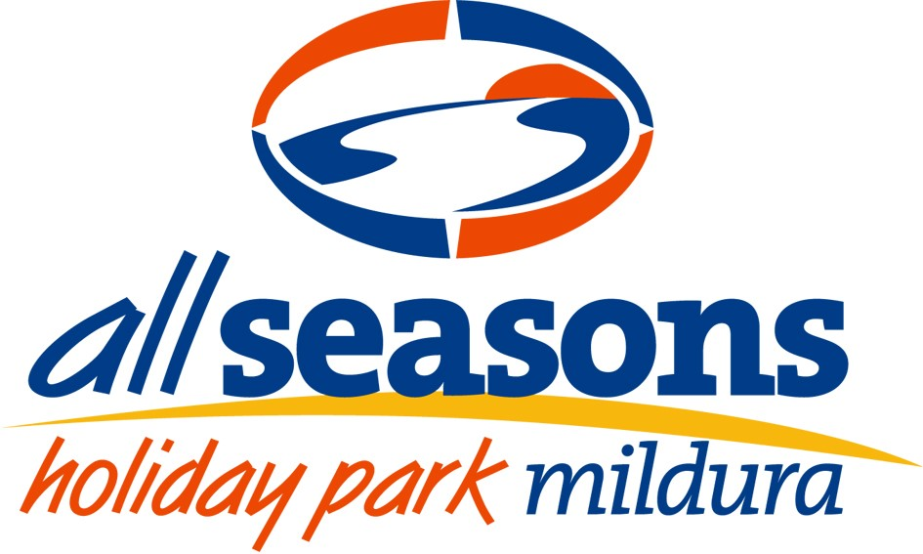

Bookings

The business offers the following methods for bookings and enquiries:
- Phone
- Email
- Webportal
- Our forms have high contract boxes and submit boxes

Emergency Management
- There are Audible device/s to alert occupants to evacuate with instructions on how to evacuate.
- Exit signs are clear and easy to see
- Exit access is free and clear at all times
We ensure exit access is free and clear at all times by:
All team members are trained in our emergency evacuation procedures, which include keeping exit routes clear at all times. Housekeeping, maintenance, and reception staff check all exits during their routine rounds, and any issues are reported and resolved immediately.
- Exits and access to exists are greater than 900mm
- Exit doors are able to be opened by all occupants
- Exits to the emergency evacuation point does not include stairways
- The evacuation point is clearly marked by a sign
The business identifies guests who need additional assistance should an emergency occur by:
This is noted on bookings and bookings in accessible cabins are in a seperate category
The procedure for assisting guests who need assisted rescue is:
Staff are trained to assist guests with mobility, sensory, or cognitive needs during emergencies. This includes guiding guests with low vision by arm and providing clear, calm instructions. We ensure a staff member stays with the guest throughout the evacuation to offer reassurance and support.
- Guests with disabilities are noted in the guest log book for emergency and evacuation purposes

Communications
- Our business offers the following alternative communication methods
- Plain English
- Braille Displays

Not specified
- There is easy to read signage and information (e.g. menus and emergency information)

Other Information
- The business accepts the companion card

Guide Dog and Service Animals
- The business provides a secure area with shade and water for service animals
- The business provides a toilet area for service animals
The business provides the following services for services animals:
Service animals are welcome in any cabin as well as public areas

GENERAL

Pre-arrival, arrival and reception
The business has the following in place to support guests during pre-arrival, arrival and reception
- There is a reception/public entryway.
- A clipboard to allow check-in/ticket purchase whilst seated
- A tablet with text to voice or pen and paper at reception to aid in communication
- Lighting in the reception area is even and glare free
- Large print information sheets and registration forms
- Information and maps are available in written form
- Advertising material, web sites and social media contain information relating to phone numbers available for non-voice communication e: Text, SMS, email and fax
- A key to any accessible facilities that are locked
- Luggage assistance
- In addition, the following further information can assist guests:
Staff are trained to recognise signs of fatigue and proactively offer seating, water, or alternative arrangements to minimise wait times.

Cognitive Impairment Support
- Access has alternative procedures and clear written instructions with universal access symbols

Car Park and Access amenities
The business has the following Car Park and Access amenities
- A drop off zone
- The public transport services available are:

Verbal information from reception staff

Entry
The business has the following amenities/systems in place for entry
- A drop off point close to the entrance
- A path of access to the building is slip resistance and even
- A path of access to the building is clear of obstruction
- Self opening entry doors or fitted with a self closer
- Glass doors are fitted with a visual sighting strip
- Door jams/doors are of a contrasting colour to surrounding walls
- Door handles are of a contrasting colour to the door
- Signage is written in a contrasting colour
- Signage is written in a Sans Serif font and use upper and lower case letters
- The entry door is a minimum of 850mm wide
- The entry door has self opening or a light opening pressure (for manual operations)
- There a clear space of at least 1500mm x 1500mm in front of all doors.
- The entrance door mats have a thickness less than 13mm and a width of 7500mm or greater

Internal Spaces
- Clear and unobstructed routes through and between buildings
- Interior walls are matte or low sheen
- Floors, walls, counters and furniture are of contrasting colours
- Any protruding or overhanging obstructions are at least 2meters above the floor or are protected
- Floor surfaces are hard or short pile carpet
- Accessible facilities are clearly signed and visible from all areas
- All corridors greater than 900mm

Public areas
The public areas have the following amenities in place
- Even lighting
- Seating

External Paths
External paths of travel
- Surfaces are concrete, asphalt, smooth paving or hard packed fine gravel (max aggregate size 13mm)
- Pathways are wider than 900mm
- There 3 successive steps or less on any path or at any doorway

No paths with steps within the park

Steps
Steps
- There are steps.
- Handrails fitted to all open sets of steps
- Handrails extend 300mm beyond the top and bottom step
- Where steps are present are there three steps or less

Ramps
Ramps have the following amenities are in place
- There are ramps.
- All fixed ramps are 1:14 or less
- Hand rails are fitted
- Long ramps (more than 10m) are 1:20 or less
- In addition, the following further information can assist guests:
Ramps are fitted with non-slip grip tape to reduce the risk of slipping

Public Toilets/Adult change facilities
Public Toilets/Adult change facilities have the following amenities are in place
- There is an accessible toilet for public use
- The door is at least 850mm wide
- There is a minimum of 850mm beside the toilet
- Handrails are fitted
- The toilet seat is 460mm above the floor
- The toilet seat of a contrasting colour to the floor
- The toilet seat is460mm above the floor
- In addition, the following further information can assist guests:
Additional assistive technology, such as hoists, is available for hire and can be delivered by our neighbouring provider, Country Care Mildura.

ACCOMMODATION

Bedrooms
The bedrooms have the following facilities/amenities in place
- There are 3 rooms available to guests who use a wheelchair
- Bedroom furniture can be re-arranged on request
  - Layout of room Image(s)
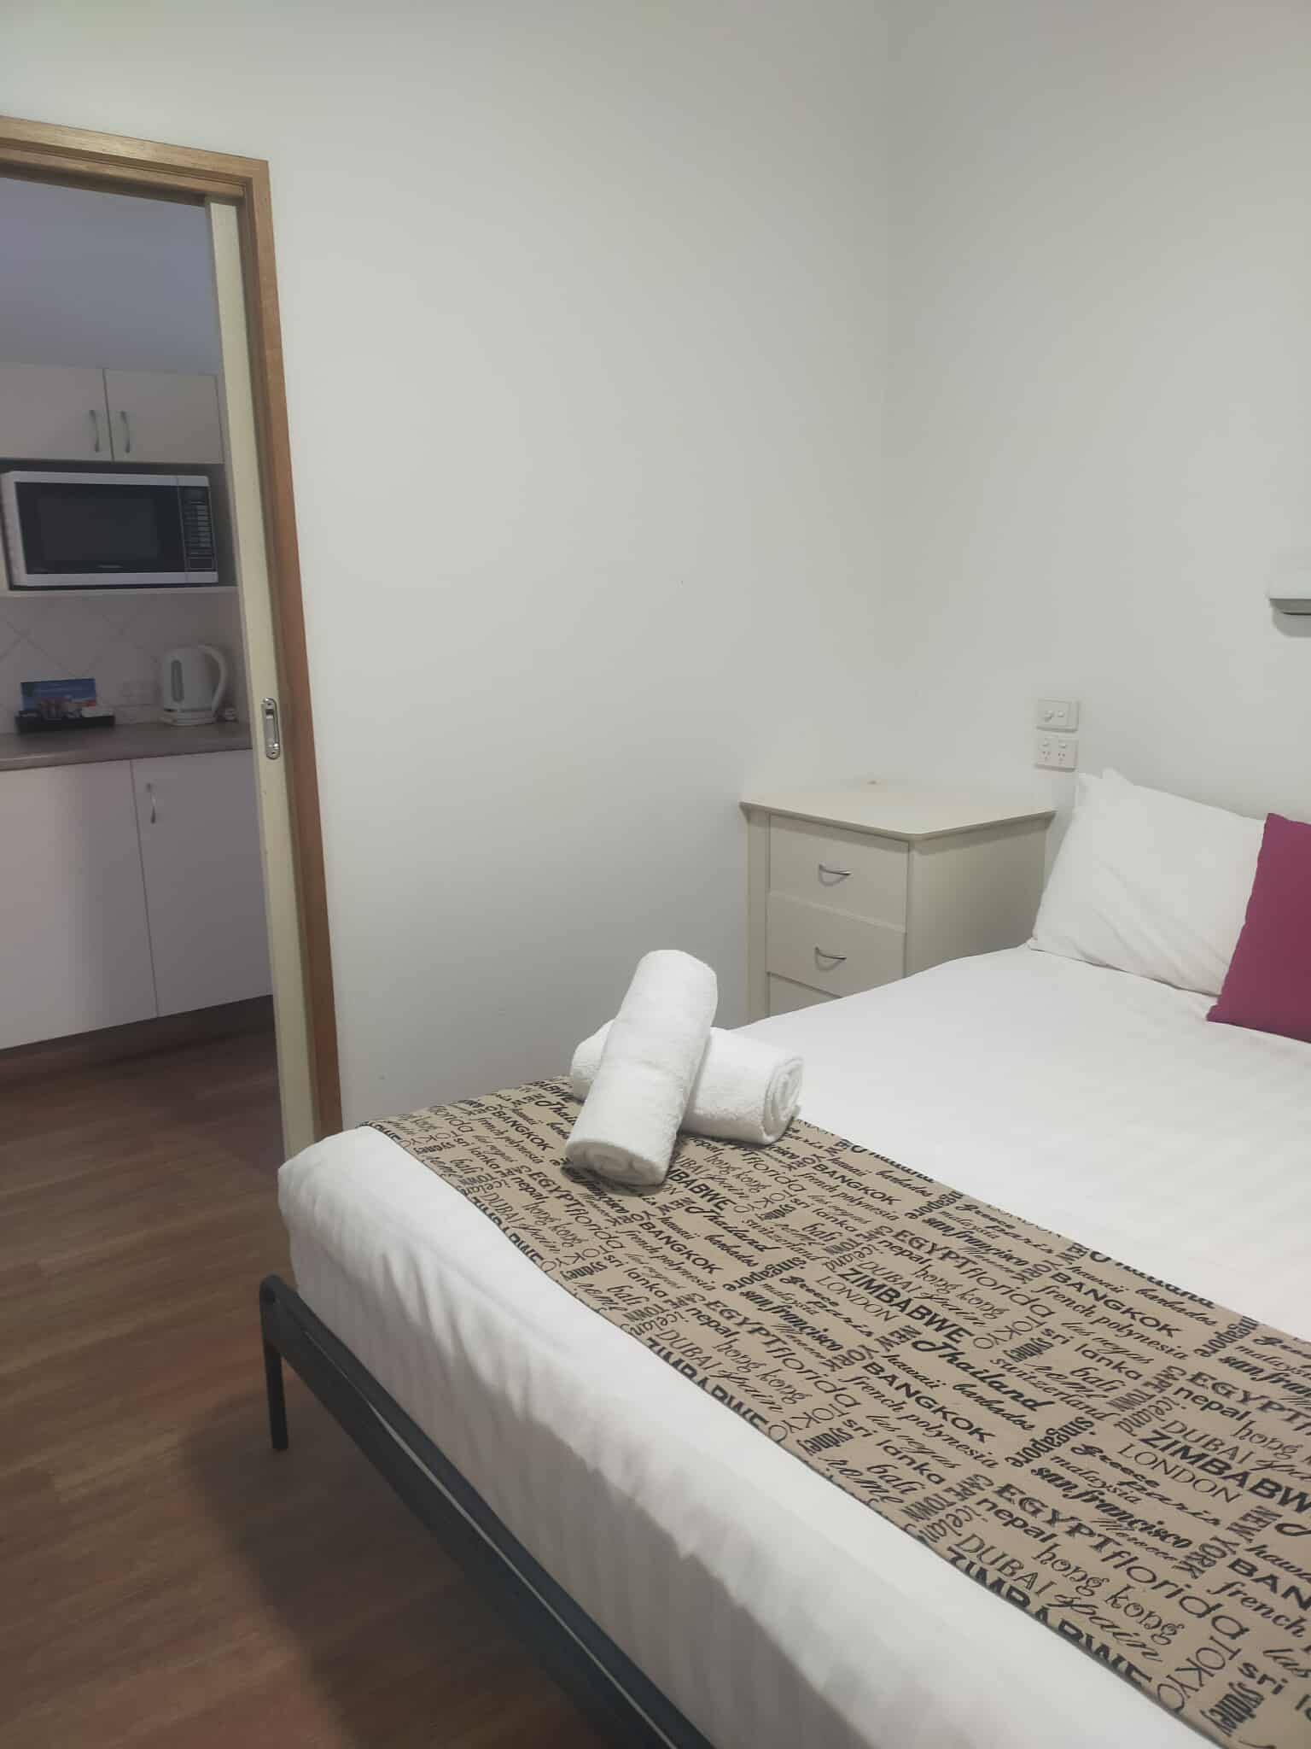
527818691_1385598135869274_1194455107568181084_n
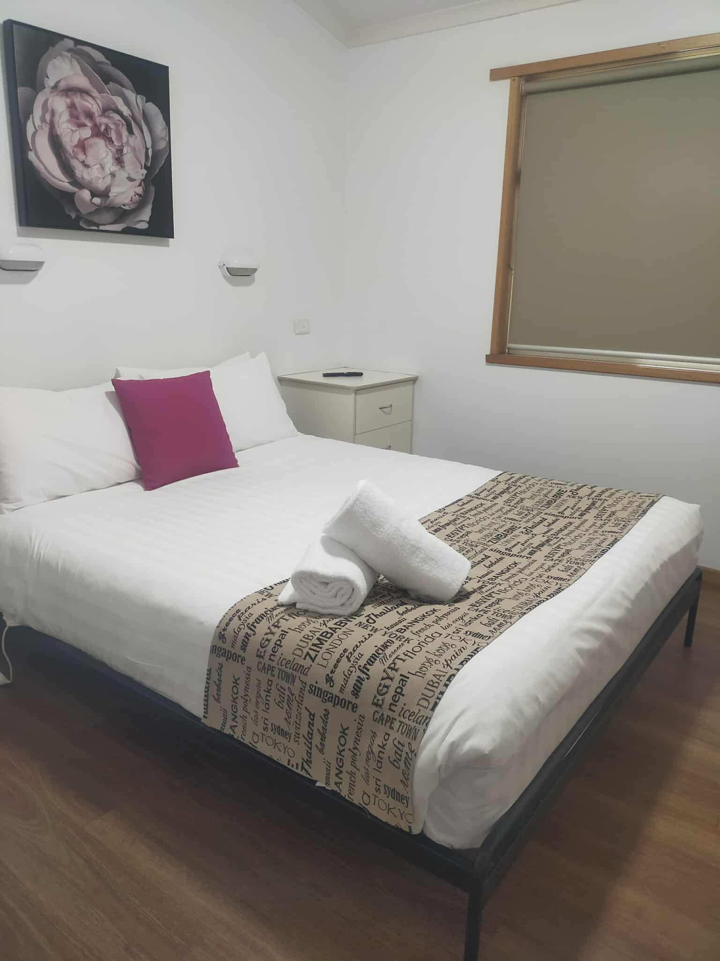
531615505_1831682171075890_7897933686139827787_n

Room Amenities
- There is contrast between the walls, skirtings, floor and furniture
- There is a clear path through the room
- The edges of all furniture and fixtures are rounded
- Wardrobe handles are a contrasting colour to the doors and draws
- Doors open fully against the adjoining wall
- There is a clear opening at least 850mm wide
- There luggage racks for at least two suitcases
- Wardrobe and drawer handles are easy to grip
- The bedside lamp switch is easy to reach from the bed
- There is at least 850mm clear space beside the bed
- The bed height is no higher than 680mm from the floor
- Blocks are available to put under the bed legs
- Non-allergenic cleaning products are used

Bathrooms
The bathrooms have the following facilities/amenities in place
- All heating appliances and hot water pipes are protected or insulated
- All shower, bath and basin taps are clearly differentiated between hot and cold
- Fixtures and fittings have rounded edges
- The door is at least 850mm wide
- There is a minimum of 850mm beside the toilet
- Handrails are fitted
- There is 1270mm mm of clear space in front of the toilet
- The toilet seat is a contrasting colour to the floor
- The actual height of the toilet seat is 440mm.
- There is a roll-in shower with fold down fixed seat or a shower chair
- There is a portable shower head on flexible hose
  - Bathroom Image(s)
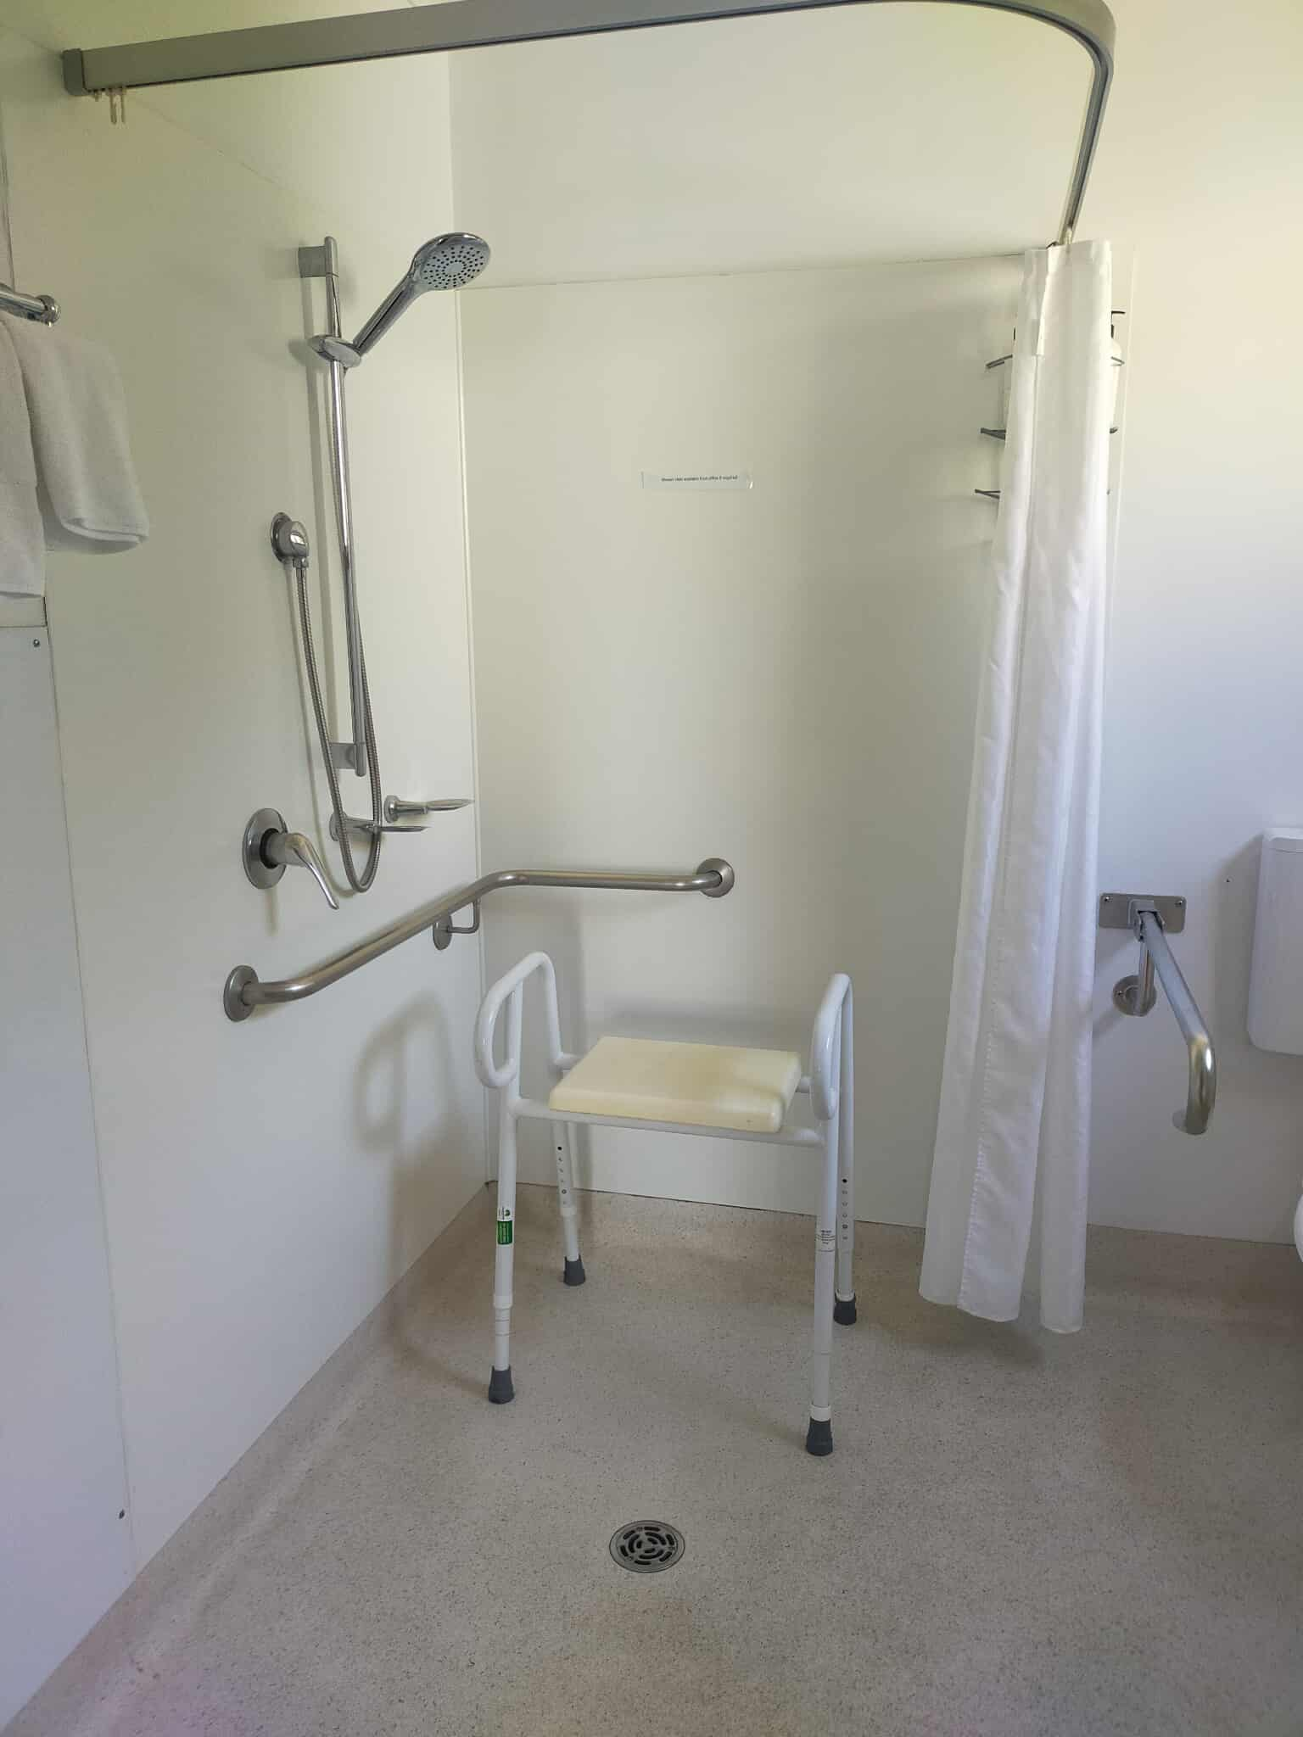
516419858_1427302281717344_7417115654708986264_n
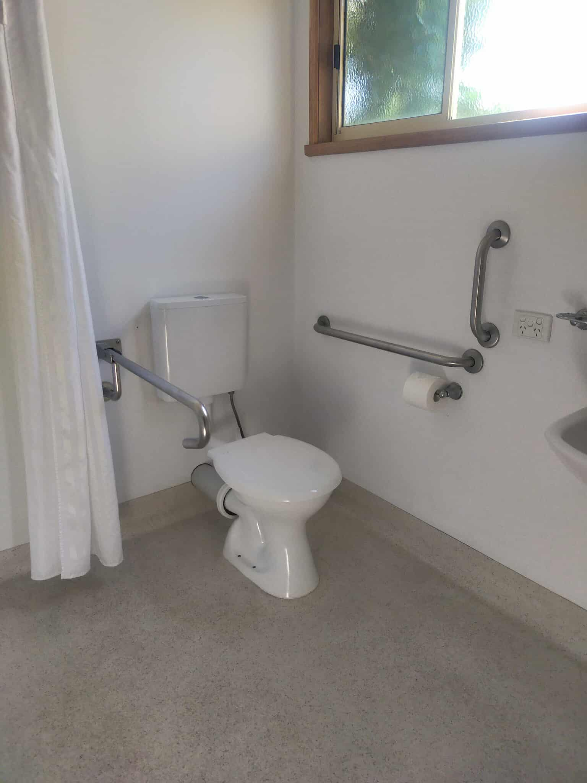
521153313_1504077120731930_1797531635879845963_n
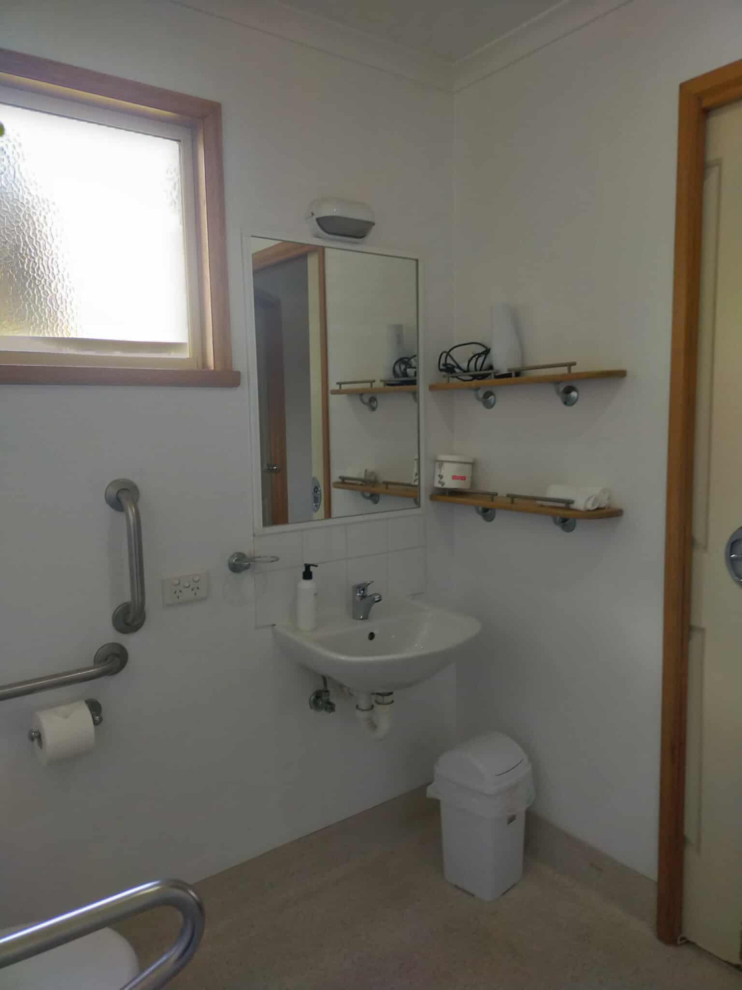
528354905_1061178202460237_4571379443533024516_n

COMMON AREAS

Play Spaces
- Level access is provided to play spaces
- The surface of the play space is of a composite or rubberized material
- The play space contains cognitive play panels
- The play space contains tactile play panels or activities
- The space contain colour contrasting elements
- Seating is provided in or around the play space

Swimming pools, spas and waterparks
- The following swimming pools, spas and waterparks amenities are available
- Unisex change facilities with an accessible toilet

Report Disclaimer
Please note that this business report, provided as a result of the use of the diagnostic assessment, is for information purposes only.
Australian Tourism Industry Council (ATIC) cannot guarantee the accuracy of respondent’s answers, or that they are fully representative of your business. Therefore, ATIC does not warrant or guarantee any particular outcome in respect of your businesses self-assessment.
This report is intended as guidance only for your business and should not be relied on for future marketing considerations. ATIC recommends that you seek your own independent advice as well as the results from the diagnostic.
Links to external web sites are inserted for convenience and do not constitute endorsement of material at those sites, or any associated organisation, product or service.
ATIC does not:
- Assume any legal liability for the accuracy, completeness, or usefulness of any information from this report or any links provided; or
- Accept responsibility for any loss associated directly or indirectly from the use of this report.

