ATIC Accessibility
To support the accessible community in making informed travel decisions for their individual needs

This report prepared for:
Business name: | Moonlit Sanctuary Wildlife Conservation Park
Address: | 550 Tyabb-Tooradin Rd
Town: | Pearcedale
Contact for enquiries: | Michael Johnson
Contact Number: | 03 5978 7935
Contact Email: | michael@moonlit-sanctuary.com
Website: | https://moonlitsanctuary.com.au
Date: | 2026-09-11 18:19

ATIC Accessibility
The following pages provides travellers with information on the businesses facilities and amenities which aims to support the traveller to make an informed decision on whether the business is suitable for their individual needs.
OVERVIEW 4
Business Overview 4
Bookings 4
Communications 4
Other Information 5
Guide Dog and Service Animals 5
GENERAL 6
Pre-arrival, arrival and reception 6
Cognitive Impairment Support 6
Car Park and Access amenities 6
Entry 7
Internal Spaces 7
Public areas 7
Displays, exhibits, commentary and live performances 8
External Paths 8
Ramps 8
Public Toilets/Adult change facilities 9
ATTRACTIONS 10
Attractions Basics 10
Zoos and Wildlife Parks 10
COMMON AREAS 14
Report Disclaimer 16

OVERVIEW

Business Overview

The business has the following products/services available
- Attraction

Our business caters for the following disability types:
- Blind or low vision
- Deaf or low hearing
- Limited mobility
- Wheelchairs or mobility scooters
- Food allergies or intolerances
- Cognitive or people on the Autism Spectrum


Bookings

The business offers the following methods for bookings and enquiries:
- Phone
- Email
- Webportal
- Our website supports Screen Readers
- Our forms have high contract boxes and submit boxes

Communications
- An accessibility guide is available on the website

https://moonlitsanctuary.com.au/visit/accessibility/ https://moonlitsanctuary.com.au/visit/inclusive-resources/ https://moonlitsanctuary.com.au/wp-content/uploads/2023/11/visual-story.pdf
- Our business offers the following alternative communication methods
- Plain English
- Magnifiers

We use a a plugin on our website called "ALLY". It can be accessed from any page and can be used to present the website in various forms, such as increasing the size of the text, light background. increase text size, high contrast, negative contrast, or change font.
- There is easy to read signage and information (e.g. menus and emergency information)

Other Information
- For bookings made onsite, the ticket booth/counter/box office is accessible for people using a wheelchair
- The business accepts the companion card

Guide Dog and Service Animals
The business provides the following services for services animals:
No services are offered for service animals. Admission is allowed however it is discouraged as bringing a service animal with the guest would severely degrade the guest experience.

GENERAL

Pre-arrival, arrival and reception
The business has the following in place to support guests during pre-arrival, arrival and reception
- Booking information and websites are compatible with screen readers
- There is a reception/public entryway.
- A tablet with text to voice or pen and paper at reception to aid in communication
- Lighting in the reception area is even and glare free
- Large print information sheets and registration forms

We have a Visual Story online available to download in large print. Staff can identify visitors with disabilities and take them through admissions.
- Information and maps are available in written form
- In addition, the following further information can assist guests:
Long wait times are exceptional at admissions as the admission process is swift. Staff can identify people with a disability and bring them forward.

Cognitive Impairment Support
- Documents are available in plain English for people with cognitive impairment (This may include instructions, guides, menus and general information)
- A "social script" guide to your premises or attraction describing the sights, sounds and smells to aid parents/carers prepare visitors in advance
- A space for parents and children on the Autism Spectrum
- Access has alternative procedures and clear written instructions with universal access symbols

Car Park and Access amenities
The business has the following Car Park and Access amenities
- A drop off zone
- Designated disabled parking bays
- Level or ramped access from the car park to the entrance
- In addition, the following further information can assist guests:
Moonlit Sanctuary car park is not gated.

Entry
The business has the following amenities/systems in place for entry
- A drop off point close to the entrance
- A path of access to the building is slip resistance and even
- A path of access to the building is clear of obstruction
- Self opening entry doors or fitted with a self closer
- Glass doors are fitted with a visual sighting strip
- Door handles are of a contrasting colour to the door
- Signage is written in a contrasting colour
- Signage is written in a Sans Serif font and use upper and lower case letters
- The entry door is a minimum of 850mm wide
- The entry door has self opening or a light opening pressure (for manual operations)
- The entrance sill is less than 13mm
- There a clear space of at least 1500mm x 1500mm in front of all doors.
- The entrance door mats have a thickness less than 13mm and a width of 7500mm or greater

Internal Spaces
- Clear and unobstructed routes through and between buildings
- Interior walls are matte or low sheen
- Floor surfaces are hard or short pile carpet
- Seating is available for guests unable to stand for long periods
- Accessible facilities are clearly signed and visible from all areas
- All corridors greater than 900mm
- There is a quiet space for parents and children on the Autism Spectrum
- In addition, the following further information can assist guests:
We have quieter spaces. These can be identified from the Visual Story which can be downloaded from our website.

Public areas
The public areas have the following amenities in place
- Even lighting
- Seating

Displays, exhibits, commentary and live performances
For displays, exhibits, commentary and live performances the following amenities are in place
- Seating
- Wheelchair accessible spaces/seating
- In addition, the following further information can assist guests:
Visually impared guests are catered

External Paths
External paths of travel
- Surfaces are concrete, asphalt, smooth paving or hard packed fine gravel (max aggregate size 13mm)
- Pathways are wider than 900mm

There are no steps or stairs in public areas at Moonlit Sanctuary

There are no steps or stairs in public areas at Moonlit Sanctuary
- In addition, the following further information can assist guests:
There are no steps or stairs in public areas at Moonlit Sanctuary
- In addition, the following further information can assist guests:
There are no steps or stairs in public areas at Moonlit Sanctuary

Ramps
Ramps have the following amenities are in place
- There are ramps.
- All fixed ramps are 1:14 or less
- Hand rails are fitted
- Ramps have a raised edge of at least 100mm
- In addition, the following further information can assist guests:
Moonlit Sanctuary does not have ramps longer than 10 metres.

Public Toilets/Adult change facilities
Public Toilets/Adult change facilities have the following amenities are in place
- There is an accessible toilet for public use
- The door is at least 850mm wide
- There is a minimum of 850mm beside the toilet
- Handrails are fitted
- The toilet seat is 460mm above the floor
- The toilet seat of a contrasting colour to the floor
- The toilet seat is460mm above the floor

ATTRACTIONS

Attractions Basics
- A park map is available here:

https://moonlitsanctuary.com.au/visit/park-map/

Zoos and Wildlife Parks
- Guide and service dogs are welcome
- In addition, the following further information can assist guests:
Excluded from walk-through areas and aviaries, and encounters. We advise visitors not to bring guide dogs, if possible, as one of the features of Moonlit Sanctuary is the ability to get close to animals and even touch some animals, and this is not possible if a dog is around.
- Displays have glass or mesh viewing panels for children or people seated in wheelchairs
- Signage is positioned between 800mm and 1200mm above the ground
- Signage is in a font larger than 18 point
- Signage and information provide pictorial information
- In addition, the following further information can assist guests:
Keeper talks throughout the day.
- Seating is provided at regular intervals
- Aviaries and other enclosures provide level access
- Airlocks provide sufficient room for a wheelchair
  - Image(s)
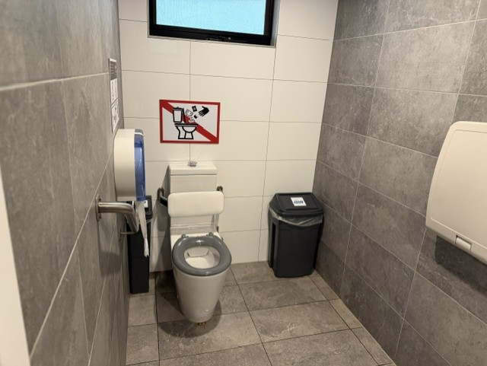
5afc37d7-9b85-491b-b447-727deb95a9fa
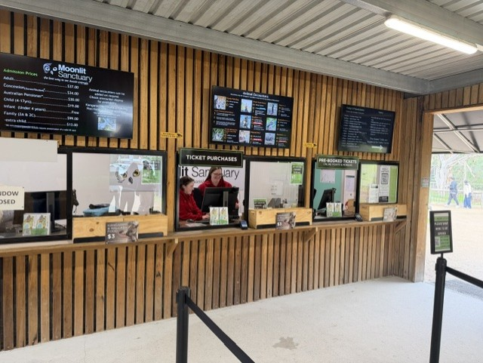
8f9c33d1-a3e7-425d-8192-664df1def79d
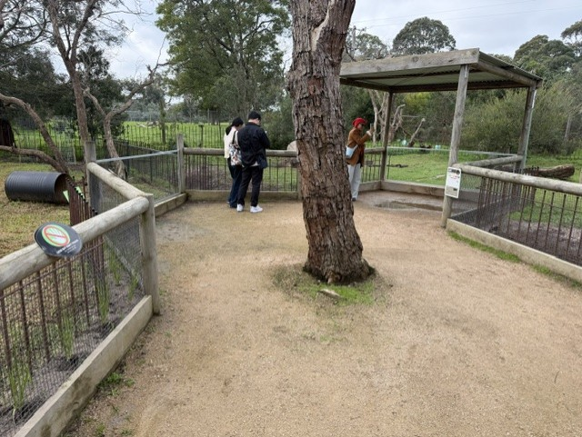
63b62ec5-9310-49ee-a71c-2c5519f90539
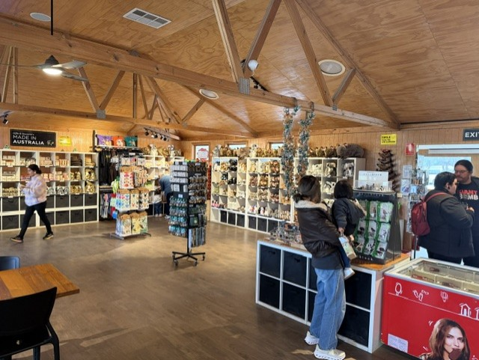
43881b80-14d5-4664-ac53-3f7ae6215480
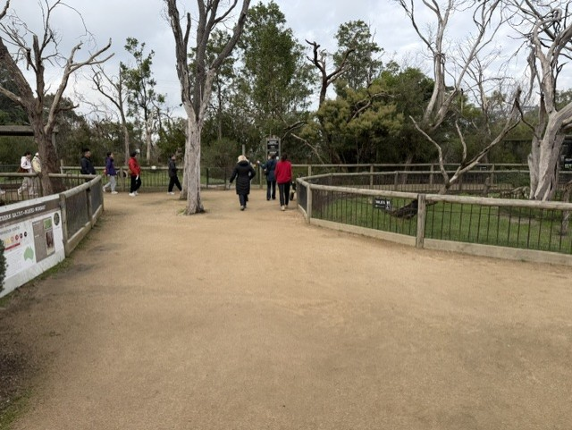
126331ef-eeeb-4536-83f5-c516e17309b5
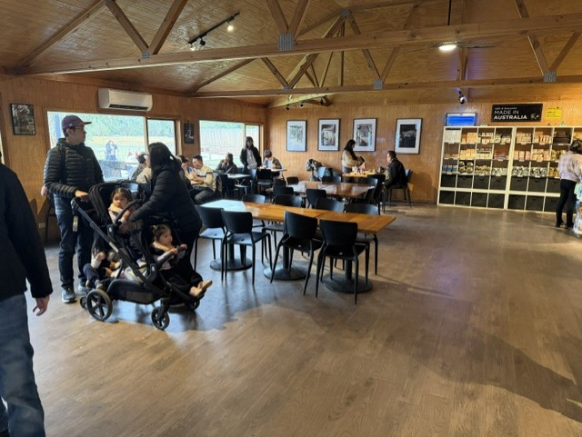
736723f9-9d4a-494a-93c3-07fdd2dc2577
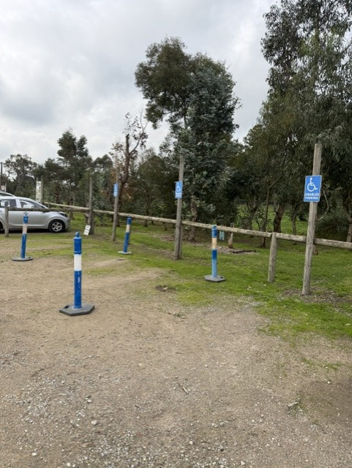
26241270-fb97-4c7a-9c2e-048b1d0ebce5
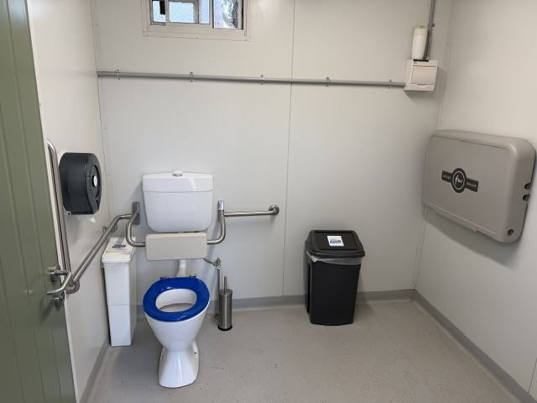
aa616472-444b-41dc-be50-c2546b695209
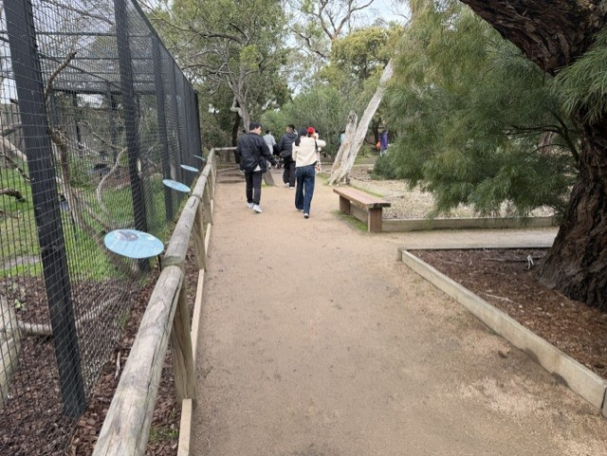
aae42f55-a25d-4755-9ac7-435b4236e657
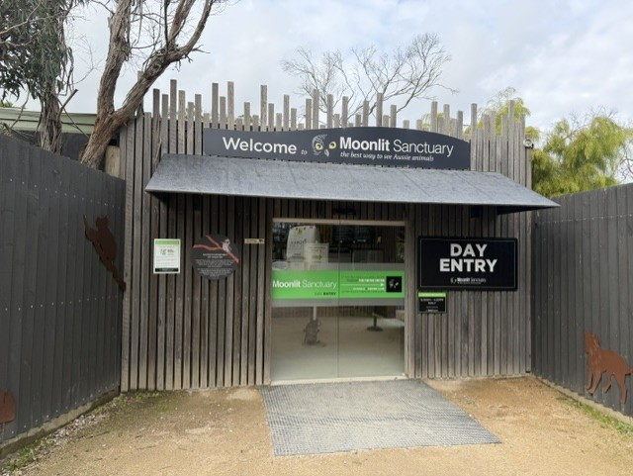
cecb271b-c7ca-4301-b805-c98827ea8fb4

COMMON AREAS

Report Disclaimer
Please note that this business report, provided as a result of the use of the diagnostic assessment, is for information purposes only.
Australian Tourism Industry Council (ATIC) cannot guarantee the accuracy of respondent’s answers, or that they are fully representative of your business. Therefore, ATIC does not warrant or guarantee any particular outcome in respect of your businesses self-assessment.
This report is intended as guidance only for your business and should not be relied on for future marketing considerations. ATIC recommends that you seek your own independent advice as well as the results from the diagnostic.
Links to external web sites are inserted for convenience and do not constitute endorsement of material at those sites, or any associated organisation, product or service.
ATIC does not:
- Assume any legal liability for the accuracy, completeness, or usefulness of any information from this report or any links provided; or
- Accept responsibility for any loss associated directly or indirectly from the use of this report.

