ATIC Accessibility
To support the accessible community in making informed travel decisions for their individual needs

This report prepared for:
Business name: | Yanawal Units
Address: | 30 Arnhem Road
Town: | Nhulunbuy
Contact for enquiries: | Jodie Douglas
Contact Number: | 08 8987 3433
Contact Email: | jodie.douglas@rirratjingu.com
Website: | www.yanawalunits.com
Date: | 2026-09-09 18:06

ATIC Accessibility
The following pages provides travellers with information on the businesses facilities and amenities which aims to support the traveller to make an informed decision on whether the business is suitable for their individual needs.
OVERVIEW 4
Business Overview 4
Bookings 4
Emergency Management 5
Communications 5
Other Information 5
Guide Dog and Service Animals 5
GENERAL 7
Pre-arrival, arrival and reception 7
Cognitive Impairment Support 7
Car Park and Access amenities 7
Internal Spaces 8
External Paths 8
Ramps 8
Public Toilets/Adult change facilities 8
ACCOMMODATION 9
Bedrooms 9
Room Amenities 9
Bathrooms 9
COMMON AREAS 12
Report Disclaimer 14

OVERVIEW

Business Overview

The business has the following products/services available
- Accommodation

Our business caters for the following disability types:
- Blind or low vision
- Deaf or low hearing
- Limited mobility
- Wheelchairs or mobility scooters
- Food allergies or intolerances
- Cognitive or people on the Autism Spectrum


Bookings

The business offers the following methods for bookings and enquiries:
- Phone
- Email
- Webportal
- Our forms have high contract boxes and submit boxes
- Staff have undergone disability awareness and training

Emergency Management
- The business has an emergency management and evacuation plan for guests with a disability
- Emergency and evacuation procedures are explained on arrival
- Guests with disabilities are noted in the guest log book for emergency and evacuation purposes

Communications
- An accessibility guide is available on the website

https://www.yanawalunits.com/stay
- Our website meets WCAG 2.0 accessibility standards
- Our business offers the following alternative communication methods
- Plain English
- Braille Displays

Not specified
- There is easy to read signage and information (e.g. menus and emergency information)

Online communication forms, guest communication cards

Other Information
- The business accepts the companion card

Guide Dog and Service Animals
- The business provides a secure area with shade and water for service animals
- The business provides a toilet area for service animals
- Bowls, bedding, etc. are provided for service animals
The business provides the following services for services animals:
We work with residents to establish appropriate access arrangements, ensuring service animals are able to move freely and safely within the unit and relevant common areas in accordance with applicable legislation and tenancy requirements.

GENERAL

Pre-arrival, arrival and reception
The business has the following in place to support guests during pre-arrival, arrival and reception
- Booking information and websites are compatible with screen readers
- Information and maps are available in written form
- A step free map/guide
- A familiarisation tour
- Advertising material, web sites and social media contain information relating to phone numbers available for non-voice communication e: Text, SMS, email and fax
- A key to any accessible facilities that are locked
- Keys are available for each guest
- Luggage assistance
- In addition, the following further information can assist guests:
As a small property the wait times are limitied. We can offer a quiet dark space with water and a chair if required. We are planning to install benches along the walkways for rest stops.

Cognitive Impairment Support
- Documents are available in plain English for people with cognitive impairment (This may include instructions, guides, menus and general information)
- A "social script" guide to your premises or attraction describing the sights, sounds and smells to aid parents/carers prepare visitors in advance
- The 'social script' is available in word and other editable formats
- Quiet periods or early opening times for people on the Autism Spectrum
- A space for parents and children on the Autism Spectrum

Car Park and Access amenities
The business has the following Car Park and Access amenities
- A drop off zone
- Designated disabled parking bays
- Level or ramped access from the car park to the entrance
- The accessible entrance is clearly signed from the parking bay
- Kerb ramps are in place where a pavement or walkway needs to be crossed
- In addition, the following further information can assist guests:
We do not have intercom or phones on site. All communication is done on the guests device.

Internal Spaces
- Tableware/glassware contrast with the table surface or table cloth

External Paths
External paths of travel
- Surfaces are concrete, asphalt, smooth paving or hard packed fine gravel (max aggregate size 13mm)
- Paths or slopes longer than 15 metres have resting places or seats
- Pathways are wider than 900mm
- There 3 successive steps or less on any path or at any doorway
- Any paths having steps are clearly identified as non-wheelchair accessible
- Step free routes clearly signed

Ramps
Ramps have the following amenities are in place
- There are ramps.
- All fixed ramps are 1:14 or less
- Hand rails are fitted
- Long ramps (more than 10m) are 1:20 or less
- Ramps have a raised edge of at least 100mm

Public Toilets/Adult change facilities
Public Toilets/Adult change facilities have the following amenities are in place
- There is an accessible toilet for public use
- The door is at least 850mm wide
- There is a minimum of 850mm beside the toilet
- Handrails are fitted
- The toilet seat is 460mm above the floor
- The toilet seat of a contrasting colour to the floor
- The toilet seat is460mm above the floor

ACCOMMODATION

Bedrooms
The bedrooms have the following facilities/amenities in place
- There are 2 rooms available to guests who use a wheelchair
- Bedroom furniture can be re-arranged on request

Room Amenities
- Lower hanging rails are in wardrobes
- Visual alarm is fitted to the room
- Televisions are equipped with closed captioning capability
- Room phones have volume control
- Room phones have a visual ringing indicator
- There is contrast between the walls, skirtings, floor and furniture
- There is a clear path through the room
- The edges of all furniture and fixtures are rounded
- Wardrobe handles are a contrasting colour to the doors and draws
- Housekeeping procedures instruct staff not to reposition furniture that has been moved
- Doors open fully against the adjoining wall
- There is a clear opening at least 850mm wide
- There luggage racks for at least two suitcases
- There at least one chair with rigid arms
- Wardrobe and drawer handles are easy to grip
- The bedside lamp switch is easy to reach from the bed
- There is at least 850mm clear space beside the bed
- The bed height is no higher than 680mm from the floor
- There is at least 130mm clearance under the bed
- The business offers a range of non-allergenic bedding
- Non-allergenic cleaning products are used
- In addition, the following further information can assist guests:
All items contrast for ease of use.

Bathrooms
The bathrooms have the following facilities/amenities in place
- All heating appliances and hot water pipes are protected or insulated
- All shower, bath and basin taps are clearly differentiated between hot and cold
- Fixtures and fittings have rounded edges
- The hot water is thermostatically controlled to 41 degrees
- The door is at least 850mm wide
- There is a minimum of 850mm beside the toilet
- Handrails are fitted
- There is a minimum of 1400mm of clear space in front of the toilet
- The toilet seat is a contrasting colour to the floor
- The toilet seat is 460mm above the floor
- A range of non-allergenic toiletries are available
- There is a roll-in shower with fold down fixed seat or a shower chair
- There is a portable shower head on flexible hose
- A door is fitted to the shower
- A door is fitted to the showers with an outward swing at minimum width of 900 mm
  - Bathroom Image(s)
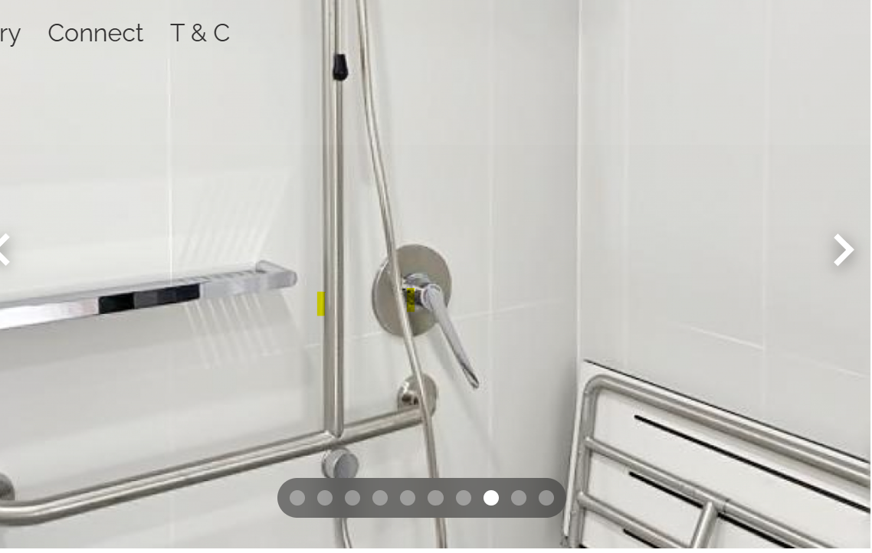
bathroom
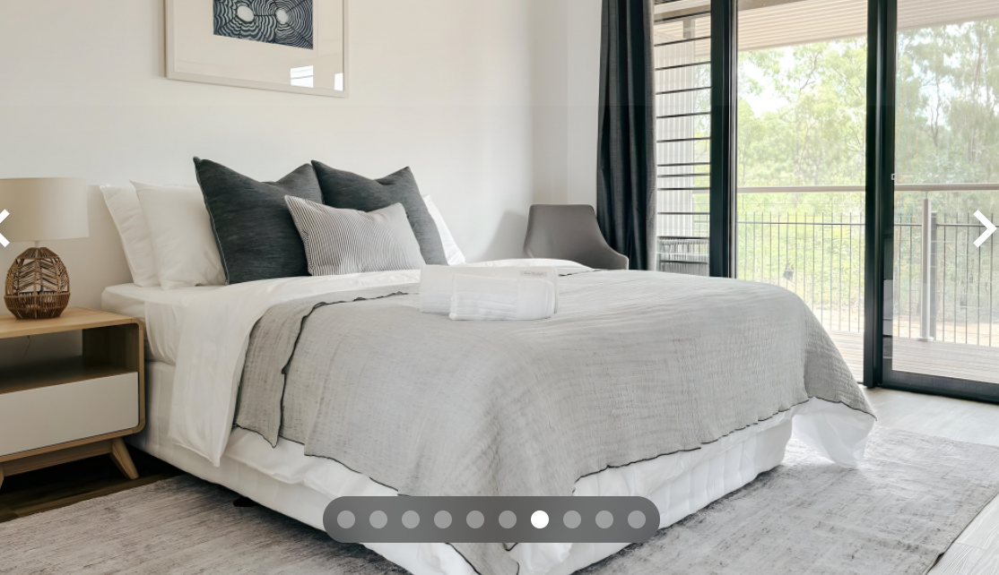
bed
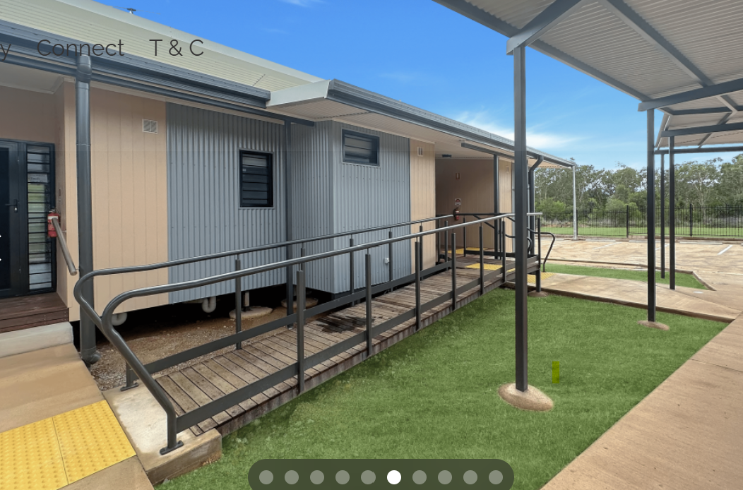
Ramp
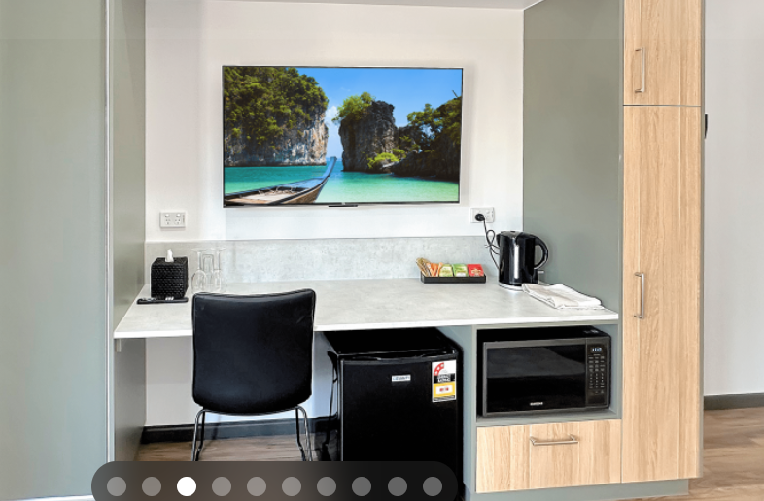
room

COMMON AREAS

Report Disclaimer
Please note that this business report, provided as a result of the use of the diagnostic assessment, is for information purposes only.
Australian Tourism Industry Council (ATIC) cannot guarantee the accuracy of respondent’s answers, or that they are fully representative of your business. Therefore, ATIC does not warrant or guarantee any particular outcome in respect of your businesses self-assessment.
This report is intended as guidance only for your business and should not be relied on for future marketing considerations. ATIC recommends that you seek your own independent advice as well as the results from the diagnostic.
Links to external web sites are inserted for convenience and do not constitute endorsement of material at those sites, or any associated organisation, product or service.
ATIC does not:
- Assume any legal liability for the accuracy, completeness, or usefulness of any information from this report or any links provided; or
- Accept responsibility for any loss associated directly or indirectly from the use of this report.

