ATIC Accessibility
To support the accessible community in making informed travel decisions for their individual needs

This report prepared for:
Business name: | Kies Family Wines
Address: | 1303 Barossa Valley Way
Town: | Lyndoch
Contact for enquiries: | Jesse Kies
Contact Number: | 08 8524 4110
Contact Email: | cellardoor@kieswines.com.au
Website: | www.kieswines.com.au
Date: | 2026-10-17 09:59

ATIC Accessibility
The following pages provides travellers with information on the businesses facilities and amenities which aims to support the traveller to make an informed decision on whether the business is suitable for their individual needs.
OVERVIEW 4
Business Overview 4
Bookings 4
Emergency Management 5
Communications 5
Other Information 5
Guide Dog and Service Animals 5
GENERAL 7
Pre-arrival, arrival and reception 7
Cognitive Impairment Support 8
Car Park and Access amenities 8
Internal Spaces 9
External Paths 10
Public Toilets/Adult change facilities 10
ATTRACTIONS 11
Attractions Basics 11
COMMON AREAS 12
FOOD AND DRINK 13
Dining Spaces 13
Report Disclaimer 18

OVERVIEW

Business Overview

The business has the following products/services available
- Attraction
- Food and Drink

Our business caters for the following disability types:
- Blind or low vision
- Deaf or low hearing
- Limited mobility
- Wheelchairs or mobility scooters
- Food allergies or intolerances
- Cognitive or people on the Autism Spectrum
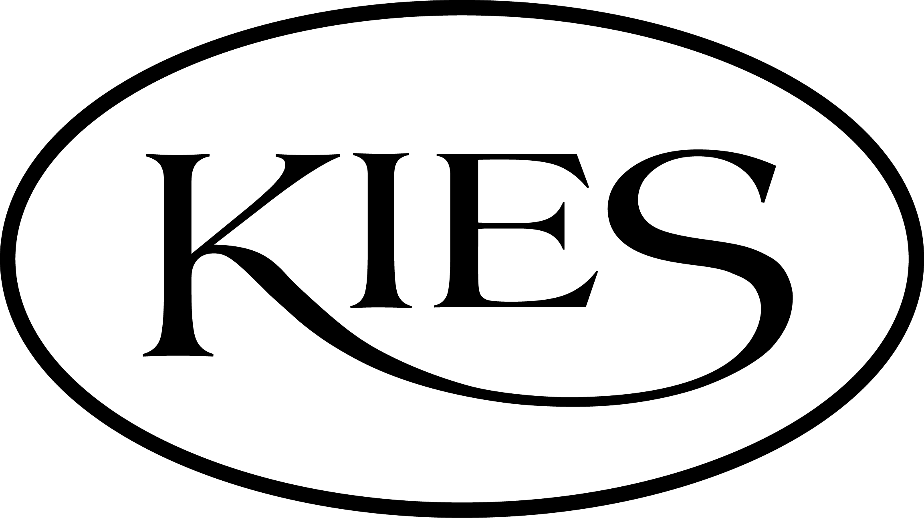

Bookings

The business offers the following methods for bookings and enquiries:
- Phone
- Email
- Webportal
- Our website supports Screen Readers
- Our forms have high contract boxes and submit boxes
- Staff have undergone disability awareness and training

Emergency Management
- The business has an emergency management and evacuation plan for guests with a disability
- Emergency and evacuation procedures are explained on arrival
- Guests with disabilities are noted in the guest log book for emergency and evacuation purposes

Communications
- An accessibility guide is available on the website

https://www.kieswines.com.au/kies-family-wines-an-accessible-barossa-attraction/?srsltid=AfmBOorPsnoVtoYUWJoLmRjUdSutx8_Eg6Bv6sItckwjKVyK0-ryy-9j
- Our website meets WCAG 2.0 accessibility standards
- Our business offers the following alternative communication methods
- Plain English
- Braille Displays
- Magnifiers

Not specified
- There is easy to read signage and information (e.g. menus and emergency information)
- There is a Pictorial menu
- There are Picture boards

We offer community request cards

Other Information
- For bookings made onsite, the ticket booth/counter/box office is accessible for people using a wheelchair
- The business accepts the companion card

Guide Dog and Service Animals
- The business provides a secure area with shade and water for service animals
- The business provides a toilet area for service animals
- Bowls, bedding, etc. are provided for service animals
The business provides the following services for services animals:
We offer a warm blanket for service animals to sit on in the cold weather. We offer a water bowl and a garden as a safe place for service animals to relieve themselves.

GENERAL

Pre-arrival, arrival and reception
The business has the following in place to support guests during pre-arrival, arrival and reception
- Booking information and websites are compatible with screen readers
- There is a reception/public entryway.
- Seating available at reception
- A lower counter at reception/ticket office
- A clipboard to allow check-in/ticket purchase whilst seated
- A tablet with text to voice or pen and paper at reception to aid in communication
- Picture Board at reception to aid in communication
- Lighting in the reception area is even and glare free
- Large print information sheets and registration forms
- Information and maps are available in written form
- A facility map and information is available in Braille
- A step free map/guide
- A familiarisation tour
- In addition, the following further information can assist guests:
To ensure that no one is disadvantaged by long wait times, we have implemented the following accommodations:

Priority Service: Guests who notify us of fatigue-related needs are offered priority service to minimise waiting times at our Cellar Door and Monkey Nut Café.

Comfortable Seating: There is ample, comfortable seating available both indoors and outdoors, allowing guests to rest while waiting.

Flexible Booking Options: We encourage guests to pre-book tastings or café visits, which helps us prepare for individual needs and reduce delays.

Staff Awareness and Support: Our team is trained to recognise when someone may need assistance or expedited service and will respond promptly and respectfully.

Accessibility Planning: We welcome guests to contact us prior to their visit to discuss any specific requirements, so we can ensure the most comfortable and accommodating experience possible.

- In addition, the following further information can assist guests:
Our restaurant online booking page asks guests to detail their access needs so that we can adequately prepare for their visit.

Cognitive Impairment Support
- Documents are available in plain English for people with cognitive impairment (This may include instructions, guides, menus and general information)
- A "social script" guide to your premises or attraction describing the sights, sounds and smells to aid parents/carers prepare visitors in advance
- The 'social script' is available in word and other editable formats
- Quiet periods or early opening times for people on the Autism Spectrum
- A space for parents and children on the Autism Spectrum

Car Park and Access amenities
The business has the following Car Park and Access amenities
- A drop off zone
- Designated disabled parking bays
- Level or ramped access from the car park to the entrance
- The accessible entrance is clearly signed from the parking bay
- The public transport services available are:

A guide is downloadable at our website.
- In addition, the following further information can assist guests:
At Kies Family Wines, we are committed to creating an inclusive, supportive environment for all our guests. We recognise that individuals with cognitive impairment may benefit from additional tools and resources to ensure their visit is comfortable, enjoyable, and accessible.

Below is an outline of the support we provide to assist guests with cognitive impairment:

Pictorial MenuWe provide a pictorial version of our Monkey Nut Café menu. This menu includes images of our most popular dishes alongside their names and simplified descriptions. It allows guests to visually identify food and drink options, supporting more independent decision-making.

Easy-Read Menus and DocumentsWe offer an Easy-Read Menu featuring large, clear fonts, plain English, and simplified layout to reduce cognitive load. These are available for both our café and wine tasting experiences.We can also provide plain text versions of our menus and wine lists in accessible Word or PDF formats upon request.

Social Script Venue GuideA comprehensive social script is available to help guests and their carers understand what to expect during a visit. This guide includes descriptions of the sights, sounds, smells, and atmosphere across our premises. It is especially helpful for preparing visitors who may be anxious or benefit from routine and predictability.

Braille Menus and SignageWe have braille menus available for both wine tastings and the café. Guests are welcome to request these from our staff at any time.In addition, key areas throughout the venue, including restrooms and entry points, are fitted with braille signage to support wayfinding for guests with visual impairments or multi-sensory disabilities.

Staff Training and SupportOur team has received training in inclusive communication and disability awareness. Staff are attentive, respectful, and happy to provide support tailored to each guest’s needs. This includes reading menus aloud, guiding guests through the venue, or offering quiet spaces to rest.

Planning Your VisitWe encourage guests with cognitive impairments, or their carers, to contact us ahead of time so we can assist with any specific requirements. We are happy to adapt our service to ensure a positive experience for everyone.

Internal Spaces
- Menus are available in large print or Braille
- Tableware/glassware contrast with the table surface or table cloth

External Paths
External paths of travel
- Surfaces are concrete, asphalt, smooth paving or hard packed fine gravel (max aggregate size 13mm)
- Paths or slopes longer than 15 metres have resting places or seats
- Pathways are wider than 900mm
- There 3 successive steps or less on any path or at any doorway
- Any paths having steps are clearly identified as non-wheelchair accessible
- Step free routes clearly signed
- In addition, the following further information can assist guests:
We offer step free access throughout the Monkey Nut Cafe and Kies Teas. There is a small step with an access ramp into the Kies Family Wines Cellar Door.

Public Toilets/Adult change facilities
Public Toilets/Adult change facilities have the following amenities are in place
- There is an accessible toilet for public use
- The door is at least 850mm wide
- There is a minimum of 850mm beside the toilet
- Handrails are fitted
- The toilet seat is 460mm above the floor
- The toilet seat of a contrasting colour to the floor
- The toilet seat is460mm above the floor
- A facility with an adult change table

ATTRACTIONS

Attractions Basics
- A park map is available here:

http://kieswinery.au/accessibility/

COMMON AREAS

FOOD AND DRINK

Dining Spaces
The dining spaces have the following facilities/amenities in place
- The entrance has level access
- The doorway is at least 850mm wide
- There is level access through the dining area
- Chairs are moveable to allow for wheelchairs to be seated at the tables
- There are areas of full lighting
- There are large print menus
- There are Plain English menus
- There is an accessible toilet

Our business caters for the following dietary requirements
- Sugar free (diabetic)
- Gluten free (celiac)
- Lactose free (dairy free)
- Nut free
- Vegetarian
- Vegan
- In addition, the following further information can assist guests:
At our venue, we take food safety and dietary needs seriously, with clear procedures in place to avoid cross-contamination:

We operate a dedicated fryer exclusively for coeliac-friendly food to eliminate the risk of gluten contamination.

Our kitchen is a zero-peanut environment, meaning we do not use peanuts in any form, reducing the risk of severe allergic reactions.

We offer clearly labelled and safely prepared Vegetarian, Vegan, Nut Free, Gluten Free, Sugar Free, and Lactose Free (dairy free) options.

All team members undergo regular training on allergen awareness and food handling protocols to ensure proper separation of ingredients and utensils.

Where required, we use separate preparation areas and equipment to minimise any risk of cross-contact.

If guests have specific dietary requirements, our staff are always available to answer questions and ensure meals are prepared safely.

- There is a sample menu available online
Sample menu is available here -
https://monkeynutcafe.com.au/wp-content/uploads/menu/0451-KFW_A4MonkeyNutCafeMenu_Latest.pdf
  - Food and Beverage Image(s)
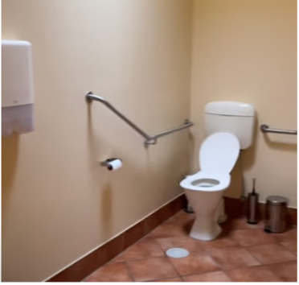
ToiletRail
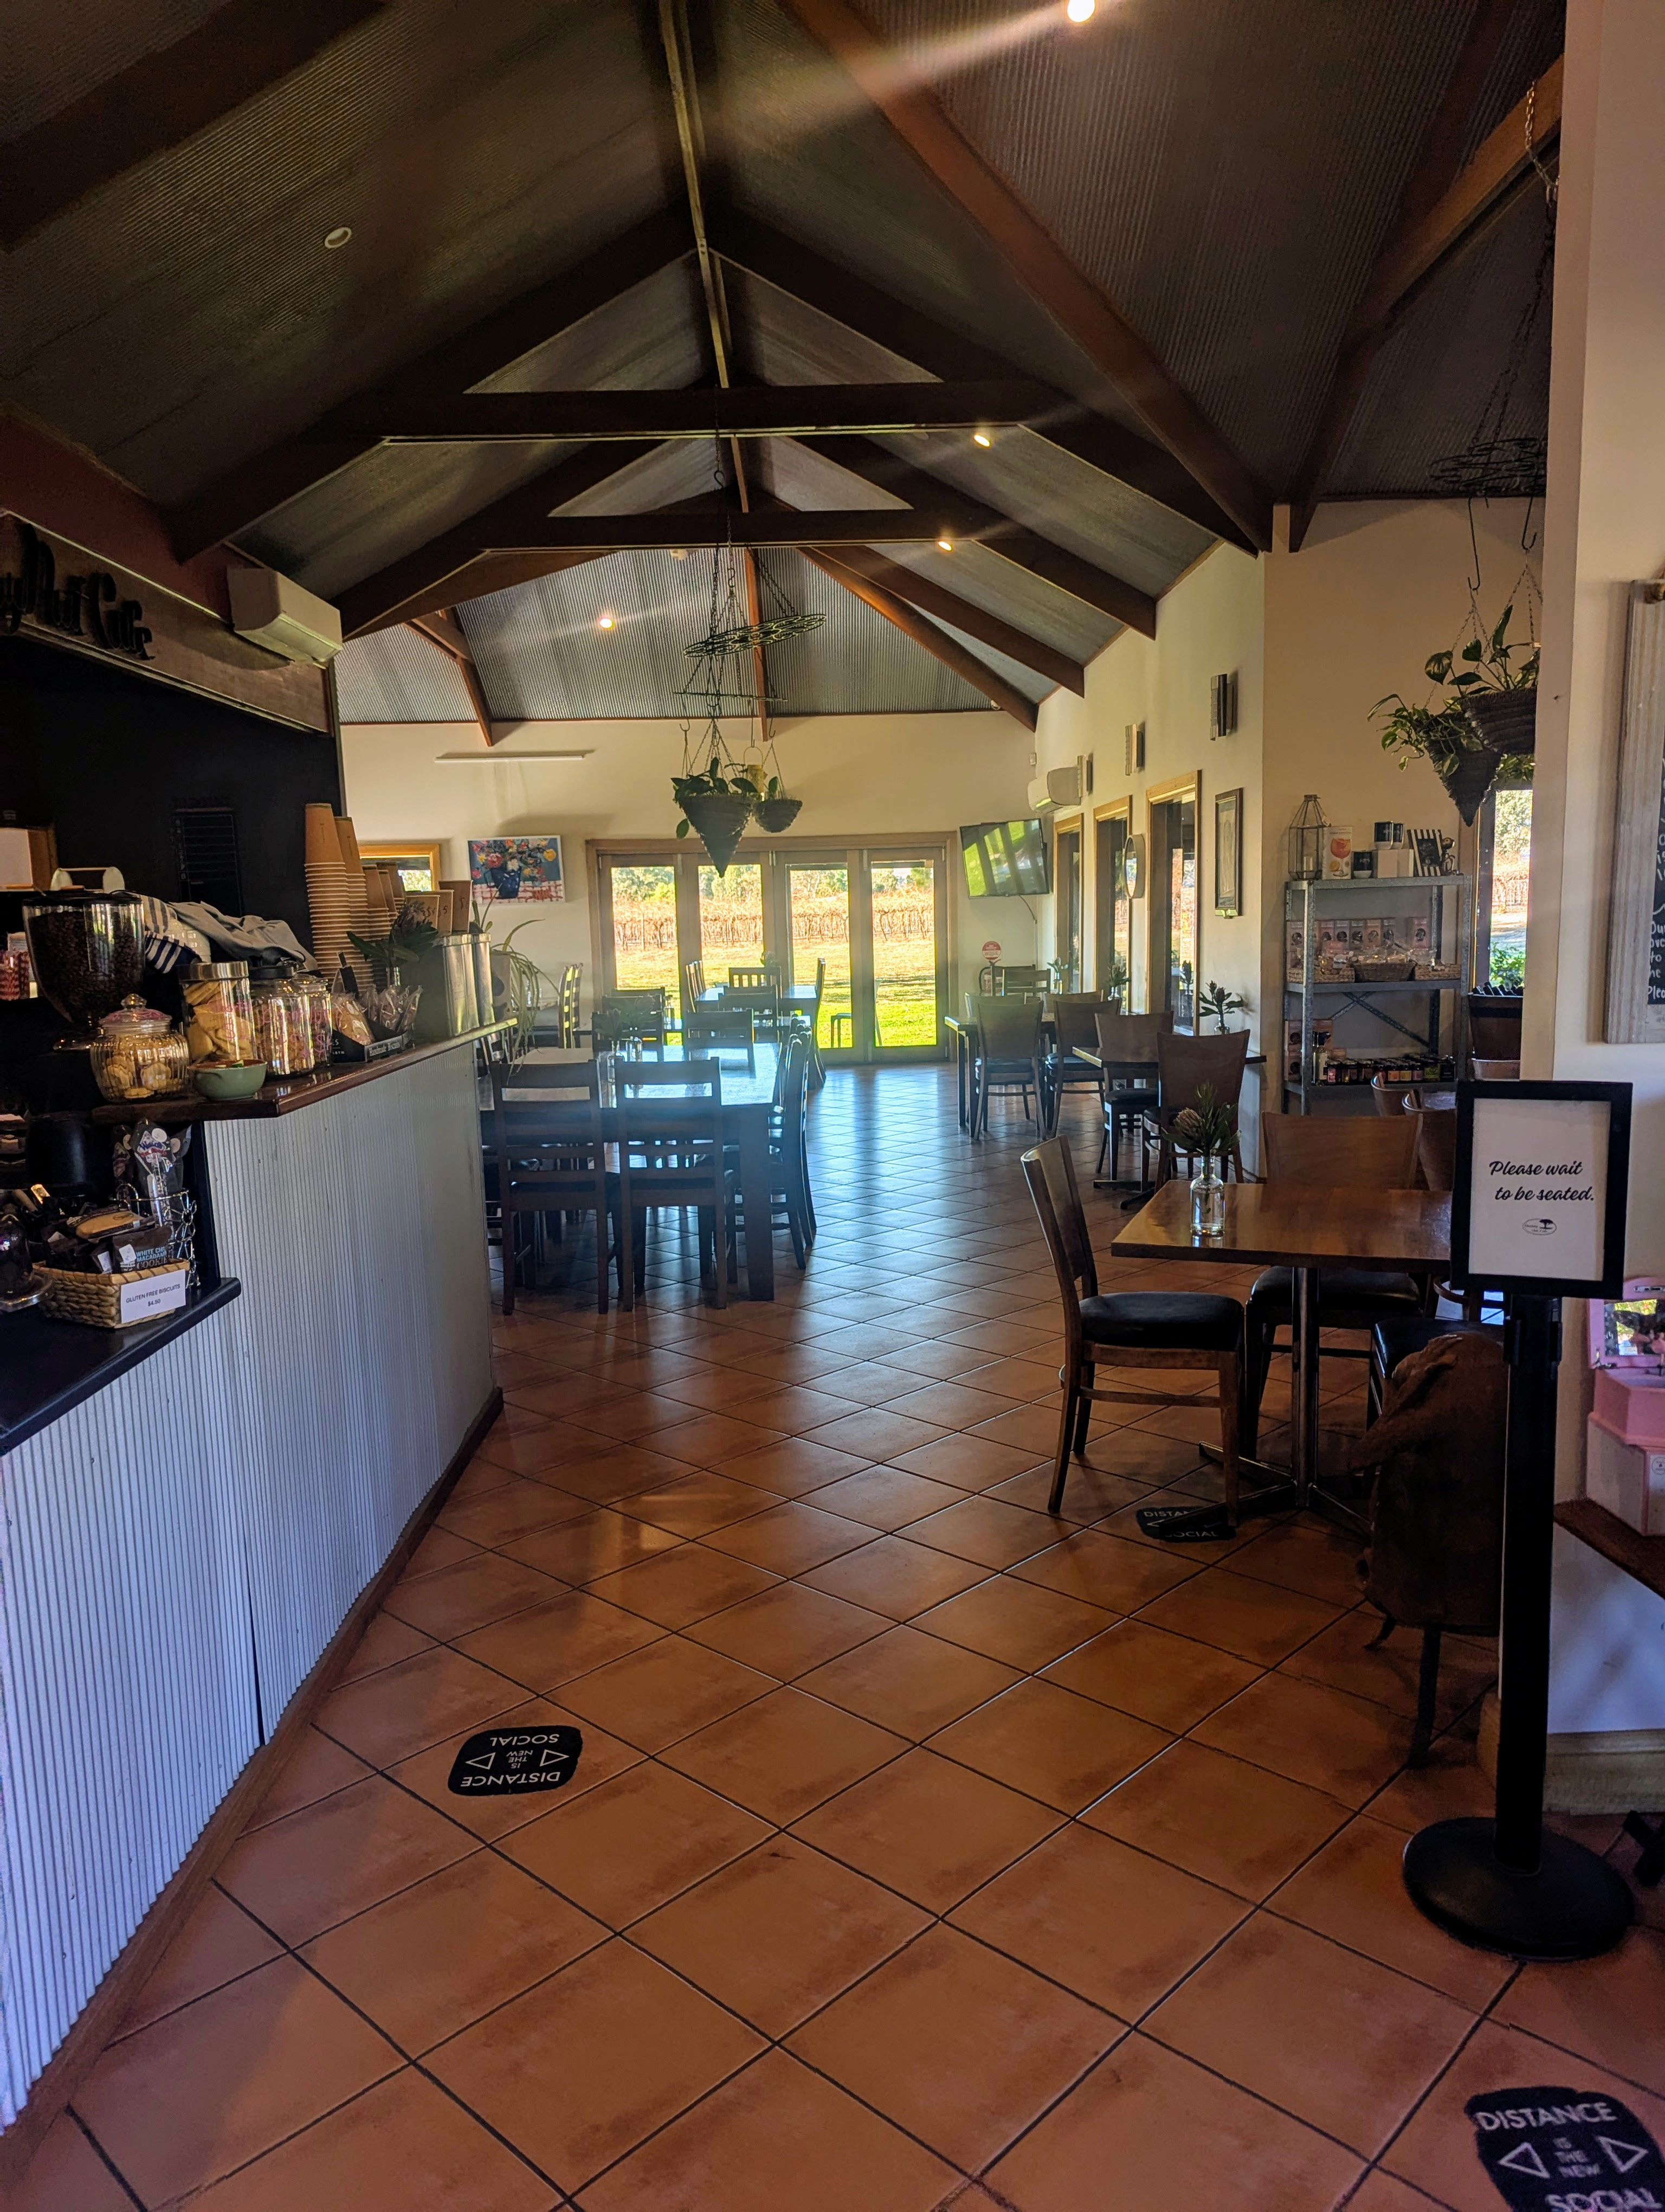
Walkways inside Monkey Nut Cafe
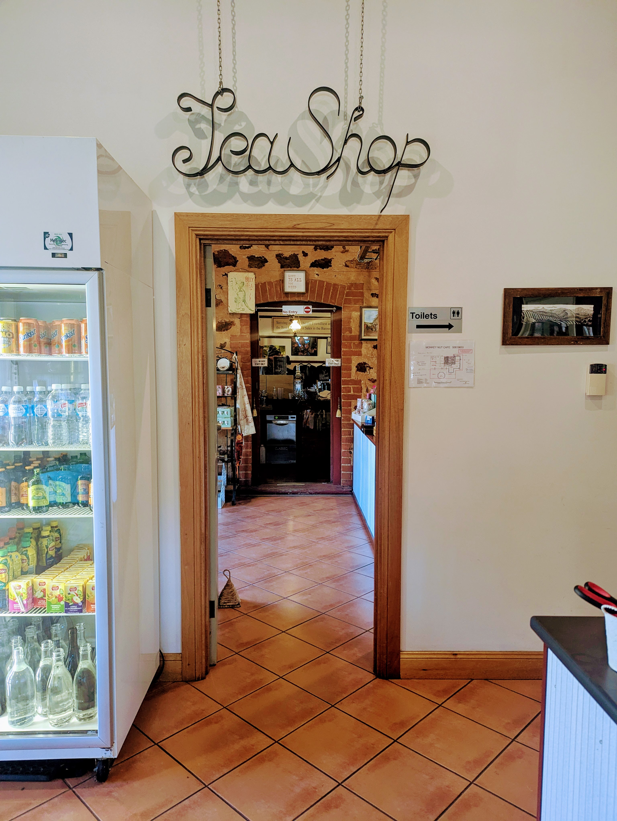
Entrance to Tea Shop
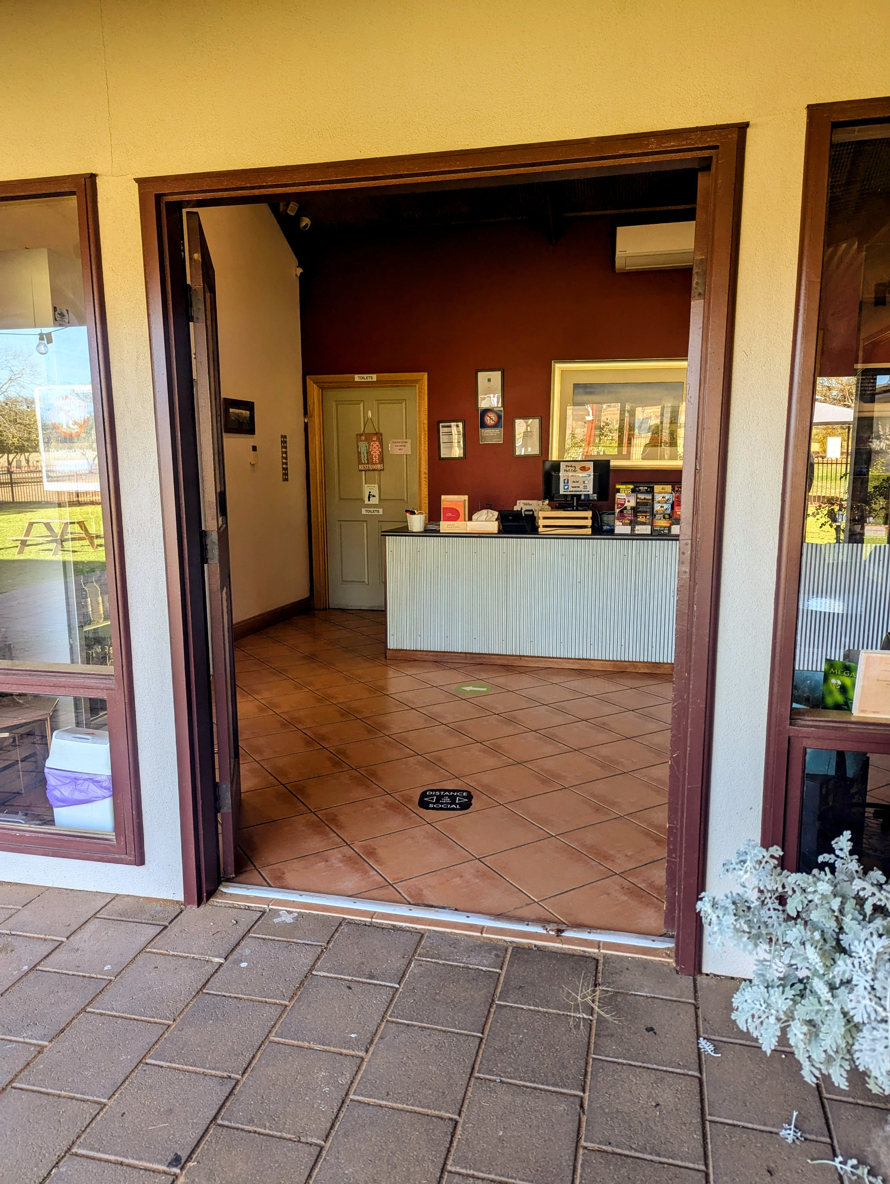
Entrance to Monkey Nut Cafe
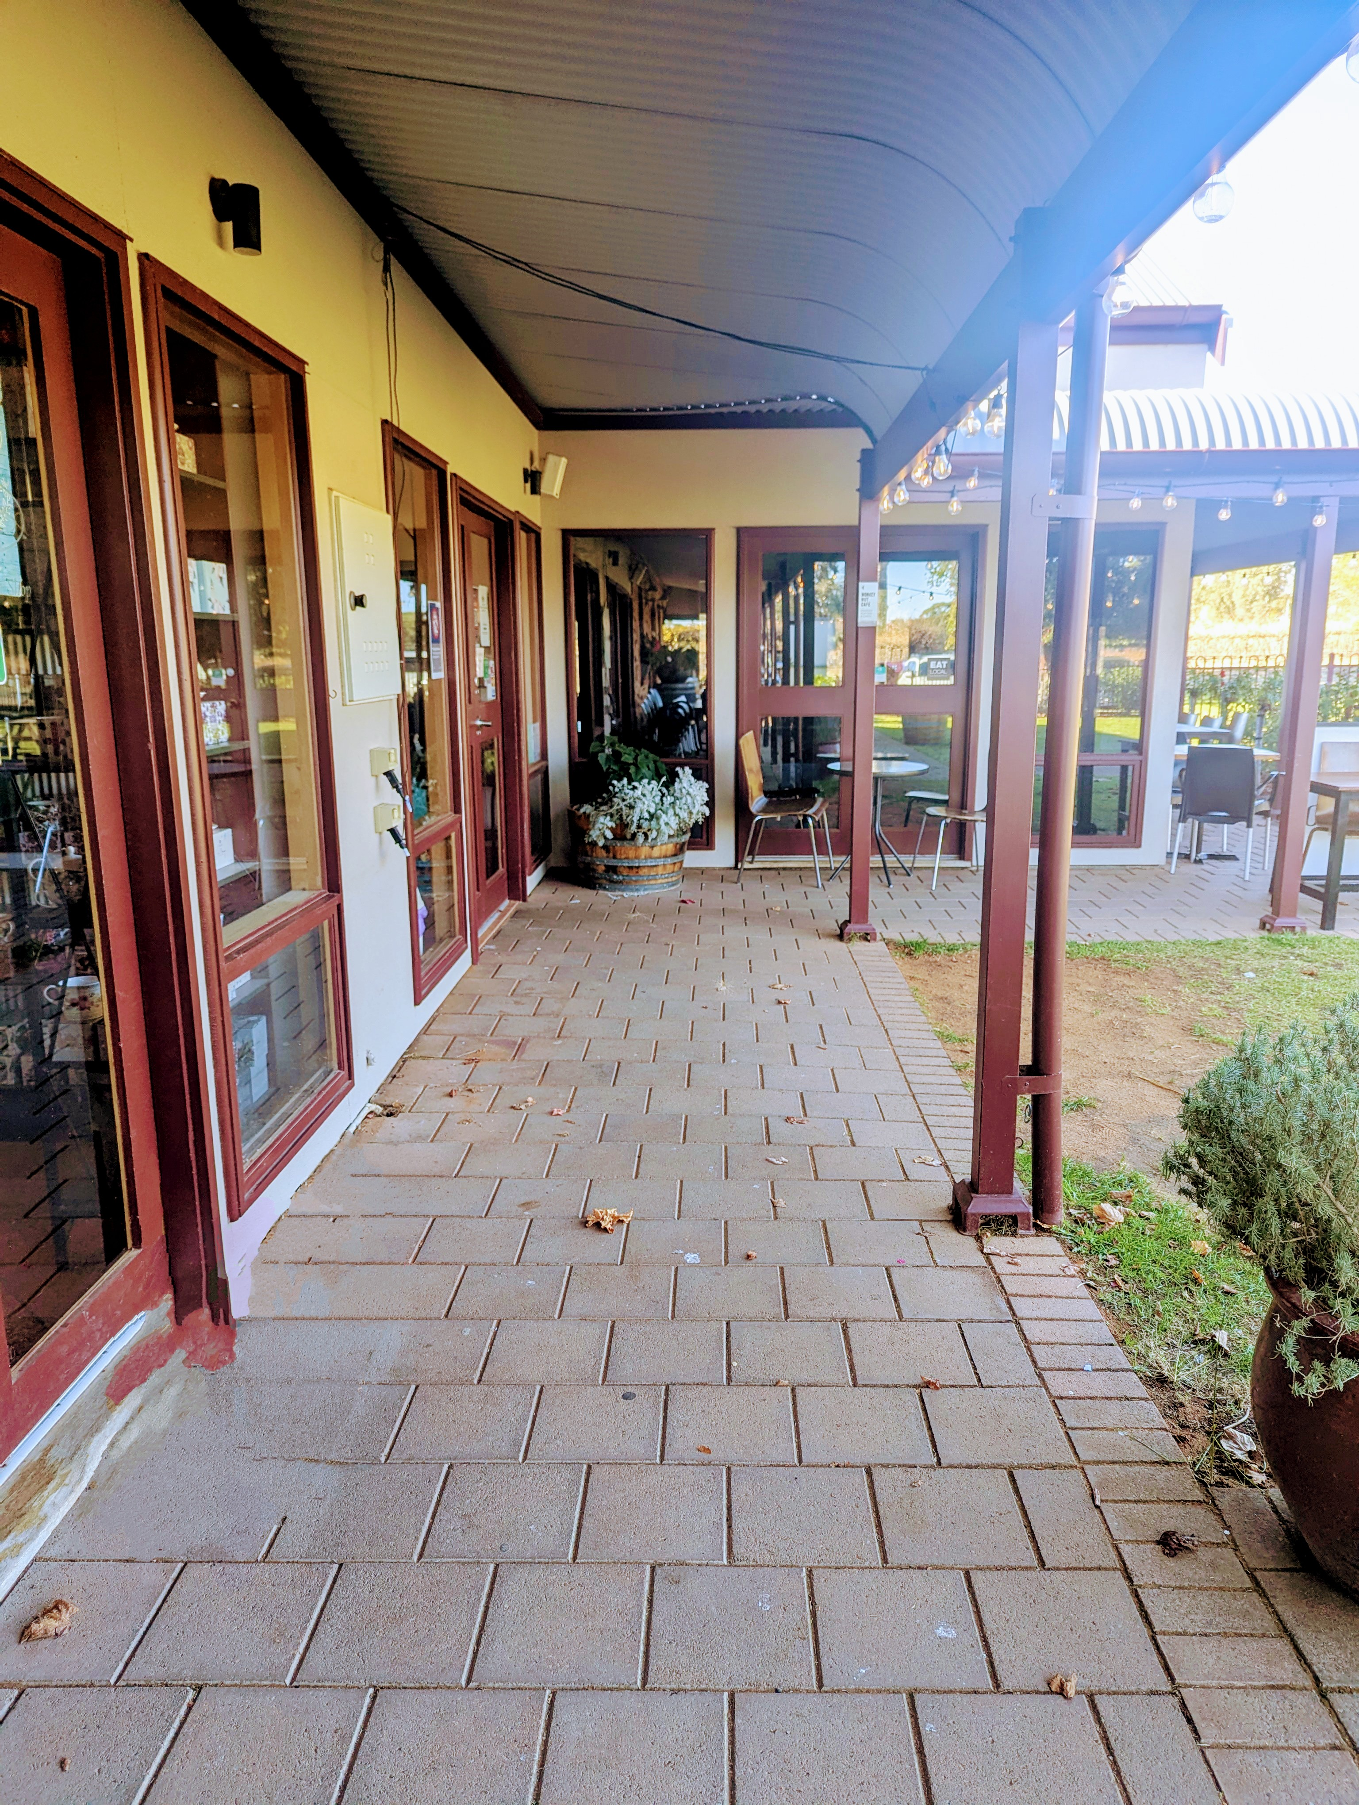
Entrance Walkway
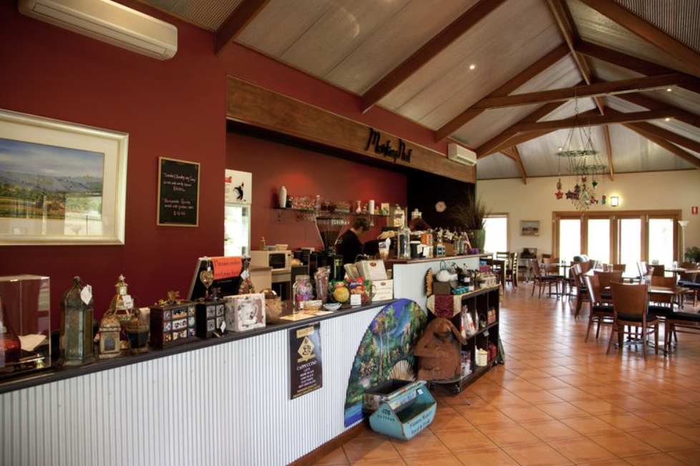
Bar Service Counter
- In addition, the following further information can assist guests:
Monkey Nut Cafe, nestled within Kies Family Wines in Lyndoch, offers a delightful experience among the Barossa Valley’s vineyards. This cozy cafe is known for its warm ambiance and delectable offerings, including wine flights paired with local produce platters.

Accessibility is a key feature, with a carpark conveniently located next to the cafe, making entry easy for all guests. The cafe is fully accessible, with ground floor access throughout, including to Kies Teas, a charming nook filled with an array of loose leaf teas and tea accessories. Additionally, the cafe has a spacious, wheelchair-accessible toilet equipped with right hand grab rails, ensuring an inclusive visit.

Report Disclaimer
Please note that this business report, provided as a result of the use of the diagnostic assessment, is for information purposes only.
Australian Tourism Industry Council (ATIC) cannot guarantee the accuracy of respondent’s answers, or that they are fully representative of your business. Therefore, ATIC does not warrant or guarantee any particular outcome in respect of your businesses self-assessment.
This report is intended as guidance only for your business and should not be relied on for future marketing considerations. ATIC recommends that you seek your own independent advice as well as the results from the diagnostic.
Links to external web sites are inserted for convenience and do not constitute endorsement of material at those sites, or any associated organisation, product or service.
ATIC does not:
- Assume any legal liability for the accuracy, completeness, or usefulness of any information from this report or any links provided; or
- Accept responsibility for any loss associated directly or indirectly from the use of this report.

