ATIC Accessibility
To support the accessible community in making informed travel decisions for their individual needs

This report prepared for:
Business name: | Seashells Mandurah
Address: | 16 Dolphin Drive
Town: | Mandurah
Contact for enquiries: | Chris McDonald
Contact Number: | 08 9550 3000
Contact Email: | mandurah@seashells.com.au
Website:
Date: | 2026-09-26 12:00

ATIC Accessibility
The following pages provides travellers with information on the businesses facilities and amenities which aims to support the traveller to make an informed decision on whether the business is suitable for their individual needs.
OVERVIEW 4
Business Overview 4
Bookings 4
Emergency Management 5
Communications 5
Other Information 5
Guide Dog and Service Animals 5
GENERAL 6
Pre-arrival, arrival and reception 6
Cognitive Impairment Support 6
Car Park and Access amenities 6
External Paths 7
Steps 7
Ramps 7
Public Toilets/Adult change facilities 7
ACCOMMODATION 9
Bedrooms 9
Room Amenities 9
Bathrooms 10
COMMON AREAS 12
Swimming pools, spas and waterparks 12
Report Disclaimer 16

OVERVIEW

Business Overview

The business has the following products/services available
- Accommodation

Our business caters for the following disability types:
- Blind or low vision
- Deaf or low hearing
- Limited mobility
- Wheelchairs or mobility scooters
- Food allergies or intolerances
- Cognitive or people on the Autism Spectrum


Bookings

The business offers the following methods for bookings and enquiries:
- Phone
- Email
- Webportal
- Staff have undergone disability awareness and training

Emergency Management
- The business has an emergency management and evacuation plan for guests with a disability
- Guests with disabilities are noted in the guest log book for emergency and evacuation purposes

Communications
- Our business offers the following alternative communication methods
- Plain English

Not specified
- There is easy to read signage and information (e.g. menus and emergency information)

Other Information
- For bookings made onsite, the ticket booth/counter/box office is accessible for people using a wheelchair

Guide Dog and Service Animals
The business provides the following services for services animals:
Eligible to attend conferences with owner and stay in accommodation with owner

GENERAL

Pre-arrival, arrival and reception
The business has the following in place to support guests during pre-arrival, arrival and reception
- Booking information and websites are compatible with screen readers
- There is a reception/public entryway.
- Seating available at reception
- A lower counter at reception/ticket office
- A clipboard to allow check-in/ticket purchase whilst seated
- A tablet with text to voice or pen and paper at reception to aid in communication
- Lighting in the reception area is even and glare free
- Information and maps are available in written form
- A familiarisation tour
- Keys are available for each guest
- Luggage assistance
- In addition, the following further information can assist guests:
During peak periods additional staff available for servicing counter and seating is located in foyer

Cognitive Impairment Support
- Documents are available in plain English for people with cognitive impairment (This may include instructions, guides, menus and general information)

Car Park and Access amenities
The business has the following Car Park and Access amenities
- A drop off zone
- Designated disabled parking bays
- Level or ramped access from the car park to the entrance
- The accessible entrance is clearly signed from the parking bay
- The public transport services available are:

Depending on the request printed information can be obtained from website
- Kerb ramps are in place where a pavement or walkway needs to be crossed

External Paths
External paths of travel
- Surfaces are concrete, asphalt, smooth paving or hard packed fine gravel (max aggregate size 13mm)
- Pathways are wider than 900mm
- There 3 successive steps or less on any path or at any doorway

Steps
Steps
- There are steps.
- All steps or staircases have enclosed risers
- The underside of all staircases are enclosed or protected to a height of at least 2 metres
- Handrails fitted to all open sets of steps
- Handrails extend 300mm beyond the top and bottom step
- Where steps are present are there three steps or less

Ramps
Ramps have the following amenities are in place
- There are ramps.
- All fixed ramps are 1:14 or less
- Hand rails are fitted
- Long ramps (more than 10m) are 1:20 or less
- Ramps have a raised edge of at least 100mm

Public Toilets/Adult change facilities
Public Toilets/Adult change facilities have the following amenities are in place
- There is an accessible toilet for public use
- The door is at least 850mm wide
- There is a minimum of 850mm beside the toilet
- Handrails are fitted
- The toilet seat is 460mm above the floor
- There is 1600mm mm of clear space in front of the toilet
- The toilet seat of a contrasting colour to the floor
- The toilet seat is460mm above the floor

ACCOMMODATION

Bedrooms
The bedrooms have the following facilities/amenities in place
- There are 2 rooms available to guests who use a wheelchair
- Bedroom furniture can be re-arranged on request
  - Layout of room Image(s)
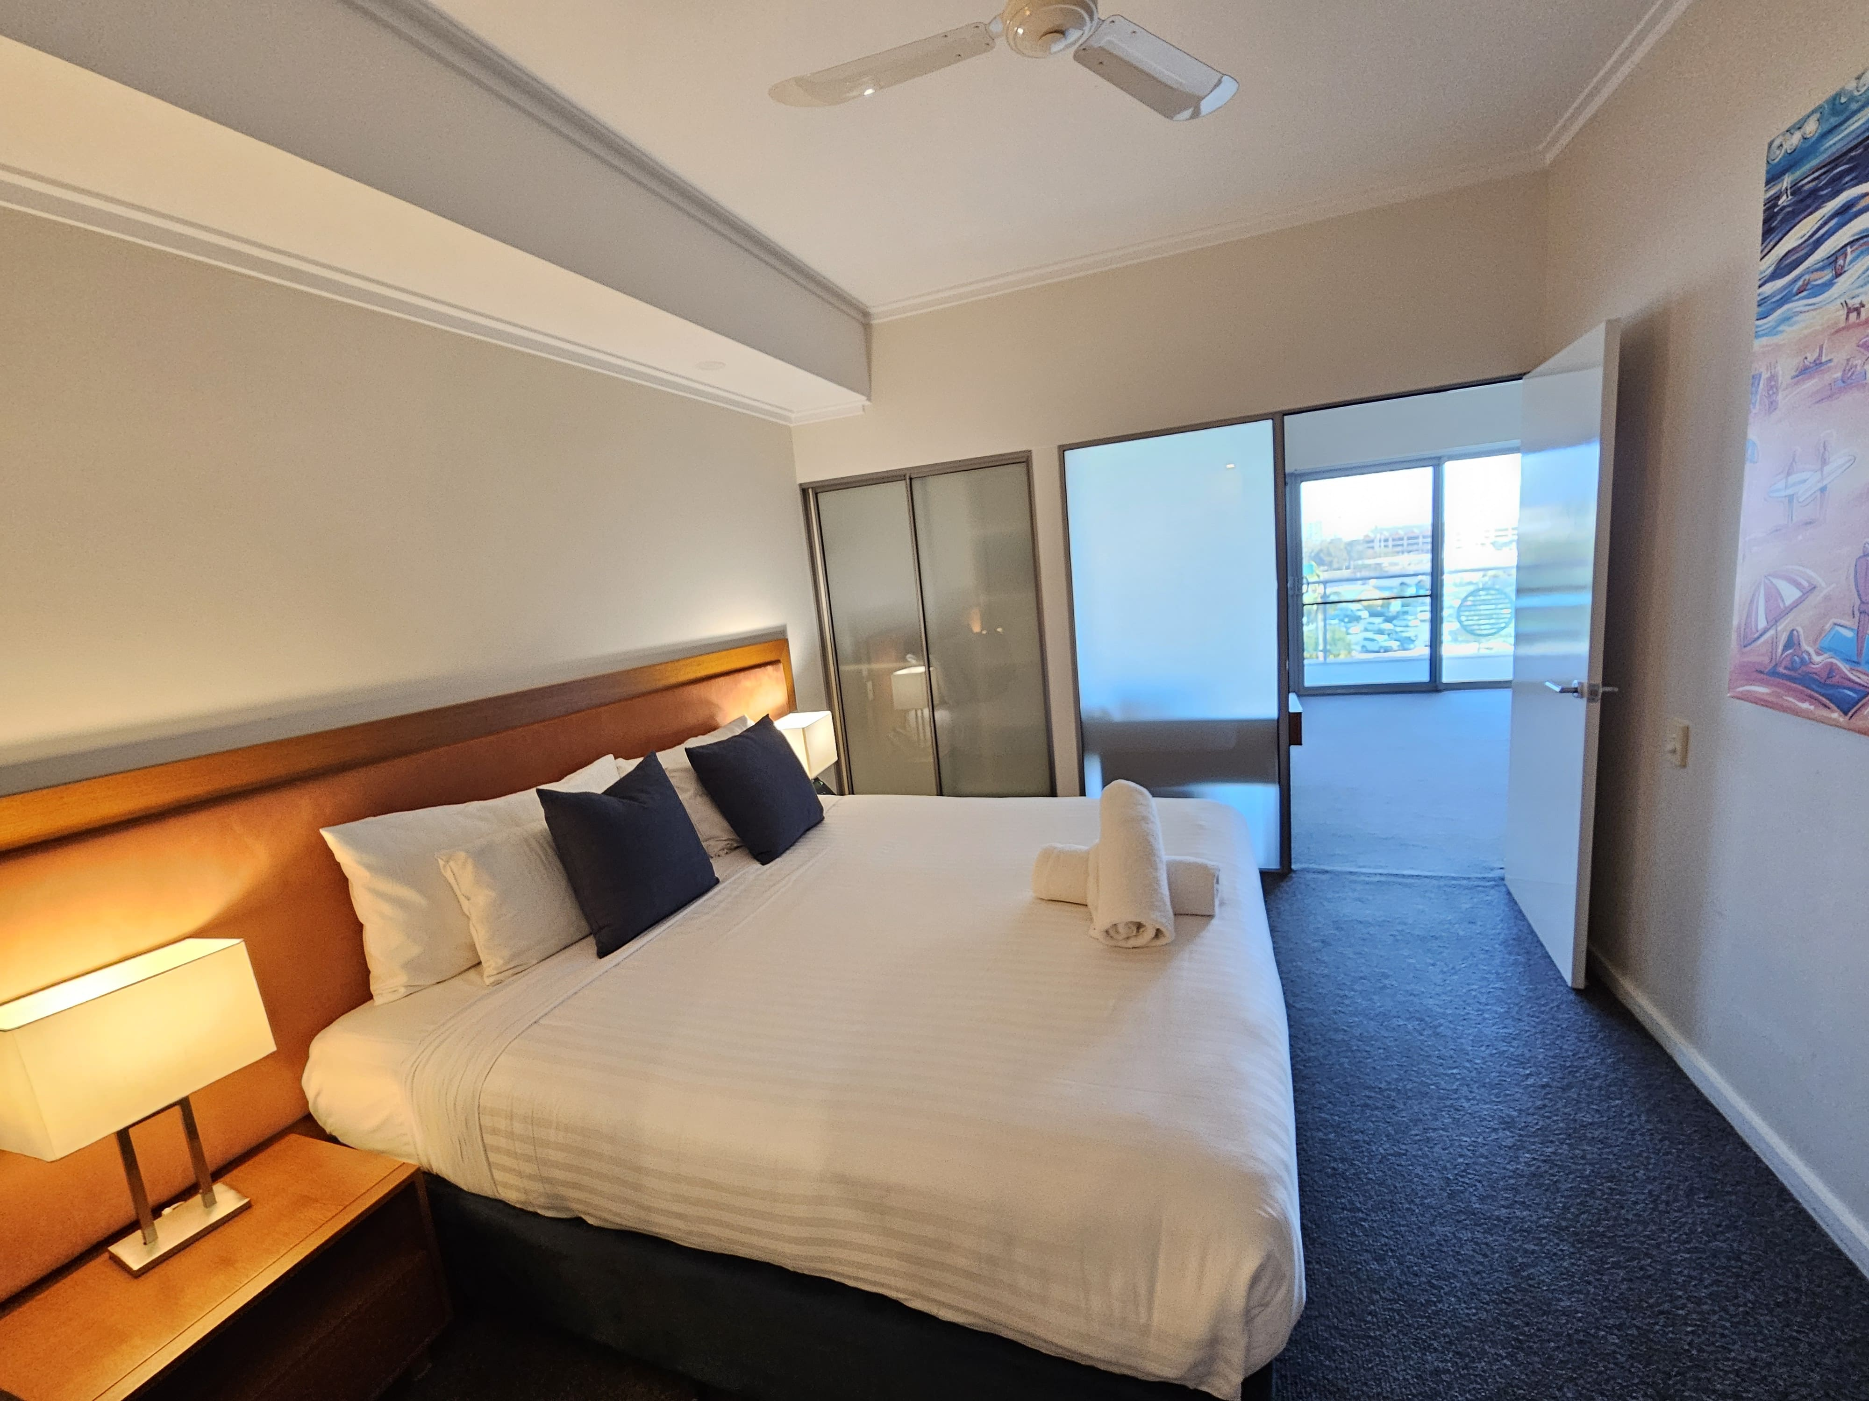
Accessible Apartment - Bedroom

Room Amenities
- Lower hanging rails are in wardrobes
- In addition, the following further information can assist guests:
As noted on our booking and registration records at the time of checkin we will have staff member attend to assisting with safe evacuation
- Televisions are equipped with closed captioning capability
- Room phones have volume control
- Room phones have a visual ringing indicator
- There is contrast between the walls, skirtings, floor and furniture
- There is a clear path through the room
- Wardrobe handles are a contrasting colour to the doors and draws
- Housekeeping procedures instruct staff not to reposition furniture that has been moved
- Doors open fully against the adjoining wall
- There is a clear opening at least 850mm wide
- There luggage racks for at least two suitcases
- There at least one chair with rigid arms
- Wardrobe and drawer handles are easy to grip
- The bedside lamp switch is easy to reach from the bed
- There is at least 850mm clear space beside the bed
- The bed height is no higher than 680mm from the floor
- There is at least 130mm clearance under the bed

Bathrooms
The bathrooms have the following facilities/amenities in place
- All heating appliances and hot water pipes are protected or insulated
- All shower, bath and basin taps are clearly differentiated between hot and cold
- Fixtures and fittings have rounded edges
- The door is at least 850mm wide
- There is a minimum of 850mm beside the toilet
- Handrails are fitted
- There is a minimum of 1400mm of clear space in front of the toilet
- The toilet seat is a contrasting colour to the floor
- The toilet seat is 460mm above the floor
- There is a roll-in shower with fold down fixed seat or a shower chair
- There is a portable shower head on flexible hose
  - Bathroom Image(s)
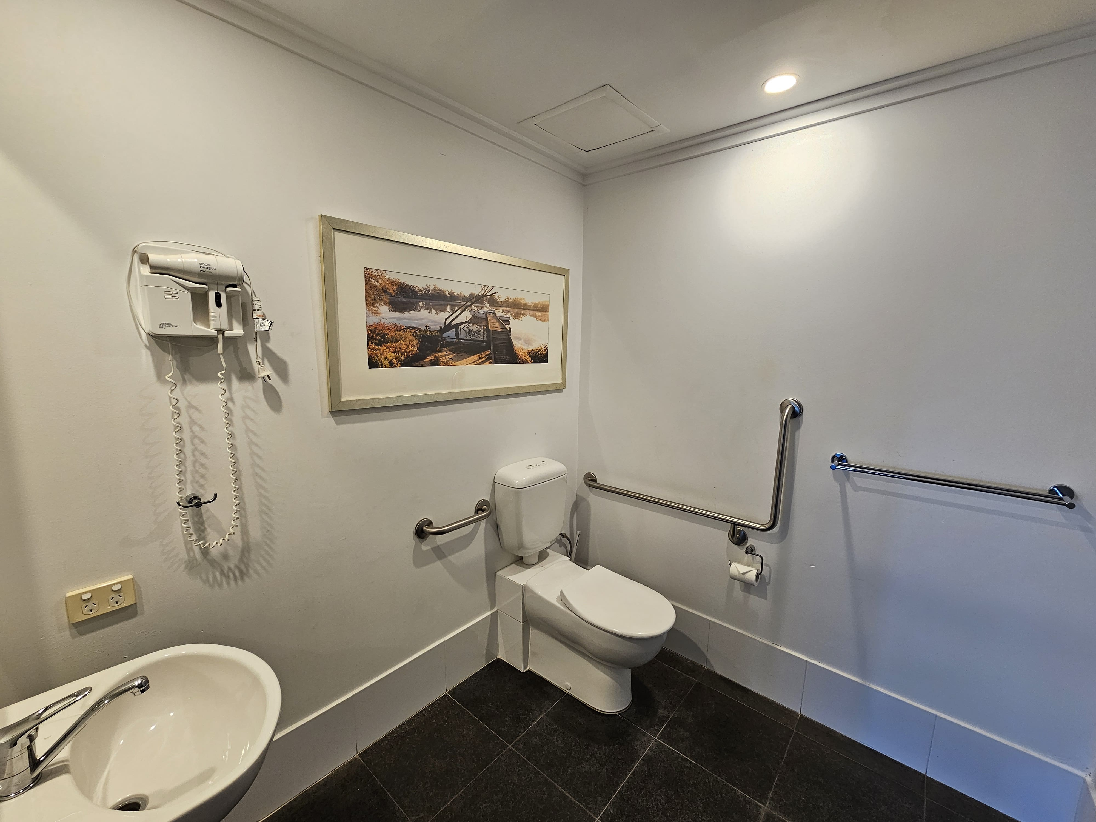
Accessible Apartment - Bathroom
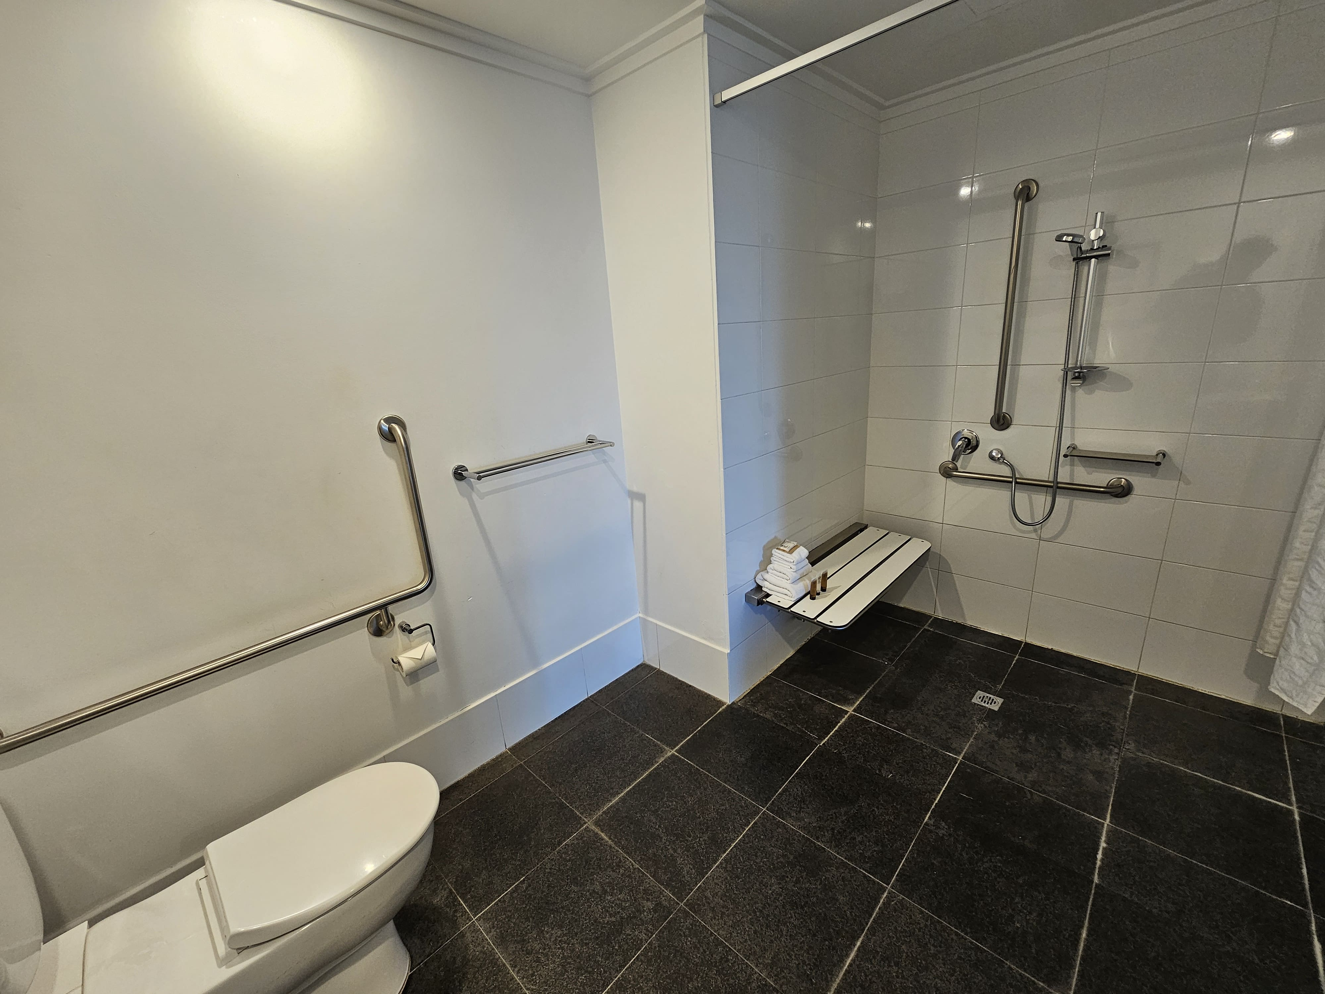
Accessible Apartment - Bathroom2

COMMON AREAS

Swimming pools, spas and waterparks
- The following swimming pools, spas and waterparks amenities are available
- Unisex change facilities with an accessible toilet
- The park map includes a step free route
  - Pool Access Image(s)
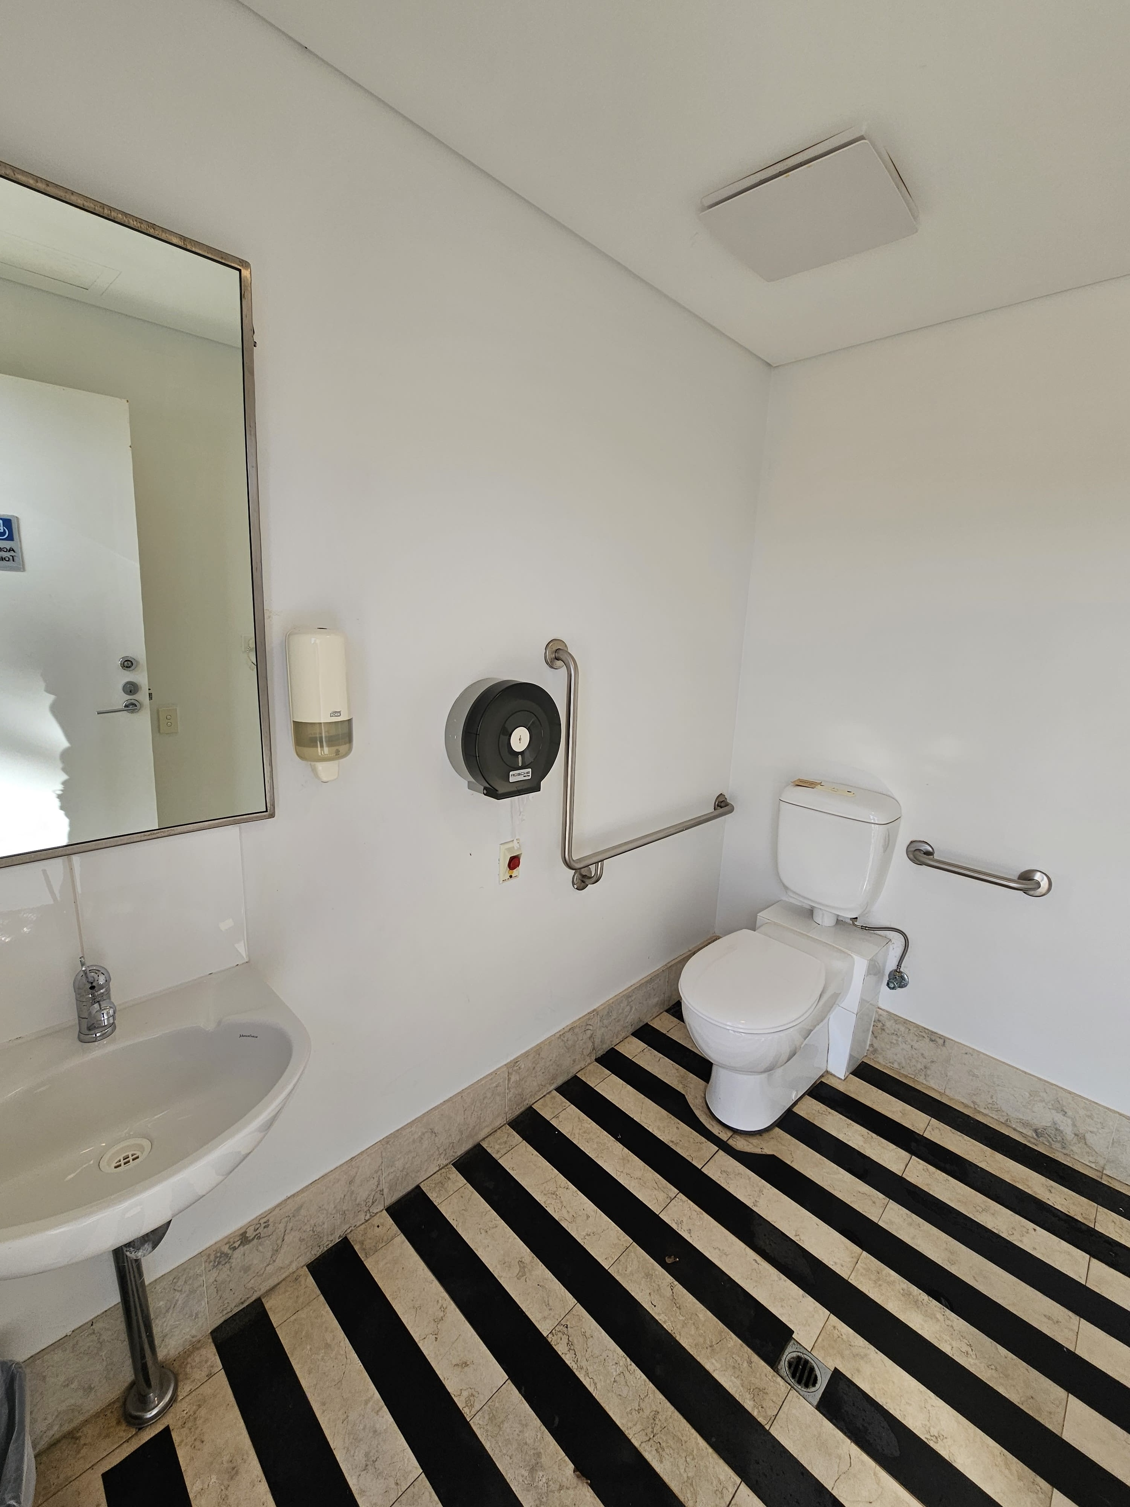
Pool Accessible Bathroom and Changeroom
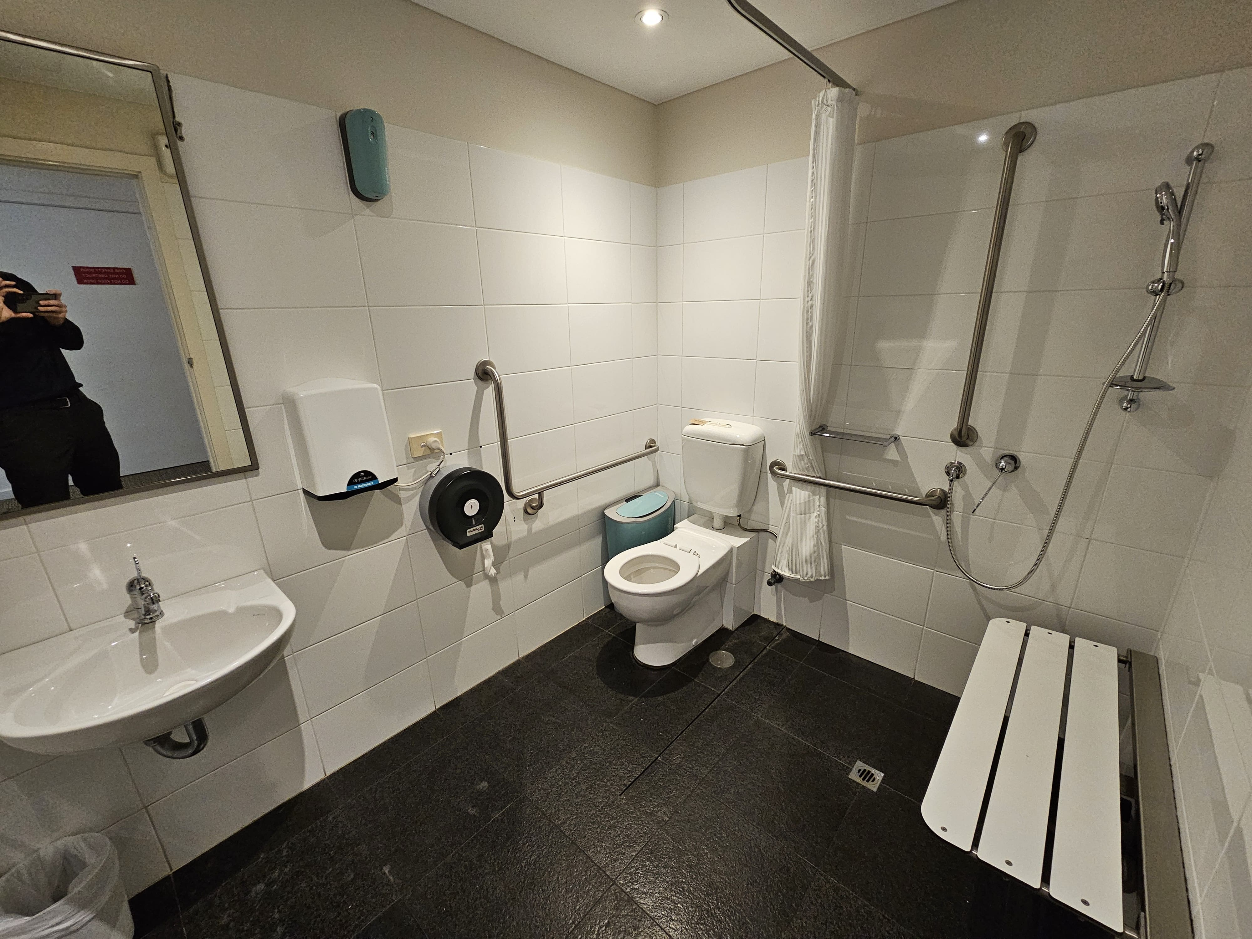
Reception Bathroom and Changeroom
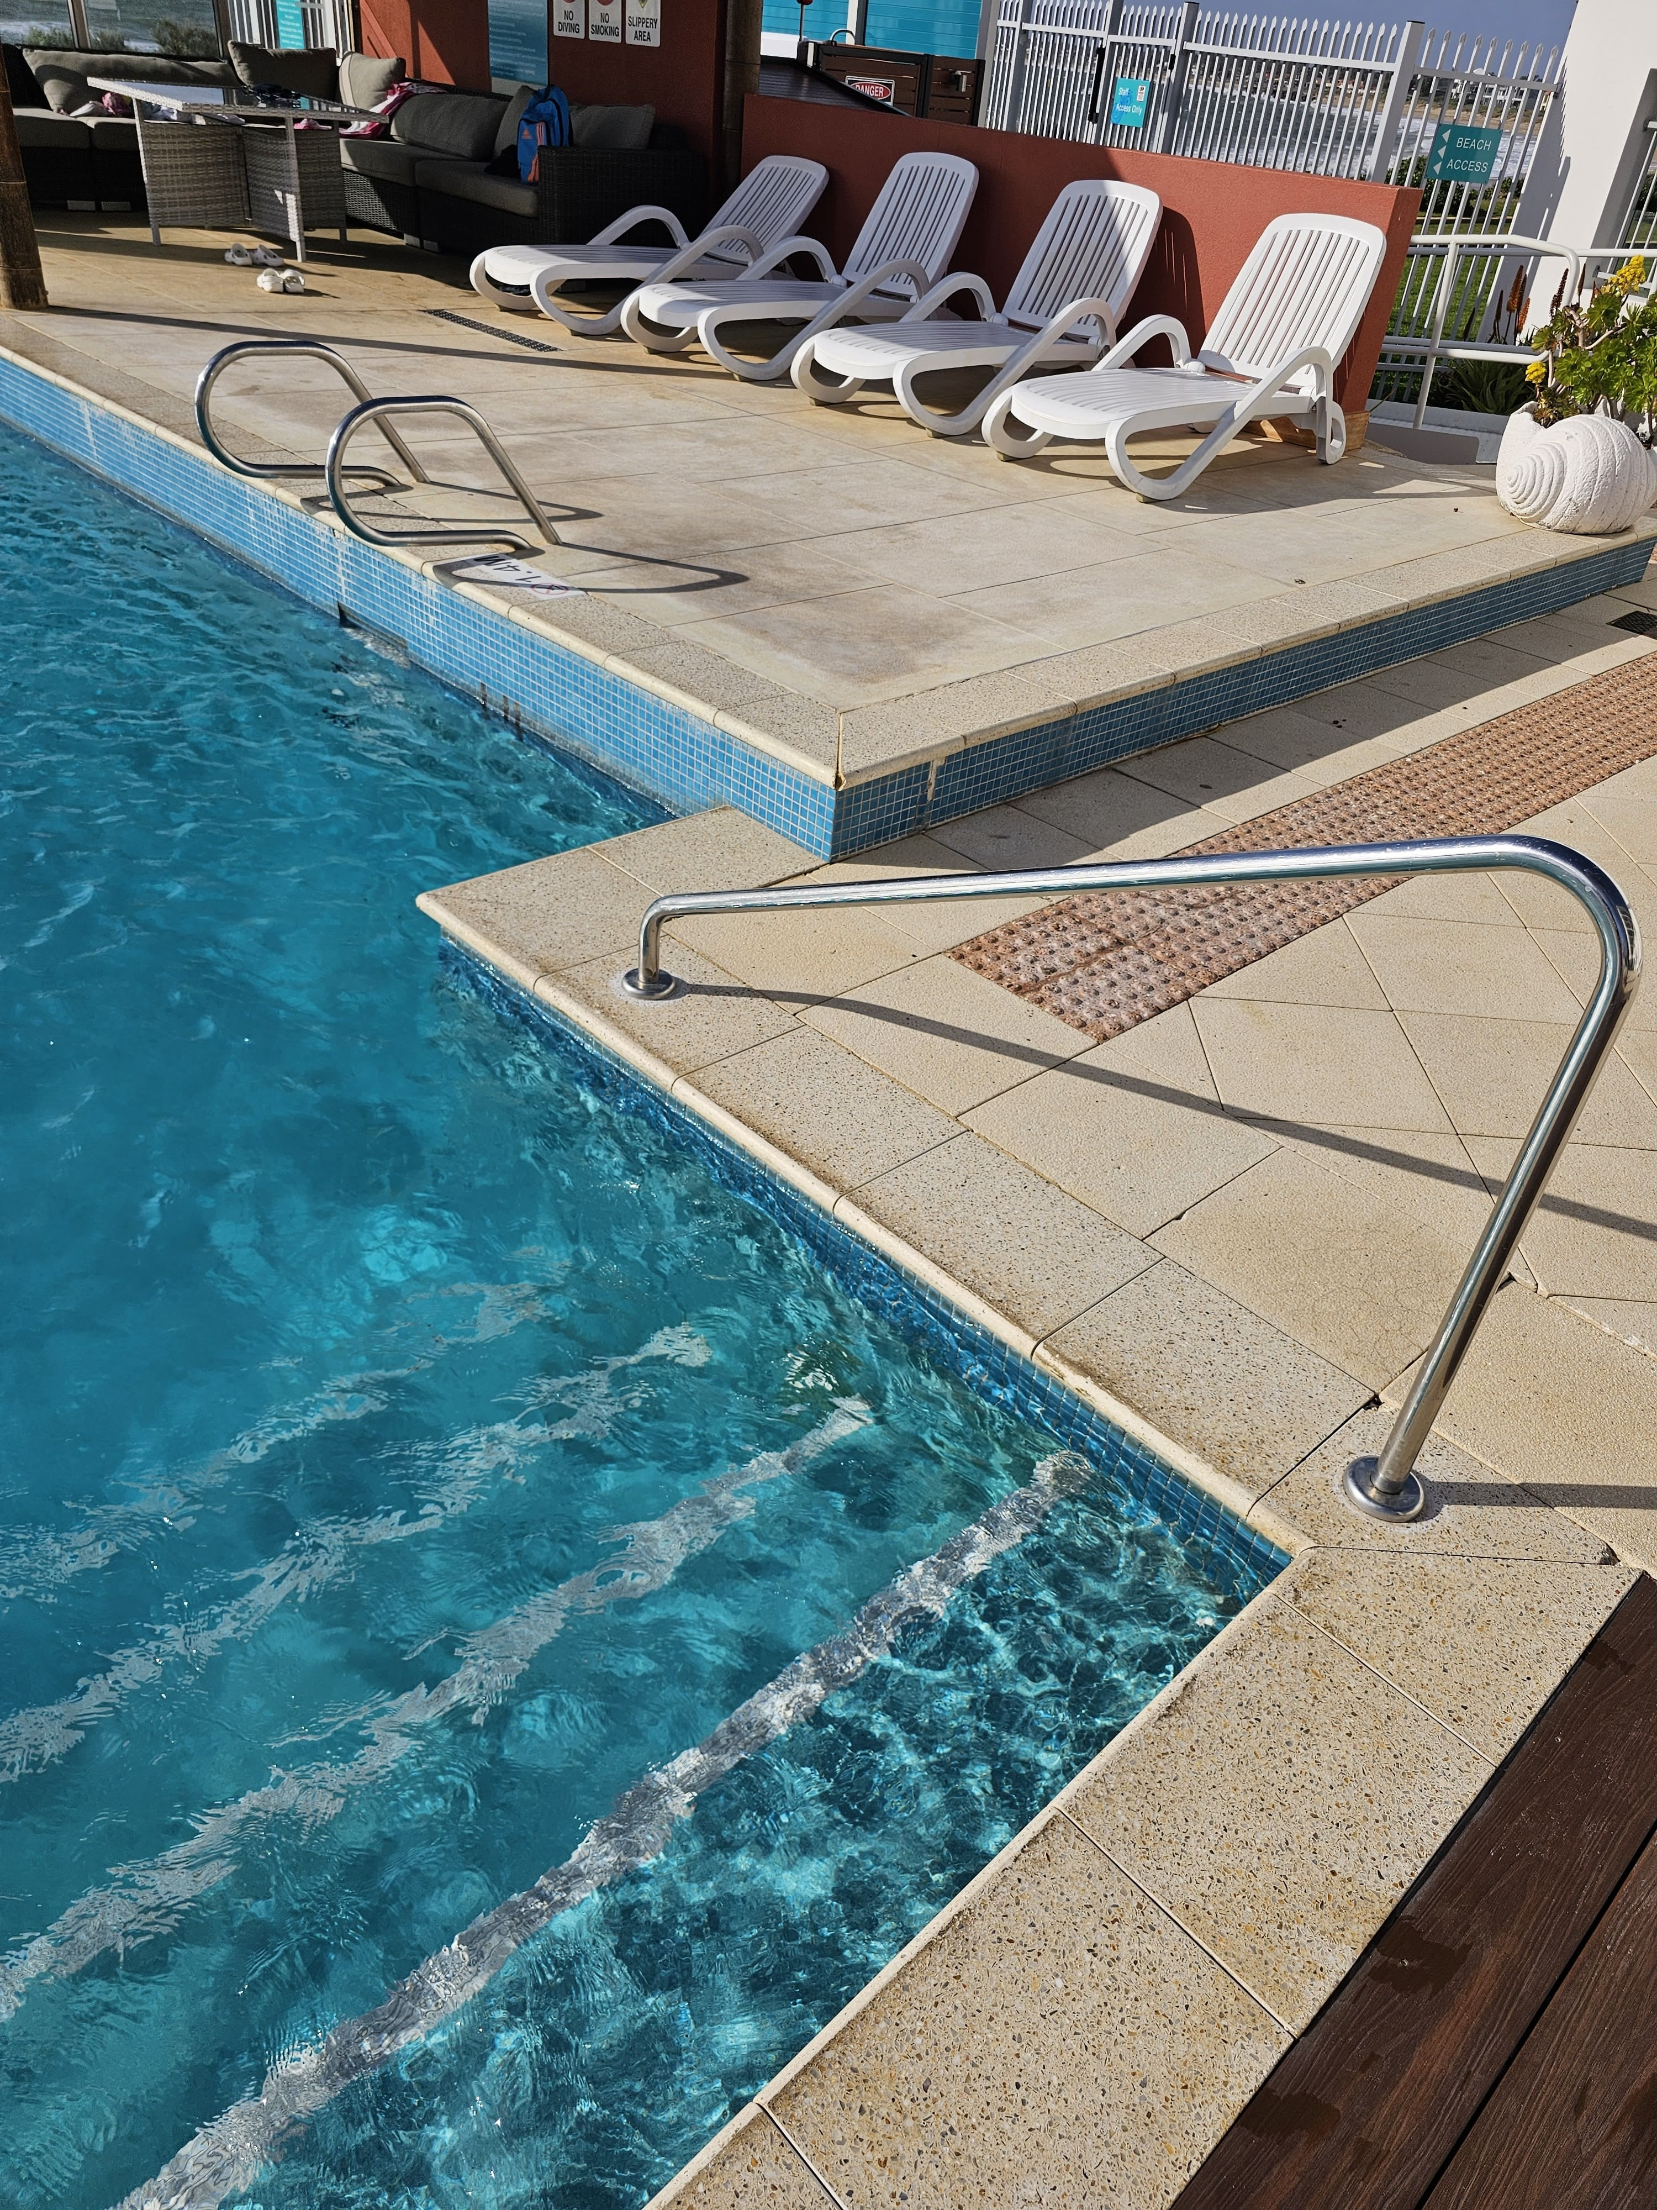
Pool Access
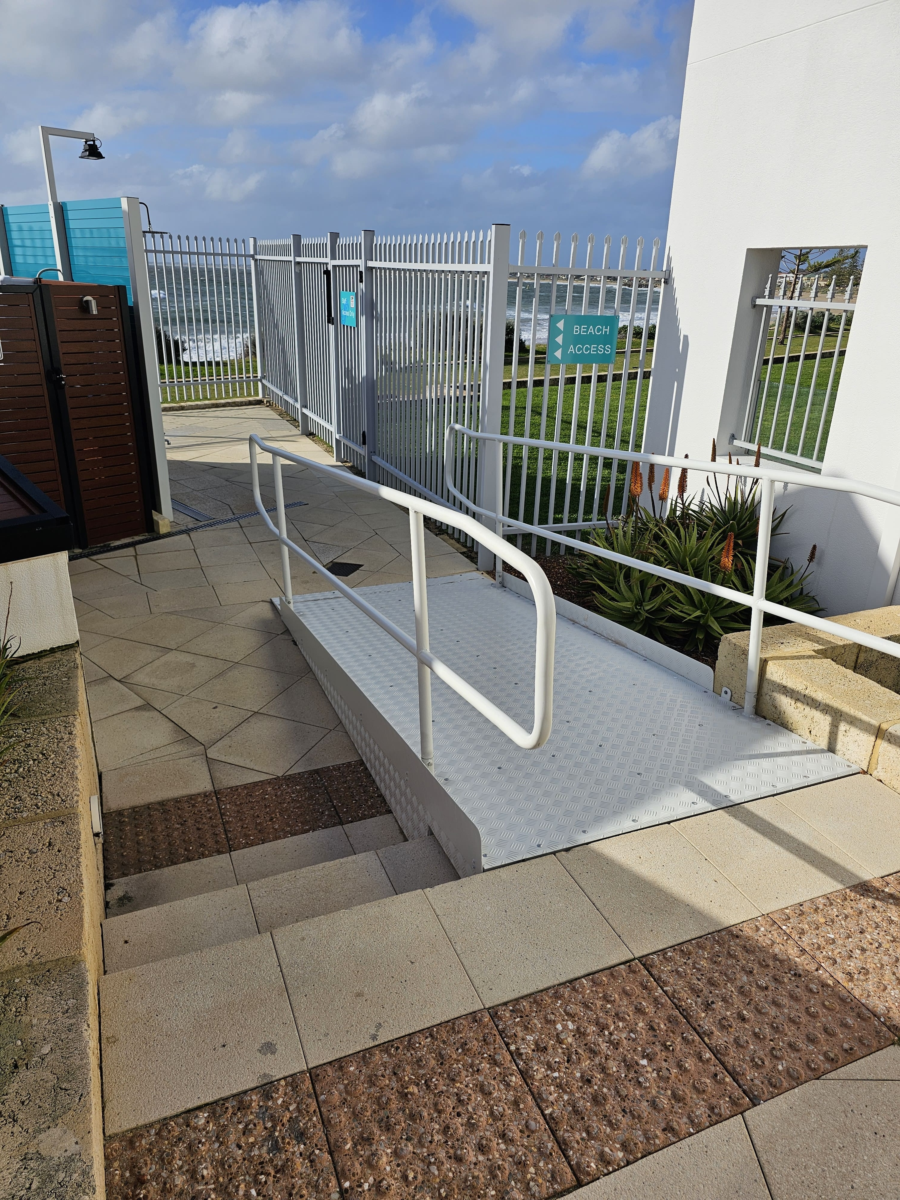
Pool Area Ramp
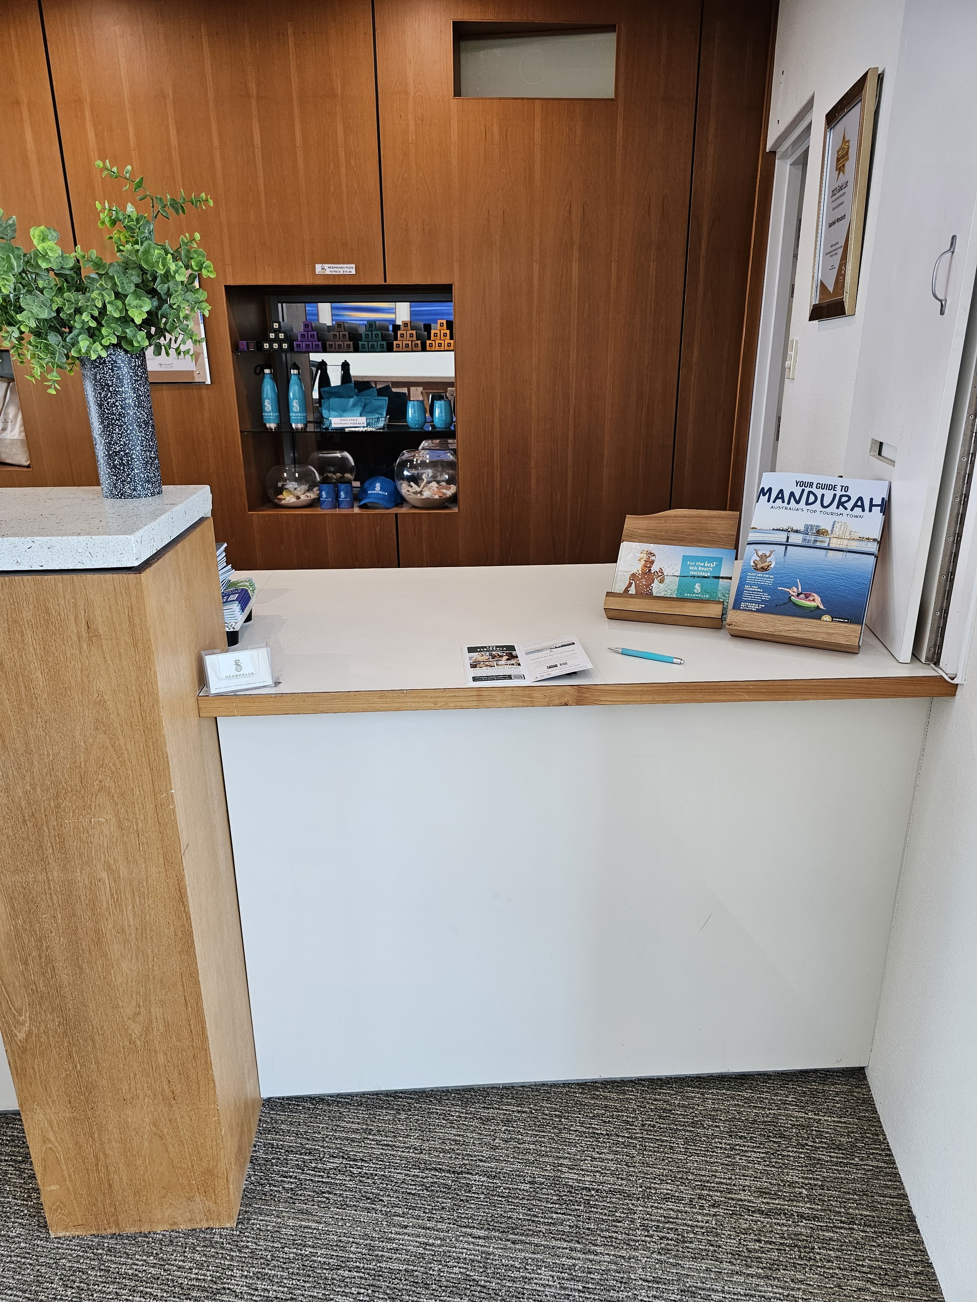
Reception Desk
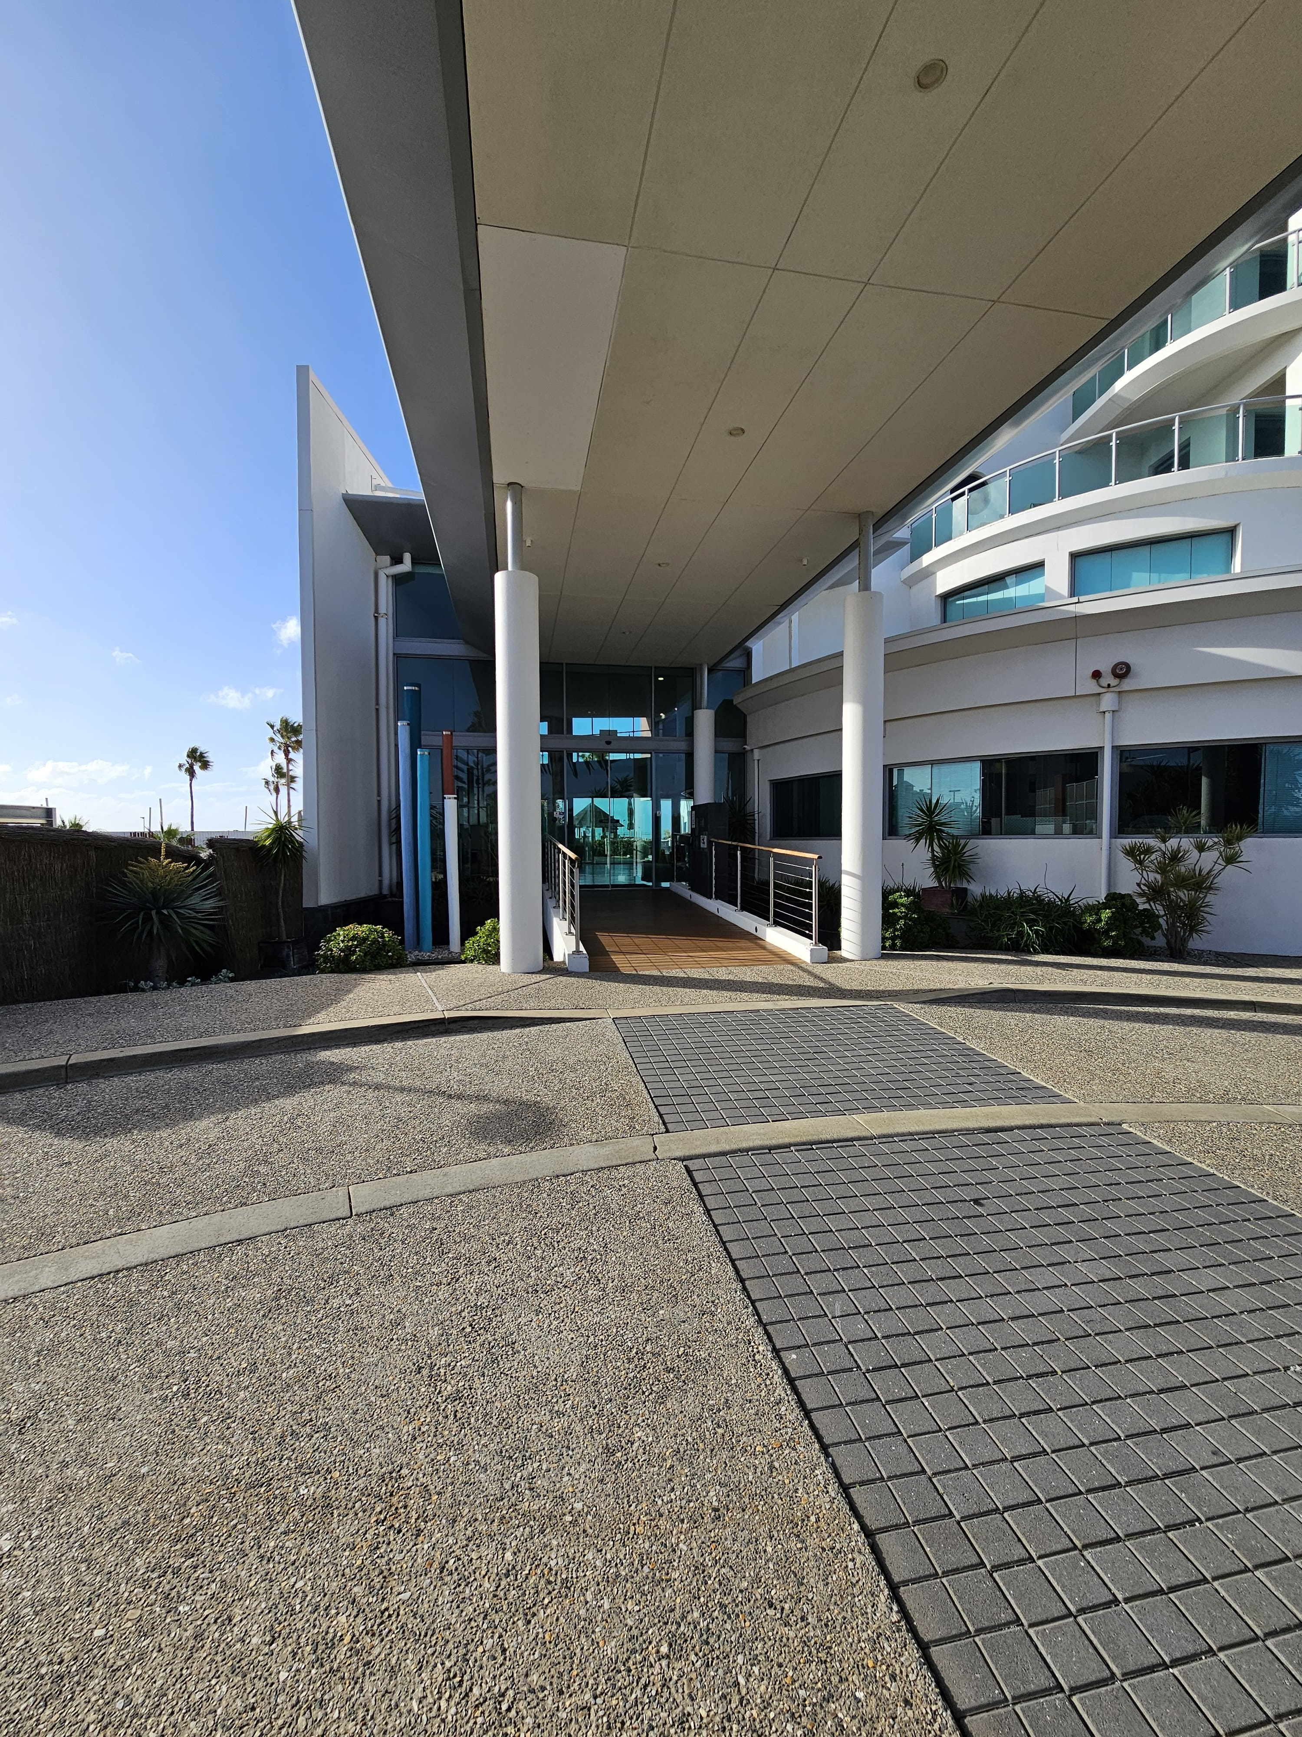
Reception Entry

Report Disclaimer
Please note that this business report, provided as a result of the use of the diagnostic assessment, is for information purposes only.
Australian Tourism Industry Council (ATIC) cannot guarantee the accuracy of respondent’s answers, or that they are fully representative of your business. Therefore, ATIC does not warrant or guarantee any particular outcome in respect of your businesses self-assessment.
This report is intended as guidance only for your business and should not be relied on for future marketing considerations. ATIC recommends that you seek your own independent advice as well as the results from the diagnostic.
Links to external web sites are inserted for convenience and do not constitute endorsement of material at those sites, or any associated organisation, product or service.
ATIC does not:
- Assume any legal liability for the accuracy, completeness, or usefulness of any information from this report or any links provided; or
- Accept responsibility for any loss associated directly or indirectly from the use of this report.

