ATIC Accessibility
To support the accessible community in making informed travel decisions for their individual needs

This report prepared for:
Business name: | Broome Whale Watching
Address: | 3 Spoonbill Ave
Town: | Broome
Contact for enquiries: | Cameron Birch
Contact Number: | (08) 9192 8163
Contact Email: | admin@broomewhalewatching.com.au
Website: | www.broomewhalewatching.com.au
Date: | 2026-10-24 14:44

ATIC Accessibility
The following pages provides travellers with information on the businesses facilities and amenities which aims to support the traveller to make an informed decision on whether the business is suitable for their individual needs.
OVERVIEW 4
Business Overview 4
Bookings 4
Emergency Management 4
Communications 5
Other Information 5
Guide Dog and Service Animals 5
GENERAL 6
Pre-arrival, arrival and reception 6
Cognitive Impairment Support 6
Car Park and Access amenities 6
Displays, exhibits, commentary and live performances 7
External Paths 7
TOUR OPERATORS 8
Tour/Transport Services 8
Route Planning 8
Guides 8
Report Disclaimer 11

OVERVIEW

Business Overview

Our business caters for the following disability types:
- Blind or low vision
- Deaf or low hearing
- Limited mobility
- Food allergies or intolerances
- Cognitive or people on the Autism Spectrum
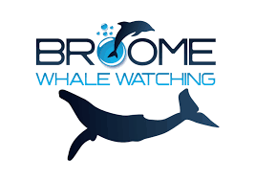

Bookings

The business offers the following methods for bookings and enquiries:
- Phone
- Email
- Webportal
- Our website supports Screen Readers
- Our forms have high contract boxes and submit boxes
- Staff have undergone disability awareness and training

Emergency Management
- The business has an emergency management and evacuation plan for guests with a disability
- Emergency and evacuation procedures are explained on arrival
- Guests with disabilities are noted in the guest log book for emergency and evacuation purposes

Communications
- An accessibility guide is available on the website

https://accreditation.qualitytourismaustralia.com/report/AccessReportPublicHtml2/1cd91e2b-9d34-4f7a-9060-15e681387c99
- Our website meets WCAG 2.0 accessibility standards
- Our business offers the following alternative communication methods
- Plain English

Not specified
- There is easy to read signage and information (e.g. menus and emergency information)

Information booklet outline content covered in the commentary provided by our staff.

Other Information
- For bookings made onsite, the ticket booth/counter/box office is accessible for people using a wheelchair
- The business accepts the companion card

Guide Dog and Service Animals
The business provides the following services for services animals:
We are unable to host service animals on board due to food safety and hygiene practices. We must also ensure walkways are free in the event of an emergency evacuation.

GENERAL

Pre-arrival, arrival and reception
The business has the following in place to support guests during pre-arrival, arrival and reception
- Booking information and websites are compatible with screen readers
- Information and maps are available in written form
- A familiarisation tour
- In addition, the following further information can assist guests:
We provide 2-3 bus services for transfers in our business to ensure no guest is waiting too long between boat and bus transfers. Cushioned seating on the vessel is also available on the bottom deck whilst guests are waiting to disembark. Should there be any concerns with fatigue, priority vehicle transfers are also provided by reception staff.
- In addition, the following further information can assist guests:
We offer the use of an amphibious transfer vessel for guests to access our tours. This vessel caters to many physical requirements.

Cognitive Impairment Support
- Documents are available in plain English for people with cognitive impairment (This may include instructions, guides, menus and general information)
- A "social script" guide to your premises or attraction describing the sights, sounds and smells to aid parents/carers prepare visitors in advance
- The 'social script' is available in word and other editable formats
- A space for parents and children on the Autism Spectrum

Car Park and Access amenities
The business has the following Car Park and Access amenities
- A drop off zone
- Designated disabled parking bays
- Level or ramped access from the car park to the entrance
- The accessible entrance is clearly signed from the parking bay
- Kerb ramps are in place where a pavement or walkway needs to be crossed
- In addition, the following further information can assist guests:
Once on board our vessel we have a speaker system for our guests to hear the commentary provided by staff.

Displays, exhibits, commentary and live performances
For displays, exhibits, commentary and live performances the following amenities are in place
- Seating
- A written transcript where audio description is provided i.e. display commentary, tour commentary
- In addition, the following further information can assist guests:
We provide an information folder outlining the details of the tour commentary. This is available to guests and includes photographs and illustrations.

External Paths
External paths of travel
- Surfaces are concrete, asphalt, smooth paving or hard packed fine gravel (max aggregate size 13mm)
- Pathways are wider than 900mm

We board from the beach.

We board from the beach.
- In addition, the following further information can assist guests:
We have a ladder that is used by our customers to access the top level of the boat.
- In addition, the following further information can assist guests:
We have a toilet on board that isn't accessible to wheel chair.

TOUR OPERATORS

Tour/Transport Services
The tour/transport services have the following facilities/amenities in place
- Buses/Coaches
- Nil vehicles have wheelchair lifts or ramps
- Nil vehicles have low floors with ramped entry
The maximum wheelchair capacity available in the fleet is:
Nil
- Commentary is available in written format
- Audio visual displays are sub titles

Route Planning
- Route Planning
- In addition, the following further information can assist guests:
A standard sized toilet is available on board that requires passengers to take a small step into.
- Lunch stop venues are accessible
- Sightseeing and photo opportunity stops are step free

Guides
- Use of clear/simple English
- Correct pronunciation for lip readers
- Marine
- An aisle chair of other means of boarding
- In addition, the following further information can assist guests:
Sealegs an amphibious vessel is provided to passengers to transfer guests onto main vessel.
The sealegs lowers down onto the beach which provides easier access for guests with low mobility.
- Accessibility is tide dependent
  - Image(s)
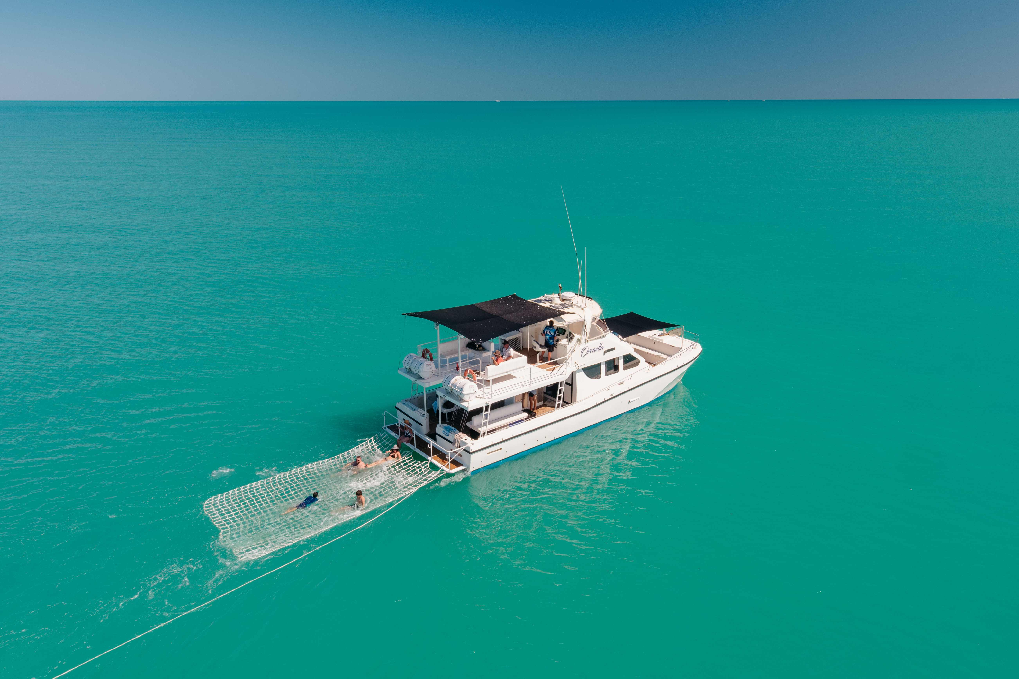
Boat
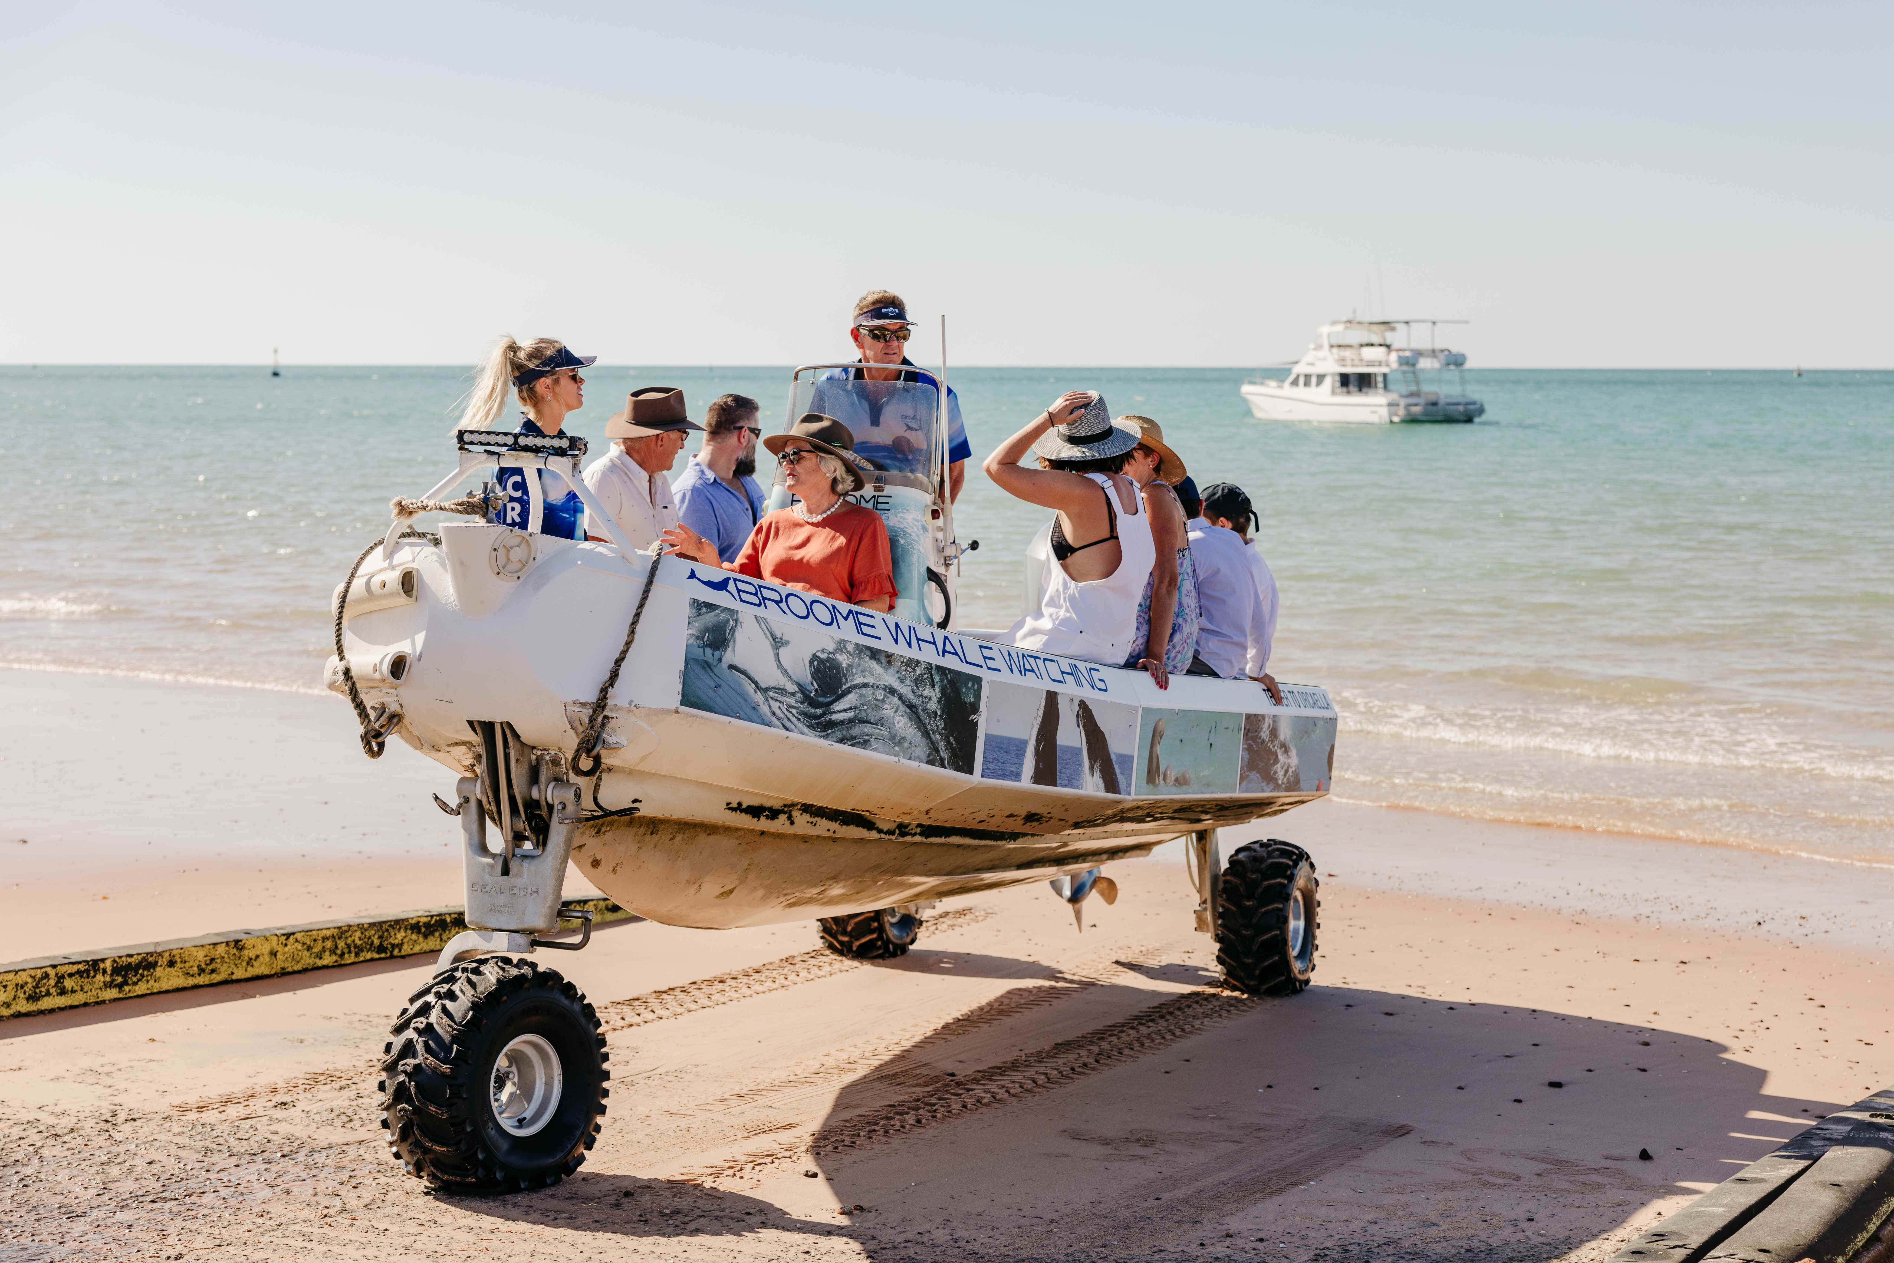
sealegs
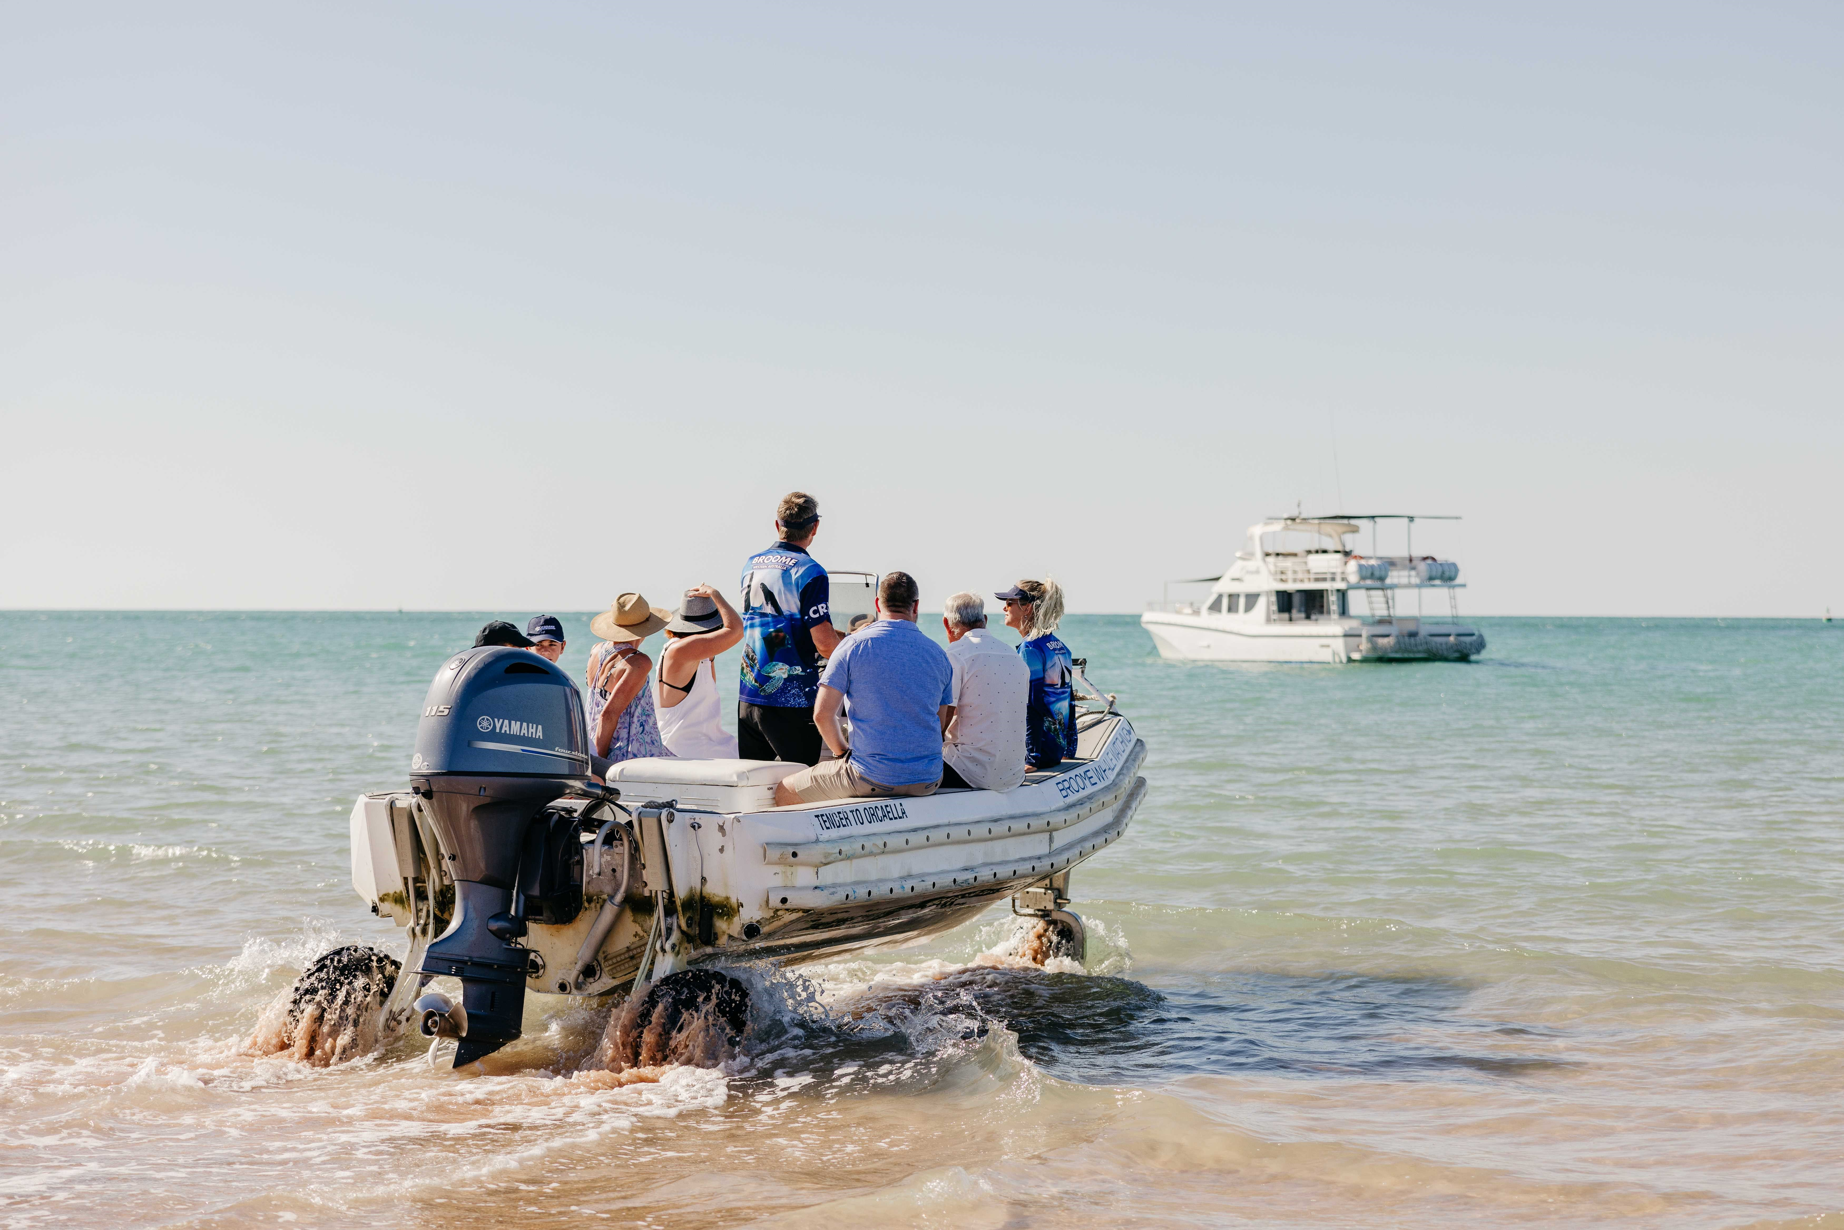
sealegs heading into water
- In addition, the following further information can assist guests:
As part of our courtesy bus service, we collect guests from various resorts and accommodation in Broome.

Report Disclaimer
Please note that this business report, provided as a result of the use of the diagnostic assessment, is for information purposes only.
Australian Tourism Industry Council (ATIC) cannot guarantee the accuracy of respondent’s answers, or that they are fully representative of your business. Therefore, ATIC does not warrant or guarantee any particular outcome in respect of your businesses self-assessment.
This report is intended as guidance only for your business and should not be relied on for future marketing considerations. ATIC recommends that you seek your own independent advice as well as the results from the diagnostic.
Links to external web sites are inserted for convenience and do not constitute endorsement of material at those sites, or any associated organisation, product or service.
ATIC does not:
- Assume any legal liability for the accuracy, completeness, or usefulness of any information from this report or any links provided; or
- Accept responsibility for any loss associated directly or indirectly from the use of this report.

