ATIC Accessibility
To support the accessible community in making informed travel decisions for their individual needs

This report prepared for:
Business name: | Fremantle Markets
Address: | cnr south tce and henderson st
Town: | Fremantle
Contact for enquiries: | Natasha Atkinson
Contact Number: | (08) 9335 2515
Contact Email: | info@fremantlemarkets.com.au
Website: | fremantlemarkets.com.au
Date: | 2026-05-26 03:51

ATIC Accessibility
The following pages provides travellers with information on the businesses facilities and amenities which aims to support the traveller to make an informed decision on whether the business is suitable for their individual needs.
OVERVIEW 4
Business Overview 4
Bookings 4
Emergency Management 4
Communications 5
Guide Dog and Service Animals 5
GENERAL 7
Pre-arrival, arrival and reception 7
Cognitive Impairment Support 7
Car Park and Access amenities 7
Entry 8
Internal Spaces 8
Public areas 8
Displays, exhibits, commentary and live performances 9
External Paths 9
Steps 9
Ramps 9
Public Toilets/Adult change facilities 9
ATTRACTIONS 11
Attractions Basics 11
COMMON AREAS 12
FOOD AND DRINK 13
Dining Spaces 13
Report Disclaimer 16

OVERVIEW

Business Overview

The business has the following products/services available
- Attraction
- Food and Drink

Our business caters for the following disability types:
- Limited mobility
- Wheelchairs or mobility scooters
- Food allergies or intolerances


Bookings

The business offers the following methods for bookings and enquiries:
- Phone
- Email
- Webportal

Emergency Management

It is not possible to explain it to 50,000 guests per weekend.
- There are Audible device/s to alert occupants to evacuate with instructions on how to evacuate.
- There are visual device/s to alert occupants to evacuate.
- Exit signs are clear and easy to see
- Exit access is free and clear at all times
We ensure exit access is free and clear at all times by:
they are the main entrances/exits to the market. They must be clear for customers to enter.
- Exits and access to exists are greater than 900mm
- Exit doors are able to be opened by all occupants
- Exits to the emergency evacuation point does not include stairways
- The evacuation point is clearly marked by a sign
The business identifies guests who need additional assistance should an emergency occur by:
They will be the ones that don't start exiting the building with the others.
The procedure for assisting guests who need assisted rescue is:
We must follow Warden Training and offer assistance and move them to the exit, if they refuse we leave them and tell emergency services of their location.

Communications
- An accessibility guide is available on the website

https://www.fremantlemarkets.com.au/sites/default/files/Fremantle%20Markets%20Accessibility%20Guide.pdf

Guide Dog and Service Animals
- The business provides a secure area with shade and water for service animals
The business provides the following services for services animals:
Under the Disability Discrimination Act 1992 (Cth) and relevant State legislation, assistance animals are legally permitted in public places, including retail environments like the Fremantle Markets. We recognise that assistance animals are not pets and must not be refused entry or treated less favourably. Team members are trained to accommodate assistance animals respectfully and without unnecessary questioning, in line with the law. Services Offered for Assistance Animals: Full Access: Assistance animals are welcome throughout all public areas of Fremantle Markets. Awareness Training: Staff and wardens are trained to recognise assistance animals and understand their rights and responsibilities under relevant legislation. Rest Areas: While not specifically designated, we do provide quiet shaded areas where assistance animals can rest if needed. Water Stations: Water bowls are available upon request for assistance animals. Clear Signage & Communication: We ensure our team is aware not to request proof unless there is a legitimate reason to question the status of an animal under the law.

GENERAL

Pre-arrival, arrival and reception
The business has the following in place to support guests during pre-arrival, arrival and reception
- Booking information and websites are compatible with screen readers
- There is a reception/public entryway.
- Seating available at reception
- A tablet with text to voice or pen and paper at reception to aid in communication

We are a shopping area, guests usually do not require our services. If the did, we would communicate via the guest they are travelling with or we would offer what's necessary to aid communication.
- Information and maps are available in written form
- A step free map/guide
- A familiarisation tour
- In addition, the following further information can assist guests:
We are a shopping area, there are not wait times.&nbsp;

Cognitive Impairment Support
- Documents are available in plain English for people with cognitive impairment (This may include instructions, guides, menus and general information)
- A space for parents and children on the Autism Spectrum

Car Park and Access amenities
The business has the following Car Park and Access amenities
- A drop off zone
- Designated disabled parking bays
- Level or ramped access from the car park to the entrance
- The accessible entrance is clearly signed from the parking bay

Entry
The business has the following amenities/systems in place for entry
- A drop off point close to the entrance
- A path of access to the building is slip resistance and even
- A path of access to the building is clear of obstruction
- Self opening entry doors or fitted with a self closer
- Glass doors are fitted with a visual sighting strip
- Door jams/doors are of a contrasting colour to surrounding walls
- Door handles are of a contrasting colour to the door
- Signage is written in a contrasting colour
- Signage is written in a Sans Serif font and use upper and lower case letters
- The entry door is a minimum of 850mm wide
- The entry door has self opening or a light opening pressure (for manual operations)
- The entrance sill is less than 13mm
- There a clear space of at least 1500mm x 1500mm in front of all doors.
- The entrance door mats have a thickness less than 13mm and a width of 7500mm or greater

Internal Spaces
- Clear and unobstructed routes through and between buildings
- Interior walls are matte or low sheen
- Floors, walls, counters and furniture are of contrasting colours
- Any protruding or overhanging obstructions are at least 2meters above the floor or are protected
- Floor surfaces are hard or short pile carpet
- Seating is available for guests unable to stand for long periods
- All corridors greater than 900mm
- There is a quiet space for parents and children on the Autism Spectrum

Public areas
The public areas have the following amenities in place
- Seating

Displays, exhibits, commentary and live performances
For displays, exhibits, commentary and live performances the following amenities are in place
- Seating
- Wheelchair accessible spaces/seating

External Paths
External paths of travel
- Surfaces are concrete, asphalt, smooth paving or hard packed fine gravel (max aggregate size 13mm)
- Pathways are wider than 900mm

Steps
Steps
- There are steps.
- Top and bottom steps are easily distinguished through colour contrast or the use of TGSIs (Tactile Ground Surface Indicators)
- The underside of all staircases are enclosed or protected to a height of at least 2 metres
- Handrails fitted to all open sets of steps
- In addition, the following further information can assist guests:
Only one small area has stairs and due to heritage nature this cannot change.&nbsp;

Ramps
Ramps have the following amenities are in place
- There are ramps.
- All fixed ramps are 1:14 or less
- Hand rails are fitted
- Long ramps (more than 10m) are 1:20 or less

Public Toilets/Adult change facilities
Public Toilets/Adult change facilities have the following amenities are in place
- There is an accessible toilet for public use
- The door is at least 850mm wide
- There is a minimum of 850mm beside the toilet
- The toilet seat is 460mm above the floor
- The toilet seat of a contrasting colour to the floor
- The toilet seat is460mm above the floor

ATTRACTIONS

Attractions Basics
- A park map is available here:

https://www.fremantlemarkets.com.au/interactive_map

COMMON AREAS

FOOD AND DRINK

Dining Spaces
The dining spaces have the following facilities/amenities in place
- The entrance has level access
- The doorway is at least 850mm wide
- There is level access through the dining area
- Chairs are moveable to allow for wheelchairs to be seated at the tables
- All glass doors and full height windows have contrast markings
- There are areas of full lighting
- There are Plain English menus
- There is an accessible toilet

Our business caters for the following dietary requirements
- Sugar free (diabetic)
- Gluten free (celiac)
- Lactose free (dairy free)
- Nut free
- Organic
- Vegetarian
- Vegan
- Halal
- In addition, the following further information can assist guests:
We have different businesses specialising in different products. The gluten free stall doesn't stock any gluten.&nbsp;
  - Food and Beverage Image(s)
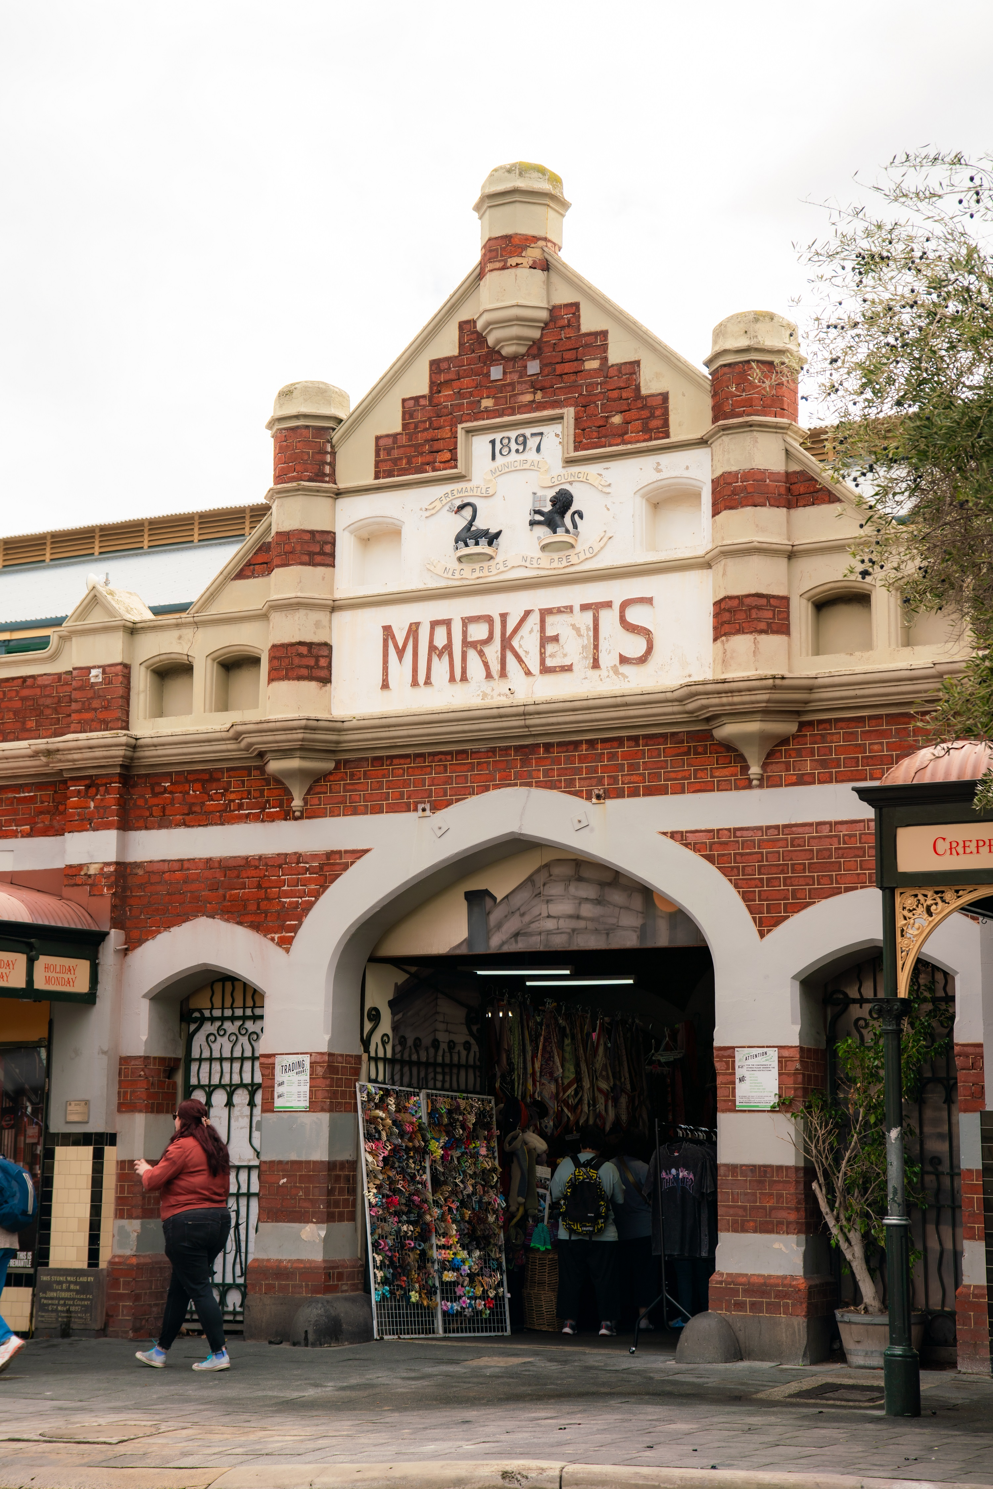
freo-distillery-134

Report Disclaimer
Please note that this business report, provided as a result of the use of the diagnostic assessment, is for information purposes only.
Australian Tourism Industry Council (ATIC) cannot guarantee the accuracy of respondent’s answers, or that they are fully representative of your business. Therefore, ATIC does not warrant or guarantee any particular outcome in respect of your businesses self-assessment.
This report is intended as guidance only for your business and should not be relied on for future marketing considerations. ATIC recommends that you seek your own independent advice as well as the results from the diagnostic.
Links to external web sites are inserted for convenience and do not constitute endorsement of material at those sites, or any associated organisation, product or service.
ATIC does not:
- Assume any legal liability for the accuracy, completeness, or usefulness of any information from this report or any links provided; or
- Accept responsibility for any loss associated directly or indirectly from the use of this report.

