ATIC Accessibility
To support the accessible community in making informed travel decisions for their individual needs

This report prepared for:
Business name: | RockWire Mt Buller
Address: | Summit Road
Town: | Mt Buller
Contact for enquiries: | Florian Tabelander
Contact Number: | 1800285537 ( as per website - updated)
Contact Email: | info@rockwire.com.au
Website: | https://www.rockwire.com.au/
Date: | 2026-10-31 23:54

ATIC Accessibility
The following pages provides travellers with information on the businesses facilities and amenities which aims to support the traveller to make an informed decision on whether the business is suitable for their individual needs.
OVERVIEW 4
Business Overview 4
Bookings 4
Emergency Management 5
Communications 5
Other Information 5
GENERAL 6
Pre-arrival, arrival and reception 6
Cognitive Impairment Support 6
Car Park and Access amenities 6
Entry 7
Internal Spaces 7
Public areas 8
External Paths 8
Ramps 8
TOUR OPERATORS 9
ATTRACTIONS 10
Attractions Basics 10
COMMON AREAS 11
ADVENTURE ACTIVITIES 12
Adventure activities 12
Report Disclaimer 14

OVERVIEW

Business Overview

The business has the following products/services available
- Attraction
- Adventure

Our business caters for the following disability types:
- Blind or low vision
- Deaf or low hearing
- Limited mobility
- Food allergies or intolerances
- Cognitive or people on the Autism Spectrum
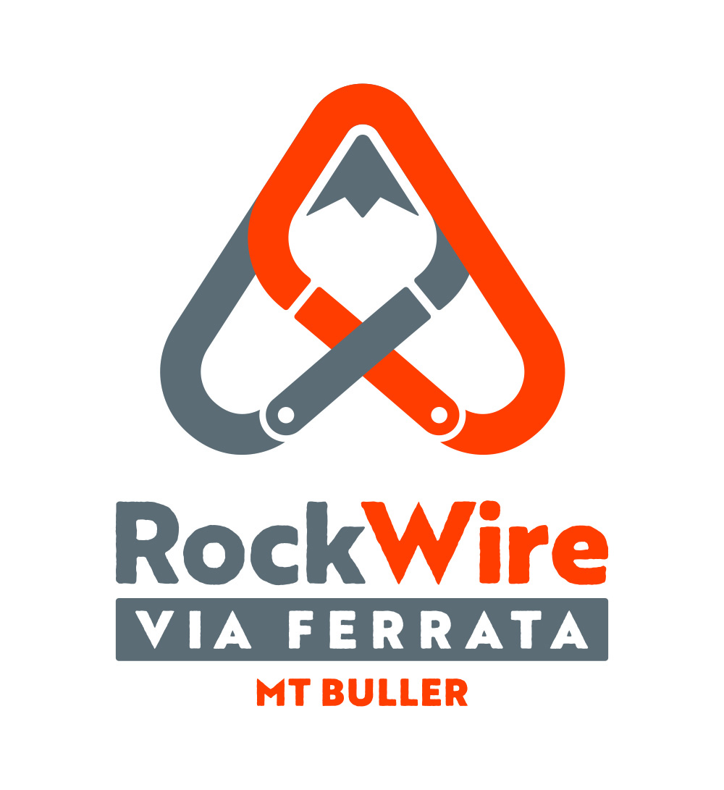

Bookings

The business offers the following methods for bookings and enquiries:
- Phone
- Email
- Webportal
- Our forms have high contract boxes and submit boxes

Emergency Management
- Emergency and evacuation procedures are explained on arrival
- Exit signs are clear and easy to see
- Exit access is free and clear at all times
We ensure exit access is free and clear at all times by:
Door wedged open
- Exit doors are able to be opened by all occupants
- Exits to the emergency evacuation point does not include stairways
- The evacuation point is clearly marked by a sign
- The evacuation point is clearly marked by a sign with raised letters or braille
- In addition, the following further information can assist guests:
Communication
- In addition, the following further information can assist guests:
As per Emergency Management Plan

Communications
- Our business offers the following alternative communication methods
- Plain English

Not specified
- There is easy to read signage and information (e.g. menus and emergency information)

Other Information
- For bookings made onsite, the ticket booth/counter/box office is accessible for people using a wheelchair
The business provides the following services for services animals:
N/A

GENERAL

Pre-arrival, arrival and reception
The business has the following in place to support guests during pre-arrival, arrival and reception
- Booking information and websites are compatible with screen readers
- There is a reception/public entryway.
- Seating available at reception
- A lower counter at reception/ticket office
- A tablet with text to voice or pen and paper at reception to aid in communication
- Lighting in the reception area is even and glare free
- Large print information sheets and registration forms
- Information and maps are available in written form
- A familiarisation tour
- In addition, the following further information can assist guests:
Wait times are not applicable
- In addition, the following further information can assist guests:
N/A

Cognitive Impairment Support
- Documents are available in plain English for people with cognitive impairment (This may include instructions, guides, menus and general information)
- Quiet periods or early opening times for people on the Autism Spectrum
- A space for parents and children on the Autism Spectrum

Car Park and Access amenities
The business has the following Car Park and Access amenities
- A drop off zone
- Designated disabled parking bays
- Level or ramped access from the car park to the entrance
- The accessible entrance is clearly signed from the parking bay
- Kerb ramps are in place where a pavement or walkway needs to be crossed
- In addition, the following further information can assist guests:
N/A

Entry
The business has the following amenities/systems in place for entry
- A drop off point close to the entrance
- A path of access to the building is slip resistance and even
- A path of access to the building is clear of obstruction
- Self opening entry doors or fitted with a self closer
- Glass doors are fitted with a visual sighting strip
- Door jams/doors are of a contrasting colour to surrounding walls
- Door handles are of a contrasting colour to the door
- Signage is written in a contrasting colour
- The entry door is a minimum of 850mm wide
- The entry door has self opening or a light opening pressure (for manual operations)
- The entrance sill is less than 13mm
- There a clear space of at least 1500mm x 1500mm in front of all doors.
- The entrance door mats have a thickness less than 13mm and a width of 7500mm or greater
- In addition, the following further information can assist guests:
N/A
- In addition, the following further information can assist guests:
Single Floor

Internal Spaces
- Clear and unobstructed routes through and between buildings
- Interior walls are matte or low sheen
- Floors, walls, counters and furniture are of contrasting colours
- Any protruding or overhanging obstructions are at least 2meters above the floor or are protected
- Floor surfaces are hard or short pile carpet
- Seating is available for guests unable to stand for long periods
- Accessible facilities are clearly signed and visible from all areas
- All corridors greater than 900mm
- There is a quiet space for parents and children on the Autism Spectrum
- In addition, the following further information can assist guests:
N/A

Public areas
The public areas have the following amenities in place
- Display units, Televisions, Video displays etc. are open captioned
- Even lighting
- Seating
- In addition, the following further information can assist guests:
N/A

External Paths
External paths of travel
- Surfaces are concrete, asphalt, smooth paving or hard packed fine gravel (max aggregate size 13mm)
- Paths or slopes longer than 15 metres have resting places or seats
- Pathways are wider than 900mm
- There 3 successive steps or less on any path or at any doorway
- Step free routes clearly signed
- In addition, the following further information can assist guests:
N/A
- In addition, the following further information can assist guests:
N/A

Ramps
Ramps have the following amenities are in place
- There are ramps.
- All fixed ramps are 1:14 or less
- Hand rails are fitted
- Long ramps (more than 10m) are 1:20 or less
- Ramps have a raised edge of at least 100mm
- In addition, the following further information can assist guests:
N/A
- In addition, the following further information can assist guests:
Amenities provided in Village Square (15 metres away)

TOUR OPERATORS
- 0 vehicles have wheelchair lifts or ramps
- 0 vehicles have low floors with ramped entry
The maximum wheelchair capacity available in the fleet is:
0

ATTRACTIONS

Attractions Basics
- A park map is available here:

https://www.rockwire.com.au/the-routes/

COMMON AREAS

ADVENTURE ACTIVITIES

Adventure activities
The adventure activities have the following facilities/amenities in place
- Our adventure activities cater for people with a disability
- In addition, the following further information can assist guests:
Catering to those that are confident with this special type of product
- In addition, the following further information can assist guests:
Guide knowledge
- In addition, the following further information can assist guests:
Mobility and Access Needs to and on the Climbing Routes
- In addition, the following further information can assist guests:
N/A

Report Disclaimer
Please note that this business report, provided as a result of the use of the diagnostic assessment, is for information purposes only.
Australian Tourism Industry Council (ATIC) cannot guarantee the accuracy of respondent’s answers, or that they are fully representative of your business. Therefore, ATIC does not warrant or guarantee any particular outcome in respect of your businesses self-assessment.
This report is intended as guidance only for your business and should not be relied on for future marketing considerations. ATIC recommends that you seek your own independent advice as well as the results from the diagnostic.
Links to external web sites are inserted for convenience and do not constitute endorsement of material at those sites, or any associated organisation, product or service.
ATIC does not:
- Assume any legal liability for the accuracy, completeness, or usefulness of any information from this report or any links provided; or
- Accept responsibility for any loss associated directly or indirectly from the use of this report.

