ATIC Accessibility
To support the accessible community in making informed travel decisions for their individual needs

This report prepared for:
Business name: | Roma Central Motel
Address: | 17-19 Bowen
Town: | Roma
Contact for enquiries: | Emma McMullan
Contact Number: | 07 4622 8746
Contact Email: | stay@romacentral.com.au
Website: | http://www.romacentralmotel.com.au/
Date: | 2026-10-25 03:57

ATIC Accessibility
The following pages provides travellers with information on the businesses facilities and amenities which aims to support the traveller to make an informed decision on whether the business is suitable for their individual needs.
OVERVIEW 4
Business Overview 4
Bookings 4
Other Information 4
Guide Dog and Service Animals 5
GENERAL 6
Pre-arrival, arrival and reception 6
Car Park and Access amenities 6
External Paths 6
Steps 7
ACCOMMODATION 8
Bedrooms 8
Room Amenities 10
Bathrooms 10
COMMON AREAS 12
Report Disclaimer 14

OVERVIEW

Business Overview

The business has the following products/services available
- Accommodation

Our business caters for the following disability types:
- Limited mobility
- Wheelchairs or mobility scooters


Bookings

The business offers the following methods for bookings and enquiries:
- Phone
- Email
- Webportal
- Our forms have high contract boxes and submit boxes

Other Information
- For bookings made onsite, the ticket booth/counter/box office is accessible for people using a wheelchair

Guide Dog and Service Animals
The business provides the following services for services animals:
N/A

GENERAL

Pre-arrival, arrival and reception
The business has the following in place to support guests during pre-arrival, arrival and reception
- There is a reception/public entryway.
- Seating available at reception
- A lower counter at reception/ticket office
- A clipboard to allow check-in/ticket purchase whilst seated
- Keys are available for each guest
- In addition, the following further information can assist guests:
Our reception has minimal seating. We are a small motel and have short wait periods at check-in. We do our best to ensure the check-in process is quick and efficient.
- In addition, the following further information can assist guests:
N/A

Car Park and Access amenities
The business has the following Car Park and Access amenities
- Designated disabled parking bays
- The accessible entrance is clearly signed from the parking bay
- In addition, the following further information can assist guests:
N/A

External Paths
External paths of travel
- Surfaces are concrete, asphalt, smooth paving or hard packed fine gravel (max aggregate size 13mm)
- Pathways are wider than 900mm
- In addition, the following further information can assist guests:
Both accessibility friendly rooms and located ground floor next to reception. There are no steps. We do have upstairs rooms, Queen and Twin however, if you book our accessibility friendly room then you will not be allocated upstairs. We encourage you to let us know prior to arrival if you have a scooter or wheelchair so we can ensure that you are provide with a suitable room.

Steps
Steps
- There are steps.
- Top and bottom steps are easily distinguished through colour contrast or the use of TGSIs (Tactile Ground Surface Indicators)
- Handrails fitted to all open sets of steps
- In addition, the following further information can assist guests:
N/A
- In addition, the following further information can assist guests:
N/A

ACCOMMODATION

Bedrooms
The bedrooms have the following facilities/amenities in place
- There are 2 rooms available to guests who use a wheelchair
  - Layout of room Image(s)
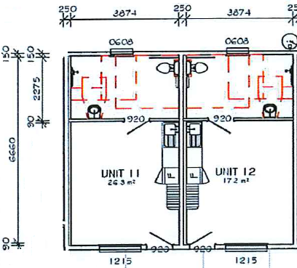
Roma Central Motel Accessibility Room Dimensions - Copy
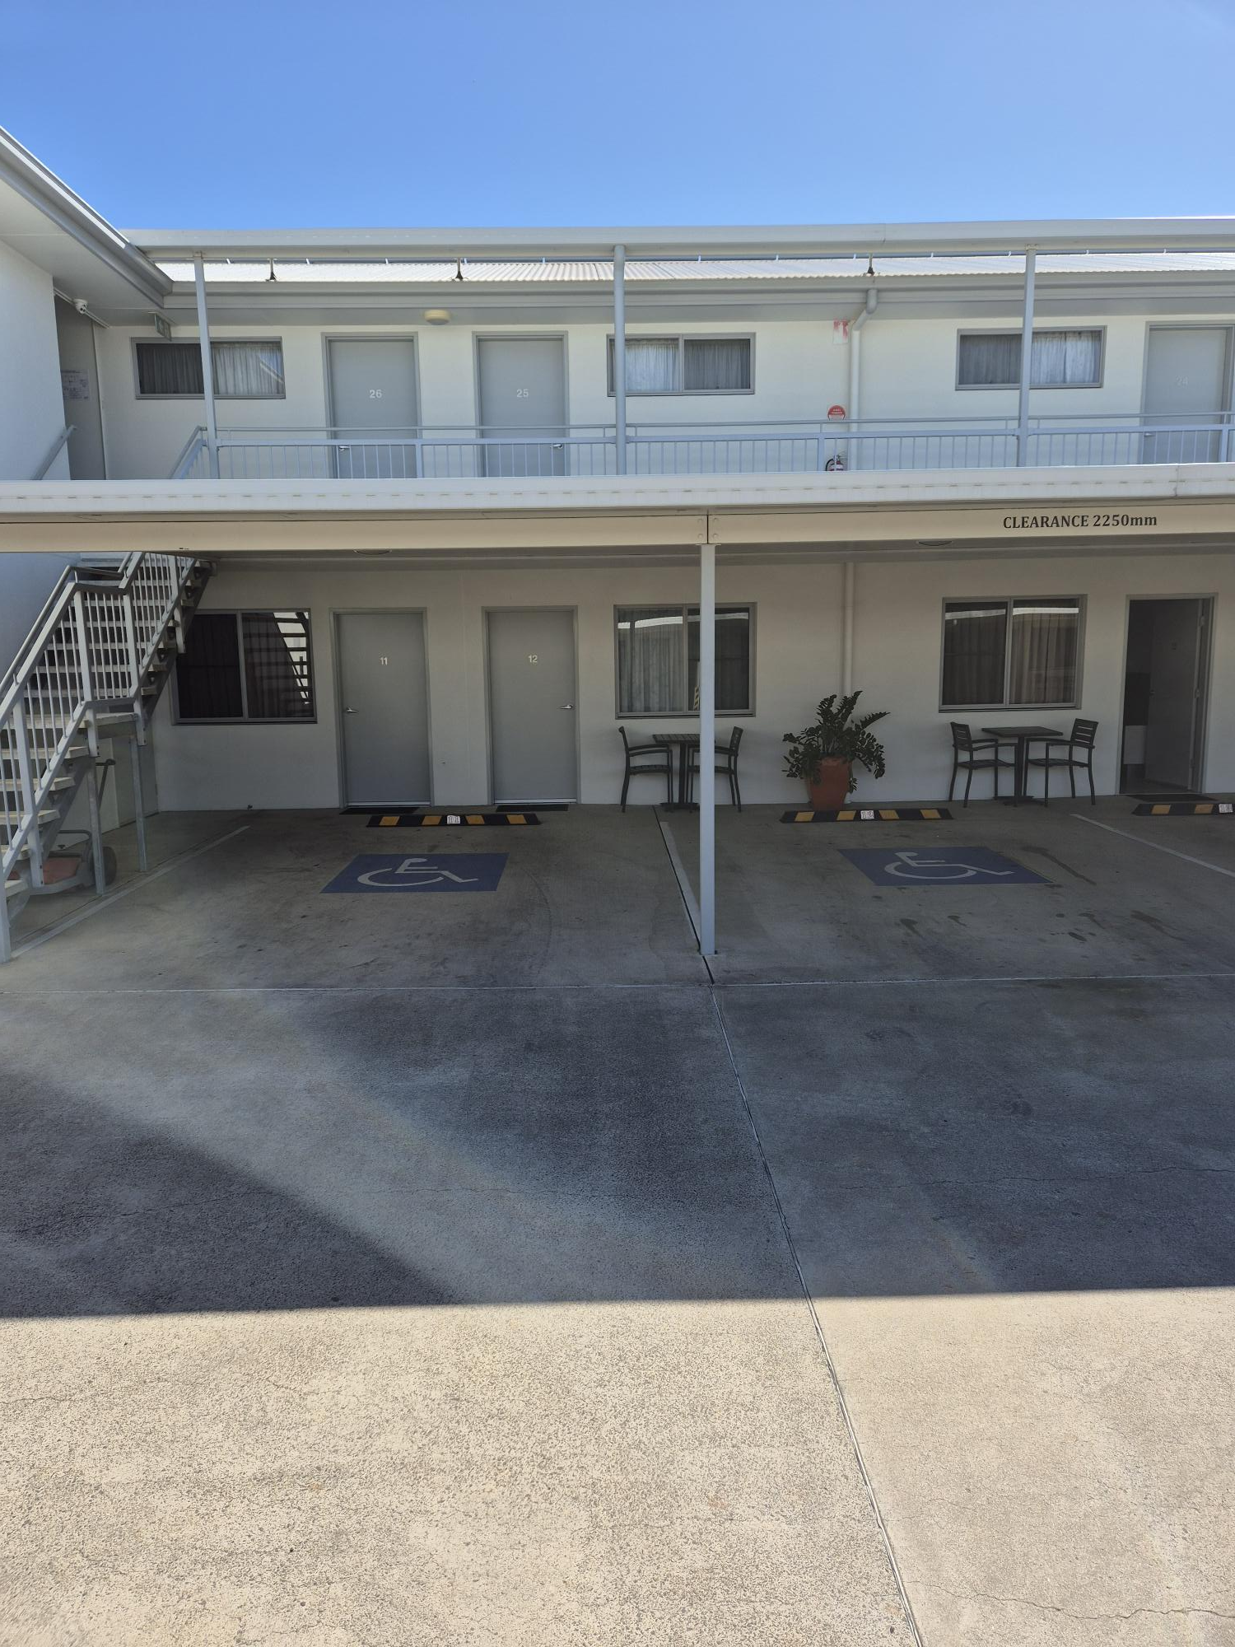
20240823_095132
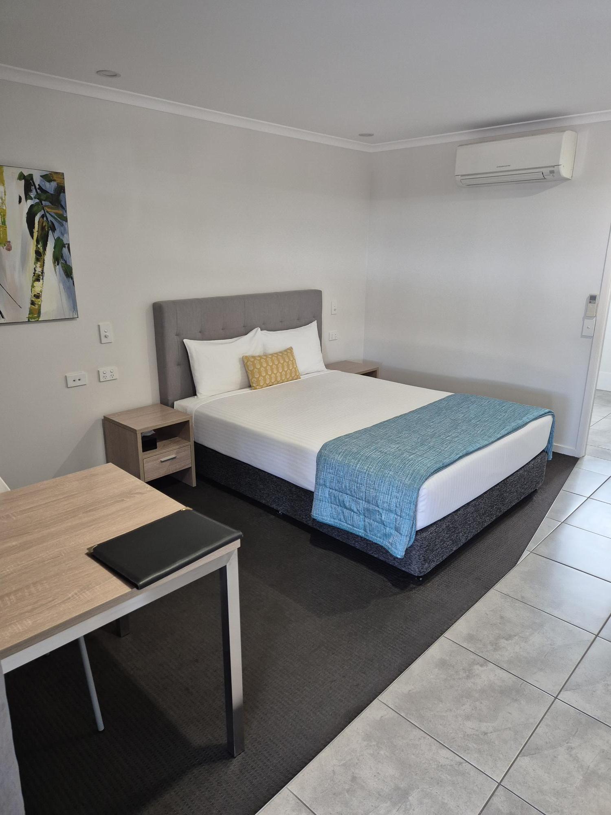
20240823_095239
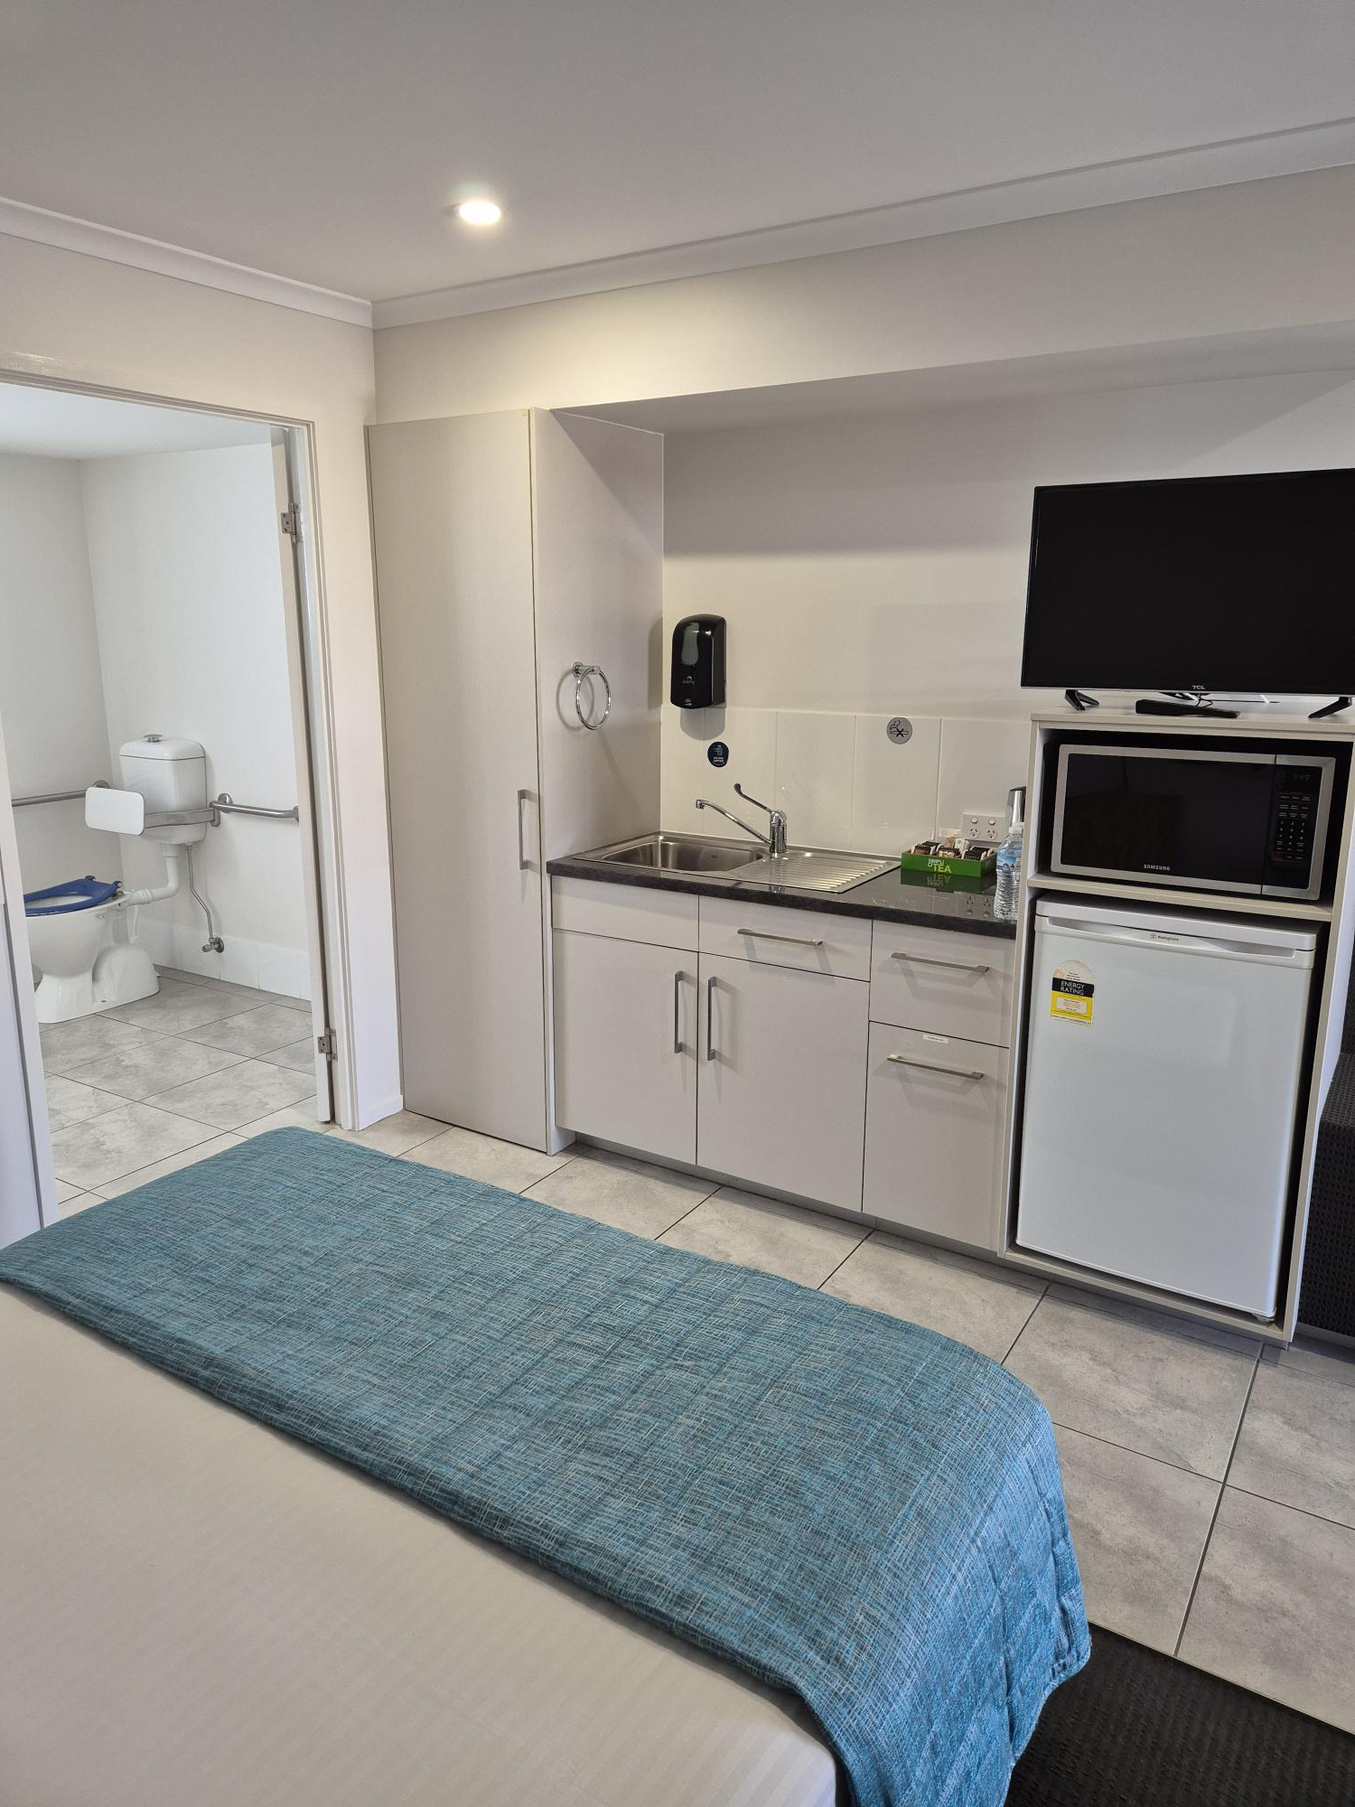
20240823_095252
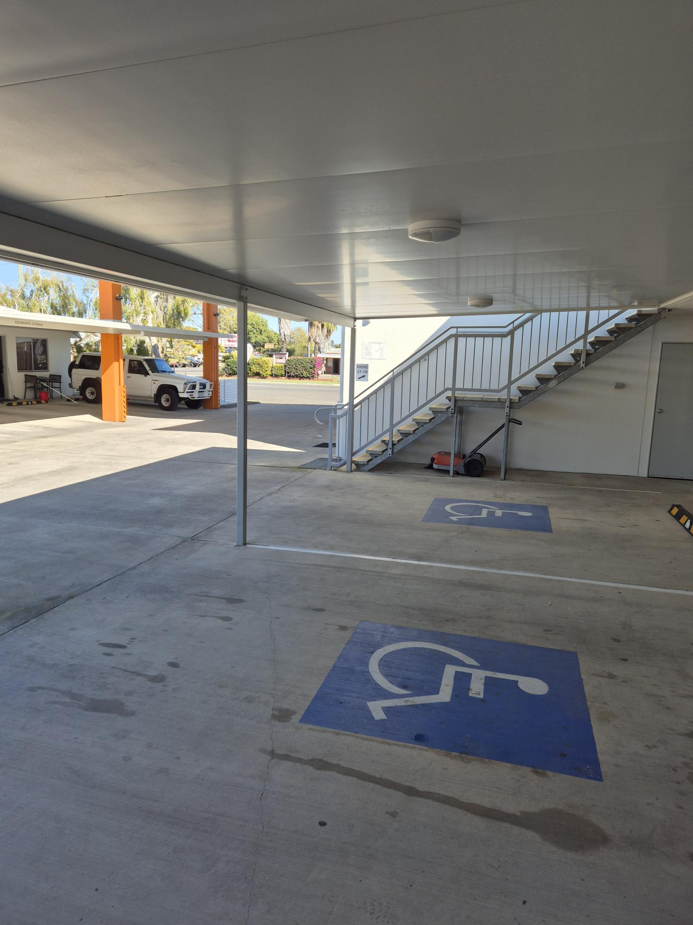
20240823_095146
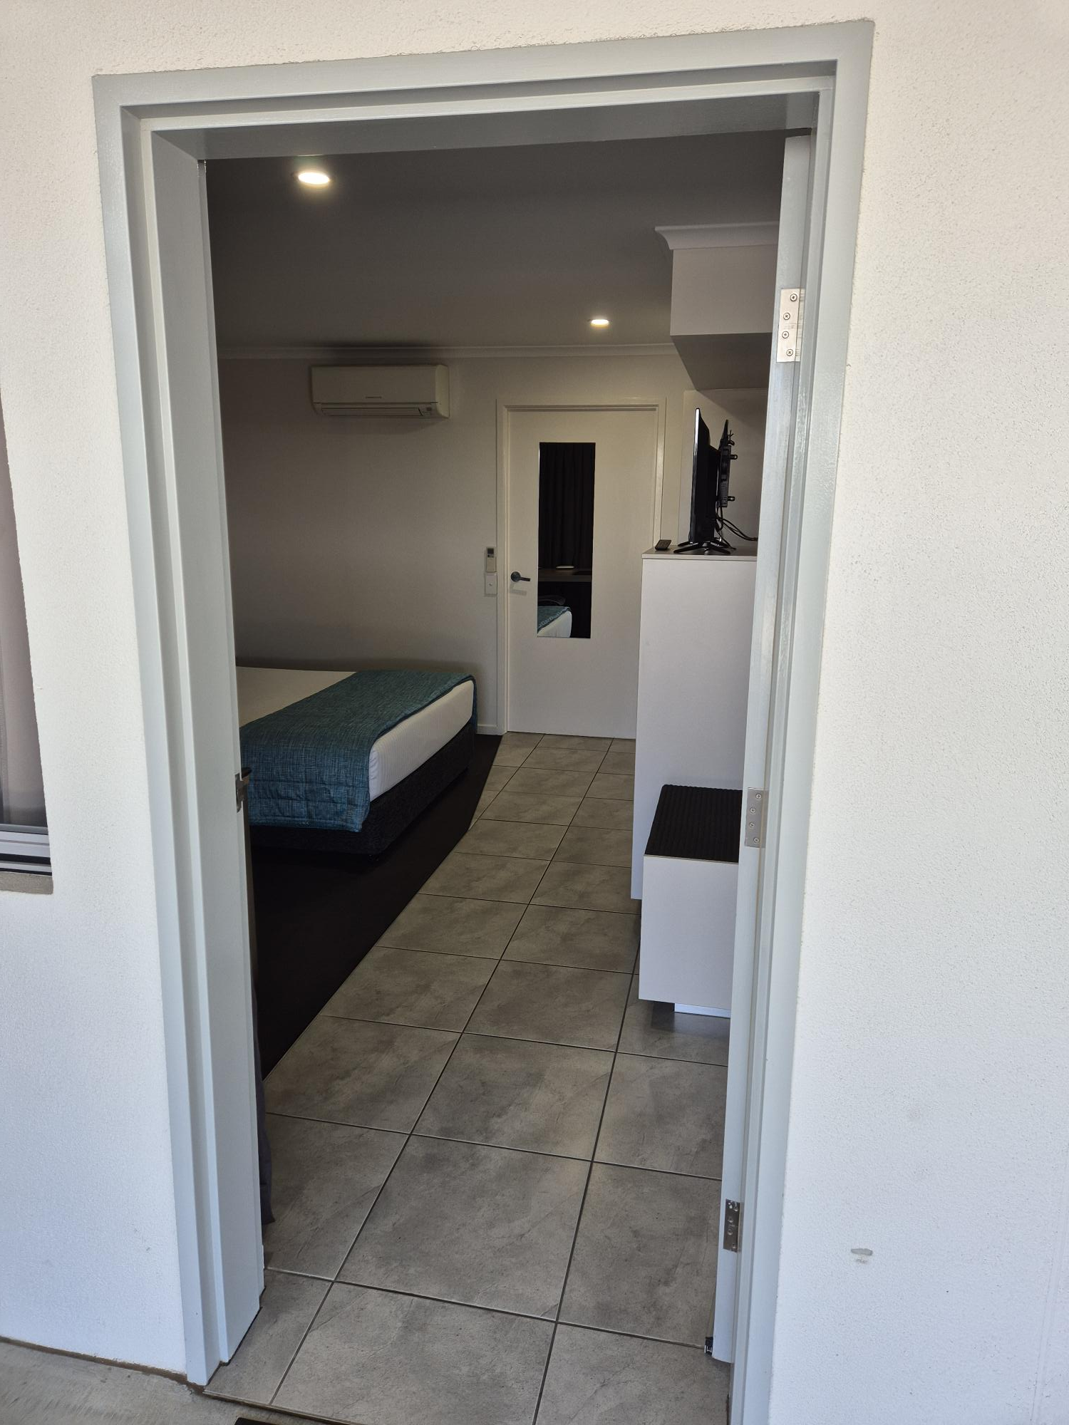
20240823_095222

Room Amenities
- There is a clear path through the room
- There is a clear opening at least 850mm wide
- There luggage racks for at least two suitcases
- The bedside lamp switch is easy to reach from the bed
- In addition, the following further information can assist guests:
Beds and mattresses are of standard size and are not tailored towards disability needs.

Bathrooms
The bathrooms have the following facilities/amenities in place
- All heating appliances and hot water pipes are protected or insulated
- The door is at least 850mm wide
- There is a minimum of 850mm beside the toilet
- Handrails are fitted
- There is a minimum of 1400mm of clear space in front of the toilet
- The toilet seat is a contrasting colour to the floor
- The toilet seat is 460mm above the floor
- There is a roll-in shower with fold down fixed seat or a shower chair
- There is a portable shower head on flexible hose
  - Bathroom Image(s)
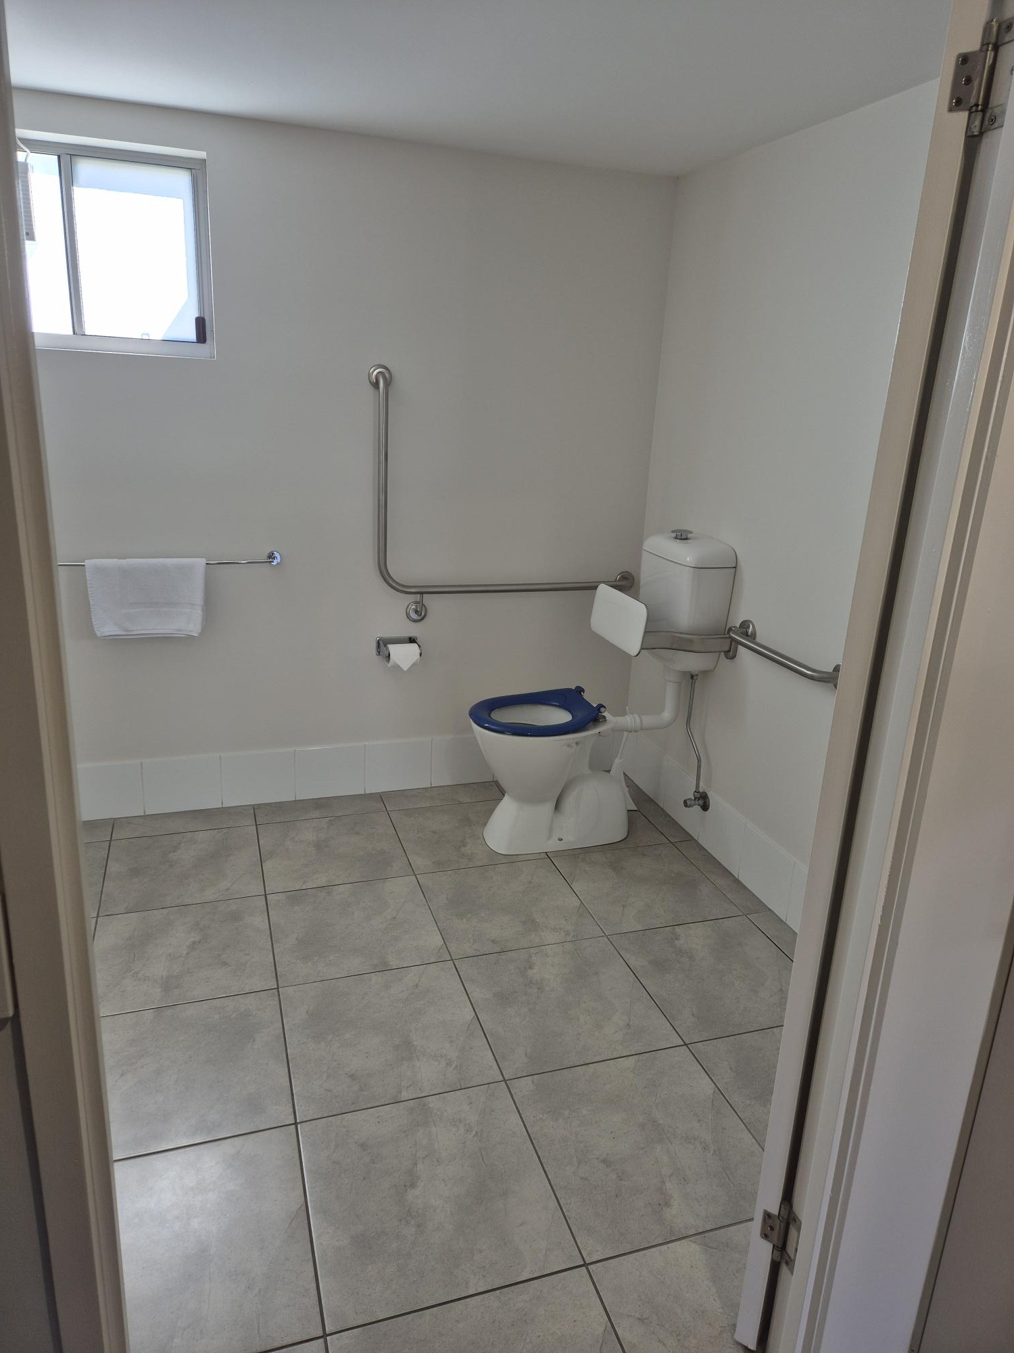
20240823_095258
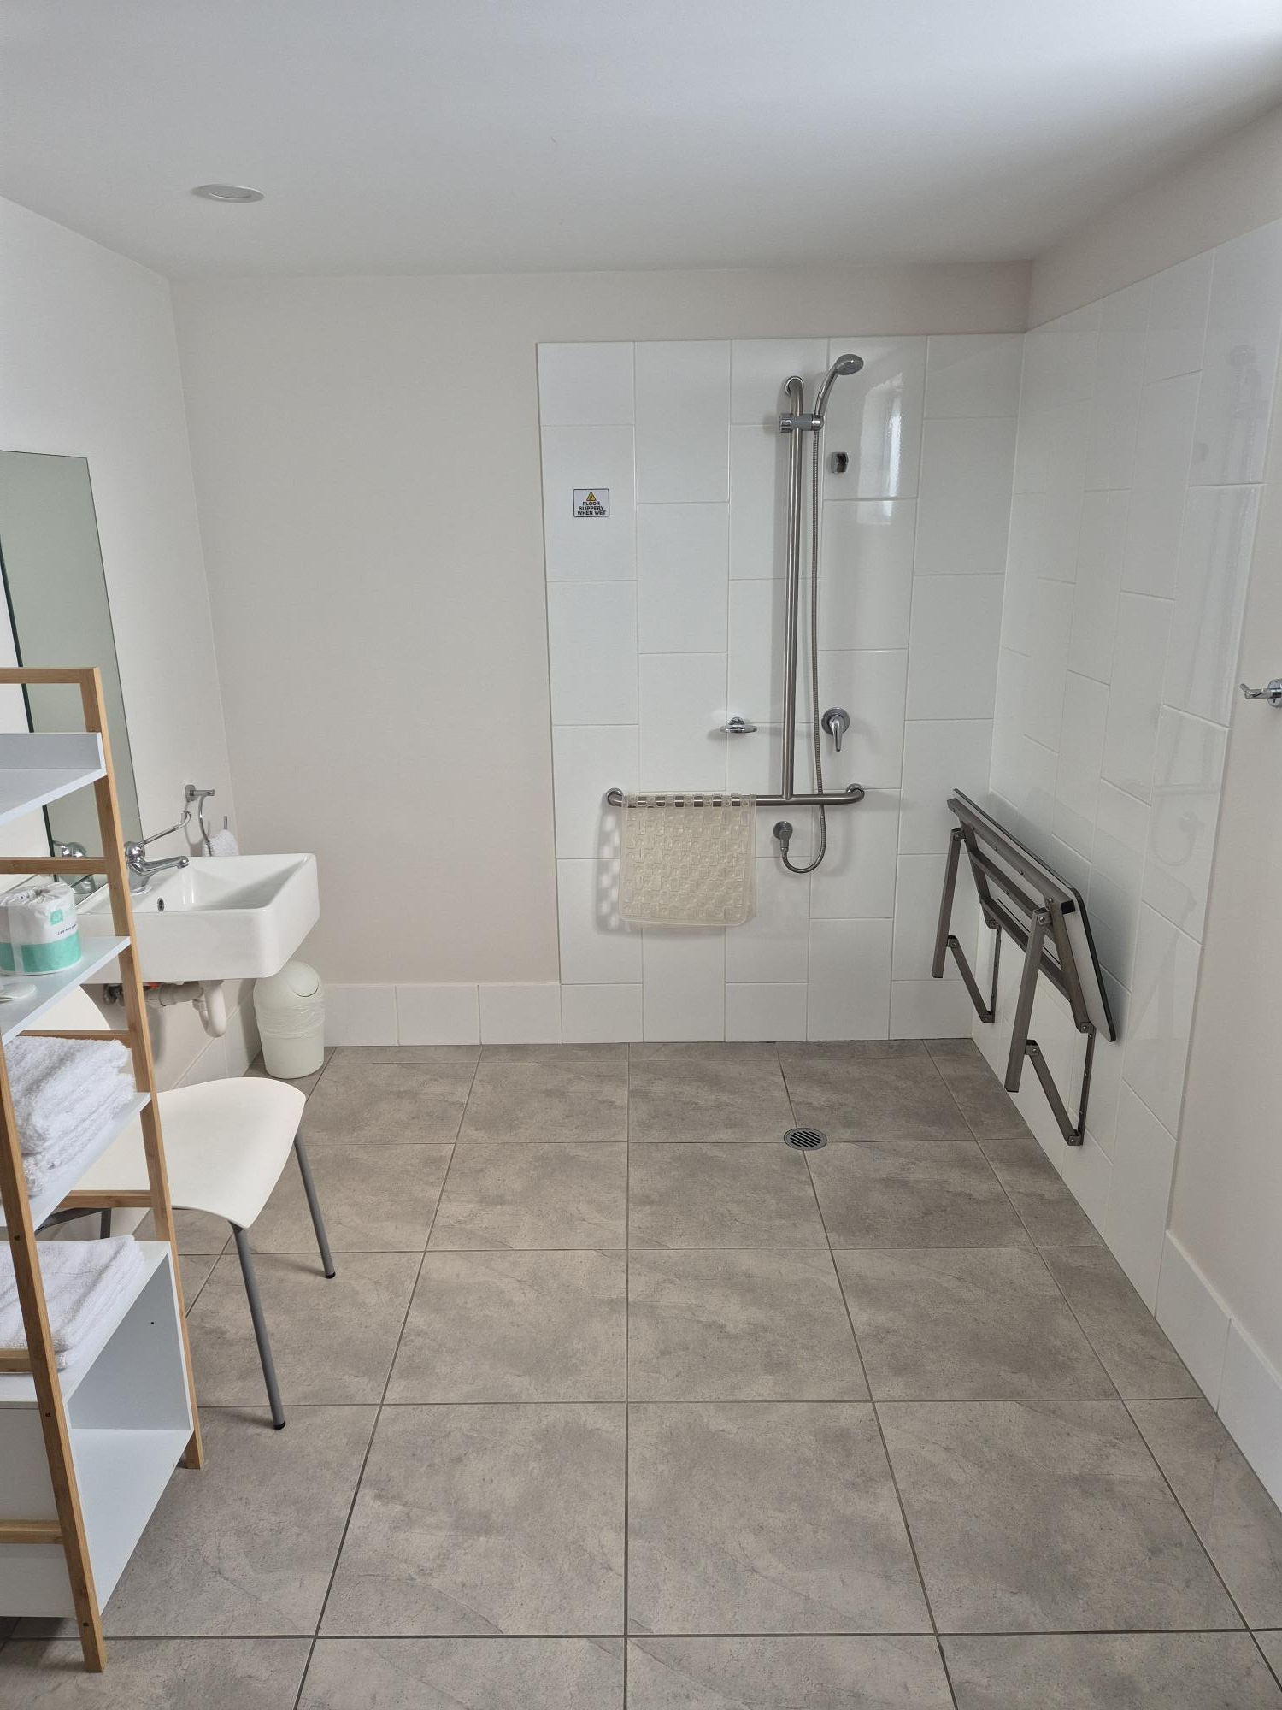
20240823_095305
- In addition, the following further information can assist guests:
N/A

COMMON AREAS

Report Disclaimer
Please note that this business report, provided as a result of the use of the diagnostic assessment, is for information purposes only.
Australian Tourism Industry Council (ATIC) cannot guarantee the accuracy of respondent’s answers, or that they are fully representative of your business. Therefore, ATIC does not warrant or guarantee any particular outcome in respect of your businesses self-assessment.
This report is intended as guidance only for your business and should not be relied on for future marketing considerations. ATIC recommends that you seek your own independent advice as well as the results from the diagnostic.
Links to external web sites are inserted for convenience and do not constitute endorsement of material at those sites, or any associated organisation, product or service.
ATIC does not:
- Assume any legal liability for the accuracy, completeness, or usefulness of any information from this report or any links provided; or
- Accept responsibility for any loss associated directly or indirectly from the use of this report.

